EXPERIMENT – 11 Change Hardware compatibility of a VM (Either by clone/create new one) which is already created and configured, using virtual box.
Aim:
To change the hardware configuration of an already created and configured Virtual Machine using VirtualBox.
Procedure:
- Open Oracle VirtualBox on your host machine.
- Select the virtual machine (VM) whose hardware you want to modify.
- Ensure the VM is powered off.
- Right-click the VM and select Settings.
- Navigate to the following hardware sections and modify as needed:
  - System → Motherboard: Change base memory (RAM), boot order.
  - System → Processor: Change the number of CPU cores.
  - Display → Screen: Adjust video memory or enable 3D acceleration.
  - Storage → Controller: Add or remove virtual hard disks.
  - Network: Change adapter type or network mode (NAT/Bridged).
- Click OK to save the new configuration.
- Start the VM and verify that it runs correctly with the updated hardware settings.
Output:
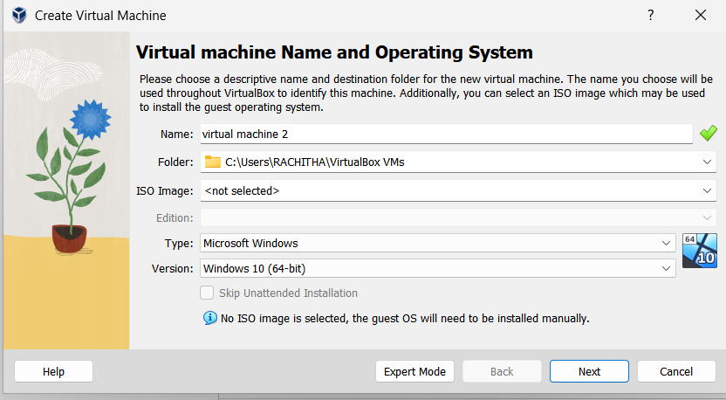

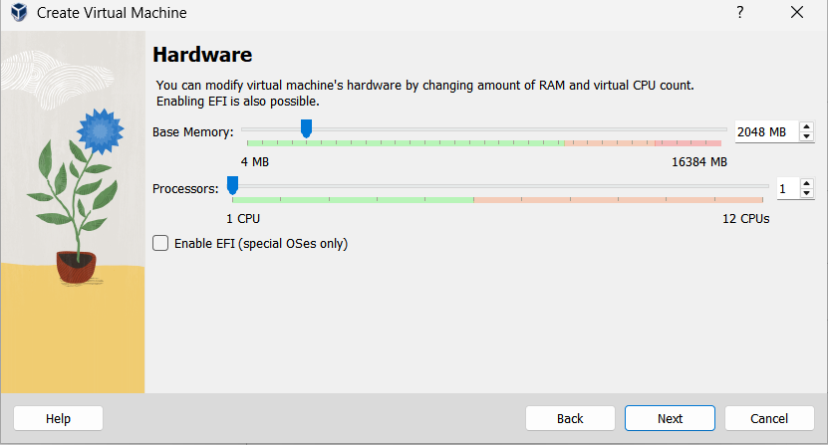

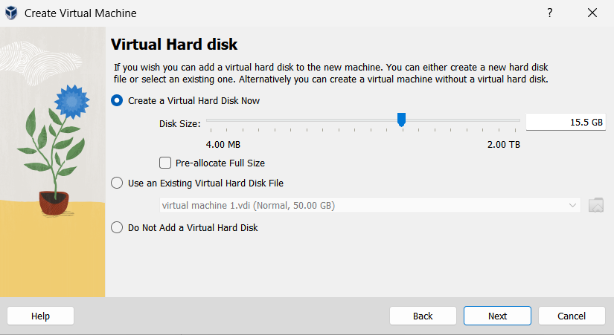

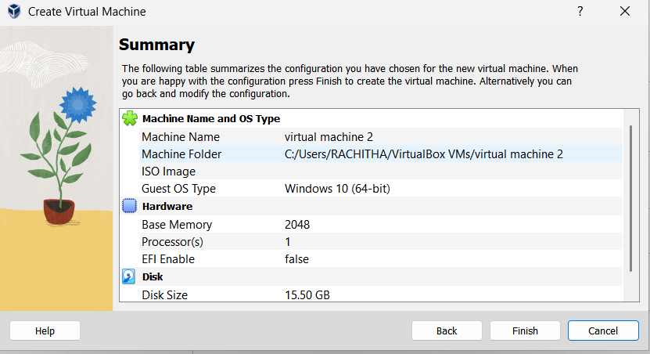

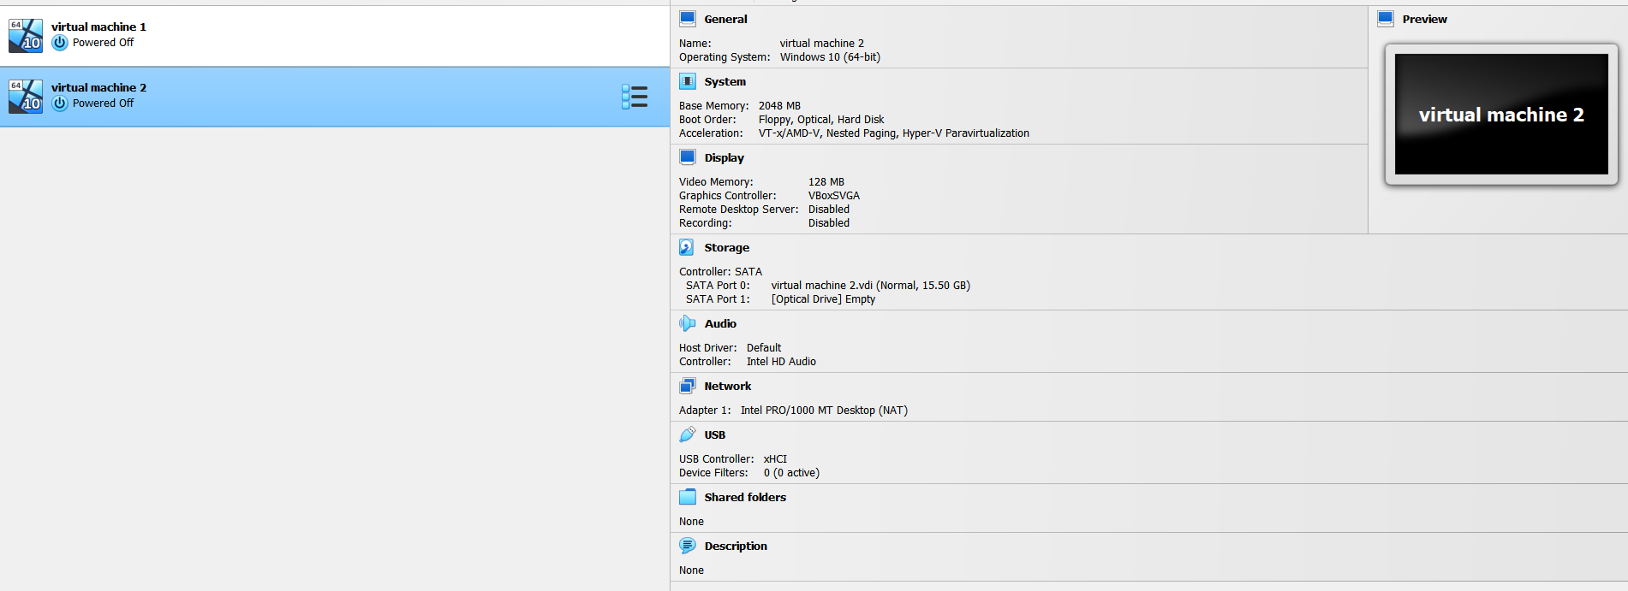

Result:
The hardware compatibility of the VM was successfully modified in VirtualBox. The VM ran correctly after changing RAM, CPU, storage, and other hardware settings, demonstrating hardware reconfiguration in a Type-2 Hypervisor.

