EXPERIMENT – 07 Create a Virtual Machine with 1 CPU, 2GB RAM and 15GB storage disk using a Type 2 Virtualization Software, using virtual box.
Aim:
To create a Virtual Machine with 1 CPU, 2GB RAM, and 15GB storage disk using a Type-2 Virtualization Software (VirtualBox).
Procedure:
- Install VirtualBox:
Download and install Oracle VirtualBox on your host system.
- Launch VirtualBox:
Open the VirtualBox Manager and click on New to create a new VM.
- Name & OS Selection:
  - Enter VM name (e.g., Ubuntu-VM or Windows-VM).
  - Select Type: Windows/Linux.
  - Choose version (e.g., Ubuntu 64-bit or Windows 10).
- Allocate Memory (RAM):
  - Assign 2048 MB (2GB) RAM.
- CPU Configuration:
  - In Processor settings, allocate 1 CPU core.
- Create Virtual Hard Disk:
  - Select Create a virtual hard disk now.
  - Choose format as VDI (VirtualBox Disk Image).
  - Allocate 15 GB storage (dynamically allocated or fixed size).
- Mount OS ISO:
  - Go to VM Settings → Storage → Attach the OS ISO image (Linux/Windows).
- Start the VM:
  - Boot the VM and proceed with OS installation.

Output:
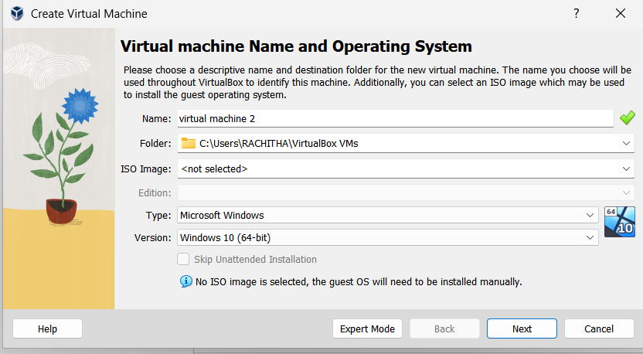

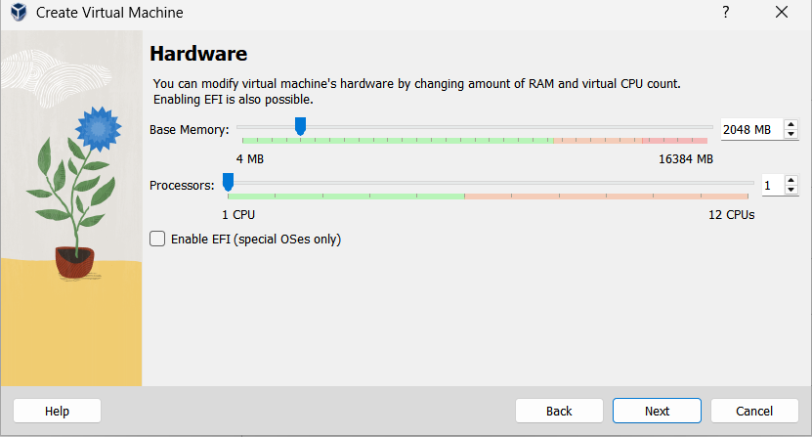

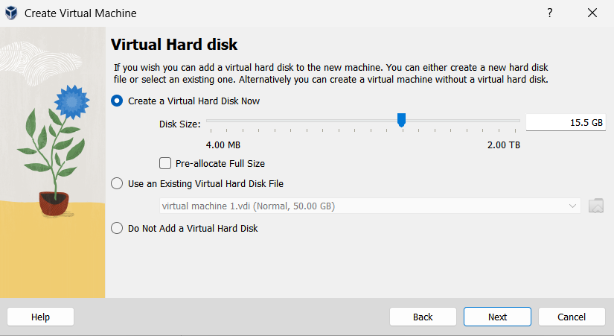

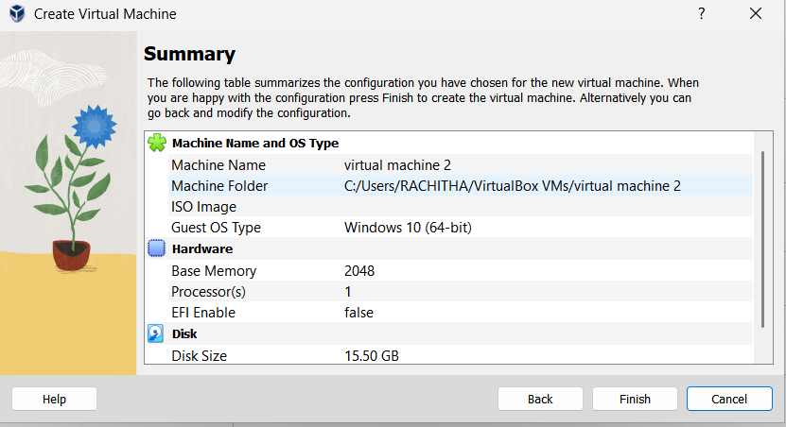

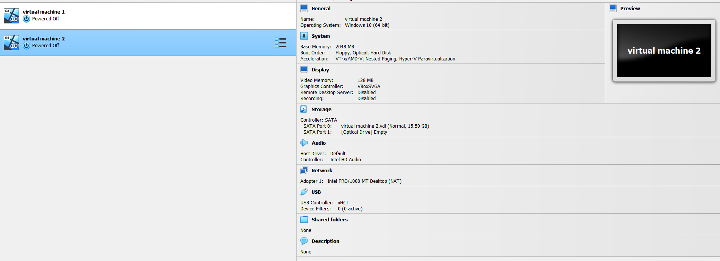

Result:
A Virtual Machine with 1 CPU, 2GB RAM, and 15GB storage disk was successfully created and configured using VirtualBox.

