EXPERIMENT – 08 Create a Virtual Hard Disk and allocate the storage using virtual box.
Aim:
To create a Virtual Hard Disk (VHD) and allocate storage for a Virtual Machine using VirtualBox.
Procedure:
- Open VirtualBox:
Launch Oracle VirtualBox on your host machine.
- Create / Select VM:
  - If you are creating a new VM → click New.
  - If you already have a VM → select it and go to Settings → Storage.
- Create Virtual Hard Disk:
  - In the VM creation wizard, choose Create a virtual hard disk now.
  - Select disk type:
    - VDI (VirtualBox Disk Image) – default format.
    - (Other options: VHD, VMDK).
- Allocate Storage:
  - Choose Dynamically allocated (grows as you use) OR Fixed size (reserves full space immediately).
  - Enter storage size (e.g., 15 GB).
- Attach Virtual Hard Disk:
  - The created disk will be automatically attached to the VM.
  - You can view/edit it under Settings → Storage → Controller: SATA.
- Finalize Setup:
  - Start the VM and proceed with OS installation, which will now use the allocated virtual hard disk.

Output:
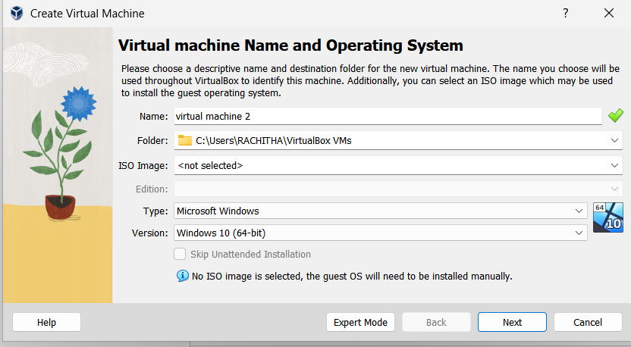

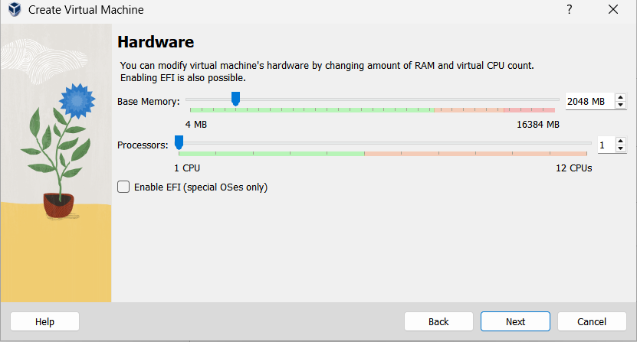

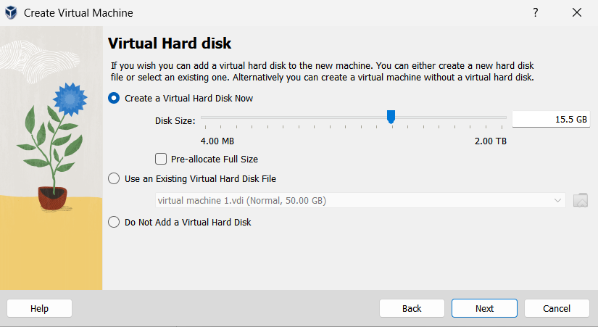

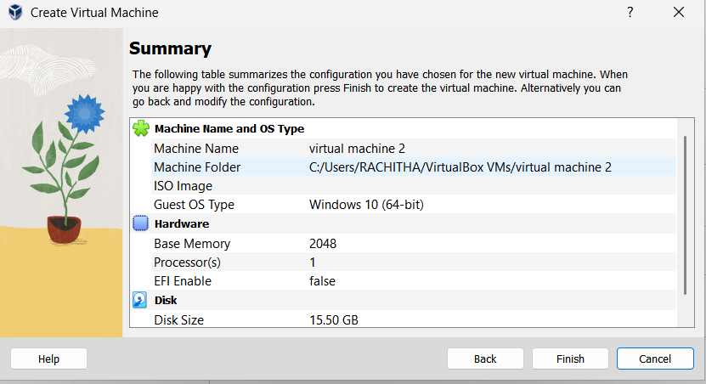

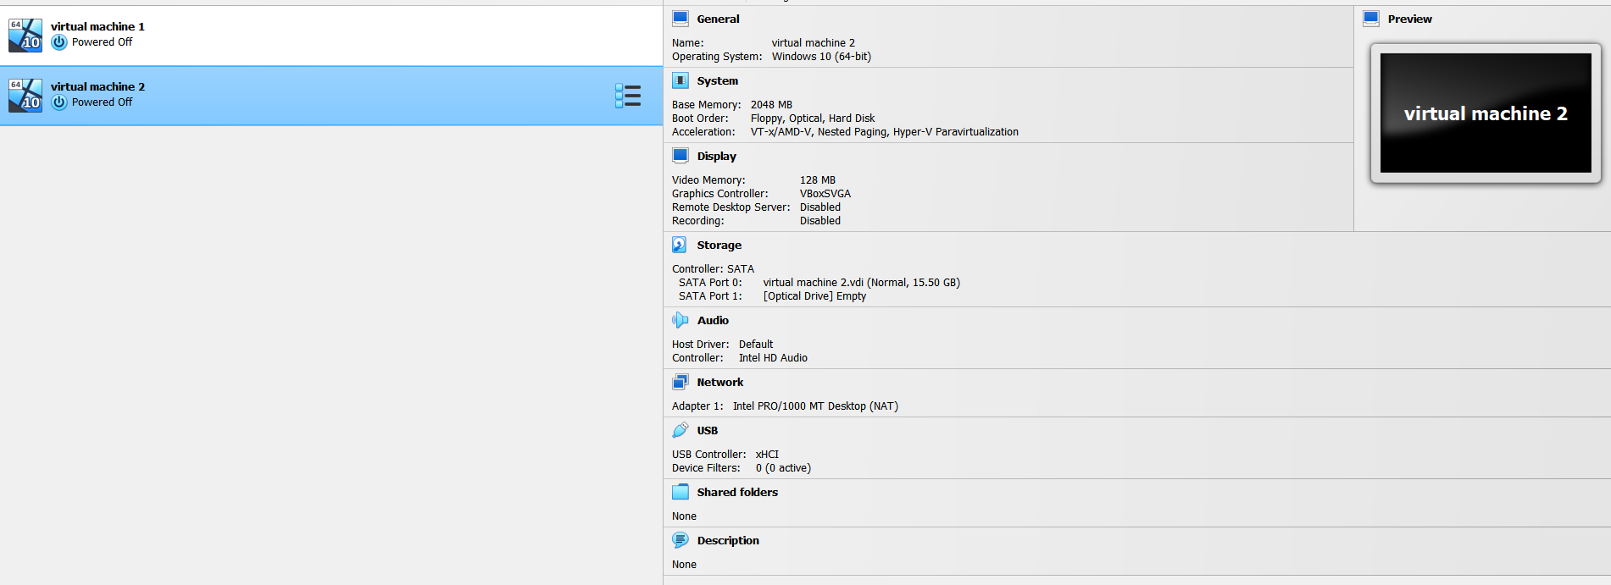

Result:
A Virtual Hard Disk was successfully created and allocated (e.g., 15GB) for use in a Virtual Machine using VirtualBox.

