**STEPS TO ACCESS STREAMLIT IN SNOWFLAKE**

**Step 1:**

In Snowflake, click on Projects and click on streamlit.

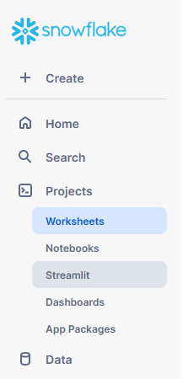

**STEP 2:**

Click on Latest streamlit app, to view the Meta data web UI.

