**Steps followed to complete the project :**

1. Go to sql server and import the data file in one of the database - SQL server

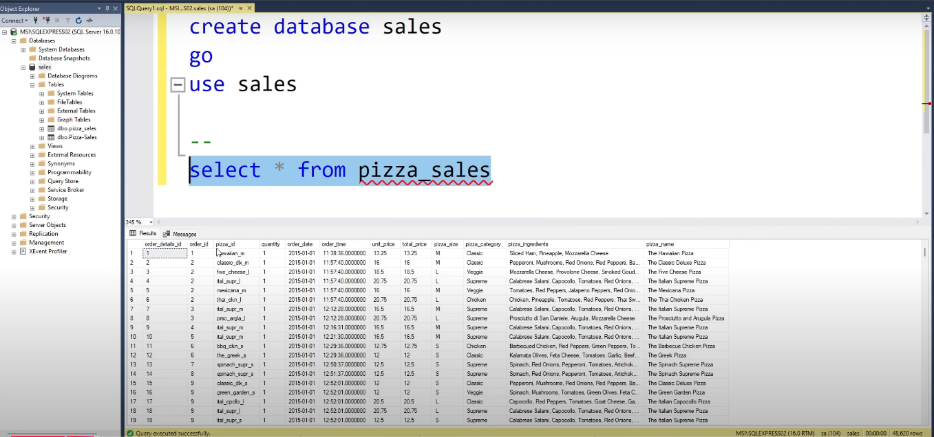

1. Create azure storage account

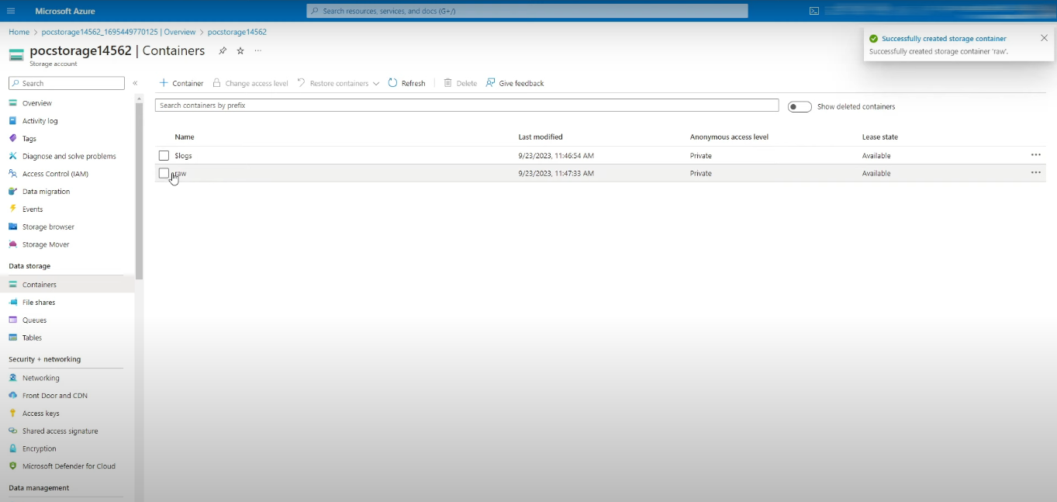

1. Create azure data factory

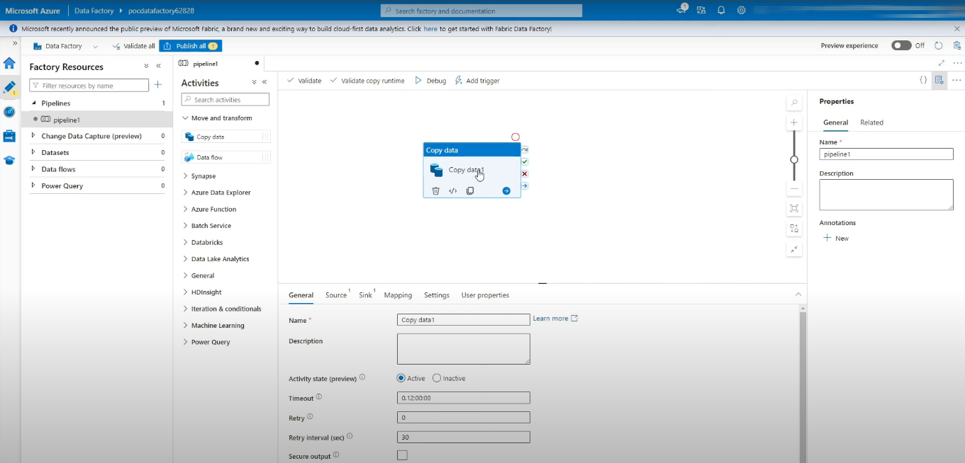

1. Setup azure integration run time - Azure Data Factory

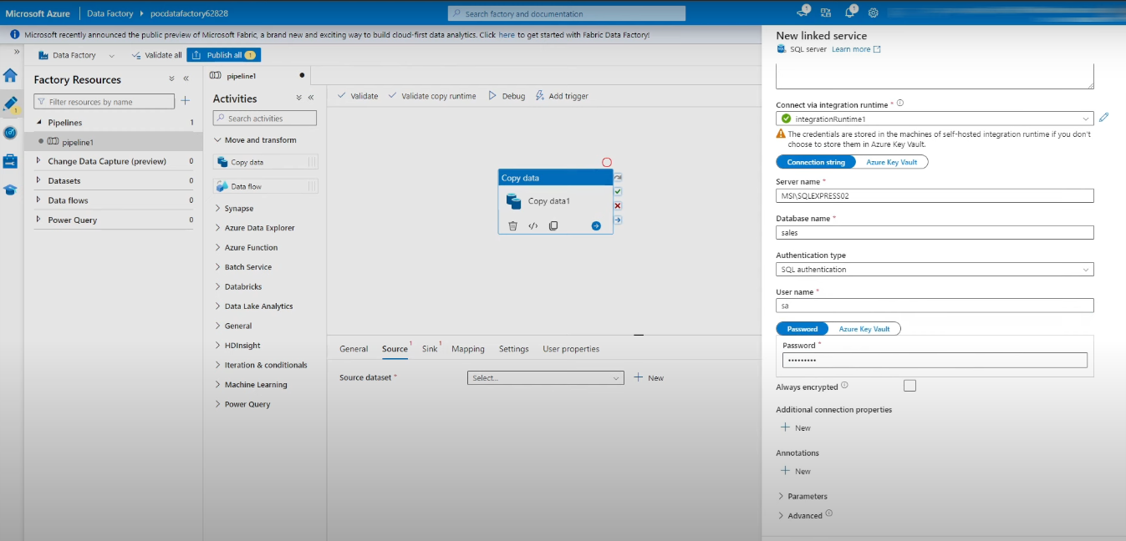

1. Load data from sql to azure storage - data pipeline

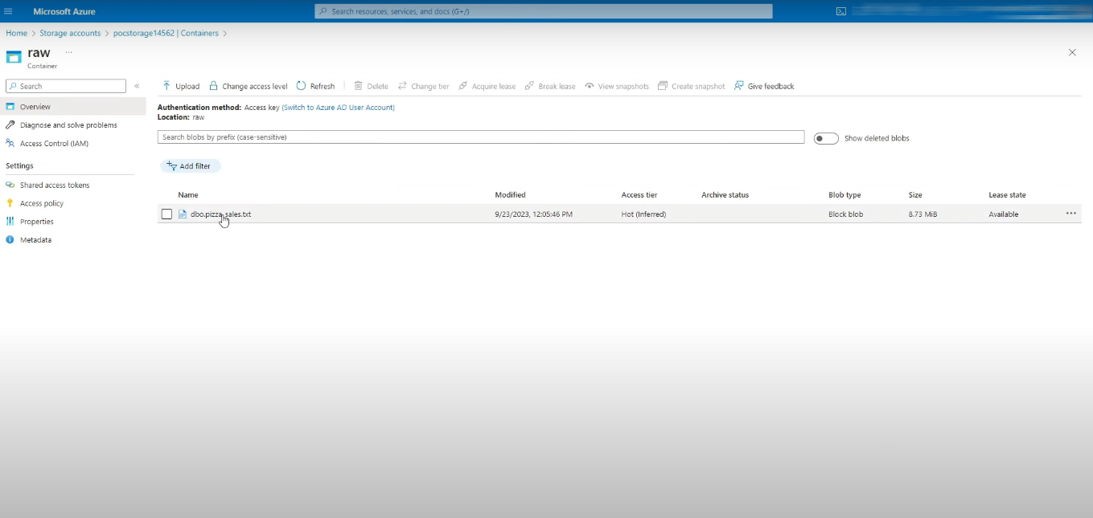

1. Connect databricks to storage – pyspark

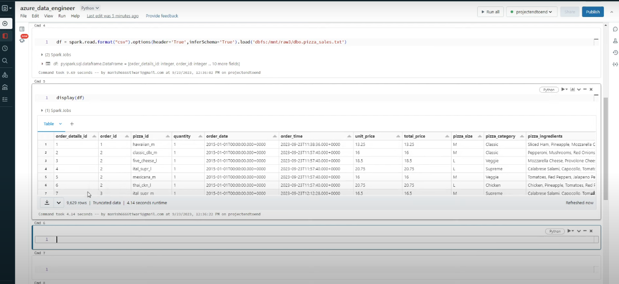

1. Databricks aggregates table building - spark sql

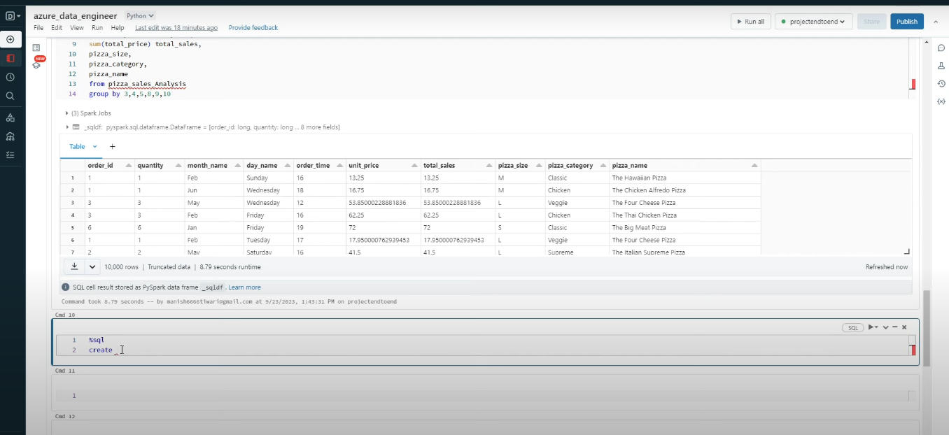

1. PowerBI Report

