We must pick the Latest AMI ID which will usually release on every Monday by GDCPCMS team with the following tags.

“Owner=193158486465” “Vf-pcs-rhel-7”

We need to copy the AMI into our local accounts respectively like PROD and NON-PROD (or) with the help of lambda function we can automate this process and pre steps will be performed by the following.

**State machine: state-machine-lambda-invoke.**

In cases if we want to run each lambda function then use the following functions.

**step-functions-AMI-Backup-lambda**

**step-functions-Launch-EC2-Instance**

Once the functions are executed, we will find the latest AMI in the logs or from cloud watch logs.

Note: The same process needs to perform in the PROD and NON PROD we can test it in dev and check if that works as expected

For the non-prod AMI, we can share to the respective team like CCOE to plan the activity in their environments: tcc6, tcc7, tcc8, tcc9, tcc10, PAT2.

We need to make sure AMI to update in the non-prod-buildhost, non-prod-externalbastion…

As part of process, we need to check with testing team to support the activity for Plive and Live, for this we need to raise the Work request and check for the availability dates from CM Team and raise the CRQ as well, accordingly raise the test data.

[Digital - Work Request Form (Run Demand) - Power Apps](https://apps.powerapps.com/play/e/default-68283f3b-8487-4c86-adb3-a5228f18b893/a/5913da1e-8663-4ca8-bc42-19d7c7853103?tenantId=68283f3b-8487-4c86-adb3-a5228f18b893&source=portal&screenColor=rgba%280%2C+176%2C+240%2C+1%29&skipAppMetadata=true)

Note: for the NON PROD environment make sure, CCOE team to sync with our master branch code changes and deploy under middleware pipeline

Post completion of activity in lower environment plan plive activity before a week of LIVE ones. So, testing team complete their end-to-end testing with all necessary scenarios.

Pick the latest AMI ID from prod account which we can get from lambda logs and verify during the previous activity how the launch config changes in A and B were mentioned in the Pipeline.

During the activity create a latest feature branch from ex 6.1.0(master) and build it.

Take a backup of RDS Database with the following record ID’s or run from pipeline

[co-uk-live-rds-ecarerds-qc6otuf6atae-dbinstance-2w7edgulclxe](https://eu-west-1.console.aws.amazon.com/rds/home?region=eu-west-1#database:id=co-uk-live-rds-ecarerds-qc6otuf6atae-dbinstance-2w7edgulclxe;is-cluster=false)

[co-uk-live-rds-ucmstaticrds-1i661g5wsem-dbinstance-ho5bkn5l5cku](https://eu-west-1.console.aws.amazon.com/rds/home?region=eu-west-1#database:id=co-uk-live-rds-ucmstaticrds-1i661g5wsem-dbinstance-ho5bkn5l5cku;is-cluster=false)

[co-uk-plive2-rds-ecarerds-1bbyh7jhot90u-dbinstance-m3je33w020tr](https://eu-west-1.console.aws.amazon.com/rds/home?region=eu-west-1#database:id=co-uk-plive2-rds-ecarerds-1bbyh7jhot90u-dbinstance-m3je33w020tr;is-cluster=false)

[co-uk-plive2-rds-ucmstaticrds-1d4omahg5-dbinstance-g215muf7r8ib](https://eu-west-1.console.aws.amazon.com/rds/home?region=eu-west-1#database:id=co-uk-plive2-rds-ucmstaticrds-1d4omahg5-dbinstance-g215muf7r8ib;is-cluster=false)

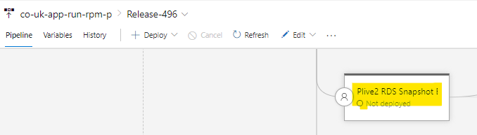

Now update the variable values in the variables for pipeline- **AMI-Automation-Pipeline** under [**co-uk-prod-infrastructure-common**](https://vfuk-digital.visualstudio.com/Digital/_apps/hub/ms.vss-distributed-task.hub-library?itemType=VariableGroups&view=VariableGroupView&variableGroupId=5860)

AMIImageId = “ami id” 🡪 Older to newer

ImageId = “ami id” 🡪 Newer to Older

RedHatImageId = “ami id” 🡪 Newer to Older

And update in the following group [**co-uk-live-infrastructure**](https://vfuk-digital.visualstudio.com/Digital/_apps/hub/ms.vss-distributed-task.hub-library?itemType=VariableGroups&view=VariableGroupView&variableGroupId=5859)

LaunchTemplateA – TRUE/FALSE

LaunchTemplateB – FALSE/TRUE

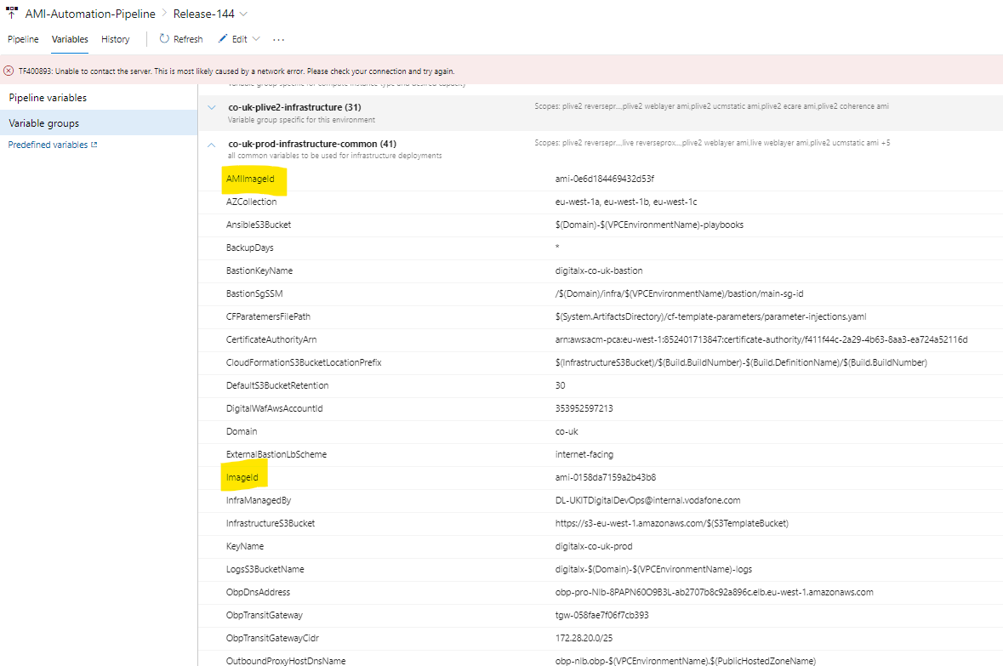 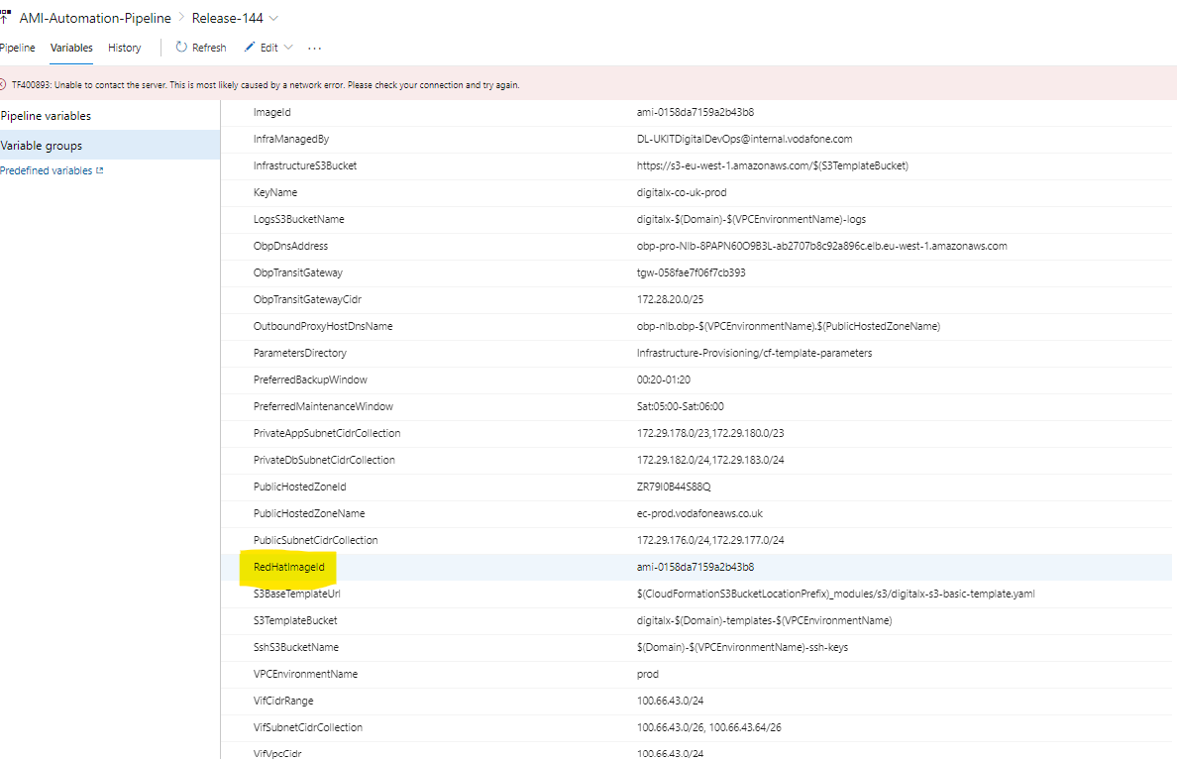

Once we made the changes in Template A and Template By changing True-> False ad False->True

In the first step Accordingly deploy in all the respective stages

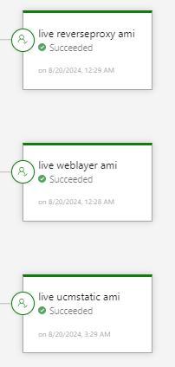 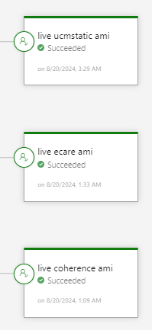

In the second step we have to update the Launch Template both A &B as false and deploy in all the above mentioned stages..

Note: this make the servers which are running with Older AMI will be terminated and there wouldn’t be any downtime during the process for the application and exclude the coherence

Now before the coherence deployment make sure to raise the Holding pages to avoid the issues and follow the same process as mentioned from first release and then second release...

During the process note down the eCare, UCM static and Coherence managed servers IP’s which are running with older AMI.

Once the second release was completed delete the managed servers from weblogic console by referring the IP’s.

NOTE: In Case if the new managed servers with NEW AMI was not healthy, terminate the ec2 instance and delete the managed server.

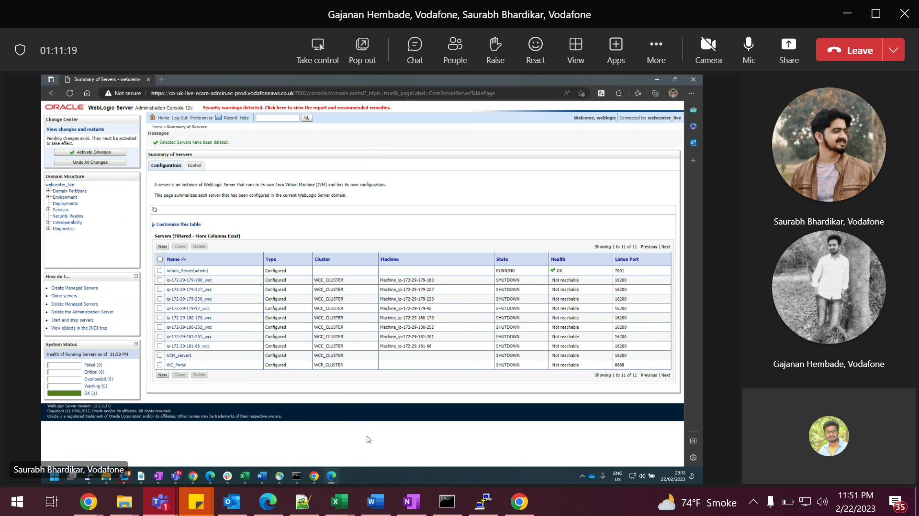

Once all the servers are up and running now add the hosts entries to connect at backend in following path in all the eCare WCP servers

/etc/hosts

Run the post implementation Automation stage from the pipeline- **[co-uk-app-run-rpm-p](https://vfuk-digital.visualstudio.com/Digital/_apps/hub/ms.vss-releaseManagement-web.hub-explorer-2?definitionId=1044&view=mine&_a=releases)**

