First step go to S3 location and place in the created ami instance from lamda

[co-uk-prod-shared - S3 bucket | S3 | eu-west-1 (amazon.com)](https://eu-west-1.console.aws.amazon.com/s3/buckets/co-uk-prod-shared?region=eu-west-1&bucketType=general&prefix=co-uk-prod-L2-deployment/Redhat_files/&showversions=false)

Only [redhat-rhui.repo](https://eu-west-1.console.aws.amazon.com/s3/object/co-uk-prod-shared?region=eu-west-1&bucketType=general&prefix=co-uk-prod-L2-deployment/Redhat_files/redhat-rhui.repo) file   
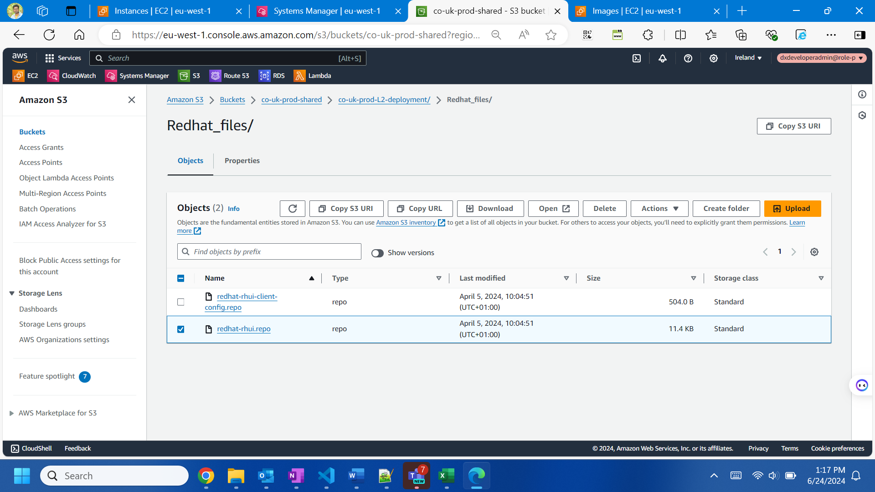

GOto that instance and etc/yum.repos.d then take backup file

And copy from s3 into server location

Then take AMI from that ec2 instance

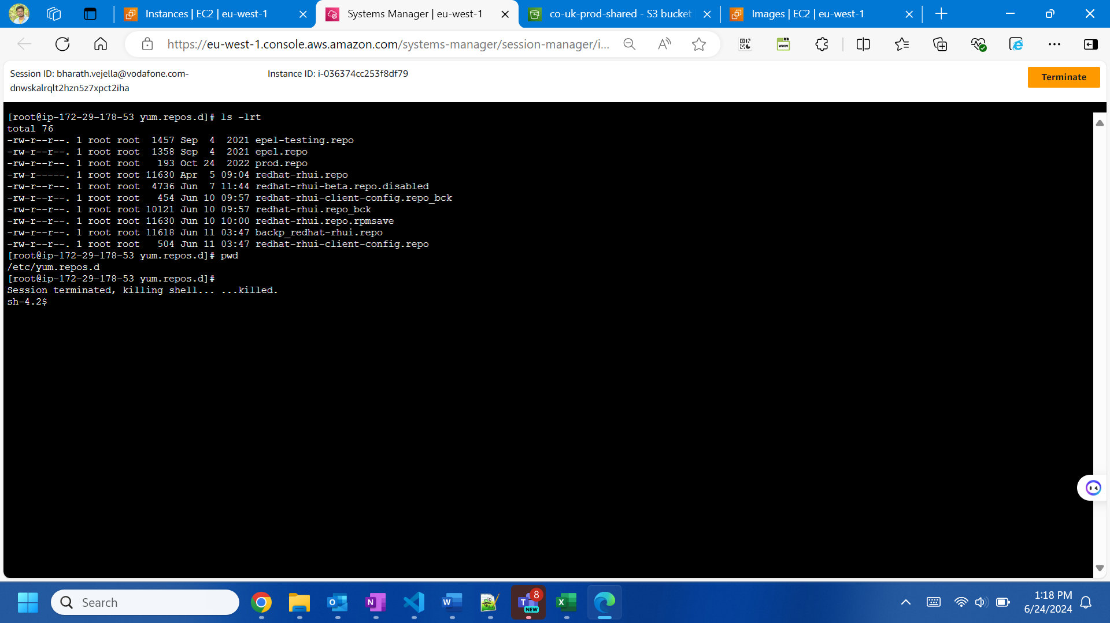

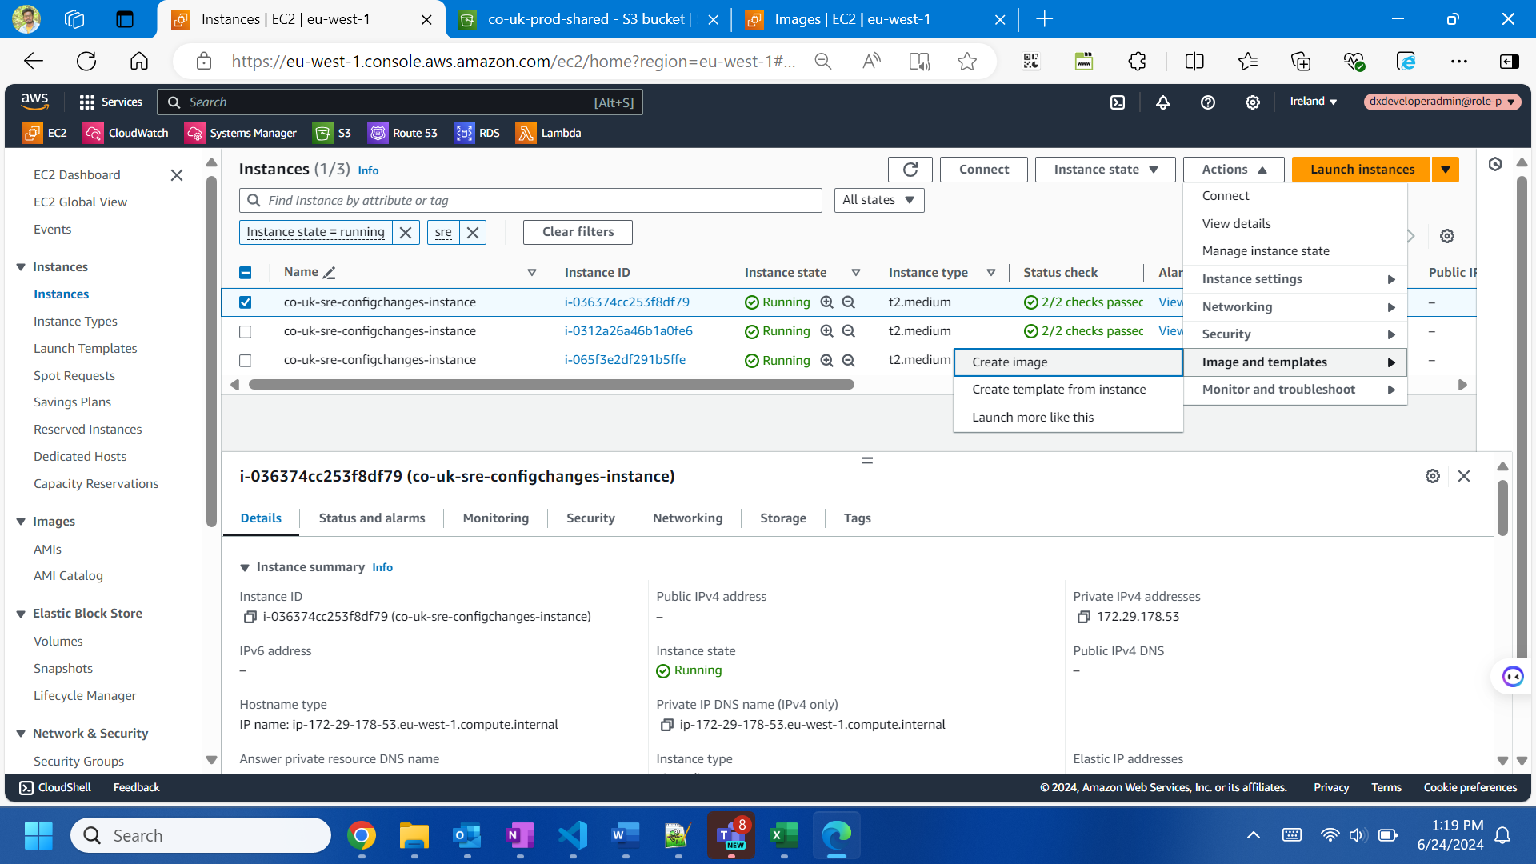

[ami-028ecff2dc695bd2a](https://eu-west-1.console.aws.amazon.com/ec2/home?region=eu-west-1#ImageDetails:imageId=ami-028ecff2dc695bd2a)



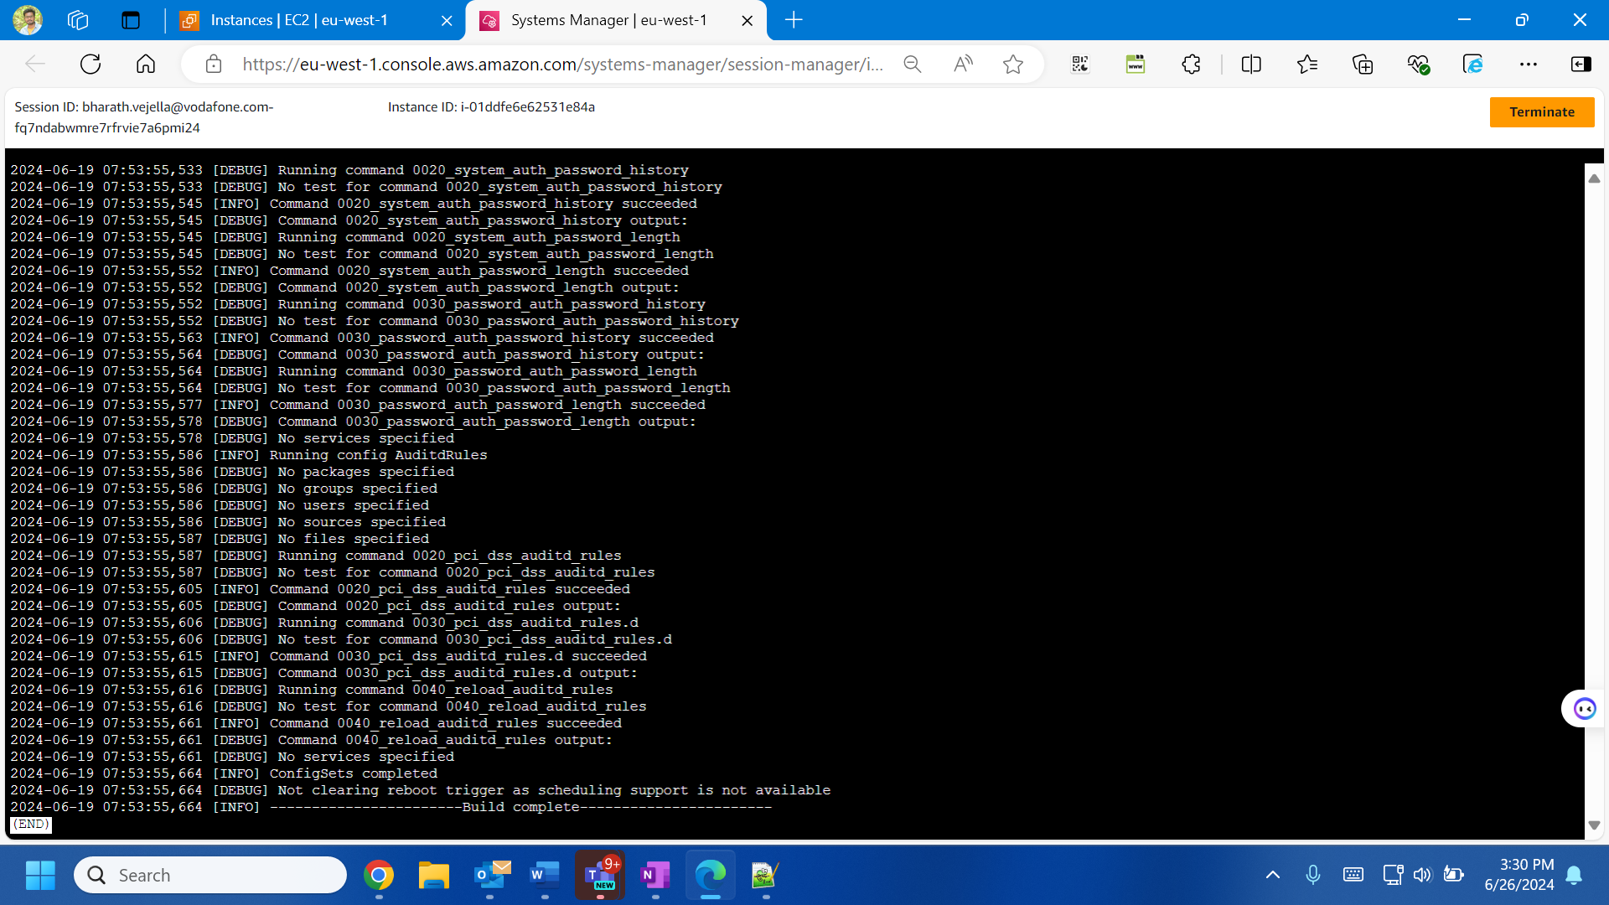

ami-0e6d184469432d53f

in this process you can deploy post creatin of ami in the plive2 ops host by building it and changing variables of ami.. during this process

while deploying if you got build fail in pipeline go to variable by clicking edit and disable the dev/temp deploy check left click mouse  
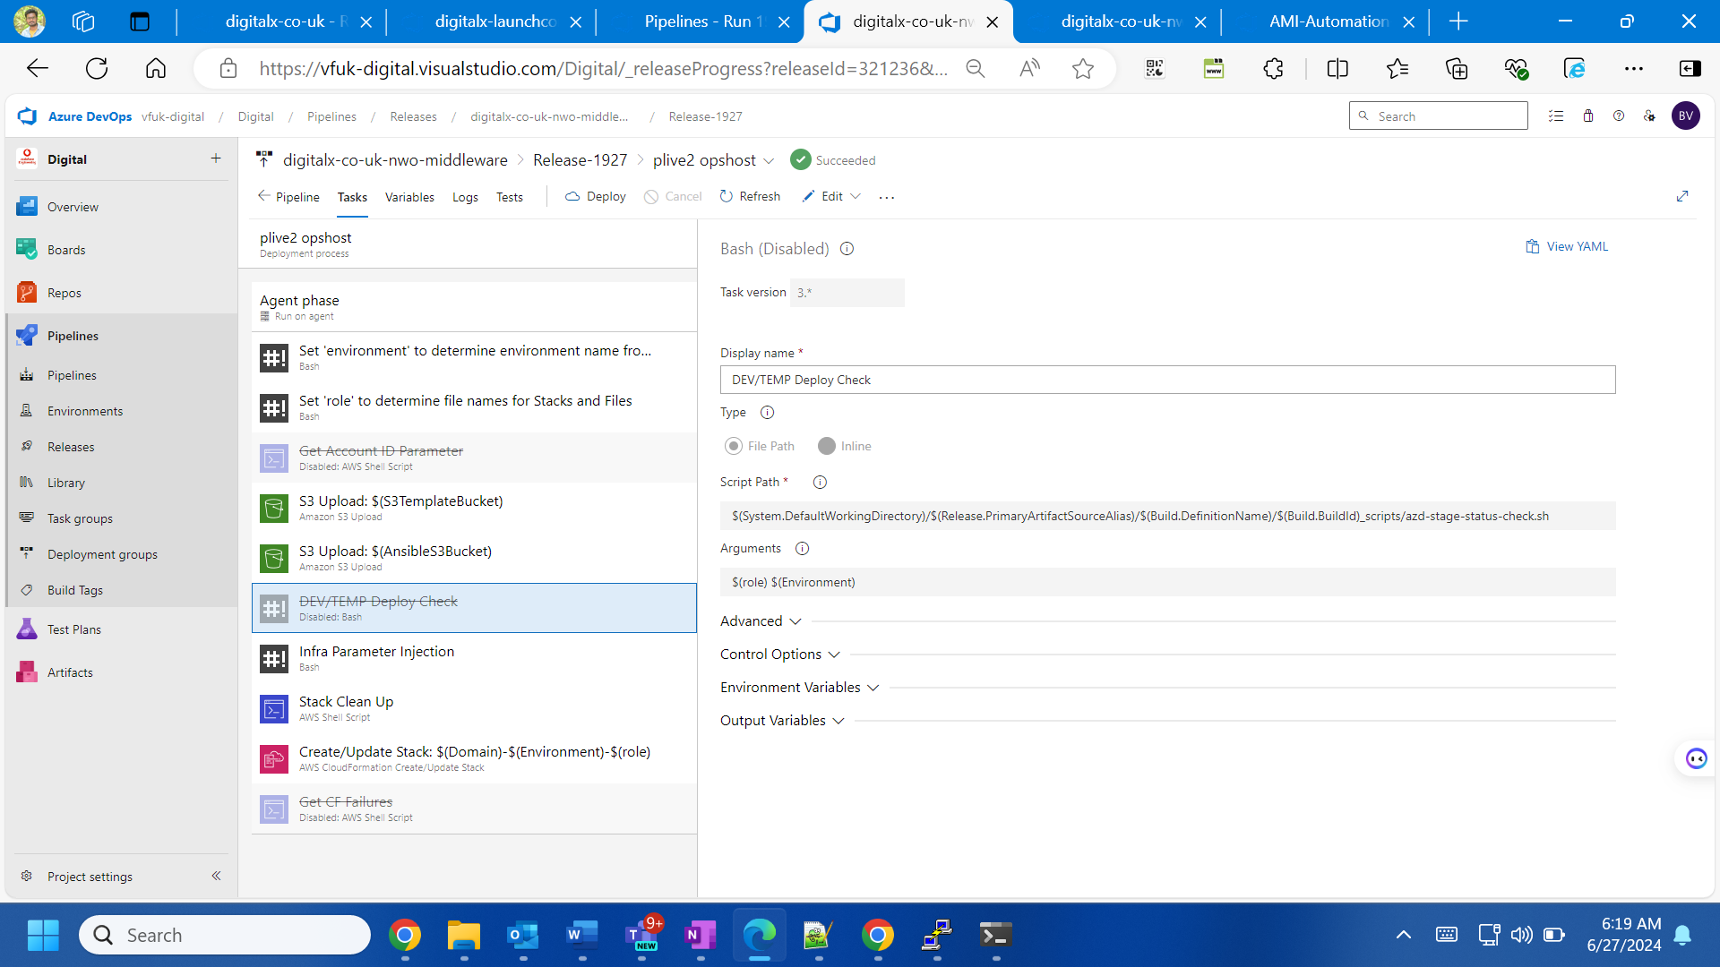

post this

once good then drop email to redirection team that we wont deploy anything and update in sit pat group and leads as well

create a pipleing in ami automation pipleing before u can change the variable of template A, B with new changes … and also the variable shou;d be changed

in this patching I made Template A as true and Template B as false . so I need to give latest AMI id in the AMI image id but in the image id, redhat imade id need to update the older ami id under prod infrastrcutre common variable and plive2 infrastructure

in next patching I need to make Template A as false and Template B as true. So I need to give latest AMI id in the image id, redhat imade id variables and in the AMI image variable it should make older AMI id

while starting deploying lets check in the dev .. but the thing is u cant check with this ami because its non prod … so we need to pick ccoe ami make like above changes and deploy..

IMP: The first step before deploying in plive is we need to change again the variables in pipeline with latest Ami in image id and red hat image id and then deploy in prod build host because this pipeline is nwo base so that’s why this his process deploy..during this go and comment pip code and nggt in setup and main file and rerun build.. post completing use the first setp release as the varuables wont change already created deploy in rest and check the things…

During this time I had an issue with launch config as trend micro was not commented 4 lines of code and merged to master branch,, so I updated in the launchconfig-ami file and commented there and redployed then it worked things…but I can see the build take older one in instance and not terminating.. so I asked someone for termination and it worked with latest build and succesdded