Containers: Containers are isolated execution environments.

Bare Metal: no virtualization -the application or service is deployed directly onto the machine.

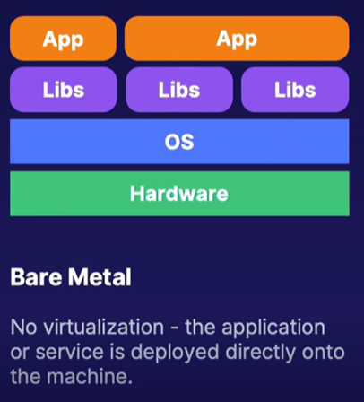

Virtual machines: the hardware is virtualized so multiple operating systems can be isolated on the macihine

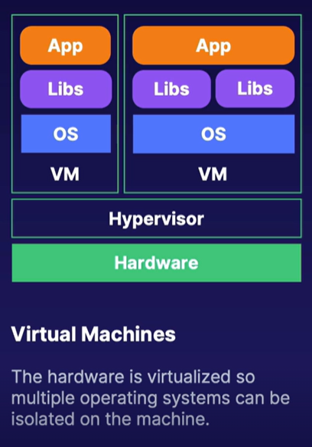

Containers: These are virtualized operating systems libraries and applications are isolated within their own namespaces.

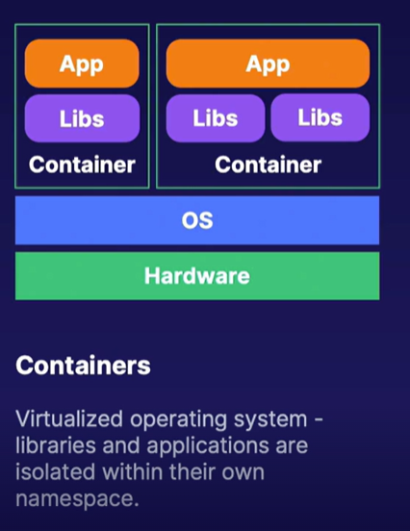

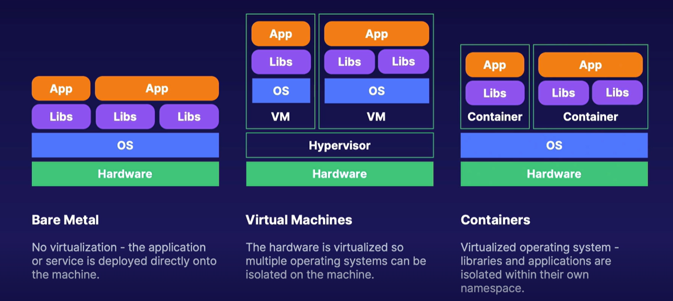

These are simple, consistent, fast by the container

How to install the docker:  
