h&g3SX89Q*kBlXbp&X&7

809491197113

cloud_user

<https://809491197113.signin.aws.amazon.com/console?region=us-east-1>

Terraform –version

Post download of the latest version of exe file place in any folder and add directly in the environment variable

Terraform init -First command to initialize the directory.

Terraform plan – create execution plan, it output the deployment plan

Terraform apply it apply all the changes in the configuration

Terraform destroy – it will destroy all the infrastructiore

Terraform plan -destroy – it will destroy the plan.

Post creating of AWS account of IAM User create a access key   
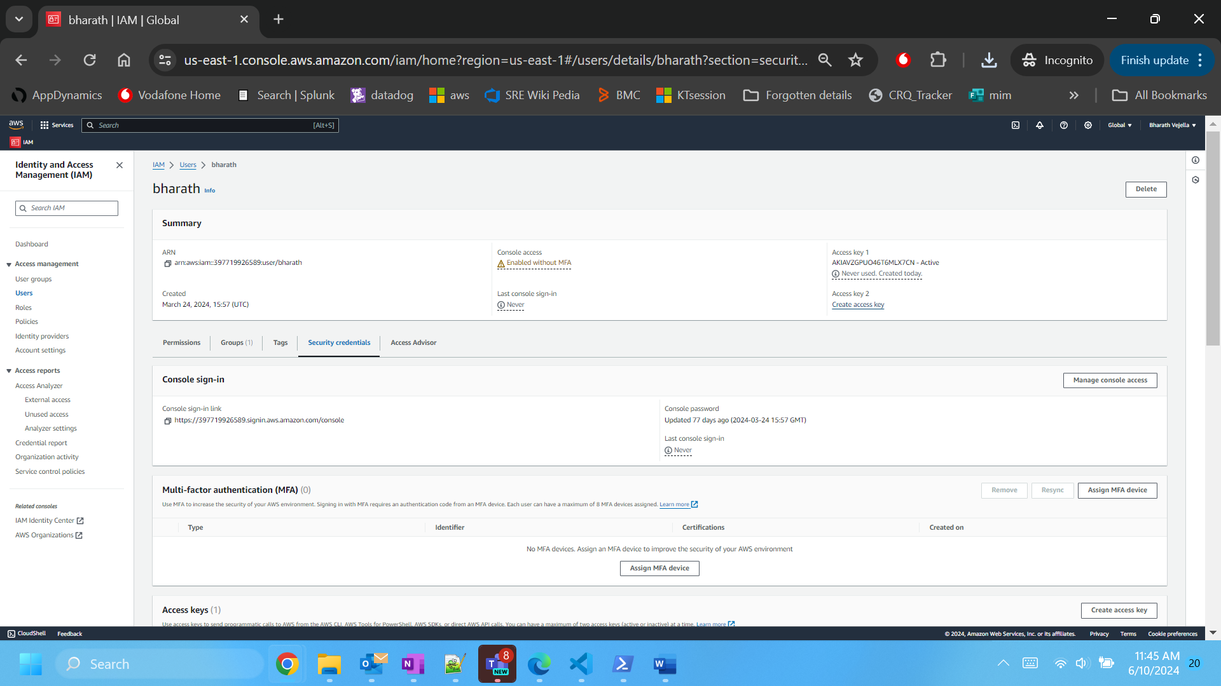

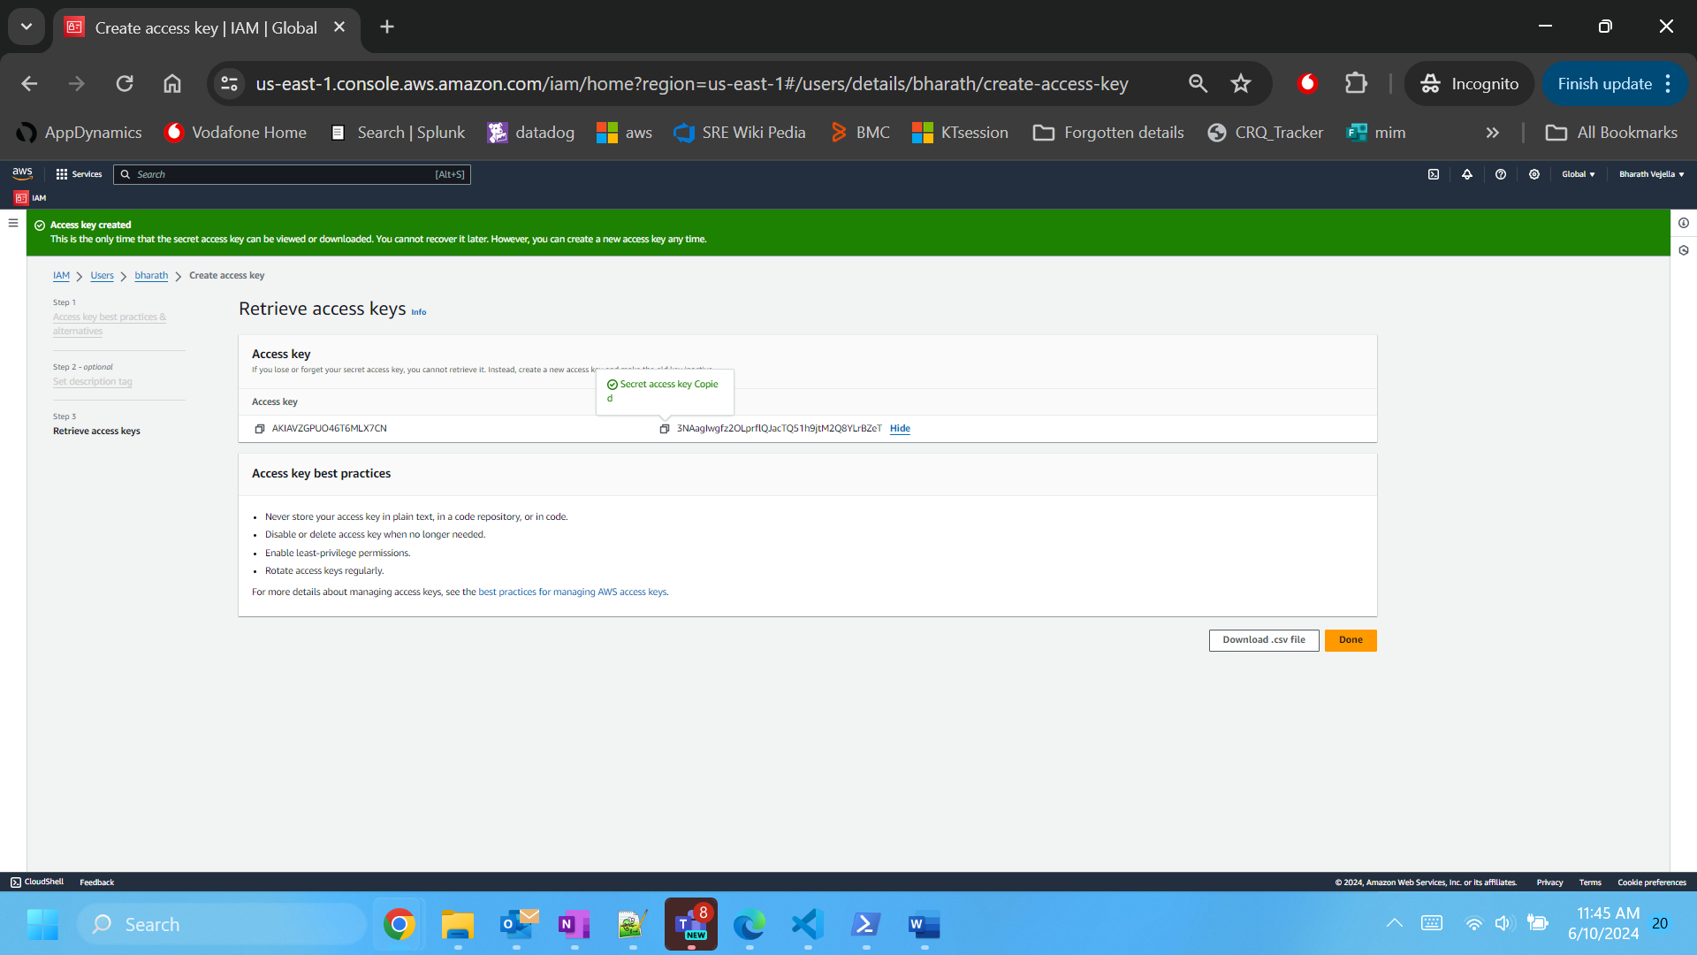

Then Open powershell or cmd and run the aws configure

Give the secret key and access key then give region as us-east-1 and reposne as json

Then finally run aws configure list command to see the aws properly configured or not

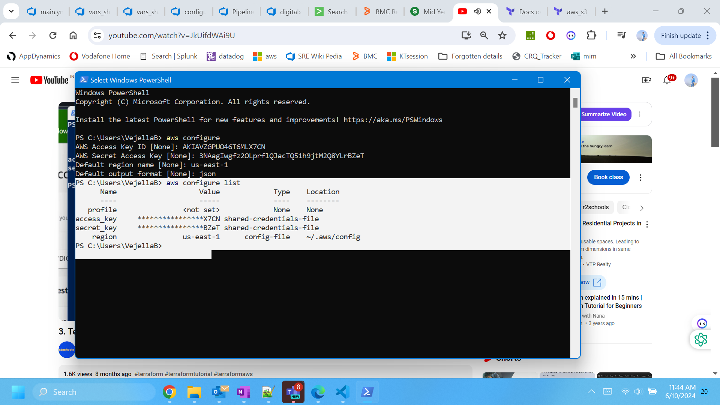

You can use the terraform apply -auto-approve

Now in terraform they were params of 2 types variables:

1. Input variable
2. Output variable

Post creating the variables in afile you have to run the following command while terraform applying

variable "s3bucketname" {

  description = "s3 bucket name for prod"

  type = string

  default = "bharathvejella-1995"

}

terraform apply -var-file="variables.tfvars"

instead of this either you can you the enviornmnet varaibales, but you need to add the evry variable in it..

TF_VAR_<variable_name>.

The terraform.tfvars file is a dynamic variable to enter manually during the execution

Module: It’s a structure of code present in the folder and calling from once tf file

Remote backend: instead if state file creating in local or VM it will be created in s3 bucket/terraform cloud/ azure storage thus avoid the disadvantage of multiple devops works on terraform code while running

Dynamo DB helps to create the object locking system for the terraform state file so that one enginnerr in a team making the changes in infra another will be blocked to perform during the same time…

In terraform ingress as inbound egress as outbound for ec2 creating in security group

If you want to call variables within a resource then use self.variablename

Provisioners: execute and implement some actions during the creation like running the python script

Remote exec provisioner

Local exec provisioner

File provisioner