Architecture Specification Document
Automated repository discovery & architecture baseline
Source: https://github.com/spring-projects/spring-petclinic.git
Generated: 2026-04-27 18:13 UTC
Document version 1.0 · Draft — machine-assisted

1. Document identification & control
Baseline metadata for traceability, audits, and regeneration of this report.
Report title | Architecture Specification Document
Repository URL | https://github.com/spring-projects/spring-petclinic.git
Branch / tag | main
Resolved commit | c7ee170434ec3e369fdc9201290ba2ea4c92b557
OpenAPI source URL | http://localhost:8080/v3/api-docs
Deliverable format | DOCX
Generator | asd-architecture-service (automated ASD pipeline)
Classification | Internal technical baseline — validate before external distribution

2. Executive summary
High-level findings from automated clone, file inventory, build hints, Spring heuristics, SQL, and optional OpenAPI.
• Repository scan covered 200 file system nodes.
• Dominant technology signals: JAVA (47), PROPERTIES (14), HTML (12), YAML (8), SQL (7).
• Build: Maven root POM present (org.springframework.samples:spring-petclinic).
• Java surface: 47 source files scanned heuristically; Spring signals include ~0 @RestController and ~2 @Service hits (text search, not AST).
• SQL: 7 .sql file(s) discovered; inferred relational footprint ~7 table name(s) from DDL heuristics.
• HTTP contract: OpenAPI not ingested — supply swaggerUrl on the request for API inventory.
• Figures in §8 illustrate a reference layered flow; ER diagram appears in §6 when DDL allows inference.
This document is generated without execution of the application. Counts and diagrams are indicative and should be validated by engineering owners before contractual or compliance use.
3. Repository & codebase inventory
Polyglot signals and extension mix from a capped filesystem walk (see scan capped flag).
3.1 Scan summary
Files scanned (nodes) | 200
Scan capped | false
pom.xml files | 1
Gradle files | 2
Spring-style config files (application*) | 3

3.2 Language & technology categories
Category | Files (count)
JAVA | 47
PROPERTIES | 14
HTML | 12
YAML | 8
SQL | 7
STYLES | 5
XML | 3
MARKDOWN | 1
JSON | 1

3.3 Top file extensions
Extension | Files
.java | 47
.properties | 14
.html | 12
(no-ext) | 12
.yml | 8
.sql | 7
.scss | 4
.png | 4
.txt | 4
.svg | 3
.xml | 3
.gradle | 2
.eot | 2
.ttf | 2
.woff | 2
.css | 1
.gitignore | 1
.md | 1

4. Build system & modularity
Root Maven coordinates and module list when pom.xml is present at repository root.
Attribute | Value
Group ID | org.springframework.samples
Artifact ID | spring-petclinic
Version | 4.0.0-SNAPSHOT
Packaging | jar
Declared modules | 0
Direct dependencies (sample size) | 24
Dependency artifacts (sample) | spring-boot-starter-actuator, spring-boot-starter-cache, spring-boot-starter-data-jpa, spring-boot-starter-thymeleaf, spring-boot-starter-validation, spring-boot-starter-webmvc, cache-api, jakarta.xml.bind-api, h2, caffeine, mysql-connector-j, postgresql, webjars-locator-lite, bootstrap, font-awesome, spring-boot-devtools, spring-boot-starter-data-jpa-test, spring-boot-starter-restclient, spring-boot-starter-restclient-test, spring-boot-starter-webmvc-test

5. Application layer — Spring components
Textual scan of .java sources for common stereotype annotations (not a full AST).
Observation / metric | Count | Interpretation
Java files scanned | 47 | Enumeration of .java paths visited by the scanner.
REST controllers (@RestController) | 0 | —
MVC controllers (@Controller) | 6 | Heuristic hit count (line scan).
Services (@Service) | 2 | Domain / orchestration layer.
Repositories (@Repository) | 0 | —
Feign HTTP clients (@FeignClient) | 0 | —
Configuration (@Configuration) | 3 | Beans & integration wiring.

6. Data & persistence (SQL)
Migration/script inventory and DDL/DML heuristics; ER figure when CREATE TABLE / REFERENCES can be inferred.
Metric | Value
.sql files discovered | 7
.sql files analyzed | 7
Estimated DDL statements | 48
Estimated DML statements | 141
Estimated query statements | 0
Other SQL-like lines | 11
ER diagram inferred | Yes
Inferred table count | 7
Method | Heuristic line / DDL scan — not a certified schema parser.

6.1 Inferred entity–relationship view
PNG rendered from merged .sql DDL heuristics (see JSON relationships in Appendix B for raw edge list).
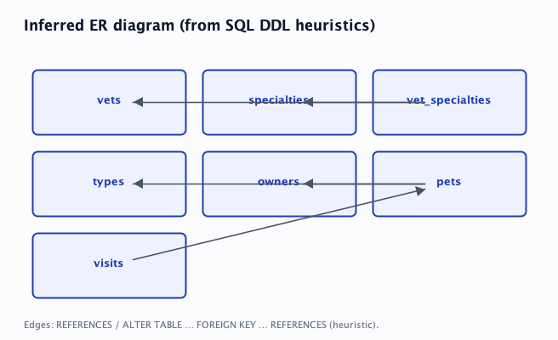
7. External interfaces — HTTP / OpenAPI
OpenAPI was not ingested for this run. Re-submit the generation request with swaggerUrl (for example http://localhost:8080/v3/api-docs) while the service is reachable.
8. Architectural views
8.1 Reference layered flow
Illustrative request/data path for discussion workshops — not extracted from runtime traces.
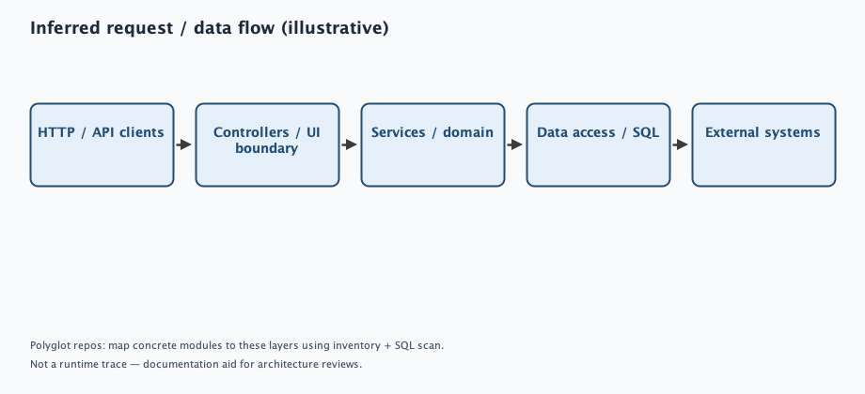
Mermaid (text, not rendered by Word):
flowchart LR
HTTP --> CTRL --> SVC --> REPO --> EXT
9. Quality attributes (initial RAG)
Red / Amber / Green style wording avoided where no evidence exists — defaults to “Not assessed (automated)”.
Concern | Assessment | Recommended follow-up
Scalability & elasticity | Not assessed (automated) | Confirm horizontal scaling, statelessness, and cache topology with platform owners.
Database connectivity & pooling | Partial signal | 3 Spring-style configuration file(s) detected — review datasource / pool settings in deployment.
Persistence performance (N+1, ORM) | Not assessed (automated) | No repository stereotype hits in heuristic scan.
Observability & operability | Not assessed (automated) | Map to logging, metrics, tracing, and SLOs outside this document.

10. Security & compliance posture
Topic | Assessment | Recommended follow-up
Secret & credential hygiene | Not assessed (automated) | Run secret scanning (e.g. gitleaks), verify CI policies, and rotate any leaked material.
HTTP authorization model | Not assessed (automated) | Few or no REST controller hits; still validate non-Spring HTTP surfaces if any.
Dependency & supply-chain risk | Partial signal | Cross-check declared dependencies with CVE feeds (OWASP Dependency-Check, OSV, Dependabot).
Attack surface (HTTP) | Not assessed (automated) | Ingest OpenAPI (swaggerUrl) to align exposure with implementation.

11. AI-assisted narrative (template)
Optional section for a governed LLM workflow: ground models only on the structured outputs and diagrams in this document, require citations to repository paths and OpenAPI operationIds, and keep human sign-off.
Appendix A — Tool execution trace
Ordered pipeline steps returned on POST /api/v1/asd/generate/bundle under toolTrace.
Tool | Status | Detail
git_clone | START | Cloning into /var/folders/v8/p0jyl0ld6r140qs_nbqt03rw0000gn/T/asd-ws-3436042386802218420/repository
git_clone | OK | HEAD=c7ee170434ec3e369fdc9201290ba2ea4c92b557
repo_inventory | START | /var/folders/v8/p0jyl0ld6r140qs_nbqt03rw0000gn/T/asd-ws-3436042386802218420/repository
repo_inventory | OK | files=200
maven_module_graph | START | /var/folders/v8/p0jyl0ld6r140qs_nbqt03rw0000gn/T/asd-ws-3436042386802218420/repository/pom.xml
maven_module_graph | OK | artifact=spring-petclinic
spring_stereotype_scan | START | /var/folders/v8/p0jyl0ld6r140qs_nbqt03rw0000gn/T/asd-ws-3436042386802218420/repository
spring_stereotype_scan | OK | javaFiles=47
sql_script_analysis | START | /var/folders/v8/p0jyl0ld6r140qs_nbqt03rw0000gn/T/asd-ws-3436042386802218420/repository
sql_script_analysis | OK | sqlFiles=7 erTables=7
openapi_ingest | START | http://localhost:8080/v3/api-docs
openapi_ingest | FAIL | I/O error on GET request for "http://localhost:8080/v3/api-docs": null
asd_document_export | START | DOCX

Appendix B — Machine-readable excerpts (truncated)
Condensed JSON for diffing across runs; not a substitute for source or live API metadata.
Inventory summary
{
"pomXmlCount" : 1,
"polyglotCategoryCounts" : {
"JAVA" : 47,
"MARKDOWN" : 1,
"PROPERTIES" : 14,
"XML" : 3,
"STYLES" : 5,
"HTML" : 12,
"JSON" : 1,
"YAML" : 8,
"SQL" : 7
},
"capped" : false,
"gradleFileCount" : 2,
"extensionHistogramTop" : {
".html" : 12,
".scss" : 4,
".svg" : 3,
".gradle" : 2,
".css" : 1,
".gitignore" : 1,
".properties" : 14,
".md" : 1,
".java" : 47,
".eot" : 2,
".png" : 4,
".ttf" : 2,
".txt" : 4,
".sql" : 7,
".woff" : 2,
"(no-ext)" : 12,
".yml" : 8,
".xml" : 3
},
"applicationConfigFileCount" : 3,
"filesScanned" : 200
}
Maven summary
{
"groupId" : "org.springframework.samples",
"artifactId" : "spring-petclinic",
"packaging" : "jar",
"present" : true,
"version" : "4.0.0-SNAPSHOT",
"dependencyArtifactsSample" : [ "spring-boot-starter-actuator", "spring-boot-starter-cache", "spring-boot-starter-data-jpa", "spring-boot-starter-thymeleaf", "spring-boot-starter-validation", "spring-boot-starter-webmvc", "cache-api", "jakarta.xml.bind-api", "h2", "caffeine", "mysql-connector-j", "postgresql", "webjars-locator-lite", "bootstrap", "font-awesome", "spring-boot-devtools", "spring-boot-starter-data-jpa-test", "spring-boot-starter-restclient", "spring-boot-starter-restclient-test", "spring-boot-starter-webmvc-test", "spring-boot-testcontainers", "spring-boot-docker-compose", "testcontainers-junit-jupiter", "testcontainers-mysql" ],
"modules" : [ ]
}
Spring summary
{
"stereotypes" : {
"CONTROLLER" : 6,
"CONFIGURATION" : 3,
"SERVICE" : 2,
"REPOSITORY" : 0,
"REST_CONTROLLER" : 0,
"FEIGN_CLIENT" : 0
},
"capped" : false,
"javaFilesScanned" : 47
}
SQL summary
{
"estimatedDdlStatements" : 48,
"note" : "Heuristic line scan — not a full SQL parser. Use for inventory and review triage.",
"erDiagramInferred" : true,
"erDiagramTableCount" : 7,
"sampleRelativePaths" : [ "src/main/resources/db/h2/data.sql", "src/main/resources/db/h2/schema.sql", "src/main/resources/db/postgres/data.sql", "src/main/resources/db/postgres/schema.sql", "src/main/resources/db/mysql/data.sql", "src/main/resources/db/mysql/schema.sql", "src/main/resources/db/mysql/user.sql" ],
"sqlFilesDiscovered" : 7,
"estimatedDmlStatements" : 141,
"erDiagramTables" : [ "vets", "specialties", "vet_specialties", "types", "owners", "pets", "visits" ],
"estimatedQueryStatements" : 0,
"erDiagramRelationships" : [ {
"from" : "vet_specialties",
"to" : "vets"
}, {
"from" : "vet_specialties",
"to" : "specialties"
}, {
"from" : "pets",
"to" : "owners"
}, {
"from" : "pets",
"to" : "types"
}, {
"from" : "visits",
"to" : "pets"
} ],
"otherSqlishLines" : 11,
"sqlFilesAnalyzed" : 7
}
End of Architecture Specification Document · Automated baseline — confirm before reliance

