Annexure 18
Ph.D. Thesis Template

[Title of the thesis, font: times new roman, Size 14 pt bold centered, all caps, line space: double]
Thesis submitted to Alliance University
for the Award of
DOCTOR OF PHILOSOPHY
In
[Faculty of Management Studies/ Law & Policy Studies / Engineering and Technology/ Liberal Arts & Sciences/ Doctoral Studies]

By
[NAME OF THE Researcher]
Under the Supervision
Of
[name of supervisor]


Alliance University
Central Campus, Chikkahadage Cross Chandapura-Anekal, Main Road, Bengaluru, Karnataka 562106

[Year]

DECLARATION
I declare that the thesis entitled [Name of the Thesis] has been prepared by me under the guidance of [Name of the Supervisor], Professor of [Department/College/School Name], [University Name]. No part of this thesis has formed the basis for the award of any degree in any University or fellowship previously.

[Scholar’s Name]
[School / College Name], Alliance University
Chikkahagade Cross, Chandapura-Anekal Main Road, Anekal, Bangalore, Karnataka - 562106

Signature

Date:

CERTIFICATE
I certify that [Scholar’s Name] has prepared [his/her] thesis entitled [TYPE THESIS TITLE HERE], for the award of PhD degree of Alliance University, under my guidance. He/She has carried out the work at [School / College Name], Alliance University.

[Guide’s Name]
[School / College Name], Alliance University
Chikkahagade Cross, Chandapura-Anekal Main Road, Anekal, Bangalore, Karnataka - 562106

Signature

Date:
DEDICATION
[Dedication body text starts here. Use style body text introductory pages]

ACKNOWLEDGEMENT
[I Acknowledge that]

ABSTRACT
[Abstract text starts here]

PREFACE
[Abstract text starts here]

table of Contents
Title of Chapter 1 1

LIST OF TABLES
[List starts here]

LIST OF FIGURES
[List starts here]

LIST OF Appendices
APPENDIX A: [Type your Appendix A here]
APPENDIX B: [Type your Appendix B here]
APPENDIX C: [Type your Appendix C here]
APPENDIX D: [Type your Appendix D here]
CHAPTER 1

Title of Chapter 1
[Type your Contents of First Chapter, Type your Contents of First Chapter, Type your Contents of First Chapter, Type your Contents of First Chapter, Type your Contents of First Chapter, Type your Contents of First Chapter, Type your Contents of First Chapter, Type your Contents of First Chapter, Type your Contents of First Chapter, Type your Contents of First Chapter, Type your Contents of First Chapter, Type your Contents of First Chapter]

CHAPTER 2

Title of Chapter 2
[Type your Contents of First Chapter, Type your Contents of First Chapter, Type your Contents of First Chapter, Type your Contents of First Chapter, Type your Contents of First Chapter, Type your Contents of First Chapter, Type your Contents of First Chapter, Type your Contents of First Chapter, Type your Contents of First Chapter, Type your Contents of First Chapter, Type your Contents of First Chapter, Type your Contents of First Chapter]
Equation 1
$$\frac{-b±\sqrt{b^{2}-4ac}}{2a}$$
[Type your Contents of First Chapter, Type your Contents of First Chapter, Type your Contents of First Chapter, Type your Contents of First Chapter, Type your Contents of First Chapter, Type your Contents of First Chapter, Type your Contents of First Chapter, Type your Contents of First Chapter, Type your Contents of First Chapter, Type your Contents of First Chapter, Type your Contents of First Chapter, Type your Contents of First Chapter]
Table 1: Description of the table here
Name | Description | Amount
Person 1 | Student | 1200

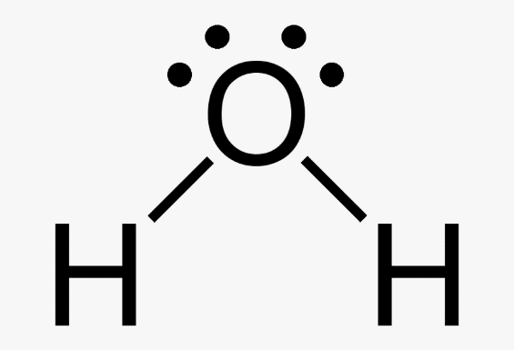
Figure 1: Description of the figure here
(Source: www.alliance.edu.in)

REFERENCES
APA Style for ASB and ASLA
Dey, B., Raj, S., Mahapatra, S., & Márquez, F. P. G. (2024). A variegated GWO algorithm implementation in emerging power systems optimization problems. Engineering Applications of Artificial Intelligence, 129, 107574.
Chicago Style for ACED
Dey, Bishwajit, Saurav Raj, Sheila Mahapatra, and Fausto Pedro García Márquez. "A variegated GWO algorithm implementation in emerging power systems optimization problems." Engineering Applications of Artificial Intelligence 129 (2024): 107574.

Bluebook (20th ed.) for ASOL
LIST OF APPENDICES

