Evaluating Identifier Readability Using CodeBERT Embeddings and Self-Attention Bi-LSTM with Explainable Modeling
¹Bharat Babaso Mane, ²Dr. Rathnakar Achary
^{1,2}Department of Computer Science and Engineering, Alliance University, Bengaluru, Karnataka - 562106, India.
bharat.mane@gmail.com, rathnakar.achary@alliance.edu.in
Abstract
Identifier names are natural language representations of program models in source code that play a significant part in program understanding. Studies of the quality of identifier names commonly concentrate on their role in program knowledge, for example, the usage of identifier names by readers and programmers of source code. Provide the significance of identifier names and the value of naming conventions for programming understanding. This process was predicted in early work that a connection occurs between the software quality and the quality of identifier names. Recently, the employment of deep learning (DL) has developed a highly efficient model for identifying intelligibility examination challenges. DL algorithms like transformer-based frameworks and attention mechanisms may acquire contextual and sequential relations between identified tokens. Therefore, this study proposes an Identifier Readability Analysis Framework using Explainable Attention-Based Deep Learning (IRAF-XADL). The major intension of the proposed IRAF-XADL approach is to assess the quality of identifier names in Python and C++ source code. In the initial stage, a syntax-aware identifier preprocessing pipeline based on language-specific abstract syntax tree parsing is applied to extract identifiers and perform lexical normalization and semantic cleaning. From the normalized identifiers, this study computes ten linguistically and cognitively grounded readability parameters. Besides, semantic and contextual representations are attained using CodeBERT embeddings. The obtained representations are then processed by a self-attention-based bidirectional long short-term memory model to learn sequential and contextual dependencies. Furthermore, the model is optimized using the AdamW optimizer, enabling improved convergence and overall performance. In the last stage, the SHAP-based explainability technique is integrated for interpreting the contribution of identifier tokens and features toward readability predictions. The experimental result analysis of the IRAF-XADL technique is carried out on benchmark Code Snippets: Insights and Readability Dataset, and the comparative results proved the improved performance over the existing approaches in terms of diverse metrics.
Keywords: Identifier Readability; Code Snippets; CodeBERT Embeddings; Model Optimization; Explainability Artificial Intelligence; Deep Learning
1. Introduction
Unreadable code can impair program comprehension, and it can lead to the introduction of bugs. Code mainly contains a natural language text, both in comments and identifiers, and it is a specific form of text [1]. But the methods presented to approximate code readability account for only organizational aspects and visual characteristics of source code, like alignment of characters and line length. Source code could be understandable and readable [2]. These two features are frequently considered equivalent, but they are unique textual features. Readability relationship to the difficulties of the proposed text, during understandability, is associated with the reader's capability to understand the meaning of the text [3]. Therefore, code assessed as readable might still not be understandable to a non-reader without the essential knowledge or experience to comprehend it. As the study displays, code comprehension and reading are the regular activities created by software developers [4]. Consequently, code readability, i.e., the ease with which a program can send data to a reader, is a specifically desirable characteristic of the source code. Incomprehensible code could both create more challenges for developers when they try to obtain data from the source code (which applies greater software maintenance expenses in the long run) and can better hide bugs [5]. Automatically searching for unreadable code in large code is essential for many reasons. Practitioners can utilize this data to estimate where they must focus their efforts in code cleaning and enhancement tasks. Analyst, in contrast, could research how readability (or lack thereof) affects further software attributes or tasks [6].
Identifier names interconnect program perceptions to the reader, and are significant essentials in the procedure of program understanding, and, thus, maintenance of the software. Identifier names are also constituting artefacts of the intellectual steps of the programmer, and might be seen as a representation of the programmer’s comprehension of the concepts involved in the described solution in the source code [7]. That low-quality identifier names could be a safety guard to program understandability is enough motivation to make good-quality identifiers. Moreover, there can be broader outcomes of low-quality identifier names. Modern studies on source code readability validated a link between less readable source code and software flaws. Therefore, the study avoids the quality of identifier names [8]. Provided the significance of source code readability of identifier names, we hypothesize that the quality of identifier names is relative to the software quality [9]. The readability metric is consequent from the textual and typographical characteristics of source code, like the usage of whitespace, the total number of brackets and line length, and parentheses [10]. The readability metric doesn’t measure the identifier names quality; it archives only the frequency and length of identifiers, without considering typography or natural language content [11].
Current studies on source code readability concentrate on the involvement of the modules of source code in readability, and the method in which the semantic content of identifiers contributes to readability and understandability [12]. The modern computing power, convenience of data, and novel algorithms have led to major achievements in artificial intelligence (AI) currently. In this context, an additional potential application area for AI/ML is automated code analysis and intelligent software study with multiple motives like vulnerability recognition, code classification, code summarization, and clone identification [13]. Utilizing ML for software security analysis not only decrease the relies on field specialists for the feature extraction or hand-made pattern, but also supports to ease and automate procedures that are compulsory for the existing security analysis methods.
1.1. Key Contributions and Article Layout
To enhance the accuracy of identifier readability assessment in source code, this paper presents an Identifier Readability Analysis Framework using Explainable Attention-Based Deep Learning (IRAF-XADL). The proposed model intends to evaluate the quality of identifiers in Python and C++ programs. The proposed model consists of multiple stages, including syntax-aware identifier preprocessing, computation of readability parameters, CodeBERT embeddings, attention-based readability analysis, and AdamW-based optimization. Moreover, the proposed model integrates SHAP to provide interpretable insights. The efficiency of the IRAF-XADL system is assessed under several performance measures.
- Introduce a comprehensive set of ten linguistically and cognitively grounded readability parameters, allowing multidimensional assessment of identifier quality from semantic, structural, contextual, and cognitive perspectives.
- Utilize CodeBERT embeddings for capturing semantic and contextual representations of identifiers that efficiently model programming-specific language characteristics beyond surface-level token attributes.
- Leverage a self-attention-based bidirectional long short-term memory (SA-BiLSTM) model to learn sequential and contextual relations among identifier tokens for practical identifier readability assessment.
- Integrate AdamW optimizer for hyperparameter tuning to ensure better convergence behavior and superior model performance.
- Incorporate the SHAP-based explainability method to provide interpretable insights into the contribution of identifier tokens toward readability predictions.
- Perform a comprehensive experimental evaluation on the benchmark datasets, signifying that the proposed framework performed better over other techniques under diverse evaluation measures.
This manuscript proceeds as follows. In Section 2, related works on identifier readability are presented. Section 3 elaborates the proposed model design, detailing the preprocessing, word embeddings, classification technique, optimization, and explainability analysis. Section 4 presents the result analysis, comprising a dataset summary, performance measures, experimental outcomes, and comparisons with existing models. At last, Section 5 concludes the study by summarizing the key contributions.
2. Literature Review on Identifier Readability Assessment
A summary of existing related works regarding identifier readability techniques is presented in this section. Zeng et al. [14] presented RoFTCodeSum, a new fine-tuning technique that improves the robustness of code summarization against poorly readable code. RoFTCode simplifies the curriculum learning and meta-learning concepts: on the basis of an initial dataset for fine-tuning, it makes curricular training sets, e.g., obscuring identifiers and function names from the code, corresponding to which have difficulty progressing in code understanding. In every training stage, the method meta-updates the gradient parameter utilizing these increasingly more difficult datasets, thus enhancing both readability, robustness, and accuracy at the same time. Midolo et al. [15] presented an experimental analysis on LLM-based restructuring utilizing GPT-4o, applied to 100 Python classes drawn from the ClassEval benchmark. In a distinct previous work, the author discovers a high range of class-level restructuring motivated by Fowler's catalog and assesses their impacts from three complementary insights: (i) code quality, evaluated through Pylint, Flake8, and SonarCloud; (ii) behavioural correctness, demonstrated by unit tests; and (iii) readability, measured utilizing an advanced readability tool. The authors [16] presented that they trained and assessed a DL-based method proficient in operating entirely inside protected corporate environments to categorize the source code quality. The technique, referred to as the Source Code Quality Classification Model (SCQC model), has been developed and assessed employing both internal source code (ISS) and open-source software (OSS). The accuracy denies expressively because of variances in code architectures and training practices, underlining the primary significance of domain alignment.
Verma et al. [17] proposed the initial survey for ML-driven PLI techniques offering expertise into the domain's current status and supervision towards an advanced tool growth for PLI. The authors demonstrate multiple ML methods that detect programming languages. The author's research inspects the merits and restrictions of recognizing the programming language in images, text, and videos. The author's examination also highlights the abilities of the current solutions that enhance software development practices. Biagiola et al. [18] presented integrating the efficiency of search-driven producers with the readability of LLM-provided examinations. The author’s method of attention to enhancing test as well as variable names created through search-driven tools, when preserving their semantics unaffected. Author assessment on 9 industrial and open source LLMs displays that author readability enhancement alterations are complete, semantically-keeping, and constant over various iterations. Lu et al. [19] presented MALSIGHT, a new code summarization architecture that could repeatedly produce binary malware descriptions by discovering malicious source code and harmless pseudocode. At the development steps, the author tunes his presented MalT5, a new LLM-driven code technique, on the MalS and harmless pseudocode datasets. The mentioned process eases the comprehension of pseudocode architecture and models complex interactions among functions, therefore enhancing summaries' accuracy, usability, and completeness.
Yang et al. [20] presented SrcMarker, a watermarking application to unobtrusively encode ID bitstrings to source code, without influencing the use and semantics of code. Accordingly, SrcMarker executes transformations on an AST-driven intermediate abstraction that allows integrated conversions among different programming languages. The fundamentals of the system use learning-driven embedding and extraction modules to choose rule-based conversion for watermarking. Additionally, a new feature-estimation model is developed to tackle the inherent non-differentiability of the selection rule. Dai et al. [21] presented a method for embedding software necessities and source code into characteristic vectors. Precise traceability relations for the code are implemented through comparison of resemblance among these vectors. The author creates a prototype tool, RCT-driven on this model. To decrease the effect of variations in developer’s coding methods and enhance the normalizations of the tracking model to practical conditions. A comparative analysis of existing code identifier evaluation models, including their objectives, methods, benefits, and drawbacks, is presented in Table 1.
Table 1 Summary of code identifier evaluation models
Reference | Years | Objectives | Methods | Benefits | Drawbacks
Zeng et al. [14] | 2026 | To test how well AI models summarize poorly written or confusing code and to improve their understanding ability. | Curriculum and meta learning models. | Makes models better at handling messy or unclear code while still working well on normal code. | Needs extra training effort, more time, and higher computing resources.
Midolo et al. [15] | 2026 | To study how AI can automatically improve code structure and quality without changing how the program works. | LLM technique | Helps reduce code issues, improves overall code quality, and saves developer time through automated improvements. | Even though code quality improves, readability can decrease, and AI-based refactoring may still not be fully reliable for real-world use.
Tokumoto et al. [16] | 2025 | To build AI model to classify source code quality within secure environments without relying on online tools. | DL model | Supports offline use and improves accuracy with domain-specific data. | Performance drops on different codebases and needs quality labeled data.
Verma et al. [17] | 2025 | To review methods used to automatically identify programming languages in software development. | ML method | Enhances software maintenance, migration, and security analysis processes. | Existing approaches face accuracy and scalability issues in complex environments.
Biagiola et al. [18] | 2025 | To combine automatic test generation with AI to make unit tests both effective and easy to read. | LLM model | Improves test readability without reducing code coverage, making tests easier for developers to understand. | Still depends on AI quality, and results may vary across models or projects.
Lu et al. [19] | 2025 | To generate human-readable malware descriptions while understanding complex function relationships. | LLM method | Increases accuracy, completeness, and readability of malware summaries. | Relies on specialized models and datasets, limiting immediate scalability.
Yang et al. [20] | 2024 | To create a system that securely tracks source code ownership through watermarking without affecting code functionality | ML and DL techniques. | Protects intellectual property, preserves code readability, and works across multiple programming languages. | Requires complex integration of learning-based models and rule-based transformations, which can increase system complexity.
Dai et al. [21] | 2023 | To embed software requirements and code into feature vectors to identify traceability links. | NBOW, RNN, CNN, and self-attention methods. | Reduces manual effort, improves accuracy, and supports software evolution. | Requires expertise in neural networks and substantial computing power.

3. Proposed Identifier Readability Framework
This study introduces a novel method for assessing identifier readability in source code. Fig. 1 presents the high-level workflow of the proposed identifier readability methodology. Benchmark Code Snippets: Insights and Readability Dataset (data_python and data_CPP) serve as the foundation for model training and evaluation. To allow precise analysis of identifier quality in Python and C++ programs, a syntax-aware preprocessing pipeline that depends on language-specific abstract syntax tree parsing is employed for extracting identifiers and performing lexical normalization and semantic cleaning. Then, ten linguistically and cognitively grounded readability parameters are computed. Semantic and contextual representations are learned using CodeBERT embeddings. Moreover, the SA-BiLSTM model captures sequential and contextual dependencies for effective code identifier readability classification into three classes: high, low, and medium. Lastly, the AdamW optimization strategy is implemented for fine-tuning the model parameters and improving convergence. At the same time, SHAP-driven explainability is incorporated to provide a transparent interpretation of the contribution of identifier attributes toward readability predictions.
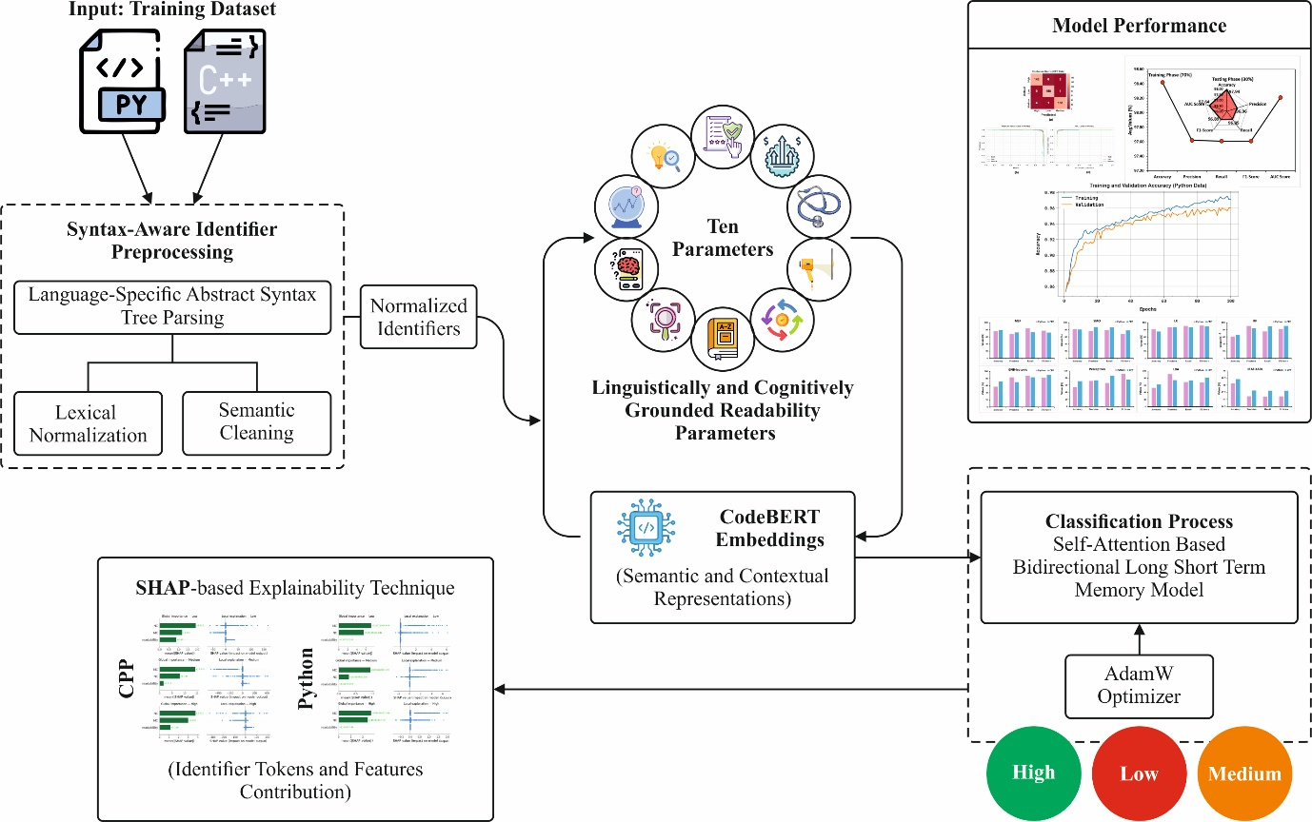
Fig. 1 presents the high-level workflow of the IRAF-XADL approach
3.1. Identifier Preprocessing and Normalization Pipeline
To enhance the feature quality, which is extracted from code snippets and improve readability prediction, we adopt a syntax-aware identifier preprocessing module [22]. This module concentrates on extracting, normalizing, and semantically cleaning identifiers from Python and C++ code.
Identifier Extraction from Code Snippets
Rather than naive tokenization, the method utilizes language-based AST tokenizers to dependably extract identifiers like: Function names, Parameter names, Class names, and Variable names.
- LibCST is a Python analysis architecture, which produces an existing syntax tree while conserving formatting details, allowing accurate and structure-based code methods.
- Tree-Sitter is a quick, gradual analysis architecture that generates a strong syntax tree for programming languages, assisting effective, stable assessment.
Identifier Preprocessing
Identifier preprocessing uses lexical normalization methods like split snakeCase and camelCase, lowercase normalization, and digit–letter separation for decomposing the identifiers with expressive semantic tokens and decrease the vocabulary sparsity.
- CamelCase splitting: camelCase identifiers was separate within essential words for separating the entrenched lexical units for example: (getUserName → get user name).
- snake_case splitting: it was decayed at highlight boundaries for extracting the distinct semantic tokens for example: (user_name_id → user name id).
- digit–letter separation: it was divided with numeric and alphabetic components for separating the entrenched numeric data. For example: (file2Path → file 2 path).
- lowercase normalization: Each identifier token has been transformed into lowercase to ensure case-insensitive similarity and decrease the vocabulary sparsity.
Token Cleaning
Token cleaning commonly denotes to the NLP preprocessing step where raw, tokenized text is enhanced by eliminating unrelated elements for enriching the data quality for DL models.
- Stopword removal: Uninformative tokens, containing traditional code-based stopwords and English stopwords (for example: var, obj, tmp), it was eliminated for enhancing the feature discrepancy and reducing the lexical noise.
- Lemmatization: Tokens have been lemmatized to their recognized base forms employing a WordNet lemmatizer for enhancing the semantic consistency and normalizing the morphological variants.
3.2. Feature Engineering
From the normalized identifiers, we compute a set of ten linguistically and cognitively grounded readability parameters for quantitatively modeling human-perceived identifier readability.
Meaningful Clarity (MC): MC models how philologically meaningful the identifier tokens are.
$$MC=\frac{1}{n}\sum_{i=1}^{n}{I(}w_{i}∈V) (1)$$
Naming Conformance (NC): NC assesses observance to language-based naming conventions.
$$NC=\left\{\begin{matrix}1, & \text{if identifier follows naming conventions} \\ 0, & \text{otherwise}\end{matrix}\right. (2)$$

Optimal Length (OL): OL estimates how near the identifier length is to an optimum distance.
$$OL=1-\frac{∣len\left(name\right)-L_{opt}∣}{L_{max}} (3)$$
Domain Relevance (DR): DR evaluates how closely identifier tokens associate with domain-based vocabulary.
$$DR=\frac{1}{n}\sum_{i=1}^{n}{cos⁡(embedding(}w_{i}),embedding(D)) (4)$$
Pronounceability (PR): this method estimates how simply an identifier can be defined depending on the ratio of vowels for the entire characters.
$$PR=\frac{\#vowels}{\#characters} \left(5\right)$$
Lexical Familiarity (LF): Measures how acquainted identifier tokens are by averaging their utilization frequency in a large natural language corpus.
$$LF=\frac{1}{n}log∑\left(freq\left(w_{i}\right)\right) (6)$$
Context Consistency (CC): estimates the semantic constancy of an identifier along with closely identifiers employing embedding-driven comparison.
$$CC=cosine\left(embedding\left(name\right),embedding\left(nearest_{k_{names}}\right)\right) (7)$$
Scope Appropriateness (SA): measures either an identifier’s length is suitable comparative for the scope size.
$$SA=\frac{OL}{\log\left(scope_{size}+1\right)} (8)$$
Cognitive Load Score (CLS): estimates the cognitive exertion need for understanding an identifier by integrating familiarity, clarity, and ambiguity-relevant factors.

$$CLS=0.4\left(1-MC\right)+0.3\left(1-LF\right)+0.3\left(AD\right) (9)$$
Predictability (PRED): estimates how probable an identifier is of producing its surrounding code context employing a stochastic language method.
$$PRED=P\left(name ∣ surrounding_{code}\right) (10)$$
3.3. CodeBERT-based Embeddings
The proposed approach used the CodeBERT language technique for extracting the contextual and semantic information of identifiers and their surrounding code framework [23]. CodeBERT is a pre-trained algorithm, a framework that is enhanced for handling the programming-based contexts efficiently. This is trained on a huge corpus of programming languages. The CodeBERT is intended for understanding the semantic source code, and it was established to be an effective technique in different software engineering applications. To acquire the embedding vector of identifier token series, this method transforms the token order within three encoded vectors such as (1) Segment Embeddings $[EA]$ (2) Position embedding $[EP]$ and (3) Token Embeddings $E\left[tk\right].$ Position embedding supports the encoder for embedding the token for its position. CodeBERT creates an embedding vector for a token that links to its position when the token appears two times. The architecture of CodeBERT includes twelve layers of transformers, each having 768 hidden units. The encoder employs a feed-forward neural network and a multi-head attention for extracting semantic information from the source code. This encoder uses three dissimilar encoding vectors to map a token to an m-dimensional fixed-length vector. Specifically, CodeBERT represents each token with a 768-dimensional illustration. So, every source code file is eventually signified by a matrix with dimensions $d_{n}×d_{t}$.
$$E(TS)=\left\{E\left[CLS\right], E\left[T_{1}\right], E\left[T_{2}\right], ……., E\left[T_{n}\right], E\left[SEP\right]\right\} (11)$$
Now, $E[CLS]$is a superior classification token embedding, which acquires the complete semantic information of the identifier and its related utilization into the source code. In conclusion, this method combines all token embeddings employing an average pooling layer for obtaining the last feature extraction $H$ that is consequently utilized for identifier intelligibility forecast.
3.4. Attention-Driven Deep Learning Architecture for Identifier Readability
The extracted representations are then passed into the SA-BiLSTM model for robust identifier readability classification.
BiLSTM Layer: BiLSTM is an extension of traditional LSTMs. The BiLSTM layer encompasses dual separate LSTMs to analyze the data of an identifier series from dual directions [24]. LSTM is an individual variant of recurrent model, particularly intended for retaining the long‐scale relationships for solving the gradient issue in standard RNN systems. LSTM integrates a cell memory gate for monitoring values across alternating time intervals and 3 inherent gates, such as forget, input, and output gates, for handling the data flow. The presented technique estimates the output gate $(o_{t})$, forget gate $(f_{t})$, input gate $(i_{t})$, input modulation gate $(g_{t})$, cell memory state $(c_{t})$ and hidden state $(h_{t})$, for present time-step employing identifier embedding vectors $(x_{t-1})$ from present time-step, hidden state vector $(h_{t-1})$ from current time-step and the engineered identifier attributes $(r_{t})$.
$$\begin{matrix}i_{t}=σ\left(W_{i}^{*}x_{t-1}+H_{i}^{*}h_{t-1}+R_{i}^{*}r_{t}+b_{i}\right), \\ f_{t}=σ\left(W_{f^{*}}x_{t-1}+H_{f^{*}}h_{t-1}+R_{f^{*}}r_{t}+b_{f}\right), \\ o_{t}=σ\left(W_{o}^{*}x_{t-1}+H_{o}^{*}h_{t-1}+R_{o}^{*}r_{t}+b_{o}\right), \\ g_{t}=σ\left(W_{c}^{*}x_{t-1}+H_{c}^{*}h_{t-1}+R_{c}^{*}r_{t}+b_{c}\right), \\ c_{t}=f_{t}^{*}c_{t-1}+i_{t}^{*}g_{t}, \\ h_{t}=o_{t}^{*}tanh\left(c_{t}\right),\end{matrix} (12)$$
This equation, $t$ represents the specific time step, $H$,$R,$ and$W$ implies learned weights, $b$ denotes the logistic and bias sigmoid process is signified through variables σ$.$ The LSTM captures related information of identifier series automatically, depending on the identifier-associated features constant at each time step, as shown in equation (12). Firstly, the identifier feature vectors are given to the two self-governing multilayer perceptrons to initialize the values of cell and hidden states $(h_{0})$.
$\begin{matrix}c_{0}=\tanh_{init,c}\left(e\right), \\ h_{0}=\tanh_{init,h}(e)\end{matrix} (13)$
Within BiLSTM, the forward LSTM estimates the hidden state vector $hf_{t}$ utilizing $x_{t}$ and $hf_{t-1}$. Also, the regressive LSTM assesses hidden state vectors $hb_{t}$ employing $hb_{t-1}$ and $x_{t}$ from the opposite direction. Before the BiLSTM’s terminal hidden state vector has been acquired through integrating the backward and forward hidden vectors $(hb$ and $hf_{t})$, it is denoted in Eq. (14).
$$h_{t}=\left[hf_{t}, hb_{t}\right] (14)$$
Self‐Attention Layer: The distinctive BiLSTM could not identify the features essential for determining the identifier readability, depending on related utilization. To acquire text features, which are further relevant to the contextual data, the mechanism called self‐attention mechanism (SAM) is along with the presented decoding algorithm. The SAM enables the given input for interacting with itself and extract the significant attributes by allocating more weight to designate the importance of the feature. Fig. 2 shows the architecture of the self-attention mechanism.
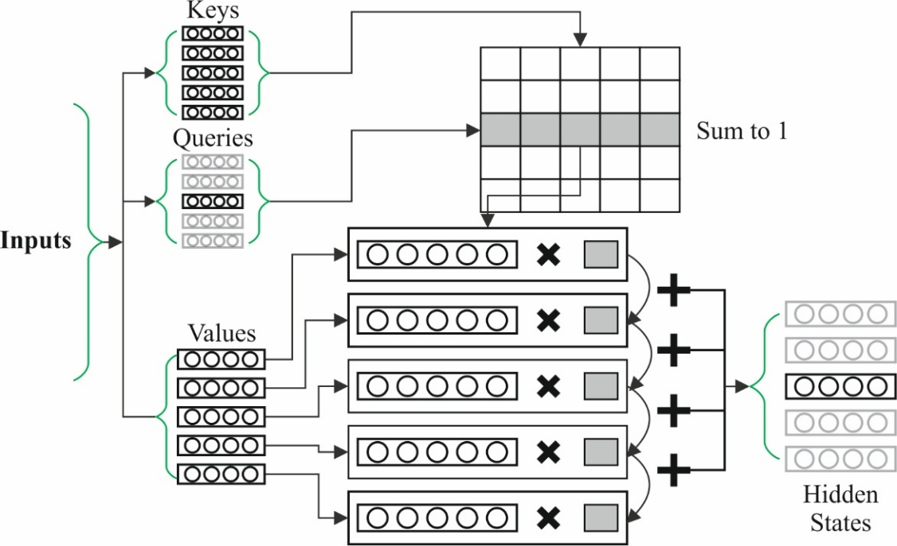
Fig. 2. Architecture of self-attention mechanism
The $h_{t}$ acquired from the BiLSTM layer has been given to the input for the SA layer. The SAM illustrated in equations (15).
$$\begin{matrix}α_{t}=tanh\left(W_{w}*h_{t}+b_{w}\right), \\ δ_{t}=\frac{exp(α_{t}*α_{w})}{\sum_{t}{exp}(α_{t}*α_{w})} \\ a=\sum_{t}{δ_{t}}*h_{t},\end{matrix} (15)$$
Wherever $b_{w}$ and $W_{w}$represent the bias and weight, correspondingly, that is utilized for finding the new information of the hidden vector $(α_{t})$. $α_{w}$ Signifies the great dimensional context vector employed for predicting the importance of various features in the text series that is prepared randomly in the learned jointly and training phase. Furthermore, the softmax layer in the decoding is employed for generating an identifier dependability forecast depend on the consequential result from the SAM layer. At every time step $t$, it chooses the words with great possibility and refers them to the next time step for producing the whole text caption.
$y_{t}=softmax \left(W_{a}*a+b_{a}\right), (16)$
Wherever$b_{a}{, W}_{a},$and $y_{t }$denote the bias and the weighted matrix, respectively. Fig. 3 illustrates the model diagram of SA-BiLSTM.
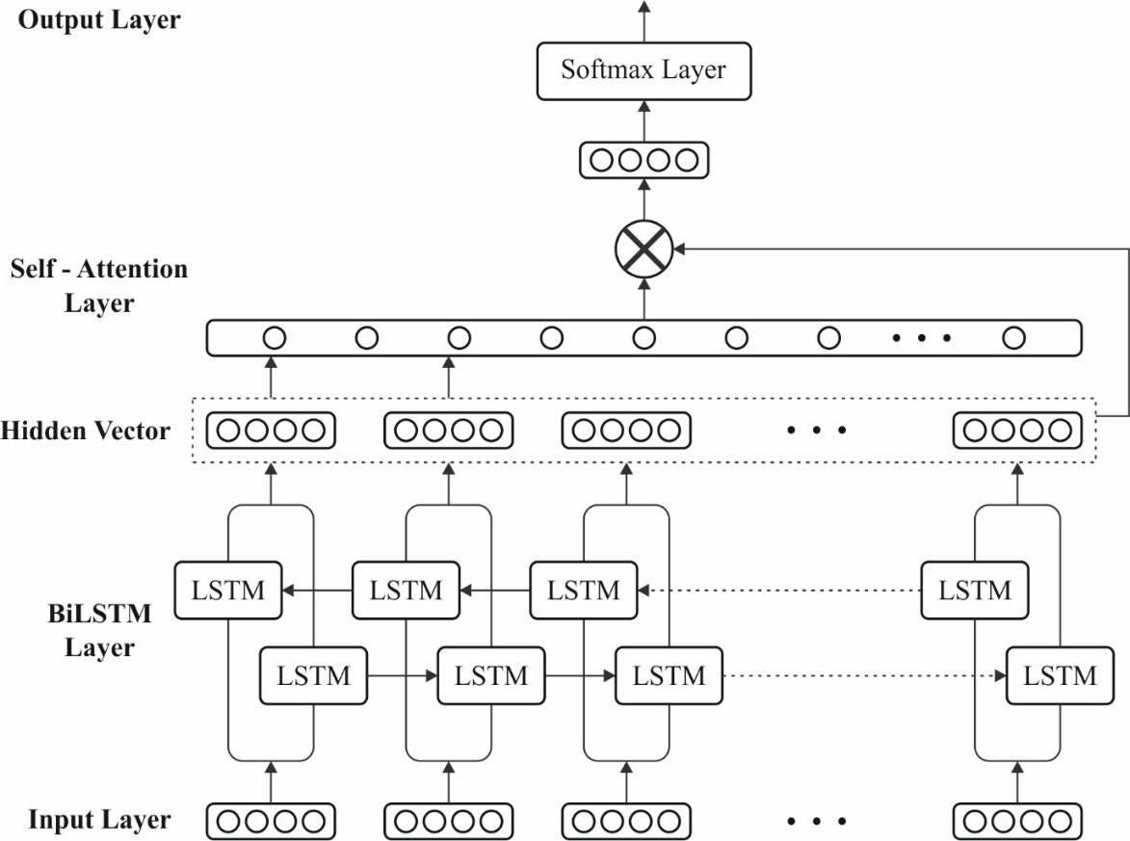
Fig. 3. Model diagram of SA-BiLSTM
3.5. Model Optimization using AdamW
AdamW is an optimized variant of the Adam optimizer that decouples weight decay from the gradient update, enhancing generalization in DL models [25]. The parameters updated in AdamW are correctly declared in the given formula:
$$\begin{matrix}m_{t}=β_{1}m_{t-1}+(1-β_{1})g_{t'} \\ υ_{t}=β_{2}v_{t-1}+(1-β_{2})g_{t'}^{2} \\ {\hat{m}}_{t}=\frac{m_{t}}{1-β_{1}^{t}}, \\ {\hat{υ}}_{t}=\frac{v_{t}}{1-β_{2}^{t}} \\ θ_{t}=θ_{t-1}-\frac{α}{\sqrt{{\hat{υ}}_{t}}+ϵ}\left({\hat{m}}_{t}+λθ_{t-1}\right),\end{matrix} (17)$$
Wherever $v_{t}$ and $m_{t}$signify the rapidly weighted first‐ and second‐moment estimations of the random gradient $g_{t},$ correspondingly; $β_{2}$ and $β_{1}$are there parallel decay factors, and ${\hat{v}}_{t}$and ${\hat{m}}_{t}$ denote the bias‐corrected forms of $v_{t}$ and${ m}_{t}$. Furthermore, α represents the base learning‐rate hyper-parameter, $e$ signifies a small positive constant presented for ensuring the numerical stability, and $λ$ defines the strength of the decoupled weight‐decay regularizer.
Contrasting the original Adam method that couples ${}_{L2}$ normalization to the gradient update, AdamW implements weight decay directly to the parameters. This clear decoupling separates the normalization impact from the dynamic update, resulting in further constant convergence and better simplification. Therefore, weight decay could be incorporated as a$_{n L2}$ normalization term with coefficient $λ$ in the given amplified loss function:
$$L_{total}(w)=L_{data}(w)+\frac{λ}{2}‖w‖_{2}^{2}, (18)$$
Here, $L_{data}(w)$ is the original task loss. Taking the gradient of $L_{total}(w)$ and implementing a learning‐rate process submits the traditional shrinkage update,
$w_{t+1}=\left(1-αλ\right)w_{t}-α∇_{w}L_{data}\left(w_{t}\right), (19)$
That shrinks every weight by a factor of $(1-αλ),$ previously the data‐based modification. In AdamW, the above decay term is clearly decoupled from the dynamic moment approximation, as illustrated in the last update Equation (19). This decoupling assures that normalization does not interfere with adjustable learning dynamics, leading to further constant convergence and improved simplification.
Table 2 summarizes the optimized hyperparameters utilized in the proposed model. The input sequence length is fixed at 50, while the BiLSTM is configured with three layers, 128 hidden units, and a dropout rate of 0.3 to efficiently capture bidirectional dependencies and reduce overfitting. A self-attention mechanism with four heads and an attention dimension of 128 improve contextual feature learning. The dense layer employs 64 neurons with ReLU activation for nonlinear feature mapping. Training employs the AdamW optimizer with a weight decay of 0.01, learning rate of 0.001, batch size of 32, 100 epochs, and gradient clipping of 1.0 to ensure stable and efficient convergence.
Table 2 Parameter setting
Component | Parameter | Optimized Value
Input Layer | Max Sequence Length | 50
BiLSTM | Number of Layers | 3
 | Hidden Units | 128
 | Dropout Rate | 0.3
Self-Attention | Attention Heads | 4
 | Attention Dimension | 128
Dense Layer | Fully Connected Units | 64
 | Activation Function | ReLU
Optimization (AdamW) | Learning Rate | 0.001
 | Weight Decay | 0.01
 | β₁ | 0.9
 | β₂ | 0.999
Training | Batch Size | 32
 | Epochs | 100
Regularization | Gradient Clipping | 1.0

3.6. Explainability and Feature Attribution via SHAP
SHAP-based explainability is utilized for interpreting the contribution of identifier tokens and features toward readability predictions. SHAP is a post‐hoc explanatory tool, which is a method intended for assisting the clarification of the output produced by all DL algorithms [26]. SHAP depends on the impression of Shapley value, and it has a robust foundation in collaborative game theory. The estimation of Shapley values for every feature relies on a tentative expectation function that enables the interpretation of the feature’s marginal involvement. By estimating the Shapley value for every given input feature.
$$f\left(x^{*}\right)=∅_{0}+\sum_{j=1}^{M}{∅_{j}^{*}} (20)$$
Here, $f(x^{*})$ signifies ML forecasted value, $∅_{0}$ represents the average estimation for training datasets, and $∅_{j}^{*}$ denotes Shapley value for feature $j.$
The SHAP algorithms enable both local and global Explanations of DL algorithms. Global Explanations condense the effect of individual features over the whole dataset, though local Explanations detect the effect of every attribute for a precise instance of examples. Moreover, XAI analysis enhances the comprehensibility of the DL algorithms.
4. Performance Evaluation and Explainability Insights
In this section, a comprehensive analysis of the results attained from the proposed model is present, along with the evaluation metrics used to assess its performance.
4.1. Dataset Used
The performance validation of the proposed model can be analyzed using Code Snippets: Insights and Readability dataset [27]. This dataset is a collection of C++ and Python code snippets annotated with various code properties. Table 3 shows the details on dataset.
Table 3 Details of dataset
Identifier Readability Level | Count
 | Python | CPP
Medium | 560 | 500
High | 560 | 502
Low | 561 | 502
Total Samples | 1681 | 1504
Python Data: This dataset offers an extensive collection of metrics and readability scores for Python code snippets. Every entry contains information, namely the python solutions, problem title, number of lines, difficulty level, comments, code length, indents, cyclomatic complexity, loop count, identifiers, line length, and readability score. The dataset is developed for facilitating the examination of coding patterns, complexity, and readability in Python programming. Table 4 provides the details of python code dataset.
Table 4 Details of python code dataset
S.no | Python Code | Identifier Readability Level
1 | class Solution:  def missingNumber(self, nums: List[int]) -> int:  #nums.sort()  list1=[x for x in range(0,len(nums)+1) if x not in nums]  print(list1[0])  return list1[0] | High
2 | class Solution:  def singleNumber(self, nums: List[int]) -> int:  return (sum(set(nums))*3-sum(nums))//2 | Medium
3 | class Solution:  def reverseString(self, s: List[str]) -> None:  """  Do not return anything, modify s in-place instead.  """  n = len(s)-1  for i in range(n,-1,-1):  s.append(s[i])  s.pop(i) | Low

C++ Data: This dataset offers a comprehensive set of metrics and readability scores for C++ code snippets. Each record includes details such as number of lines, code itself, comments, code length, number of indents, cyclomatic complexity, line length, loop count, identifiers, and readability score. The dataset is made for supporting the examination of coding styles, complexity, and readability in C++ programming. Table 5 presents the details of CPP code dataset
Table 5 Details of CPP code dataset
S.no | CPP Code | Identifier Level
1 | class Solution {  public:  string truncateSentence(string s, int k) {  for (int i = 0; i < s.length(); ++i)  if (s[i] == ' ' && --k == 0)  return s.substr(0, i);  return s;  }  }; | High
2 | class Solution {  public:  bool checkOnesSegment(string s) {  return s.find("01") == string::npos;  }  }; | Medium
3 | class Solution {  public:  bool checkIfPangram(string sentence) {  return unordered_set(begin(sentence), end(sentence)).size() == 26;  }  }; | Low

4.2. Model Evaluation Metrics
Multiple performance metrics are used for evaluating and comparing the efficiency of all the trainable models.
Accuracy: It is the ratio of exactly categorized samples and the total counts of samples. This can be denoted in a mathematical way,
$Accuracy=\frac{True Positiνe Ratio+True Negatiνe Ratio}{Total number of Samples} (21)$
Precision: Measure the amount of appropriately identified positive cases divided by the entire count of identified positive instances. It is represented by,
$Precision=\frac{True Positiνe Ratio}{True Positiνe Ratio+False Positiνe Ratio} (22)$
Recall: The number of appropriately classified positive cases is described as the ratio of the summation of actual positive instances. Computationally, it is signified as given below,
$$Recall =\frac{True Positiνe Ratio}{True Positiνe Ratio+False Negatiνe Ratio} (23)$$
F1-Score: It is the harmonic mean of recall as well as precision. Mathematically, it can be denoted as:
$$F1-Score=\frac{2*\left(Precision*Recall\right)}{Precision+Recall} (24)$$
AUC: It is also a performance indicator utilized for evaluating the efficiency of the binary classifier. It is acquired by participating the TPR when compared to the FPR with entire thresholds. TPR is described by dividing the counts of true positives and total count of true positive samples $(TP +FN)$ , while FPR is measured by dividing the false positive counts by the total number of true negative instances $(FP +TN)$. A better AUC value offers greater capability of classification.
4.3. Result Analysis on Python Data
Fig. 4 describes the classifier results of IRAF-XADL method on python data. Fig. 4a demonstrate the confusion matrix with effective recognition of each class. Fig. 4b depicts the PR investigation, signifying maximal efficiency on every class. Finally, Fig. 4c displays the ROC study, exhibiting efficacious outcomes with greater ROC values for different classes.
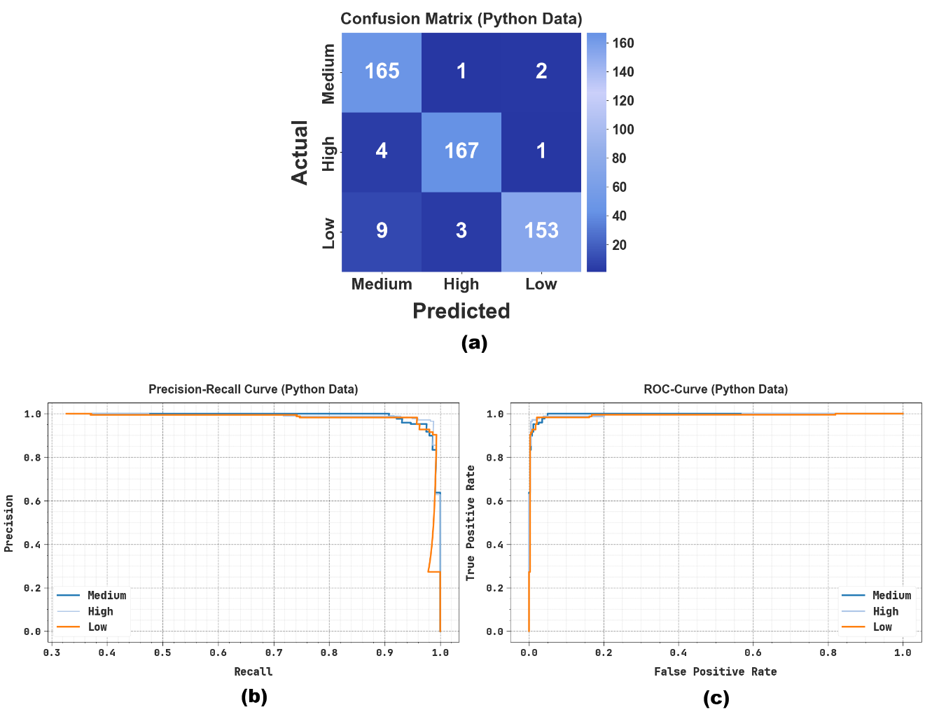
Fig. 4. Classifier outcome of IRAF-XADL method (a) Confusion matrices and (b-c) PR and ROC curves using python data
Table 6 signify the code identifier outcomes of IRAF-XADL methodology on python data at 70:30. Under 70%, the IRAF-XADL system achieves average value with $acc{ur}_{y}$ of 98.13%, $preci_{n}$ of 97.22%, $recal_{l}$ of 97.20%, ${F1}_{score}$ of 97.21% and ${AUC}_{score}$ of 97.90%. At the same time, with 30% IRAF-XADL method offers average value with $acc{ur}_{y}$ of 97.36%, $preci_{n}$ of 96.14%, $recal_{l}$ of 96.01%, ${F1}_{score}$ of 96.03% and ${AUC}_{score}$ of 97.02%.
Table 6 Code identifier result of IRAF-XADL technique using python data with 70:30 split
Classes | $$Acc{ur}_{y}$$ | $$Pre{ci}_{n}$$ | $$Rec{al}_{l}$$ | $$F1_{score}$$ | $${AUC}_{score}$$
Training Phase (70%)
Medium | 97.36 | 95.24 | 96.94 | 96.08 | 97.26
High | 99.32 | 99.22 | 98.71 | 98.97 | 99.17
Low | 97.70 | 97.19 | 95.96 | 96.57 | 97.27
Average | 98.13 | 97.22 | 97.20 | 97.21 | 97.90
Testing Phase (30%)
Medium | 96.83 | 92.70 | 98.21 | 95.38 | 97.18
High | 98.22 | 97.66 | 97.09 | 97.38 | 97.95
Low | 97.03 | 98.08 | 92.73 | 95.33 | 95.92
Average | 97.36 | 96.14 | 96.01 | 96.03 | 97.02

Fig. 5 depicts the training (TRAIN) and validation (VALID) accuracy curves on python data. TRAIN accuracy rises steadily and reaches a higher level, signifying robust learning and convergence. The VALID accuracy meticulously follows the training trend with a minor and steady gap, indicating better generality and minimum overfitting. Moreover, the reliable progress and convergence of both curves assure the reliability of the proposed system.
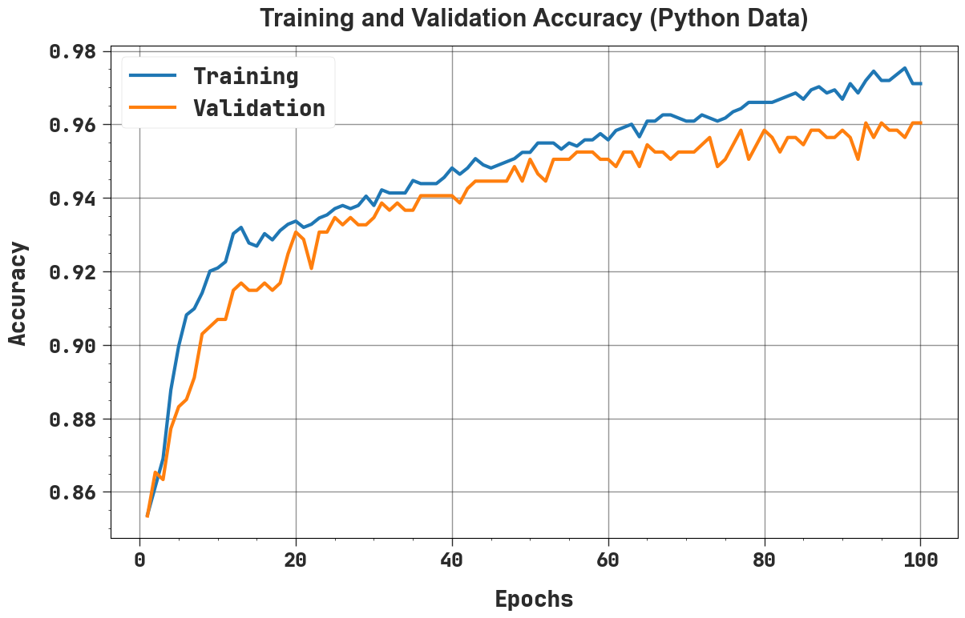
Fig. 5. $Accur_{y}$ curve of IRAF-XADL method with python data
Fig. 6 demonstrates the TRAIN and VALID loss curves of IRAF-XADL model on python data. Both losses reduce sharply in the initial epochs, which denotes swift learning, and then progressively decrease in a smooth and steady manner, exhibiting reliable convergence. The consistent overlap among training and validation loss, with only a minor gap, denotes lesser overfitting and higher generalizability.
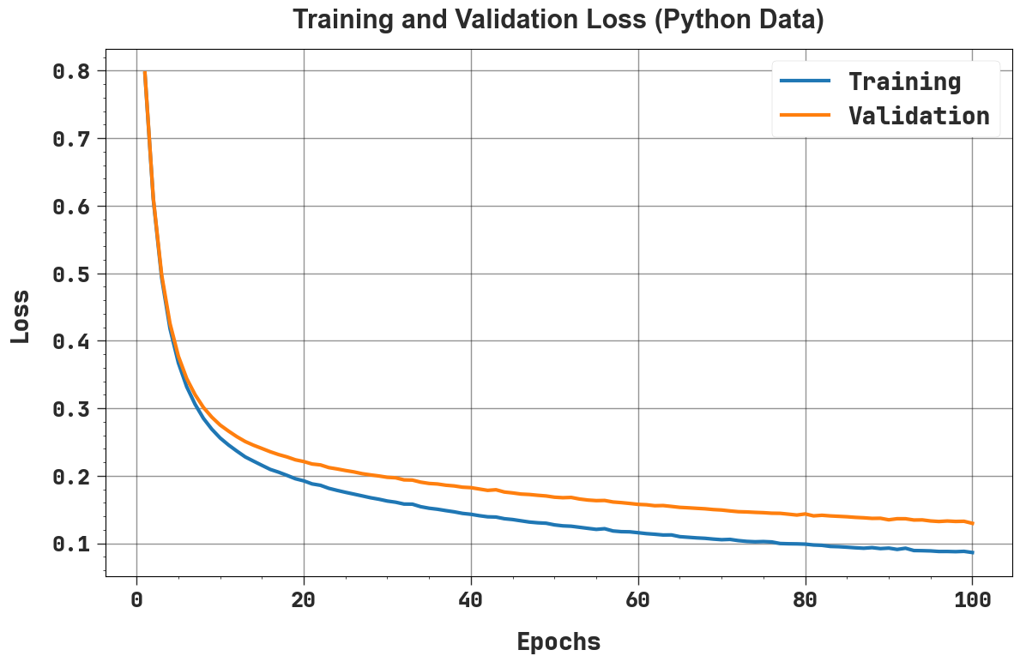
Fig. 6. Loss curve of IRAF-XADL system with python data
4.4. Result Analysis on CPP Data
Fig. 7 shows the classifier results of IRAF-XADL system on CPP data. Fig. 7a illustrate the confusion matrix with precise recognition of every class. Fig. 7b displays the PR assessment, implying maximal performance on all classes. Finally, Fig. 7c explains the ROC investigation, which exemplifies capable outcomes with greater ROC values for multiple classes.
Next, Fig. 8 denote the code identifier results of IRAF-XADL model on CPP data at 70:30. Under 70%, the IRAF-XADL model accomplishes average value with $acc{ur}_{y}$ of 98.42%, $preci_{n}$ of 97.62%, $recal_{l}$ of 97.61%, ${F1}_{score}$ of 97.61% and ${AUC}_{score}$ of 98.21%. Further, at 30% the IRAF-XADL system achieves average value with $acc{ur}_{y}$ of 97.94%, $preci_{n}$ of 96.96%, $recal_{l}$ of 96.85%, ${F1}_{score}$ of 96.89% and ${AUC}_{score}$ of 97.64%.

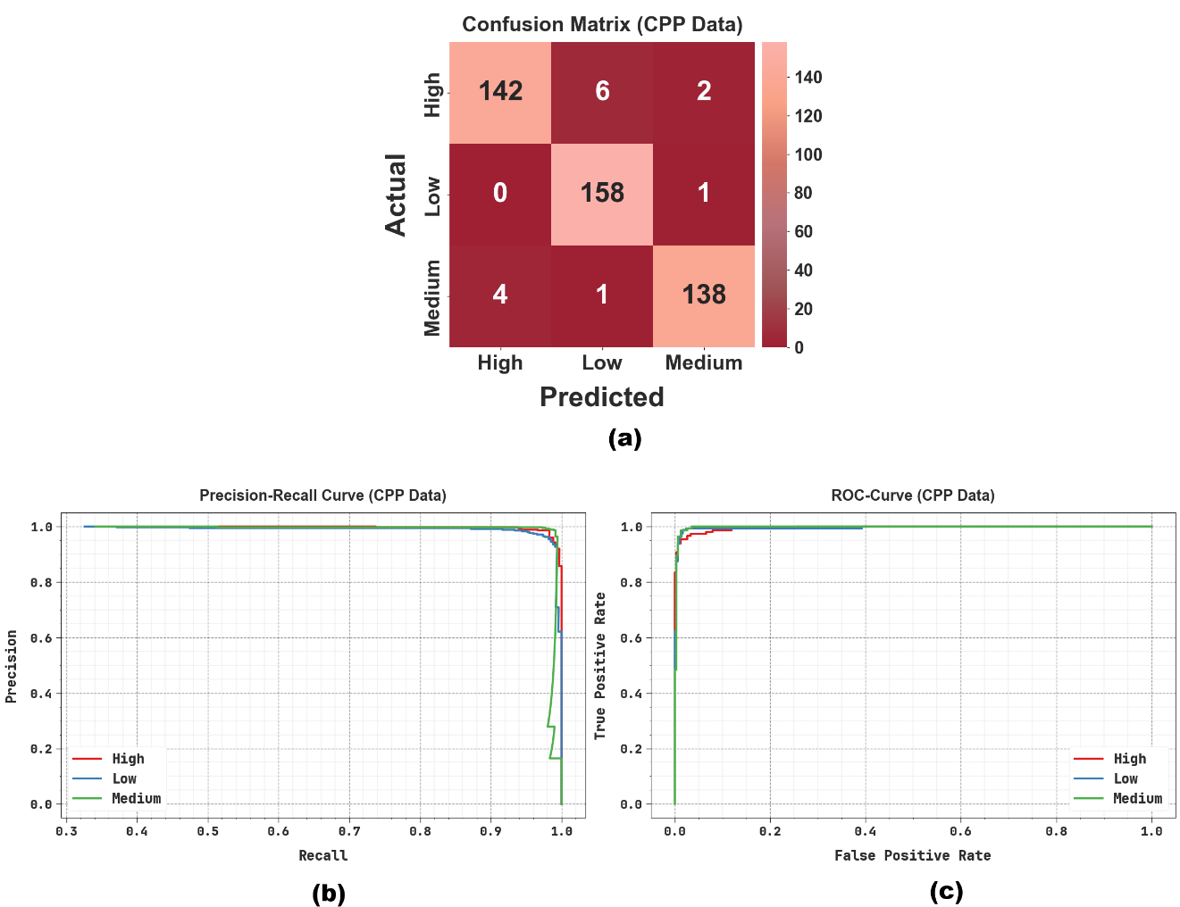
Fig. 7. Classifier outcome of IRAF-XADL method (a) Confusion matrices and (b-c) PR and ROC curves using CPP data
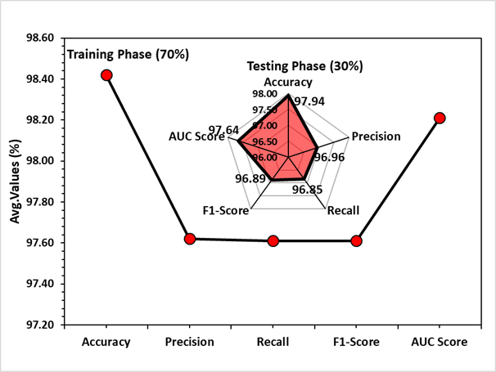
Fig. 8. Classification result of IRAF-XADL approach using CPP data with 70:30 split
Fig. 9 illustrates the TRAIN and VALID accuracy curves using CPP data. TRAIN accuracy surges steadily and attains a greater level, specifying efficient learning and convergence. The VALID accuracy closely follows the training trend with a slight and stable gap, revealing improved generality and minimum overfitting.
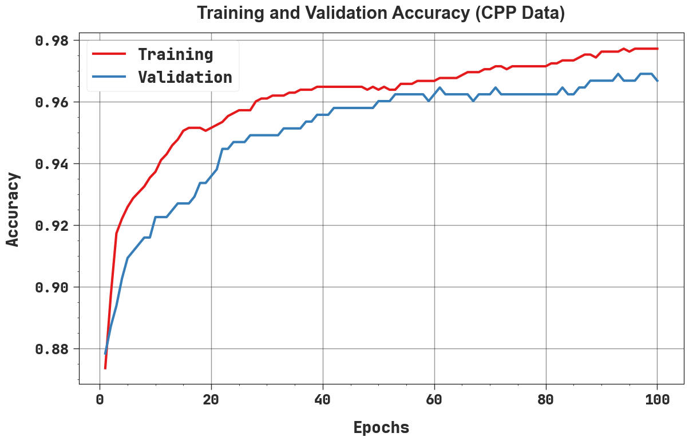
Fig. 9. $Accur_{y}$ curve of IRAF-XADL approach with CPP data
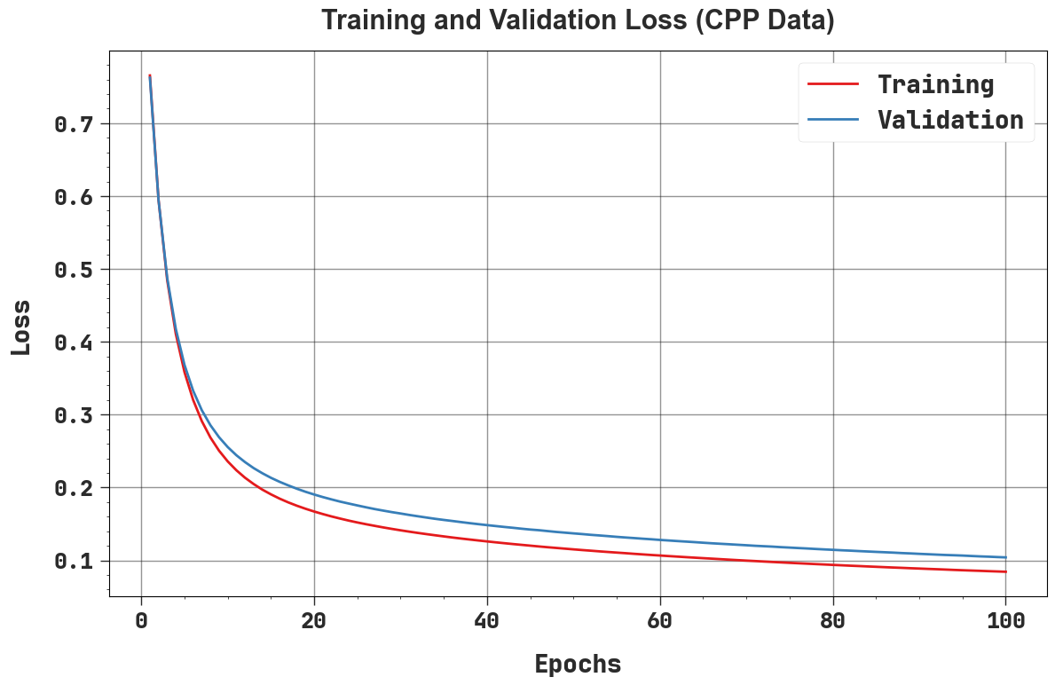
Fig. 10. Loss curve of IRAF-XADL system with CPP data
Fig. 10 proves the TRAIN and VALID loss curves using CPP data. Both losses decline abruptly during the initial epochs, signifying rapid learning, and then steadily decrease in a smooth and secure manner, indicating effective convergence. The consistent overlap amid training and validation loss, with only a small consistent gap, implies minimum overfitting and strong generality.
4.5. Comparative Discussions
To prove the improved performance of the IRAF-XADL methodology, a brief comparison analysis is made in Table 7 [28, 29]. Under Python dataset, the results confirmed that the GNB-Isotonic, Perceptron, and LDA technique have demonstrated lesser classification results. In the meantime, the RF model have tried to obtain slightly closer results. Moreover, the MLP, SMO, and LR models has exhibited reasonable performance. However, the IRAF-XADL model establishes capable performance with $acc{ur}_{y}$ of 98.13%, $pre{ci}_{n}$ of 97.22%, $rec{al}_{l}$ of 97.20%, and ${F1}_{score}$ of 97.21%, correspondingly, Similarly, at CPP dataset, the result suggests that the LDA and RF approaches have demonstrated lower classification outcomes. Likewise, the RF model have reached somewhat minimal performance with $acc{ur}_{y}$ of 65.00%, $pre{ci}_{n}$ of 83.88%, $rec{al}_{l}$ of 90.07%, and ${F1}_{score}$ of 90.48%. Additionally, the MLP, LR, GNB-Isotonic, Perceptron, and SMO methods has displayed reasonable performance. But the IRAF-XADL framework depicts promising outcomes with $acc{ur}_{y}$ of 98.42%, $pre{ci}_{n}$ of 97.62%, $rec{al}_{l}$ of 97.61%, and ${F1}_{score}$ of 97.61%.
Table 7 Comparative analysis of IRAF-XADL system with existing systems under python and CPP dataset
Methods | Datasets | $$Acc{ur}_{y}$$ | $$Pre{ci}_{n}$$ | $$Rec{al}_{l}$$ | $$F1_{score}$$
MLP | Python | 76.00 | 67.48 | 83.50 | 77.52
 | CPP | 79.33 | 72.45 | 73.54 | 72.02
SMO | Python | 82.00 | 76.25 | 78.63 | 67.95
 | CPP | 80.56 | 87.65 | 86.89 | 78.35
LR | Python | 81.00 | 87.02 | 90.58 | 91.96
 | CPP | 75.23 | 87.55 | 87.05 | 89.37
RF | Python | 61.10 | 90.52 | 75.41 | 82.16
 | CPP | 65.00 | 83.88 | 90.07 | 90.48
GNB-Isotonic | Python | 57.00 | 83.28 | 87.65 | 82.61
 | CPP | 71.56 | 69.54 | 83.23 | 90.13
Perceptron | Python | 54.10 | 71.86 | 65.96 | 91.47
 | CPP | 71.08 | 73.60 | 86.30 | 75.19
LDA | Python | 53.00 | 91.45 | 69.03 | 68.23
 | CPP | 62.45 | 74.44 | 73.65 | 81.88
IRAF-XADL | Python | 98.13 | 97.22 | 97.20 | 97.21
 | CPP | 98.42 | 97.62 | 97.61 | 97.61

4.6. XAI Analysis
Fig. 11 depicts the SHAP-based feature importance analysis for Python code classification at three levels: Low, Medium, and High. The left panels portray global importance, signifying that MC and NC have the maximum influence on the model, while readability contributes minimally. The right panels display local explanations, in which every dot signifies the SHAP value for an individual prediction, which shows how features impact the output. MC reliably pushes predictions positively across all levels, NC has a reasonable positive effect, and readability has negligible influence. The magnitude of SHAP values reduces from Low to High importance levels, exhibiting feature impact varies with model complexity.
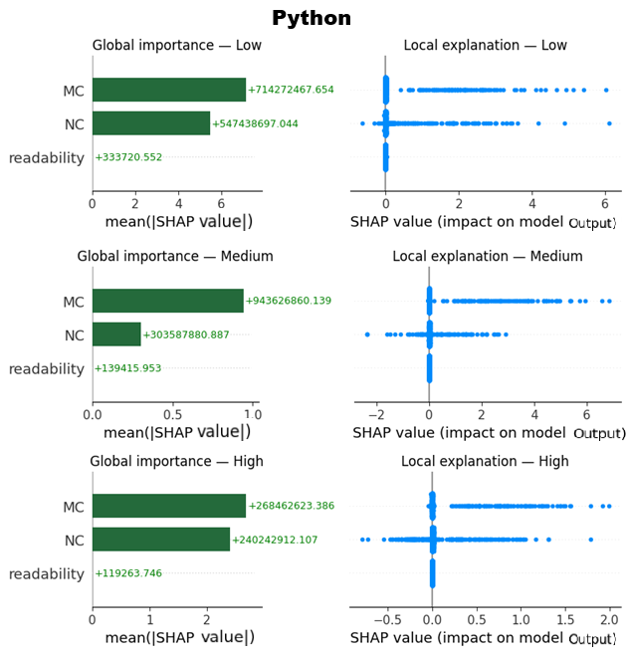
Fig. 11. SHAP value with python data
Fig. 12 provides the SHAP-based feature importance analysis for C++ code classification at Low, Medium, and High levels. The left panels demonstrate global importance, representing that NC and MC are the dominant features, while readability has a lesser impact across every level. The right panels show local explanations, where each dot signifies the SHAP value for an individual prediction, displaying how attributes influence the model output. At the Low level, NC has the strongest positive effect, followed by MC, while at Medium, MC becomes the most influential. At the High level, NC slightly outweighs MC, but readability reliably has minimum impact.

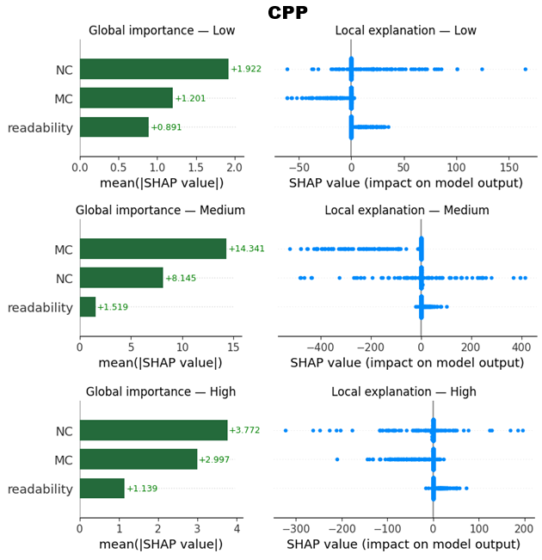
Fig. 12. SHAP value with CPP data
5. Conclusion
In this article, the IRAF-XADL model has been presented for assessing the quality of identifier names in Python and C++ source code. To perform that, a syntax-aware identifier preprocessing module, depending on language-specific AST parsing, is used for identifier extraction, lexical normalization, and semantic cleaning. From the normalized identifiers, this paper calculates ten cognitively and linguistically grounded readability parameters. In addition, semantic and contextual representations are obtained through CodeBERT embeddings, which are processed by an SA-BiLSTM network for learning sequential and contextual dependencies. Moreover, the model is optimized with the AdamW optimizer, allowing better convergence and enhanced overall performance. Finally, the SHAP-based explainability method is incorporated to interpret the contribution of identifier tokens and attributes toward readability predictions. The experimental result analysis of the IRAF-XADL model is conducted, and the comparative results highlighted the supremacy of the proposed system with an accuracy of 98.13% and 98.42% under Python and CPP data compared to other techniques concerning different measures.
Data Availability Statement: The data that support the findings of this study are openly available in Kaggle repository at https://www.kaggle.com/datasets/paakhim10/code-snippets-insights-and-readability/data, reference number [27].
References
- Geo, A.A., Michael, G., Anuradha, C., Akilandasowmya, G. and Nirmaladevi, G., 2026, January. Automated extraction of identifiers from object-oriented codebases. In AIP Conference Proceedings (Vol. 3345, No. 1, p. 020308). AIP Publishing LLC.
- Rahman, M.M., Md, N.G., SD, M.K.S., Rahman, M.M. and Hossain, M.S., 2026. AI-Powered Defect Prediction: From Code Smells to Failure Forecasting.
- Susanto, B., Ferdiana, R. and Adji, T.B., 2025. Predicting Multiclass Java Code Readability: A Comparative Study of Machine Learning Algorithms. International Journal of Advanced Computer Science & Applications, 16(4).
- Dipongkor, A.K., Yao, Z. and Moran, K., 2025. Reassessing Code Authorship Attribution in the Era of Language Models. arXiv preprint arXiv:2506.17120.
- Duvvur, V., An Efficient Source Code Transformation Strategy Based on Graph-Based Machine Learning and Generative Ai Techniques.
- Han, B., Li, C., Deng, H., Liu, G. and Zheng, Z., 2024. Domain‐specific translation tool from structured text to C source code with code readability enhancement in programmable logic controllers. Concurrency and Computation: Practice and Experience, 36(15), p.e8100.
- Shin, J., Hashtroudi, S., Hemmati, H. and Wang, S., 2024, September. Domain adaptation for code model-based unit test case generation. In Proceedings of the 33rd ACM SIGSOFT International Symposium on Software Testing and Analysis (pp. 1211-1222).
- Li, T. and Zhang, Y., 2024. Multilingual code refactoring detection based on deep learning. Expert Systems with Applications, 258, p.125164.
- Dong, Z., Hu, Q., Zhang, Z. and Zhao, J., 2024. On the effectiveness of graph data augmentation for source code learning. Knowledge-Based Systems, 285, p.111328.
- Hu, Y., Jiang, H. and Hu, Z., 2023. Measuring code maintainability with deep neural networks. Frontiers of Computer Science, 17(6), p.176214.
- Gerhold, M., Solovyeva, L. and Zaytsev, V., 2024, March. The limits of the identifiable: Challenges in python version identification with deep learning. In 2024 IEEE International Conference on Software Analysis, Evolution and Reengineering (SANER) (pp. 137-146). IEEE.
- Szalontai, B., Kukucska, Á., Vadász, A., Pintér, B. and Gregorics, T., 2023, July. Localizing and idiomatizing nonidiomatic python code with deep learning. In Science and Information Conference (pp. 683-702). Cham: Springer Nature Switzerland.
- Szalontai, B., Kukucska, Á., Vadász, A., Pintér, B. and Gregorics, T., 2023, July. Localizing and idiomatizing nonidiomatic python code with deep learning. In Science and Information Conference (pp. 683-702). Cham: Springer Nature Switzerland.
- Zeng, W., Chai, Y., Zhou, H., Meng, F., Zhou, J. and Gu, X., 2026. Readability-Robust Code Summarization via Meta Curriculum Learning. arXiv preprint arXiv:2601.05485.
- Midolo, A., Tramontana, E. and Di Penta, M., 2026. From Human to Machine Refactoring: Assessing GPT-4's Impact on Python Class Quality and Readability. arXiv preprint arXiv:2601.13139.
- Tokumoto, S., Kusumoto, S. and Imai, R., 2025. Development and Evaluation of a Deep Learning-Based Model for Source Code Quality Classification Using Industrial Data. Journal of Software Engineering Practice, 6(1), pp.1-19.
- Verma, A., Saha, R., Kumar, G., Brighente, A., Conti, M. and Kim, T.H., 2025. Exploring the Landscape of Programming Language Identification With Machine Learning Approaches. IEEE Access.
- Biagiola, M., Ghislotti, G. and Tonella, P., 2025, March. Improving the readability of automatically generated tests using large language models. In 2025 IEEE Conference on Software Testing, Verification and Validation (ICST) (pp. 162-173). IEEE.
- Lu, H., Peng, H., Nan, G., Cui, J., Wang, C., Jin, W., Wang, S., Pan, S. and Tao, X., 2025. Malsight: Exploring malicious source code and benign pseudocode for iterative binary malware summarization. IEEE Transactions on Information Forensics and Security.
- Yang, B., Li, W., Xiang, L. and Li, B., 2024, May. Srcmarker: Dual-channel source code watermarking via scalable code transformations. In 2024 IEEE Symposium on Security and Privacy (SP) (pp. 4088-4106). IEEE.
- Dai, P., Yang, L., Wang, Y., Jin, D. and Gong, Y., 2023. Constructing traceability links between software requirements and source code based on neural networks. Mathematics, 11(2), p.315.
- Diamantopoulos, T., Karagiannopoulos, G. and Symeonidis, A.L., 2018, May. Codecatch: Extracting source code snippets from online sources. In Proceedings of the 6th International Workshop on Realizing Artificial Intelligence Synergies in Software Engineering (pp. 21-27).
- Sahar, S., Younas, M., Khan, M.M. and Sarwar, M.U., 2024. DP-CCL: A supervised contrastive learning approach using CodeBERT model in software defect prediction. IEEE Access, 12, pp.22582-22594.
- Ma, X., Hou, M., Zhan, J. and Liu, Z., 2023. Interpretable predictive modeling of tight gas well productivity with SHAP and LIME techniques. Energies, 16(9), p.3653.
- Lopez-Ramirez, J.L., Hernandez-Gutierrez, F.D., Avina-Ortiz, J.R., Bravo-Aguilar, P.D., Avina-Bravo, E.G., Ruiz-Pinales, J. and Avina-Cervantes, J.G., 2026. Multi-Scale ConvNeXt for Robust Brain Tumor Segmentation in Multimodal MRI. Technologies, 14(1), p.34.
- Ma, X., Hou, M., Zhan, J. and Liu, Z., 2023. Interpretable predictive modeling of tight gas well productivity with SHAP and LIME techniques. Energies, 16(9), p.3653.
- https://www.kaggle.com/datasets/paakhim10/code-snippets-insights-and-readability/data
- Mi, Q., Keung, J., Xiao, Y., Mensah, S. and Mei, X., 2018, June. An inception architecture-based model for improving code readability classification. In Proceedings of the 22nd International Conference on Evaluation and Assessment in Software Engineering 2018 (pp. 139-144).
- Susanto, B., Ferdiana, R. and Adji, T.B., 2025. Predicting Multiclass Java Code Readability: A Comparative Study of Machine Learning Algorithms. International Journal of Advanced Computer Science & Applications, 16(4).

