Explainable Artificial Intelligence with Hybrid Ensemble Learning based Automated Code Comprehension Prediction
¹Bharat Babaso Mane, ²Dr. Rathnakar Achary
^{1,2}Department of Computer Science and Engineering, Alliance University, Bengaluru, Karnataka - 562106, India.
bharat.mane@gmail.com, rathnakar.achary@alliance.edu.in
Abstract
Code readability is deliberated an essential element of software quality. It reflects a human evaluation of the readability and comprehensibility in the source code. In recent times, it has more and more substantial development features in software engineering owing to the huge number of software projects and considerably increased the difficulties and size. Code readability is strenuously relevant to the maintenance and significantly impacts software maintenance. To ensure precise classification models, the preceding analysis mainly relied on handcrafted features. Nevertheless, the manual process of feature engineering is typically labor-intensive and can acquire only partial information about the source code, which has a limit to the model performance. Recently, numerous deep learning (DL)–based code readability classification approaches are presented. Although it is still unclear what features of the input model generate its decisions, which hinders its practical utilization in the software in dustry. In this paper, we propose an Explainable for Code Readability Classification Using Vector Representations and Majority Voting-Based Ensemble Learning (ECRVR-MVEL) approach. The aim of this paper is to design an interpretable approach for code readability analysis that enhances code quality. To perform that, the proposed model initially preprocesses the input code that comprises four steps, namely tokenization, removal comments or normalization of white space and detecting languages. Moreover, CodeBERT is used to transform raw code into vector representations, enabling robust text embeddings for a classification model. For classification, a weighted majority voting ensemble classification integrates a graph convolutional network, a deep belief network, and a bidirectional temporal convolutional network to categorize code readability into high, medium and low levels. Besides, the Nadam is applied to improve the performance of the code readability classification model. Eventually, the LIME is utilized to visualize the interpretability and ensure transparency of model. An extensive result is accomplished to ensure the significance of the ECRVR-MVEL model under Python and C++ datasets. The simulation outcomes reported the promising solutions of the ECRVR-MVEL technique over other existing methodologies.
Keywords: Code Readability Classification; Ensemble Classification; Source Code; Nadam Optimizer; Software Engineering; LIME
1. Introduction
Around 70 percentage of the life-cycle cost of a software project is in the maintenance stage. To estimates the high cost of maintenance relates to the complexity of understanding and reading the source code, especially that authored by others that underlines the significance of code readability [1]. The code readability recommends to a human decision of readability and comprehensibility of the program’s source code. Evaluating the code readability snippets has been mandatory to assess their qualities [2]. Developers assume code readability to be a key aspect in their source code development activities as they frequently consume a lot of time for reading and understanding the source code. Easily comprehensible code streamlines maintenance activities, decreases bug introduction, and signifies the onboarding workflow for novel members [3]. Highlighting these dual features is important for the constant progress and growth of software projects. To simplify recycle, and generate maintainable and readable code, that significant to consider the following features when suggesting source code snippets [4]. Several examiners have introduced code developers that utilize the readability score generated by models as a feature in the code snippet grading procedure. Moreover, these scores individually denote the possibility of a code snippet being readable or unreadable, without producing a rating score for readability [5]. Another method to measure the readability of code snippets is by the usage of ASATs like Sonar-Qube2. This tool provides a set of rules that could increase probable concerns with code readability violations [6].
The most important threat is probably applied feature engineering approach [7]. Such previous research (comprising but not restricted to) commonly hand-made surface-level features like line lengths or operator counts to indicate code readability. The procedure is confessedly time-consuming, and it is possible that a few significant factors will not be captured [8]. Therefore, rather than manual design and feature extraction, we propose a deep learning-driven method that could automatically learn the most complex underlying features from the source code [9]. Provide the possible significance of automatically measuring code readability, previous task concentrated on representing methods to attain this objective. Motioned methods depend on Machine Learning (ML) or Deep Learning (DL) methodologies and, therefore, they must be trained on a classified dataset. Initially, ML-driven techniques depended on feature engineering. [10] They determine textual, Structural, and visual aspects. That could be measured on the provided source code snippet. Those features were previously utilized to classify the (labeled) source code [11]. Lastly, datasets were developed to train a binary classifier that could classify code snippets as “readable” or “unreadable.” The latest literature analyzed the probability of developing DL-driven methods to enhance the accuracy of current techniques [12].
  - Paper Contribution
To enhance the performance of code readability classification, this article presents a novel Explainable Code Readability Classification Using Vector Representations and Majority Voting-Based Ensemble Learning (ECRVR-MVEL) approach. The proposed ECRVR-MVEL method aims to design an interpretable framework for code readability, which improves code quality. The proposed ECRVR-MVEL technique follows text preprocessing, CodeBERT embedding, weighted majority ensemble classification, optimization and explainability analysis for providing accurate, readable and transparent code quality. The proposed ECRVR-MVEL approach is calculated utilizing Python and C++ datasets under numerous metrics. The significant contribution of this study is as follows:
- Employ CodeBERT-based embedding for transforming raw code into vectorized representations, which enhances the robust code readability.
- Design a weighted majority voting ensemble model, which incorporates three deep learning approaches, namely graph convolutional network (GCN), deep belief network (DBN) and bidirectional temporal network (Bi-TCN) techniques, for categorizing high, medium, and low levels and increasing the performance of code readability analysis.
- Present a Nadam optimizer for hyperparameter tuning, which helps to accomplish improved performance of code readability classification with limited computational complexity.
- Utilize LIME-based explainability techniques to highlight code elements and provides interpretable explanation.
- Validate the performance of the proposed ECRVR-MVEL technique under Python and C++ datasets and calculate the results with several aspects.
2. Literature Survey of Code Readability Classification
This section briefly reviews prior related works on code readability classification. Simoes and Venson [13] propose using Large Language Models (LLMs) to examine the quality of code characteristics associated with its readability in a reproducible, normalized, and reliable way. The author performed quasi-experiment research to determine the impacts of code modifications on LLM explanation with respect to its readability as a quality characteristic. Nine LLMs have been examined, continuing three measures: eliminating comments, replace classifier names with unclear names, and restructuring for eliminating code smells. Vitale et al. [14] proposed to gauge readability of code based on subjective perceptions through developers and modified code readability methodology for assessment. Consequently, authors adopt an LLM with less amount of learning to attain their objective. The outcomes are displayed that the method attains poorer outcomes than a pioneering feature-driven method that is developed to work at the snippet-level. Álvarez-Fidalgo et al. [15] proposed CLAVE, an innovative DL method for source code verification of authorship that exploits different learning. The authors early pre-train CLAVE on Python’s source code documents separated from GitHub. Then, author fine-tuning CLAVE for authorship verification utilizing deep learning on Python-based submissions by unique developers.
Segedinac et al. [16] proposed the Python code readability statements generally utilized courses. The readability method depends upon tracks the eye movement of the reader during the reading phase. It utilizes ML, models and depends on a new set of observational features that monitor how the codes are read by readers. The ML approach forecast readability based on the collective data and the textual code snippet and structural aspects. Fawareh et al. [17] presented the effect of AI-created code on software quality, concentrating on readability, code complexity, quality, and documentation. It assesses main metrics like cyclomatic complexity (CC), comment density, code lines, variable names, and code-to-code ratio. The outcomes exposed that though both AI-created and human-created code could be effective and brief, code created by AI tools displays a better focus, more clearly on documentation. AI-created code, particularly in difficult activities, displayed enhanced readability through greater comment density and clear variable name usage. Gorchakov et al. [18] presented the progress and analyses of methodologies that are developed to estimate the activities fixed by source code. Practical usage of these task recognition approach comprises model name forecasting, software–hardware separating, detection of programming standard violation, and semantic code replication search.
Tang et al. [19] proposed a new DL-based methodology, CSGVD, that deliberates vulnerability at the function-level identification as a graph binary classification activity. Initially, the author presents a PE-BL element that obtains and improves the information from the existing language model. Lastly, a mean biaffine based attention pooling, M-BFA, to greater total node data as a graph’s feature illustration. Tashtoush et al. [20] introduces the existing shortcomings and research the relation among software complexity and code readability. Consequently, the significance of software complexity and code readability has been managed to assess the most time-consuming elements in every software maintenance tasks. Usually researches the relation between software complexity and code readability utilizing different complexity and readability metrics and ML algorithms. Table 1 presents a comparative analysis of prior studies on code readability classification.
Table 1 Related work on existing code readability models
Authors | Research gap | Models | Datasets | Outcomes | Limitations
Simoes and Venson [13] | Semantic code readability evaluation using LLMs is not yet well validated against human judgment. | LLM models | Code snippet dataset | Achieves  Better performance. | Model  Assessments show response variability and limited reliability for consistent real-world use.
Vitale et al. [14] | Personalized, developer-specific code readability assessment is still not well developed. | LLM models | Ds and Db&w, datasets. | Attained a greater result. | Inconsistent and contradictory dataset labels reduce model reliability.
Álvarez-Fidalgo et al. [15] | Generalizable source code authorship verification for unseen programmers is still limited. | Transformer, Contrastive learning and LLM  techniques. | Python dataset | AUC of 0.9782. | The approach depends heavily on Python and specific datasets, restricting broader real-world applicability.
Segedinac et al. [16] | Subjective, reader-behavior–based code readability modeling is still limited. | ML model | Python code snippets dataset | F-measure of 0.85 | Results are restricted to Python and undergraduate students, limiting generalization.
Fawareh et al. [17] | Limited empirical evidence compares AI-generated and human-written code quality across tasks of varying complexity. | AI technique | Code snippet dataset | Obtained high code readability. | Evaluation relies on selected metrics and specific tasks, which may not reflect real-world development diversity.
Gorchakov et al. [18] | Optimal source code representation methods for task classification are still unclear. | KNN, MLP and SVM models. | Python code snippets dataset | Accuracy of 98.2 ± 1.3 | Results depend on specific datasets and feature designs, limiting generalization.
Tang et al. [19] | Current vulnerability detection methods do not fully unify code meaning and structure in a single learning framework. | DL model | C/C++ dataset | Accuracy  of 64.46%. | The approach is computationally heavy and its effectiveness may drop outside benchmark datasets.
Tashtoush et al. [20] | The mutual influence between code readability and complexity is not well studied. | SVM, NN and DTs methods. | code-readabi-  lity-krod dataset. | Accuracy of 90.01%. | Based on Java data and specific metrics, limiting generalization.

3. Proposed Framework
The proposed ECRVR-MVEL method follows a methodological framework for code readability classification. Fig. 1 depicts the overall process of the ECRVR-MVEL technique. Towards that, the proposed method involves text preprocessing, embeddings using CodeBERT, weighted voting ensemble classification, optimization and explainability analysis for improving transparency and performance of model.
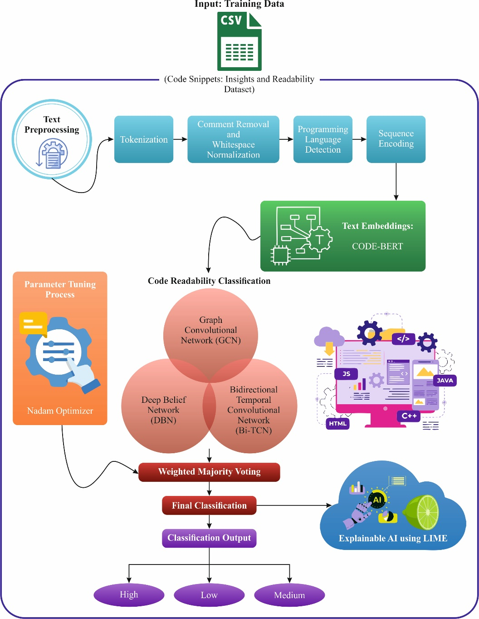
Fig. 1. Overall process of the proposed ECRVR-MVEL approach
Preprocessing: At the initial stage, preprocessing includes tokenization, removing comments or normalizing white space, and detecting language and encoding sequences to clean and standardize raw code for increasing the model performance.
Text Embeddings: CodeBERT embedding model is used to convert raw source code into vector embeddings representation that allows effective code readability assessment.
Weighted Majority Voting Ensemble Model: This voting-based ensemble model integrates GCN, DBN and BiTCN approaches to classify the code into three readability classes, namely high, medium and low levels.
Parameter Tuning Process: The utilization of Nadam optimizer is to improve classification performance and convergence speed of the model.
Explainability Model: A LIME-based explainable approach is used to visualize the transparency of the model.
3.1. Text Preprocessing
This preprocessing is a critical phase for preparing raw source code for efficient examination and subsequent application of ML and DL techniques [21]. While programming languages show semantic rules and structured syntax, traditional NLP models can be carefully adapted. In this method, C++ and Python source codes are key inputs, and a dedicated pre-processing pipeline is used for preserving syntactic integrity whereas improving performance as well as model interpretability.
Tokenization: In the initial phase of preprocessing, raw source code was tokenized to order of useful tokens. Different natural language texts, a code tokenizer treats programming constructs as atomic units. Particularly, keywords (for example, while, if, return, for), identifiers (function names, class names, and variable names), literals (string and numeric constants), operators (logical, relational, and arithmetic), punctuation symbols and delimiters are obtained as separate tokens. Language-specific tokenization is used for ensuring precise parsing of C++ as well as Python syntax, thus preserving both structural and lexical data vital for downstream learning challenges.
Comment Removal and Whitespace Normalization: Source code frequently covers irregular formatting and comments, which are unrelated to functional semantics. For noise reduction and enhancing representation constancy, multi-line as well as single-line comments are optionally eliminated in preprocessing. Moreover, redundant line breaks, excessive whitespace, and unreliable indentation are normalizers. Although indentation has been syntactically important in Python, normalizer is made carefully to retain logical structure. This phase enhances robustness, decreases vocabulary size, and improves learning efficacy without changing program action.
Programming Language Detection: As the framework helps both C++ and Python inputs, an automatic language classification model is used previous to encoding tokens. Language classification is obtained by utilizing file extensions, reserved keyword analysis, and syntactic patterns. It allows the selection of proper tokenization rules and encoding approaches, assuring that language-specific features are captured accurately.
Sequence Encoding: Afterward, tokenization, the extracted tokens are mapped into numerical representations appropriate for model ingestion. All tokens are encoded by employing a vocabulary created from the training corpus, and sequences are truncated or padded to a fixed length to uphold uniform input dimensions. Language-aware embedded were used for capturing syntactic dependency and semantic relations inside the code. Its encoded representation acts as a normalized and structured input for subsequent feature extractors and classifier mechanisms.
3.2. CodeBERT-based Embeddings
Code embedded converts into program code with incessant vector models, allowing the comprehension of logical relations and semantical codes [22]. For efficiently capturing the complexities of code, code embedded to solve dual crucial considerations: (1) Vulnerable code components consist of crucial elements such as conditional judgments as well as variable declarations will take together from other crucial positions. (2) Code statements inside a function were logically and consecutively relevant, need embedds to maintain longer‐distance dependency and uphold semantical precision.
Utilizes CodeBERT as code embedding, employing the multi‐layer Transformer encoded by producing semantical depictions of source code. The multi‐head self‐attention model resides at the heart of CodeBERT that calculates token‐level relations for capturing the variable dependency and control flow data. The model allows CodeBERT to concentrate on crucial code elements efficiently, enabling the feature extraction through different significant areas.
Capturing the longer‐distance relations inside the code, encode position has been integrated into the token embedded of the input layer. To add encode position for the token vectors, the method obtains the capability of best preserving the semantic and structural features, taking logical connections through distant code statements.
$$PE_{(pos,2i)}= sin \left(\frac{pos}{10000^{\frac{2i}{d_{mode1}}}}\right) (1)$$
$$PE_{(pos,2i+1)}= cos \left(\frac{pos}{10000^{\frac{2i}{d_{mode1}}}}\right) (2)$$
3.3. Weighted Voting-based Ensemble Classification
The weighted voting-based ensemble model integrates GCN, DBN, and Bi-TCN for categorizing code readability levels. The decision‐making in the voting approach known as the weighted majority voting ensemble model, wherein weights are decided as per the classifier outcome of all DL classification [23]. In this method, classifications that have shown high outcomes in the prior evaluations are awarded maximal weights that could support to enhance the model execution. The decision‐making method employs the weighted strategy for assuring more consistent classification has more impact on the last decision.
$$WC=\frac{AC}{ΣAN} (3)$$
3.3.1. GCN
In GCN, the embedded vectorization of text and image nodes are upgraded to integrate the connection data from adjacent nodes [24]. Moreover, the weight of edge are decided by the cosine similarity among the sentences and the cropped imageries. Therefore, this method upgrades every node’s data more visibly while the relations among texts and images are nearby. To use three layers of the GCN model; Hence, $l$ implies the values of $1, 2,$ or $3$. While $l=1,$ $x_{i}^{l-1}$ denotes the early embedded obtained via BLIP. In the final layer $(l=L)$ , $x_{i}^{L}$ denotes the ending node embedded for each node $i$, $L$ is 3 for the instances. where, $h_{s,i}^{v}$ depicts the ending image embeds and $h_{s,j}^{t}$ denote texture node embeds$,$ correspondingly, here $s$ implies the index of the subject, $i$ signifies the index of the cropped image, and j denote the index of the sentence. Within a GCN that deliberates on the weights of edges, the relations among sentences and sub‐images were learned to account for local data up to three hops. The last embedds of all nodes exposes data from neighboring text nodes as well as neighboring image nodes. Fig. 2 denotes the structure of GCN technique.
Graph‐level Classification
After attained the final embedded vectors for each node, these are aggregated into a graph‐level embedded vector for the graph‐level categorizations. To use mean pooling, the graph‐level embedded vector has the mean of each node's embedded vectors. The global mean pooling vector for each node and for subject $s$, implies $h_{s}$ as.
$$h_{s}=\frac{1}{2}\left(〈h_{s,i}^{v}〉+〈h_{s,j}^{t}〉\right) (4)$$
Here, $⟨∙⟩$ implies the operation of mean, $h_{s,i}^{v}$ signifies the final image embeds a vector and $h_{s,j}^{t}$ denotes the text node embeds vector, correspondingly.
$$y=Linear\left(h_{s}\right) (5)$$
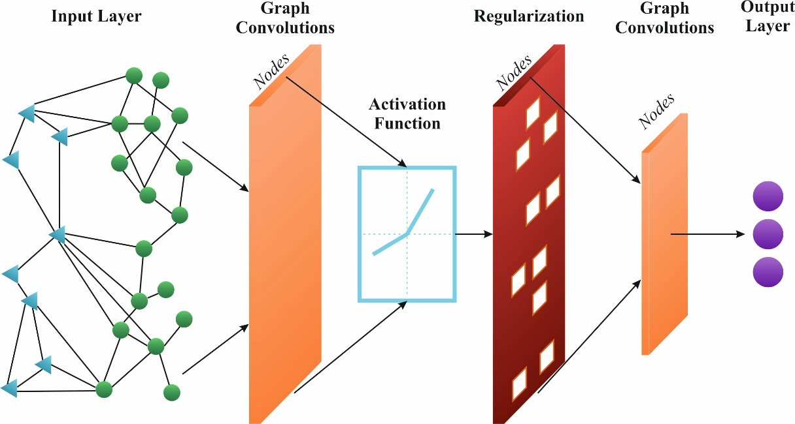
Fig. 2. Structure of GCN technique
3.3.2. DBN
This network offers the initial layer of structure to make an unsupervised hierarchical feature extractor [25]. Thereby, the method contains various layers of RBM that are probabilistic NNs, which learn the model of input information throughout unsupervised training. It enables every layer to gradually abstract characteristics that in turn allow the technique for discovering intricate patterns to distinguish from applications. At this stage, the DBN structure comprises $L$ stacked layers of RBM, let all layers RBM, $for/=1,2,$ $…$ , $L$ contains a visible layer $v,$ and $h$ denotes the equivalent latent layer. These layers were organized by the outcome of all RBM acts as the input to the succeeding layer. This configuration allows the gradual abstraction of feature models, allowing the DBN for learning gradually high‐level and intricate forms of input data. The probabilistic behavior of all RBM layer has been categorized by the joint distribution among the hidden and visible units.
$$P\left(v, h\right)=\frac{1}{Z}ex\left(-E\left(v, h\right)\right) (6)$$
Here, $Z$ denote function of partition and $E(v, h)$ signifies the energy function.
$$E\left(v, h\right)=-v^{T}Wh-b^{T}v-c^{T}h (7)$$
3.3.3. BiTCN
The model is an innovative DL model structure that is intended for improving longer time series forecast [26]. This is structured into 3 major elements: feature fusion layer, residual connections and bidirectional temporal blocks.
Bidirectional Temporal Blocks
This model recollects dilation convolution as a main function. especially backward convolution, which is a significant element of the BiTCN, presents a further pathway, which allows the network to integrate both past dependency and upcoming covariates. The arithmetic model of backward and forward dilated convolutions in the equation:
$$H_{f}\left(t\right)=\sum_{i=0}^{k-1}{h_{f}}\left(i\right)⋅x_{t-d_{m}⋅i} (8)$$
$$H_{b}\left(t\right)=\sum_{i=0}^{k-1}{h_{b}}\left(i\right)⋅x_{t+d_{m}⋅i} (9)$$
Here, $H_{f}(t)$ denotes the forward outcome BiTCN and $H_{b}(t)$ implies the backward outcome of BiTCN, $h_{f}(i)$ signifies the forward component in convolution kernel and $h_{b}(i)$ implies the backward component with convolution kernel, $k$ signifies dimension of kernel, $x_{t}$ represents the input, and $d_{m}⋅i$ implies expansion factor.
Feature Fusion Layer
This layer is intended for combining backward as well as forward outcomes into a unified representation. Its layer assures that the method efficiently utilizes data from both temporal perception, improving the feature extractor and enhancing prediction outcomes. The fused outcome $H(t)$ could be computed in below expression.
$$H_{b}\left(H\left(t\right)=α⋅H_{f}\left(t\right)+\left(1-α\right)⋅H_{b}\left(t\right)\right)=\sum_{i=0}^{k-1}{h_{b}}\left(i\right)⋅x_{t+d_{m}⋅i} (10)$$
Residual Connections
The major impact of residual connection train to stabilize and enable flow of gradient, connecting the input exactly to the outcome of all layers. It protects disappearing gradients in deeper networks and preserves important characteristics from previous layers. The outcome $y_{BiTCN}$ is computed in below:
$$y_{BiTCN}=ReLU\left(H\left(t\right)+x_{t}\right) (11)$$
3.4. Nadam-driven Performance Enhancement
Nadam (Nesterov‐accelerated Adaptive Moment Estimation) is an expansion of the Adam optimization, which combines NAG into the momentum element of Adam [27]. In contrast with standard momentum upgrades, Nadam uses Nesterov’s lookahead approach where the gradient has been calculated after velocity. It enables the optimization for anticipating the additional parameters position, leading to constant upgrade and more responsive system. By incorporating the adaptive moment valuation of Adam with Nesterov momentum, it intends to enhance both convergence speed as well as the general quality of learning techniques, especially in intricate, non‐convex optimizer landscapes. Particularly, $m_{t}$ denote 1st moment and $v_{t}$ denotes 2nd moment at time step $t$.
$$m_{t}=β_{1}⋅m_{t-1}+\left(1-β_{1}\right)⋅g_{t} (12)$$
$$v_{t}=β_{2}⋅v_{t-1}+\left(1-β_{2}\right)⋅g_{t}^{2} (13)$$
Here, $β_{1}$ implies exponential decay rates for 1st moment and $β_{2}$ implies exponential decay rate for 2nd moments, correspondingly. Bias correction has been used to both moment evaluations to account for initializer impacts:
$${\hat{m}}_{t}=\frac{m_{t}}{1-β_{1}^{t}}, {\hat{v}}_{t}=\frac{v_{t}}{1-β_{2}^{t}}, (14)$$
Let, $β_{1}^{t}=(β_{1})^{t}$ and $β_{2}^{t}=(β_{2})^{t}$ and $t$ denotes the number of iterations. Dissimilarly, Nadam applies a lookahead module that integrates the gradient promptly to the upgrade rule.
$$θ_{t+1}=θ_{t}-α⋅(\frac{β_{1}⋅{\hat{m}}_{t}+\frac{\left(1-β_{1}\right)⋅g_{t}}{1-β_{1}^{t}}}{\sqrt{{\hat{v}}_{t}}+e}1 (15)$$
where, $θ_{t}$ implies parameter at iteration $t,$ $α$ denotes rate of learning, and $e$ denote smaller constant for numerical constancy Nadam’s anticipatory actions support the optimization guide sharp curvature more efficiently leading to enhanced convergence for a type of DL challenges.

3.5. LIME based Interpretability Analysis
LIME is a local explanation method and model‐independent for ML techniques, which explains the forecast for a particular example [28]. By perturbing and sampling the example in the feature space, LIME processes a model interpretation about the sample of interest, like a linear regression method. Interpretable models estimate the activities of ML techniques on a local scale and used for explaining the performance.
$$score \left(x_{i}\right)=\frac{Σ\left[f\left(z\right)-f\left(xi\right)\right]}{s*g\left(d\left(z,x_{i}\right)\right)} (16)$$
Here, $x_{i}$ denote feature interest, $z$ denote perturbed sample, f denotes ML technique, $S$ denotes the amount of sample, $g$ implies the function of the kernel, and $d$ signifies distance measures. The signification score metrics the influence of all features. Depending on the involvement of all pixels, LIME build a boundary about the important portion of the input imaging that will have a higher weight to the decision‐making procedure. Fig. 3 signifies the general architecture of XAI approach.
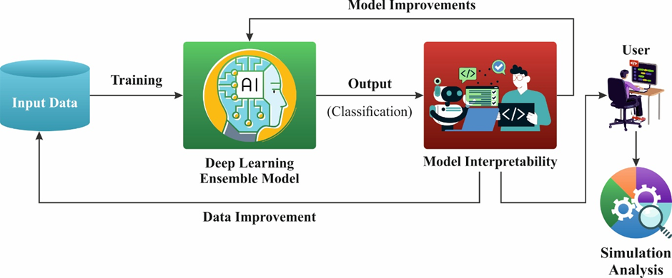
Fig. 3. General Architecture of XAI technique
3.6. Evaluation Metrices
To calculate the performance of entire technique has been classified using numerous balancing metrics for ensuring both statistical strength and reliability.
Accuracy: It is the ratio of properly categorizing the overall conditions.
$$Accuracy=\frac{TP+TN}{TP+TN+FP+FN}×100 (17)$$
Precision: It is determined the quantity of predictable samples that must true one.
$$Precision=\frac{TP}{TP+FP}×100 (18)$$
Recall: It calculates the capability to find true conditions.
$$Recall=\frac{TP}{TP+FN}×100 (19)$$
F1‐score: It describes the harmonic mean of recall and precision, balancing these dual metrics.
$$F1=2×\frac{Precision×Reca11}{Precision+Reca11}×100 (20)$$
Here, the term TN implies true negative, TP implies true positive, FN indicates false negative, and FP means false positives.
AUC (Area Under the ROC Curve): It offers threshold‐independent measurement of discriminative capacity; thus, it can be summarized as the trade‐off among true positive rate (TPR) and false positive rate (FPR) through entire outcome thresholds.
4. Performance Validation
The performance validation of the ECRVR-MVEL techniques could be analysed employing Code Snippets: Insights and Readability dataset [29]. This dataset is a collection of C++ and Python code snippets annotated with various code properties. Table 2 shows the details on dataset.
Table 2 Details of dataset
Category | Python | C++ | Combined Readability Score
Low Readability | 561 | 502 | —
Medium Readability | 560 | 500 | —
High Readability | 560 | 502 | —
Total Samples | 1681 | 1504 | —
Mean | — | — | 3.79
Standard Deviation | — | — | 1.72
Minimum | — | — | -7.19
Maximum | — | — | 7.15
25% (Low) | — | — | 2.81
50% (Medium) | — | — | 4.10
75% (High) | — | — | 5.02

Python Code Dataset
The above dataset gives a complete collection of readability and metrics scores for Python code snippets. Every entry contains information like the Python solutions, difficulty level, loop count, number of lines, code length, comments, cyclomatic complexity, indents, problem title, identifiers, readability score, and line length. The dataset is intended for facilitating the examination of complexity, coding patterns, and readability in Python programming. Table 3 illustrate the details of python dataset
Table 3 Details of python dataset
Problem Title | Python Code | readability | Readability Level
palindrome number | class Solution:  def isPalindrome(self, x: int) -> bool:  y = list(str(x))  return y== list(reversed(y)) | 5.35 | High
single number ii | class Solution:  def singleNumber(self, nums: List[int]) -> int:  return (sum(set(nums))*3-sum(nums))//2 | 4.25 | Medium
majority element ii | class Solution:  def majorityElement(self, nums: List[int]) -> List[int]:  return [v for v in set(nums) if nums.count(v)>math.floor(len(nums)/3)] | 2.305 | Low
C++ Code Dataset
This dataset provides an inclusive set of readability and metrics scores for C++ code snippets. Every record contains information’s like the number of lines, code length, code itself, cyclomatic complexity, comments, loop count, number of indents, readability score, line length, and identifiers. The dataset is made for assisting the analysis of complexity, coding styles, and readability in C++ programming. Table 4 demonstrate the details of python dataset
Table 4 Details of CPP dataset
CPP Data | readability | Readability Level
class Solution {  public:  vector<int> circularPermutation(int n, int start) {  vector<int> ans;  for (int i = 0; i < 1 << n; ++i)  ans.push_back(start ^ i ^ i >> 1);  return ans;  }  }; | 6.175 | High
class Solution {  public:  int titleToNumber(string s) {  return accumulate(begin(s), end(s), 0,  [](int a, int b) { return a * 26 + (b - 'A' + 1); });  }  }; | 3.89 | Medium
class Solution {  public:  int getLastMoment(int n, vector<int>& left, vector<int>& right) {  const int maxLeft = left.empty() ? 0 : *max_element(begin(left), end(left));  const int minRight =  right.empty() ? n : *min_element(begin(right), end(right));  return max(maxLeft, n - minRight);  }  }; | 2.305 | Low

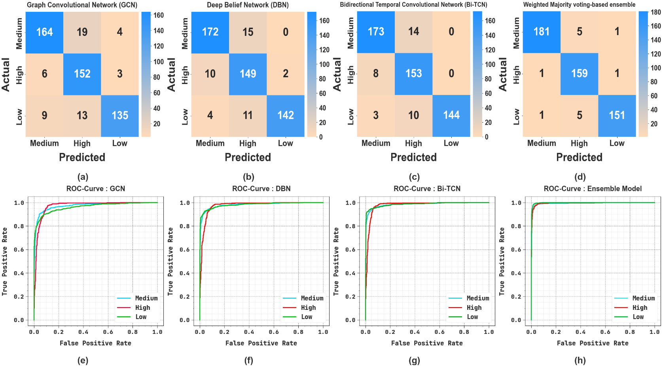
Fig. 4. Confusion matrices and ROC curve of (a, e) GCN, (b, f) DBN, (c, d) Bi-TCN and
(d, h) Ensemble model using python dataset
Fig. 4 demonstrates the confusion matrices and ROC analysis of BiTCN, DBN, GCN and Ensemble techniques. Figs. 4a, 4b, 4c, and 4d exhibits the confusion matrices with precise identification of each classes. Finally, Figs. 4e, 4f, 4g, and 4h exhibits the ROC examination, implying proficient solutions with enhanced ROC analysis for different class labels.
Table 5 and Fig. 5 signify the code classification outcomes on Python data with 70% training split. Depend on the GCN system reaches average value with $acc{ur}_{y}$ of 91.95%, $pre{ci}_{n}$ of 88.20%, $rec{al}_{l}$ of 87.88%, $F1_{score}$of 87.91%, and ${AUC}_{score}$ of 90.92%. Moreover, the DBN method attains average value with $acc{ur}_{y}$ of 94.33%, $pre{ci}_{n}$ of 91.78%, $rec{al}_{l}$ of 91.50%, $F1_{score}$of 91.54%, and ${AUC}_{score}$ of 93.63%. Additionally, the Bi-TCN model reaches average value with $acc{ur}_{y}$ of 95.41%, $pre{ci}_{n}$ of 93.33%, $rec{al}_{l}$ of 93.10%, $F1_{score}$of 93.14%, and ${AUC}_{score}$ of 94.83%. Lastly, the WMVE approach obtains average value with $acc{ur}_{y}$ of 97.11%, $pre{ci}_{n}$ of 95.68%, $rec{al}_{l}$ of 95.64%, $F1_{score}$of 95.65%, and ${AUC}_{score}$ of 96.73%.
Table 5 Code classification results using python data with 70% training
Methods | Classes | $$Acc{ur}_{y}$$ | $$Pre{ci}_{n}$$ | $$Rec{al}_{l}$$ | $$F1_{score}$$ | $${AUC}_{score}$$
Graph Convolutional Network (GCN) | Medium | 91.92 | 88.83 | 85.25 | 87.00 | 90.14
 | High | 91.24 | 83.48 | 92.48 | 87.75 | 91.54
 | Low | 92.69 | 92.29 | 85.89 | 88.97 | 91.07
 | Average | 91.95 | 88.20 | 87.88 | 87.91 | 90.92
Deep Belief Network (DBN) | Medium | 94.73 | 91.91 | 91.42 | 91.67 | 93.84
 | High | 92.60 | 86.11 | 93.23 | 89.53 | 92.76
 | Low | 95.66 | 97.32 | 89.85 | 93.44 | 94.28
 | Average | 94.33 | 91.78 | 91.50 | 91.54 | 93.63
Bidirectional Temporal Convolutional Network (Bi-TCN) | Medium | 95.58 | 93.73 | 92.23 | 92.97 | 94.68
 | High | 93.88 | 88.11 | 94.74 | 91.30 | 94.09
 | Low | 96.77 | 98.16 | 92.33 | 95.15 | 95.71
 | Average | 95.41 | 93.33 | 93.10 | 93.14 | 94.83
Weighted Majority voting-based ensemble(WMVE) | Medium | 97.02 | 95.92 | 94.64 | 95.28 | 96.39
 | High | 96.43 | 93.86 | 95.74 | 94.79 | 96.26
 | Low | 97.87 | 97.26 | 96.53 | 96.89 | 97.55
 | Average | 97.11 | 95.68 | 95.64 | 95.65 | 96.73

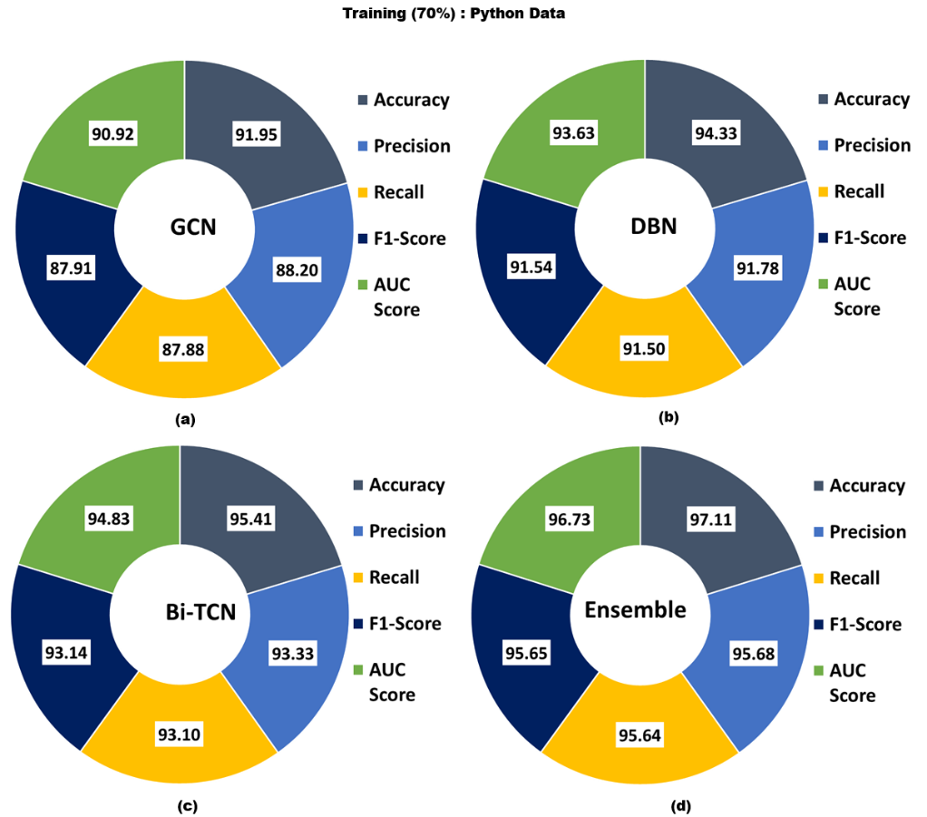
Fig. 5. Classification results on Python data with 70% training split.
Table 6 and Fig. 6 denotes the code classification outcomes on Python data with 30% training split. Depend on the GCN technique reaches average value with $acc{ur}_{y}$ of 92.87%, $pre{ci}_{n}$ of 89.77%, $rec{al}_{l}$ of 89.37%, $F1_{score}$of 89.34%, and ${AUC}_{score}$ of 92.01%. Also, the DBN method attains average value with $acc{ur}_{y}$ of 94.46%, $pre{ci}_{n}$ of 92.08%, $rec{al}_{l}$ of 91.66%, $F1_{score}$of 91.76%, and ${AUC}_{score}$ of 93.74%. Furthermore, the Bi-TCN system obtains average value with $acc{ur}_{y}$ of 95.38%, $pre{ci}_{n}$ of 93.49%, $rec{al}_{l}$ of 93.09%, $F1_{score}$of 93.16%, and ${AUC}_{score}$ of 94.80%. Eventually, the WMVE approach obtains average value with $acc{ur}_{y}$ of 98.15%, $pre{ci}_{n}$ of 97.23%, $rec{al}_{l}$ of 97.24%, $F1_{score}$of 97.21%, and ${AUC}_{score}$ of 97.94%.
Table 6 Code classification results using python data with 30% testing
Methods | Classes | $$Acc{ur}_{y}$$ | $$Pre{ci}_{n}$$ | $$Rec{al}_{l}$$ | $$F1_{score}$$ | $${AUC}_{score}$$
Graph Convolutional Network (GCN) | Medium | 92.48 | 91.62 | 87.70 | 89.62 | 91.49
 | High | 91.88 | 82.61 | 94.41 | 88.12 | 92.55
 | Low | 94.26 | 95.07 | 85.99 | 90.30 | 91.99
 | Average | 92.87 | 89.77 | 89.37 | 89.34 | 92.01
Deep Belief Network (DBN) | Medium | 94.26 | 92.47 | 91.98 | 92.23 | 93.79
 | High | 92.48 | 85.14 | 92.55 | 88.69 | 92.49
 | Low | 96.63 | 98.61 | 90.45 | 94.35 | 94.94
 | Average | 94.46 | 92.08 | 91.66 | 91.76 | 93.74
Bidirectional Temporal Convolutional Network (Bi-TCN) | Medium | 95.05 | 94.02 | 92.51 | 93.26 | 94.53
 | High | 93.66 | 86.44 | 95.03 | 90.53 | 94.03
 | Low | 97.43 | 100.00 | 91.72 | 95.68 | 95.86
 | Average | 95.38 | 93.49 | 93.09 | 93.16 | 94.80
Weighted Majority voting-based ensemble(WMVE) | Medium | 98.42 | 98.91 | 96.79 | 97.84 | 98.08
 | High | 97.62 | 94.08 | 98.76 | 96.36 | 97.93
 | Low | 98.42 | 98.69 | 96.18 | 97.42 | 97.80
 | Average | 98.15 | 97.23 | 97.24 | 97.21 | 97.94
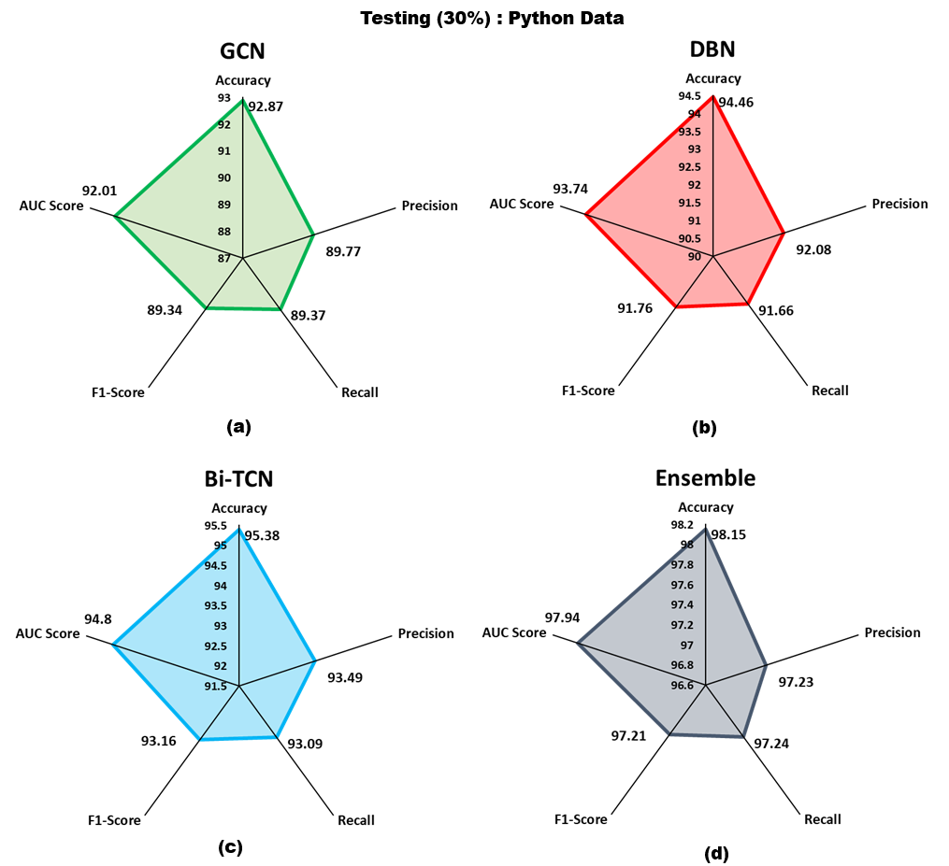
Fig. 6. Classification results on Python data with 30% testing split

Fig. 7 illustrate the training (TRAIN) and validation (VALID) precision curves of ensemble model with python data. TRAIN accuracy improves progressively and attains a better level, suggesting efficient learning and convergence. The VALID accuracy nearly follows the training trend with a stable and small gap, representing minimal overfitting and good generalization. Generally, the steady development and convergence of both curves confirm the reliability and robustness of the proposed technique.
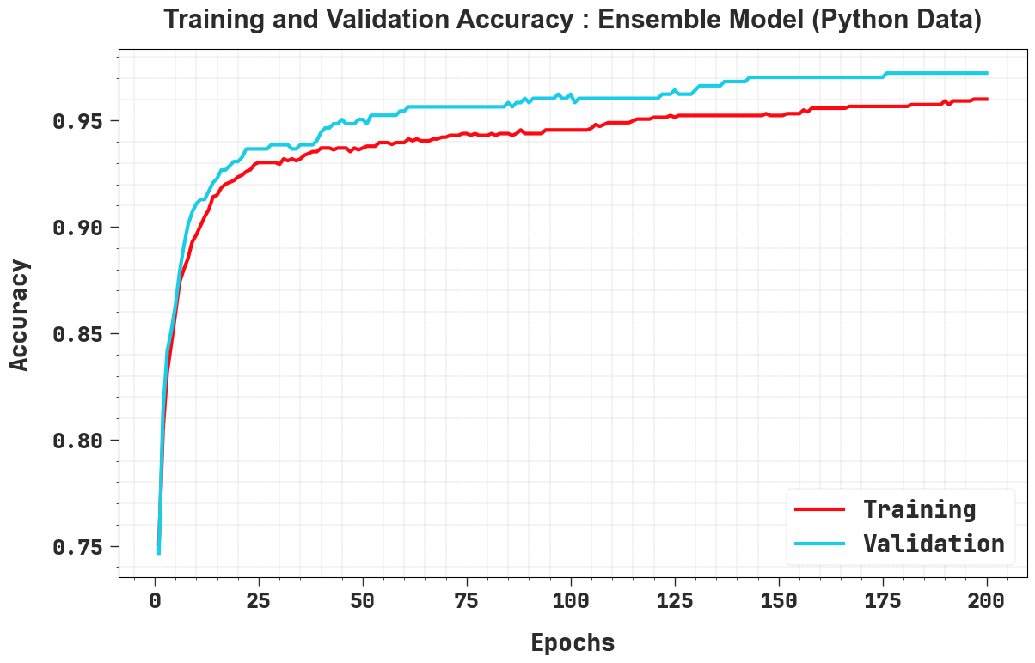
Fig. 7. $Accur_{y}$ curve of ensemble model with python data
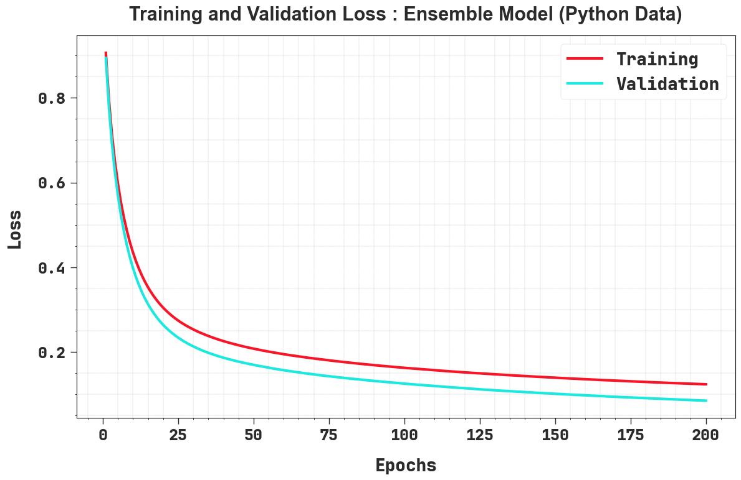
Fig. 8. Loss curve of ensemble model with python data
Fig. 8 exhibits the TRAIN and VALID loss curves of ensemble model with python data. Both losses diminish sharply in the starting epochs, suggesting rapid learning, and then progressively decline in a stable and smooth manner, reflecting efficient convergence. The near alignment among validation and training loss, by only a small reliable gap, recommends strong generalization and minimal overfitting ability. Generally, the stable reduction in loss confirms the efficacy and constancy of the training approach.
To show the higher performance of the ECRVR-MVEL approach employing python dataset, a brief comparison research is shown in Table 7 [30, 31]. The results illustrated, which the Logistic Regression, RF, and DT models has been exhibits lesser classification outcomes. Concurrently, the Bayesian Network, SVM methodologies, Naïve Bayes and has been tried for completing somewhat near classification outcomes. Moreover, the Neural Network system has showed realistic performance with $acc{ur}_{y}$ of 90.11%, $pre{ci}_{n}$ of 83.01%, $rec{al}_{l}$ of 80.60%, and ${F1}_{score}$ of 89.70%. Though, the ECRVR-MVEL method illustrates hopeful performance with $acc{ur}_{y}$ of 98.15%, $pre{ci}_{n}$ of 97.23%, $rec{al}_{l}$ of 97.24%, and ${F1}_{score}$ of 97.21%.
Table 7 Comparative study of ECRVR-MVEL method with existing systems using python data
Python Data
Algorithms | $$Acc{ur}_{y}$$ | Error Rate | $$Pre{ci}_{n}$$ | $$Rec{al}_{l}$$ | $$F1_{score}$$
Decision Tree | 60.40 | 39.60 | 77.98 | 78.88 | 83.39
Logistic Regression | 65.10 | 34.90 | 83.59 | 71.08 | 86.93
Random Forest | 69.20 | 30.80 | 77.25 | 74.93 | 90.43
Naïve Bayes | 88.58 | 11.42 | 89.35 | 90.70 | 86.85
Bayesian Network | 87.02 | 12.98 | 85.17 | 83.13 | 76.42
SVM | 89.62 | 10.38 | 88.43 | 76.42 | 76.12
Neural Network | 90.11 | 9.89 | 83.01 | 80.60 | 89.70
ECRVR-MVEL | 98.15 | 1.85 | 97.23 | 97.24 | 97.21

Fig. 9 exhibits the confusion matrices and ROC investigation of DBN, BiTCN, GCN and Ensemble techniques. Figs. 9a, 9b, 9c, and 9d demonstrate the confusion matrix with precise identification of each class labels. Finally, Figs. 9e, 9f, 9g, 9h shows the ROC examination, illustrate proficient outcomes with superior ROC analysis for numerous classes.
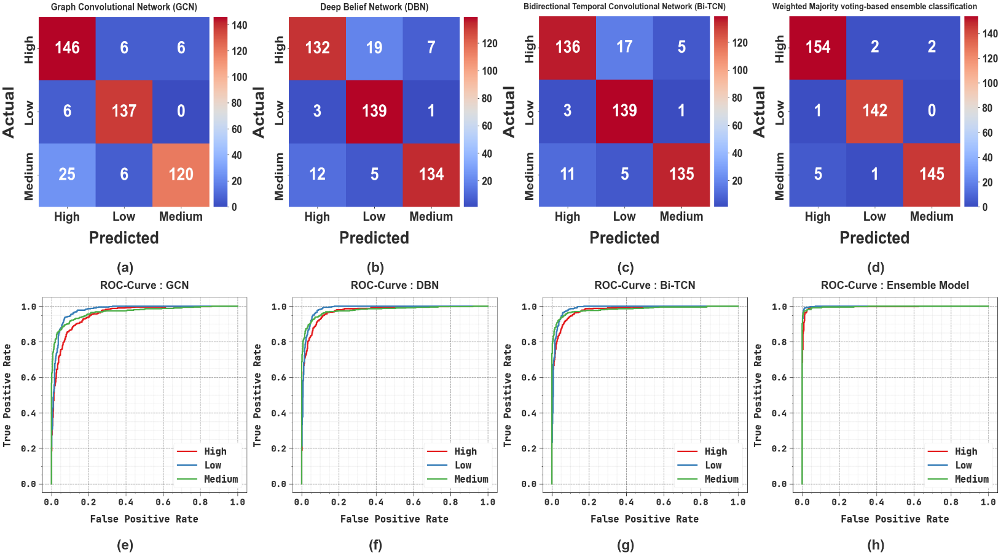
Fig. 9. Confusion matrices and ROC curve of (a, e) GCN, (b, f) DBN, (c, d) Bi-TCN and
(d, h) Ensemble model using CPP data
Table 8 and Fig. 10 illustrate the code classification outcomes on CPP data with 70% training split. Depend on the GCN technique reaches average value with $acc{ur}_{y}$ of 91.06%, $pre{ci}_{n}$ of 87.73%, $rec{al}_{l}$ of 86.60%, $F1_{score}$of 86.52%, and ${AUC}_{score}$ of 89.96%. Similarly, the DBN method attains average value with $acc{ur}_{y}$ of 93.73%, $pre{ci}_{n}$ of 90.73%, $rec{al}_{l}$ of 90.55%, $F1_{score}$of 90.56%, and ${AUC}_{score}$ of 92.93 %. Moreover, the Bi-TCN model reaches average value with $acc{ur}_{y}$ of 94.30%, $pre{ci}_{n}$ of 91.53%, $rec{al}_{l}$ of 91.41%, $F1_{score}$of 91.43%, and ${AUC}_{score}$ of 93.57%. Lastly, the WMVE approach obtains average value with $acc{ur}_{y}$ of 98.04%, $pre{ci}_{n}$ of 97.07%, $rec{al}_{l}$ of 97.05%, $F1_{score}$of 97.04%, and ${AUC}_{score}$ of 97.79%

Table 8 Code classification results using CPP data with 70% training
Methods | Classes | $$Acc{ur}_{y}$$ | $$Pre{ci}_{n}$$ | $$Rec{al}_{l}$$ | $$F1_{score}$$ | $${AUC}_{score}$$
Graph Convolutional Network (GCN) | High | 89.26 | 78.55 | 92.11 | 84.79 | 90.00
 | Low | 92.87 | 87.57 | 92.20 | 89.82 | 92.71
 | Medium | 91.06 | 97.07 | 75.50 | 84.94 | 87.18
 | Average | 91.06 | 87.73 | 86.60 | 86.52 | 89.96
Deep Belief Network (DBN) | High | 92.49 | 87.46 | 89.77 | 88.60 | 91.78
 | Low | 94.39 | 89.68 | 94.43 | 91.99 | 94.40
 | Medium | 94.30 | 95.05 | 87.46 | 91.10 | 92.59
 | Average | 93.73 | 90.73 | 90.55 | 90.56 | 92.93
Bidirectional Temporal Convolutional Network (Bi-TCN) | High | 93.16 | 88.79 | 90.35 | 89.57 | 92.43
 | Low | 94.77 | 90.64 | 94.43 | 92.50 | 94.69
 | Medium | 94.96 | 95.15 | 89.46 | 92.22 | 93.59
 | Average | 94.30 | 91.53 | 91.41 | 91.43 | 93.57
Weighted Majority voting-based ensemble(WMVE) | High | 97.24 | 94.33 | 97.37 | 95.83 | 97.28
 | Low | 98.67 | 98.05 | 98.05 | 98.05 | 98.52
 | Medium | 98.19 | 98.82 | 95.73 | 97.25 | 97.58
 | Average | 98.04 | 97.07 | 97.05 | 97.04 | 97.79

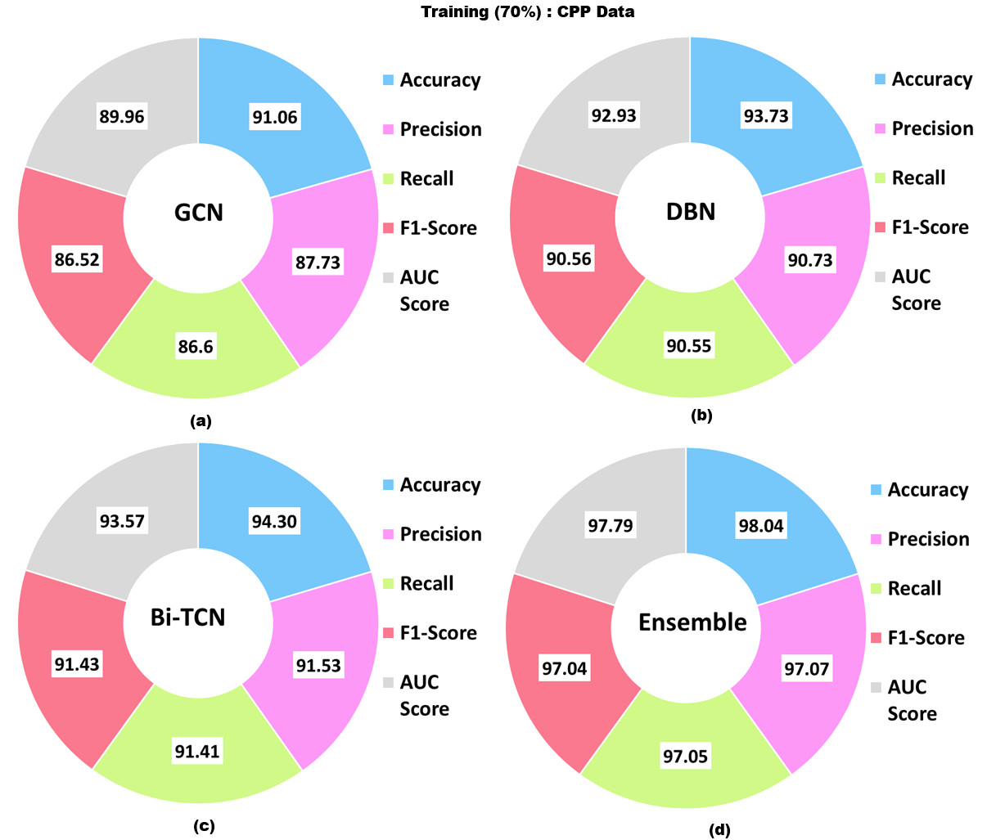
Fig. 10. Classification results on CPP data with 70% training split
Table 9 and Fig. 11 signifies the code classification outcomes on CPP data with 30% training split. Depend on the GCN approach reaches average value with $acc{ur}_{y}$ of 92.77%, $pre{ci}_{n}$ of 89.89%, $rec{al}_{l}$ of 89.23%, $F1_{score}$of 89.21%, and ${AUC}_{score}$ of 91.88%. Also, the DBN method attains average value with $acc{ur}_{y}$ of 93.07%, $pre{ci}_{n}$ of 89.81%, $rec{al}_{l}$ of 89.83%, $F1_{score}$of 89.62%, and ${AUC}_{score}$ of 92.33%. Furthermore, the Bi-TCN model accomplishes average value with $acc{ur}_{y}$ of 93.81%, $pre{ci}_{n}$ of 90.92%, $rec{al}_{l}$ of 90.89%, $F1_{score}$of 90.74%, and ${AUC}_{score}$ of 93.13%. Eventually, the WMVE approach obtains average value with $acc{ur}_{y}$ of 98.38%, $pre{ci}_{n}$ of 97.61%, $rec{al}_{l}$ of 97.60%, $F1_{score}$of 97.59%, and ${AUC}_{score}$ of 98.19%.
Table 9 Code classification results using CPP data with 30% testing
Methods | Classes | $$Acc{ur}_{y}$$ | $$Pre{ci}_{n}$$ | $$Rec{al}_{l}$$ | $$F1_{score}$$ | $${AUC}_{score}$$
Graph Convolutional Network (GCN) | High | 90.49 | 82.49 | 92.41 | 87.16 | 90.93
 | Low | 96.02 | 91.95 | 95.80 | 93.84 | 95.96
 | Medium | 91.81 | 95.24 | 79.47 | 86.64 | 88.74
 | Average | 92.77 | 89.89 | 89.23 | 89.21 | 91.88
Deep Belief Network (DBN) | High | 90.93 | 89.80 | 83.54 | 86.56 | 89.22
 | Low | 93.81 | 85.28 | 97.20 | 90.85 | 94.72
 | Medium | 94.47 | 94.37 | 88.74 | 91.47 | 93.04
 | Average | 93.07 | 89.81 | 89.83 | 89.62 | 92.33
Bidirectional Temporal Convolutional Network (Bi-TCN) | High | 92.04 | 90.67 | 86.08 | 88.31 | 90.66
 | Low | 94.25 | 86.34 | 97.20 | 91.45 | 95.04
 | Medium | 95.13 | 95.74 | 89.40 | 92.47 | 93.71
 | Average | 93.81 | 90.92 | 90.89 | 90.74 | 93.13
Weighted Majority voting-based ensemble(WMVE) | High | 97.79 | 96.25 | 97.47 | 96.86 | 97.71
 | Low | 99.12 | 97.93 | 99.30 | 98.61 | 99.16
 | Medium | 98.23 | 98.64 | 96.03 | 97.32 | 97.68
 | Average | 98.38 | 97.61 | 97.60 | 97.59 | 98.19

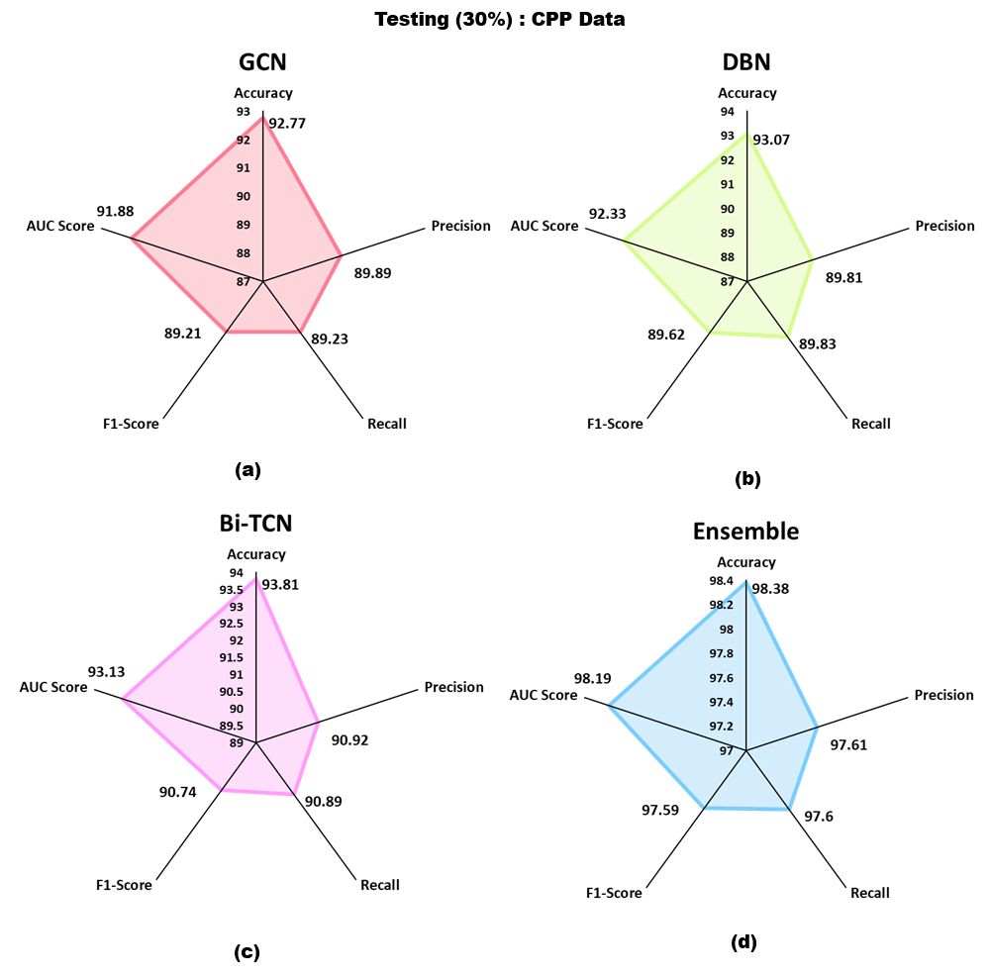
Fig. 11. Classification results on CPP data with 30% testing split
Fig. 12 illustrate the training (TRAIN) and validation (VALID) precision curves of ensemble model with CPP data. TRAIN accuracy improves progressively and attains a better level, representing efficient learning and convergence. The VALID accuracy nearly follows the training trend with a stable and small gap, signifying minimal overfitting and good generalization. Generally, the steady development and convergence of both curves confirm the reliability and robustness of the presented technique.

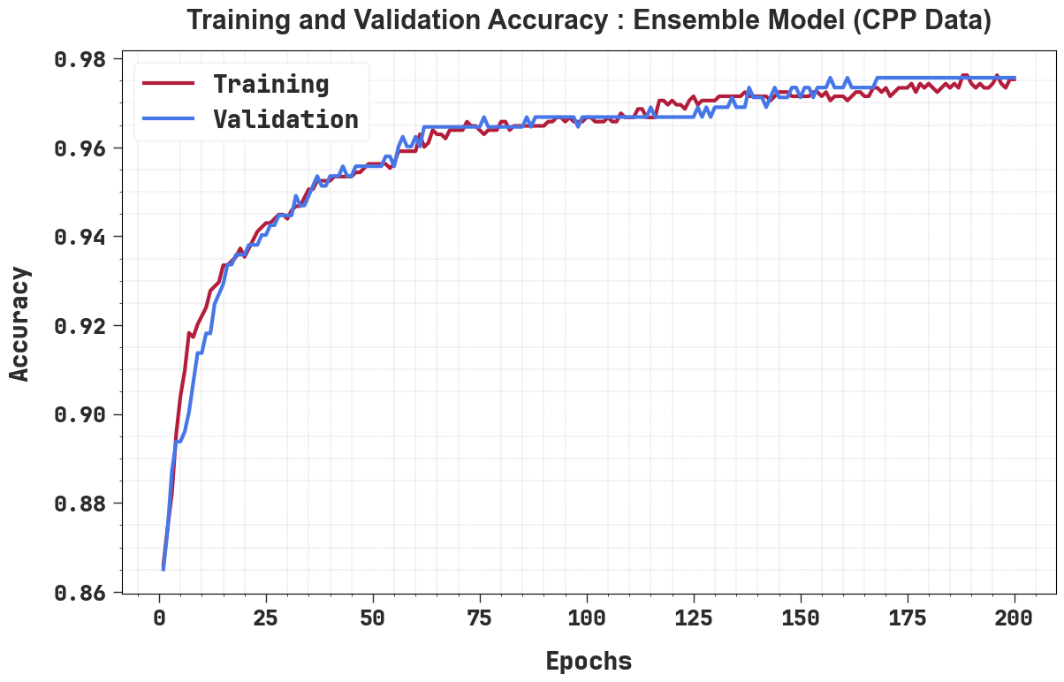
Fig. 12. $Accur_{y}$ curve of ensemble model with CPP data

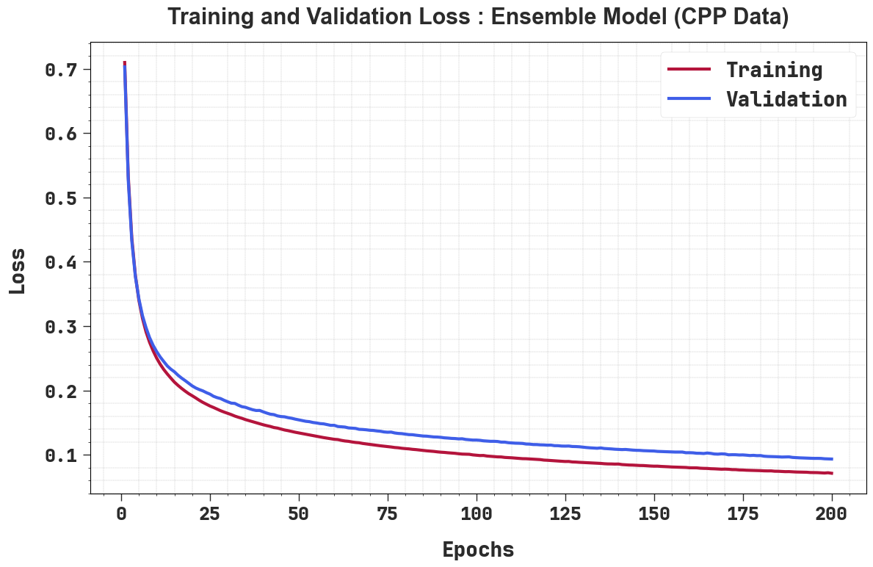
Fig. 13. Loss curve of ensemble model with CPP data
Fig. 13 shows the TRAIN and VALID loss curves of ensemble model with CPP data. Both losses decrease sharply in the starting epochs, representing rapid learning, and then progressively decline in a stable and smooth manner, reflecting efficient convergence. The near alignment among training and validation loss, with only a small reliable gap, recommends strong generalization and minimal overfitting capability. Generally, the stable reduction in loss confirms the efficiency and stability of the training method.
The comparative analysis of the ECRVR-MVEL method employing other present techniques with CPP data is specified in Table 10. The simulation outcomes inferred that the ECRVR-MVEL approach has showed higher performances. Depend on $acc{ur}_{y}$, the ECRVR-MVEL system has superior $acc{ur}_{y}$ of 98.38% where the Logistic Regression, Random Forest, Naïve Bayes, Bayesian Network, SVM, DT, and NN methods have minimal $acc{ur}_{y}$ of 92.84%, 69.23%, 78.04%, 94.58%, 73.20%, 76.00%, and 88.58%, correspondingly. Lastly, depend on ${F1}_{score}$, the ECRVR-MVEL approach has a higher ${F1}_{score}$ of 97.59% in the Logistic Regression, DT, NB, Bayesian Network, SVM, Random Forest, and Neural Network models have smaller ${F1}_{score}$ of 90.54%, 91.07%, 90.58%, 78.37%, 88.43%, 74.97%, and 85.78%, respectively.
Table 10 Comparative study of ECRVR-MVEL method with existing systems using CPP data
CPP Data
Algorithms | $$Acc{ur}_{y}$$ | Error Rate | $$Pre{ci}_{n}$$ | $$Rec{al}_{l}$$ | $$F1_{score}$$
Decision Tree | 92.84 | 7.16 | 90.61 | 80.56 | 90.54
Logistic Regression | 69.23 | 30.77 | 69.26 | 83.17 | 91.07
Random Forest | 78.04 | 21.96 | 73.55 | 72.22 | 90.58
Naïve Bayes | 94.58 | 5.42 | 73.54 | 69.54 | 78.37
Bayesian Network | 73.20 | 26.80 | 86.09 | 92.89 | 88.43
SVM | 76.00 | 24.00 | 80.98 | 79.90 | 74.97
Neural Network | 88.58 | 11.42 | 85.35 | 87.77 | 85.78
ECRVR-MVEL | 98.38 | 1.62 | 97.61 | 97.60 | 97.59

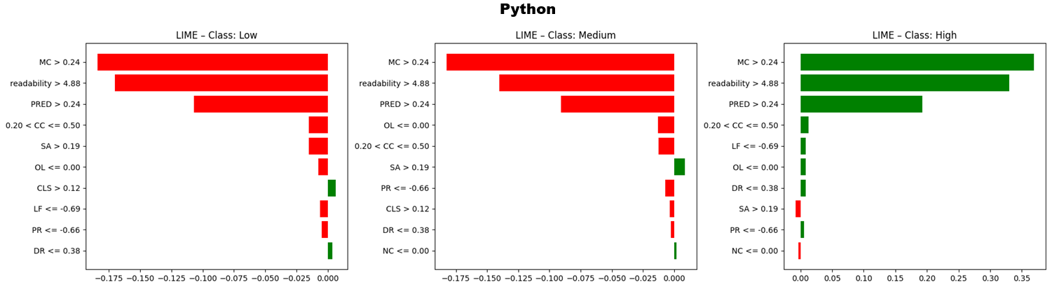
Fig. 14. LIME model with python data
Fig. 14 shows LIME-based explanations of Python code readability forecasts for Low, Medium, and High classes. Every bar demonstrate a feature’s impact on the prediction, with red bars reducing and green bars improving the probability of the class. For Low and Medium readability, features such as readability > 4.88 and MC > 0.24 powerfully drive predictions to such classes, while for better readability, the same features definitely contribute, and another metrics have minor negative impacts.
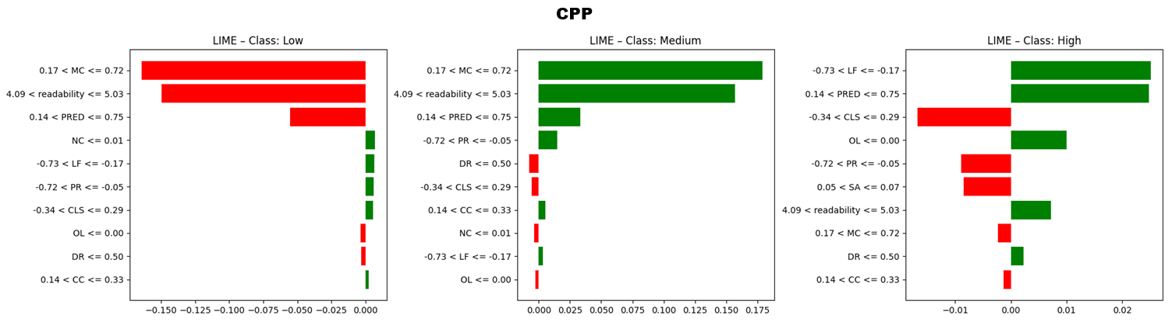
Fig. 15. LIME model with CPP data
Fig. 15 illustrate LIME-based explanations for the CPP approach over three classes: Low, Medium, and High. For Class Low, features like PRED and readability powerfully push predictions to Low (red bars), while features like NC have slight positive contributions (green bars). In the readability, Class Medium and PRED positively affect predictions, while CLS somewhat reduces probability. For Class High, features like readability and PRED favor the class, while SA and CLS negatively influence it. These values highlighted the betterment of the proposed model over other models.
5. Conclusion
In this paper, we have presented the ECRVR-MVEL approach to design an interpretable methodology for code readability analysis that improves the quality of code. Primarily, the proposed model preprocesses the input code that contains four stages like tokenization, removal of comments or normalization of white space and detecting languages. Furthermore, the CodeBERT is employed for transforming raw code into vector representations, allowing effective text embeddings for a classification model. For classification, a weighted majority voting ensemble classification incorporates GCN, DBN and BiTCN for classifying code readability into high, medium and low levels. Additionally, the Nadam is implemented to boost the execution of the code readability classification model. Ultimately, the LIME is applied to visualize the interpretability and transparency of the model. An extensive experimental outcome is carried out to assure the significance of the ECRVR-MVEL approach. A brief comparison of outcomes reported the promising solutions of the ECRVR-MVEL model through other existing models.
Data Availability Statement: The data that support the findings of this study are openly available in Kaggle repository at https://www.kaggle.com/datasets/paakhim10/code-snippets-insights-and-readability/data, reference number [29].
References
- Siino, M., Parisi, E., Barchi, F., Acquaviva, A. and Bartolini, A., 2026. A transformer-based approach for source code classification for heterogeneous device mapping. Engineering Applications of Artificial Intelligence, 163, p.112987.
- Komolov, S., Mazzara, M. and Bajwa, I.S., 2026. Design Pattern Prediction From Source Code Using LLM–Based Feature Engineering and SVM Classification. IET Software, 2026(1), p.7163249.
- Mi, Q., Xiao, Z., Zhan, Y., Tao, L. and Zhang, J., 2025. Towards Explainable Code Readability Classification With Graph Neural Networks. Journal of Software: Evolution and Process, 37(9), p.e70048.
- Barrameda, R.B. and Ballera, M.A., 2025. Enhancing Code Quality: A CNN-Based Approach for Readability Classification and Bug Localization in Programming. In Computer and Electrical Engineering (pp. 87-96). IOS Press.
- Liang, W., Zeng, Y., Zheng, H.T., Wang, J., Lin, H., Kim, H.G., An, B., Wei, Z. and Xu, Y., 2025, June. Repository-Level Code Smell Detection Based on Multi-Scale Code Information and LLM Assistance. In 2025 International Joint Conference on Neural Networks (IJCNN) (pp. 1-8). IEEE.
- Amin, M.F.I., Watanobe, Y., Rahman, M.M. and Shirafuji, A., 2025. Source code error understanding using bert for multi-label classification. IEEE Access.
- Mock, M., Borsani, T., Di Fatta, G. and Russo, B., 2025, April. Optimizing deep learning models to address class imbalance in code comment classification. In 2025 IEEE/ACM International Workshop on Natural Language-Based Software Engineering (NLBSE) (pp. 45-48). IEEE.
- Harel, R.E., Kadosh, T., Hasabnis, N., Mattson, T., Pinter, Y. and Oren, G., 2025. Pragformer: data-driven parallel source code classification with transformers. International Journal of Parallel Programming, 53(1), p.2.
- Sergeyuk, A., Lvova, O., Titov, S., Serova, A., Bagirov, F. and Bryksin, T., 2024. Assessing consensus of developers' views on code readability. arXiv preprint arXiv:2407.03790.
- Park, K.I., Johnson, J., Peterson, C.S., Yedla, N., Baysinger, I., Aponte, J. and Sharif, B., 2024. An eye tracking study assessing source code readability rules for program comprehension. Empirical Software Engineering, 29(6), p.160.
- Chen, Y., Ding, Z., Alowain, L., Chen, X. and Wagner, D., 2023, October. Diversevul: A new vulnerable source code dataset for deep learning-based vulnerability detection. In Proceedings of the 26th International Symposium on Research in Attacks, Intrusions and Defenses (pp. 654-668).
- Michailoudis, A., Diamantopoulos, T. and Symeonidis, A.L., 2023, July. Towards Readability-Aware Recommendations of Source Code Snippets. In ICSOFT (pp. 688-695).
- Simoes, I.R.D.S. and Venson, E., 2025. Measuring how changes in code readability attributes affect code quality evaluation by Large Language Models. arXiv preprint arXiv:2507.05289.
- Vitale, A., Guglielmi, E., Oliveto, R. and Scalabrino, S., 2025. Personalized Code Readability Assessment: Are We There Yet?. arXiv preprint arXiv:2503.07870.
- Álvarez-Fidalgo, D. and Ortin, F., 2025. CLAVE: A deep learning model for source code authorship verification with contrastive learning and transformer encoders. Information Processing & Management, 62(3), p.104005.
- Segedinac, M., Savić, G., Zeljković, I., Slivka, J. and Konjović, Z., 2024. Assessing code readability in Python programming courses using eye‐tracking. Computer Applications in Engineering Education, 32(1), p.e22685.
- Fawareh, H., Al-Shdaifat, H.M., Al-Refai, M., Fawareh, F.A. and Khouj, M., 2024, December. Investigates the Impact of AI-generated Code Tools on Software Readability Code Quality Factor. In 2024 25th International Arab Conference on Information Technology (ACIT) (pp. 1-5). IEEE.
- Gorchakov, A.V., Demidova, L.A. and Sovietov, P.N., 2023. Analysis of program representations based on abstract syntax trees and higher-order markov chains for source code classification task. Future Internet, 15(9), p.314.
- Tang, W., Tang, M., Ban, M., Zhao, Z. and Feng, M., 2023. CSGVD: A deep learning approach combining sequence and graph embedding for source code vulnerability detection. Journal of Systems and Software, 199, p.111623.
- Tashtoush, Y., Abu-El-Rub, N., Darwish, O., Al-Eidi, S., Darweesh, D. and Karajeh, O., 2023. A notional understanding of the relationship between code readability and software complexity. Information, 14(2), p.81.
- Rahman, S., Koana, U.A. and Hoque, E., 2024. RefineCode: Enhancing Code Quality Through Actionable Code Review Recommendations and Intelligent Issue Resolution.
- Zou, Z., Jiang, T., Wang, Y., Xue, T., Zhang, N. and Luan, J., 2025. Code vulnerability detection based on augmented program dependency graph and optimized CodeBERT. Scientific Reports, 15(1), p.39301.
- Javidan, S.M., Ampatzidis, Y., Banakar, A., Asefpour Vakilian, K. and Rahnama, K., 2025. An intelligent group learning framework for detecting common tomato diseases using simple and weighted majority voting with deep learning models. AgriEngineering, 7(2), p.31.
- Lee, B., Bang, J.U., Song, H.J. and Kang, B.O., 2025. Alzheimer’s disease recognition using graph neural network by leveraging image-text similarity from vision language model. Scientific Reports, 15(1), p.997.
- Kauser. Sk, H. and Anu. V, M., 2025. Hybrid deep learning model for accurate and efficient android malware detection using DBN-GRU. PloS one, 20(5), p.e0310230.
- Du, P., Zhang, X., Chen, T. and Yang, W., 2025. An Interpretable Hybrid System Using Temporal Convolutional Network and Informer Model for Carbon Price Prediction. Systems, 13(11), p.1011.
- Sayın, K.A., Gürsoy, N.K., Yolcu, T. and Gürsoy, A., 2025. On the Synergy of Optimizers and Activation Functions: A CNN Benchmarking Study. Mathematics, 13(13), p.2088.
- Gupta, R.K., 2025. Interpretable AI-Enabled Model for Skin Cancer Diagnosis using LIME. Procedia Computer Science, 260, pp.3-11.
- https://www.kaggle.com/datasets/paakhim10/code-snippets-insights-and-readability/data
- Duijn, M., Kucera, A. and Bacchelli, A., 2015, May. Quality questions need quality code: Classifying code fragments on stack overflow. In 2015 IEEE/ACM 12th Working Conference on Mining Software Repositories (pp. 410-413). IEEE.
- Tashtoush, Y., Abu-El-Rub, N., Darwish, O., Al-Eidi, S., Darweesh, D. and Karajeh, O., 2023. A notional understanding of the relationship between code readability and software complexity. Information, 14(2), p.81.

