**Internship Task 1 Report - Ethical Hacking**

Name: Bharat Nama

Date: 04 August 2025

Internship: Elevate Labs - Cybersecurity Intern

# Step 1: Find Your IP Address

Command:

ip a

Output:

My IP: 192.168.130.129/24

# Step 2: Network Scan using Nmap

Command:

nmap -sS -oN scan_results.txt 192.168.130.129/24

Live Hosts Found:

* 192.168.130.1
* 192.168.130.2
* 192.168.130.129
* 192.168.130.254

# Step 3: Banner Grabbing

Command:

nmap -sV -oN banner_scan.txt 192.168.130.2

Result:

* Open Port: 53/tcp
* Service: domain (DNS)
* State: filtered
* MAC Address: 00:50:56:F4:07:6A (VMware)
* 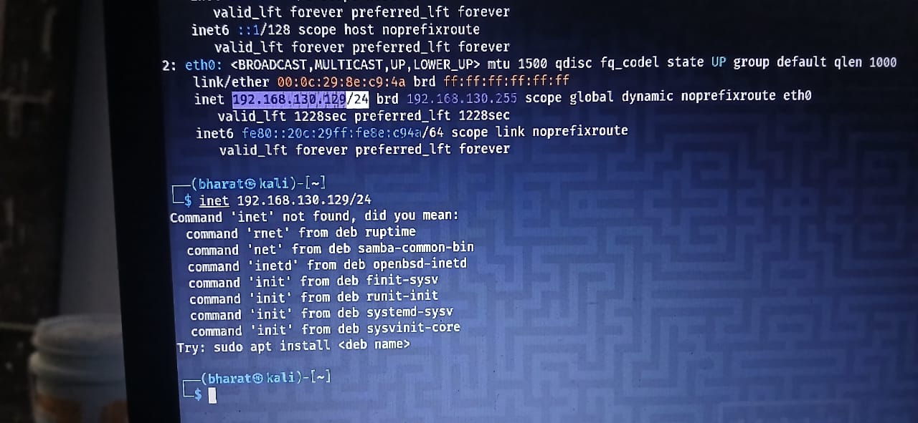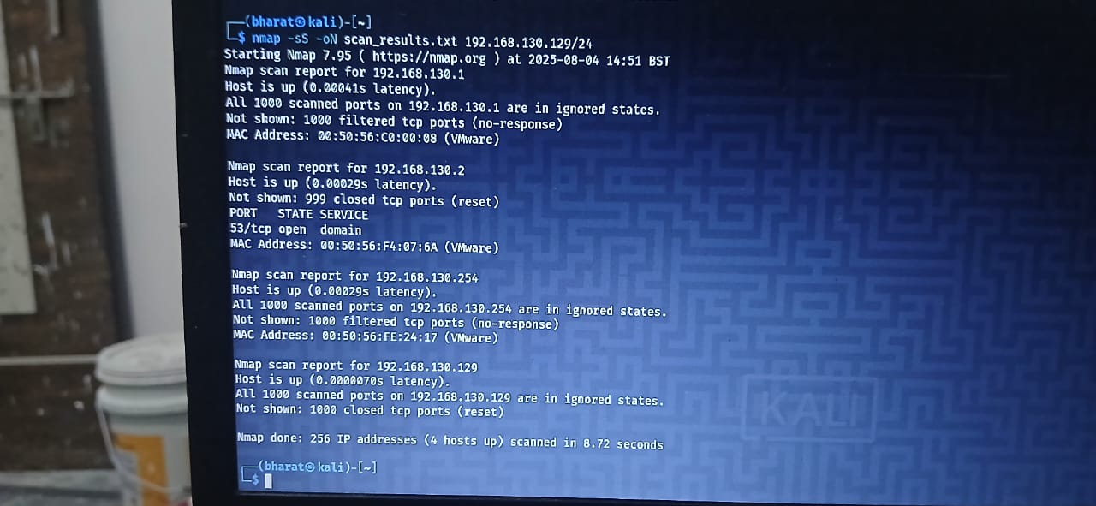A computer screen with a blue and white screen

  AI-generated content may be incorrect.