EXPERIMENT-7

NAME-BHARAT UID-24BDA70052 DOE-02-09-2026

Aim of the Experiment

Implement a secure backend system with JWT-based authentication, role-based access control, token lifecycle management, and encrypted storage for sensitive third-party credentials.

Objective of the Experiment

To implement a secure backend system using Spring Security, JWT-based authentication, and Role-Based Access Control (RBAC) to protect APIs, manage access tokens, and encrypt sensitive credentials using AES encryption.

Theory

Spring Security is a Java framework used to secure backend applications and APIs. JWT (JSON Web Token) is used for user authentication, allowing users to access protected APIs using a valid token. The JWT authentication filter intercepts requests and validates the token before allowing access.
Role-Based Access Control (RBAC) restricts access according to user roles, such as USER and ADMIN. Access tokens are short-lived, while refresh tokens are used to generate new access tokens after expiry. HTTP-only cookies help protect tokens from JavaScript access.
AES (Advanced Encryption Standard) is a symmetric encryption algorithm used to protect sensitive information, such as OAuth tokens, before storing it in a database. Token rotation replaces old refresh tokens with new ones to improve security.
Together, JWT, Spring Security, RBAC, encryption, and token lifecycle management provide a secure and reliable backend system.

Procedure

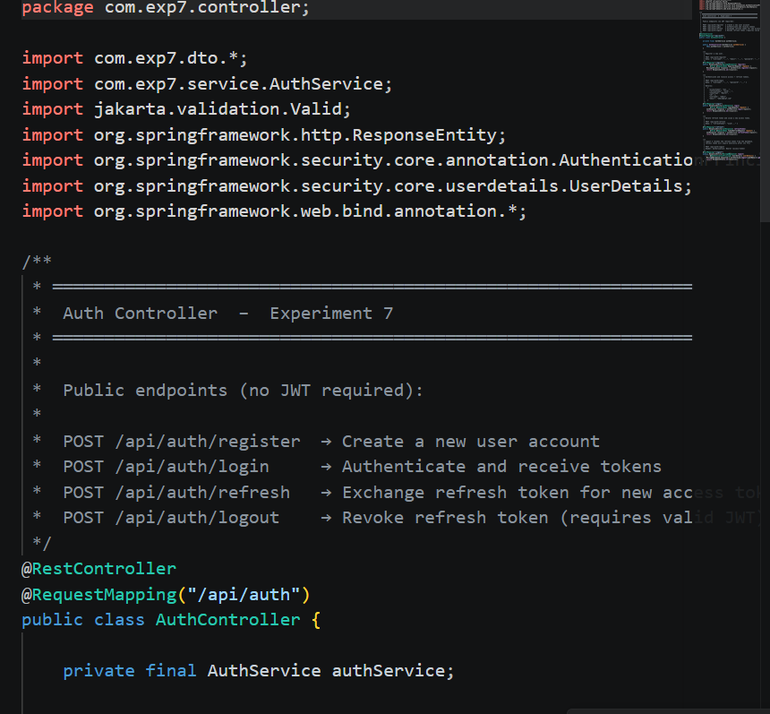

Results

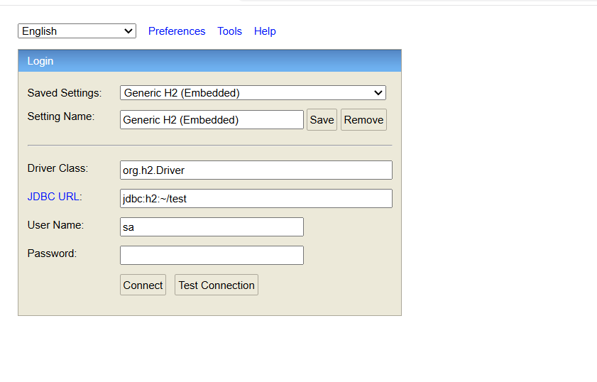
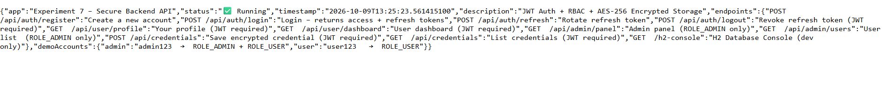

Conclusion
In this experiment, we learned how to develop a secure backend system using Spring Boot and Spring Security. We studied JWT (JSON Web Token) authentication to verify users and protect APIs from unauthorized access. We also learned about Role-Based Access Control (RBAC), which allows different users to access different features according to their roles, such as USER and ADMIN. Furthermore, we understood the importance of access and refresh tokens for managing user sessions securely. We studied HTTP-only cookies to help protect tokens and AES encryption to securely store sensitive information, such as third-party OAuth credentials. Token rotation was also covered to improve security by replacing old refresh tokens with new ones. Overall, this experiment helped us understand how authentication, authorization, token management, and encryption work together to protect backend applications. These techniques are essential for developing secure, reliable, and scalable applications in real-world environments.

.Learning Outcomes
- Learned to implement JWT-based authentication to verify users and secure backend APIs.
- Understood Spring Security and its role in protecting APIs from unauthorized access.
- Learned to implement Role-Based Access Control (RBAC) to assign permissions to different users.
- Understood the use of access tokens and refresh tokens for secure session management.
- Learned how HTTP-only cookies help protect sensitive tokens from JavaScript access.
- Understood AES encryption for securely storing sensitive credentials in a database.
- Learned the importance of token rotation and token expiry in improving backend security.
- Understood how authentication, authorization, and encryption work together to build secure and reliable backend applications.
- Evaluation Grid

 | MARKS | TOTAL
APPROACH |  | 4
IMPLEMENT |  | 8
OUTPUT & RESULT |  | 6
VIVA |  | 12

