USPTO Patent Downloader PoC
Technical Architecture, Validation Results, and Path to an M365 Copilot Agent

Current validated capability Given an inventor name, the program searches every inventor position, downloads complete USPTO grant PDFs, downloads only pending publications when no grant exists, writes a machine-readable manifest, and creates an inventor-specific ZIP.

Prepared for internal proof-of-concept planning
Status date: August 16, 2026

Contents
Section | Topic
1 | Executive summary
2 | Business objective and scope
3 | Current solution architecture
4 | Detailed workflow
5 | USPTO interfaces and data model
6 | Document-selection strategy
7 | Rate limiting, reliability, and resume behavior
8 | Output package and manifest
9 | Validation results
10 | Current limitations and open decisions
11 | Target M365 Copilot architecture
12 | Implementation roadmap
13 | Operating guide
14 | Security and governance
15 | References

Reading guide Sections 3 through 9 document the working Go proof of concept. Sections 11 through 14 describe the transition to a company-shareable M365 Copilot agent.

1. Executive summary
The proof of concept validates an end-to-end method for identifying United States patent records by inventor and packaging the relevant complete patent documents. The operator supplies an inventor name. The program searches the USPTO Open Data Portal across every named-inventor position, captures application metadata, chooses the complete grant whenever a grant exists, chooses the complete published application only when the application has not been granted, and builds a ZIP package.
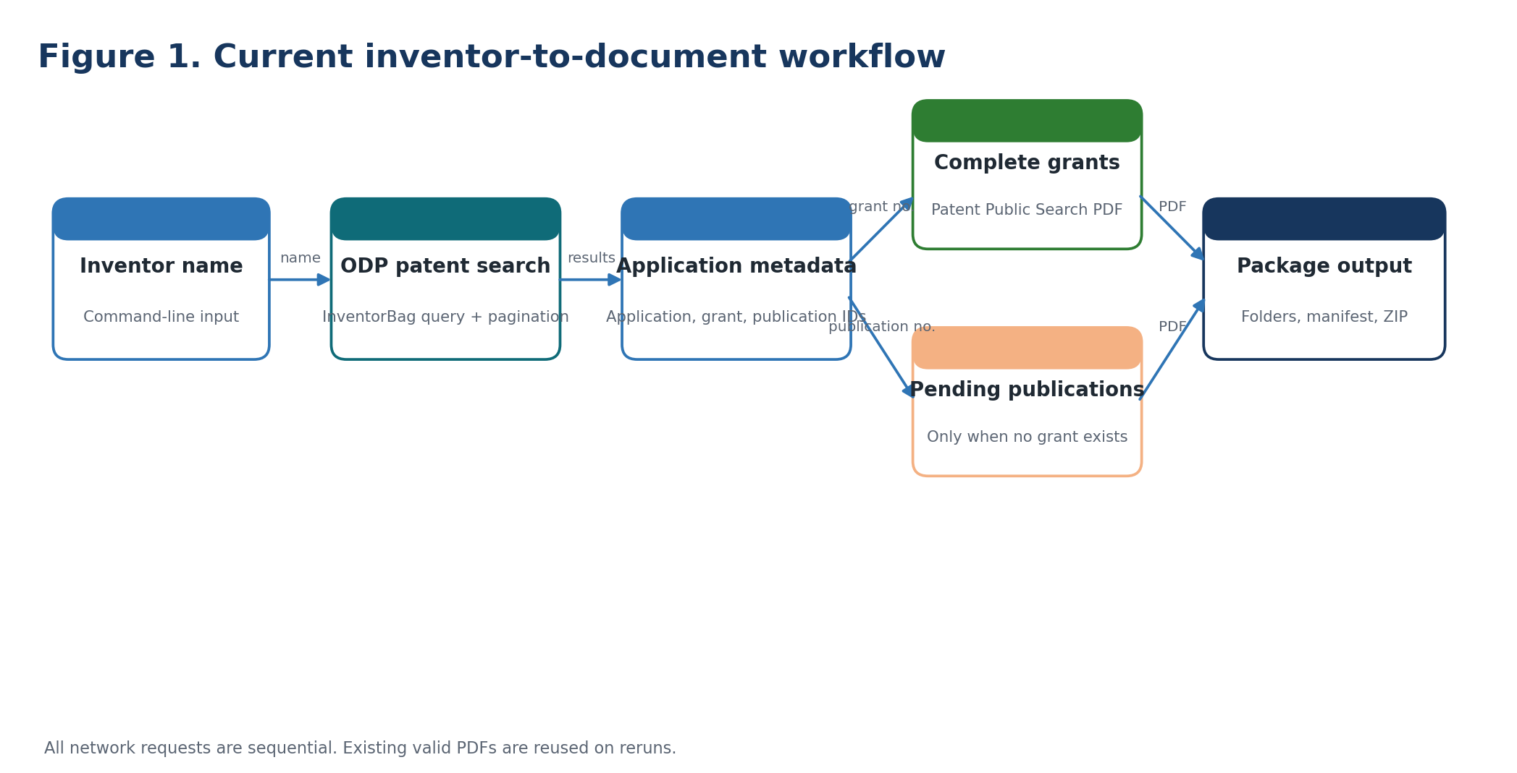
The validated workflow separates metadata discovery from complete-document retrieval.
Capability | Status | Evidence
Inventor search across all inventor positions | Working | Uses inventorBag.inventorNameText rather than first-inventor matching.
Search pagination | Working | Processes result pages in batches of 100.
Complete grant retrieval | Working | Uses patent numbers with the USPTO Patent Public Search image service.
Pending-publication retrieval | Working | Uses earliest publication number only when no grant exists.
Request pacing and retry | Working | Sequential requests, minimum delay, Retry-After support, exponential backoff.
Resume behavior | Working | Valid existing PDFs are reused; partial files use .part suffix.
Manifest and ZIP | Working | Inventor-specific JSON manifest and ZIP package.
M365 Copilot distribution | Planned | Requires centrally hosted action and agent publishing.

2. Business objective and scope
The intended user experience is simple: a company employee asks an M365 Copilot agent for an inventor portfolio and receives counts plus a downloadable ZIP. The ZIP should contain one relevant complete US patent document per application: the issued patent when granted, or the published application while pending.

Primary business questions
- How many distinct US patents have been granted to the named inventor?
- How many US applications remain pending?
- Which complete documents support those counts?
- Can the results be shared as one auditable package?

PoC boundaries
In scope | Deferred
US Patent File Wrapper metadata and US complete PDFs | Foreign-office family consolidation
Named-inventor search across all inventor positions | Claim-scope comparison between continuations
Grant-first document selection | Production retention and legal-hold policies
ZIP and JSON manifest | Enterprise-scale job queue and monitoring
Three-inventor internal PoC | Broad tenant-wide production rollout

3. Current solution architecture
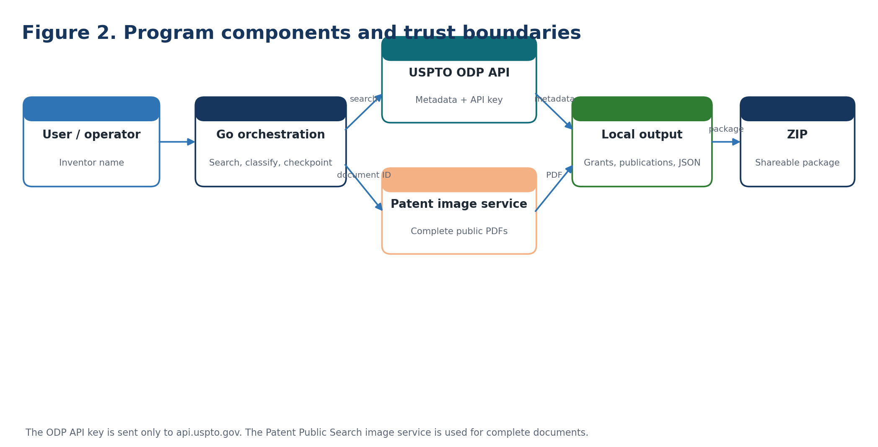
Current program components and external service boundaries.
The Go application coordinates two distinct USPTO services. The ODP API supplies inventor-search results and bibliographic metadata. The Patent Public Search image endpoint supplies complete document PDFs by grant number or publication number. This division avoids downloading dozens of prosecution-history PDFs for each application.
Component | Responsibility | Key input | Key output
Command-line entry point | Accept inventor name and start job | Inventor name | Execution context
ODP client | Search inventor records and paginate | ODP API key, query | Application metadata
Classifier | Choose grant or pending publication | Patent and publication IDs | Selected document ID
Rate limiter | Serialize and pace network calls | Request stream | Controlled request timing
PDF downloader | Retrieve and validate complete PDFs | Document number | Validated PDF
Manifest writer | Checkpoint results after each application | Application state | manifest.json
ZIP builder | Package selected documents | Output directory | Inventor ZIP

4. Detailed workflow
Step | Behavior
1. Normalize input | Trim the inventor name and create a filesystem-safe folder name.
2. Validate configuration | Require USPTO_API_KEY before making an ODP request.
3. Search metadata | Query applicationMetaData.inventorBag.inventorNameText with an exact quoted name.
4. Paginate | Retrieve up to 100 results per page until the count is exhausted.
5. Deduplicate applications | Use application number as the map key.
6. Classify document | Prefer patentNumber. Use earliestPublicationNumber only when patentNumber is empty.
7. Resume or download | Validate existing PDF header. Otherwise download to a temporary .part file.
8. Checkpoint | Rewrite the manifest atomically after each application.
9. Package | Create a ZIP containing the selected grants, pending publications, and manifest.
10. Report | Print counts, failures, manifest path, and ZIP path.

Selection principle The program counts legal records, not patent families. Every distinct issued patent number remains a distinct grant. Family consolidation is postponed because continuation and divisional records can carry distinct claims.

5. USPTO interfaces and data model
Interface | Purpose | Authentication | Relevant fields
ODP patent search | Find applications where the person is a named inventor | X-API-Key | applicationNumberText, inventorBag, patentNumber, earliestPublicationNumber, status fields
Patent Public Search image PDF | Retrieve complete grant or publication PDF | Public endpoint in current PoC | Numeric patent or 11-digit publication number
ODP continuity | Potential future family analysis | X-API-Key | Parent and child application relationships
Patent File Wrapper documents | Discovery and prosecution history; no longer used for final package | X-API-Key | Document codes, identifiers, download options

Core metadata mapping
ODP field | Use
ApplicationNumberText | Unique application key and audit reference
ApplicationMetaData.InventorBag | Matches inventor regardless of order
ApplicationMetaData.PatentNumber | Signals an issued US patent and drives grant PDF retrieval
ApplicationMetaData.EarliestPublicationNumber | Drives pending-publication retrieval after removing US prefix and kind code
ApplicationMetaData.ApplicationStatusDescriptionText | Planned input for precise pending/abandoned classification
ApplicationMetaData.GrantDate | Report and selection metadata

6. Document-selection strategy
The initial implementation filtered the File Wrapper document list for EGRANT.PDF. That worked for newer eGrants but missed older grants. A discovery run then downloaded every PDF option to identify the available codes. The discovery run proved that File Wrapper records contain extensive prosecution history and are unsuitable for the final compact package.
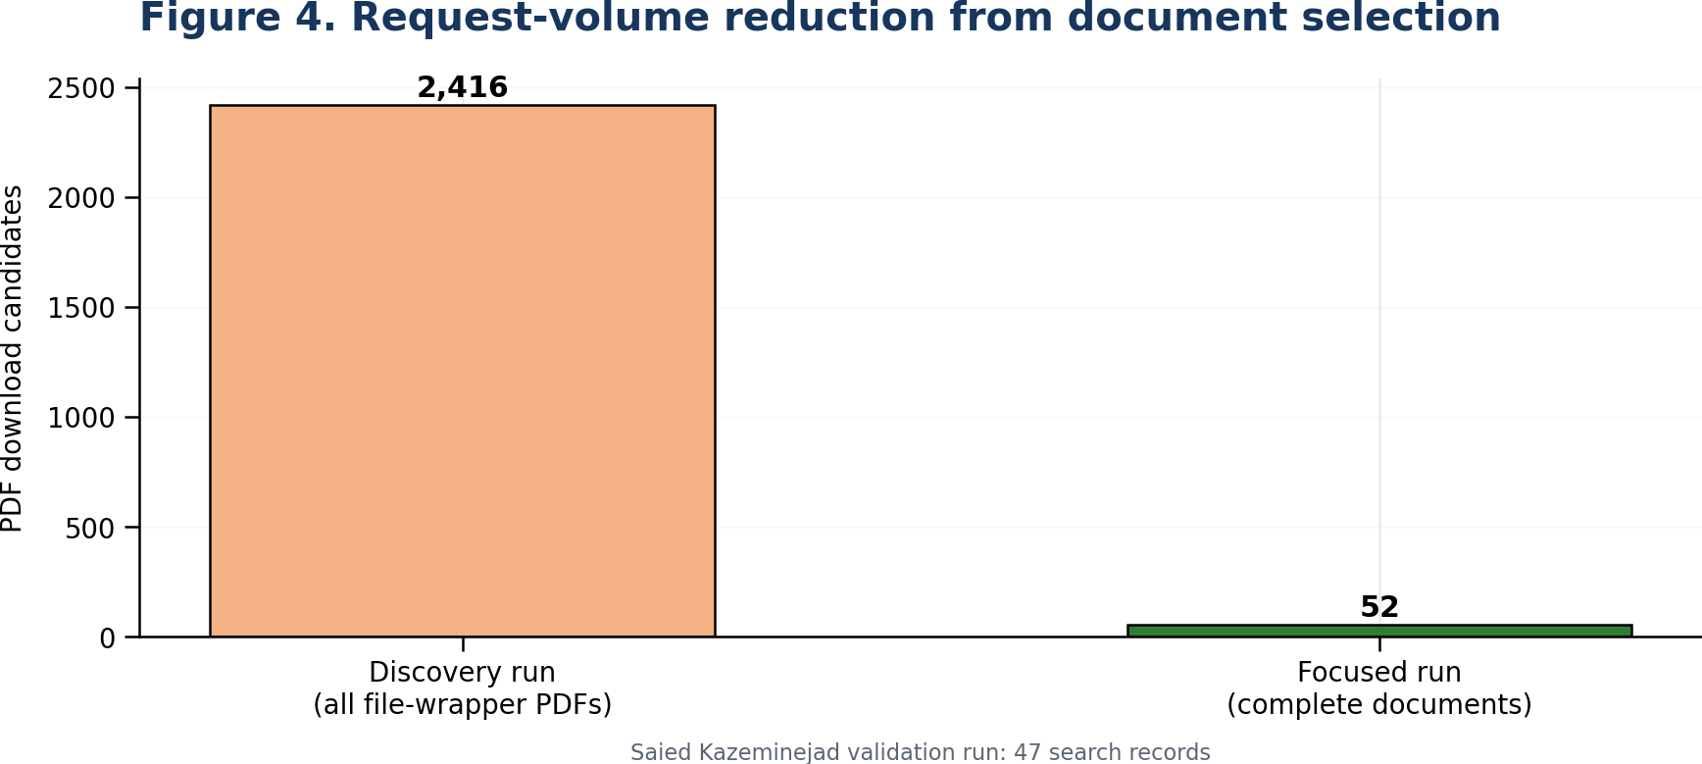
The focused strategy reduces candidate PDF downloads from 2,416 to 52 for the validation inventor.
Condition | Action | Manifest status
Patent number exists | Download or reuse complete grant; remove same-application publication copy | grant: downloaded/existing; publication: superseded_by_grant
No patent number; publication number exists | Download or reuse complete published application | publication: downloaded/existing
Neither identifier exists | Retain metadata only | not_available
Download fails after retries | Retain failure and continue | failed + error

Publication-number normalization
The ODP value includes a country prefix and kind code, for example US20100227567A1. The image service expects the 11-digit publication number, 20100227567. A corrected parser removes the US prefix and trailing kind code without appending the numeric part of A1.

7. Rate limiting, reliability, and resume behavior
Control | Implementation | Purpose
Single active request | No worker pool or parallel downloads | Comply with one-request burst behavior for a key
Minimum pacing | 750 ms between request starts | Reduce burst pressure
429 handling | Honor Retry-After; minimum 5-second wait | Recover from throttling
Backoff | 5, 10, 20, 40, then up to 60 seconds plus jitter | Avoid immediate retry loops
Retry limit | Five retries for 429 and server errors | Bound execution
Partial file protection | .part suffix and atomic rename | Avoid treating interrupted files as complete
PDF validation | Require %PDF- file signature | Reject HTML/error bodies
Checkpointing | Atomic manifest rewrite after each application | Preserve progress
Resume | Skip existing, nonempty, valid PDFs | Make reruns efficient

Operational rule Only one process should use the same USPTO API key at a time. A second simultaneous run can generate 429 responses even when each process is internally sequential.

8. Output package and manifest
Each inventor receives a stable output root outside the source repository. This keeps generated PDFs and ZIPs separate from Git history and allows repeated runs without deleting unrelated results.
Path | Contents
~/patent-data/<Inventor>/Complete_Patent_Documents/Grants/ | One complete PDF for each distinct grant
~/patent-data/<Inventor>/Complete_Patent_Documents/Publications/ | Only published applications without grants
~/patent-data/<Inventor>/Complete_Patent_Documents/manifest.json | Counts, metadata, status, source URL, local path, errors
~/patent-data/<Inventor>/<Inventor>_Complete_Patent_Documents.zip | Shareable package

Manifest model
Object | Selected fields
Summary | Inventor, search results, applications processed, grant/publication counts, failures, paths, timestamp
Application | Application number, patent number, publication number, title, first inventor, grant/publication dates
Grant result | Normalized number, source value, status, URL, local file, error
Publication result | Normalized number, source value, status, URL, local file, error

9. Validation results
Metric | Discovery run | Focused run | Current grant-first run
Inventor search records | 47 | 47 | 47
Applications processed | 47 | 47 | 47
PDF candidates | 2,416 | 52 | 44 grants plus only ungranted publications
Successful PDFs | 2,408 | 52 | Validation inventor: 44 grants
Failures | 8 rate-limit errors | 0 | 0 in validated focused run
Package content | Prosecution history | 44 grants + 8 duplicate publications | One current complete document per application

Validated outcomes for Saied Kazeminejad
- 47 search records were returned across all inventor positions.
- 44 distinct patent numbers produced 44 complete grant PDFs.
- 8 complete publication PDFs were successfully retrieved during validation.
- All 8 publications belonged to applications that also had grants, so the current grant-first rule marks them superseded and removes them from the final package.
- Three metadata records lacked a downloadable US grant or US publication identifier in the search response.

10. Current limitations and open decisions
Area | Current position | Next decision
Pending count | No-grant records are not automatically treated as pending | Use application status descriptions to classify pending, abandoned, and closed records
Name ambiguity | Exact name query can include namesakes or variants | Add normalized name review and optional location/assignee filters
PCT records | Recorded but not downloaded as US documents | Report separately; decide whether to retrieve WO publications
Family deduplication | Disabled for primary counts | Optional analytical metric only
Historical retention | Files remain in user output folder | Set storage and cleanup policy for hosted agent
Access control | Local operator controls output | Use company identity and authorized storage in hosted design

11. Target M365 Copilot agent architecture
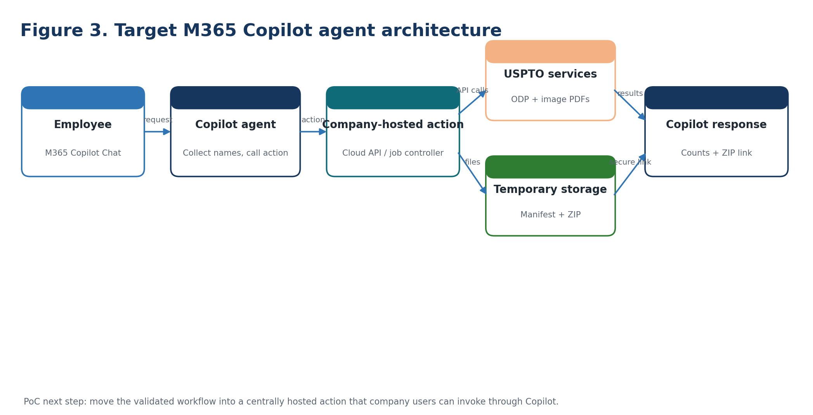
Target architecture for a company-shareable M365 Copilot agent.
The local Go workflow is the validated engine. To make the capability available to other company users, the engine should run behind a centrally hosted action. The Copilot agent gathers inventor names, submits a job, receives counts and a secure ZIP link, and presents the result in M365 Copilot Chat.
Layer | Responsibility
M365 Copilot agent | Understand the user request, gather inventor names, invoke the action, explain results
Copilot action / connector | Send a structured request and receive job status plus file link
Hosted patent service | Run the validated search, classification, download, manifest, and ZIP workflow
Secret store | Hold the ODP API key outside prompts and source code
Temporary file store | Host ZIP for a limited period with company-authorized access
Monitoring | Record job ID, requester, timing, counts, failures, and expiration

12. Implementation roadmap
Phase | Deliverable | Acceptance criterion
1. Freeze PoC baseline | Tagged source and test inventor package | Three inventor runs produce valid manifests and ZIPs
2. Status classification | Granted, pending-published, pending-unpublished, abandoned, PCT | Counts match manual spot checks
3. Cloud action | HTTPS endpoint for inventor list | Returns job ID and secure ZIP URL
4. Copilot agent | Published internal agent with one action | Employee request returns counts and link
5. Guardrails | Authentication, authorization, retention, quota handling | Approved internal pilot
6. Pilot review | Usage and accuracy report | Decision on production rollout

Minimum action contract
Direction | Payload
Request | inventors[], includeManifest, requestId
Response | jobId, status, grantedCount, pendingPublishedCount, unavailableCount, zipFileName, secureDownloadUrl, expiresAt

13. Operating guide

Current command-line PoC
Run command go run . "Inventor Name"

Check | Command or expected result
API key available | USPTO_API_KEY is present in the process environment
Output location | ~/patent-data/<Inventor>/
Manifest review | Confirm counts, failures, and statuses
ZIP review | List archive members and spot-open PDFs
Rerun behavior | Existing valid PDFs should show as existing rather than downloading again
Concurrency | Do not start another job with the same key until the first finishes

Git checkpoints
Checkpoint | Meaning
aa7db8d / v0-working-zip | Original working inventor search, eGrant download, and ZIP
3ca01a6 | Generated artifacts removed from source repository
Recommended next tag | Complete grants, grant-first pending-publication logic, pacing, retries, and resume

14. Security and governance
Risk | Current PoC control | Hosted-agent control
API key disclosure | Environment variable | Managed secret store; service identity access
Unauthorized package access | Local filesystem permissions | Company identity, short-lived link, access logging
Excess retention | Manual cleanup | Automatic expiration and deletion
Rate-limit contention | Single local process | Central job scheduler and per-key serialization
Result accuracy | Manifest and manual review | Status classifier tests, audit fields, sampled QA
Sensitive metadata in logs | Minimal console output | Structured logs with approved fields only

Credential note The API key previously entered in chat should be rotated before a centrally hosted implementation. The production service should read the replacement key only from an approved secret store.

15. References
Source | URL | Use in this PoC
USPTO Open Data Portal API rate limits | https://data.uspto.gov/apis/api-rate-limits | Sequential same-key calls, burst limit, rate guidance, 429 handling, weekly quotas.
USPTO Patent File Wrapper API dataset description | https://catalog.data.gov/dataset/open-data-portal-odp-patent-file-wrapper-pfw-api-search-application-data-continuity-docume | Search, application data, continuity, documents, and related endpoints.
USPTO eGrants and eCertificates of Correction | https://www.uspto.gov/patents/apply/patent-center/egrants | Electronic patent grants and availability beginning April 18, 2023.
USPTO Patent Center document description list | https://www.uspto.gov/patents/apply/filing-online/efs-info-document-description | Official document-code descriptions.
USPTO Patent Document Authority Files | https://www.uspto.gov/patents/search/patent-document-authority-files | Separate pre-grant publication and patent-grant document collections.
patent-dev/uspto-odp Go client | https://github.com/patent-dev/uspto-odp | Go wrapper used for ODP search and metadata access.

End of document

