Q.1 Prompt for amount, interest rate and no. of years and calculate simple interest.

Ans.

// java script function code

function si() {
var amount = prompt("Please enter your amount");
var rate = prompt("Please enter your rate");
var time = prompt("Please enter your time");
var si;
if (amount != null && rate!=null && time!=null) {
si=(amount*rate*time)/100;

document.getElementById("demo").innerHTML =
"Simple Intrest is " + si;
}
}

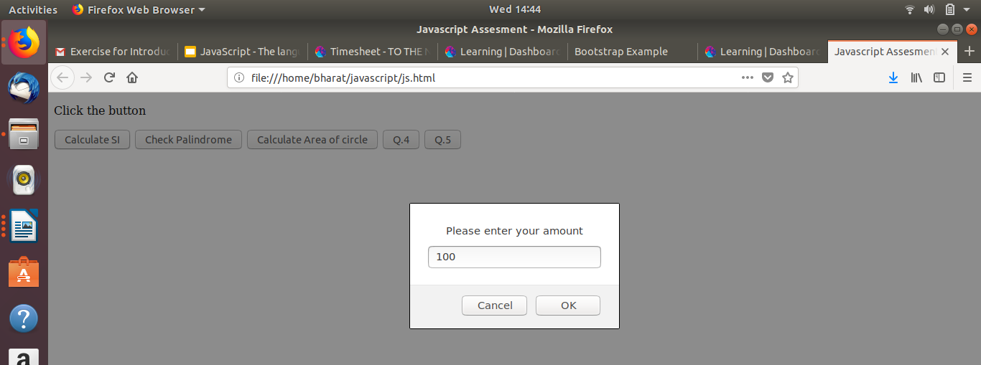
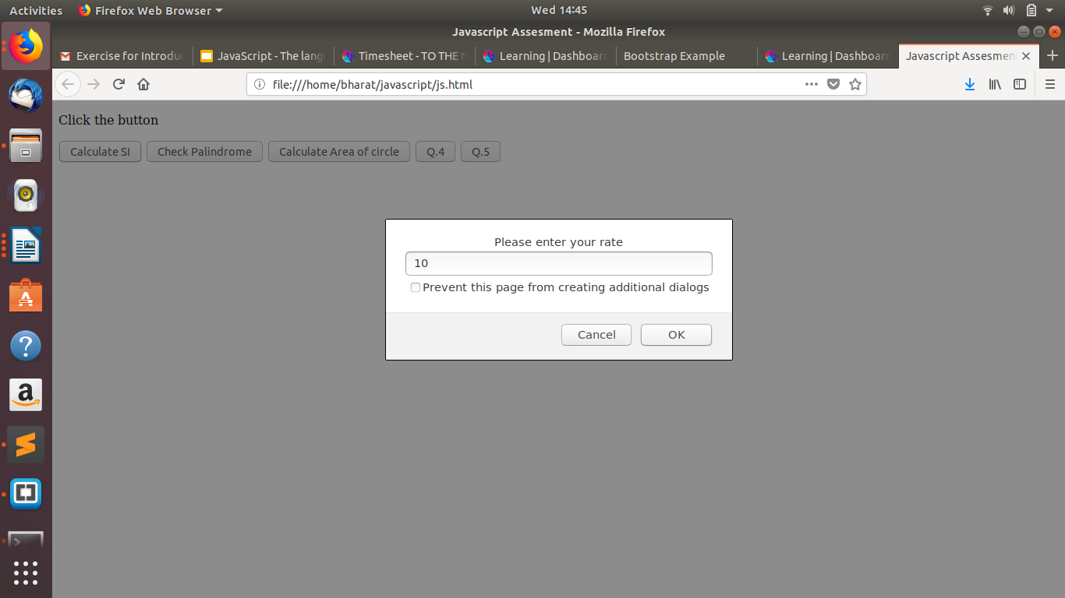

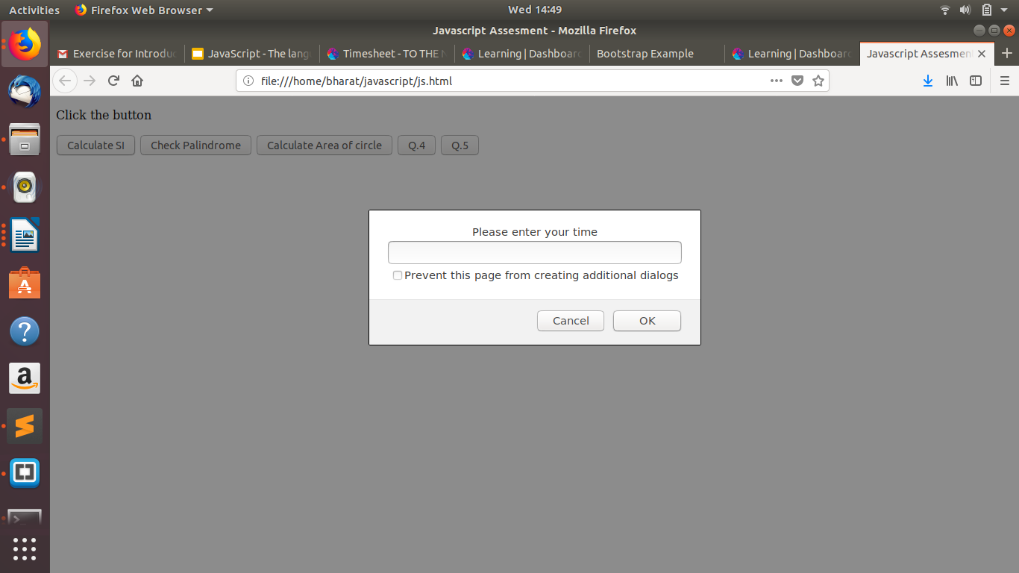

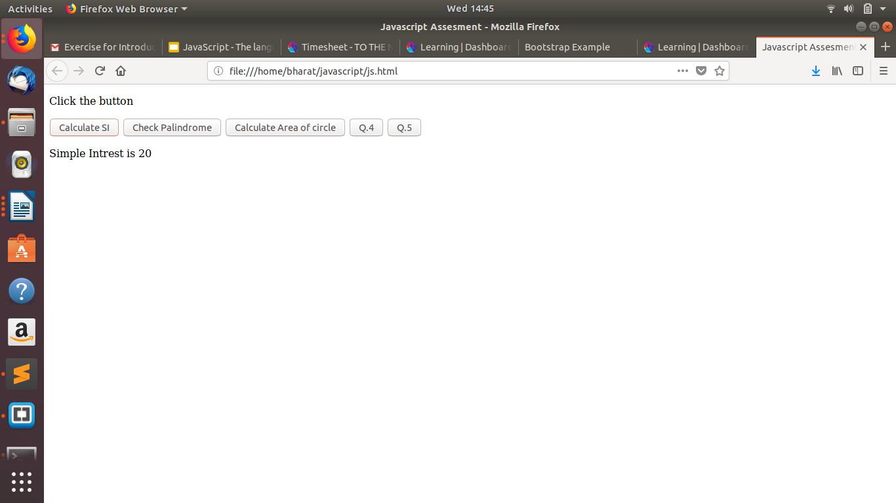

Q.2 is palindrome string
Ans.

//javascript function code

function palindrom(s){
s = s.toString();
var f = true; l = s.length/2, len = s.length -1;
for(var i=0; i < l; i++){
if(s[i] != s[len - i]){
f = false;
break;
}
}
return f;

}

}
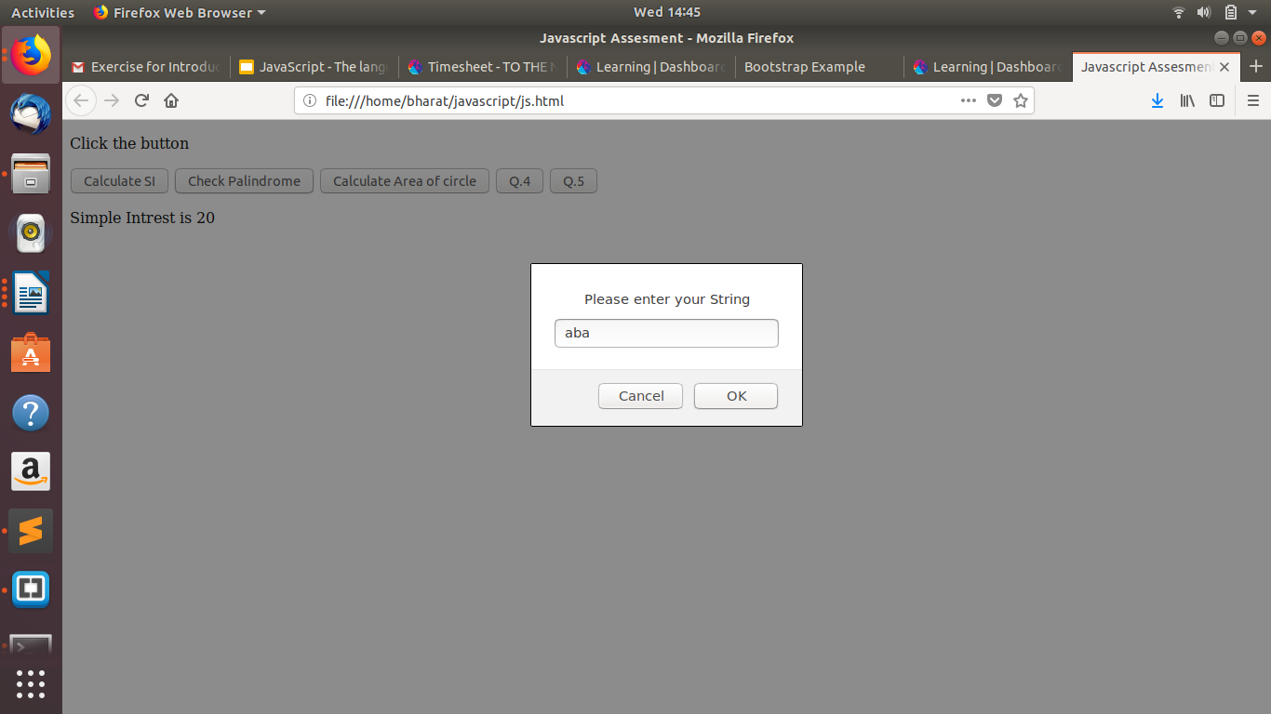
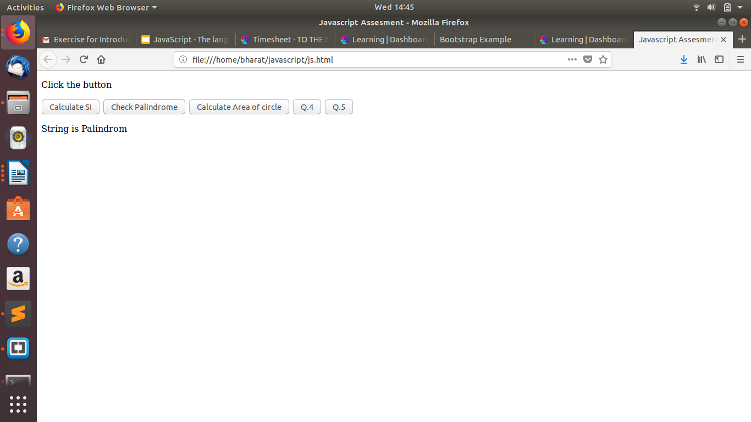

Q.3 Area of circle

Ans.

//function to calculate area

function area() {
var r=prompt("please enter the radius");
var area=22/7*(r*r);
document.getElementById("demo").innerHTML =
"Area of circle is "+area;

// body...
}
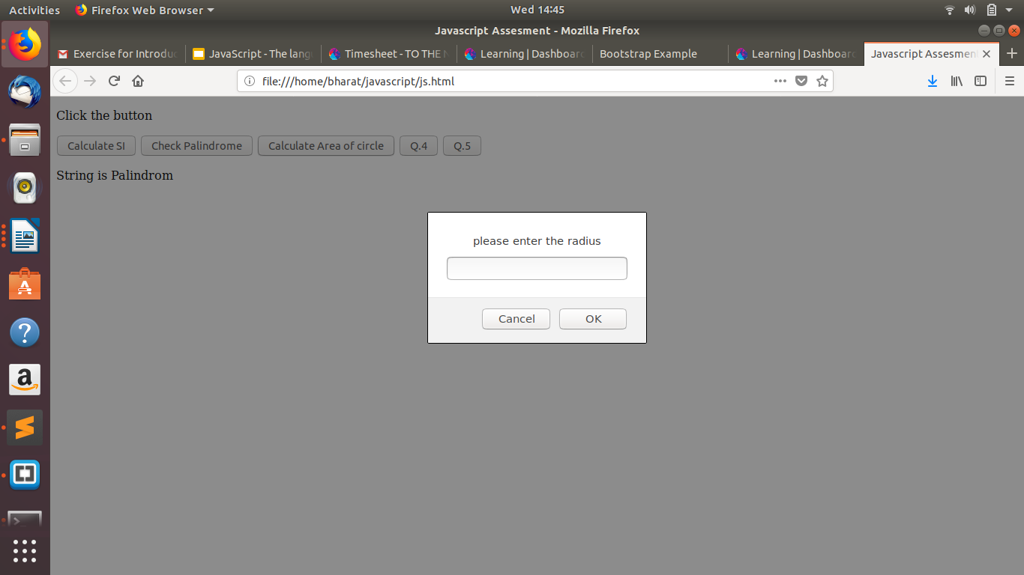
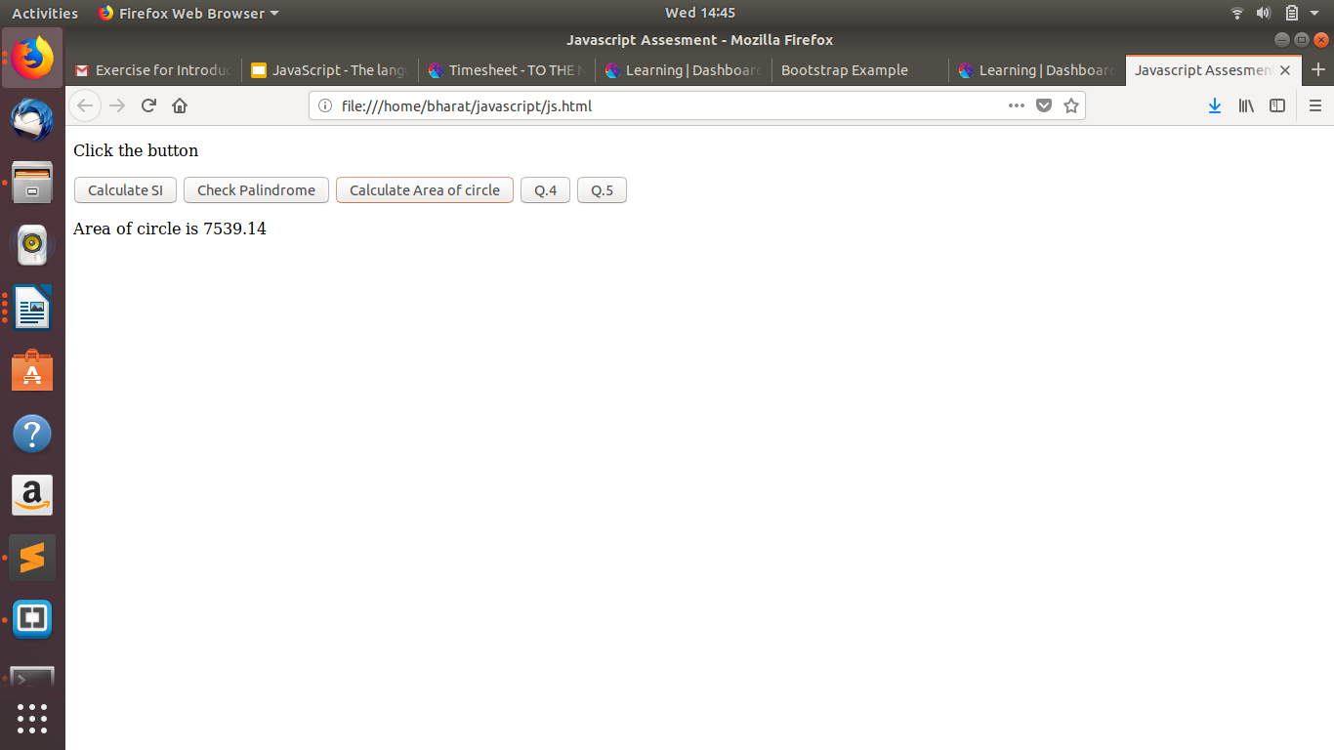

Q.4 Copy information of one object to another and log it to console.

Ans.

//for copying data
function cop(){
var person = {firstName:"bharat", lastName:"Saxena",competancy:"android"};
var copy = Object.assign({}, person);
console.log(copy);

}

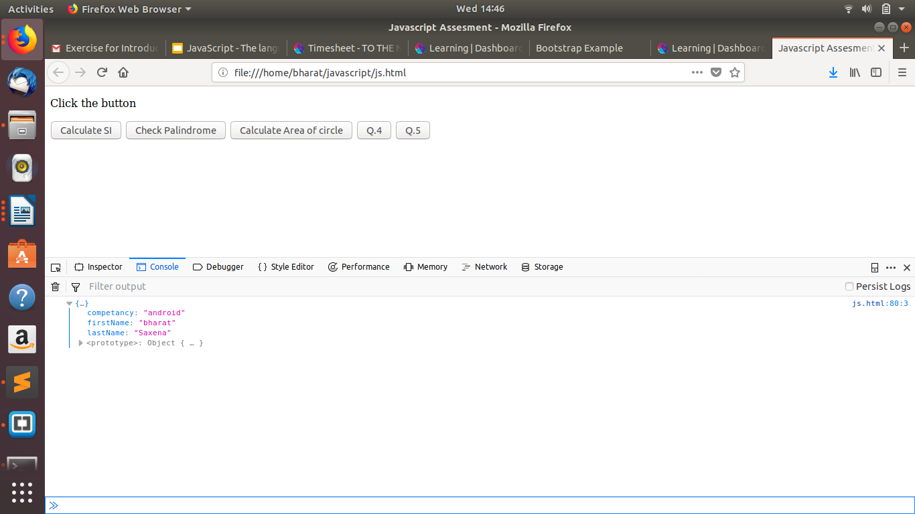

Q.5 create a list of objects of Employee with info as follow :
- Name, age, salary ,DOB
- filter all employees with salary greater than 5000
- group employee on the basis of their age
- fetch employees with salary less than 1000 and age greater than 20. Then give them an increment 5 times their salary.
Ans.

function Q5(){

function Q5(){
// ans 5.1 declaring name,age ,salary and dob
var emp = [
{Name:"bharat", age:"21",salary:"10000000",dob:"1-1-1111"},
{Name:"bharat1", age:"11",salary:"900",dob:"1-1-1111"},
{Name:"bharat2", age:"20",salary:"10000",dob:"1-1-1111"},
{Name:"bharat4", age:"40",salary:"100000",dob:"1-1-1111"},
{Name:"bharat5", age:"50",salary:"100",dob:"1-1-1111"},
{Name:"bharat4", age:"15",salary:"500",dob:"1-1-1111"}
];
console.log("answes of Q.5 part 1");
console.log(emp);

var ar=[];
var j=0;
//console.log(emp.length);

// ans 5.2 for getting emp whose salary less than 5000
console.log("answes of Q.5 part 2");
for(var i=0;i<emp.length;i++)
{
if(emp[i].salary>=5000)
{
ar[j]=emp[i];
j=j+1;
}
}
console.log(ar);

console.log("answes of Q.5 part 3")
// ans 5.3 for grouping objects on the basic of age
var child=[];
var young=[];
var old=[];
var j=0,k=0,l=0;
for(var i=0;i<emp.length;i++)
{
//grouping emp as child
if(emp[i].age>0 && emp[i].age<20)
{
//console.log(emp[i]+" young age=="+emp[i].age)
child[j]=emp[i];
j+=1;
}
else if(emp[i].age>=20 && emp[i].age<40)
{
//grouping emp as young
young[k]=emp[i];
k+=1;
}
else
{
//groping emp as old
old[l]=emp[i];
l+=1;
}

}

//grouping all them together

var group={"child":child,"young":young,"old":old};
console.log(group);

console.log("answes of Q.5 part 4");

// ans 5.4 for getting employee having salary less than 1000 and age less than 20 and increment five time their salary

for(var i=0;i<emp.length;i++)
{
if(emp[i].salary<1000 && emp[i].age<20)
{
emp[i].salary=emp[i].salary*5;
}
}
console.log(emp);

}
