Q.1.How are inline and block elements different from each other?
ANS- Block-level Elements
A block-level element always starts on a new line and takes up the full width available (stretches out to the left and right as far as it can).
Inline Elements
An inline element does not start on a new line and only takes up as much width as necessary.
Q.2.Explain the difference between visibility:hidden and display:none
ANS-
display: “none”;, completely gets rids of the tag, as it had never exists in the HTML page.
visibility: “hidden”;, just makes the tag invisible it will still be on the HTML page occupying space it’s just invisible.

Q.3. Explain the clear and float properties.

float
The float property is used for positioning and formatting content e.g. let an image float left to the text in a container.
Float can have 4 values -left,right,none,inherit
Clear
The clear property specifies what elements can float beside the cleared element and on which side.
The clear property can have one of the following values:none,both,left,right,inherited

Q.4. explain difference between absolute, relative,fixed and static.
ANS-
static-
An element with position:static; is not positioned in any special way; it is always positioned according to the normal flow of the page.
absolute-An element with position:absolute; is positioned relative to the nearest positioned parent.
relative-Setting the top, right, bottom, and left properties of a relatively-positioned element will cause it to be adjusted away from its normal position. Other content will not be adjusted to fit into any gap left by the element.
fixed-An element with position:fixed; is positioned relative to the viewport, which means it always stays in the same place even if the page is scrolled.
Q.5. Write the HTML code to create a table in which there are 4 columns( ID , Employee Name, Designation, Department) and at least 6 rows. Also do some styling to it.
Ans.
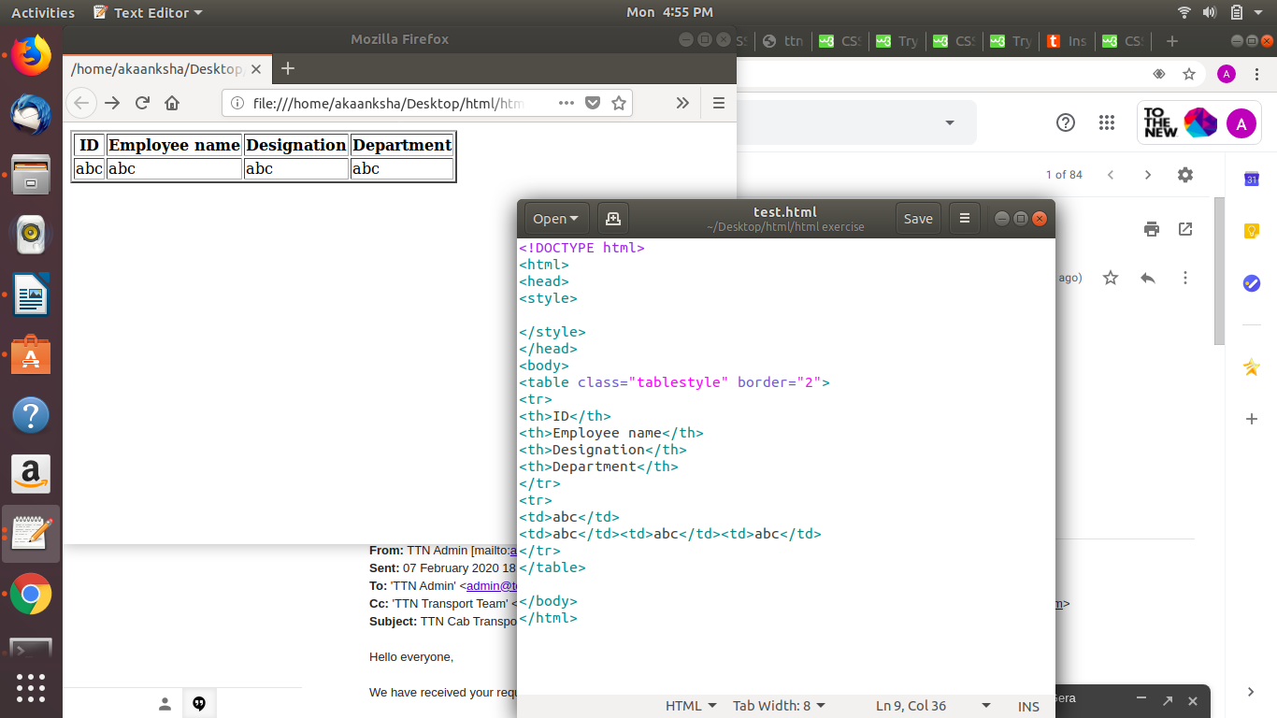

Q.6. Why do we use meta tags?
Metadata is data (information) about data. The <meta> tag provides metadata about the HTML document. Metadata will not be displayed on the page, but will be machine parsable.
Q.7. Explain box model.
The CSS box model is essentially a box that wraps around every HTML element. It consists of: margins, borders, padding, and the actual content. The image below illustrates the box model:
Content- The content of the box, where text and images appear
- Padding - Clears an area around the content. The padding is transparent
- Border- A border that goes around the padding and content
- Margin - Clears an area outside the border. The margin is transparent

Q.8. What are the different types of CSS Selectors?
- Universal selector – give css to whole page(using *)
- id selector – give css to particular id (using #)
- class selector -give css to group of elements(using .)
- group selector
- element selector
Q.9. Define Doctype.
ANS-
The <!DOCTYPE> declaration is not an HTML tag; it is an instruction to the web browser about what version of HTML the page is written in.
Q.10. Explain 5 HTML5 semantic tags.
ANS-
- <aside>-element defines some content aside from the content it is placed in (like a sidebar)

- <details>-Defines additional details that the user can view or hide.
- <figcaption>-an image and a caption can be grouped together in a <figure> element
- <figure>-the purpose of a figure caption is to add a visual explanation to an image.
- <article>-specifies independent, self-contained content
11. Create HTML for web-page.jpg (check resources, highest weightage for answers)
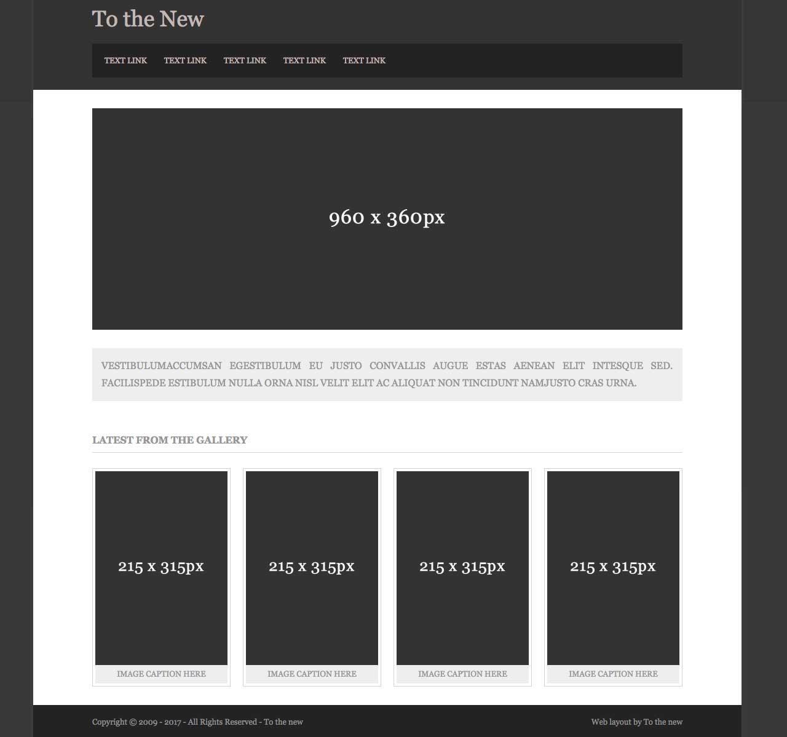

Q.12. Create HTML for form.png (check resources, highest weightage for answers).
