Q. Implement the same exercise of HTML & CSS on Bootstrap.

//for code implementation of Q.11 (boot.html and style2.css) for Q.12 (form.html and form.css)
Ans . For answer no 11

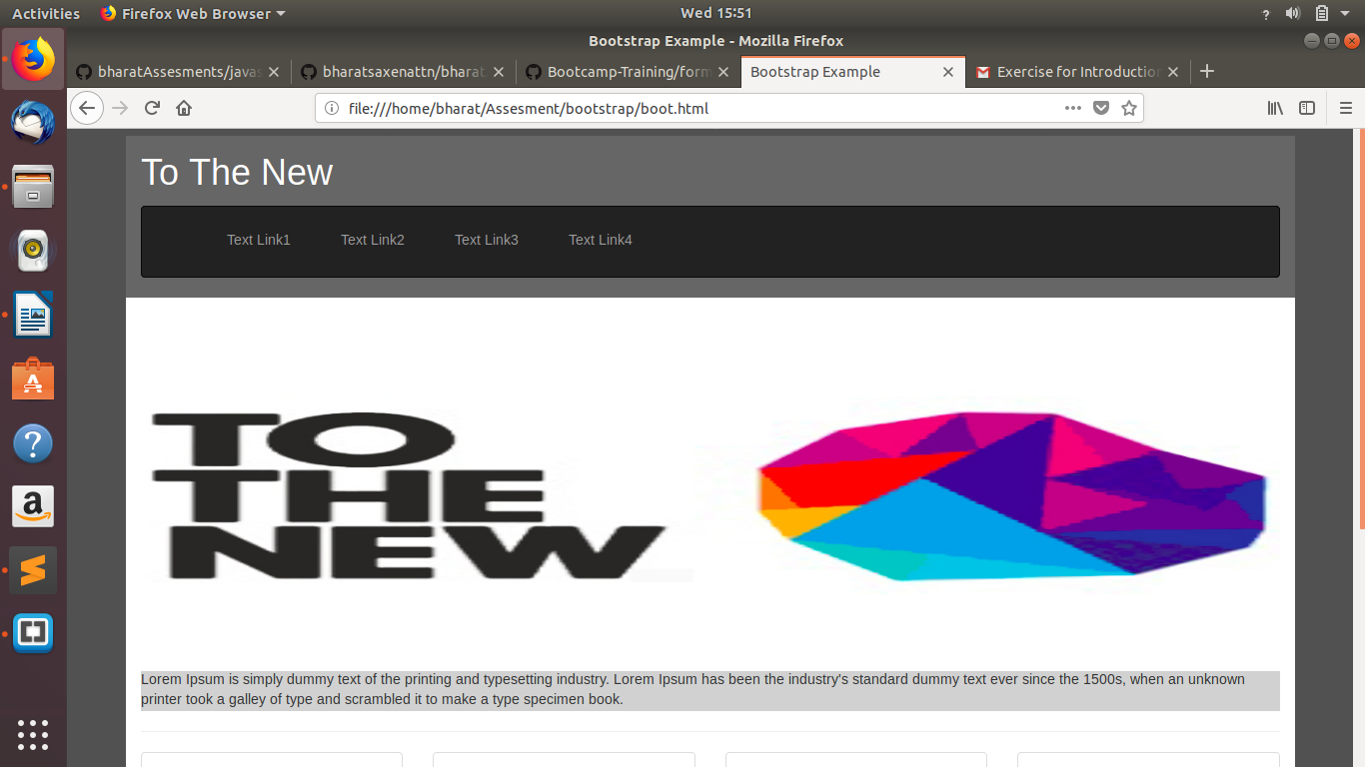

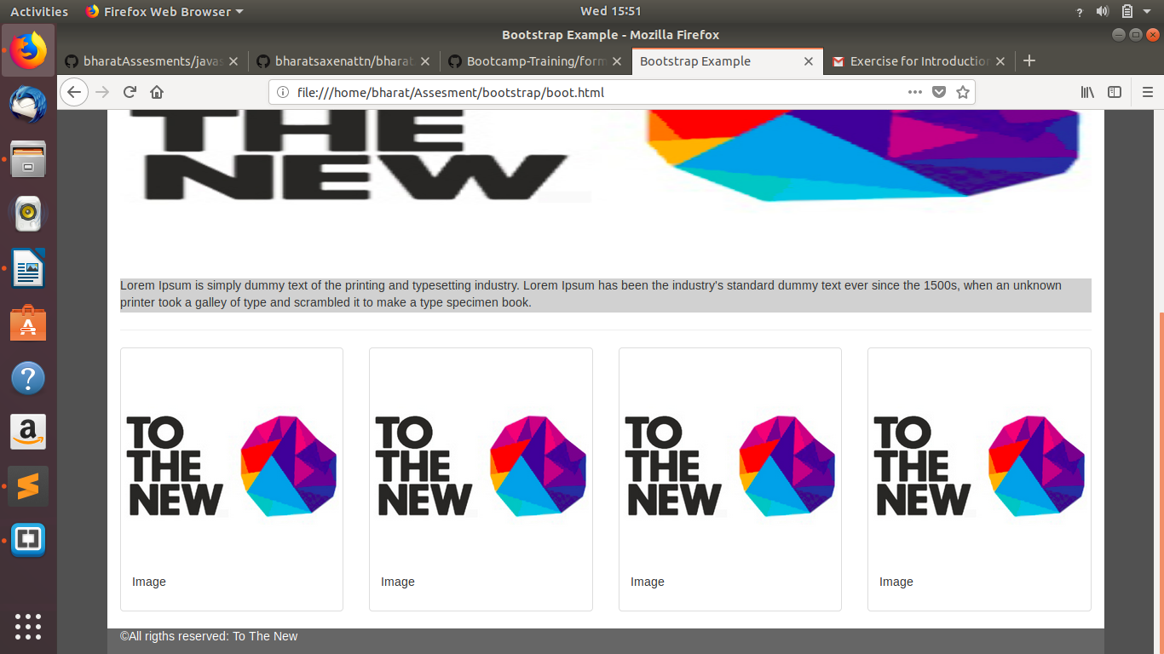

for ans.12

