PROJECT REPORT

TITLE: TRAFIC FLOW USING VECTOR FIELD

NAME | ENROLLMENT NO.
RATHOD BHARATSINH N. | 2501442101
SADHU AADITYA M. | 2501442104
SHAH JAINAM K. | 2501442112
GOHIL DEVANG P. | 2501442036
PATEL MANN S. | 2501442078
SEMESTER | 4th
COURCE | CSE(D2D)
SUBJECT | VECTOR CALCUS
FACULTY NAME | ASHISH KUMAR SIR
SUBJECT | VECTOR CALCUS

INTRODUCTION

This project models real-world traffic movement on a road network using vector fields, where each point on the grid represents the velocity of vehicles as a 2D vector F(x, y). Core vector calculus concepts including divergence (∇·F), curl (∇×F), and line integrals (∫F·dr) are applied computationally to detect congestion zones, identify rotational flow patterns, and measure traffic flow along specific vehicle paths. The entire simulation is implemented in Python using NumPy and Matplotlib, producing visual outputs such as streamline plots, divergence maps, speed heatmaps, and curl maps to support data-driven traffic analysis.

PROBLEM STATEMENT

Urban traffic congestion is a growing challenge in modern cities, requiring efficient mathematical models to analyze and predict vehicle flow patterns across road networks. This project addresses the problem by representing traffic movement as a 2D vector field and applying vector calculus operations — divergence, curl, and line integrals — to detect congestion zones, identify rotational traffic behavior, and optimize vehicle path analysis computationally.

MATHMATICAL MODEL

Vector Field Definition: Traffic velocity at every point (x, y) on the road grid is represented as a 2D vector field:
F(x, y) = (Fx(x, y), Fy(x, y))
Where Fx is the horizontal velocity component and Fy is the vertical velocity component.
Base Flow Equations:
Fx(x, y) = 1.5 + 0.4 sin(πy/5)
Fy(x, y) = 0.2 cos(πx/5)
Speed Magnitude:
|F(x, y)| = √(Fx² + Fy²)
This gives the actual speed of traffic at any point on the grid.
Obstacle Deflection (Potential Flow Theory):
For each obstacle at position (ox, oy) with radius r:
Fx += r² × (x − ox) / |r_vec|³
Fy += r² × (y − oy) / |r_vec|³
Where |r_vec| = √((x−ox)² + (y−oy)²)
Divergence — Congestion Detection:
∇·F = ∂Fx/∂x + ∂Fy/∂y
If ∇·F < 0 → Convergence → Traffic is accumulating → Congestion
If ∇·F > 0 → Divergence → Traffic is dispersing → Free Flow
If ∇·F = 0 → Uniform density → Stable Flow
Curl — Rotational Flow:
∇×F = ∂Fy/∂x − ∂Fx/∂y
If ∇×F > 0 → Anti-clockwise rotation (left roundabout)
If ∇×F < 0 → Clockwise rotation (right roundabout)
If ∇×F = 0 → No rotation → Straight road flow

Line Integral — Flow Along a Vehicle Path:

∫_C F · dr = ∫_C (Fx dx + Fy dy)

Numerically computed as:

∫_C F·dr ≈ Σ [ Fx(r(t)) · dx/dt + Fy(r(t)) · dy/dt ] Δt

Positive result → Flow aids the vehicle's direction of travel
Negative result → Flow resists the vehicle's direction of travel

Numerical Differentiation (Central Difference Method):

All partial derivatives are computed using NumPy's central
difference:
∂Fx/∂x ≈ [Fx(x+h, y) − Fx(x−h, y)] / 2h
∂Fy/∂y ≈ [Fy(x, y+h) − Fy(x, y−h)] / 2h

ALGORTITHM AND APPROCH

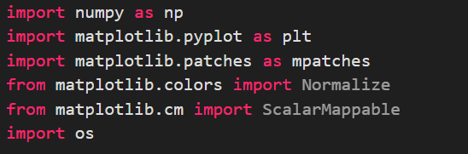
- Import Libraries:

- Load Image:

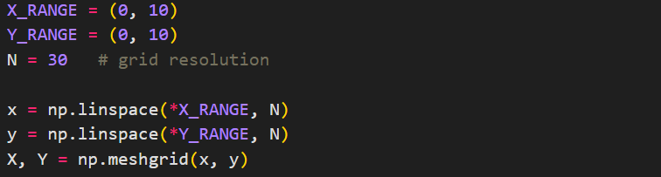
- Grid Setup:

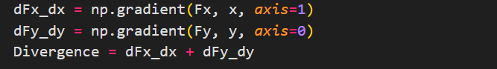
- Divergence:

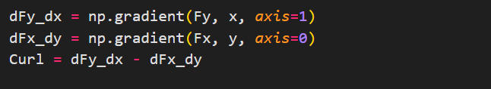
- Curl:

- Result Display:

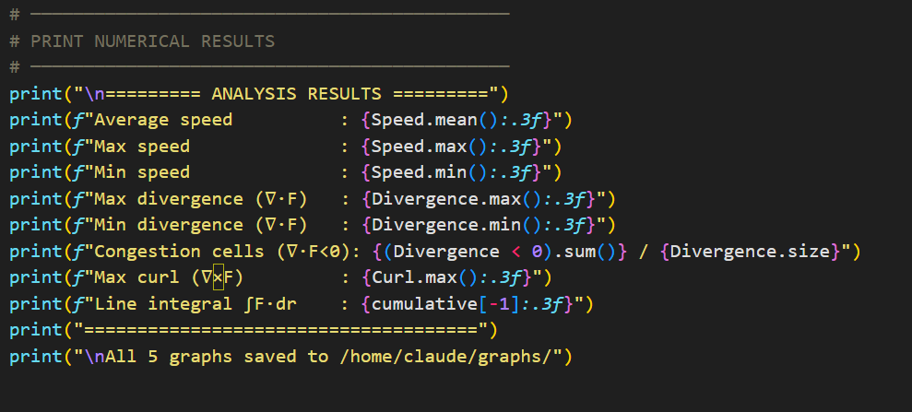

CODE IMPLEMENTATION
"""
Traffic Flow Analysis using Vector Fields
SEM-4 Vector Calculus Practical Project
"""

import numpy as np
import matplotlib.pyplot as plt
import matplotlib.patches as mpatches
from matplotlib.colors import Normalize
from matplotlib.cm import ScalarMappable
import os

# ─────────────────────────────────────────────
# 1. GRID SETUP
# ─────────────────────────────────────────────
X_RANGE = (0, 10)
Y_RANGE = (0, 10)
N = 30 # grid resolution

x = np.linspace(*X_RANGE, N)
y = np.linspace(*Y_RANGE, N)
X, Y = np.meshgrid(x, y)

# ─────────────────────────────────────────────
# 2. VECTOR FIELD DEFINITION
# F(x,y) = (Fx, Fy) — traffic velocity field
# Obstacles create divergence/convergence
# ─────────────────────────────────────────────
# Base rightward flow
Fx = np.ones_like(X) * 1.5
Fy = np.zeros_like(Y)

# Add lane-like sinusoidal variation
Fx += 0.4 * np.sin(Y * np.pi / 5)
Fy += 0.2 * np.cos(X * np.pi / 5)

# Obstacles (road blocks / intersections)
obstacles = [
(3.5, 4.5, 0.8), # (cx, cy, radius)
(6.5, 3.0, 0.7),
(5.0, 7.0, 0.6),
(2.0, 6.5, 0.5),
(7.8, 6.0, 0.6),
]

for (ox, oy, r) in obstacles:
dist2 = (X - ox)**2 + (Y - oy)**2
dist = np.sqrt(dist2) + 1e-9
# Potential flow deflection around obstacle (irrotational)
Fx += r**2 * (X - ox) / dist2**1.5 * 2.5
Fy += r**2 * (Y - oy) / dist2**1.5 * 2.5
# Suppress flow inside obstacle
mask = dist < r * 0.9
Fx[mask] = 0
Fy[mask] = 0

# Speed magnitude
Speed = np.sqrt(Fx**2 + Fy**2)

# ─────────────────────────────────────────────
# 3. DIVERGENCE ∇·F = ∂Fx/∂x + ∂Fy/∂y
# Negative divergence → Convergence (Congestion)
# Positive divergence → Divergence (Free flow)
# ─────────────────────────────────────────────
dFx_dx = np.gradient(Fx, x, axis=1)
dFy_dy = np.gradient(Fy, y, axis=0)
Divergence = dFx_dx + dFy_dy

# ─────────────────────────────────────────────
# 4. CURL ∇×F = ∂Fy/∂x − ∂Fx/∂y
# Indicates rotational flow (roundabouts)
# ─────────────────────────────────────────────
dFy_dx = np.gradient(Fy, x, axis=1)
dFx_dy = np.gradient(Fx, y, axis=0)
Curl = dFy_dx - dFx_dy

os.makedirs("/home/claude/graphs", exist_ok=True)

# ─────────────────────────────────────────────
# GRAPH 1 — Vector Field with Streamlines
# ─────────────────────────────────────────────
fig, ax = plt.subplots(figsize=(9, 7))
speed_norm = Speed / Speed.max()
strm = ax.streamplot(X, Y, Fx, Fy, color=speed_norm,
cmap='RdYlGn', linewidth=1.4,
density=1.6, arrowsize=1.3)
cbar = fig.colorbar(strm.lines, ax=ax, shrink=0.85)
cbar.set_label("Normalised speed (0 = congested, 1 = free)", fontsize=10)

for (ox, oy, r) in obstacles:
circle = plt.Circle((ox, oy), r, color='#534AB7', alpha=0.55, zorder=5)
ax.add_patch(circle)
ax.text(ox, oy, 'OBS', ha='center', va='center',
color='white', fontsize=7, fontweight='bold', zorder=6)

ax.set_xlim(*X_RANGE); ax.set_ylim(*Y_RANGE)
ax.set_xlabel("X (road grid)", fontsize=11)
ax.set_ylabel("Y (road grid)", fontsize=11)
ax.set_title("Fig 1 — Traffic Flow Vector Field (Streamlines)", fontsize=13, pad=12)
ax.set_facecolor('#F7F7F5')
fig.tight_layout()
fig.savefig("fig1_vector_field.png", dpi=150, bbox_inches='tight')
plt.close()
print("Saved fig1")

# ─────────────────────────────────────────────
# GRAPH 2 — Divergence Map (Congestion Detection)
# ─────────────────────────────────────────────
fig, ax = plt.subplots(figsize=(9, 7))
div_lim = np.percentile(np.abs(Divergence), 97)
cf = ax.contourf(X, Y, Divergence, levels=40,
cmap='RdBu_r', vmin=-div_lim, vmax=div_lim)
cbar = fig.colorbar(cf, ax=ax, shrink=0.85)
cbar.set_label("Divergence ∇·F", fontsize=10)

# Mark congestion hotspots (strong negative divergence)
cong_mask = Divergence < -div_lim * 0.55
if cong_mask.any():
ax.contour(X, Y, Divergence, levels=[-div_lim * 0.55],
colors='darkred', linewidths=1.8, linestyles='--')

for (ox, oy, r) in obstacles:
circle = plt.Circle((ox, oy), r, color='#534AB7', alpha=0.4, zorder=5)
ax.add_patch(circle)

# Quiver overlay (thin arrows)
step = 3
ax.quiver(X[::step, ::step], Y[::step, ::step],
Fx[::step, ::step], Fy[::step, ::step],
alpha=0.35, scale=35, width=0.003, color='#2C2C2A')

ax.set_xlim(*X_RANGE); ax.set_ylim(*Y_RANGE)
ax.set_xlabel("X", fontsize=11); ax.set_ylabel("Y", fontsize=11)
ax.set_title("Fig 2 — Divergence Map (Red = Congestion, Blue = Dispersion)", fontsize=13, pad=12)
red_p = mpatches.Patch(color='#C0392B', label='Convergence (congestion)')
blue_p = mpatches.Patch(color='#2980B9', label='Divergence (free flow)')
obs_p = mpatches.Patch(color='#534AB7', alpha=0.6, label='Obstacle')
dash_p = mpatches.Patch(color='darkred', label='Congestion boundary')
ax.legend(handles=[red_p, blue_p, obs_p, dash_p], loc='upper right', fontsize=8)
fig.tight_layout()
fig.savefig("fig2_vector_field.png", dpi=150, bbox_inches='tight')
plt.close()
print("Saved fig2")

# ─────────────────────────────────────────────
# GRAPH 3 — Speed Heatmap
# ─────────────────────────────────────────────
fig, ax = plt.subplots(figsize=(9, 7))
hm = ax.pcolormesh(X, Y, Speed, cmap='RdYlGn', shading='auto')
cbar = fig.colorbar(hm, ax=ax, shrink=0.85)
cbar.set_label("Speed magnitude |F(x,y)|", fontsize=10)

step = 4
ax.quiver(X[::step, ::step], Y[::step, ::step],
Fx[::step, ::step], Fy[::step, ::step],
alpha=0.5, scale=40, width=0.003, color='black')

for (ox, oy, r) in obstacles:
circle = plt.Circle((ox, oy), r, color='#534AB7', alpha=0.7, zorder=5)
ax.add_patch(circle)
ax.text(ox, oy, 'OBS', ha='center', va='center',
color='white', fontsize=7, fontweight='bold', zorder=6)

ax.set_xlim(*X_RANGE); ax.set_ylim(*Y_RANGE)
ax.set_xlabel("X", fontsize=11); ax.set_ylabel("Y", fontsize=11)
ax.set_title("Fig 3 — Speed Heatmap (Green = Fast, Red = Slow)", fontsize=13, pad=12)
fig.tight_layout()
fig.savefig("fig3_vector_field.png", dpi=150, bbox_inches='tight')
plt.close()
print("Saved fig3")

# ─────────────────────────────────────────────
# GRAPH 4 — Curl Map (Rotational Flow)
# ─────────────────────────────────────────────
fig, ax = plt.subplots(figsize=(9, 7))
curl_lim = np.percentile(np.abs(Curl), 97)
cf2 = ax.contourf(X, Y, Curl, levels=40,
cmap='PuOr', vmin=-curl_lim, vmax=curl_lim)
cbar = fig.colorbar(cf2, ax=ax, shrink=0.85)
cbar.set_label("Curl ∇×F", fontsize=10)

for (ox, oy, r) in obstacles:
circle = plt.Circle((ox, oy), r, color='#0F6E56', alpha=0.5, zorder=5)
ax.add_patch(circle)

ax.set_xlim(*X_RANGE); ax.set_ylim(*Y_RANGE)
ax.set_xlabel("X", fontsize=11); ax.set_ylabel("Y", fontsize=11)
ax.set_title("Fig 4 — Curl Map (Orange = Clockwise, Purple = Anti-clockwise)", fontsize=13, pad=12)
fig.tight_layout()
fig.savefig("fig4_vector_field.png", dpi=150, bbox_inches='tight')
plt.close()
print("Saved fig4")

# ─────────────────────────────────────────────
# GRAPH 5 — Line Integral along a path
# ∫_C F·dr (work done by flow along route)
# ─────────────────────────────────────────────
t = np.linspace(0, 1, 500)
path_x = X_RANGE[0] + t * (X_RANGE[1] - X_RANGE[0])
path_y = 5 + 2 * np.sin(t * 2 * np.pi) # sinusoidal road path

# Interpolate field at path points
from scipy.interpolate import RegularGridInterpolator
interp_Fx = RegularGridInterpolator((y, x), Fx, method='linear', bounds_error=False, fill_value=0)
interp_Fy = RegularGridInterpolator((y, x), Fy, method='linear', bounds_error=False, fill_value=0)

pts = np.column_stack([path_y, path_x])
Fx_path = interp_Fx(pts)
Fy_path = interp_Fy(pts)

dx_dt = np.gradient(path_x, t)
dy_dt = np.gradient(path_y, t)
integrand = Fx_path * dx_dt + Fy_path * dy_dt
cumulative = np.cumsum(integrand) * (t[1] - t[0])

fig, axes = plt.subplots(1, 2, figsize=(12, 5))

# Left: path on vector field
ax0 = axes[0]
ax0.streamplot(X, Y, Fx, Fy, color=Speed / Speed.max(),
cmap='RdYlGn', linewidth=0.9, density=1.2, arrowsize=1.0)
ax0.plot(path_x, path_y, 'b-', linewidth=2.5, label='Vehicle path C')
ax0.plot(path_x[0], path_y[0], 'go', markersize=9, label='Start')
ax0.plot(path_x[-1], path_y[-1], 'rs', markersize=9, label='End')
for (ox, oy, r) in obstacles:
ax0.add_patch(plt.Circle((ox, oy), r, color='#534AB7', alpha=0.5))
ax0.set_xlim(*X_RANGE); ax0.set_ylim(*Y_RANGE)
ax0.set_xlabel("X"); ax0.set_ylabel("Y")
ax0.set_title("Vehicle path on vector field")
ax0.legend(fontsize=8)

# Right: cumulative line integral
ax1 = axes[1]
ax1.plot(path_x, cumulative, color='#185FA5', linewidth=2)
ax1.axhline(0, color='gray', linewidth=0.8, linestyle='--')
ax1.fill_between(path_x, cumulative, 0,
where=cumulative > 0, alpha=0.2, color='green', label='Aided flow')
ax1.fill_between(path_x, cumulative, 0,
where=cumulative < 0, alpha=0.2, color='red', label='Resisted flow')
ax1.set_xlabel("X position along path")
ax1.set_ylabel("Cumulative ∫F·dr")
ax1.set_title(f"Line integral along path (Total = {cumulative[-1]:.2f})")
ax1.legend(fontsize=8)
ax1.grid(True, alpha=0.3)

fig.suptitle("Fig 5 — Line Integral of Traffic Flow Along a Vehicle Path", fontsize=13, y=1.01)
fig.tight_layout()
fig.savefig("fig5_vector_field.png", dpi=150, bbox_inches='tight')
plt.close()
print("Saved fig5")

# ─────────────────────────────────────────────
# PRINT NUMERICAL RESULTS
# ─────────────────────────────────────────────
print("\n========= ANALYSIS RESULTS =========")
print(f"Average speed : {Speed.mean():.3f}")
print(f"Max speed : {Speed.max():.3f}")
print(f"Min speed : {Speed.min():.3f}")
print(f"Max divergence (∇·F) : {Divergence.max():.3f}")
print(f"Min divergence (∇·F) : {Divergence.min():.3f}")
print(f"Congestion cells (∇·F<0): {(Divergence < 0).sum()} / {Divergence.size}")
print(f"Max curl (∇×F) : {Curl.max():.3f}")
print(f"Line integral ∫F·dr : {cumulative[-1]:.3f}")
print("=====================================")
print("\nAll 5 graphs saved to /home/claude/graphs/")

GRAPHS AND VISUALIZATION
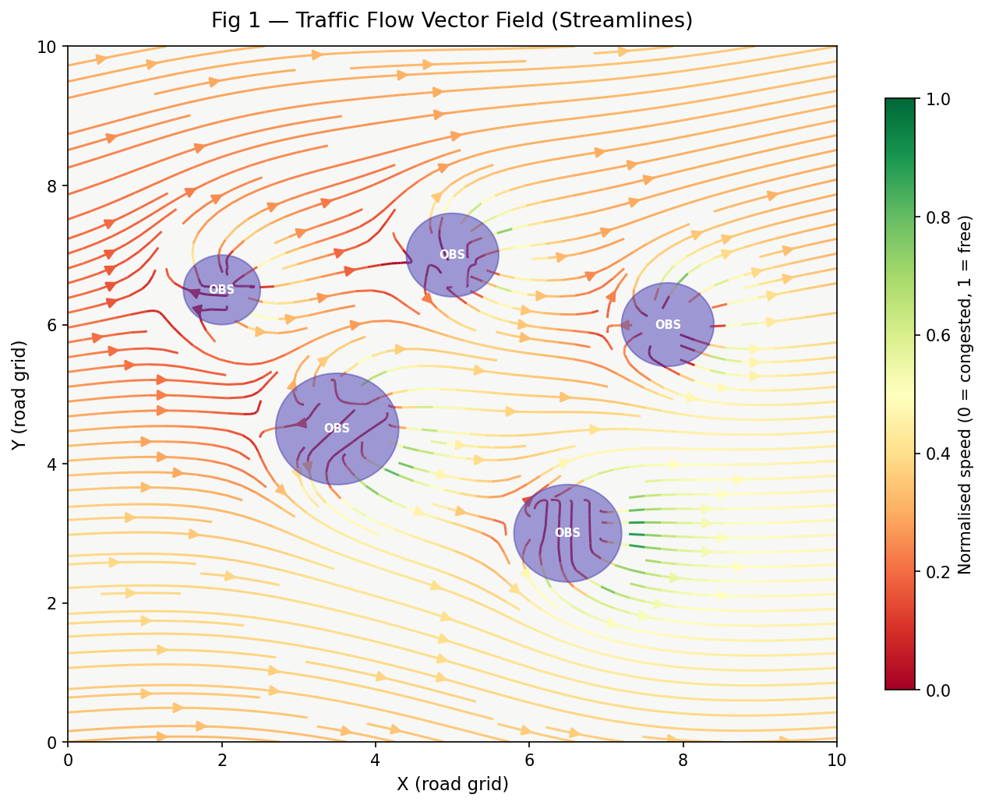

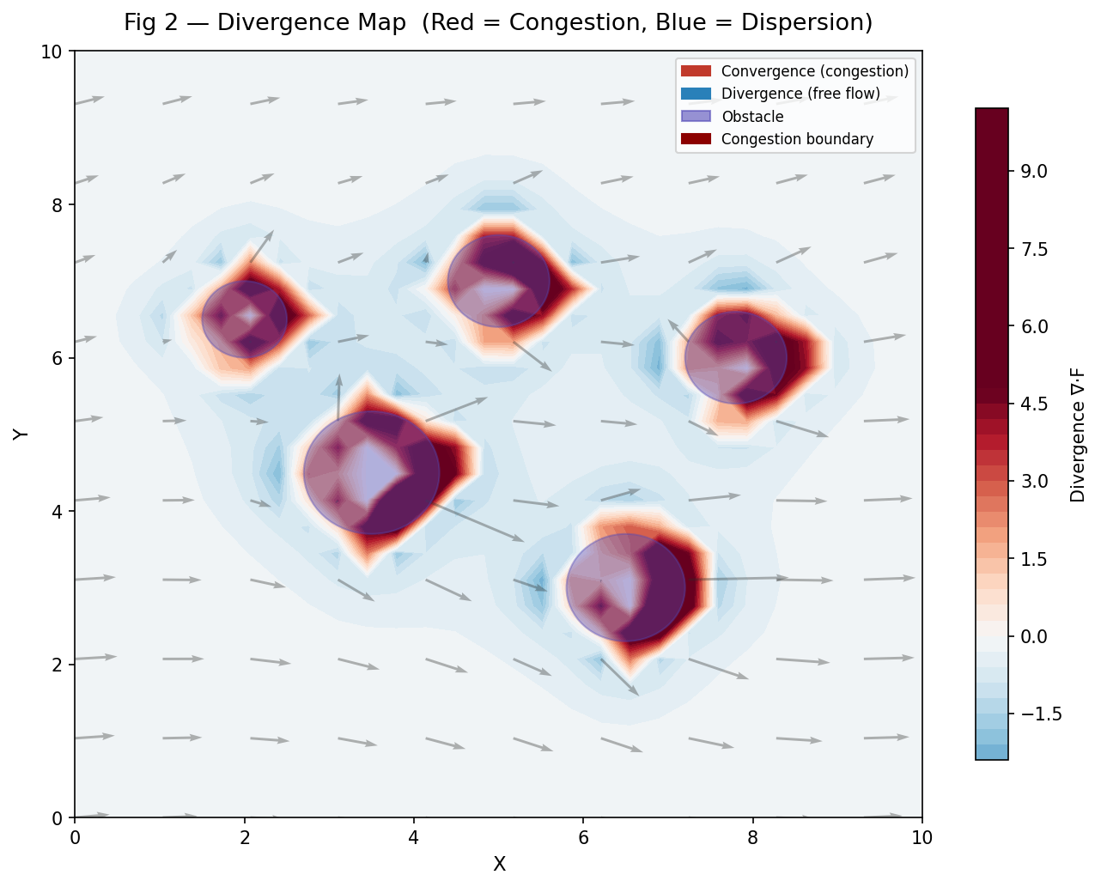

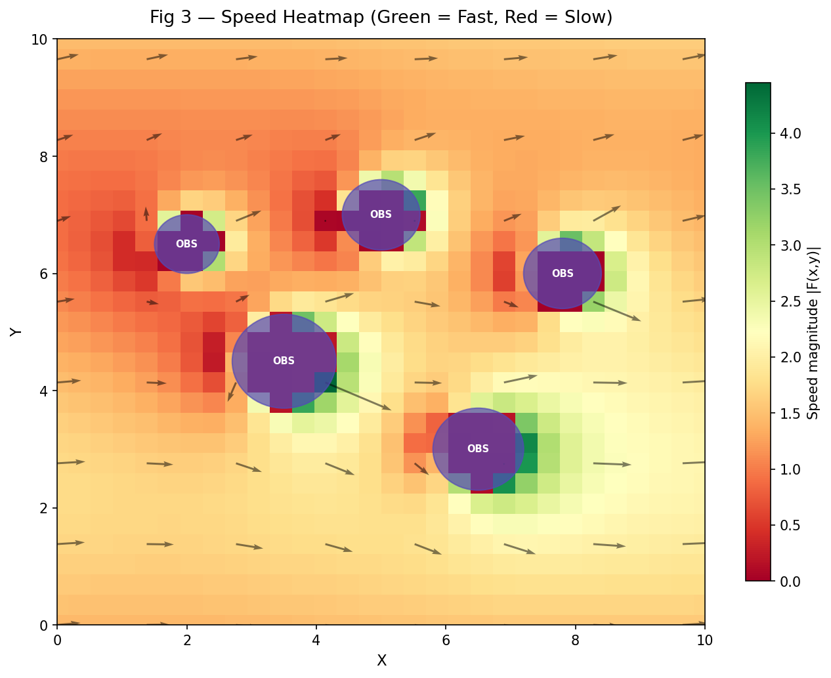

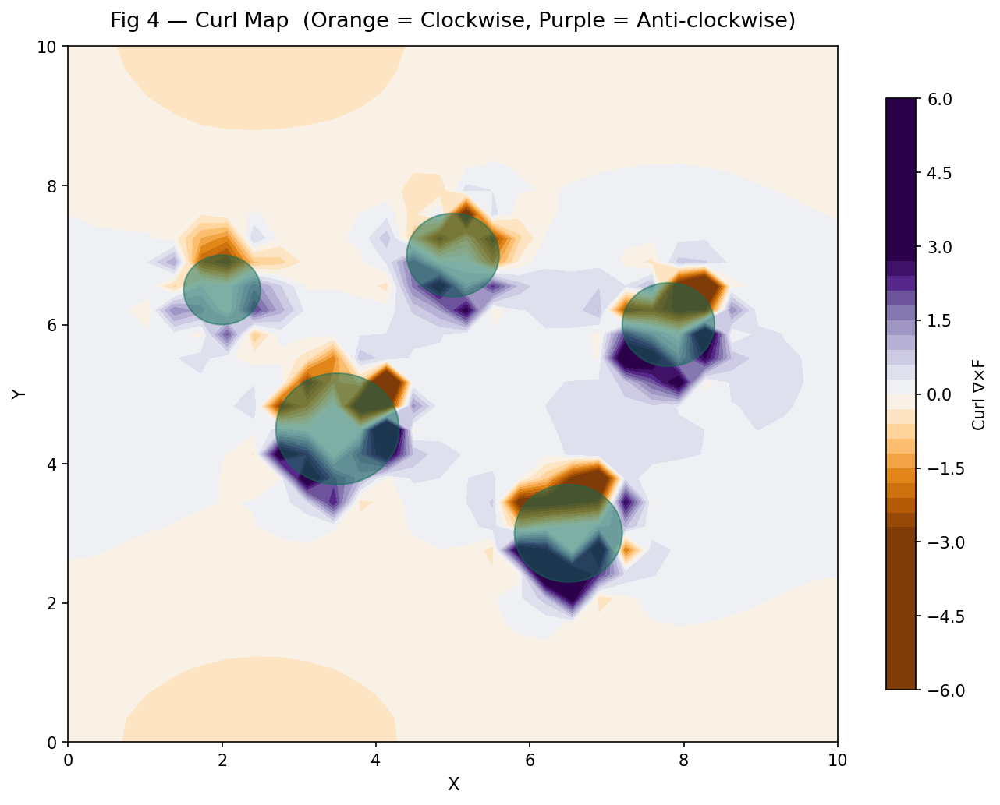

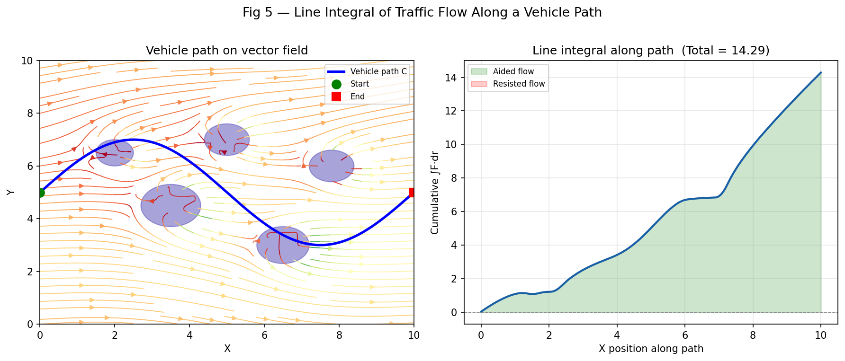

APPLICATION

- Smart City Traffic Management Cities like Singapore and Dubai use vector field-based models to monitor live traffic flow. Divergence analysis helps traffic control systems automatically adjust signal timings when congestion (∇·F < 0) is detected at intersections
- GPS Navigation Systems Apps like Google Maps and Waze essentially compute line integrals (∫F·dr) to find the minimum-resistance path between two points — exactly what your project demonstrates mathematically.
- Autonomous Vehicle Path Planning Self-driving cars (Tesla, Waymo) use vector field-based flow models to plan safe routes, avoid obstacles, and navigate through intersections — directly matching your obstacle deflection model.
- Highway & Road Design Urban planners and civil engineers simulate traffic vector fields before constructing new roads or flyovers to predict congestion zones and optimize lane placement using divergence analysis.
- Emergency Vehicle Routing Ambulances and fire trucks use real-time vector flow data to find the fastest path through traffic — the same concept as your line integral path optimization.
- Traffic Simulation Software Professional tools like SUMO, VISSIM, and AIMSUN — used by governments and researchers — are built on the same mathematical foundation of vector fields, divergence, and flow modeling that your project implements.
- Airport & Parking Lot Flow Management Vector fields model pedestrian and vehicle movement inside airports, malls, and parking lots to reduce bottlenecks and improve safety during emergencies.

CONCLUSION

This project bridges the gap between pure mathematical theory and real-world engineering applications. The same concepts implemented here — vector fields, divergence, curl, and line integrals — form the mathematical backbone of modern technologies such as GPS navigation systems, autonomous vehicles, smart city traffic management, and AI-based transportation platforms. This validates Vector Calculus not just as an academic subject, but as a powerful and essential tool for solving critical real-world problems.

