Abstract

Internet of things aims to unify every devices under a single infrastructure. Transforming real world objects into virtual nodes that can be controlled by the user. WiFi was the de-facto standard for wireless technology for more than a decade for the internet. With growing number of wireless specifications such as Bluetooth, ZigBee, Thread, Z-Wave, etc. There is hardly any effort for having any compatibility between them to achieve this unified behavior. Further, even though ZigBee and Z-Wave are mostly targeted towards IoT. It does not solve the compatibility problem. And also there will be no wireless technology which is perfect for every use case. Hypothetically speaking even if there is a perfect wireless technology, there is always “The Hipster Effect”(Jonathan Touboul, 2014).

By introducing an adapter, we can solve this issue by connecting nodes operating in different wireless specifications.

The primary and important challenge that we should take into account is the networking technology that makes up the network for any wireless technology. WiFi commonly uses IP as its networking technology. For instance, say we have to convert Bluetooth to WiFi. We need a way to make the devices discover able both sides. This is only done through the networking layer. There should be a way for the WiFi enabled devices to detect devices of the Bluetooth network. The main challenge is even though WiFi uses IP very commonly, it is not entitled to it. According to WiFi specification, it may or may not use any form of networking and its based solely on the user. Same applies to Bluetooth. This makes it hard to write a compatibility layer only based on IP. In this case we mean IPv4 when we’ve mentioned IP. Even though it is the commonly used. IPv6 is slowly taking over the internet. So if we create a compatibility layer only based on IP, there is high chance of it getting obsolete.

The second challenge is the network topology. Networking in it’s essence takes many forms. It might be a star, ring, bus, etc. In higher levels we can categorize networks into mesh and non-mesh. This type of classification allows us to focus on the network compatibility. We have to provide a methodology for existing network topology to work.

The third challenge is making the network devices discover-able. For instance, taking the classic Bluetooth to WiFi example. And assuming WiFi uses IPv4 and Bluetooth uses BNEP . We have to provide a way for the user of this adapter to choose which devices should be allowed to be discovered.

The fourth challenge is actually sending the application data over the network. If we have solved the above three challenges, we must provide a way for any application to send and receive data.

The fifth and final challenge is providing a way for the user to manage the connect nodes in the adapter.
Network Compatibility
The proposed system will have a mechanism where it is possible to add networking protocols as modules. This provides a way for new protocols to be added to the adapter after production.

Topology
As mentioned in this paper earlier. We are focusing on the classification as mesh and non-mesh. Sometimes mesh networks cannot be formed in some wireless technologies optimally. Since these wireless technologies are not optimized for wireless technologies. Latency will be very high. The proposed system will inform the user of the common problems such as above.

Device Discovery
Discovery of devices is handled by the network layer. Packet switched networks generally use IP and every low-rate wireless personal area networks (LR-WPANs) uses 802.15.4 for identification. We can use this commonality. For instance, WiFi devices can be made to discovered in Bluetooth scan by re-transmitting WiFi connected device’s MAC to Bluetooth as a Bluetooth device.

Sending Application Data
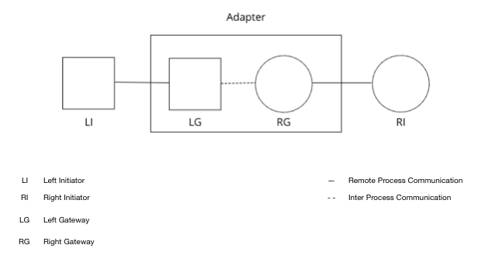
Left initiator is any device that is in square network(ex: WiFi)
Right initiator is any device that exists in circle network(ex: Bluetooth).

We propose a system which reads data from the left initiator, extracts the message from the Application layer and moves it forward to the right initiator.

