Wireless Adapter

Abstract
WiFi was the de-facto standard for wireless technology for almost a decade. With growing number of wireless specifications such as Bluetooth, ZigBee, Thread, Z-Wave, etc. There is hardly any effort for maintaining compatibility between them. By introducing an adapter, we can solve this issue by connecting nodes operating in different wireless specification.

Literature Survey
From the surveys we scanned, the solutions to this problem of cross-communication is by unifying and creating a new wireless technology from existing ones(viz. convergence). But this is impractical because, different wireless specification exist for different applications.

Existing System
For connecting two different Networks packet switching is used. This involves routers of different networks to be wired to each other through a Ethernet cable. There are no record instances of connecting different networks wirelessly.

Proposed System
The proposed system will allow protocols to run over wide range of wireless specifications.
We will be referring to the devices that needs to connect to the different wireless networks as Initiators and we will be referring to the adapter’s server as Gateway throughout this text.

The objective here is to transform the message from the left imitator to the right initiator.
Wireless technology due its nature does require it to pre-occupy most of the OSI layer.
(e.g) WiFi uses IP addressing scheme and Bluetooth uses just the mac address. The only layer that is not pre-occupied is The Application Layer.

We propose a System which reads data from the left initiator, extracts the message from the Application layer and moves it forward to the right initiator.
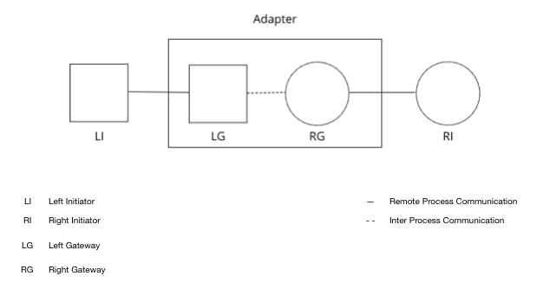

Methodology
The hardware we chose to be as the adapter for transparently transmitting data from WiFi to Bluetooth was Raspberry Pi(RPi). Because RPi has both Blutooth and WiFi transceiver making it the best candidate for implementing the adapter. Although much cheaper alternatives are available. The drivers required for RPi are abundant online. The others, not so much.

Protocol to run over the WiFI-Bluetooth connection is chosen. For simplicity we have create a custom protocol called “Hello”. The “Hello” protocol is simple and allowed us to focus on creating the adapter effectively.

“Hello” can do two things and two things only: Send and Receive “hello” over the socket. The characters in “hello” are each one byte long.
PS: Although the main objective of this proposal is to support HTTP and MQTT protocols, it is currently omitted and will be added in the future.

The Adapter is installed with a headless linux. Any distribution of linux will suffice. But for better package management we have used ‘Arch Linux’. The adapter runs the server for both WiFi and Bluetooth.

C++ is used for programming the adapter, since object-oriented designs can be easily implemented and also because of the run time speed.

Since this program really does is forwarding, we named it as Forwarder. We have achieved software compatibility with networks by using polymorphism provided by C++ and BSD sockets.

The below class diagram is our approach for attaining compatibility among networks. This time we have chosen Inheritance over composition because there aren’t that many wireless specifications (hardly 10) and composition is known to have an impact on performance.

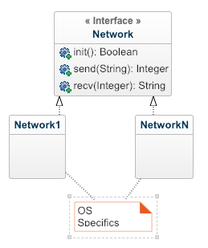
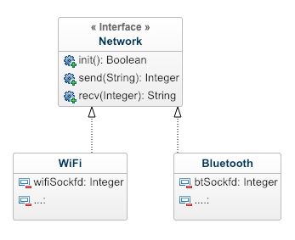
We proceed to implement the idea above with WiFi and Bluetooth.

Forwarder is the core part of the adapter. It should forward messages from LI to RI. Following is the pseudo-code we propose for the Forwarder
void forwarder(Network li, Network ri){
thread {
while(!shouldStop)
ri.send(li.recv) //forward li’s msg to ri
}
thread {
while(!shouldStop)
li.send(ri.recv) //forward ri’s msg to li
}
}

Both send and recv are blocking calls. To avoid waiting, the forwarding of the initiators is done separately using threads.

