TRANS-NETWORK FOR INTER-OPERABLE COMMUNICATION

A PROJECT REPORT

Submitted by

BHARATVAJ P.H | 111715104013
DINESH KUMAR .M | 111715104022
GOUTHAM S.M | 111715104029

in partial fulfillment for the award of the degree
of
BACHELOR OF ENGINEERING
in
COMPUTER SCIENCE AND ENGINEERING

RMK ENGINEERING COLLEGE, CHENNAI
ANNA UNIVERSITY : CHENNAI 600025
APRIL 2019

BONAFIDE CERTIFICATE
Certified that this project report “TRANS-NETWORK FOR INTEROPERABLE COMMUNICATION” is the bonafide work of “BHARATVAJ PH (111715104013), GOUTHAM SM (1117154029) and DINESH KUMAR M (111715104022)” who carried out the research under my supervision.
SIGNATURE  Dr. Sethukarasi T, M.E.,Ph.D.  HEAD OF THE DEPARTMENT  Department of Computer Science and Engineering  RMK Engineering College  Kavaraipettai, Chennai-601206 | SIGNATURE  Ms. Radhika S M.E.,(Ph.D.)  SUPERVISOR  Assistant Professor  Department of Computer Science and Engineering  RMK Engineering College  Kavaraipettai, Chennai-60206
Submitted for University Examination held on ____________

INTERNAL EXAMINER | EXTERNAL EXAMINER

ACKNOWLEDGEMENT
We are indebted to many people who helped us complete our project and assisted us since the inception of the idea till the day we documented it and even after that. Firstly, we would like to express our gratitude to Thiru.R.S.Munirathinam Chairman, R.M.K Engineering College without whose support our project could not have been completed successfully.
We would also like to thank our Principal, Dr. Mohamed Junaid K.A., B.E., M.E., Ph.D., for his continuous encouragement that led us to where we are right now, satisfied, having gotten what we had worked for.
We feel glad to express our sincere thanks to Dr. Sethukarasi T, M.E.,Ph.D, Head of the Department, Computer Science and Engineering for giving us the necessary lab facilities and continuous encouragement for the completion of the project.
We take the privilege to extend our hearty thanks to our Project Coordinator
Dr. Jaison B M.E.,M.Phil.Ph.D Associate Professor for his suggestions, support and encouragement towards the completion of the project with perfection.
We are thankful to our supervisor Ms. Radhika S M.E.,(Ph.D.), Assistant Professor for her intellectual guidance and valuable suggestions in making the project a successful one and also our sincere thanks to all our panel members for their valuable suggestions.

TABLE OF CONTENTS
CHAPTER NO. | TITLE | PAGE NO.
 | ABSTRACT | iii
 | LIST OF FIGURES | viii
 | LIST OF TABLES | x
 | LIST OF ABBREVIATIONS | xi
1. | INTRODUCTION | 1
 | 1.1 OVERVIEW | 1
2. | LITERATURE SURVEY | 4
3. | EXISTING SYSTEM | 7
 | 3.1 EXPLANATION | 7
4 | PROPOSED SYSTEM | 12
 | 4.1 EXPLANATION | 12
 | 4.2 ARCHITECTURE DIAGRAM | 12
5. | SOFTWARE REQUIREMENTS | 21
 | 5.1 C++ PROGRAMMING | 21
 | 5.1.1 C++ PLATFORM | 22
 | 5.1.2 C++ APPLICATIONS | 23
 | 5.1.3 C++ PACKAGES | 23
 | 5.2 TARGET OPERATING SYSTEM
 | 5.2.1 POSIX
5.2.2 LINUX
5.2.3 SQLITE
5.3 APPLICATION
5.3.1 ANGULAR 7
5.3.2 RX JAVA
 | 5.3.3 NPM
6. | HARDWARE REQUIREMENTS | 23
 | 6.1 ADAPTER
 | 6.1.2 RASPBERRY PI
 | 6.2 WIFI DEVICE
 | 6.3 BLUETOOTH DEVICE
 | 6.3.1 ARDUINO UNO
 | 6.3.2 BLUETOOTH MODULE HC-05
 | 6.3.3 DHT-11
7. | SYSTEM IMPLEMENTATION
 | 7.1 USER INTERFACE
 | 7.1.1 COMMAND LINE INTERFACE
 | 7.2 CONFIGURING FORWARDER
 | 7.3 DEVICE CONNECTION
 | 7.3.1 WIFI CONNECTION
 | 7.3.2 BLUETOOTH CONNECTION
 | 7.3.2.1 ARDUINO INTERFACING WITH HC-05 MODULE
 | 7.4 APPLICATION
8 | SYSTEM IMPLEMENTATION | 34
9 | CONCLUSION AND FUTURE WORK | 44
 | REFERENCES | 45

ABSTRACT
If we go into the definition of the Internet of Things (IOT), we find out that it is the concept of inter-networking of physical devices, connected devices, smart devices, and other devices embedded with electronics, software, sensors, actuators, and network connectivity that enable these objects to collect and exchange data.
It means that an object can be sensed or controlled remotely across the existing network infrastructure that enables direct integration of the physical world into computer-based systems, which, in turn, improves their efficiency and accuracy and reduces human intervention.
If augmented with sensors and actuators, the technology becomes an instance of a more general class of cyber-physical systems, which also encompasses technologies such as smart grids, virtual power plants, smart homes, intelligent transportation and smart cities.
For all of these, Wi-Fi was the de-facto standard for wireless technology used more
than a decade for the internet. With growing number of wireless specifications such as Bluetooth, ZigBee, Long Range Area-Wide Networks (LoRaWAN),
Z-Wave, etc. There is hardly any effort for having any compatibility between them to achieve this unified behavior. Further, even though ZigBee and Z-Wave are mostly targeted towards IoT. It does not solve the compatibility problem. And also there will be no wireless technology which is perfect for every use case. Hypothetically speaking, even if there is a perfect wireless technology, there is always “The Hipster Effect” (Jonathan Touboul).
By introducing an Adapter, we can provide a solution for connecting nodes operating under different wireless technologies.
The proposed system will have a mechanism capable of appending other networking protocols as modules to the newly created system. This feature helps to add new protocols to the adapter after production.

LIST OF FIGURES
FIG NO. | TITLE | PAGE NO.
7.1 | Forwarder program prompting empty shell | 37
7.2 | Adding a network with connection parameters | 37
7.3 | ls command execution | 38
7.4 | Binding IP address of ethernet device to MAC | 38
7.5 | Starting the forwarder | 38
7.6 | Arduino Pin Connections | 40

LIST OF TABLES
TABLE NO. | TABLE NAME | PAGE NO.
7.1 | Commands offerend by the CLI | 36
7.2 | Arduino Pin Configuration | 39

LIST OF ABBREVIATIONS
POSIX | Portable Operating System Interface
SUS | Single Unix Specification
NLS | Native Language Specification
TCP | Transport Control Protocol
IP | Internet Protocol
BNEP | Bluetooth Network Encapsulation Protocol
OS | Operating System
IoT | Internet of Things
WPAN | Wireless Personal Area Network
OEM  LoRa  6LoWPAN | Original Equipment Manufacturer  Long Range  IPv6 over Low-Power Wireless Personal Area Networks

CHAPTER 1

INTRODUCTION
The Internet of Things (IoT) is connectivity between people, processes and things.
While this is as vast as it sounds — spanning all industries, the enterprise, and
consumers — many businesses still struggle to enable seamless interoperability between each connection.
What is interoperability in IoT?
There are three main necessary elements:
• Multimode radios- enabling communication between IoT devices
• Software flexibility- supporting multiple protocols, frameworks, and cloud services
• Strong security- keeping all IoT nodes safe through hardwire-based features
While these elements work together to power IoT interoperability, adopting them
into your businesses comes with its challenges. The challenge interoperability poses to IoT, where we are today, and where we’re headed. Addressing this challenge is essential to unlocking the full potential of the Internet of Things.

The Internet of Things Requires Elusive Interoperability
By definition, the IoT ecosystem requires interoperability to create the seamless programmability of the very devices or sensors that enables the full potential of a connected experience. This means IoT requires standards to enable horizontal platforms that are communicable, operable, and programmable across devices, regardless of make, model, manufacturer, or industry.
The connectivity between people, processes, and things works no matter what screen type, browser, or hardware is used. The reality, however, is that the IoT is fragmented and lacks interoperability; disparate or overlapping solutions can’t easily “talk” (connect) to each other.
This fragmentation can manifest as any of the following:
• Different OEMs: devices or equipment that are not made by the same manufacturer cannot integrate
• Different OSs: inability to run on the same operating systems
• Different versions or times of purchase: devices that weren’t made or purchased at the same time
• Different/incommunicable types of connectors or connectivity frameworks (e.g. devices)
• Different/inconsistent communication protocol standards (i.e. rules)
• Lack of programmability needed to connect in the first place

Common Challenges to Achieving IoT Interoperability
Adding to the challenge is the disincentive today’s technology giants (e.g. Google, Apple, Microsoft, IBM, etc.) have to create interoperability, in which open standards undermine the competitive advantage(s) they are each trying to create. Each of these companies have big dollars and big plans supporting their individual, proprietary operating systems, equipment, and protocols. To build bridges (standards) with other systems inherently lessens their differentiation.

This challenge is underscored because those companies in whom consumers are already invested – such as Google and Apple — are likely to maintain their walled gardens. “We have an Apple Internet of Things and a Google Internet of Things,” explains Rachel Kalmar, Data Scientist at Misfit Wearables. Instead of opening infrastructure horizontally, the giants are only contributing to its fragmentation by creating vertical stacks of integrated products.

Today, every IoT device is installed in its platform and ecosystem: the smartwatch running on the Android operating system cannot interact with the smart lighting system without a proprietary gated app developed by the brand. This is less about Android and iOS and more about the free exchange of information and functionality that would need to occur for IoT to flourish at scale.

While emerging vendors are working towards full interoperability, this remains a challenge for mass consumerization of IoT. Although many things can interact with each other today, the reality remains that interoperability in this early phase remains clunky, proprietary, resource-intensive, and largely controlled by vendors. Few tech giants are working together to solve this because it undermines their proprietary assets, namely data and user base. Instead, we’re seeing tech giants corner the market with proprietary solutions ( Google purchasing smart-home device manufacturer, Nest); a blatant contradiction to interoperability across vendors and brands. So, the bad news is that fragmentation in IoT is going to exist for a while.

Preparing for the Future of IoT Interoperability
The good news is that more and more companies and products are beginning to emerge that enable interoperability through open-source development. Third party associations like the IEEE are working with global engineering communities to standardize and facilitate collaboration. M2M platform provider Axeda, for example, is dedicated to a “device agnostic” infrastructure, in which they build their cloud platforms to connect and comply with as many different device standards as possible.
Qualcomm’s “AllJoyn” supports this mission, defining itself as an open source project that provides a universal software framework and set of system services that enable interoperability, creating dynamic proximal networks. It is made up of an open, secure and universal framework and core set of services that enable interoperability across devices, applications, and operating systems. As Qualcomm explains, “We want to make the ease and standard of device connectivity what today is equivalent to having your own URL.”

Final Thought
A technological paradigm or framework without proprietary gates – but with security standards—is hard to imagine today—but so is the seamless connectivity and unprecedented insight IoT promises. Overcoming the challenge of interoperability may be the single most important hurdle for IoT to reach mass adoption, as it is what enables the boundless ‘connections’ of a connected world.

CHAPTER 2

LITERATURE SURVEY

2.1 EMERGING WIRELESS TECHNOLOGIES IN THE INTERNET OF THINGS: A COMPARATIVE STUDY Mahmoud Elkhodr, Seyed Shahrestani and Hon Cheung
Published in International Journal of Wireless & Mobile Networks (IJWMN) Vol. 8, No. 5, October 2016 from School of Computing, Engineering and Mathematics, Western Sydney University, Sydney, Australia
The Internet of Things (IoT) incorporates multiple long-range, short-range, and personal area wireless networks and technologies into the designs of IoT applications. This enables numerous business opportunities in fields as diverse as e-health, smart cities, smart homes, among many others. This research analyses some of the major evolving and enabling wireless technologies in the IoT. Particularly, it focuses on ZigBee, 6LoWPAN, Bluetooth Low Energy, LoRa, and the different versions of Wi-Fi including the recent IEEE 802.11ah protocol. The studies evaluate the capabilities and behaviours of these technologies regarding various metrics including the data range and rate, network size, RF Channels and Bandwidth, and power consumption. It is concluded that there is a need to develop a multifaceted technology approach to enable interoperable and secure communications in the IoT.
To enable the IoT vision of extending communications to anything and anywhere, the Internet must support connecting things using a variety of wireless and mobile technologies. This paper reviewed some of the enabling wireless technologies in the IoT particularly, ZigBee, 6LoWPAN, BLE, LoRa and Wi-Fi including the low-power IEEE 802.11ah protocol. It examined these technologies and evaluated their capabilities and behaviours with regards to various metrics including the data range and rate, network size, RF channels and bandwidth, power consumption, and the IoT ecosystem. The paper highlighted the unique characteristics of these wireless low power technologies and the issues about their incorporation in the IoT. It should be noted, however, that the low-power and low-cost characteristics of these technologies and their integration in the IoT demand new management, security, and privacy-preserving methods or approaching the prevailing management and security protection systems differently. There is a need to manage an unprecedented number of things connected to the Internet generating a large amount of traffic across heterogeneous networks, particularly those with low-power capabilities International Journal of Wireless & Mobile Networks (IJWMN) Vol. 8, No. 5, October 2016 80 such as those examined in this work. Thus, the challenge remains in supporting secure and interoperable communications between these various technologies creating an ecosystem of coexisted devices rather than isolated islands of networks.

2.2 The Interoperability of Wireless Sensor Networks by Daniela Ballari, Miguel Angel Manso-Callejo, Monica Wachowicz
The interoperability of heterogeneous sensor networks is needed for the achievement of a world integrated sensing system. The aim of this paper is to describe the results of an exploratory study which has been carried out to determine the role of metadata in an interoperability model for Wireless Sensor Networks. This model includes a description of the observations, processes, functionalities, status and configuration of a network to help improving the knowledge of a network itself, as well as to ensure the integration with other sensor networks. The results demonstrate the use of metadata to support different interoperability levels of Wireless Sensor Networks as a first step towards defining an interoperability model of Wireless Sensor Networks.
The preliminary results on the categorisation of WSN functionalities using the proposed interoperability model allowed us to recognise how WSN functionalities are related to different levels of interoperability .The organisational interoperability is supported by the configuration functionality; the technical interoperability is promoted by the communication functionality; meanwhile the processing and maintenance functionalities are involved in the pragmatic and dynamic interoperability. On the other hand, to achieve syntactic and semantic interoperability is necessary to pay attention to the functionalities of sensing, processing and maintenance. Finally, conceptual interoperability is not supported by any of WSN functionalities. This exploratory study has also shown the major role of metadata on the interoperability of WSN. From a more general point of view, metadata in sensor network must have an active role in order to provide detailed information required for triggering or executing process and algorithms of the network. Due the frequent changes of states of the network, metadata must be dynamic in order to represent these changes and report it back to other systems and components. For example if the nodes of a network change their positions or get damaged, the system must be able to send a message with metadata in order to inform about it to other networks and users. In addition, the creation and maintenance of metadata in WSN must be automatic, since real-time data needed real time metadata too. For example, if a node fails, the network should automatically, without human intervention, recalculate new routes to send data. In the same way if a node changes its location, the data collected (and their metadata) must reflect the new position.
Finally, this study has pointed out a “conceptual shift” from defining metadata for WSN towards defining metadata for the interoperability of WSN. Further research will focus on the implementation of a concrete case of study for the evaluation of this interoperability model and to propose a set of metadata attributes for WSN that will be based on the Sensor Web specifications as well as new metadata attributes.
2.3 Interoperability of Wireless Networks based on Layer Modification and LTE with 4G
Future generation of wireless communication systems are envisioned to offer higher data rates, higher mobility support, transparent and seamless communication.These requirements open potentials for the operators to
increase their service portfolio and for the users to experience context-rich and personalized services. Consequently the interoperability between different wireless network platforms emerges as a crucial necessity. Here focus is given to the
significance of the network interoperability aspect based on layered approach and its role in the development towards 4G.This paper gives an overview of the major and differentiating features of 4G from other generations.
Attention is also paid to the interoperability provided by LTE.

For the development of 4G networks, interoperability issues are described and elaborated. The need for pervasive and ubiquitous networking requires integration of various wireless solutions (e.g. 3G and beyond, WiMAX, WiFi),
each with own inherent characteristics, into a single platform capable of supporting transparent and uninterrupted user roaming. 4G is intended to provide high
speed, high capacity, low cost per bit, IP based services for broadband multimedia. Reconfigurable, co-operative and cross layer architecture based on layered approach for interoperability are mentioned here. The co-net architecture
also provides end-to-end services, security and self-organization. More over using multiple description coding at application layer combined with orthogonal frequency division multiplexing at the link level provides robustness against hostile wireless channels.

CHAPTER 3

EXISTING SYSTEMS

3.1 EXPLANATION
Bluetooth and Wi-Fi are both wireless networking technologies that are extensively used in IoT. They transmit information via radio signals broadcast through the air rather than over wires, allowing devices to communicate with each other and share information. Both Bluetooth and Wi-Fi usually operate on the unregulated 2.4 GHz radio frequency, although one seldom-used Wi-Fi standard uses 5 GHz.
This means that, they have the capability of sharing information within their network only i.e., Bluetooth devices can share information only with other Bluetooth devices which exists in their Networks or Sub-networks and
Wi-Fi is used for creating wireless local area networks, linking devices using central wireless access point (AP) also called as ‘Router’.

Current IoT devices is capable of communicating with the heterogeneous network, if they share a common protocol.For Example,assuming that there is a Wi-Fi based sensor device and also BLE device.
Bluetooth is capable of implementing IP addressing scheme and BNEP scheme.
Assuming that the network that is installed in home is Wi-Fi based and if we want to add a BLE device to that network, there is a challenge to be faced.
If the BLE device is been designed to route the data packets using IP address with other IP addressing scheme enabled devices (Sensors or Actuators that supports Wireless technology other than BLE ) , then heterogeneous network communication is possible because of “Common Protocol Routing”.
If the BLE device is been designed to communicate with other device (Sensors or Actuators that supports Wireless technology other than BLE ) using BNEP, their arises the problem of compatibility in heterogeneous networks.

3.2 DRAWBACKS
- Devices in Bluetooth Network cannot communicate with devices in Wi-Fi network and vice-versa. Hence Interoperable communication is not possible.

CHAPTER 4

PROPOSED SYSTEM
In our proposed system, we will be able to connect devices from various network frequency (like zigbee, z-wave, wifi, and Bluetooth), so that they can communicate with each other, thus enabling heterogeneous network devices to communicate as if they are working on the same network frequency.

4.1 EXPLANATION
Now let's take a deep look at how the whole process is done, First the forwarder turns all it's networking routers so that the connections of the devices are made with the forwarder through their respective network frequency, once they have connected to the forwarder it will be able to communicate with the devices of its own frequency as well as the other devices of different frequencies too. This type of communication is possible because we connect the device with the router of its own network type and with the help of a unique identifier like IP address or DNS we will be able to separate each of these devices separately and it will be easier to identify them. Once the devices are connected, the user will be able to view all the devices that is in the network and can start sending data to any device that he or she likes. The data can be anything and any type while it can also be sent through any type of protocol, these can be chosen by the user as per the usage.
The above architectural diagram shows how this whole system works, this shows how the communication and connection takes place between devices via our adapter or forwarder, now let's look at them in detail. There can be three types of communications possible through this adapter, they are
- Device to device communications
- Sensors to device communications
- Sensors to sensors communications
In case 1, there may be more than one user in this system and they can communicate with each other through this adapter, so the communication can either be sending messages or some data files and both these cases work similarly except the data sent is different. Now assume user A wants to send data to user B but they are not using the same network so first they have to connect with the forwarder and then they send the data through the forwarder which strips all the header and protocol stack of the information sent and then starts to repackage them as per the other network to which the data has to be sent.
In case 2, the sensors gather information and they keep on sending the data to the adapter as they produce analog signals and then once the adapter receives the signal it strips the protocol layer as well as the header and converts the data into a digital one and repackages it as per the recipient network type and sends it to the recipient device.
In case 3, the sensor gather information and they keep on sending the data to the adapter as they produce analog signals and then once the adapter receives the signal it strips the protocol layer as well as the header and converts the data into a digital one then along with repackaging it as per the other network type and then converts the signal into analog before sending it to the recipient sensor.
All these three types of communication can either be a one to one or one to many type of communications.

4.2 ARCHITECTURE DIAGRAM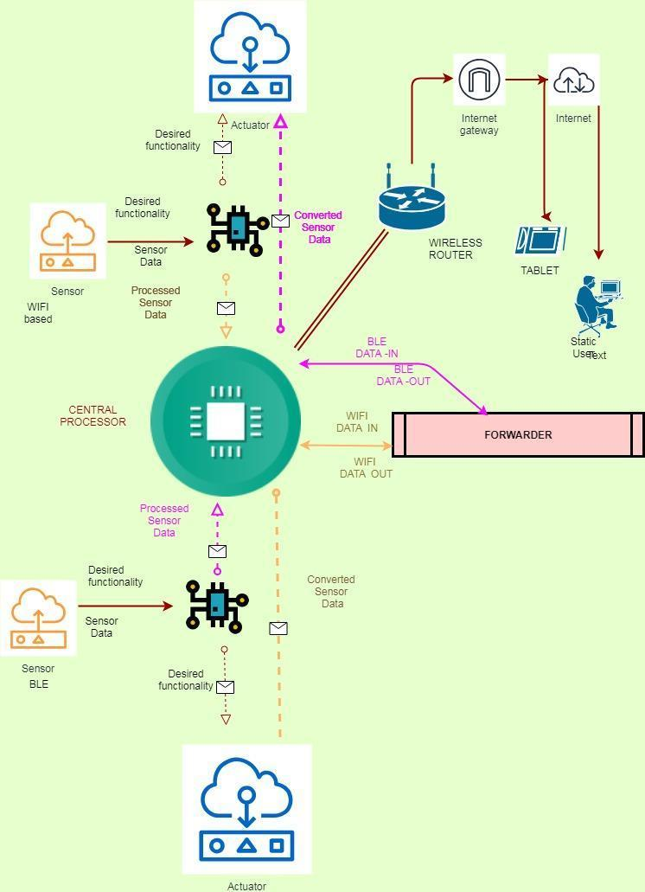

4.3 NETWORK INTERFACE
To avoid ambiguity, ‘Network Interface’ in this context is a program interface.
class Network {
protected:
std::string networkParams;
std::vector<Device *> devices;

public:
Network() {}
~Network() {}
virtual bool init();
virtual std::string getUserFriendlyName();
virtual int listen();
virtual int connect(std::string);
virtual std::vector<NetworkInfo> discover();
std::vector<Device *> getDevices() { return devices; }
};

4.4 DEVICE INTERFACE
Device provides application level communication. Device is a program interface.
class Device : public NetworkInfo {
public:
Device() {}
virtual int send(std::string msgToSend) = 0;
virtual std::string recv(int bytesToRead) = 0;
};
Device is used to send and recv information from one process to process. It is invoked by the forwarder program. The constructor of base class of Device is used to pass critical information such as device’s open socket described by the file descriptor.
class IPDevice : Device {
private:
comm_socket fd;
public:
IPDevice(comm_socket fd) : fd(fd) {}

std::string recv(int bytesToRead) override {
char buffer[bytesToRead];
::recv(fd, buffer, bytesToRead - 2, 0);
buffer[bytesToRead - 1] = '\0';
return std::string(buffer);
}

int send(std::string message) override {
return ::send(fd, message.c_str(), message.size(), 0);
}
~IPDevice() { comm_close_socket(fd); }
};

IPDevice is a base class of Device. comm_socket holds the file descriptor. It is passed through constructor by it’s Network class.

CHAPTER 5

SOFTWARE REQUIREMENTS

5.1 C++ PROGRAMMING
The reason for using C++ is to exploit the functionality provided by the Operating System. Since this process highly depends on the hardware. We need to make sure we are using technology that can actually control the hardware without requiring us to wait for device manufactures to release a driver or API to use.
The reasons for using C++ are,
- Object oriented
- High Performance
- Multithreaded
- Native code
C++ is a programming language in which a program is compiled to a particular instruction set architecture. Even though it limits our software in portability, it is necessary to completely utilize the hardware of the target operating system. Since Linux offers well defined interfaces for hardware we are choosing out target operating system as Linux.

5.1.2 C++ APPLICATIONS
The most types of programs written in C++ programming language are applications that needs to interfaced with hardware directly or application that is heavily depended on algorithms. An application in C++ is a code that is compiled for a target operating system. This makes C++ a true General Purpose Programming language. C++ applications are a popular choice for building robust applications that requires every drop of performance from the target OS. This makes it a suitable programming language for embedded devices.

5.2 TARGET OPERATING SYSTEM

5.2.1 POSIX
POSIX (Portable Operating System Interface) is a standard defined by the Open Group. There are more than ten parts to the POSIX standard, but two are widely available. POSIX.1 defines C programming interfaces (that is, a library of system calls) for files, processes, and terminal I/O. To support the library, a POSIX system must implement a Hierarchical File System (HFS). POSIX.2 defines a "shell" command interpreter and utilities (e.g., ls to list files). Certain important standards are not covered by POSIX (for example, spooling, batch processing, and NLS.
POSIX has two components:
- User space
- Kernel space
The need for classification as user space and kernel space is necessary to reduce the work done by every component software wise. Since C++ programs is highly dependent on the OS. Targeting a specification in contrast to a OS makes the process of porting to different OSes a easy process.

5.2.2 LINUX
Linux has been POSIX compatible since it’s inception and is considered the most compatible implementation of POSIX.
Linux also offers a number of hardware drivers compared to other OS. Making it easy to add new hardwares to the proposed system.

5.3 ADDITIONAL SOFTWARE

5.3.1 SQLITE
SQLite is a C-language library that implements a small, fast, self-contained, high-reliability, full-featured, SQL database engine. SQLite is the most used database engine in the world. SQLite is built into all mobile phones and most computers and comes bundled inside countless other applications that people use every day.
The SQLite file format is stable, cross-platform, and backwards compatible and the developers pledge to keep it that way through at least the year 2050. SQLite database files are commonly used as containers to transfer rich content between systems and as a long-term archival format for data.

5.3.2 ANGULAR 7
Angular is a platform that makes it easy to build applications with the web. Angular combines declarative templates, dependency injection, end to end tooling, and integrated best practices to solve development challenges. Angular empowers developers to build applications that live on the web, mobile, or the desktop.
Angular 7 is whole suite of software development for the web. Rich application can be created using Angular 7. Angular 7 uses a Component based approach which can be combined in multiple ways to produce different results.

5.3.3 RX JAVA
RxJava is a library for composing asynchronous and event-based programs by using observable sequences. The programming semantics is based on publisher-subscribe model which is a more specific form of producer-consumer model.

5.3.4 NPM
npm is the package manager for the Node JavaScript platform. It puts modules in place so that node can find them, and manages dependency conflicts intelligently. It is extremely configurable to support a wide variety of use cases. Most commonly, it is used to publish, discover, install, and develop node programs.

CHAPTER 6

HARDWARE REQUIREMENTS

6.1 ADAPTER

6.1.1 RASPBERRY PI 3
Raspberry Pi is a small and affordable computer. It is a single-board computer with wireless LAN and Bluetooth connectivity.

6.2 WIFI DEVICE
PC or Raspberry Pi is used to host the server for uploading sensor data to the internet.

6.3 BLUETOOTH DEVICE

6.3.1 ARDUINO UNO
Arduino Uno is a microcontroller board based on the ATmega328P. It has 14 digital input/output pins (of which 6 can be used as PWM outputs), 6 analog inputs, a 16 MHz quartz crystal, a USB connection, a power jack, an ICSP header and a reset button. It contains everything needed to support the microcontroller

6.3.2 BLUETOOTH MODULE HC-05
HC-05 module is an easy to use Bluetooth SPP (Serial Port Protocol) module, designed for transparent wireless serial connection setup.
Serial port Bluetooth module is fully qualified Bluetooth V2.0+EDR (Enhanced Data Rate) 3Mbps Modulation with complete 2.4GHz radio transceiver and baseband. It uses CSR Bluecore 04-External single chip Bluetooth system with CMOS technology and with AFH(Adaptive Frequency Hopping Feature). It has the footprint as small as 12.7mmx27mm. Hope it will simplify your overall design/development cycle.

6.3.3 DHT-11
The DHT11 is a basic, ultra low-cost digital temperature and humidity sensor. It uses a capacitive humidity sensor and a thermistor to measure the surrounding air, and spits out a digital signal on the data pin (no analog input pins needed). It’s fairly simple to use, but requires careful timing to grab data.

CHAPTER 7

SYSTEM IMPLEMENTATION

7.1 USER INTERFACE

7.1.1 COMMAND LINE INTERFACE
For convenience, we have created a CLI program for controlling the forwarder. This is to give us flexible control over the forwarding operations. Since different networks are in need of different connection parameters. We had to build a way which is common to every network. Network in this context roughly denotes the collection of different devices. It may or may not be associated with the Network Layer of the OSI model.
TABLE 7.1 Commands offered by the CLI
Commands | Description
add | add a network to ready state
bind | binds a address of a device from one network to other
config | create a configuration with medium and network
clear | clears the screen
ls | lists available network classes
start | started after one or more networks has been added

7.2 CONFIGURING FORWARDER
When starting forwarder, an empty prompt is shown to the user.
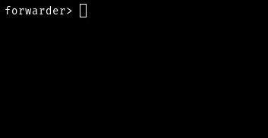
FIGURE 7.1 Forwarder program prompting empty shell
A network ‘IP’ is added to the forwarder with the interface name, which is the network parameter for this specific network. It varies from network to network.
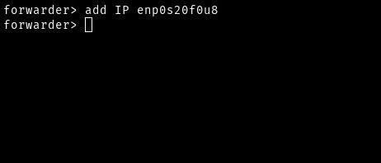
FIGURE 7.2 Adding a network with connection parameters
‘ls’ is used to print networks that are available and networks that are in ready state. If we added ‘Console’. The ‘ls’ output also will be printed with its associated network parameters.
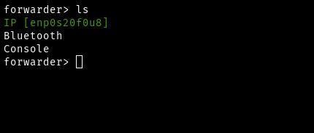
FIGURE 7.3 ls command execution
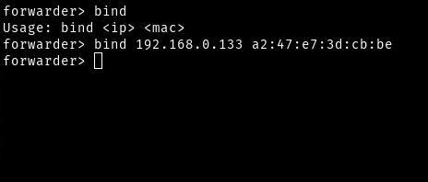
FIGURE 7.4 Binding IP address of ethernet device t
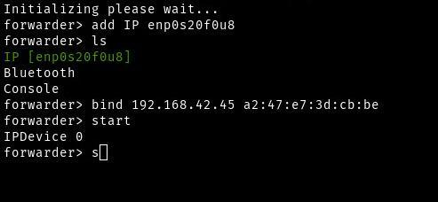
FIGURE 7.5 Starting the forwarder

7.3 DEVICE CONNECTION

7.3.1 WIFI CONNECTION
After configuring the virtual network through the forwarder, a PC is used to run a program called homate-client which is based on npm. This runs on the MQTT protocol and connected to the internet. It uses Firestore to store and retrieve IoT device information. It will establish a connection to the bluetooth device using a IP address which is the IP address binded to the Bluetooth MAC in the forwarder program. Once connection is established the forwarder program transmits the message in the application layer.

7.3.2 BLUETOOTH CONNECTION

7.3.2.1 ARDUINO INTERFACING WITH HC-05 MODULE
TABLE 7.2 Arduino Pin Configuration
ARDUINO PINS | BLUETOOTH PINS
RX (Pin 0) | TX
TX (Pin 1) | RX
5V | VCC
GND | GND

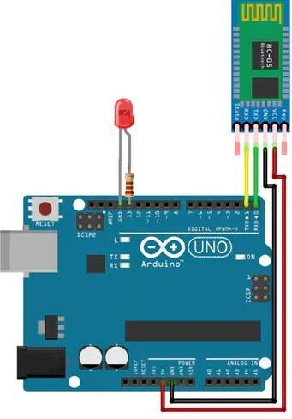
FIGURE 7.6 Arduino Pin Connections
The bluetooth device which bears the MAC address given in the bind operation is paired with the forwarder device. The code for pairing is flashed to the arduino uno board.

7.4 APPLICATION
A web page created using Angular is hosted on a web server. This web page actively listens on the Firestore DB and updates the information for the user.
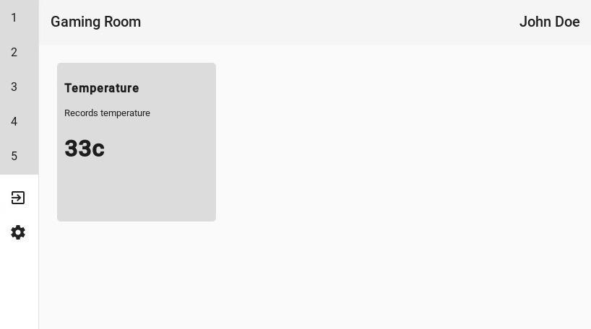
FIGURE 7.6 Web app displaying devices of Room 4
The details shown in the web app is actually transmitted information from Bluetooth to WiFi.
The page consists of the following components,
- Toolbar
- Main
- Angular Material
Uses the following data models,
Device for storing device related information
export class Device {
constructor(
public id: string,
public name: string,
public description: string,
public topic: string,
public cmd: string) { }
}
Room for storing the name and id of a room
export class Room {
constructor(
public id: string,
public name: string,
public icon: string = "") { }
}
A class called Informer is created using RxJava and notifies whenever there is a change in the database.
The following subroutine is part of Informer class and informs whenever there is a change of rooms
get rooms(): Observable<Array<Room>> {
this._observableRooms = of(this._rooms);
firebase.firestore()
.collection("rooms")
.onSnapshot(function(querySnapshot) {
querySnapshot.docChanges()
.forEach(function (change) {
if (change.type == "added")
this._rooms.push(change.doc.data() as Room)
}.bind(this));
}.bind(this));
return this._observableRooms;
}
For any selected room, the following function is called to fetch device details
get devices(room: Room) : Observable<Array<Device>> {
let devices = new Array<Device>();
let observableDevices = of(devices);

if(room.id == ""){
return observableDevices;
}
firebase.firestore()
.collection('rooms')
.doc(room.id)
.collection('devices')
.onSnapshot(function (querySnapshot) {
querySnapshot.docChanges()
.forEach(function (change) {
if (change.type == "added") {
devices.push(change.doc.data() as Device)
}
}.bind(this));
}.bind(this));
return observableDevices;
}
CHAPTER 8
CONCLUSION AND FUTURE WORK

To provide a interface that automatically configures (Discovering and Mapping). Discovery is only possible if the device provide that service. To discover a wide range of devices, we need a tremendous amount of data for identification of device and its service.
Another feature to implement is to add web interface to the forwarder. The idea for a web interface is to have a user friendly interface for a novice user. It will provide all the operations provided by the forwarder CLI. It will provide all the operations listed in table 7.1 and also provides some user friendly operations such as device discovery which is yet to be implemented.

REFERENCES
- Mahmoud Elkhodr, Seyed Shahrestani and Hon Cheung, ‘Emerging Wireless Technologies in the Internet of Things: A Comparative Study’, International Journal of Wireless & Mobile Networks (IJWMN) Vol. 8, No. 5, October 2016
- Daniela Ballari, Miguel Angel Manso-Callejo, Monica Wachowicz, ‘The Interoperability of Wireless Sensor Networks’, Workshop - “ Sensing A Changing World” 19 - 21 November 2008 - Centre for Geo-Information - Wageningen, The Netherlands
- KyeongDeok Moon, YoungHee Lee, ChangEun Lee, YoungSung Son, “Design of a Universal Middleware Bridge for device interoperability in heterogeneous home network middleware”, IEEE Transactions on Consumer Electronics March 2005.
- G. Aloi, G. Caliciuri, G. Fortino, R. Gravina, P. Pace, W. Russo and C. Savaglio, “Enabling IoT interoperability through opportunistic smartphone-based mobile gateways”, Volume 81, 1 March 2017
- Ivana Podnar Žarko, Patrick Zwickl, Ivan Gojmerac, Giuseppe Bianchi and Gino Carrozzo, “Towards the cross-domain interoperability of IoT platforms”, 2016 European Conference on Networks and Communications (EuCNC)
- B.P. Kulkarni, Aniket V. Joshi, Vibhav V. Jadhav and Akshay Kumar T, “IoT based Home Automation using Raspberry PI”, JSRST, Volume 4 Issue 8, 2018
- Himani Singh Dhami, Nidhi Chandra, Nishank Srivatsava and Avanisih Pandey, “Raspberry Pi Home Automation using Android app”, Volume 3 Issue 2, International Journal of Advanced Research, Ideas And Innovations in Technology
- E. Isa and N.Sklavos, “Smart Home automation security using GSM”, Journal of Engineering Science and Technology Review, At Ioannina, Greece, Volume: Volume 10, Issue 3, January 2017
- Naresh Kumar and Praveen Singh, “An economical home automation system”, Advances in Computational Sciences and Technology, Volume 10, Number 6, 2017
- Sudhashmitha Behera, Anish Kumar Saha, Deepak Kumar and Jagannath Polai, “Home Automation using SMS”, InternationalResearch Journal of Engineering and Technology, Volume 04 Issue 03, March 2017

