Purpose of this Proof Of Concept
The purpose of this POC is to measure the performance difference between Apache Cassandra and Apache Cassandra with Ignite. Twitter is used for getting the continuous flow of data. Time is measured in nanoseconds.

Technology Stack Overview

Apache Ignite:
A memory-centric distributed database, caching, and processing platform for transactional, analytical, and streaming workloads delivering in-memory speeds at petabyte scale.

Features:

Durable Memory

Ignite Persistence

ACID Compliance

Complete SQL Support

Key-Value

Collocated Processing

Scalability and Durability

Apache Cassandra:

Apache Cassandra is an open source NoSQL database and management system. It was designed to handle large amounts of data across many servers, data centers and clouds. It can store hundreds of terabytes of data, and differs a lot from RDBMS, it is being used by many other organizations, such as Twitter, Reddit, Rackspace, Ciscom, Cloudkick, among others.

Features:
- Cassandra can be used where there is a requirement for data to be ingested at a very high speed with all the features, reliability and redundancy.
- It is used in situations where low coupling, high throughput and low latency to read and write is required.
- It is preferred when there is a tight connection between the data.
- Cassandra is used when there is a need to store a large amount of data feeds from customers.
- It is used to store a large volume of data by compressing it, e.g., sound files of about 120MB can be stored by compressing them to about 2-5MB.
- It can be used for persistent data storage, i.e., data will be available only for the specified session, and for finding particular data based on the situation.

Factors Considered

Setup Required to run POC is described in the Readme.txt file i.e checked in with the code. Yet some features that requires attention are:

Java 8 and above

Cassandra cluster setup

ignite cluster setup

Twitter developer API Authentication

Install Java 8 or above

Install Java 8 and above on system where the application will be runnig.

Create a Cassandra Cluster

Cassandra is build to be clustered to tick the usual clustering boxes; no single point of failure, and capacity and throughput scales with cluster size.

Each node has open communication between the other nodes.

Set the Cassandra cluster configuration
Cassandra is configured using various files in the /etc/cassandra directory. The cassandra.yaml contains most of the Cassandra configuration, such as ports used, file locations and seed node IP addresses. Edit your cassandra.yaml file and fill in the details as below. The below example is for brevity and your file may contain many other settings.
etc/cassandra/cassandra.yaml
- cluster_name can be anything chosen by you to describe the name of the cluster. Space is allowed but make sure you wrap everything in quotes. All members of this cluster must have the same name.
- num_tokens is the number of virtual nodes within a Cassandra instance. This is used to partition the data and spread the data throughout the cluster. A good starting point is 256.
- seeds are the IP addresses of the clusters seed servers. Seed nodes are used as known places where cluster information (such as a list of nodes in the cluster) can be obtained. They are not a single point of failure as all active nodes have this information, they are just known locations that can be relied on to have the information when other machines can come and go. It’s recommended that there are 3 seed nodes per data centre.
- listen_address is the IP address that Cassandra will listen on for internal (Cassandra to Cassandra) communication will occur. Cassandra will try to guess your machines IP address if you leave it blank, but it’s best to specify it yourself. This will change on each node.
- rpc_address is the IP address that Cassandra will listen on for client based communication, such as through the CQL protocol. This will change on each node.
- endpoint_snitch is the ‘snitch’ used by Cassandra. A snitch is what tells Cassandra which data center and rack a node belongs to within a cluster. There are various types that could be used here, however describing them is outside the scope of this guide.
Example for node 1:
cluster_name: 'JC Cluster'
num_tokens: 256
seed_provider:
- class_name: org.apache.cassandra.locator.SimpleSeedProvider
- seeds: 10.0.0.1, 10.0.0.2
listen_address: 10.0.0.1
rpc_address: 10.0.0.1
endpoint_snitch: GossipingPropertyFileSnitch
Example for node 2:
cluster_name: 'JC Cluster'
num_tokens: 256
seed_provider:
- class_name: org.apache.cassandra.locator.SimpleSeedProvider
- seeds: 10.0.0.1, 10.0.0.2
listen_address: 10.0.0.2
rpc_address: 10.0.0.2
endpoint_snitch: GossipingPropertyFileSnitch
Example for node 3:
cluster_name: 'JC Cluster'
num_tokens: 256
seed_provider:
- class_name: org.apache.cassandra.locator.SimpleSeedProvider
- seeds: 10.0.0.1, 10.0.0.2
listen_address: 10.0.0.3
rpc_address: 10.0.0.3
endpoint_snitch: GossipingPropertyFileSnitch
Cassandra is built to be fault tolerant and will distribute data to try to minimize the risk of a failure causing loss of data or any downtime. Cassandra therefore has the understanding of a node, a rack and a data centre. Where possible, Cassandra will ensure that the data and it’s backups are stored on a different rack and a different data centre to ensure that failure, even at a data centre level isn’t catastrophic.
Edit the cassandra-rackdc.properties file on each node and set the dc and rackattributes. For this example we’ll assume everything is in the same dc, dc1 however two nodes will be on rack1 and one node will be on rack2. Names are irrelevant, just come up with a naming standard that helps you understand where the Cassandra instance actually is. Everything here is case sensitive so be sure you’re consistent.
vi /etc/cassandra/cassandra-rackdc.properties
Example for node 1:
dc=uk_dc
rack=rack1
Example for node 2:
dc=uk_dc
rack=rack1
Example for node 3:
dc=uk_dc
rack=rack2
Finally, remove the config file cassandra-topology.properties from the etc dir as that’s not used with our configuration.
rm /etc/cassandra/cassandra-topology.properties

Starting your Cassandra cluster
The final steps are to start your cluster and connect to it.
First off, start your seed instances that were specified in the cassandra.yaml config file. Once these are up and running you can start the remaining nodes.
service cassandra start
Once all of your services are started you can use the nodetool status command to check the status of your nodes. Run this from any Cassandra server. As you can see with the below output, all three servers are available in the uk_dc data centre on rack1 and rack2.
nodetool status

Datacenter: uk_dc
===============
Status=Up/Down
|/ State=Normal/Leaving/Joining/Moving
-- Address Load Tokens Owns Host ID Rack
UN 10.0.0.3 124.64 KB 256 ? bb57bbee-3fe4-47b1-9249-cd3f90cd9718 rack2
UN 10.0.0.2 124.7 KB 256 ? 6669bac4-52c5-49fb-a68a-da065f20ae2c rack1
UN 10.0.0.1 106.45 KB 256 ? ddee28dd-7909-4428-bebd-023e4e560db5 rack1

Note: Non-system keyspaces don't have the same replication settings, effective ownership information is meaningless

Connect to your Cassandra Cluster
Once all of your servers have started your cluster is ready to use! Each node will have the cqlsh utility installed that you can use to interact with your Cassandra cluster. You’ll need to use one of the IP addresses Cassandra is listening on (set with rpc_address in cassandra.yaml).
cqlsh 10.0.0.1

Connected to Uptime2 at 10.0.0.1:9042.
[cqlsh 5.0.1 | Cassandra 3.2.1 | CQL spec 3.4.0 | Native protocol v4]
Use HELP for help.
cqlsh>

Create a Ignite Cluster
Ignite has advanced clustering capabilities including logical cluster groups and auto-discovery. Inite nodes can automatically discover each other. This helps to scale the cluster when needed, without having to restart the whole cluster. Developers can also leverage from Ignite’s hybrid cloud support that allows establishing connection between private cloud and public clouds such as Amazon Web Services, providing them with best of both worlds.

Features
- Pluggable Design via IgniteDiscoverySpi
- Dynamic topology management
- Automatic discovery on LAN, WAN, and AWS
- On-demand and direct deployment
- Support for virtual clusters and node groupings

IgniteCluster
Cluster functionality is provided via IgniteCluster interface. You can get an instance of IgniteCluster from Ignite as follows:
- Java
Ignite ignite = Ignition.ignite();

IgniteCluster cluster = ignite.cluster();
Through IgniteCluster interface you can:
- Start and stop remote cluster nodes
- Get a list of all cluster members
- Create logical Cluster Groups

ClusterNode
The ClusterNode interface has very concise API and deals only with the node as a logical network endpoint in the topology: its globally unique ID, the node metrics, its static attributes set by the user and a few other parameters.

Cluster Node Attributes
All cluster nodes on startup automatically register all environment and system properties as node attributes. However, users can choose to assign their own node attributes through configuration:
- XML
<bean class="org.apache.ignite.IgniteConfiguration">
...
<property name="userAttributes">
<map>
<entry key="ROLE" value="worker"/>
</map>
</property>
...
</bean>
Following example shows how to get the nodes where "worker" attribute has been set.
- Java
ClusterGroup workers = ignite.cluster().forAttribute("ROLE", "worker");

Collection<GridNode> nodes = workers.nodes();
All node attributes are available via ClusterNode.attribute("propertyName")method.

Cluster Node Metrics
Ignite automatically collects metrics for all cluster nodes. Metrics are collected in the background and are updated with every heartbeat message exchanged between cluster nodes.
Node metrics are available via ClusterMetrics interface which contains over 50 various metrics (note that the same metrics are available for Cluster Groups as well).
Here is an example of getting some metrics, including average CPU load and used heap, for the local node:
- Java
// Local Ignite node.
ClusterNode localNode = cluster.localNode();

// Node metrics.
ClusterMetrics metrics = localNode.metrics();

// Get some metric values.
double cpuLoad = metrics.getCurrentCpuLoad();
long usedHeap = metrics.getHeapMemoryUsed();
int numberOfCores = metrics.getTotalCpus();
int activeJobs = metrics.getCurrentActiveJobs();

Local Cluster Node
Local grid node is an instance of the ClusterNode representing this Ignite node.
Here is an example of how to get a local node:
- Java
ClusterNode localNode = ignite.cluster().localNode();

Twitter Developer Api Authentication

For using twitter streaming API we need to create an application inside twitter account.

Sign up to the https://dev.twitter.com/web/sign-in and firstly create and account and then application prior to it, we will be eligible with the following parameters to use.
- ConsumerKey
- ConsumerSecret
- AccessToken
- AccessTokenSecret

Summary Report of the Application
Case 1: Fetch 1k record from DB/Cache with table having 1 million records and no partition.
Ignite + Cassandra took around 29.836 nanoseconds
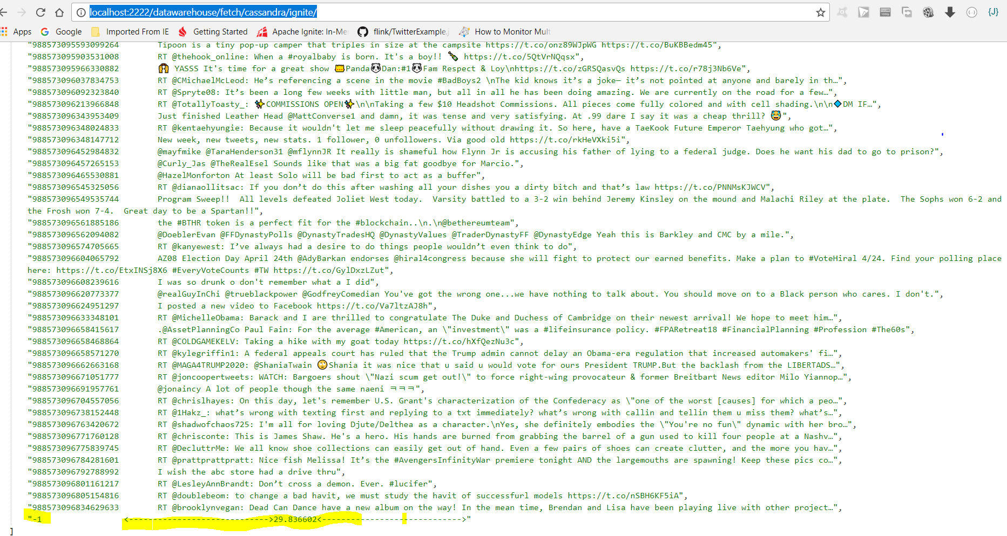

Cassandra took around 36.83 nanoseconds
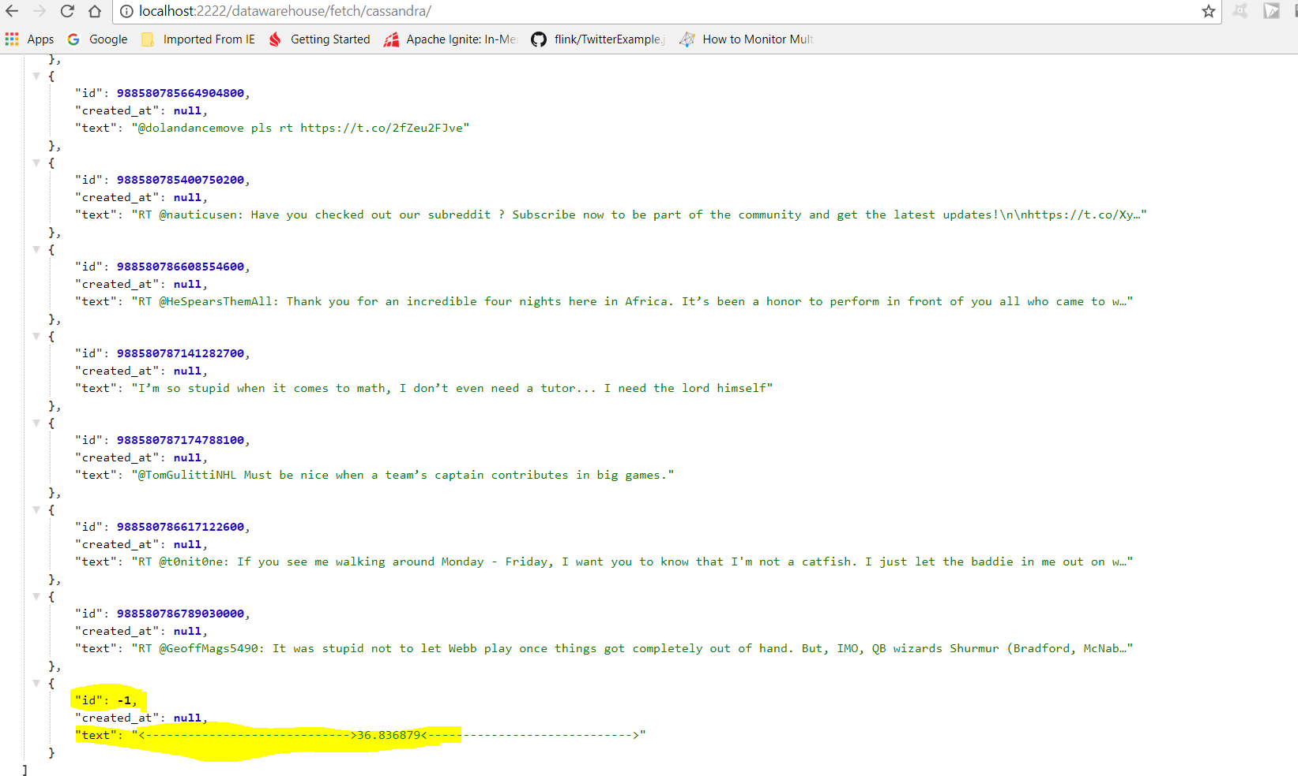
Case 2: Fetch a record from DB/Cache using ID with table having 1 million record and with no partition.
Cassandra took 14.75 nanoseconds
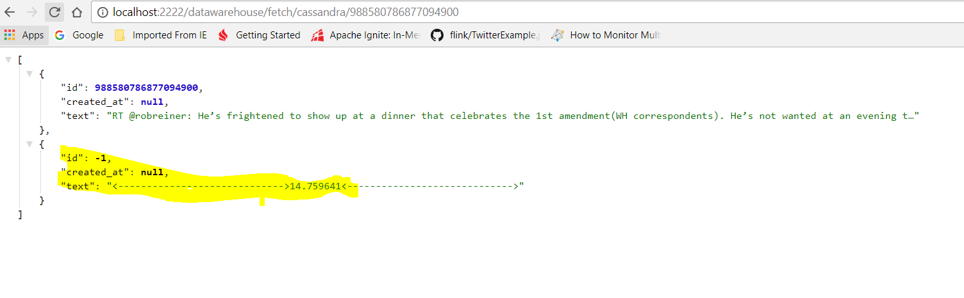
Cassandra+ Ignite took 475.21 nanoseconds

