|  |  |  |  |  |
| --- | --- | --- | --- | --- |
| Event | Repository | Tom | Susan | John |
| 1. | 3 | 2 | 3 | 2 |
| Description: | No conflicts. | | | |

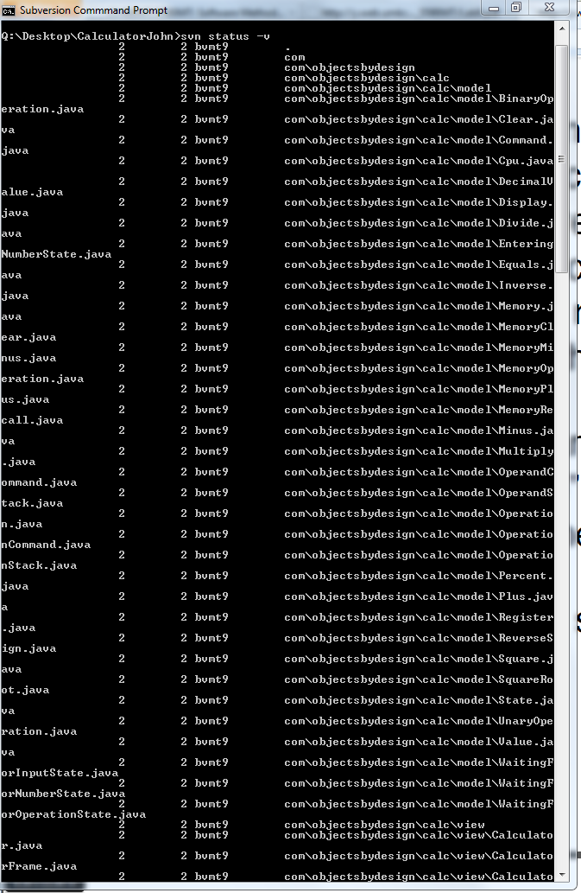

|  |  |  |  |  |
| --- | --- | --- | --- | --- |
| Event | Repository | Tom | Susan | John |
| 2. | 3 | 2 | 3 | 3 |
| Description: | No conflicts. The code file committed by Susan is synchronized in to John Working copy version. | | | |

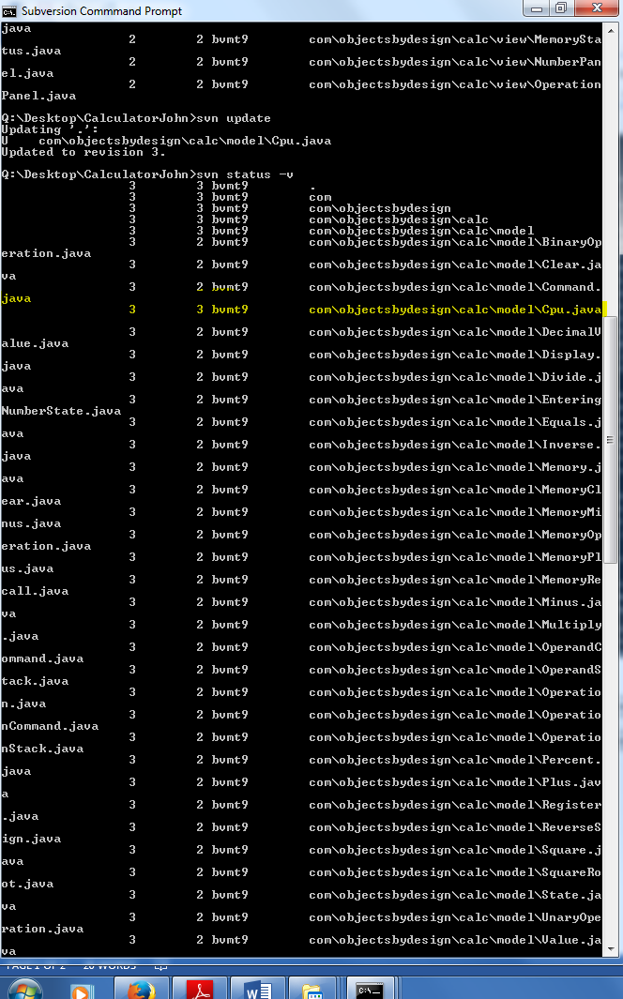

|  |  |  |  |  |
| --- | --- | --- | --- | --- |
| Event | Repository | Tom | Susan | John |
| 3. | 4 | 4 | 3 | 3 |
| Description: | Conflict occurred. As Tom has older copy of cpu.java. (Repo Version is 3 and Tom version is 2). So, to resolve this conflict   1. Done svn update. 2. Selected ‘e ‘option to edit file. 3. Resolved the conflict by giving option ‘r’ 4. Finally committed the file cpu.java using svn commit. | | | |

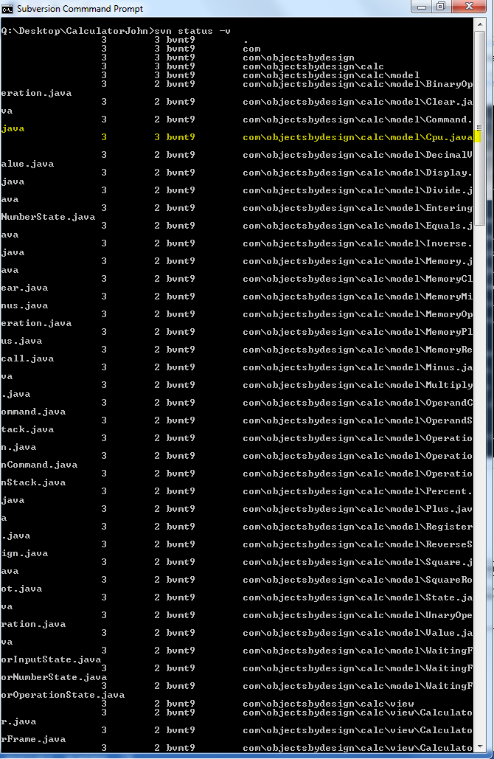

|  |  |  |  |  |
| --- | --- | --- | --- | --- |
| Event | Repository | Tom | Susan | John |
| 4 | 5 | 4 | 3 | 3 |
| Description: | No conflicts. | | | |

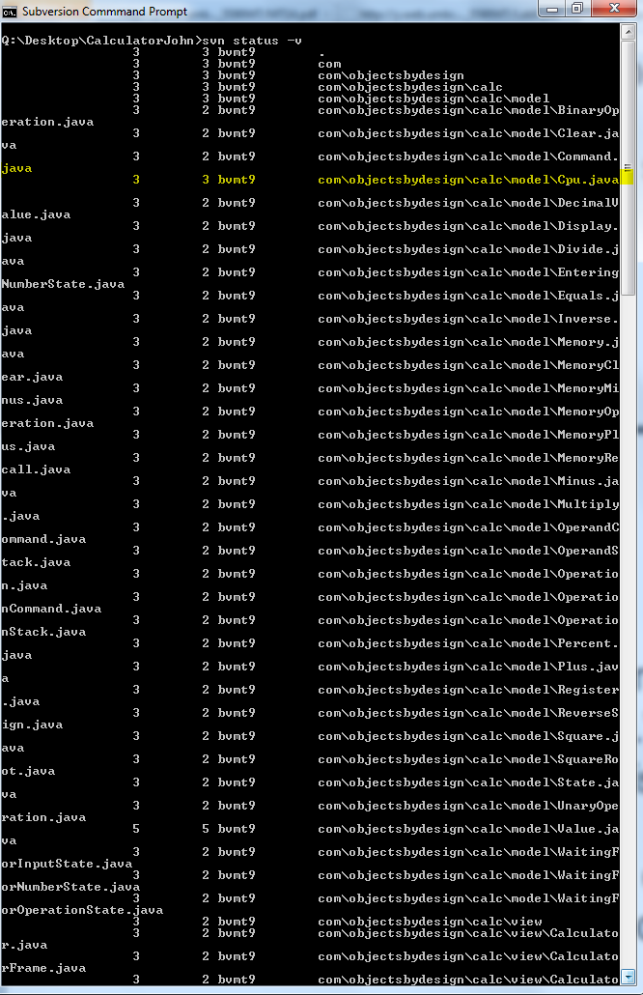

|  |  |  |  |  |
| --- | --- | --- | --- | --- |
| Event | Repository | Tom | Susan | John |
| 5 | 5 | 4 | 3 | 5 |
| Description: | No conflicts. Just synchronized with repo version for working copy of john using svn update. | | | |

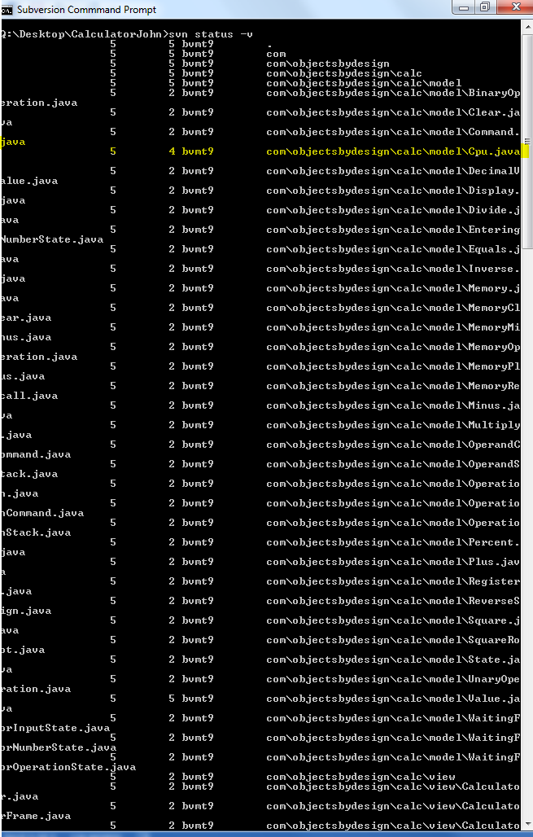

|  |  |  |  |  |
| --- | --- | --- | --- | --- |
| Event | Repository | Tom | Susan | John |
| 6 | 5 | 5 | 5 | 5 |
| Description: | No conflicts. Using svn update synchronized the versions of Susan and Tom. | | | |

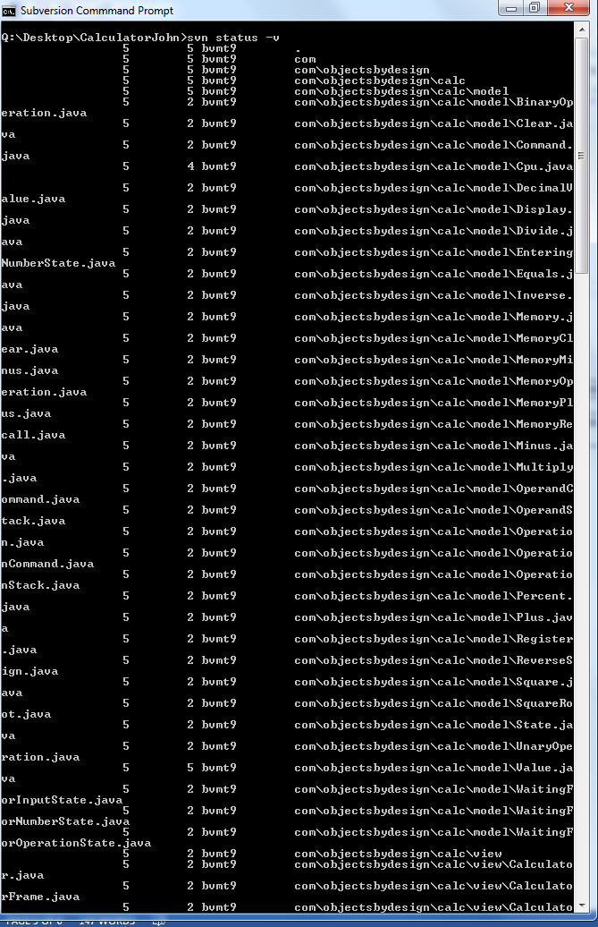

1.

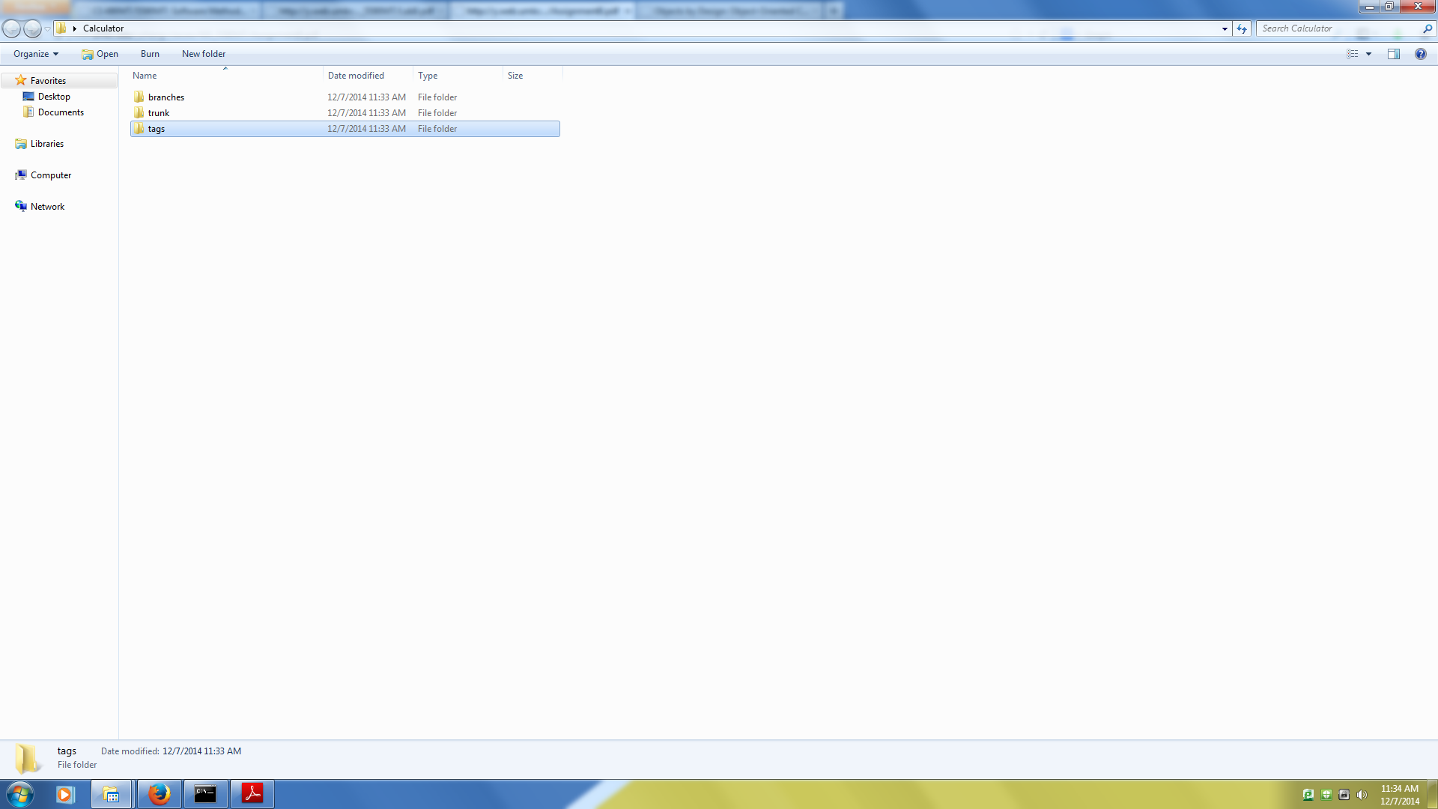

2.

