1. Screenshot of Calculator folder:

Imported the Calculator folder in to repository (calcrep).

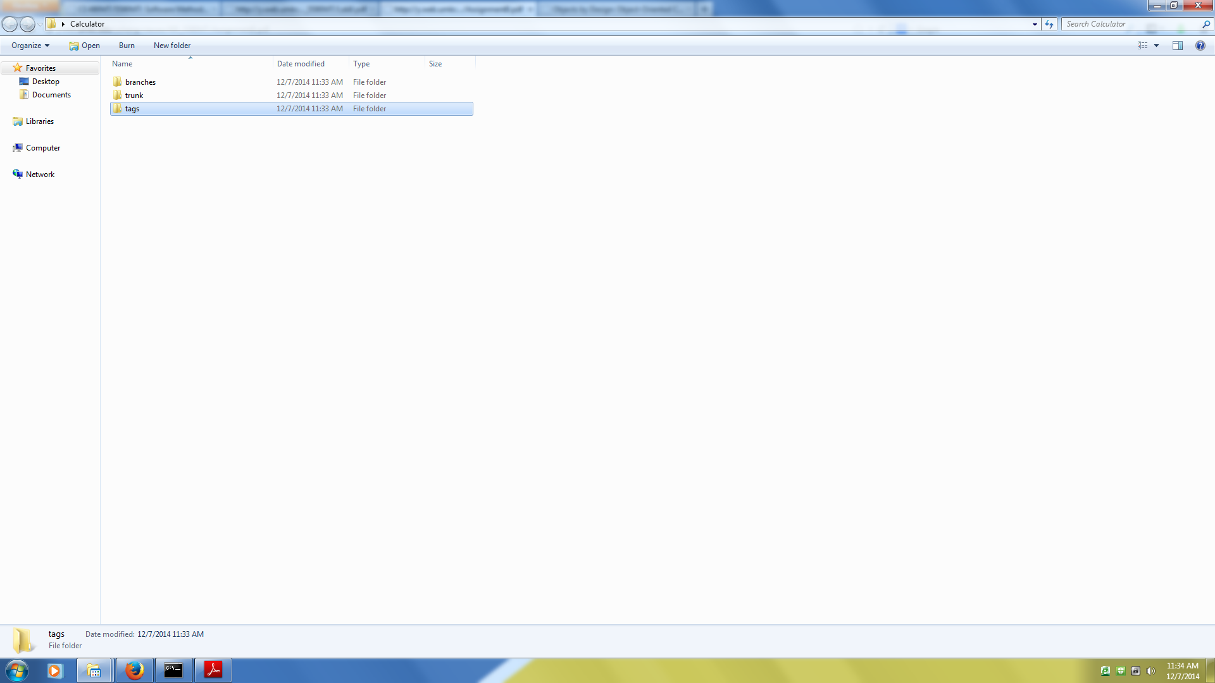

1. Content in repository cannot be seen as content is stored in database.

The screenshot is calculator folder containing model folder.

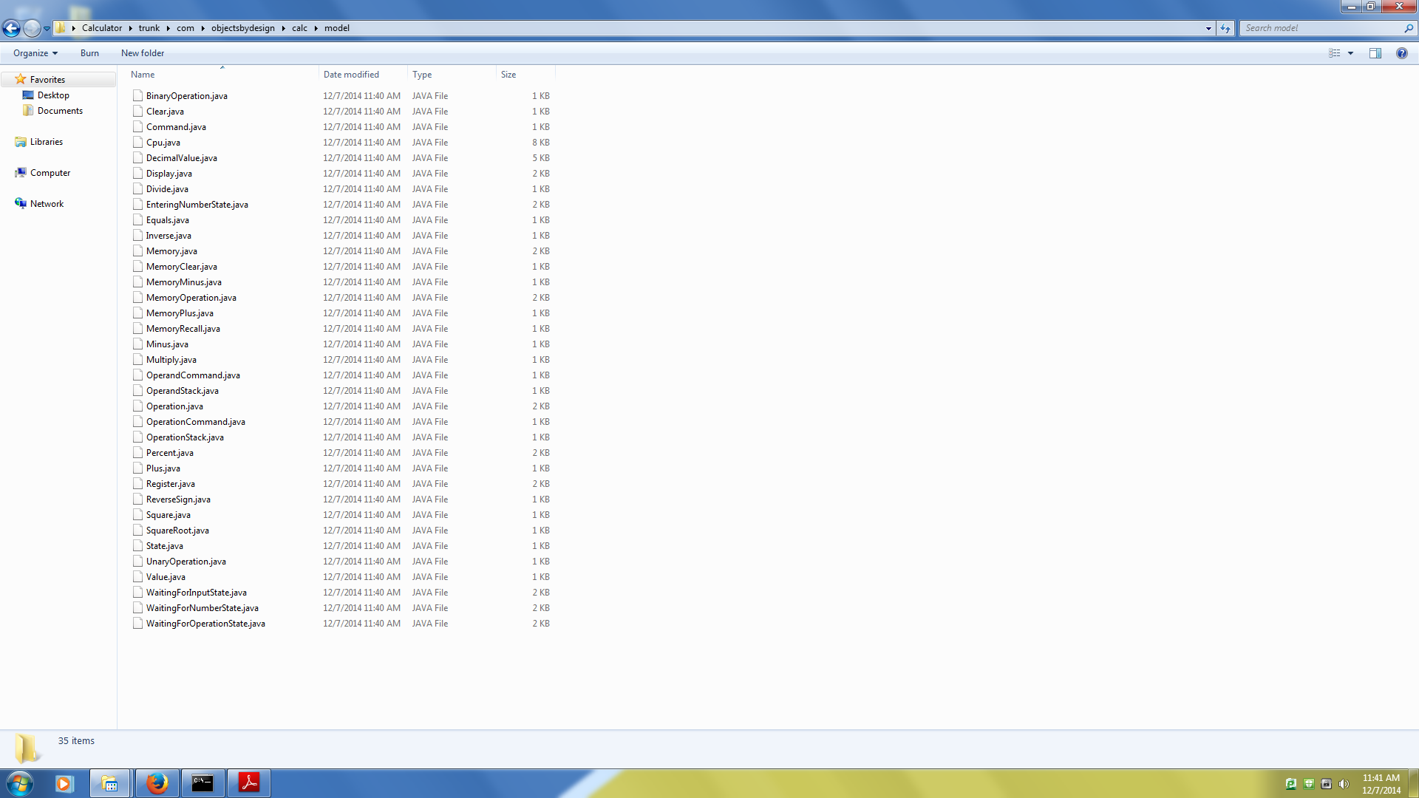

Here as once calculator folder with 3 folders branch, trunk and tags once is imported. Because of this version is changed to 1.

And then next the code from calculator is kept into the Calculator/Trunk folder and then imported the code in to repository. Then version becomes 2.

Because of this the version no starting is with 2.

1. Then created the working copies using svn checkout command.

Svn checkout <file:///Desktop/calcrepo/CalculatorTrunk> CalculatorTom

Svn checkout <file:///Desktop/calcrepo/CalculatorTrunk> CalculatorSusan

Svn checkout <file:///Desktop/calcrepo/CalculatorTrunk> CalculatorJohn

In the next pages the events are continued.

1. Event1:

|  |  |  |  |  |
| --- | --- | --- | --- | --- |
| Event | Repository | Tom | Susan | John |
| 1. | 3 | 2 | 3 | 2 |
| Description: | No conflicts. | | | |

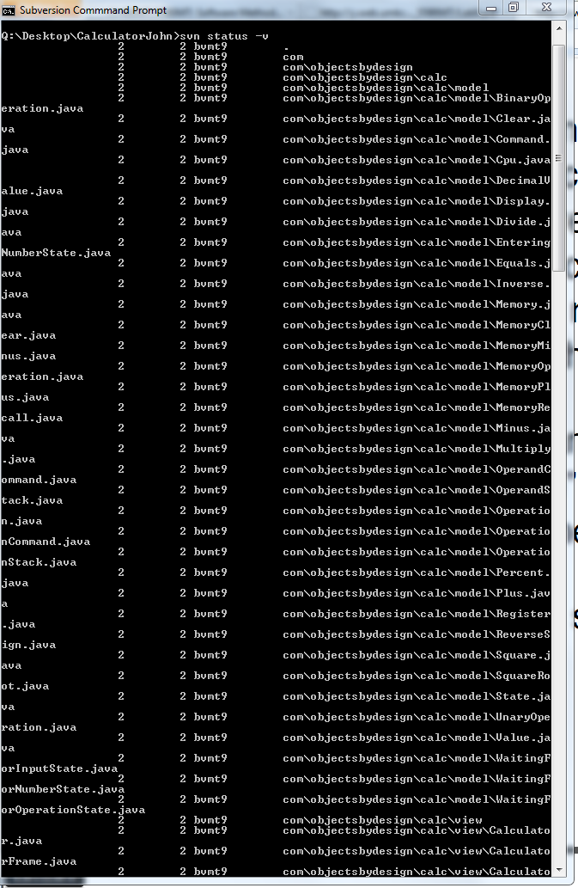

|  |  |  |  |  |
| --- | --- | --- | --- | --- |
| Event | Repository | Tom | Susan | John |
| 2. | 3 | 2 | 3 | 3 |
| Description: | No conflicts. The code file committed by Susan is synchronized in to John Working copy version. | | | |

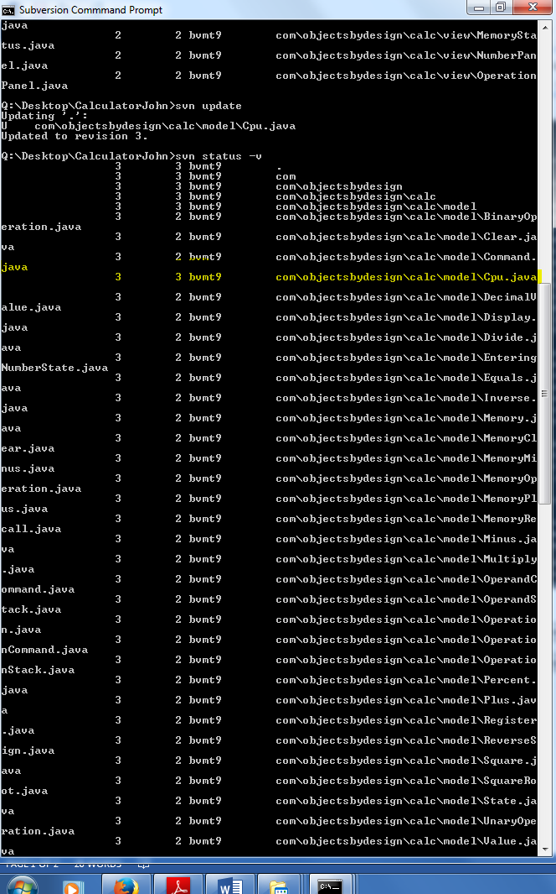

|  |  |  |  |  |
| --- | --- | --- | --- | --- |
| Event | Repository | Tom | Susan | John |
| 3. | 4 | 4 | 3 | 3 |
| Description: | Conflict occurred. As Tom has older copy of cpu.java. (Repo Version is 3 and Tom version is 2). So, to resolve this conflict   1. Done svn update. 2. Selected ‘e ‘option to edit file. 3. Resolved the conflict by giving option ‘r’ 4. Finally committed the file cpu.java using svn commit. | | | |

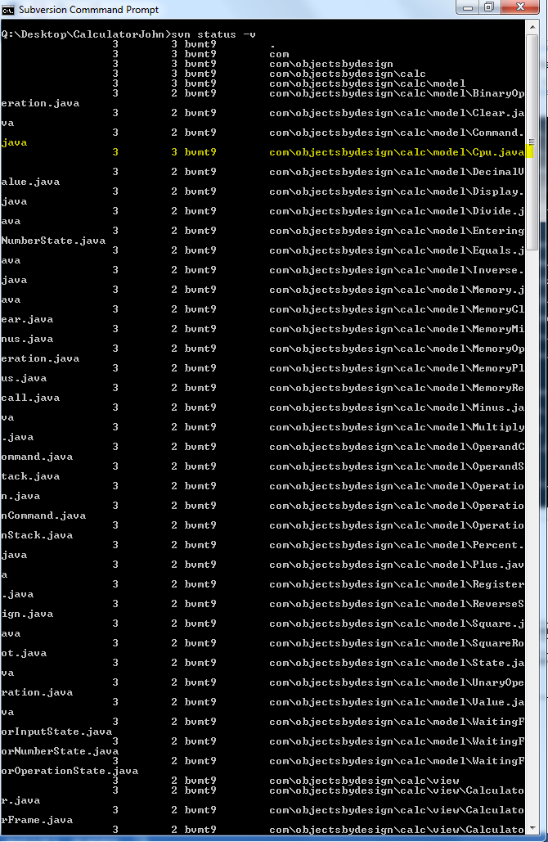

|  |  |  |  |  |
| --- | --- | --- | --- | --- |
| Event | Repository | Tom | Susan | John |
| 4 | 5 | 4 | 3 | 3 |
| Description: | No conflicts. | | | |

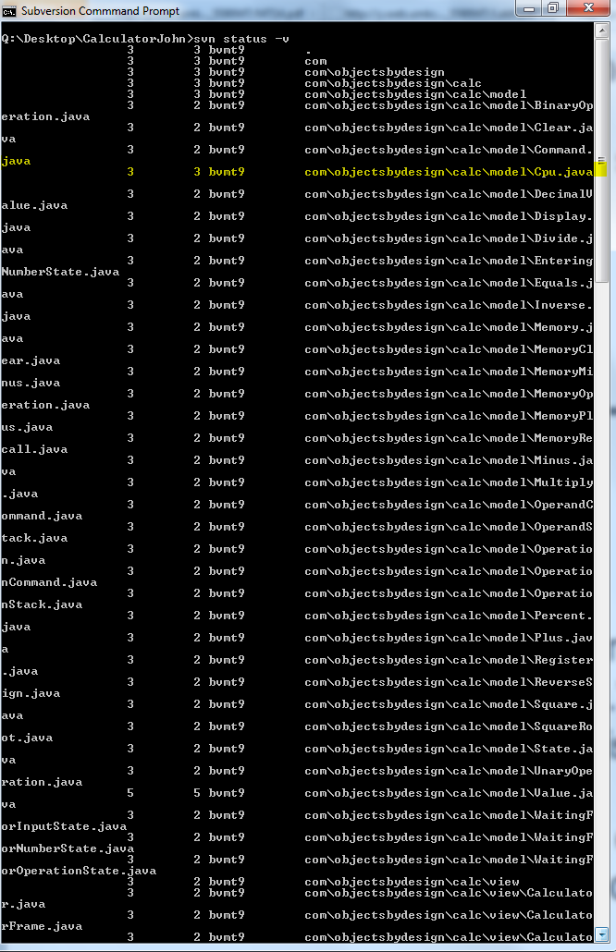

|  |  |  |  |  |
| --- | --- | --- | --- | --- |
| Event | Repository | Tom | Susan | John |
| 5 | 5 | 4 | 3 | 5 |
| Description: | No conflicts. Just synchronized with repo version for working copy of john using svn update. | | | |

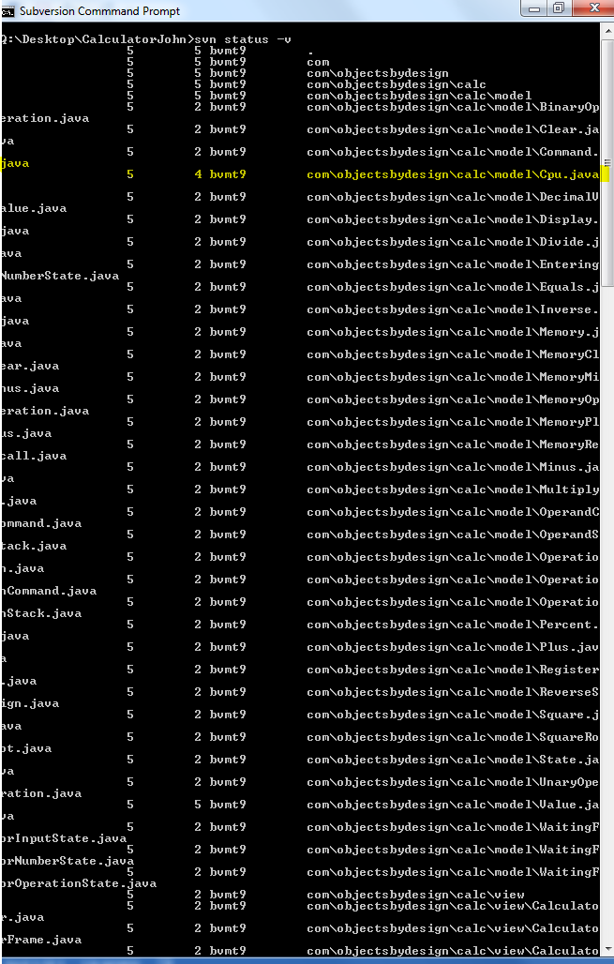

|  |  |  |  |  |
| --- | --- | --- | --- | --- |
| Event | Repository | Tom | Susan | John |
| 6 | 5 | 5 | 5 | 5 |
| Description: | No conflicts. Using svn update synchronized the versions of Susan and Tom. | | | |

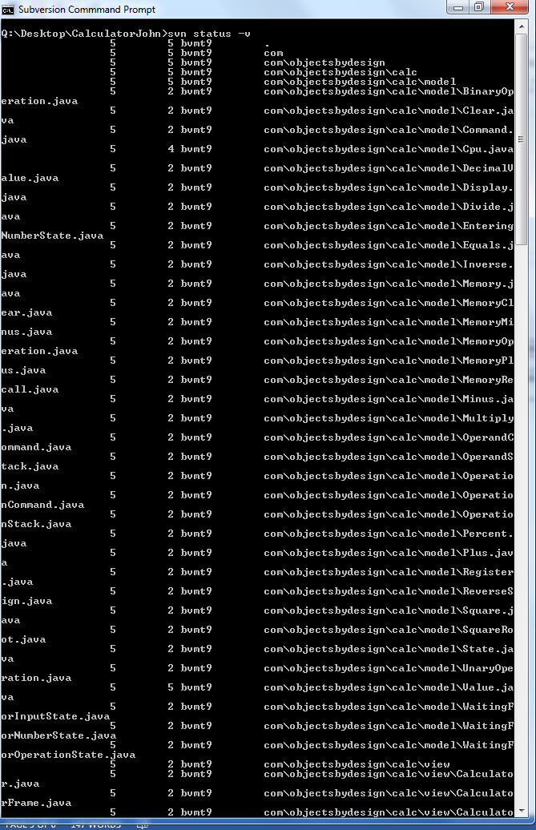

**Used the following commands:**

Svn list –v url

Svn info filepath/url

Svnadmin create reponame

Svn import <folder> repourl

Svn checkout <url> workingcopyfolder