Assignment

→

Install git on your computer and set up the global values for your user name and

email

→

Configure system level and repository level values for user name and email address

→

Create a github account and create a repository

→

Configure the

local repo with the remote repository

→

Run the add, rm, diff, commit, push command to push the changes to the remote

repository

Answers

1.

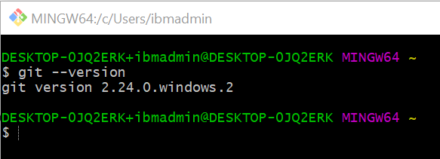

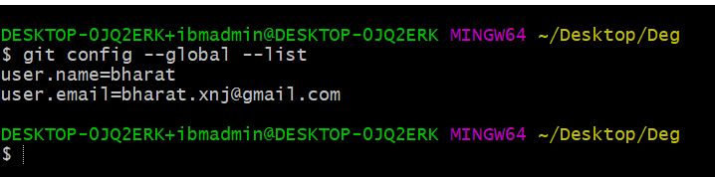

2

3

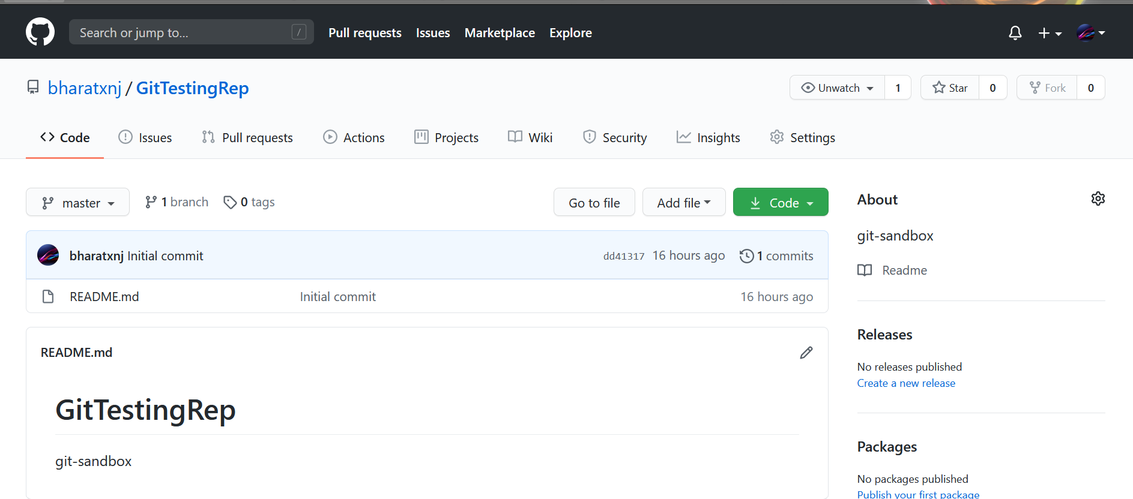

4