A Cross Domain Recommender System
Movies and Books recommendation using Tag Similarity and Collaborative Filtering.
Ms. Koyal Datta Gupta, Rohit Bhardwaj, Aditya Kumar, Bhanu Kumar, Vishesh Bhat
Maharaja Surajmal Institute of Technology, Indraprastha University, India
Department of Computer Science and Engineering
bhanu_516@ymail.com, brohit0995@gmail.com
singhadib201@yahoo.co.in, rishu.vishesh@gmail.com

Abstract—Recommendation system is a data processing system that analyzes the large datasets e.g. movies and books (Think of all the movies and books that ever existed) and recommends you a few items (movies or books) that you will like. There are many algorithm to recommend item in single domain but in the area of cross domain there aren't many algorithms. This paper is an attempt to provide a novel approach to build a cross domain recommendation system of movies and books by combining collaborative filtering algorithm (for single domain prediction) and content based recommendation algorithm (tag based similarity algorithm) for cross domain prediction.
Keywords—cross domain; movie and book recommendation; collaborative filtering; content based recommendation; tag similarity

Introduction

A recommendation system is a software that uses machine learning algorithms to predict what a user might like and recommend those items. It is used by many e-commerce website like Amazon and YouTube. Internet has a large sea of items (movies, books) and individual user can see only a limited number of them at a time, so recommender system helps them by recommending items that are most relevant to them. In 1982, John Naisbitt observed that: “we are drowning in information but starved for knowledge." [6].

Recommendation systems plays an important role in how we surf the internet e.g. recommendation given by YouTube decides which video we will see next. This could also have some negative consequences e.g. if we recommend users only one type of content, they can be easily manipulated.

A recommender system learns about its user and items. It learns features of its user e.g. someone might like action movies and don’t like romantic movies. The feature vector of this user will give more value to action movies rather than romantic movies. Similarly recommender system must learn about its items e.g. some movies will be more action than romantic so feature vector of this movie will give more value to action attribute rather than romantic.

User Feature Vector:
Attributes: [Action, Comedy, Romantic, Adventure]
Value: [0.9, 0.2, 0.5, 0.1 ]

This shows that a particular user likes action movies and don’t like adventures movies.

Item (movie) Feature Vector:
Attributes: [Action, Comedy, Romantic, Adventure]
Value: [0.2, 0.3, 0.6, 0.4 ]

This shows that a particular movie is more romantic and adventures.

Cross- Domain Recommender System

Most of the recommender systems out there are fixed to a particular domain e.g. videos for YouTube, movies for IMDB. In case of cross domain recommender system we generate recommendation across multiple domains like movies and books. In this paper we have built a recommender system that recommends both movies and books. We have used collaborative filtering algorithm to give recommendation in single domain (movie domain) and used tag based recommendation to link movies and books domain.

Background

There are many algorithms to build a recommender system mostly designed to work in a single domain.

Collaborative Filtering Algorithms:
In collaborative filtering we find users similar to our present user and recommend them movies seen and rated by the similar user [1]. These algorithm have advantages over content-based filtering algorithms, they can work on any type of items e.g. books, music, cars from the same user simultaneously.

Figure 1: Ratings given by users to movies.

Content Based Filtering Algorithms:
In content based filtering we find items similar to items liked by the user and recommend those item. Items selected for recommendation are items whose content correlates the most with the user's preferences [7].

Tag Based Recommendation (Content Based Filtering):
Tags are assigned to items and we find similarity between users and items based on the tags assigned by a user to an item .We have used tags to link two domains, movies and books. Users give tags to books and movies and we find similarity between movies and books on the basis of tags assigned to them [2].

Problem with Recommender systems

Shilling Attacks
A particular item is given misinterpreted ratings to manipulate the recommendations given. (S. Lam, D. Frankowski, and J. Riedl, 2006).

Changing User Preferences
Again suggested by Paul Edmunds, the issue here is that while today I have a particular intention when browsing e.g. Amazon - tomorrow I might have a different intention [3].

Sparsity Problem
A single user has not seen all the movies, most probably they have seen very less movies as compared to the total number of movies available. So, the rating matrix is mostly sparse. This lead to bad recommendation as we don’t have enough information about the user.

Cold Start Problem
When we enter a new item or a new user is entered in our database then we can’t give recommendation to the user as we have no information about the user. Unless some user rate or tag that item we can’t recommend that item to anybody.

Proposed Method

Step 1: Pre-processing

We have done filtering of datasets, we have cleaned the dataset by removing garbage values present e.g. some ratings are complex variables, and comma are placed inside the movie names.

We have replaced the tags that have similar meaning in books domain with tags that have similar meaning in movie domain e.g. ‘humour’ in books domain is similar to ‘Comedy’ in movie domain. We have used shell scripting to find and replace tags with similar meaning.

Step 2: Collaborative Filtering

In this phase we will get an input from a user the movies he/she like and recommend the movies he/she will like. In Figure 1 we need to predict what will be ratings that a user might give [4].
Movie | Alice (1) | Bob (2) | Carol (3) |  | (romance) | (action)
The Notebook | 5 | 5 | 0 |  | 0.99 | 0
Romance forever | 5 | ? | ? |  | 1.0 | 0.03
Titanic | ? | 4 | 0 |  | 0.89 | 0
Toy Story | ? | 0 | 5 |  | 0.13 | 1.4
The Dark Night | 0 | 0 | 5 |  | 0 | 0.9

The matrix Y (a num movies X num users matrix) stores the ratings y^{(i,j)} (from 1 to 5). The matrix R is an binary-valued indicator matrix, where R^{(i, j)} = 1 if user j gave a rating to movie i, and R(i; j) = 0 otherwise. The objective of collaborative Filtering is to predict movie ratings for the movies that users have not yet rated, that is, the entries with R(i; j) = 0. This will allow us to recommend the movies with the highest predicted ratings to the user [5].


Figure 2 (X corresponds to user vector and Theta for movie vector)
The i-th row of X corresponds to the feature vector x^{(i)} for the i-th movie, and the j-th row of Theta corresponds to one parameter vector ө ^{(j)}, for the j-th user. Both x^{(i)} and ө ^{(j)} are n-dimensional vectors.

The collaborative Filtering algorithm in the setting of movie recommendations considers a set of n-dimensional parameter vectors x⁽¹⁾… x^{(nm)} and ө⁽¹⁾…ө^{(nu)} where the model predicts the rating for movie i by user j as y^{(i,j)} = (ө ^{(j)})^{T} x^{(i)}. Given a dataset that consists of a set of ratings produced by some users on some movies, you wish to learn the parameter vectors x⁽¹⁾… x^{(nm)} and ө⁽¹⁾…ө^{(nu)} that produce the best fit (minimizes the squared error).

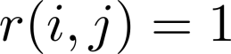 if user j has rated movie i (0 otherwise).
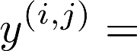 Rating by user j on movie i (if defined)
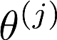= Parameter vector for user j.
 = Feature vector for movie i.
For user j, movie i, predicted rating: 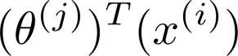

Collaborative Filtering Cost function

For Theta Vector:

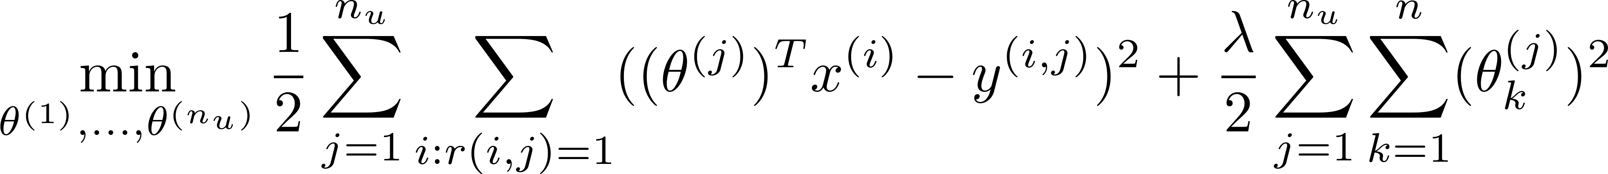

For X Vector:

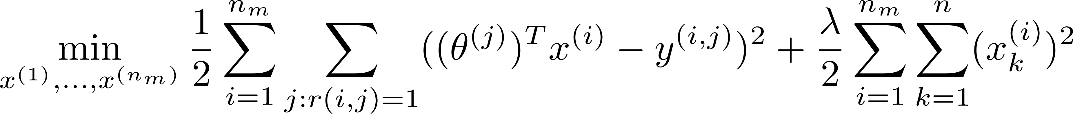

Combined Cost:

Minimisation Objective:

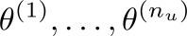

Collaborative Filtering gradient
Gradient Refers to the changes we have need to make in our Theta and X vector to minimise the cost. It is the small step that we take to minimise[4]
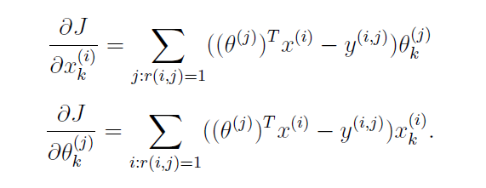
Figure 1 Collaborative Filtering in Books and Movie
We have completed the recommendation in single domain. Using this Collaborative Filtering algorithm. We have generated a list of movies that a user will like. We will use this list to find the similarity between movies and books. More the number of recommended movies we have more the number of tags we will generate

Step 3: Content Based Recommendation (Tag based similarity)
In this phase, we have used the movies liked by a user and the movies we have recommended for that user to give recommendation across multiple domains. Tags and genre are the medium through which we have like single domains movies and books.
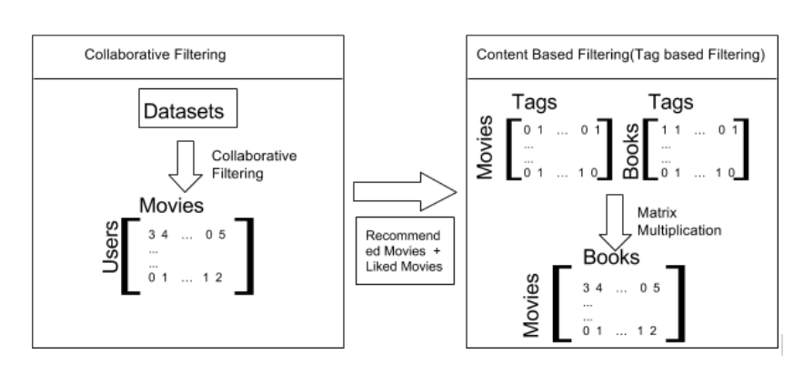
Figure 3(Combining collaborative and content based algorithm)
We have built a matrix M(n_{movies} x n_{books}) which contains the similarity between each movie and book. A movie is similar to a book if there are tags that are common between them. Figure 3 shows how we have generated movie and tags matrix and books and tags generated. 1 in movie and tags matrix means a movie is given a tag. We have used both collaborative filtering and content based filtering to generate books recommendation.

Conclusion
In this paper, we presented a novel cross-domain collaborative filtering method via codebook-based knowledge transfer (CBT) for recommender systems, which can transfer useful knowledge from the auxiliary rating matrix in some other domains to remedy the sparsity of the rating matrix in a target Domain. The knowledge is transferred in the form of a codebook, which is learned from an auxiliary rating matrix by compressing the cluster-level user-item rating patterns into an informative and yet compact representation. The sparse target rating matrix can thus be reconstructed by expanding the codebook. The experimental results show that codebook transfer can clearly outperform the many state-of-theart methods. This can validate that, in collaborative filtering, additional useful information indeed can be gained from the auxiliary tasks in other domains to aid the target task.

Data sets
- MovieLens (Target task): A movie rating data set comprising 100,000 ratings (scales 1–5) by 943 users on 1682 movies. We randomly select 1100 users with more than 30 ratings.

- Library Thing (Target task): A book rating data set comprising more than 1.1 million ratings (scales 1–10) by 7279 users on 37,232 books. We have selected 5000 tags from the top to recommend books.

References
- Li, B.: Cross-domain collaborative filtering: A brief survey. In: Proc. of ICTAI 2011, pp. 1085–1086 (2011).
- Cremonesi, P., Tripodi, A., Turrin, R.: Cross-domain recommender systems. In: Proc. of ICDMW 2011 Workshops, pp. 496–503 (2011).
- Li, B., Yang, Q., Due, and X.: Can movies and books collaborate? Cross-domain collaborative filtering for sparsity reduction. In: Proc. of IJCAI 2009, pp. 2052–2057 (2009) K. Elissa, “Title of paper if known,” unpublished.
- Li, B., Yang, Q., Xue, and X.: Transfer learning for collaborative filtering via a rating-matrix generative model. In: Proc. of ICML 2009, pp. 617-624 (2009).
- Chris Ding, Tao Li, Wei Peng, and Haesun Park. Orthogonal nonnegative matrix tri-factorizations for clustering. In Proc. of the 12th ACM SIGKDD Int’l Conf., pages 126–135, 2006.

[6] Larose, D. Discovering knowledge in Data. Wiley Interscience, 2008.

[7] van Meteren, R., and van Someren, M. Using content-based Filtering for recommendation.

