**Introduction**

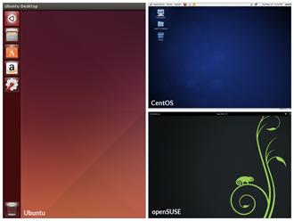

You can use either a Command Line Interface (**CLI**) or a Graphical User Interface (**GUI**) when using Linux. To work at the CLI, you have to remember which programs and commands are used to perform tasks, and how to quickly and accurately obtain more information about their use and options. On the other hand, using the GUI is often quick and easy. It allows you to interact with your system through graphical icons and screens. For repetitive tasks the CLI is often more efficient, while the GUI is easier to navigate if you don't remember all the details or do something only rarely.

In this section you will learn how to manage sessions using the GUI for the three Linux distribution families that we explicitly cover in this course: **CentOS** (**Fedora** family), **openSUSE** (**SUSE** family) and **Ubuntu** (**Debian** family). As you'll see shortly, **openSUSE** uses **KDE** instead of **GNOME** as the default desktop manager. However, since in many cases we use just a single distro for illustration, we've used **GNOME** for the openSUSE visuals throughout this course. If you are using **KDE** your experience will vary somewhat from what is shown.

**GNOME Desktop Environment**



**GNOME** is a popular desktop environment with an easy to use graphical user interface. It is bundled as the default desktop environment for many distributions including **Red Hat Enterprise Linux**, **Fedora**, **CentOS**, **SUSE Linux Enterprise**, and **Debian**. **GNOME** has menu-based navigation and is sometimes an easy transition for at least some **Windows** users. However, as you'll see, the look and feel can be quite different across distributions, even if they are all using **GNOME**.

Another common desktop environment very important in the history of Linux and also widely used is **KDE**, which is used by default in **openSUSE**.

Other alternatives for a desktop environment include **Unity** (from **Ubuntu**, based on **GNOME**), **Xfce**, and **LXDE**. Most desktop environments follow a similar structure to **GNOME**.

* [Previous](https://courses.edx.org/courses/LinuxFoundationX/LFS101x/2T2014/courseware/567b9d65c6b34e86812afc13627cb11b/55ab0145eb7e4b43afaee6754f4361c0/#)
* [Next](https://courses.edx.org/courses/LinuxFoundationX/LFS101x/2T2014/courseware/567b9d65c6b34e86812afc13627cb11b/55ab0145eb7e4b43afaee6754f4361c0/#)

**GUI Startup**



When you install a desktop environment, the **X** display manager starts at the end of the boot process. This **X** display manager is responsible for starting the graphics system, logging in the user, and starting the user’s desktop environment. You can often select from a choice of desktop environments when logging in to the system.

The default display manager for **GNOME** is called **gdm**. Other popular display managers include **lightdm** (used on **Ubuntu**) and **kdm** (associated with **KDE**).

**Locking the Screen**

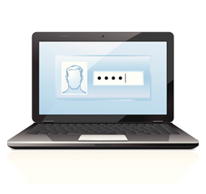

It is often a good idea to lock your screen to prevent other people from accessing your session while you are away from your computer. Note this does not suspend the computer; all your applications and processes continue to run while the screen is locked. There are two ways to lock your screen:

1. Using the graphical interface.
2. Using the keyboard shortcut **CTRL-ALT-L**.

**Note:** The keyboard shortcut for locking the screen in the three distros can be changed as indicated below:

* **CentOS:** System → Preferences → Keyboard Shortcuts
* **openSUSE:** Configure Desktop → Shortcuts and Gestures
* **Ubuntu:** System Settings → Keyboard → Shortcuts

**Locking and Unlocking the Screen in CentOS**

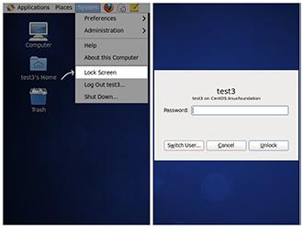

To lock and unlock your screen in **CentOS**, perform the following steps:

1. On the **CentOS** desktop screen, click the **System** menu on the top bar.
2. Click **Lock Screen**. The screen is locked immediately.
3. To unlock the screen, enter the password.
4. Click **Unlock** and the desktop screen is displayed.

**Note: When you lock the screen, GNOME will blank the screen or run a screensaver, depending on your settings.**

Click the image to view an enlarged version.

* [Previous](https://courses.edx.org/courses/LinuxFoundationX/LFS101x/2T2014/courseware/567b9d65c6b34e86812afc13627cb11b/55ab0145eb7e4b43afaee6754f4361c0/#)
* [Next](https://courses.edx.org/courses/LinuxFoundationX/LFS101x/2T2014/courseware/567b9d65c6b34e86812afc13627cb11b/55ab0145eb7e4b43afaee6754f4361c0/#)

**Locking and Unlocking the Screen in openSUSE**

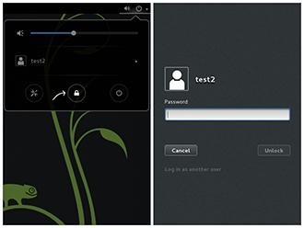

To lock and unlock your screen in **openSUSE**, perform the following steps:

1. On the **openSUSE** desktop screen, click the power icon on the upper-right corner of the screen.
2. Click the lock icon. The screen is locked immediately.
3. Press **Enter**. The login screen is displayed.
4. To unlock the screen, enter the password.
5. Click **Unlock** and the desktop screen is displayed.

**Note: When you lock the screen, GNOME will blank the screen or run a screensaver, depending on your settings.**

**Locking and Unlocking the Screen in Ubuntu**

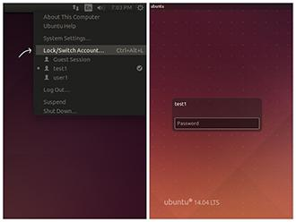

To lock and unlock your screen in **Ubuntu**, perform the following steps:

1. On the **Ubuntu** desktop screen, click the power icon with username on the upper-right corner of the screen.
2. Click **Lock/Switch Account**… to lock the screen.
3. The login screen is displayed.
4. To unlock the screen, enter the password.
5. The desktop screen is displayed.

**Note: When you lock the screen, GNOME will blank the screen or run a screensaver, depending on your settings.**

**Switching Users**



Linux is a true multiuser operating system which allows more than one user to be simultaneously logged in. If more than one person uses the system, it is best for each person to have their own user account and password. This allows for individualized settings, home directories, and other files. Users can take turns using the machine while keeping everyone's sessions alive, or even be logged in simultaneously through the network.

**Note: The next few screens cover the demonstrations and Try-It-Yourself activities of a member of each of the three Linux distribution families we cover in this course. You can view a demonstration for the distribution type of your choice and practice the procedure through the relevant Try-It-Yourself activity.**

**Shutting Down and Restarting**



Besides normal daily starting and stopping of the computer, a system restart may be required as part of certain major system updates, generally only those involving installing a new Linux **kernel**.

The **init** process is responsible for implementing both restarts and shut downs. On systems using **System V** **init**, run level 0 is usually used for shutting down, and run level 6 is used to reboot the system. (We will discuss system run levels later.)

Next we will discuss how to shut down and restart the system in the three different reference distributions.

* [Previous](https://courses.edx.org/courses/LinuxFoundationX/LFS101x/2T2014/courseware/567b9d65c6b34e86812afc13627cb11b/55ab0145eb7e4b43afaee6754f4361c0/#)
* [Next](https://courses.edx.org/courses/LinuxFoundationX/LFS101x/2T2014/courseware/567b9d65c6b34e86812afc13627cb11b/55ab0145eb7e4b43afaee6754f4361c0/#)

**Suspending**

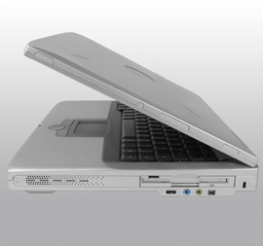

Most modern computers support **suspend mode** or **sleep mode** when you stop using your computer for a short while. Suspend mode saves the current system state and allows you to resume your session more quickly while remaining on but using very little power. It works by keeping your system’s applications, desktop, and so on in system RAM, but turning off all of the other hardware. The suspend mode bypasses the time for a full system start-up and continues to use minimal power.

* [Previous](https://courses.edx.org/courses/LinuxFoundationX/LFS101x/2T2014/courseware/567b9d65c6b34e86812afc13627cb11b/55ab0145eb7e4b43afaee6754f4361c0/#)
* [Next](https://courses.edx.org/courses/LinuxFoundationX/LFS101x/2T2014/courseware/567b9d65c6b34e86812afc13627cb11b/55ab0145eb7e4b43afaee6754f4361c0/#)

**Default Directories**

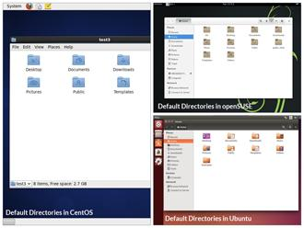

Every user with an account on the system will have a **home** directory, usually created under /home and named the same as the username (such as /home/student). By default, files the user saves will be placed in a directory tree starting there. Account creation, whether during system installation or at a later time when a new user is added, also induces default directories to be created under the user's home directory, such as **Documents**, **Desktop**, and **Downloads**.

On the next few screens, you will learn more about the default directories in **CentOS**, **openSUSE**, and **Ubuntu**.

**Viewing Files**

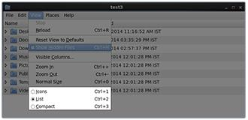

**Nautilus** (the name of the File Manager or file browser) allows you to view files and directories in several different formats.

To view files in the **Icons**, **List**, or **Compact** formats, click the **View** drop-down and select your view, or press **CTRL-1** , **CTRL-2** and **CTRL-3** respectively.

In addition you can also arrange the files and directories by **Name**, **Size**, **Type**, or **Modification Date** for further sorting. To do so, click **View** and select **Arrange Items**.

**More About Viewing Files**

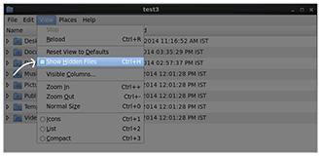Another useful option is to show **hidden** files (sometimes imprecisely called system files), which are usually configuration files that are hidden by default and whose name starts with a dot. To show hidden files, click **View** and select **Show Hidden Files** or press **CTRL- H**.

The file browser provides multiple ways to customize your window view to facilitate easy drag and drop file operations. You can also alter the size of the icons by selecting **Zoom In** and **Zoom Out** under the **View** menu.

Click the image to view an enlarged version.

**Searching for Files**



**Nautilus** includes a great search tool inside the file browser window.

1. Click **Search** in the toolbar (to bring up a text box).
2. Enter the keyword in the text box.
3. Nautilus will perform a recursive search from the current directory for any file or directory which contains a part of this keyword.
4. To open Nautilus from the command line, simply type nautilus
5. To open Nautilus in graphical mode, Press **ALT-F2** and search for Nautilus. Click the icon that appears.

**Note: Both the above methods, will open the graphical interface for the program.**

The shortcut key to get to the search text box is **CTRL-F**. You can exit the search text box view by clicking the **Search** button again.

**Nautilus** allows you to refine your search beyond the initial keyword by providing drop-down menus to further filter the search.

1. Based on **Location** or **File Type**, select additional criteria from the drop-down.
2. To regenerate the search, click the **Reload** button.
3. To add multiple search criteria, click the **+** button and select **additional search criteria**.

For example, if you want to find a PDF file containing the word Linux in your **home** directory, navigate to your **home** directory and search for the word “Linux” . You should see that the default search criterion limits the search to your **home** directory already. To finish the job, click the + button to add another search criterion, select **File Type** for the type of criterion, and select **PDF** under the **File Type** drop-down.

Click the image to view an enlarged version.

**Editing a File**

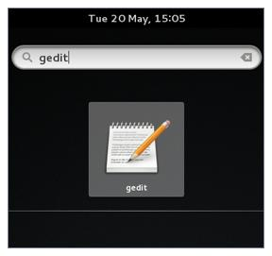

Editing any text file through the graphical interface is easy in the **GNOME** desktop environment. Simply double-click the file on the desktop or in the **Nautilus** file browser window to open the file with the default text editor.

The default text editor in **GNOME** is **gedit**. It is simple yet powerful, ideal for editing documents, making quick notes, and programming. Although **gedit** is designed as a general purpose text editor, it offers additional features for spell checking, highlighting, file listings, and statistics.

You'll learn much more about using text editors in a later chapter.

* [Previous](https://courses.edx.org/courses/LinuxFoundationX/LFS101x/2T2014/courseware/567b9d65c6b34e86812afc13627cb11b/f08273abdf38410a8c0c504472d02e7c/#)
* [Next](https://courses.edx.org/courses/LinuxFoundationX/LFS101x/2T2014/courseware/567b9d65c6b34e86812afc13627cb11b/f08273abdf38410a8c0c504472d02e7c/#)

**Removing a File**



Deleting a file in **Nautilus** will automatically move the deleted files to the .local/share/Trash/files/ directory (a trash can of sorts) under the user's **HOME** directory. There are several ways to delete files and directories using Nautilus.

1. Select all the files and directories that you want to delete.
2. Press **Delete** (in Unity/KDE) or **CTRL-Delete** (in GNOME) on your keyboard. Or, Right-click the file.
3. Select **Move to Trash**. Or, Highlight the file.
4. Click **Edit** and **Move to Trash** through the graphical interface.

* [Previous](https://courses.edx.org/courses/LinuxFoundationX/LFS101x/2T2014/courseware/567b9d65c6b34e86812afc13627cb11b/f08273abdf38410a8c0c504472d02e7c/#)
* [Next](https://courses.edx.org/courses/LinuxFoundationX/LFS101x/2T2014/courseware/567b9d65c6b34e86812afc13627cb11b/f08273abdf38410a8c0c504472d02e7c/#)

Alternatively, select the file or directory you want to permanently delete and press **Shift-Delete**.

As a precaution, you should **never delete your home directory** as doing so will most likely erase all your **GNOME** configuration files and possibly prevent you from logging in. Many personal system and program configurations are stored under your **home** directory.