**Introduction to Linux Documentation Sources**

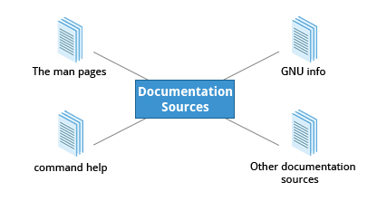

Whether you are an inexperienced user or a veteran, you won’t always know how to use various Linux programs and utilities, or what to type at the command line. You will need to consult the help documentation regularly. Because Linux-based systems draw from a large variety of sources, there are numerous reservoirs of documentation and ways of getting help. Distributors consolidate this material and present it in a comprehensive and easy-to-use manner.

Important Linux documentation sources include:

* The **man pages** (short for manual pages)
* GNU **Info**
* The **help** command and **--help** option
* Other Documentation Sources, e.g. <https://www.gentoo.org/doc/en/>

**The man pages**



The **man pages** are the most often-used source of Linux documentation. They provide in-depth documentation about many programs and utilities as well as other topics, including configuration files, system calls, library routines, and the kernel.

Typing **man** with a topic name as an argument retrieves the information stored in the topic's **man pages**. Some Linux distributions require every installed program to have a corresponding **man** page, which explains the depth of coverage. (Note: **man** is actually an abbreviation for **manual**.) The **man pages** structure were first introduced in the early UNIX versions of the early 1970s.

The **man pages** are often converted to:

* Web pages
* Published books
* Graphical help
* Other formats

**man**

The **man** program searches, formats, and displays the information contained in the **man pages**. Because many topics have a lot of information, output is piped through a **terminal pager** program such as **less** to be viewed one page at a time; at the same time the information is formatted for a good visual display.

When no options are given, by default one sees only the dedicated page specifically about the topic. You can broaden this to view all **man pages** containing a string in their name by using the -f option. You can also view all **man pages** that discuss a specified subject (even if the specified subject is not present in the name) by using the –k option.

man –f generates the same result as typing **whatis**.

man –k generates the same result as typing **apropos.**

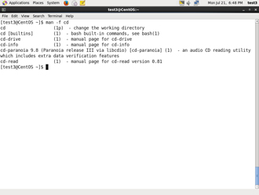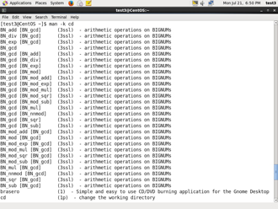

**Manual Chapters**

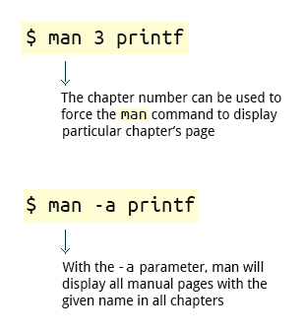

The **man pages** are divided into nine numbered chapters (1 through 9). Sometimes, a letter is appended to the chapter number to identify a specific topic. For example, many pages describing part of the **X Window** API are in chapter 3X.

The chapter number can be used to force **man** to display the page from a particular chapter; it is common to have multiple pages across multiple chapters with the same name, especially for names of library functions or system calls.

With the -a parameter, **man** will display all pages with the given name in all chapters, one after the other.

$ man 3 printf

$ man -a printf

**GNU Info System**



The next source of Linux documentation is the **GNU Info System**.

This is the **GNU** project's standard documentation format (**info**) which it prefers as an alternative to **man**. The **info** system is more free-form and supports linked sub-sections.

Functionally, the **GNU Info System** resembles **man** in many ways. However, topics are connected using links (even though its design predates the World Wide Web). Information can be viewed through either a command line interface, a graphical help utility, printed or viewed online.

* [Previous](https://courses.edx.org/courses/LinuxFoundationX/LFS101x/2T2014/courseware/f815b34178874936b6e3da6f32a95e76/57c11dd200d8455e962d7a92eaf58915/#)
* [Next](https://courses.edx.org/courses/LinuxFoundationX/LFS101x/2T2014/courseware/f815b34178874936b6e3da6f32a95e76/57c11dd200d8455e962d7a92eaf58915/#)

**Command Line Info Browser**

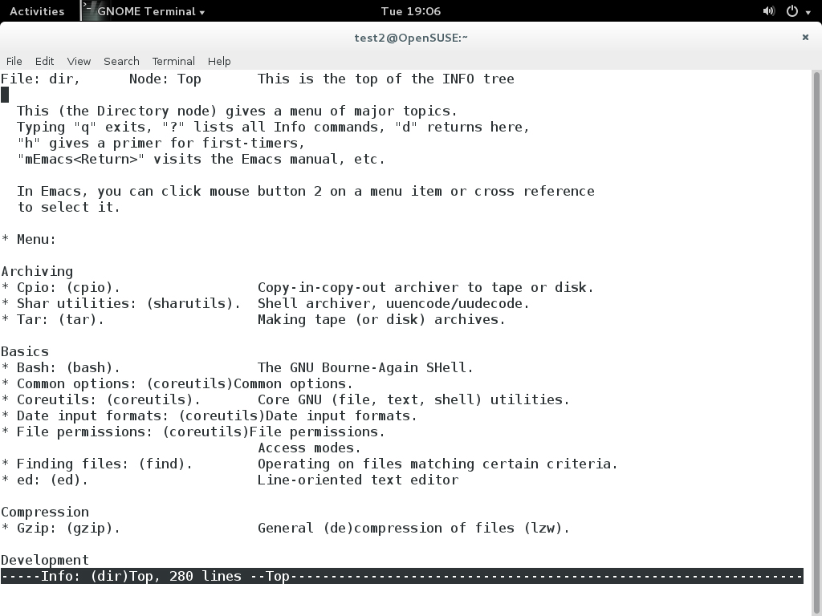

Typing **info** with no arguments in a terminal window displays an index of available topics. You can browse through the topic list using the regular movement keys: **arrows**, **Page Up**, and **Page Down**.

You can view help for a particular topic by typing info <topic name>. The system then searches for the topic in all available **info** files.

Some useful keys are: **q** to quit, **h** for help, and **Enter** to select a menu item.

Click the image to view an enlarged version.

**info Page Structure**

The topic which you view in the **info** page is called a **node**.

Nodes are similar to sections and subsections in written documentation. You can move between nodes or view each node sequentially. Each node may contain **menus** and linked subtopics, or **items**.

Items can be compared to Internet hyperlinks. They are identified by an asterisk (*) at the beginning of the item name. Named items (outside a menu) are identified with double-colons (::) at the end of the item name. Items can refer to other nodes within the file or to other files. The table lists the basic keystrokes for moving between nodes.

|  |  |
| --- | --- |
| **Key** | **Function** |
| n | Go to the next node |
| p | Go to the previous node |
| u | Move one node up in the index |

**Introduction to the help Option**

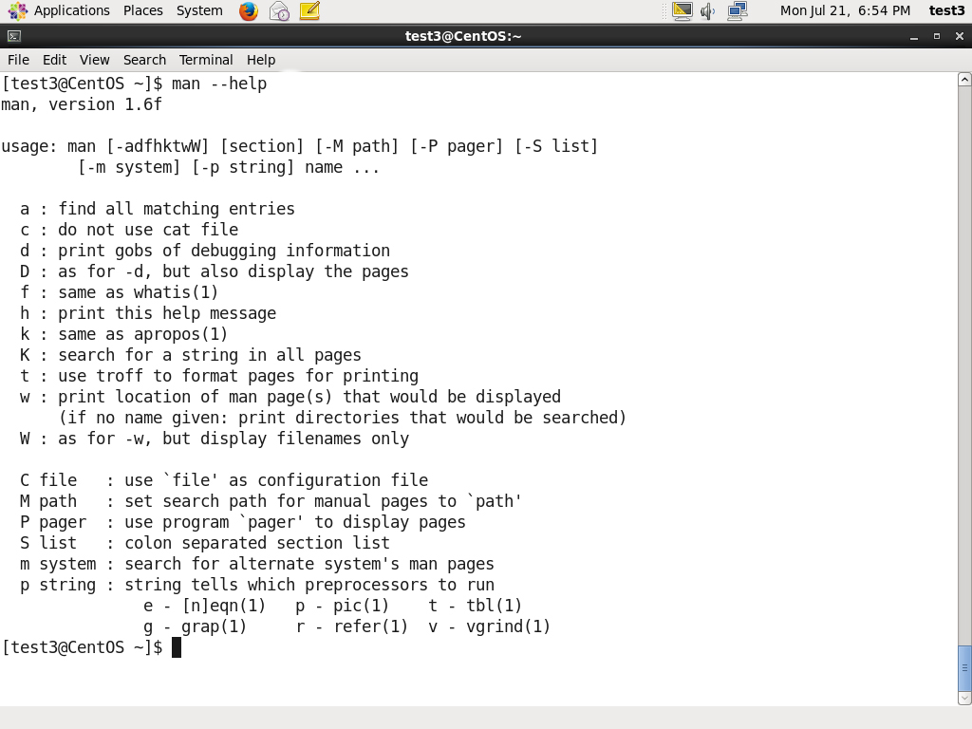The third source of Linux documentation is use of the **help** option.

Most commands have an available short description which can be viewed using the --help or the -h option along with the command or application. For example, to learn more about the **man** command, you can run the following command:

$ man --help

The --help option is useful as a quick reference and it displays information faster than the **man** or **info** pages.

**Other Documentation Sources**

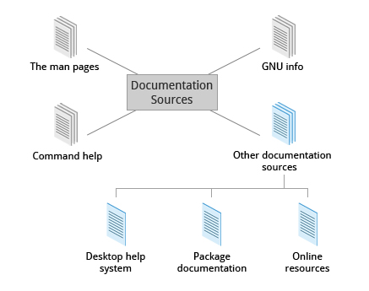

In addition to the **man pages**, the **GNU Info System**, and the **help** command, there are other sources of Linux documentation, some examples of which are shown here.

* [Previous](https://courses.edx.org/courses/LinuxFoundationX/LFS101x/2T2014/courseware/f815b34178874936b6e3da6f32a95e76/0ae11464cce2432893baca85c9d3e640/1#)
* [Next](https://courses.edx.org/courses/LinuxFoundationX/LFS101x/2T2014/courseware/f815b34178874936b6e3da6f32a95e76/0ae11464cce2432893baca85c9d3e640/1#)

**Desktop Help Systems**

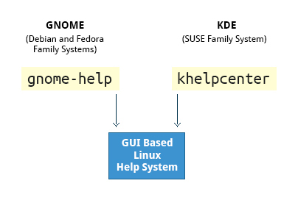

All Linux desktop systems have a graphical help application. This application is usually displayed as a question-mark icon or an image of a ship’s life-preserver. These programs usually contain custom help for the desktop itself and some of its applications, and will often also include graphically rendered **info** and **man pages**.

You can also start the graphical help system from a graphical terminal using the following commands:

* **GNOME**: **gnome-help**
* **KDE:** **khelpcenter**

**Package Documentation**

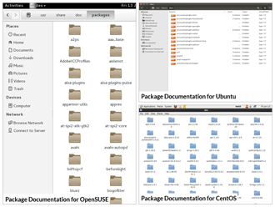

Linux documentation is also available as part of the package management system. Usually this documentation is directly pulled from the upstream source code, but it can also contain information about how the distribution packaged and set up the software.

Such information is placed under the /usr/share/doc directory in a subdirectory named after the package, perhaps including the version number in the name.

Click the image to view an enlarged version.

**Online Resources**



There are many places to access online Linux documentation, and a little bit of searching will get you buried in it.

You can also find very helpful documentation for each distribution. Each distribution has its own user-generated forums and wiki sections. Here are just a few links to such sources:

**Ubuntu:** <https://help.ubuntu.com/>

**CentOS:** <https://www.centos.org/docs/>

**OpenSUSE:** <http://en.opensuse.org/Portal:Documentation>

**GENTOO:** <http://www.gentoo.org/doc/en>

Moreover you can use online search sites to locate helpful resources from all over the Internet, including blog posts, forum and mailing list posts, news articles, and so on.

* [Previous](https://courses.edx.org/courses/LinuxFoundationX/LFS101x/2T2014/courseware/f815b34178874936b6e3da6f32a95e76/0ae11464cce2432893baca85c9d3e640/1#)
* [Next](https://courses.edx.org/courses/LinuxFoundationX/LFS101x/2T2014/courseware/f815b34178874936b6e3da6f32a95e76/0ae11464cce2432893baca85c9d3e640/1#)