**Sampling and**

**Reconstruction Trainer**

**Scientech 2101**



An ISO 9001:2008 company

**Scientech Technologies Pvt. Ltd.**

94, Electronic Complex, Pardesipura, Indore - 452 010 India,

 + 91-731 4211100, : info@scientech.bz , : www.ScientechWorld.com

|  |  |  |  |
| --- | --- | --- | --- |
|  |  | **Sampling and** |  |
|  |  | **Reconstruction Trainer** |  |
|  |  | **Scientech 2101** |  |
|  |  | **Table of Contents** |  |
| 1. |  | |  |
| 2. | Introduction | | 6 |
| 3. | Features | | 7 |
| 4. | Technical Specifications | | 8 |
| 5. | Theory | | 9 |
|  | • | Sampling | 9 |
|  | • | Principle of sampling | 9 |
|  | • | Sampling Theorem | 11 |
|  | • | Nyquist Criteria | 12 |
|  | • | Sampling Techniques | 13 |
|  | • | Types of sampling | 16 |
|  | • | Aliasing | 18 |
|  | • Sample / Hold Circuit and Its parameters | | 31 |
|  | • | Anti-aliasing | 32 |
|  | • | Low Pass Filters | 37 |

1. Experiments

7. Experiment 1 46

* Study of Signal Sampling and Reconstruction Techniques
* Study of Nyquist Criteria and Aliasing

8. Experiment 2 51

* Study of the effect of Sample /Hold Circuitry on Reconstructed Waveform.
* Effect of Sampling Pulse Duty Cycle on the Reconstructed Waveform in Sample and Sample Hold Output

9. Experiment 3 55

* Comparison of Frequency Response of 2nd order and 4th order
* Butterworth Low Pass Filter

|  |  |  |
| --- | --- | --- |
| 7. | Frequently Asked Questions | 58 |

**Introduction**

The **Scientech 2101, Sampling and Reconstruction Trainer** demonstrates the basic scheme used to transmit an information signal. It covers very basic concepts like Nyquist criteria, role of sample Amplifier, sample and hold amplifier and duty cycle of sampling pulse while transmitting a signal. It also demonstrates signal recovery using low pass filters of different orders.

**Know your Scientech 2101 trainer better:**

The trainer requires  12V and +5V (150mA) DC signal user to.

The trainer has in built 1 KHz (5Vp-p) sine wave generator as on board signal to demonstrate completely, the sampling and reconstruction technique.

Various test points on the trainer makes user to understand, the complete process that takes place for sampling and reconstruction of transmitted signal.

On- board six sampling frequencies (10, 20, 40, 80, 160, 320 KHz), out of which user can select any one (when Sampling Selector Switch is on Internal Signal position), using sampling frequency selector switch*.* For the selected signal the corresponding LED will be lightened. When the trainer is switched on, it will randomly select the sampling frequency. For selecting a particular sampling frequency a three bit control signal is applied to the Mux unit.

The selected frequency then passes through frequency divider circuit and duty cycle selector unit to generate desired sampling frequency of 1, 2, 4, 8, 16 and 32 KHz with required duty cycle (from 10% to 90%). The trainer allows user to apply external sampling signal through External Sampling Signal I/P (when Sampling Signal Selector Switch is on External Signal position)

Using Duty Cycle selector switch one can vary the duty cycle of the selected sampling frequency from 10 to 90%. The displayed digit (D) on the switch indicates (Dx10) % duty cycle of sampling signal. E.g. When displayed 5 it indicates (5x10) = 50% duty cycle of selected sampling signal (only for the case of internal sampling signal).

Once signal is sampled, user can either send Sample Amplifier output or Sample and Hold Amplifier output to any of the two LPFs. Thus a comparative study is available to recover original transmitted signal precisely.

The manual explains a detailed working of the trainer with the help of complete theory and set of three experiments. The experimentation alone with its conclusion and resulting waveforms are covered in the manual.

1

**Theory**

The signals which are required to be transmitted as information is known as information signal and in the case of voice communication this will be a continuously changing signal containing speech information. The aim of the kit is to transmit the signals in digital form and is to reproduce this information signal in analog form at the receiving end of the communication system with the help of sampling and reconstruction trainer.

In the exercises to follow, you will simulate audio signal by a 1 KHz test signal provided On-board. The repetitive, non-changing waveform does not contain information. Provided the frequency of the test-signal lies within the frequency range which an information signal will occupy, a test signal of this type can be extremely helpful in system analysis and testing.

The voice signals are limited to the range 300 Hz to 3.4 KHz, a 1 KHz frequency fits conveniently in this range and can be used to demonstrate and test many techniques used in communication system.

**Theory of sampling**

The signals we use in the real world, such as our voice, are called "analog" signals. To process these signals for digital communication, we need to convert analog signals to "digital" form. While an analog signal is continuous in both time and amplitude, a digital signal is discrete in both time and amplitude. To convert continuous time signal to discrete time signal, a process is used called as sampling. The value of the signal is measured at certain intervals in time. Each measurement is referred to as a sample.

**Principle of sampling**

Consider an analogue signal x(t) that can be viewed as a continuous function of time, as shown in figure1. We can represent this signal as a discrete time signal by using values of x(t) at intervals of nTs to form x(nTs) as shown in figure 1. We are "grabbing" points from the function x(t) at regular intervals of time, Ts, called the sampling period**.**

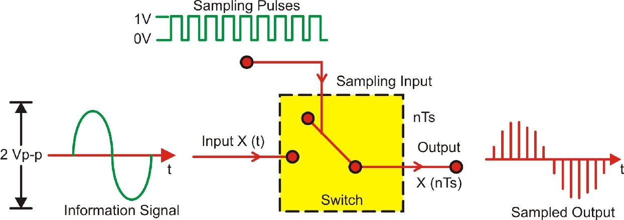

**Basic Sampling Process**

**Figure 1**

|  |  |
| --- | --- |
|  |  |

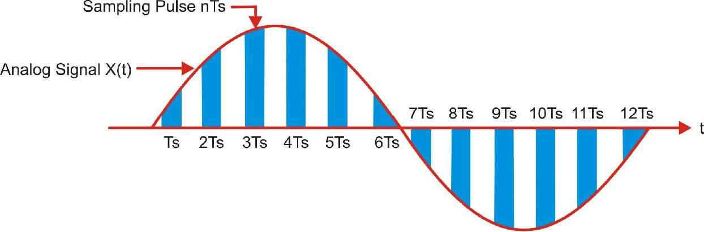

**Sampling of signal at sampling interval (period) Ts**

**Figure 2**

Figure 2 depicts the sampling of a signal at regular interval (period) t *=nT*s where n is an integer. The sampling signal is a regular sequence of narrow pulses ***δ*** (*t*) of amplitude 1.Figure 3 shows the sampled output of narrow pulses ***δ*** (*t*) at regular interval of time.

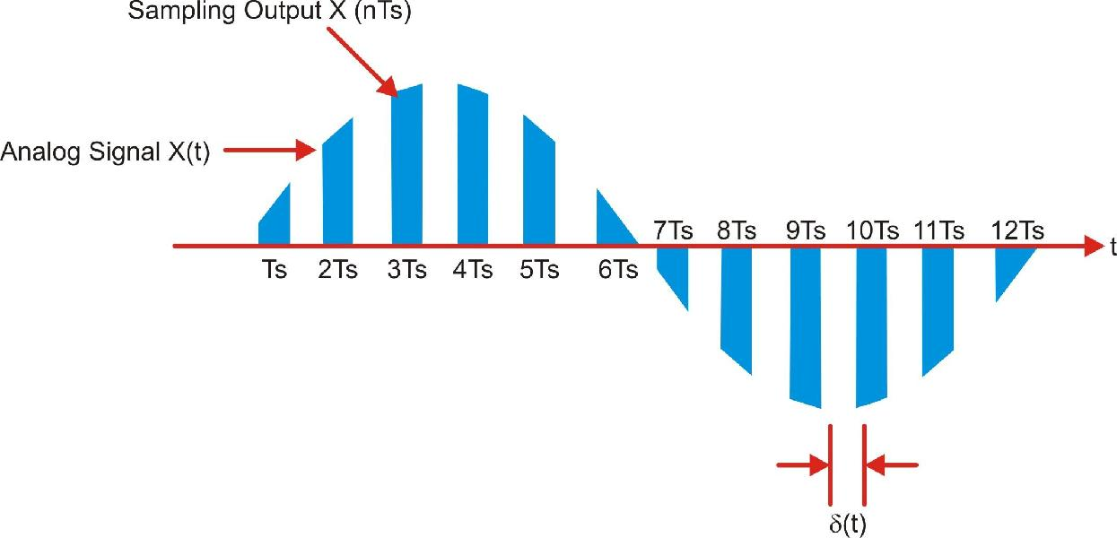

**Sampled Output of narrow pulses *δ* (*t*)**

**Figure 3**

The time distance Ts is called sampling interval or sampling period, fs*=1/*Ts is called as sampling frequency (Hz or samples/sec), also called sampling rate

**The Sampling Theorem**

The Sampling Theorem states that a signal can be exactly reproduced if it is sampled at a frequency Fs, where Fs is greater than twice the maximum frequency Fmax in the signal.

Fs > 2· Fmax

The frequency 2· Fmax is called the Nyquist sampling rate. Half of this value, Fmax, is sometimes called the Nyquist frequency.

The sampling theorem is considered to have been articulated by Nyquist in 1928 and mathematically proven by Shannon in 1949. Some books use the term "Nyquist Sampling Theorem", and others use "Shannon Sampling Theorem". They are in fact the same sampling theorem.

The sampling theorem clearly states what the sampling rate should be for a given range of frequencies. In practice, however, the range of frequencies needed to faithfully record an analog signal is not always known beforehand. Nevertheless, engineers often can define the frequency range of interest. As a result, analog filters are sometimes used to remove frequency components outside the frequency range of interest before the signal is sampled.

For example, the human ear can detect sound across the frequency range of 20 Hz to 20 KHz. According to the sampling theorem, one should sample sound signals at least at 40 KHz in order for the reconstructed sound signal to be acceptable to the human ear. Components higher than 20 KHz cannot be detected, but they can still pollute the sampled signal through aliasing. Therefore, frequency components above 20 KHz are removed from the sound signal before sampling by a band-pass or low-pass analog filter.

**Nyquist Criterion**

As shown-in the figure 4 the lowest sampling frequency that can be used without the sidebands overlapping is twice the highest frequency component present in the information signal. If we reduce this sampling frequency even further, the sidebands and the information signal will overlap and we cannot recover the information signal simply by low pass filtering. This phenomenon is known as fold-over distortion or aliasing.

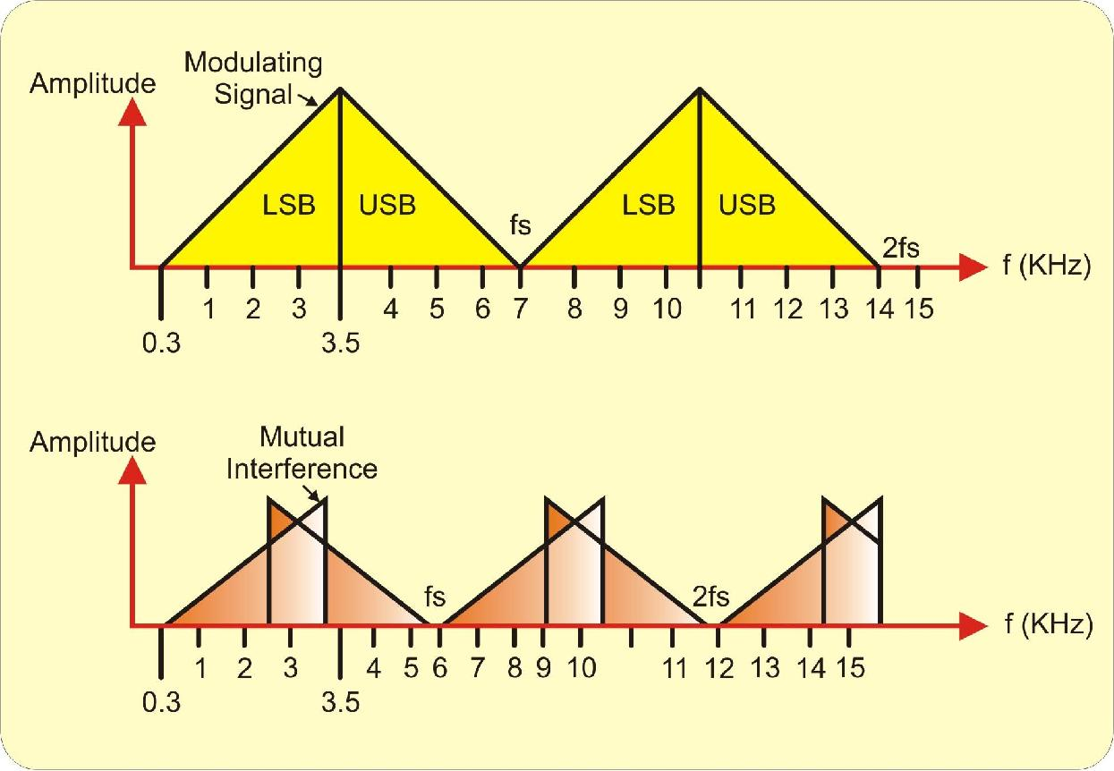

**Nyquist Criterion (Sampling Theorem)**

**Figure 4**

The Nyquist criteria states that a continuous signal band limited to Fm Hz can be completely represented by and reconstructed from the samples taken at a rate greater than or equal to 2Fm samples/second.

This minimum sampling frequency is called as Nyquist Rate i.e. for faithful reproduction of information signal fs > 2 fm.

For audio signals the highest frequency component is 3.4 KHz. So*, Sampling Frequency* **≥** 2 fm

* 2 x 3.4 KHz
* 6.8 KHz

Practically, the sampling frequency is kept slightly more than the required rate. In telephony the standard sampling rate is 8 KHz. Sample quantifies the instantaneous value of the analog signal point at sampling point to obtain pulse amplitude output.

**Nyquist’s Uniform Sampling Theorem for Low pass Signal:**

Part - I If a signal x(t) does not contain any frequency component beyond W Hz, then the signal is completely described by its instantaneous uniform samples with sampling interval (or period ) of Ts < 1/(2W) sec.

Part – II The signal x(t) can be accurately reconstructed (recovered) from the set of uniform instantaneous samples by passing the samples sequentially through an ideal (brick-wall) low pass filter with bandwidth B, where W **≤** B < fs – W and fs = 1/(Ts).

As the samples are generated at equal (same) interval (Ts) of time, the process of sampling is called uniform sampling. Uniform sampling, as compared to any non-uniform sampling, is more extensively used in time-invariant systems as the theory of uniform sampling (either instantaneous or otherwise) is well developed and the techniques are easier to implement in practical systems.

**Sampling Techniques**

There are three types of sampling techniques as under:

1. Ideal sampling or Instantaneous sampling or Impulse sampling
2. Natural sampling
3. Flat top sampling

**1.** **Ideal sampling or Instantaneous sampling or Impulse sampling:**

For the proof of sampling theorem we use ideal or impulse sampling.

The concept of ‘instantaneous’ sampling is more of a mathematical abstraction as no practical sampling device can actually generate truly instantaneous samples (a sampling pulse should have non-zero energy) . However, this is not a deterrent in using the theory of instantaneous sampling, as a fairly close approximation of instantaneous sampling is sufficient for most practical systems. To contain our discussion on Nyquist’s theorems, we will introduce some mathematical expressions. If x(t) represents a continuous-time signal, the equivalent set of instantaneous uniform samples {x(nTs)} may be represented as:

{x(nTs)} = **Σ** x(t).**δ**(t- nTs)

where x(nTs) = x(t) =nTs , **δ**(t) is a unit pulse singularity function and ‘n’ is an integer

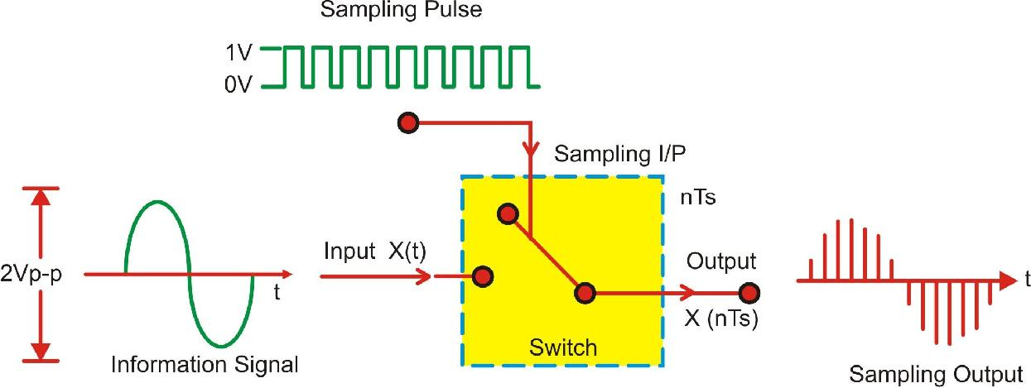

**Ideal sampling process**

**Figure 5(a)**

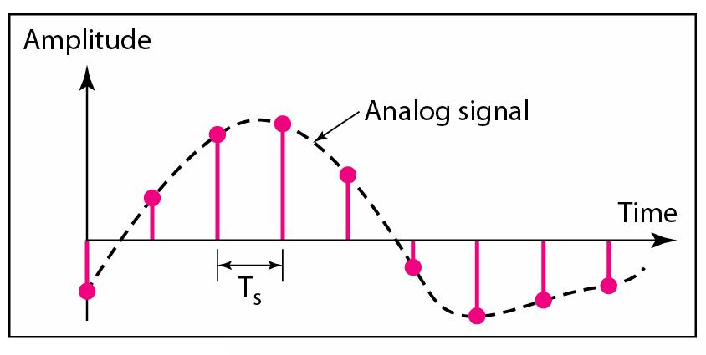

**Figure 5(b)**

1. **Natural sampling:**

In the analogue-to-digital conversion process an analogue waveform is sampled to form a series of pulses whose amplitude is the amplitude of the sampled waveform at the time the sample was taken. In natural sampling the pulse amplitude takes the shape of the analogue waveform for the period of the sampling pulse as shown in figure 6.

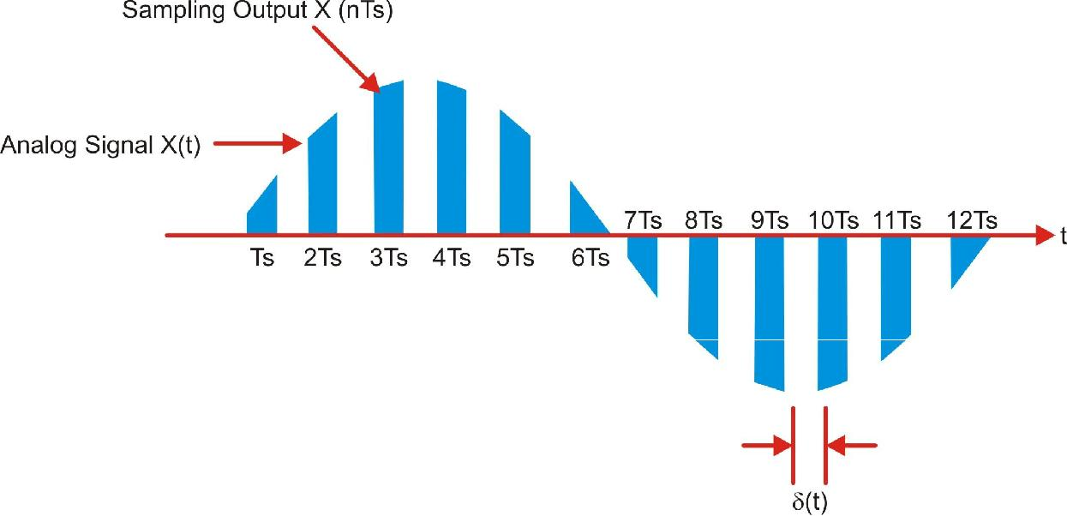

**Figure 6**

1. **Flat Top sampling:**

After an analogue waveform is sampled in the analogue-to-digital conversion process, the continuous analogue waveform is converted into a series of pulses whose amplitude is equal to the amplitude of the analogue signal at the start of the sampling process. Since the sampled pulses have uniform amplitude, the process is called flat top sampling as shown in figure 7.

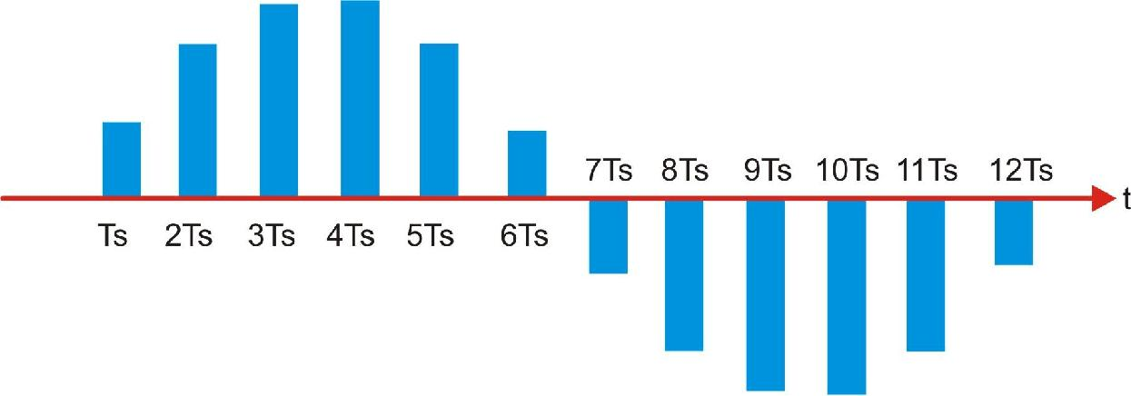

**Figure 7**

Note that due to the flat-top pulses, the spectrum of the sampled signal is distorted. The narrower the pulse width, the less distortion.

The original signal may be obtained by using a low-pass filter with a characteristic which inverts the distortion.

**Types of Sampling**

**Over Sampling:**

Graphically, if the sampling rate is sufficiently high, i.e., greater than the Nyquist rate, there will be no overlapped frequency components in the frequency domain. A "cleaner" signal can be obtained to reconstruct the original signal. This argument is shown graphically in the frequency-domain figure 8(a) and time-domain figure 8(b).

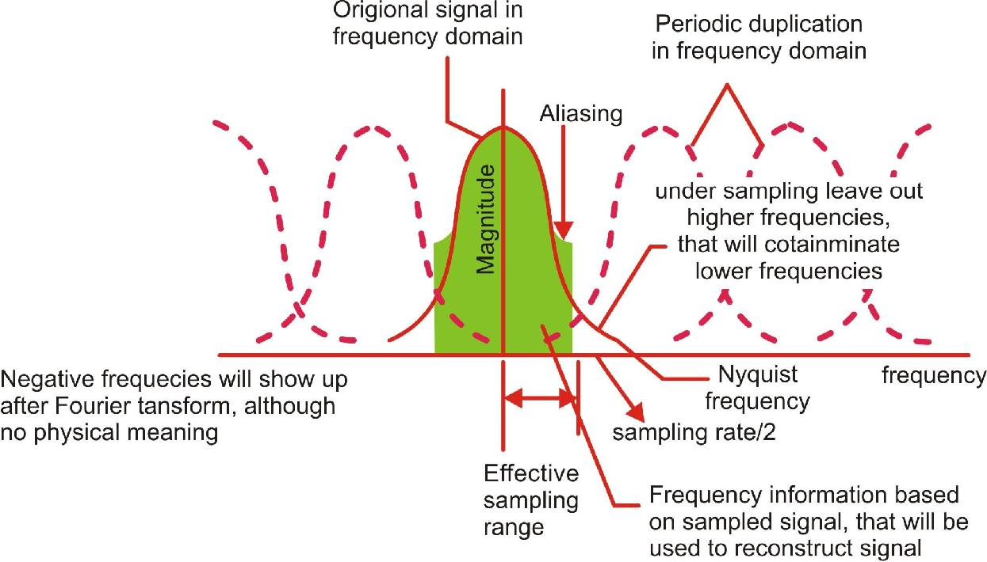

**Over sampling in Frequency Domain**

**Figure 8(a)**

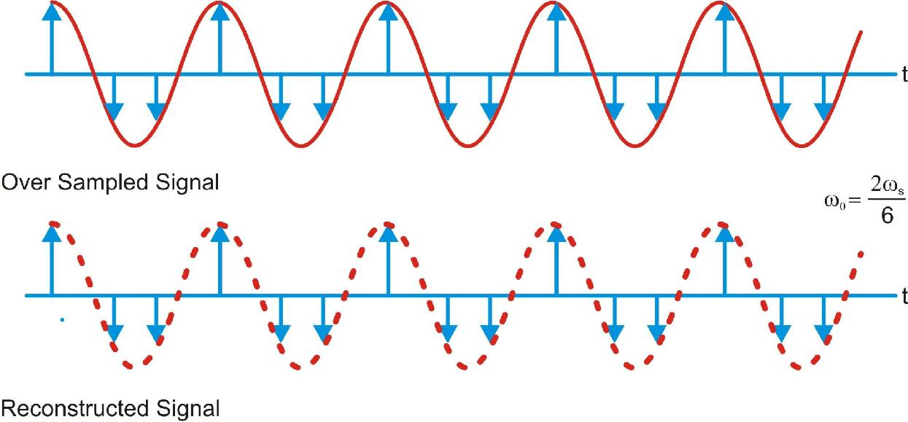

**Over sampling in Time Domain**

|  |  |
| --- | --- |
|  | **Figure 8(b)** |
|  |  |

**Under Sampling:**

When the sampling rate is lower than or equal to the Nyquist rate, a condition defined as under sampling, it is impossible to rebuild the original signal according to the sampling theorem.

An example is illustrated below, where the reconstructed signal built from data sampled at the Nyquist rate is way off from the original signal. This argument is shown graphically in the frequency-domain figure 9(a) and time-domain figure 9(b).

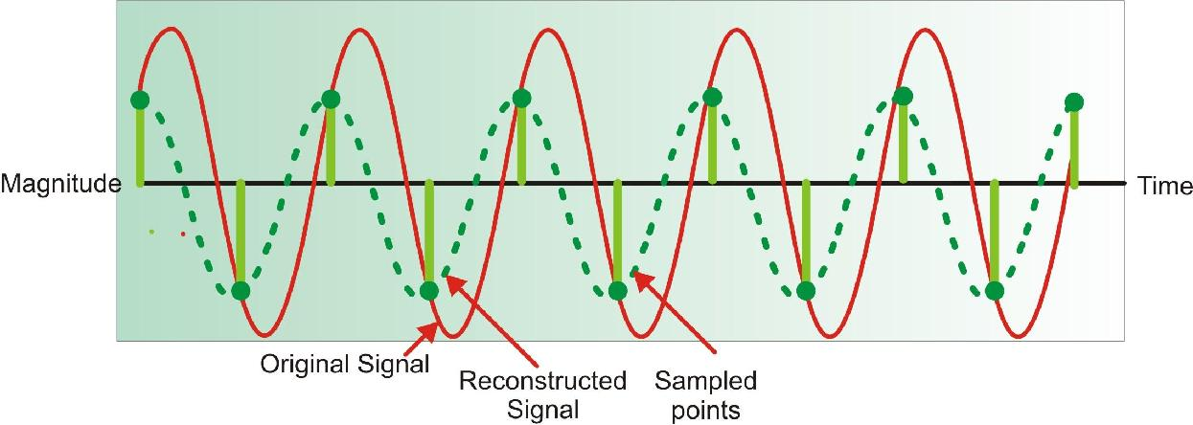

**Under sampling in frequency domain**

**Figure 9(a)**

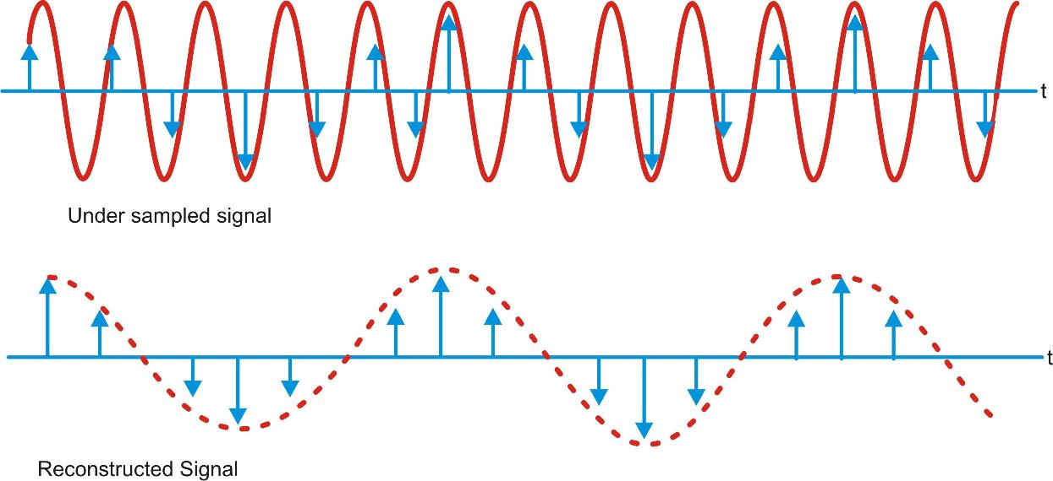

**Under sampling in Time domain**

**Figure 9(b)**

In practice, the continuous signal is sampled using an analog or digital converter (ADC), a non-ideal device with various physical limitations. This result in deviations from the theoretically perfect reconstruction capabilities collectively referred to as distortion.

Various types of distortion can occur, including:

1. **Aliasing:**

A precondition of the sampling theorem is that the signal to be band limited. However, in practice, no time-limited signal can be band limited. Since signals of interest are almost always time-limited (e.g., at most spanning the lifetime of the sampling device in question), it follows that they are not band limited. However, by designing a sampler with an appropriate guard band, it is possible to obtain output that is as accurate as necessary.

Aliasing is the presence of unwanted components in the reconstructed signal. These components were not present when the original signal was sampled. In addition, some of the frequencies in the original signal may be lost in the reconstructed signal. Aliasing occurs because signal frequencies can overlap if the sampling frequency is too low. As a result, the higher frequency components roll into the reconstructed signal and cause distortion of the signal Frequencies "fold" around half the sampling frequency. This type of signal distortion is called aliasing.

We only sample the signal at intervals.

We don't know what happened between the samples.

A crude example is to consider a 'glitch' that happened to fall between adjacent samples. Since we don't measure it, we have no way of knowing the glitch was there at all.

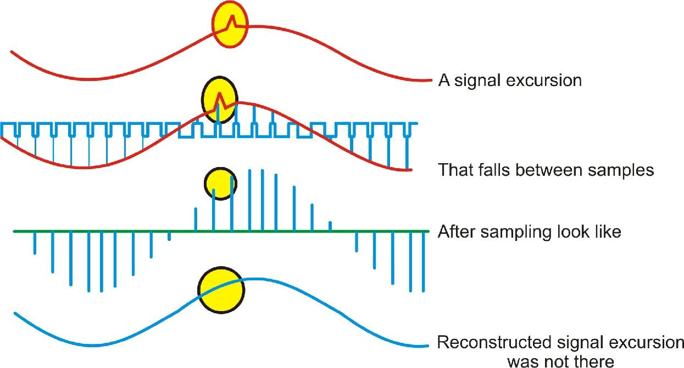

**Example of aliasing**

**Figure 10**

In a less obvious case, we might have signal components that are varying rapidly in between samples. Again, we could not track these rapid inter- sample variations. We must sample fast enough to see the most rapid changes in the signal. Sometimes we may have some a prior knowledge of the signal, or be able to make some assumptions about how the signal behaves in between samples.

If we do not sample fast enough, we cannot track completely the most rapid changes in the signal.

Some higher frequencies can be incorrectly interpreted as lower ones.

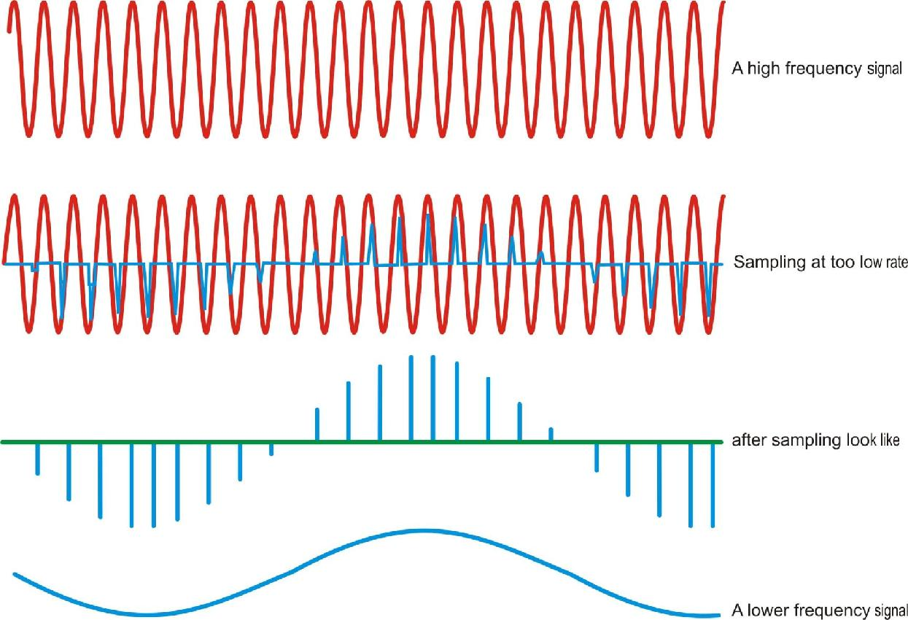

**Example of High frequency signal**

**Figure 11**

In the diagram, the high frequency signal is sampled just under twice every cycle. The result is that each sample is taken at a slightly later part of the cycle. If we draw a smooth connecting line between the samples, the resulting curve looks like a lower frequency. This is called 'aliasing' because one frequency looks like another.

Note that the problem of aliasing is that we cannot tell which frequency we have - a high frequency looks like a low one so we cannot tell the two apart. But sometimes we may have some a prior knowledge of the signal, or be able to make some assumptions about how the signal behaves in between samples, that will allow us to tell unambiguously what we have.

Nyquist showed that to distinguish unambiguously between all signal frequencies components we must sample faster than twice the frequency of the highest frequency component.

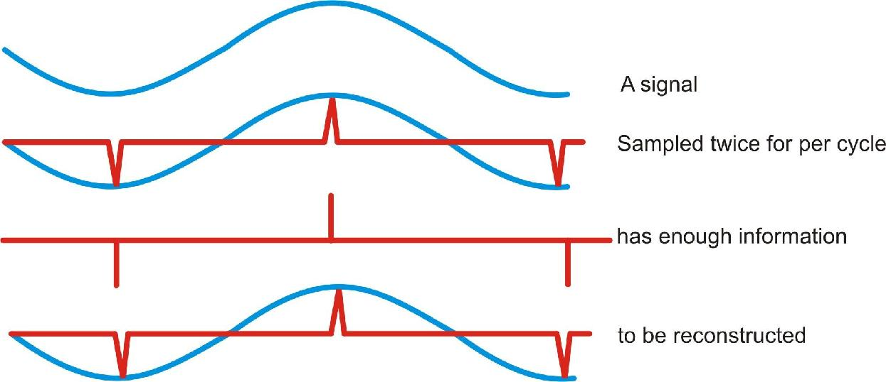

**Sampling process as per the Nyquist criteria**

**Figure 12**

In the diagram, the high frequency signal is sampled twice every cycle. If we draw a smooth connecting line between the samples, the resulting curve looks like the original signal. But if the samples happened to fall at the zero crossings, we would see no signal at all - this is why the sampling theorem demands we sample faster than twice the highest signal frequency.

The highest signal frequency allowed for a given sample rate is called the Nyquist frequency.

Actually, Nyquist says that we have to sample faster than the signal bandwidth, not the highest frequency. But this leads us into multi rate signal processing which is a more advanced subject.

1. **Integration effect or aperture effect:**

This results from the fact that the sample is obtained as a time average within a sampling region, rather than just being equal to the signal value at the sampling instant. The integration effect is readily noticeable in photography when the exposure is too long and creates a blur in the image. An ideal camera would have an exposure time of zero. In a capacitor-based sample and hold circuit, the integration effect is introduced because the capacitor cannot instantly change voltage thus requiring the sample to have non-zero width.

1. **Jitter:**

Jitter is the time variation of a periodic signal in electronics and telecommunications, often in relation to a reference clock source. Jitter may be observed in characteristics such as the frequency of successive pulses, the signal amplitude, phase of periodic signals. Jitter is a significant, and usually undesired, factor in the design of almost all communications links applications it is called timing jitter.

Jitter can be quantified in the same terms as all time-varying signals, or peak-to-peak displacement. Also like other time-varying signals, jitter can be expressed in terms of spectral density (frequency content).

Jitter period is the interval between two times of maximum effect (or minimum effect) of a signal characteristic that varies regularly with time. Jitter frequency, the more commonly quoted figure, is its inverse. Generally, very low jitter frequency is not of interest in designing systems, and the low-frequency cutoff for jitter is typically specified at 1 Hz.

1. **Noise:**

In communication system noise is fluctuations in and the addition of external factors to the stream of target information being received at a detector. In communications, it may be deliberate as for instance jamming of a radio or TV signal, but in most cases it is assumed to be merely undesired interference with intended operations. Natural and deliberate noise sources can provide both or either of random interference or patterned interference. Only the latter can be cancelled effectively in analog systems; however, digital systems are usually constructed in such a way that their quantized signals can be reconstructed perfectly, as long as the noise level remains below a defined maximum, which varies from application to application. In communication, the term noise has the following meanings:

1. An undesired disturbance within the frequency band of interest; the summation of unwanted or disturbing energy introduced into a communication system from man-made and natural sources.
2. A disturbance that affects a signal and that may distort the information carried by the signal.
3. Random variations of one or more characteristics of any entity such as voltage, current, or data.
4. A random signal of known statistical properties of amplitude, distribution, and spectral density.
5. Loosely, any disturbance tending to interfere with the normal operation of a device or system.

Noise and what can be done about it has long been studied. Shannon established information technology and in so doing clarified the essential nature of noise and the limits it places on the operation of electronic equipment.

In some cases a little noise may be considered advantageous, allowing a Dithered representation of signals below the minimum strength, or between two quantization levels.

1. **Slew rate:**

The slew rate is a fairly subtle specification. It is the time an amplifier needs to go from 10% to 90% of the total output voltage in response to a step in voltage at the input (Fig. 13). It is given in V/µs, the number of volts that the output can rise (or fall) in one microsecond. This spec obviously limits the capability of an amplifier to generate high voltage pulses with sharp rising and falling edges (Fig. 14), but is also a bandwidth limiting factor for sine-wave or arbitrary signals. This can be seen as follows. The highest rate of change in the output voltage of a sine wave is at the 0V-crossing (Fig. 15) . The higher the frequency, the faster the voltage has to rise there to prevent distortion of the sine wave. If the high voltage amplifier cannot follow due to its limited slew rate, the sine wave will be distorted and its amplitude is lower than at low frequencies. The maximum peak to peak sine wave output voltage Vpp is related to the slew rate S by Vpp = S/pi*f, where f is the frequency of the sine wave.

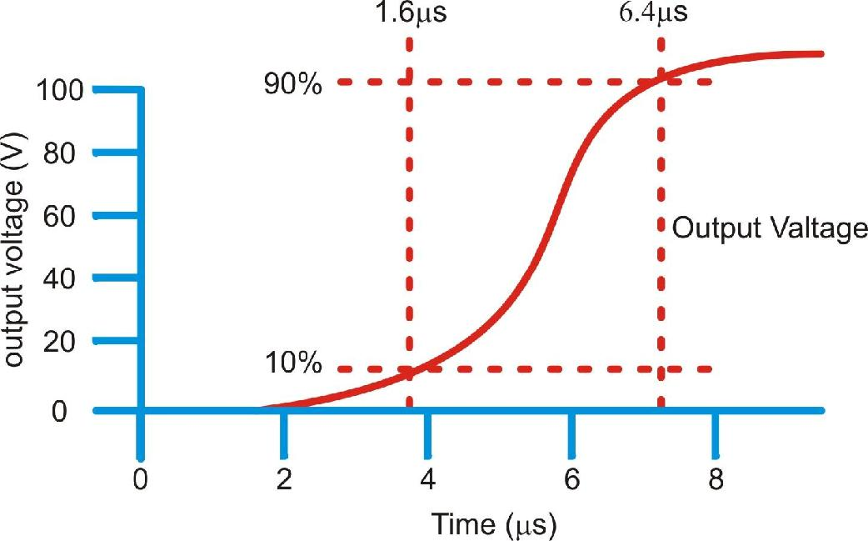

**The slew rate is the voltage step divided by time required to change the output from 10% to 90 % amplitude**

**Figure 13**

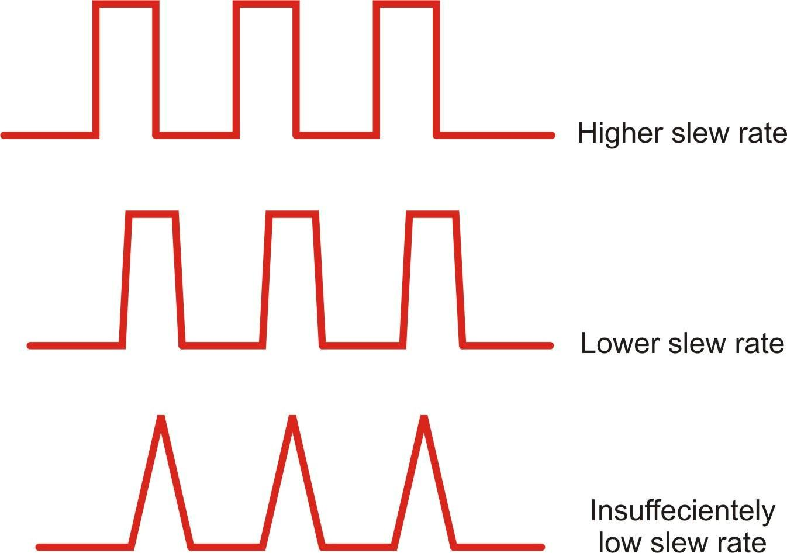

**Depending on the slew rate a set of pulses can either be amplified undistorted Figure 14**

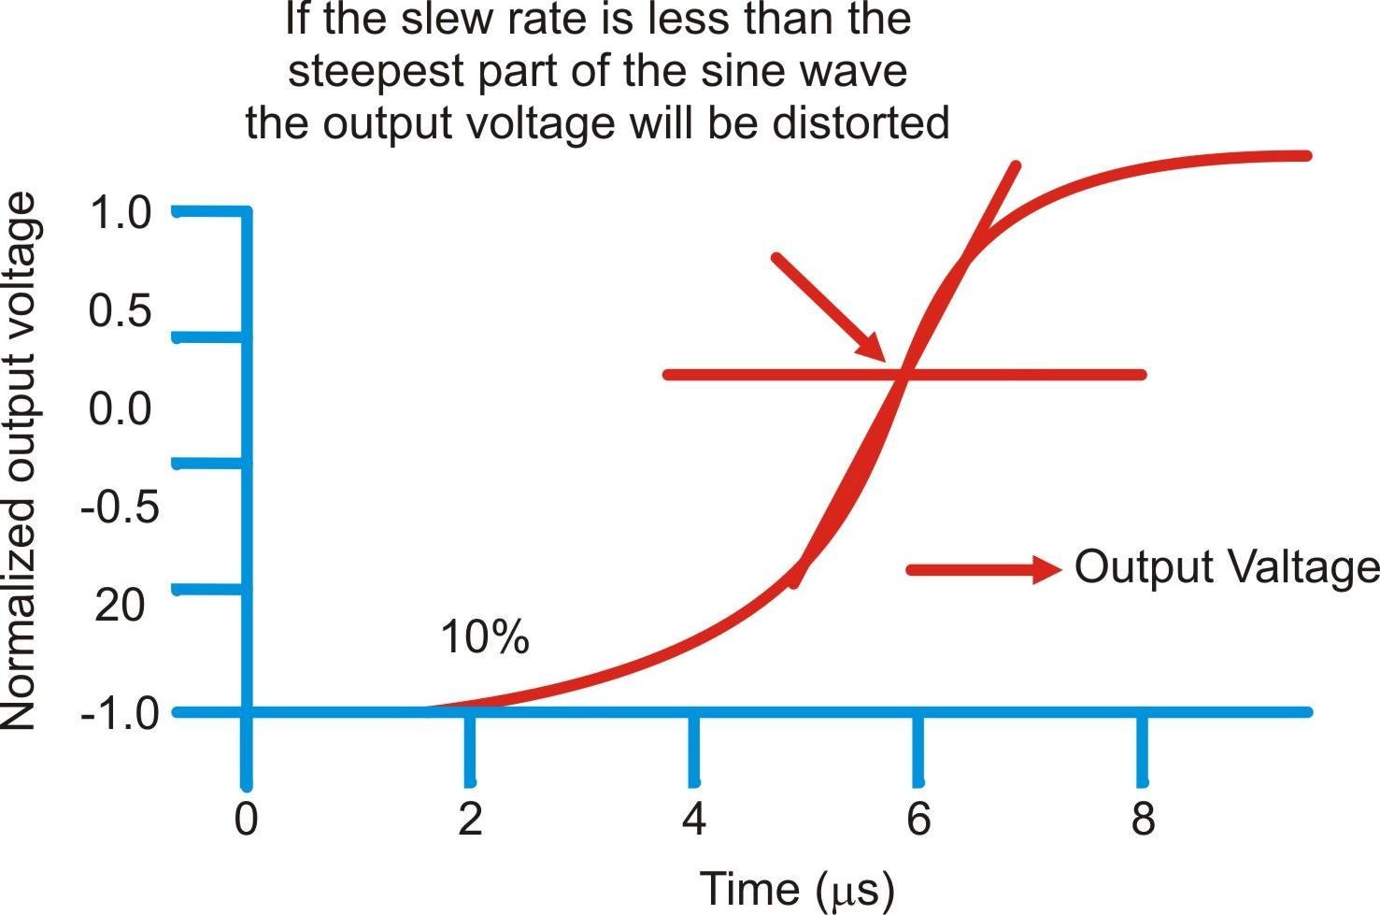

**If the slew rate is not sufficient sine waves are distorted**

**Figure 15**

1. **Quantization:**

In quantization the levels are assigned a binary codeword. All sample values falling between two quantization levels are considered to be located at the centre of the quantization interval. In this manner the quantization process introduces a certain amount of error or distortion into the signal samples. This error known as quantization noise is minimized by establishing a large number of small quantization intervals. Of course, as the number of quantization intervals increase, so must the number or bits increase to uniquely identify the quantization intervals. For example, if an analogue voltage level is to be converted to a digital system with 8 discrete levels or quantization steps three bits are required. In the ITU-T version there are 256 quantization steps, 128 positive and 128 negative, requiring 8 bits. A positive level is represented by having bit 8 (MSB) at 0 and for a negative level the MSB is 1.

This is the process of setting the sample amplitude, which can be continuously variable to a discrete value. Look at Uniform Quantization first, where the discrete values are evenly spaced.

**Uniform Quantization**

We assume that the amplitude of the signal m(t) is confined to the range (-mp, +mp ). This range (2mp) is divided into L levels, each of step size , given by

 = 2 mp / L

A sample amplitude value is approximated by the midpoint of the interval in which it lies. The input/output characteristic of a uniform quantizer is shown figure 16.

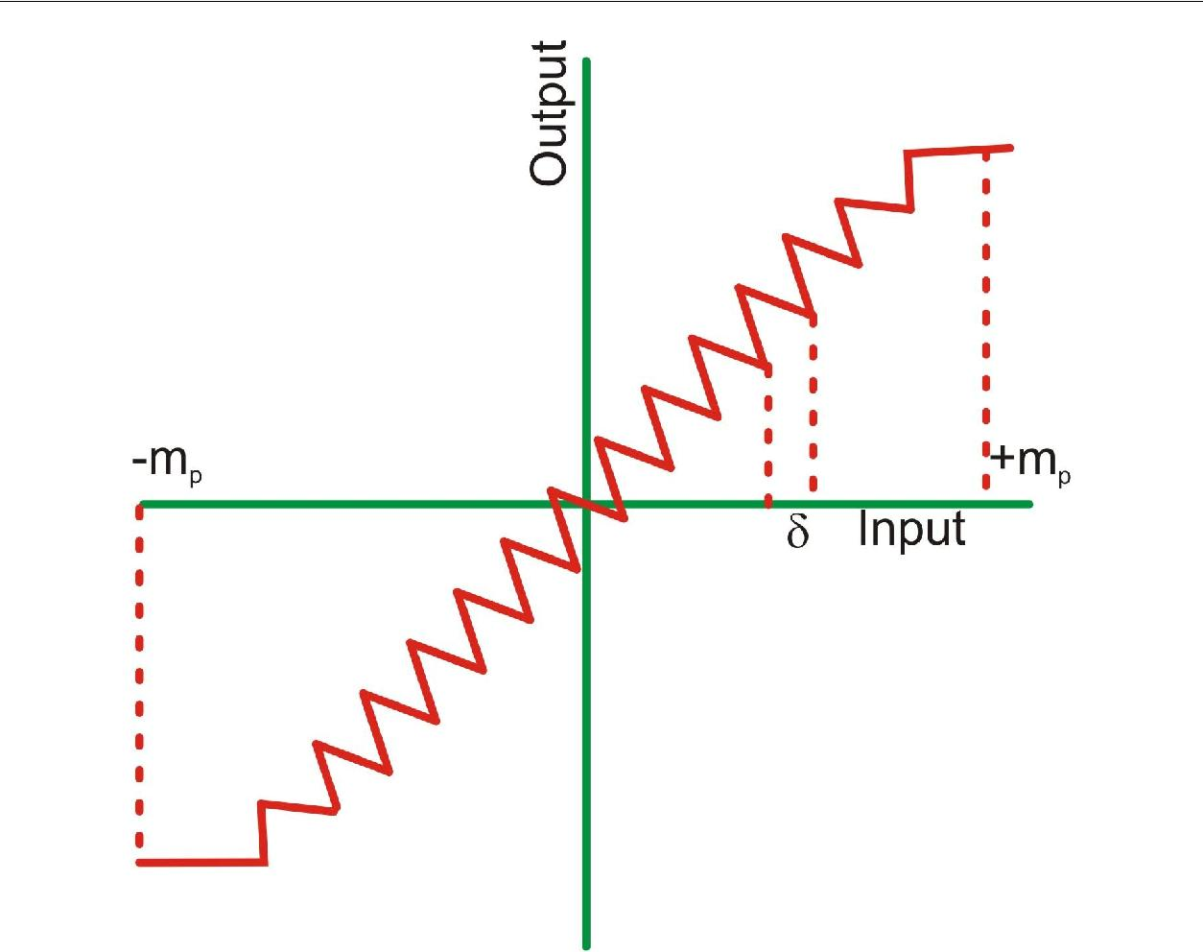

**Figure 16(a)**

The Quantization is the process that performs the transformation of a continuous analog signal in a set of discrete levels. Soon afterwards we combine through the coding each discrete levels with a digital word.

The figure 16(b) shows what explains above lines:

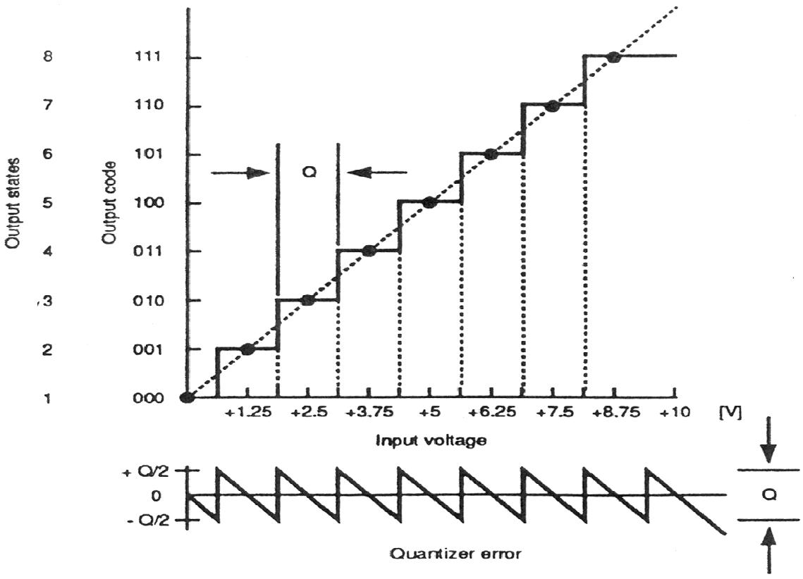

**Figure 16(b**)

The straight line is the continuous analog signal, while the staircase line is the quantized corresponding signal. If we assume a binary code, the 8 quantized states are coded through a 3 bits digital word and this corresponds to the output of a 3 bits A/D converter. The sequences of binary numbers starting from "000" and reaching "111" are assigned to the 8 output states. Let us analyze in detail a few aspects of the quantized signal. The first aspect is the "resolution", defined as the number of output states that can be coded through a binary word of n bits; with n bits we can code 2n output states. In this case we have a 3 bits quantizer; therefore we code 8 output states whereas with 12 bits we code 4096 of them. The diagram showed in figure 16(b) point out that in the quantized signal there are 2n - 1 = 7 threshold levels. These points are at 0.625 - 1.875 - 3.125 - 4.375 - 5.625 - 6.875 - 8.125 V.

The threshold points have to be set accurately to divide the range of the signal to quantize in correct quantized signals. The voltages 1.25, 2.5, 3.75, 5, 6.25, 7.5, 8.75 V are the center points of each output code word. The staircase quantization is the best possible approximation for a straight line starting from the origin and reaching full scale. The range of the input voltage for which the same output code is used is called "quantum". In figure 16(b), the quantum is 1.25 V. In general the quantum is expressed by the relation:

Q = FSR / 2n = Full scale range / 2n

It is explained that the quantum is the lowest analog difference that can be discriminated at the output. In case of a 12 bits quantizer, still with a full scale of 10V the quantum is:

Q = 10/212 = 10/4096 = .00244 V = 2.44 mV

In figure 16(b) is also reported a curve called "quantizing error". This represents the error that could not be eliminated, due to quantization. Increasing the bit number can reduce the error. The uncertainty due to quantization and therefore the error due to quantization is  Q/2. A/D converter requires a given time interval, even small, to perform the quantizing and coding operations. This time is called "conversion time" and depends on several factors, as the converter resolution, the conversion technique, the speed of the components used in the converter.

During the conversion the signal can vary. Therefore the conversion speed for a given application depends both upon the required accuracy and upon how much rapidly varies the signal to convert. The conversion time is often called improperly "aperture time" ta (figure 16(c))

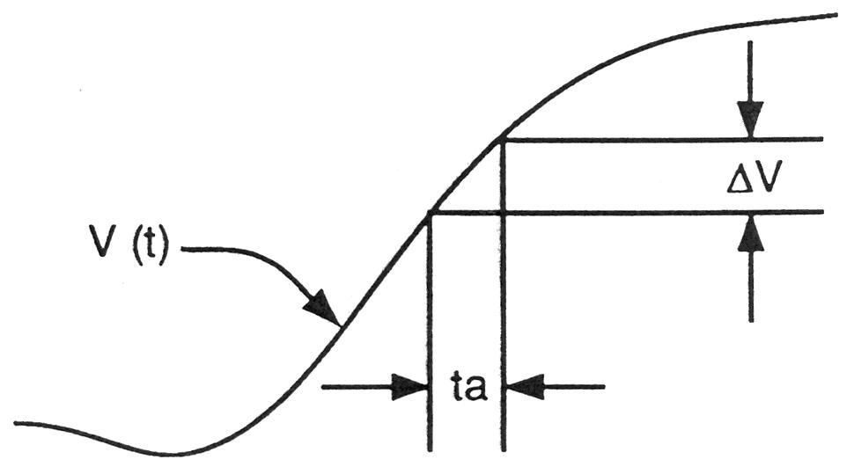

**Figure 16(c)**

If the signal changes of V during the conversion, we have an amplitude error V which is:

V = ta  dV(t) / dt

Where dV(t) /dt is the rate of change of input signal with time. A signal has not the same rate of variation everywhere, e.g. a sinusoidal signal has the biggest derivative at the zero passage.

1. Error due to other non-linear effects of the mapping of input voltage to converted output value (in addition to the effects of quantization).

The conventional, practical digital- to-analog converter (DAC) does not output a sequence of impulses (such that, if ideally low-pass filtered, result in the original signal before sampling) but instead output a sequence of piecewise constant values or rectangular pulses. This means that there is an inherent effect of the zero-order hold on the effective frequency response of the DAC resulting in a mild roll-off of gain at the higher frequencies (a 3.9224 dB loss at the Nyquist frequency). This zero-order hold effect is a consequence of the hold action of the DAC and is not due to the sample and hold that might precede a conventional ADC as is often misunderstood. The DAC can also suffer errors from jitter, noise, slewing, and non-linear mapping of input value to output voltage.

Jitter, noise, and quantization are often analyzed by modeling them as random errors added to the sample values. Integration and zero- order hold effects can be analyzed as a form of low-pass filtering. The non-linearity of either ADC or DAC are analyzed by replacing the ideal linear function mapping with a proposed nonlinear function.

**Sample & Hold circuit:**

In electronics, a sample and hold circuit is used to interface real-world signals, by changing analogue signals to a subsequent system. The purpose of this circuit is to hold the analogue value steady for a short time while the converter or other following system performs some operation that takes a little time.

**Sampling mode:**

In this mode, the switch is in the closed position and the capacitor charges to the instantaneous input voltage.

**Hold mode:**

In this mode, the switch is in the open position. The capacitor is now disconnected from the input. As there is no path for the capacitor to discharge, it will hold the voltage on it just before opening the switch. The capacitor will hold this voltage till the next sampling instant.

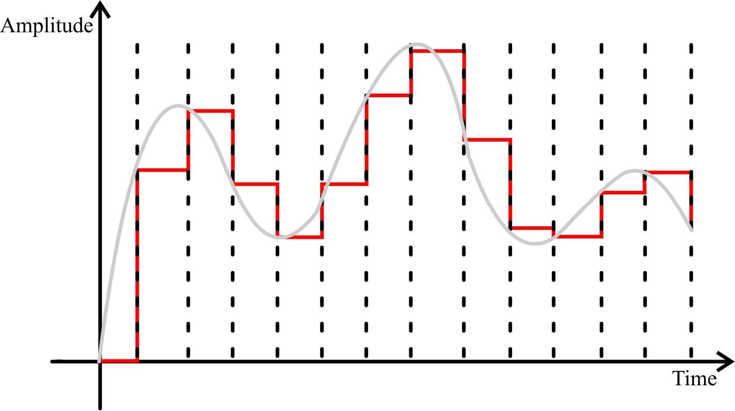

**Sample and Hold Waveform**

**Figure 17**

Now, from figure 17 the area under the curve (which is equivalent to the signal power) is greater and so the filter output amplitude and quality of reproduced signal is improved.

In most circuits, a capacitor is used to store the analogue voltage and an electronic switch or gate is used to alternately connect and disconnect the capacitor from the

analogue input. The rate at which this switch is operated is the sampling rate of the system.

In a sample and hold circuit the switch opens for a very short duration. The sample and hold circuit integrates for a short duration charge into a capacitor.

The 'hold' facility can be provided by a capacitor, when the switch connects the capacitor to PAM output it charges to the instantaneous value.

A buffered sample and hold circuit consists of unit gain buffer preceding and succeeding the charging capacitor. The high input impedance of the preceding buffer prevents the loading of the message source and also ensures that the capacitor charges by a constant rate irrespective of the source impedance see figure 18(a).

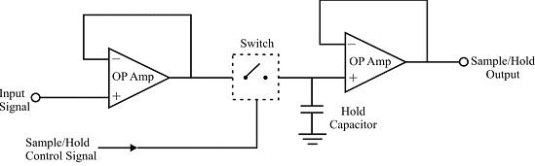

**Sample Hold Circuit**

**Figure 18(a)**

The high input impedance of the succeeding buffer prevents the charging from the capacitor due to loading and hence the capacitor can hold the charge for infinite time, at least theoretically. However, small leakage current through the capacitor dielectric into '+'ve input of second buffer is always present which causes gradual charge loss. The rate of change of voltage with respect to time dv / dt is called as droop rate and is important parameter in sample and Hold circuit design. The sample and hold waveform is shown in figure 18(b).

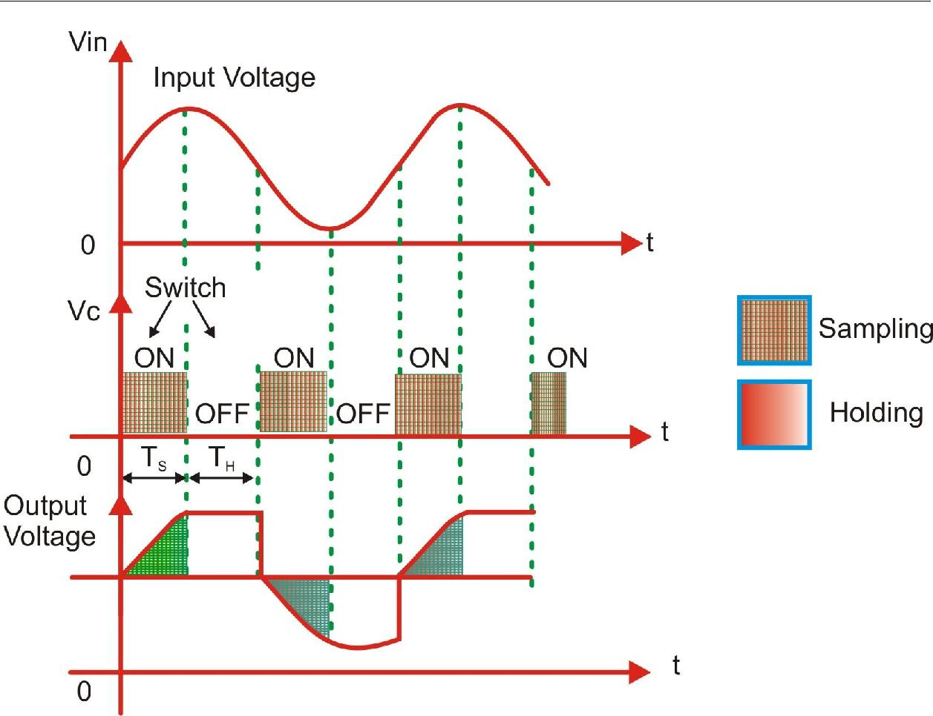

**Sample and hold wave form**

**Figure 18(b)**

**Important Parameters of Sample & Hold Circuit**

1. **Aperture time:**

The aperture time is defined as the delay time between the beginnings of the hold command to the time the capacitor voltage ceases to follow the information signal. Hence the hold value is different from the true sample value. The aperture time cannot be reducing to zero because on application of finite time taken by a switch to close & open on application of the hold signal. Therefore a small value of aperture time is sought after.

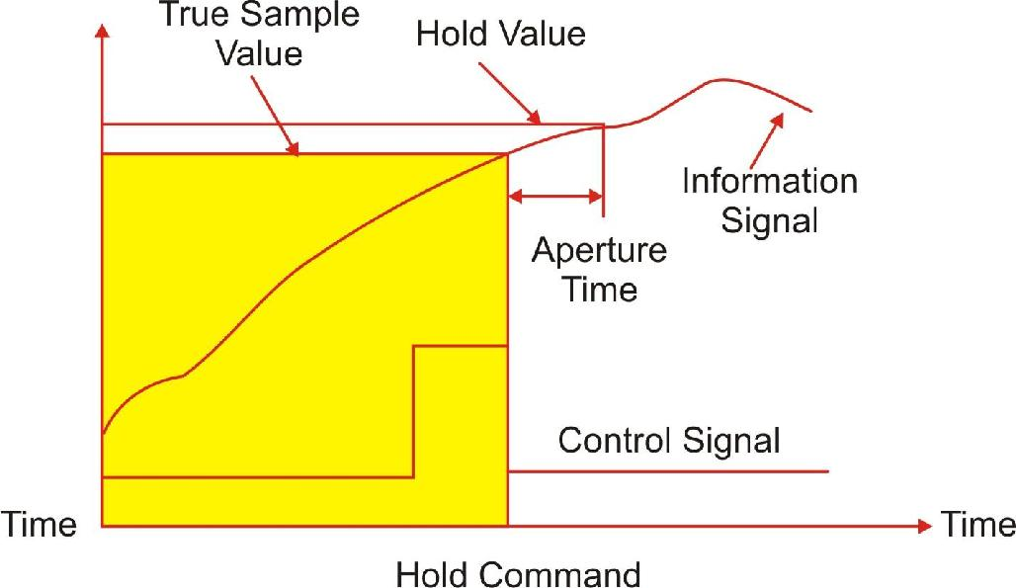

**Timing Diagram for Sample and Hold Circuit**

**Figure 18(c)**

1. **Acquisition Time:**

In sample mode, it takes finite time for the capacitor to charge to the information signal value depending on the RC time constant. This is called as the acquisition time. The acquisition time is dependent on the current flowing from the input buffer through switch and hence on RC time constant. The maximum acquisition time occurs when the capacitor voltage has to change by the full amplitude of the information signal.

1. **Droop Rate:**

As it has been discussed earlier, the presence of leakage current through capacitor dielectric to +ve input of succeeding buffer causes charge loss of capacitor. Hence the voltage level at the output falls with in time. This rate of change of voltage with respect to time dv/dt is known as droop rate. Over value of droop rate is desirable as the circuit should be able to maintain the sample at a relatively constant level until the next sample.

1. **Feed Through:**

At high frequencies, the stray capacitance within the switch causes some of the input signal to appear at the output during the hold state (switch open). The fraction of input signal appearing at the output of sample and hold circuit is called feed through.

The sample and hold feature provides both problem and benefit will be seen afterwards.

**Anti-aliasing:**

Nyquist showed that to distinguish unambiguously between all signal frequencies components we must sample at least twice the frequency of the highest frequency component. To avoid aliasing, we simply filter out all the high frequency components before sampling.

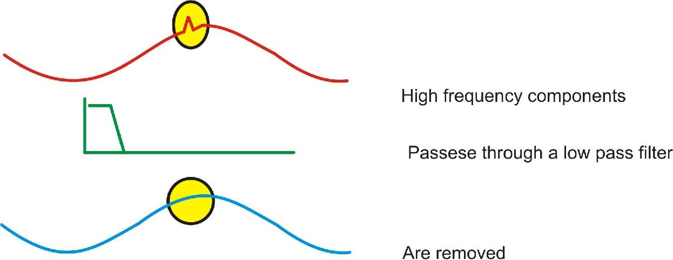

**Example of anti-aliasing**

**Figure 19**

Note that anti-alias filters must be analogue – it is too late once you have done the sampling.

This simple brute force method avoids the problem of aliasing. But it does remove information – if the signal had high frequency components, we cannot now know anything about them.

Although Nyquist showed that provide we sample at least twice the highest signal frequency we have all the information needed to reconstruct the signal, the sampling theorem does not say the samples will look like the signal as shown in figure 20.

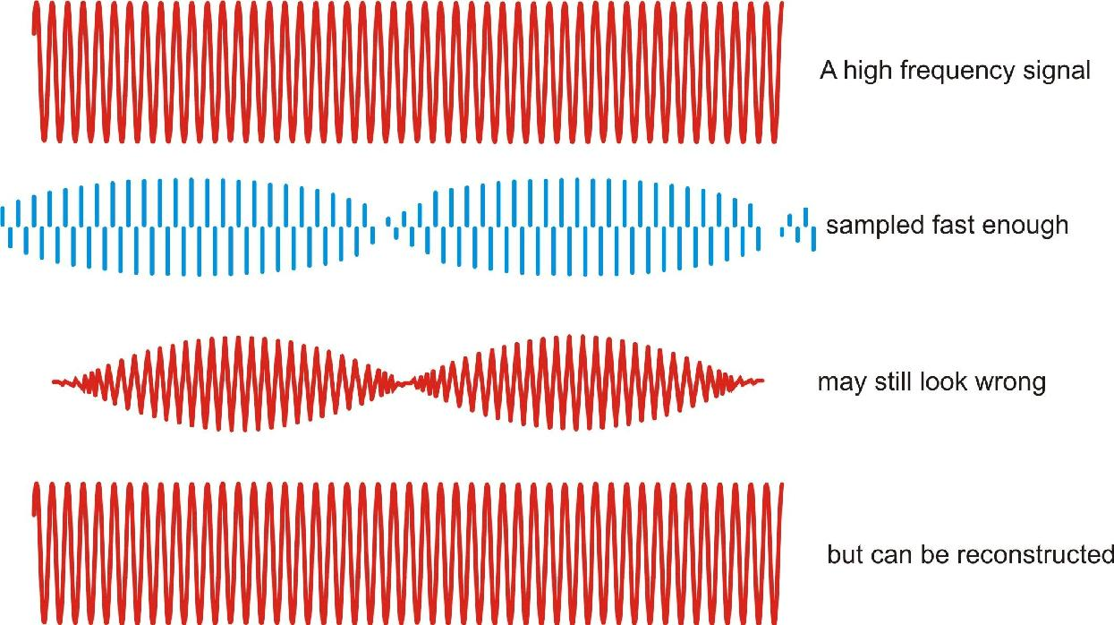

**Example of sampling theorem**

**Figure 20**

The diagram shows a high frequency sine wave that is nevertheless sampled fast enough according to Nyquist sampling theorem – just more than twice per cycle. When straight lines are drawn between the samples, the signal’s frequency is indeed evident – but it looks as though the signal is amplitude modulated. This effect arises because each sample is taken at a slightly earlier part of the cycle. Unlike aliasing, the effect does not change the apparent signal frequency. The answer lies in the fact that the sampling theorem says there is enough information to reconstruct the signal – and the correct reconstruction is not just to draw straight lines between samples.

The signal is properly reconstructed from the samples by low pass filtering: the low pass filter should be the same as the original anti-alias filter.

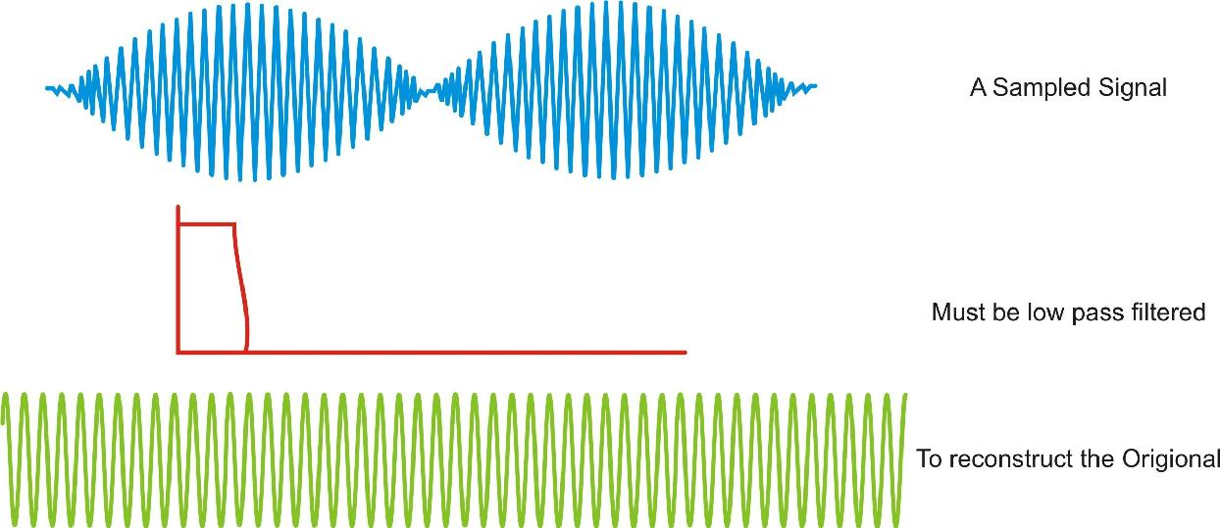

**Example of anti-aliasing**

**Figure 21**

The reconstruction filter interpolates between the samples to make a smoothly varying analogue signal. In the example, the reconstruction filter interpolates between samples in a ‘peaky’ way that seems at first sight to be strange. The explanation lies in the shape of the reconstruction filter’s impulse response

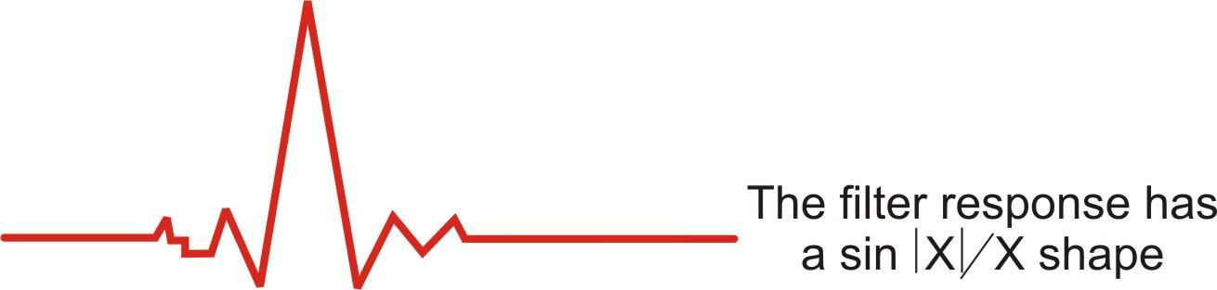

**Low pass filter response**

**Figure 22**

The impulse response of the reconstruction filter has a classic 'sin(x)/x shape. The stimulus fed to this filter is the series of discrete impulses which are the samples. Every time an impulse hits the filter, we get 'ringing' - and it is the superposition of all these peaky rings that reconstructs the proper signal. If the signal contains frequency components that are close to the Nyquist, then the reconstruction filter has to be very sharp indeed. This means it will have a very long impulse response - and so the long 'memory' needed to fill in the signal even in region of the low amplitude samples.

**To avoid the aliasing there are two approaches:**

1. To raise the sampling frequency to satisfy the sampling theorem,
2. The other is to filter off the unnecessary high-frequency component from the continuous-time signal. We limit the signal frequency by an effective low pass filter, called anti aliasing pre filter, so that the remained highest frequency is less than half of the intended sampling rate. If the filter is not perfect we must give some allowance.

The schematic below repeats the above aliasing argument in the frequency domain.

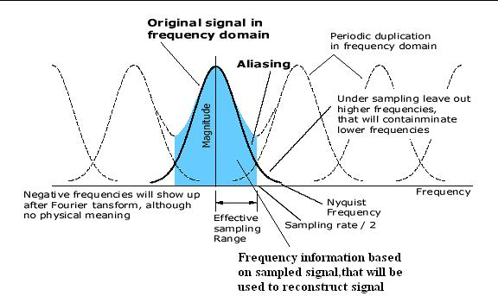

**Spectrum of Under Sampled Signal**

**Figure 23**

**Reason for aliasing & its presentation:**

1. **Aliasing due to Under-Sampling:**

If the signal is sampled at rate lower than 2Fm then it causes aliasing. Let us assume a sinusoidal waveform of frequency F IN which is being sampled at rate Fs < 2Fm. In the figure 24 dots represents the sample points.

The low-pass filter at demodulator effectively 'joins' the sample causing an unwanted frequency component to appear at the output. This unwanted component has frequency equal to (FS-FM)

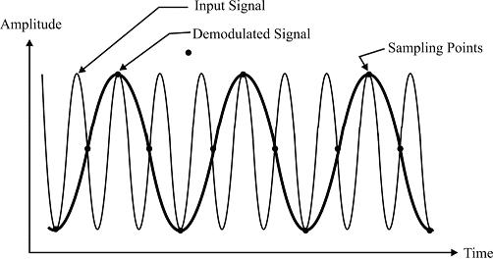

**Aliasing due to Under - Sampling**

**Figure 24**

1. **Aliasing due to wide Band Signal:**

The system is designed to take samples at frequency slightly greater than that stated by Nyquist rate. If higher frequencies are ever present in the information signal or it is affected by high frequency noise then the aliasing will occur.

This does not generally happen in properly designed telephone network where speech channels are band-limited by filters before sampling.

In control engineering and telemetry, however, out of band high frequencies either from source or due to noise pick-up can be present. In this case band-limiting filters, generally known as anti-aliasing filters are usually installed prior to sampling to prevent aliasing.

As a principle, the system is designed to sample at rate higher than the rate to take into account the equipment tolerances, aging and filter response.

1. **Aliasing Due to Filter Roll-off:**

Roll-off is a term applied to the cut-off gradient of a filter. No filter is ideal and therefore frequencies above the nominal cut-off frequency may still have significant amplitudes at a filter's output. If proper sampling rate and appropriate filter response is not chosen, aliasing will occur.

1. **Aliasing due to Noise:**

If very small duty cycle is used in sample-and-hold circuit aliasing may occur if the signal has been affected by noise. High frequency noise generally ‘mixes’ with the high frequency component of the signal and hence causes undesirable frequency components to be present at the output.

**Low Pass Filter**

Reconstruction of the message signal is done with the help of Low pass filter. Low pass filter pass the message signal as low frequency signals and higher frequency signals are attenuated.

**Filter Basic:**

The simplest type of filter is a resistance-capacitance (RC) filter. The high pass and

low pass RC filters are as shown in figure 25 (a) & 25 (b).

The analysis of these filters becomes easier if we think of them as A.C. potential dividers. The reactance of the capacitor is frequency dependent with a high value at low frequencies and a low value at high frequencies.

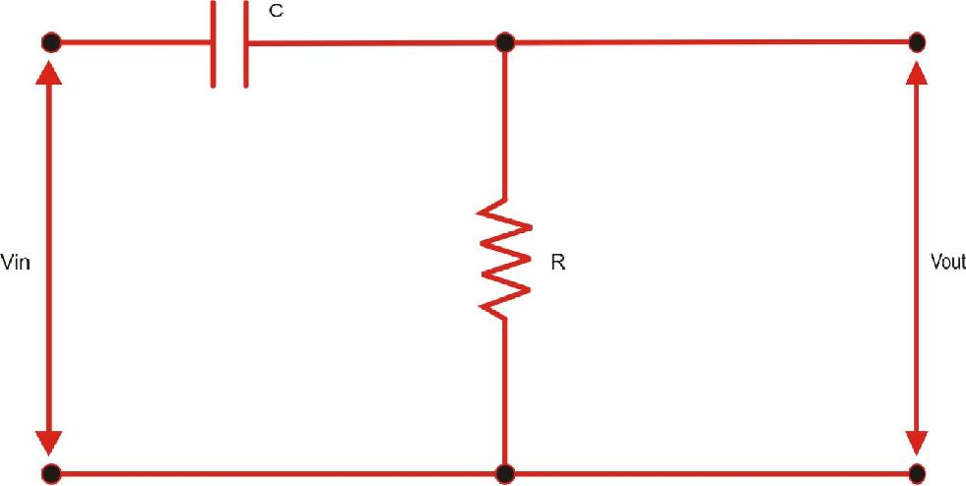

**Passive High Pass Filter**

**Figure 25 (a)**

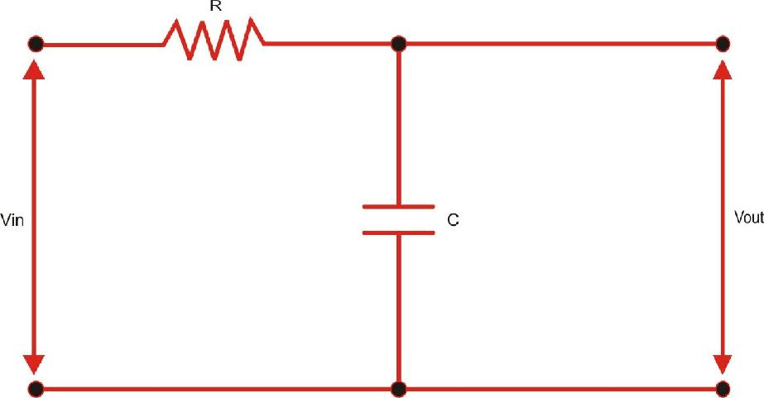

**Passive Low Pass Filter**

|  |  |
| --- | --- |
|  | **Figure 25 (b)** |

In case of high pass filter, the series capacitance has high reactance at low frequencies and hence results in reduction in output voltage. An increase in frequency causes an increase in output voltage with VOUT approaching input voltage VIN.

The effect of capacitance is capacitance is in short and decreasing its reactance.

just opposite as the case of low pass filter. Here, the hence VOUT reduces as frequency increases thereby

The ratio of VOUT to VIN is known as Transfer function for the circuit. For RC low pass filter, the transfer function can be derived by using potential divider resistance.

So,

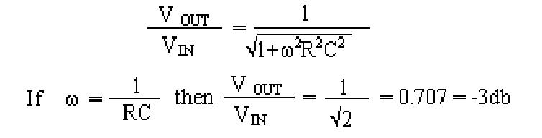

This is the half-power point of the filter i.e. at frequency  = RC, the output power decreases to half of the input power. This is also known as the cut -off frequency (Fc). The filter not only causes amplitude change but a change in phase is also experienced. A typical response of a low pass filter is as shown below:

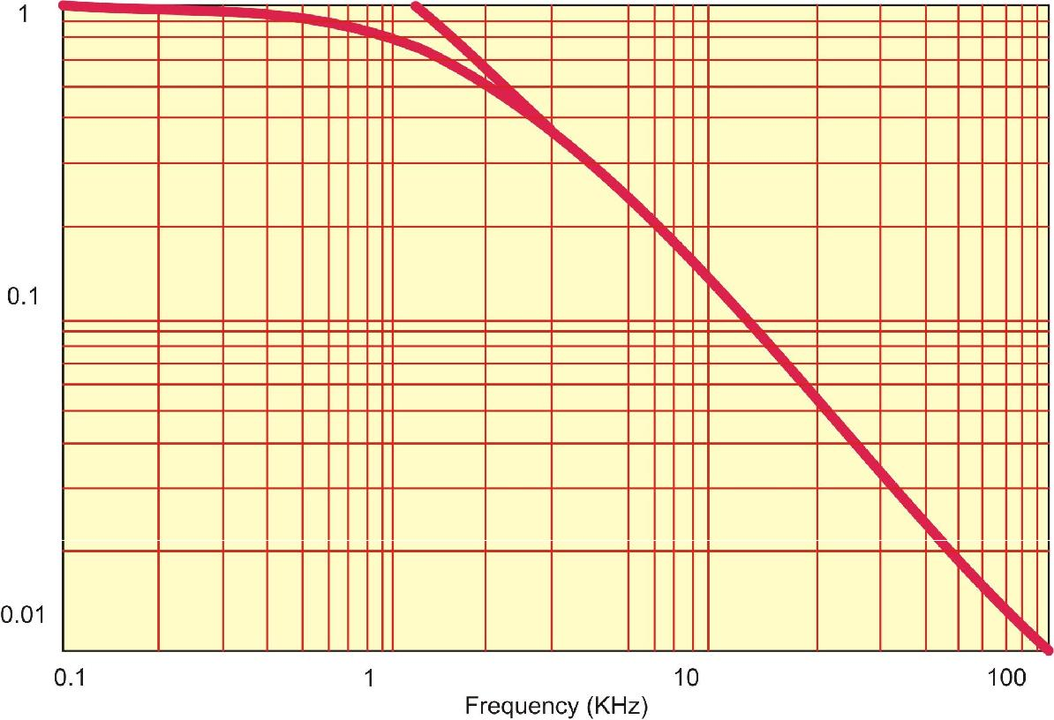

**Gain Response of Passive Filter**

**Figure 26(a)**

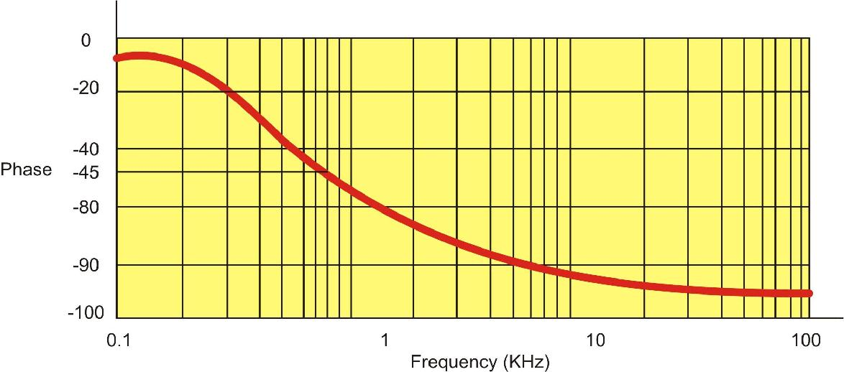

**Phase Response of Passive Filter**

**Figure 26(b)**

The RC filter is a passive filter and does not give a steeper fall-off. Cascading many such RC Filters give a steeper full-off but at a price of successive attenuation of the signal.

Active filter gives much flatter response in the pass band and they also have a steeper cut-off gradient. The following figure shows a comparison between two types of filter responses.

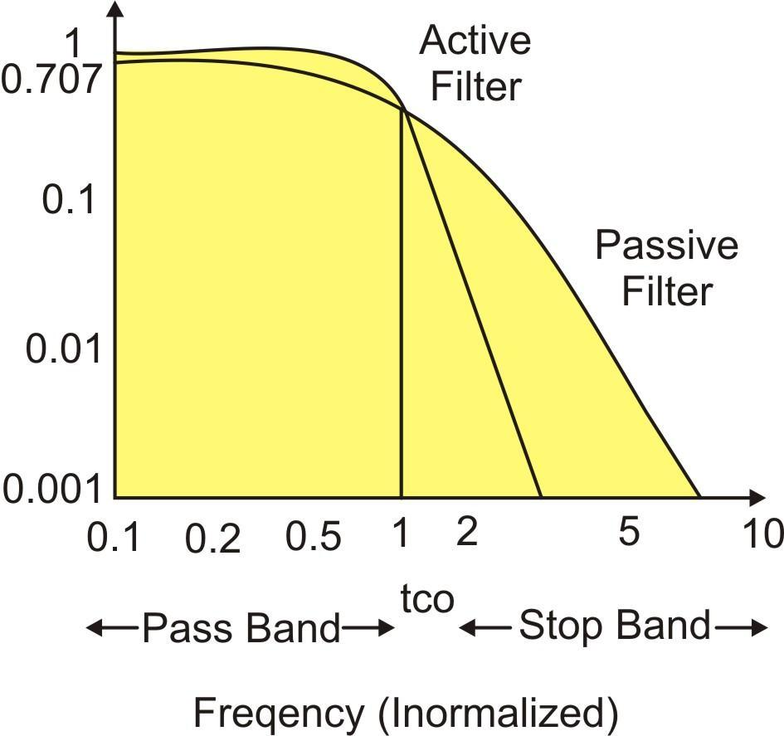

**Amplitude Response of Active & Passive Filters**

**Figure 27**

**The other advantages offered by Active Filters are:**

1. Gain frequency adjustment flexibility (i.e. easy tuning).
2. No loading problem between sources, load or successive stages.
3. They are economical than passive filters.

The active filters employ transistors or op- amps in addition to resistors and capacitors. The resistors at the output of the op-amp create a non-inverting voltage amplifier of voltage gain K while other resistor and capacitor sets the frequency response properties of the filter.

An ideal filter should have zero loss in pass band and infinite loss in stop band. In practice no ideal response exists, but there are many responses which approximate the ideal response namely, Butter worth, Chebyshev, Bessel etc. the comparison of these filter responses are as shown in figure 25.

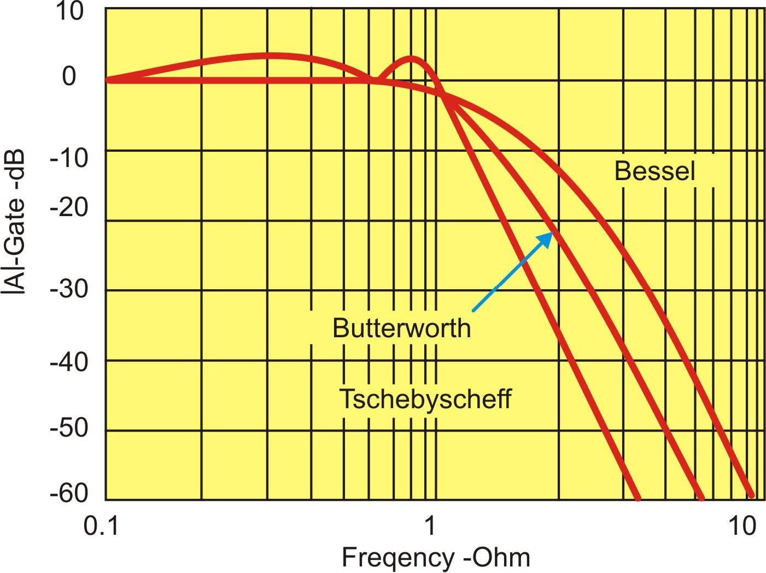

**Comparison of Filter Responses**

**Figure 28**

The voltage controlled voltage source (VCVS) can be arranged in the following manner to get the Butterworth response.

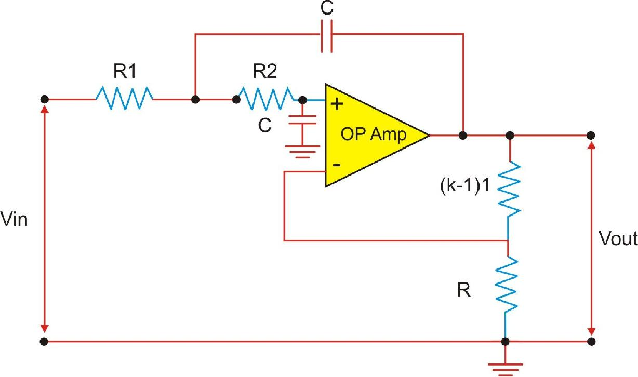

**Second Order Butterworth Low Pass Filter**

**Figure 29**

The n th order filter has a rate of fall off of 6n dB/octave or 20n dB/decade and one capacitor or inductor is required for each pulse (order).

The following table summaries the effect of fall-off gradient-on a signal such-as square wave.

|  |  |  |  |
| --- | --- | --- | --- |
| **Filter order** | **fall-off Octave** | **fall-off decade** | **Phase at cut-off** |
|  |  |  | **Frequency** |
| First | 6 | 20 | - 45 |
| Second | 12 | 40 | - 90 |
| Fourth | 14 | 80 | - 180 |
| See figure 30. |  |  |  |

The amplitude response of a Butterworth filter is given by;



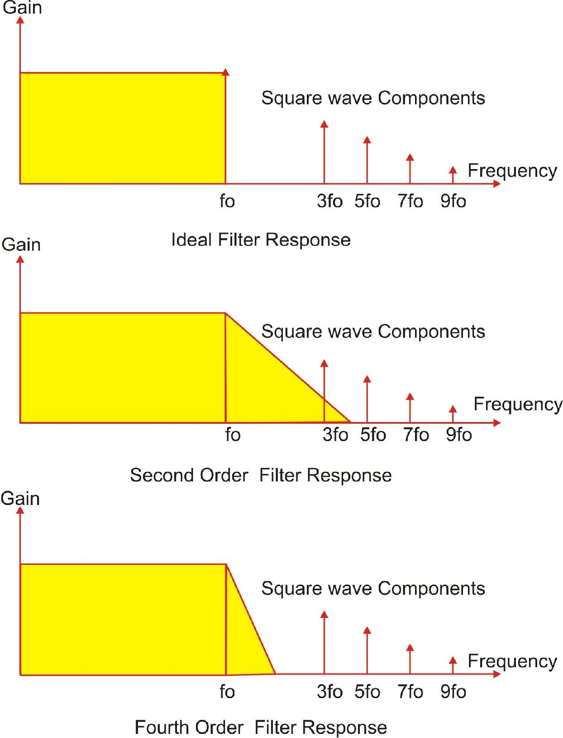

**Figure 30**

**Frequency Response of a Second Order Butter worth Low Pass Filter:**

The arrangement shown in figure 29 can be used as second order butter worth filter with cut-off frequency.



The amplitude and phase response of second order butter worth low pass filter with respect to frequency is as shown in figure 31.

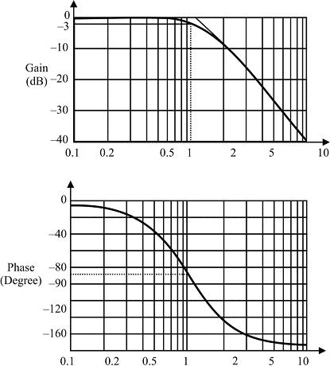

**Frequency (Normalized)**

**Amplitude Vs Frequency & Phase Vs Frequency**

**Response of Second Order Butterworth Low Pass Filter**

**Figure 31**

For this circuit, the voltage gain has been set equal to 1.586.

**Fourth Order Butter worth Low Pass Filter:**

The fourth order Butter worth filter can be formed by cascading two second order Butter worth filters. As can be seen from figure 30 the components R, and C are identical in both filter stages and they determine the cut-off frequency. In our circuit the gain of first stage has been set to 1.152 and that of other is set at 2.235.

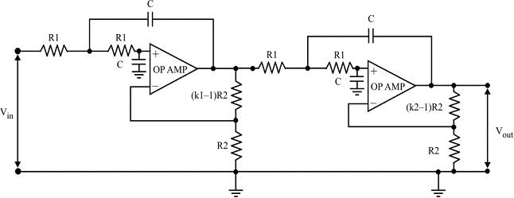

**Fourth Order Butter worth Low Pass Filter**

**Figure 32**

The amplitude/frequency and phase/frequency responses of fourth order Butterworth low pass filters are as shown in figure 31.

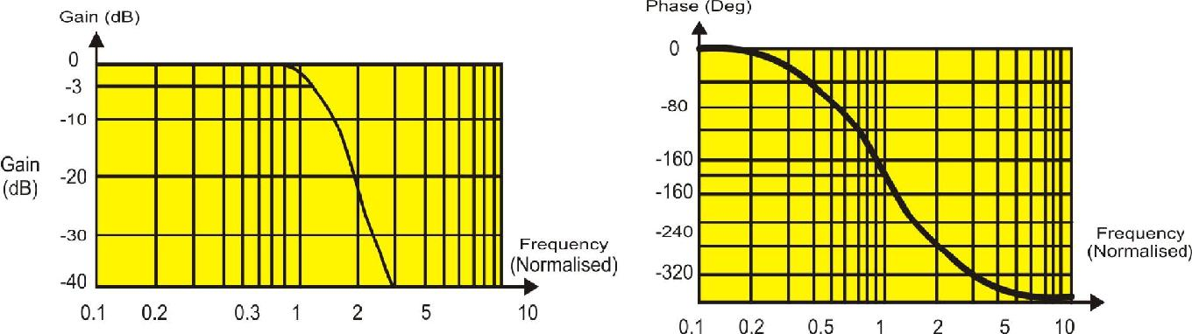

**Amplitude Vs Frequency & Phase Vs Frequency**

**Response of Second Order Butterworth Low Pass Filter**

**Figure 33**

The filter design should be done critically so that any unwanted frequency components existing close to the desired frequency components are attenuated sufficiently to save the output from getting corrupted.

Though increasing order of filter is desirable, there is a price that we have to pay for steeper fall-off.

1. Additional circuitry increases complexity and cost
2. Increase in order increases phase lag, though it is not so critical in audio circuits.

**Testing Instruments needed for Experiments**

1. **Scientech Oscilloscope Model 201**

20 MHz, Dual Trace, ALT Trigger

1. **Oscilloscope Probes X1– X 10 etc.**

**Experiment 1**

**Objective:**

* Study of sampling and reconstruction of signal.
* Study the effect of Sample /Sample and Hold output on reconstructed waveform
* Comparison of frequency response of 2nd order and 4th order low pass filter.

**Equipment Required**

1. Scientech 2101 with power supply cord
2. Oscilloscope with connecting probe
3. Connecting cords

**Procedure:**

**A. Set up for Sampling and reconstruction of signal.**

**Initial set up of trainer:**

Duty cycle selector switch position: Position 5 (to set 50% duty cycle)

Sampling selector switch : Internal position

1. Connect the power cord to the trainer. Keep the power switch in ‘Off’ position.
2. Connect 1 KHz Sine wave to signal Input.
3. Switch ‘On’ the trainer's power supply & Oscilloscope.
4. Connect BNC connector to the CRO and to the trainer’s output port.
5. Select 320 KHz (Sampling frequency is 1/10th of the frequency indicated by the illuminated LED) sampling rate with the help of sampling frequency selector switch.
6. Observe 1 KHz sine wave (TP12) and Sample Output (TP37) on Oscilloscope. The display shows 1 KHz Sine wave being sampled at 32 KHz, so there are 32 samples for every cycle of the sine wave. (figure 1.1)
7. Connect the Sample output to Input of Fourth Order low pass Filter & observe reconstructed output on (TP46) with help of oscilloscope. The display shows the reconstructed original 1 KHz sine wave. (figure 1.2)
8. By successive presses of sampling Frequency Selector switch, change the sampling frequency to 2KHz, 4KHz, 8KHz, 16KHz and back to 32KHz (Sampling frequency is 1/10th of the frequency indicated by the illuminated LED). Observe how SAMPLE output changes in each cases and how the lower sampling frequencies introduce distortion into the filter’s output waveform. This is due to the fact that the filter does not attenuate the unwanted frequency component significantly. Use of higher order filter would improve the output waveform.
9. So far, we have used sampling frequencies greater than twice the maximum input frequency.

**Conclusion:**

As the sampling frequency increases the output of sample port has more number of samples of applied input signal.

**B. Setup for sample and hold output & reconstructed signal output.**

1. Repeat the first five steps as above.
2. Connect Sample & Hold output to Fourth Order low pass Filter's Input. Set the Duty Cycle Selector switch to position 5. (figure 2.1)
3. Observe the waveform at Sample & Hold output (TP39) on oscilloscope. Vary the sampling frequency selector from 32 KHz to 2 KHz to illustrate how each sample is held at the sample/hold output. Also observe the filter output at TP46. (figure 2.2)
4. Vary the position of Duty Cycle Selector switch from 0 to 9 and note that in contrast to step 7, the filter's output amplitude is now independent of the sampling duty cycle and is equal to the amplitude of the original input signal. This is an important result - with Sample and Hold Output, the proportion of sampling time to holding time has no effect on reconstructed waveform provided that Nyquist criteria has been followed. If sample/hold feature is utilized in digital communication system many channels can be multiplexed with maximum amplitude of reconstructed signal.

**Conclusion:**

For transmitting the signal if a sample and hold amplifier is used just before the transmission channel, the signal will be less suffered from distortion as compared to when only sample amplifier is used.

**C. Comparison of frequency response of 2nd order and 4th order low pass filter.**

1. Repeat the first five steps above.

2. Connect sample output to input of the Second Order Low Pass Filter and to the input of Fourth Order Low Pass Filter respectively. Observe the outputs of two filters (TP42 and 46 respectively) on the oscilloscope. Vary the sampling frequency with duty cycle set at 5 positions. Compare the output of filter in each case. Note, that the output of fourth order filter always exhibits less distortion than second order filter. This is because fourth order filter has a sharper roll-off and thus rejects (attenuates) more unwanted frequency components caused by sampling. (Figure 3.1).

3. Repeat the above procedure with sample and hold circuitry. Observe that the output exhibits less distortion as compared to output in case of sample circuitry.

**Conclusion:**

As the order of LPF is increased at output, the recovered signal will be reconstructed more like the transmitted signal. To further verify this you can connect output of either sample amplifier or sample and hold amplifier to II order LPF Input and the output of II order LPF to the input of IV order LPF. The order of LPF is now VI.

Observe the output of IV order LPF and compare it with previously obtained waveforms

**Signal Sampling Connection Diagram:**

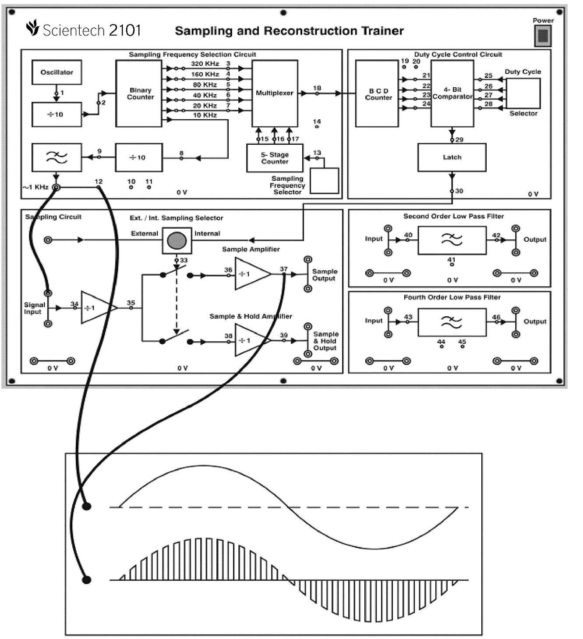

**Signal Sampling**

**Figure 1.1**

**Signal Reconstruction Connection Diagram:**

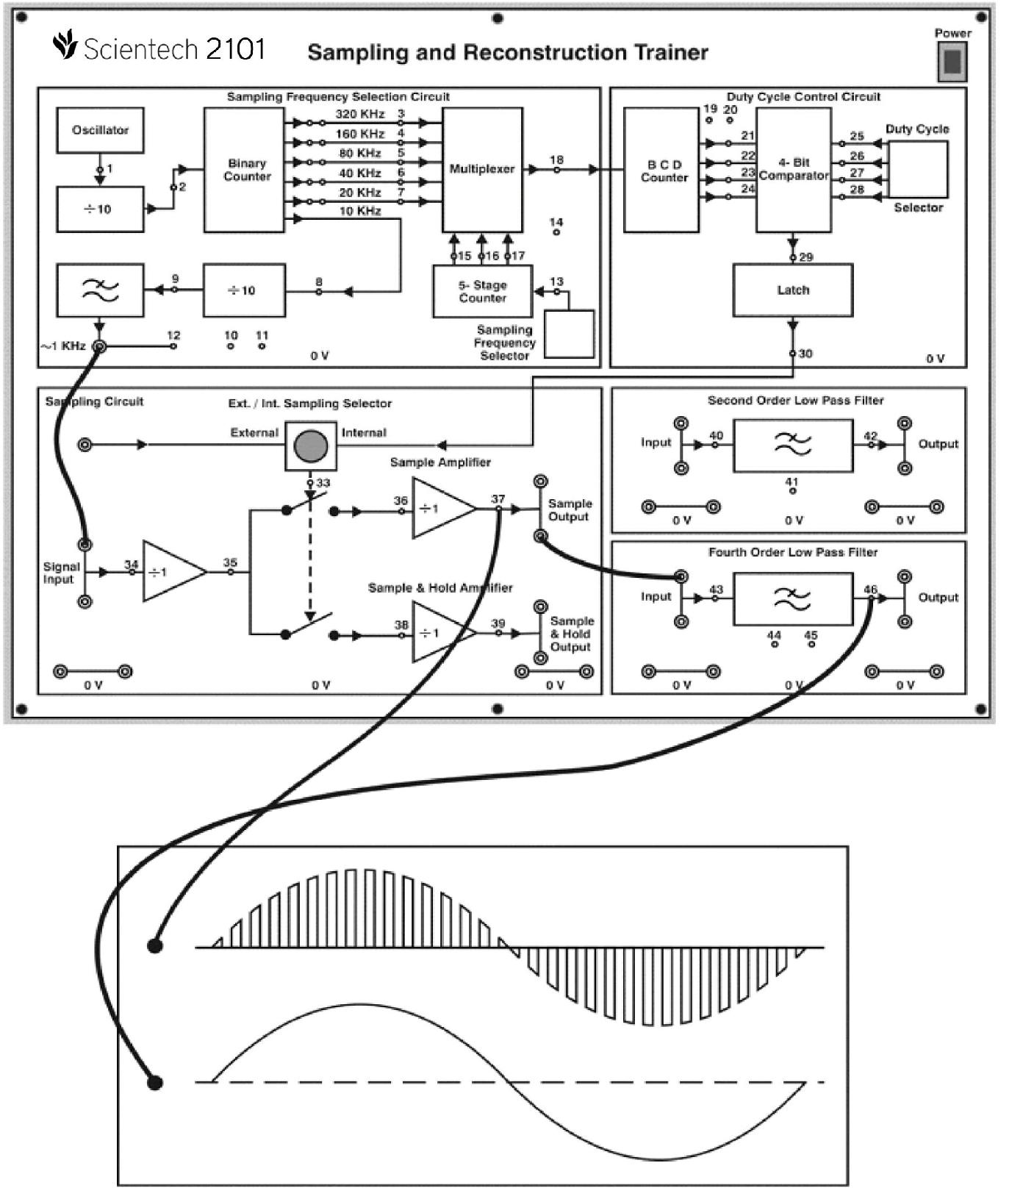

**Signal Reconstruction**

**Figure 1.2**

**Connection Block Diagram: for Sample /Sample and Hold output**

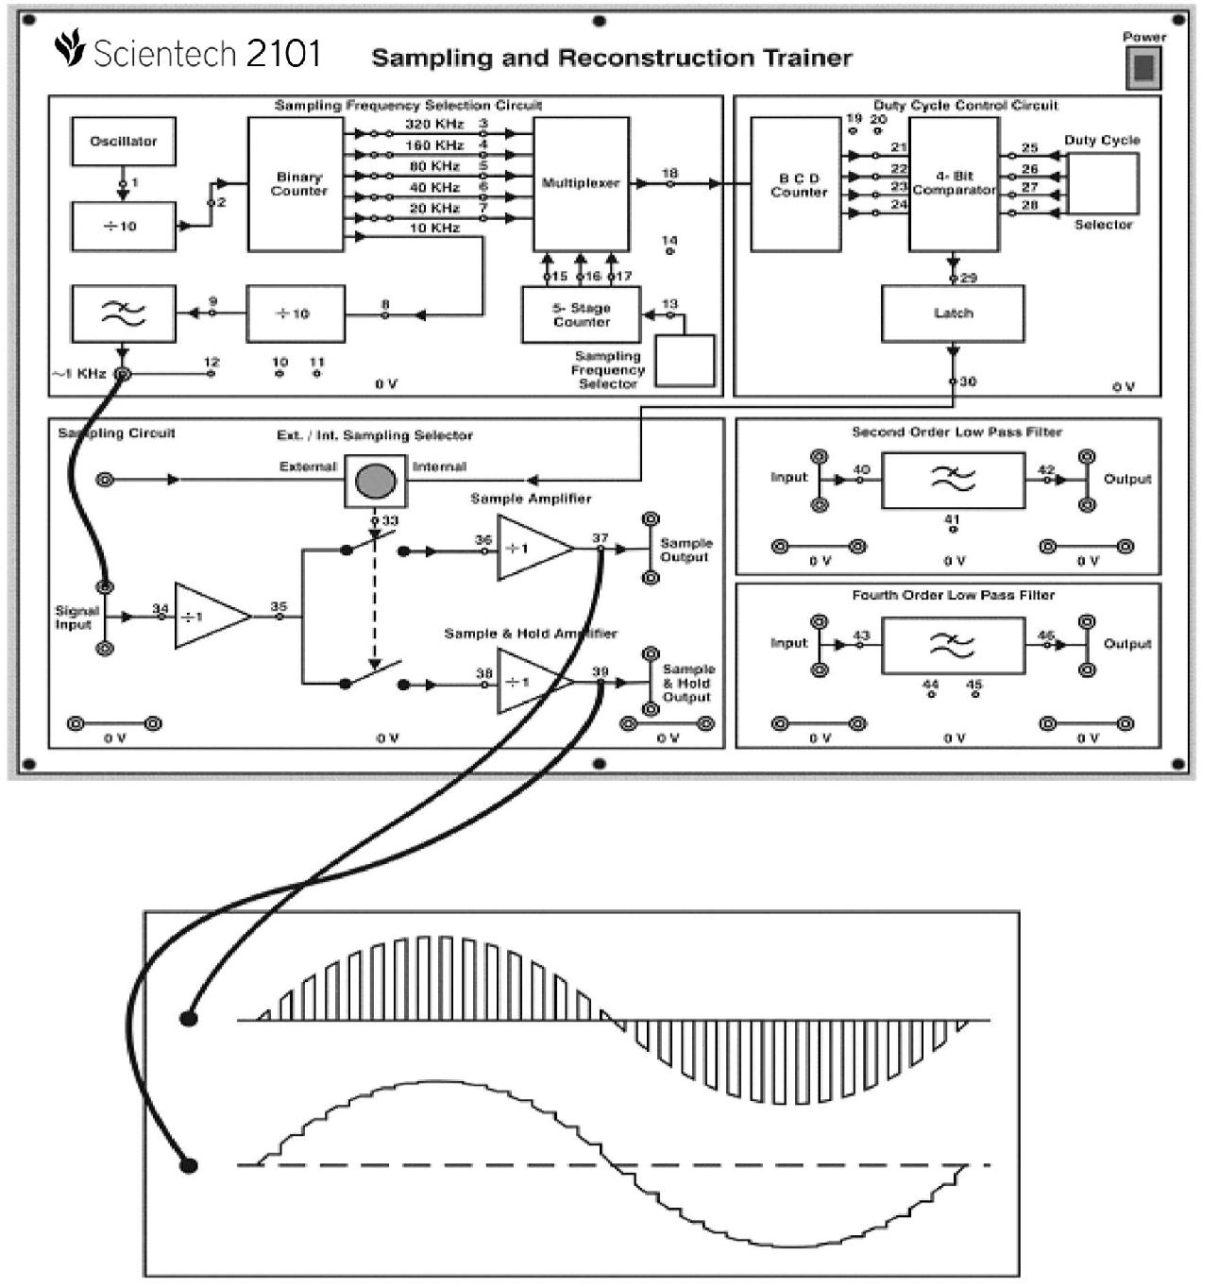

**Sampled O/P and Sample & Hold O/P**

**Figure 2.1**

**Connection Block Diagram**

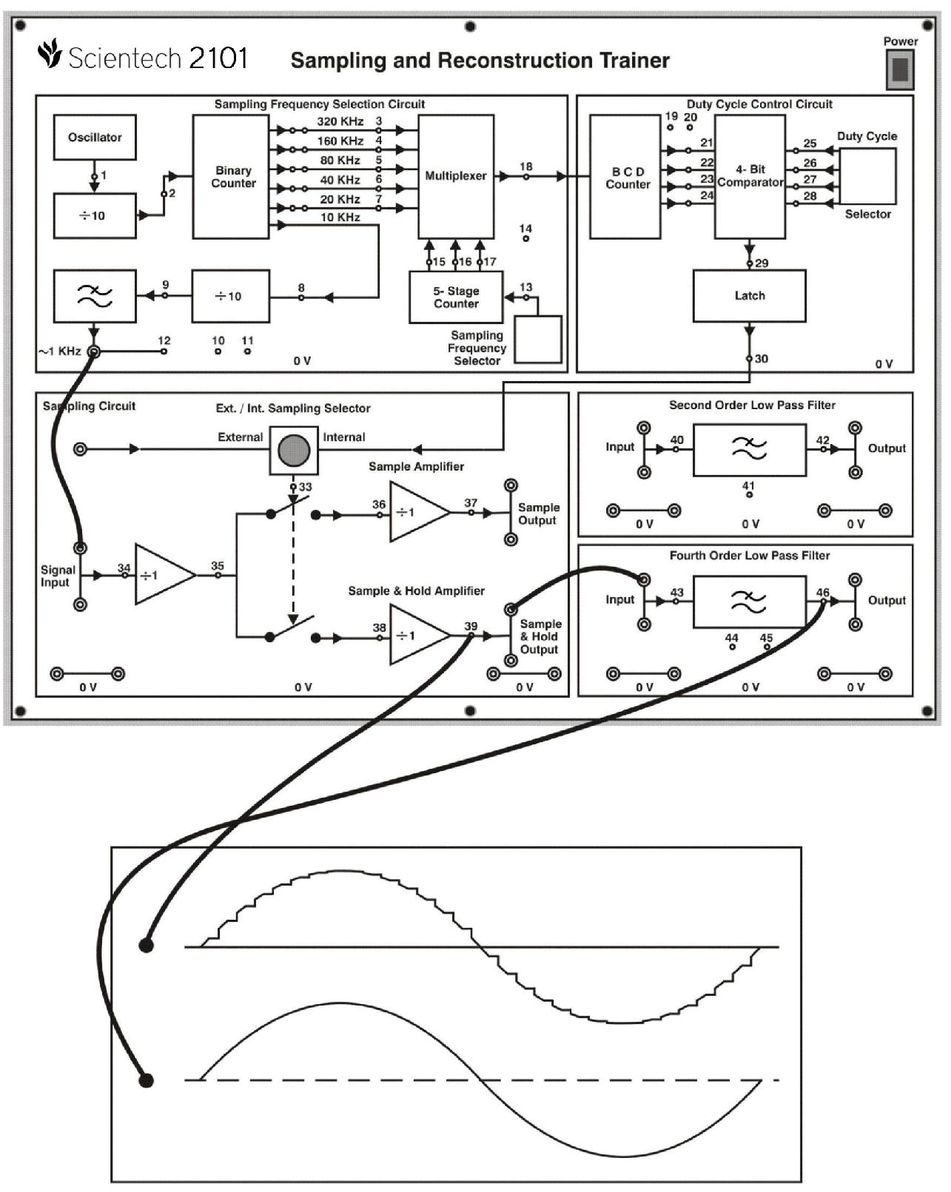

**Sample & Hold O/P**

**& LPF O/P**

**Figure 2.**

**Connection Block Diagram:**

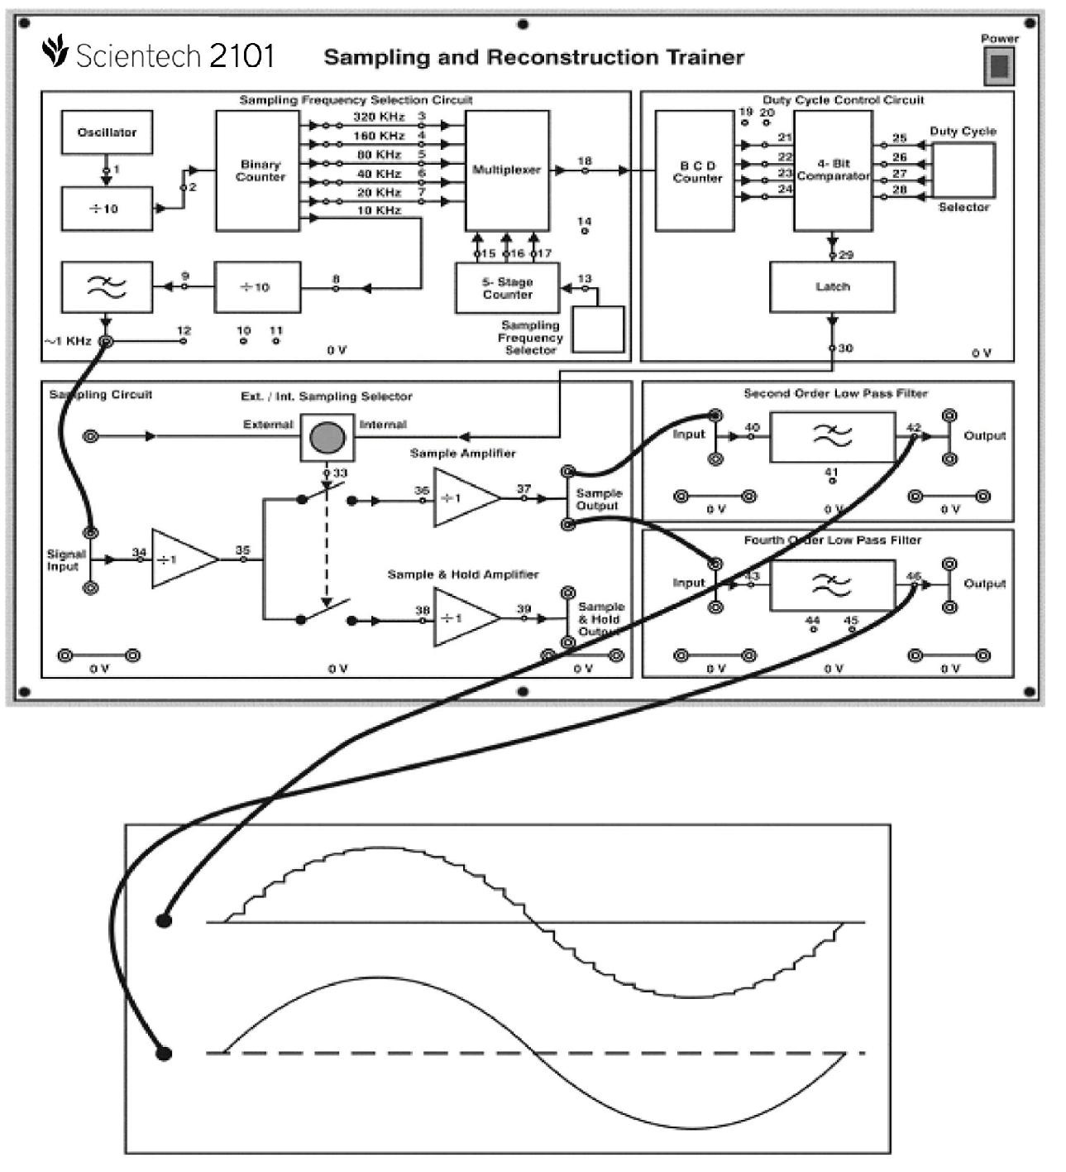

**Low Pass Filter O/P**

**Figure 3.1**

**Frequently Asked Questions**

1. **What do you mean by sampling?**

**Ans:** To convert continuous time signal to discrete time signal, a process is usedcalled as sampling.

1. **What is sampling theorem?**

**Ans:** The Sampling Theorem states that a signal can be exactly reproduced if it issampled at a frequency Fs, where F s is greater than twice the maximum frequency Fmax in the signal.

Fs > 2· Fmax

1. **What is Nyquist frequency?**

**Ans:** The frequency2·Fmaxis called theNyquist sampling rate. Half of this value,Fmax,is sometimes called the Nyquist frequency.

1. **List different sampling techniques?**

**Ans:** There are three types of sampling, which are as follows:

1. Ideal sampling or Instantaneous sampling or Impulse sampling
2. Natural sampling
3. Flat top sampling
4. **What is under sampling?**

**Ans:** When the sampling rate is lower than or equal to the Nyquist rate, a conditiondefined as under sampling, it is impossible to rebuild the original signal according to the sampling theorem.

1. **What do you mean by aliasing?**

**Ans:** Aliasing is the presence of unwanted components in the reconstructed signal.These components were not present when the original signal was sampled. In addition, some of the frequencies in the original signal may be lost in the reconstructed signal. Aliasing occurs because signal frequencies can overlap if the sampling frequency is too low. As a result, the higher frequency components roll into the reconstructed signal and cause distortion of the signal Frequencies "fold" around half the sampling frequency. This type of signal distortion is called aliasing.

1. **Explain the process of sample and hold?**

**Ans:** In electronics, a sample and hold circuit is used to interface real-world signals,by changing analogue signals to a subsequent system. The purpose of this circuit is to hold the analogue value steady for a short time while the converter or other following system performs some operation that takes a little time.

**Sampling mode:**

In this mode, the switch is in the closed position and the capacitor charges to the instantaneous input voltage.

**Hold mode:**

In this mode, the switch is in the open position. The capacitor is now disconnected from the input. As there is no path for the capacitor to discharge, it will hold the voltage on it just before opening the switch. The capacitor will hold this voltage till the next sampling instant.

1. **How aliasing is removed?**

**Ans:** Aliasing is removed by simply filtering out all the high frequency componentsbefore sampling.

1. **List methods to avoid aliasing?**

**Ans:** To avoid the aliasing there are two approaches:

1. To raise the sampling frequency to satisfy the sampling theorem,
2. The other is to filter off the unnecessary high-frequency component from the continuous-time signal. We limit the signal frequency by an effective low pass filter, called anti aliasing pre filter, so that the remained highest frequency is less than half of the intended sampling rate. If the filter is not perfect we must give some allowance.
3. **What are active and passive filter?**

**Ans:** filter is a network designed to pass signals having frequencies within certainbands (called pass bands) with little attenuation, but greatly attenuates signals within other bands (called attenuation bands or stop bands).

A filter network containing no source of power is termed passive, and one containing one or more power sources is known as an active filter network.