Battery troubleshooting knowledge graph
Approach note. Source used: Dell KB article 000123069, "How to Troubleshoot Dell Laptop Battery Issues".

1. The basic idea
A troubleshooting article looks like a long page of text. But when I read it slowly, it is really a set of if/else steps: check this, if you see X do this, if you see Y go to the next step.
I think about it like going from point A to point B when you don't know the road. Point A is the customer's problem, for example "my laptop battery is not charging". Point B is the fix. In between there are many crossroads. At every crossroad we ask one question, and the answer tells us which road to take. If we keep doing that, we reach the fix.
So my job was to read the article, find the crossroads (questions), the roads (answers) and the destinations (fixes), and store them as a graph. That is how I looked at this as a "convert unstructured text into a knowledge graph" problem.

2. Why a graph and not just text search
If the bot only searches the article text, it can find the right page but still mix up the order, skip a step, or give the fix that belongs to a different answer. In a graph the order is decided by the links. The bot can only move from a question to one of its answers, and from that answer to the next step. So it follows the same path a support engineer would follow.

3. How I built it
- Scrape. I scraped the Dell KB page and kept the text, the step lists, the LED colour table and all video and guide links.
- Clean. I removed menus, footers and cookie text, and kept the headings so I always know which section a step came from.
- Extract with an LLM. I gave the LLM the cleaned text section by section, together with the ontology (the list of allowed node types and relationships), and asked it to return nodes and relationships as JSON. Giving it a fixed list stops it from inventing new types.
- Review. I checked the output against the article. Some links are not written in the article but are needed to finish the flow, for example "Is the laptop Intel-based?". I kept those but marked them inferred = true so anyone can see they are my addition.
- Load. I loaded everything into Neo4j with a Cypher script. It uses MERGE, so running it again does not create duplicates.
- Validate. I ran Cypher queries to walk the paths from intent to resolution (section 7).
The final graph has 816 nodes and 1,047 relationships, covering 16 devices.

4. The ontology
I used the same shape as the ontology in my earlier Dell Graph RAG project (the BSOD one): Intent, then Device, then Question, Answer, Question, Answer … until we reach a Resolution.
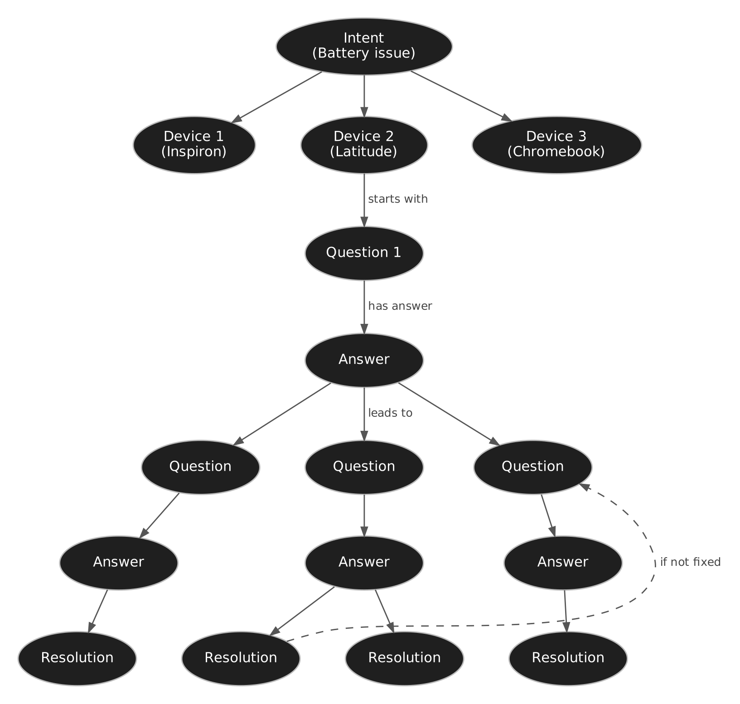
The links are simple:
- Intent HAS_DEVICE Device: which laptops this problem is written for
- Device STARTS_WITH Question: the first question for that laptop
- Question HAS_ANSWER Answer: the possible answers (Yes/No, or options like LED colours)
- Answer LEADS_TO Question or Resolution: this is the if/else
- Resolution IF_NOT_FIXED Question: if the fix did not work, carry on to the next check
There are also three small context links: Vendor MAKES Device, Device COVERED_BY KB article, and Device MODEL_OF Device (a model belongs to a product line).

5. Each node, why I kept it, and what it stores

Intent
When I look at any KB article, it is always about one particular problem: battery issue, no power, touchpad not working, BSOD and so on. That is the intent. It is the first thing the bot has to understand from what the customer types, so it sits at the top.
Stores: name, description, sample_utterances (different ways customers say the same thing), entry_question, links to videos, source_article
Example: "Laptop battery issue", with utterances like "Plugged in, not charging" and "Battery stops charging at 80%".

Device
Every troubleshooting document applies to certain laptop lines or models, and the steps can be different for each. That is why Device comes right after Intent. The bot should start from the customer's actual laptop, not from a general list of steps.
This article lists 16: Inspiron, XPS, Dell Plus, Alienware, G Series, Latitude, Vostro, Dell Pro, Dell Pro Plus, Dell Pro Premium, Dell Pro Rugged, Dell Pro Max, Dell Pro Max 16 XE MC16250, Mobile Workstations, Legacy Laptop Models and Chromebook. I made each one its own node instead of keeping them as a list inside the article.
A good example of why this matters is the Chromebook. It runs ChromeOS, so the BIOS F2 steps, the Windows powercfg commands and the Intel driver update do not apply. Its path is shorter: 7 questions instead of 11 for the Windows laptops.
Stores: name, device_level (product line, model or category), os, vendor

Question
A question is a crossroad. The bot asks it, waits for the answer and then picks the road. Many questions need the customer to do something first (for example open BIOS), so I keep those instructions on the question itself.
Stores: the question text, instructions (what to do before answering), checklist, tool needed, symptom_hint, note, video and guide links, section, device, template_id, inferred
Example: "Does BIOS show the AC adapter with the correct type and wattage?" Instructions: in BIOS open Overview and look at the AC Adapter listing. Video: "Check AC Adapter and Battery Status in BIOS".

Answer
An answer is a road. I made it a separate node and not just a label on the link, because the answer often tells us the cause, and later we want to know which answers customers pick most.
Stores: the answer text, indicates (what this answer means or the likely cause), section, device, inferred
Example: For "Which charge mode is set in BIOS?", the answer "Primarily AC Use" indicates "charge is capped at 50 to 80%".

Resolution
A resolution is the destination, the fix we give the customer. Not every fix works the first time, so a resolution can have an IF_NOT_FIXED link to the next question. That is how the article says "if this didn't help, go to the next section".
Stores: the fix text, step-by-step instructions, commands, expected_outcome, note, video and guide links
Example: "Reset Windows power management settings", with the commands powercfg -restoredefaultschemes, powercfg -h off and powercfg -h on, then restart.

KB article and Vendor
These are for context. The KB article node keeps the article number, URL, version and last modified date, so every answer the bot gives can be traced back to the source.

Metadata on every node
Every node also has source_article and section (where it came from), template_id (the same step across all devices shares one id, so if Dell updates a step I can update all copies together) and inferred (true when the step was not written in the article).

6. Walking through one example
Customer says: "My Latitude stops charging at 80%."
- The bot detects the intent: Laptop battery issue.
- It picks the device: Latitude.
- Question 1: "Have you done the six basic checks?" Customer: Yes.
- Question 2: "Which charge mode is set in BIOS?" The question carries the steps to get there (press F2 while starting, open Power or Battery). Customer: Primarily AC Use.
- That answer leads to the resolution "Change charge mode to Standard".
- If the battery still does not charge fully, the IF_NOT_FIXED link takes the bot to the next question, about the adapter wattage, and the walk continues.
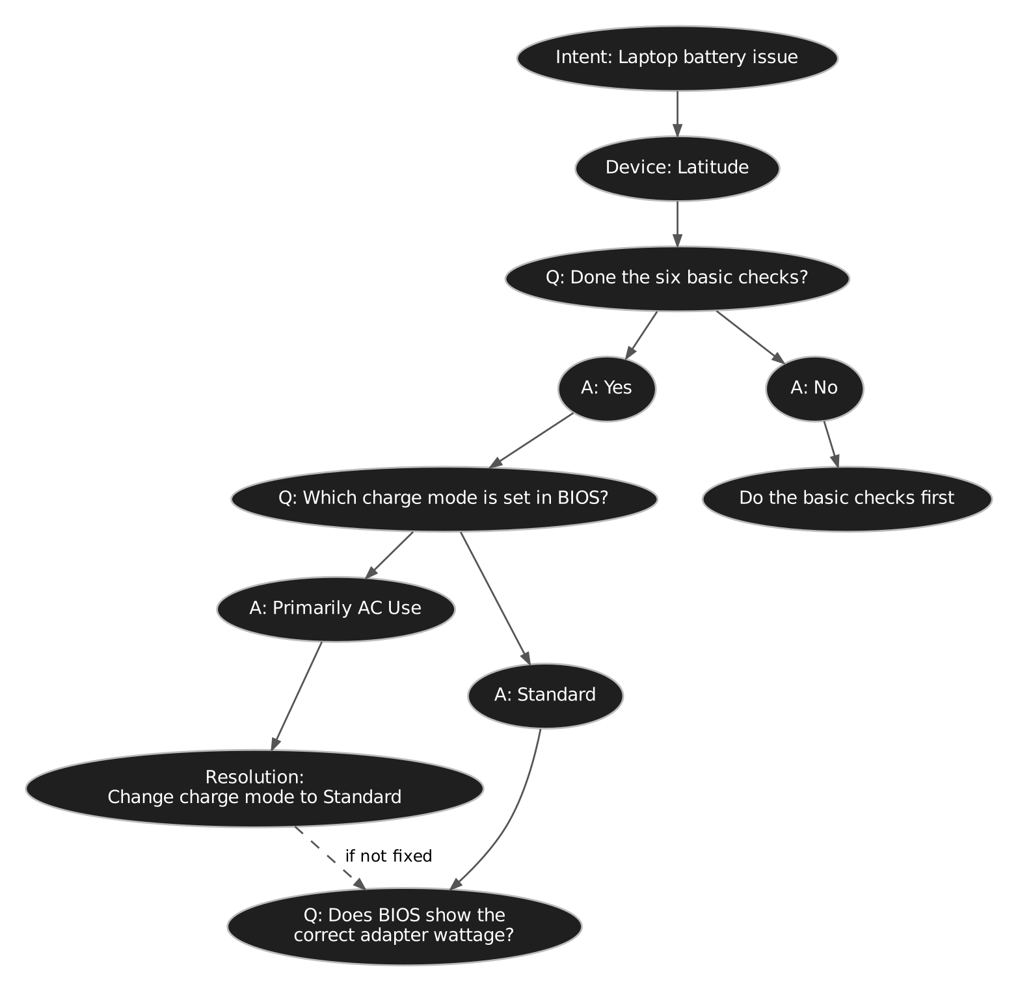

7. How I checked the flow
I ran this query in Neo4j to get every path for one device, from the intent to a resolution:
MATCH p = (:Intent {id:'INT_BATTERY'})-[:HAS_DEVICE]->(d:Device {name:'Latitude'})
-[:STARTS_WITH]->(:Question)
-[:HAS_ANSWER|LEADS_TO*]->(:Resolution)
RETURN p;
It returned 8 paths and every one of them ends in a resolution, so there are no dead ends in the first pass. In short:
- Basic checks not done → do the basic checks first
- Charge mode is Primarily AC Use, Custom, Adaptive or ExpressCharge → change charge mode to Standard (4 paths)
- Mode is Standard, adapter shows unknown or wrong wattage → try a different Dell charger
- Mode is Standard, adapter OK, advanced charge available → configure Advanced Battery Charge
- Mode is Standard, adapter OK, no advanced charge → reset Windows power settings
One thing I noticed: these 8 paths only cover the BIOS part of the article. The later parts (charging LED, Intel driver, battery replacement) are reached only when a fix does not work, through IF_NOT_FIXED. So I also tested longer scenarios with a second query that includes IF_NOT_FIXED and a fixed list of answers, and checks that the walk ends at the expected resolution. I also ran simple checks: each device has exactly one start question, each question has answers, each answer leads to exactly one place, and no path jumps from one device into another.

8. What I would improve next
- Node de-duplication. I have not done de-duplication in this version. Right now the same question or fix can appear inside many device paths. For example, the 15 Windows laptops all have their own copy of "Which charge mode is set in BIOS?". I left it like this on purpose, because one separate path per device is much easier to show and explain in a document. But we can definitely de-duplicate nodes across the whole graph: keep one shared node and only branch where a device is really different, like the Chromebook. This will remove a lot of unnecessary nodes from the database, and there will be only one place to update when Dell changes a step. The template_id I already keep on every node is what makes this easy, because copies of the same step share the same template_id.
- Embeddings. I have not stored embeddings for the text of each node in the metadata for now. Embeddings make the files very large, and it would be hard to share the graph with them inside. In the real project I will add an embedding for each node's text (questions, answers, fixes and sample utterances). That lets the bot match what the customer types to the right intent or question even when the words are different, for example "laptop won't charge past 80" matching "Battery stops charging at 80%".
- More articles. Run the same pipeline on other intents like no power, touchpad and BSOD, so they all live in one graph.

