***Fake News Detection using Ensemble Learning***

Prateek Bhardwaja, Rajat Kumarb, Pushpendra Kumarc, Abhishek Sonid, Preeti Kaure

*Department of Computer Engineering, Netaji Subhas Institute of Technology Delhi, India*

***Abstract***

***With easy access to the internet in today's world, social media is easily accessible. People share lots of content there like blogs, tweets etc. The major concern is sharing news. Shared news spreads at a very fast pace among the people, it can be fake or real. Fake news can create a situation of chaos. So, it is necessary to determine the news as fake or real as fast as possible and take appropriate action. In this paper, we present a novel approach to predict whether a news article is fake or not on the basis of the text and source or the speaker of the news. We propose an ensemble learning based model to detect fake news that has achieved an accuracy of 95% on training and 67.2% on testing on the LIAR dataset.***

# 1.Introduction

The idea of fake news is not developed in recent times. It was used in the past to divert people's attention to fulfill unethical targets. The recent development in technology makes the internet and web easily accessible to everyone which acts as a catalyst to it. In the past, fake news didn't spread easily as there was not so great communication facility but now social media is a great communication channel which spreads the news easily. Fake news can be of a text, image or video. We often see people use Deepfakes to create fake videos and images and share it on social media [7].

There will be very dangerous effects of fake news. It can influence people and create chaos among them. It misleads people down the wrong path. Fake news can destroy images of people, corporations or a whole nation. People will start losing faith in news. It raises trust issues among the people, media and government.

WhatsApp is a live example of how fake news is spread easily and how people get influenced by it [8]. It is also seen that political parties also use fake news to win elections in some parts of the world like the 2016 election in the US [9].

Therefore, we need some kind of system to filter out the fake news. There has been research work done in the past. Alvaro et al. [3] works with psychological features of the news while Agarwal and Dixit [2] uses the speaker's credibility to train and test the model. Goldani et al. [5] uses deep neural networks for the news classification.

In this paper, we bring out an ensemble classification model to classify the news as fake or real. We have used ensemble learning as it considers multiple classifiers before predicting the actual result. It helps to overcome the risk of a bad performing classifier to make predictions alone. We train and test our model on the LIAR dataset [20] using three most popular machine learning models Extra Tree Classifier, Random Forest and Decision Tree. We clean the data, extract the features from text and calculate credibility to train and test our model. We get an accuracy of 95% and 67.2% respectively on training and testing on the LIAR dataset.

**2.LITERATURE REVIEW**

In recent times, there has been a lot of research work done in the field of detecting fake news. One of the recent research projects is the work of Alvaro et al. [3]. They extracted psychological features that help in linguistic analysis. They used a vectorization technique for feature extraction and implemented it using K-Nearest Neighbour and Naive Bayes.

Faustini and Covões [4] have done detection of fake news for multiple languages. They have explored five different datasets for training and testing . For each dataset, they used different methods for feature extraction. At last, each dataset is trained on a different classification algorithm. Support Vector Machines and Random Forest work best.

# Goldani et al. [5] uses deep learning for the classification of news as real and fake. They consider the news statement’s length and other features. They achieved good accuracy only on ISOT dataset.

Arjun et al. [6] used images to extract visual, statistical features and coherence to verify news.

Hakak et al. [1] has classified the fake news using ensemble techniques. They extract the NER features as well as some meta features like number of sentences, words, character etc from news text. They get an accuracy of 100%, 44% on training and testing respectively on LIAR dataset.

Agarwal and Dixit [2] presented the work with different machine learning models and ensemble them at last. It uses the feature called speaker credibility which refers to the probability of the speaker speaking truth or fake news.

In our work, we used an ensemble learning approach which is very efficient as it makes predictions based on predictions of many simple machine learning models. So, it reduces the risk of a poor performing classifier to make solely predictions. Apart from this we have used many features which are not used before like Part of Speech tagging and Dependencies. We also used some of the features present in the past work like name entity recognition, sentiment and speaker’s credibility.

# 3.Dataset

We have explored and identified the LIAR dataset. It is a benchmark dataset for the detection of fake news. It consists of 6 output labels. There is short news with various other information like party, state, job-title about the author, location, count of barely-true, true etc [20]. The distribution of labels of the training dataset is shown in Fig. 1.

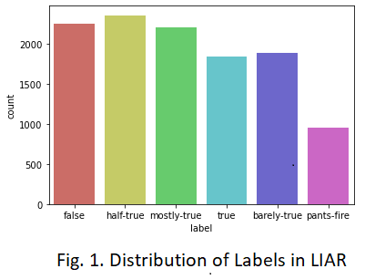

**4.METHODOLOGY**

In the proposed work, we have found multiple features to differentiate between fake and real news. Work is done in several stages from data cleaning, text preprocessing to parameter tuning. These are discussed below,

**4.1 Data Cleaning**

It refers to removing unnecessary data. In our work, we only concentrate on the news statement, speaker and the label. We can remove the rest of the data. We have to take care of Nan values present in the dataset and either remove it or fill it with some value.

# 4.2 Text Pre-Processing

In this stage, we generally remove all the noise from the dataset such as html tags, emojis, URL, punctuation marks, stop words etc. Stemming is also done for root word recognition. Preprocessing is done in the following ways:

● Tokenization: It is the process of breaking sentences into tokens of words. Lowering the word also helps to make all words in the same plane.

● Stop words removal: It refers to the removal of words which appears quite often like a, is etc. We also remove punctuation, URLs, hashtags etc.

● Stemming: It refers to reducing a word to its root. Frequency of derived words are reduced with the help of stemming.

# 4.3 FEATURE EXTRACTION

# We have to extract multiple features from the news statement and the speaker of the news. These features are really helpful as it helps us to

# get the insights of news to train our model efficiently. We have extracted the following features:

***4.3.1 Name Entity Recognition (NER)***

It basically deals with the information extraction and classifying named entities into some pre - defined categories like person, organization, percentage and so forth etc. All these features have given us a brief or quick idea whether a particular document contains the name of a particular person, or it is talking about some organization or event [13].

***4.3.2 Parts of Speech tagging (POS-TAGS)***

Parts of Speech are the grammatical units of language. It assigns the part of speech tag to every word like noun, verb, adjective and many more [13].

***4.3.3 Dependency Parsing***

A dependency tree is a grammatical shape added to a sentence or phrase which delineates the dependency among a word and the phrases it builds upon. Every sentence has a grammatical shape to it and with the help of dependency parsing, we will extract this grammatical structure [13].

***4.3.4 Speaker’s Credibility Score:***

Speaker Credibility Score correlates the speaker with the news that was delivered by them.

Credibility Score is the probability assigned to each unique speaker for each label as the odds with which the speaker delivers the news [2].

***4.3.5 Sentiment Feature Extraction:***

Sentiment feature extraction extracts the positive and negative sentiment of the text. We have used the Vador sentiment [12] to find the appropriate intention present within the textual data.

# 4.4 Model Selection

An ensemble approach is a method to make better predictions on the basis of the predictions of different classifiers [15]. We have chosen three popular classifiers for that, random forest, decision tree with bagging and extra-tree classifier. These classifiers work best for classification problems. The classifiers are described below:

***4.4.1 Random Forest Classifier***

This classifier falls under the supervised techniques. The "forest" built in this algorithm is a culmination of distinct decision trees,which generally uses bagging technique. Random forest increases the result by using a combination of different models. We generally use random forest for both regression and classification problems which simply means that it can solve more than half of the machine learning problems [17].

***4.4.2 Decision Tree with Bagging Classifier***

Bagging (or bootstrap aggregation) is the original perturb and combine method. A bootstrap sample is a random sample from a training data set. For bagging, a bootstrap sample is drawn with replacement. This means that some of the cases might be left out of the sample, and some cases might be represented more than once. When you create an ensemble of bagged trees, large trees with low bias and high variance are ideal, so pruning can be counterproductive. In the bagging method, trees are grown independently of each other, so they can be built in parallel in a distributed computing environment [16].

In Bagging with Decision trees, we generate multiple weak learners that are actually multiple decision trees [18] and at last we combine predictions produced by each weak learner and club them together using voting that is also called Bagging.

***4.4.3 Extra Tree Classifier***

It is one of the machine learning models which uses the ensemble technique which basically uses different different decision trees. Extra Tree can most of the times produce better results than the random forest classifier [19]. The major differences b/w Extra tree classifier and Random Tree Classifier is,

● Extra Tree Classifier does not do sampling with replacement, also called bootstrap aggregation as in the random forest.In this we have created a subset of sample from the input dataset with replacement of dataset. Thus nodes are split on random splits and not on best splits.

● In Extra Tree Classifier randomness is due to the random splitting of the information and not 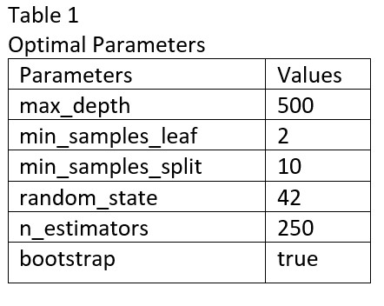due to the bootstrap aggregating.

# 4.5 Parameter Tuning and Training

We have tuned the hyper-parameters to get the optimal parameters which will provide better results. We have used Grid Search for the hyperparameter tuning in order to choose the optimal hyper parameter [14]. For our work, optimal parameters are present in Table 1.

# 

# 5.RESULTS

In this section we are going to describe the results obtained after performing the experiment.From Table 2, we can see that our proposed work gives very good results. Individual features do not provide good accuracy. Speaker Credibility individually comes closer to the proposed one in terms of testing accuracy but it gets very far in training accuracy.

For the final results, from Table 3, we get the maximum testing accuracy of 67.2% in Random Forest while maximum training accuracy is 97.2% in Bagging Decision Tree Classifier.

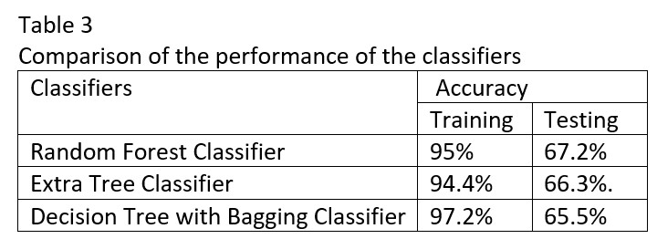

**5.1 Comparison of work with existing works**

Table 4 represents the comparison of the proposed work with prevailing works. It can be observed that the proposed work clearly outshined others at the LIAR dataset. The proposed model obtained 95% and 67.2% accuracy on training and testing respectively.

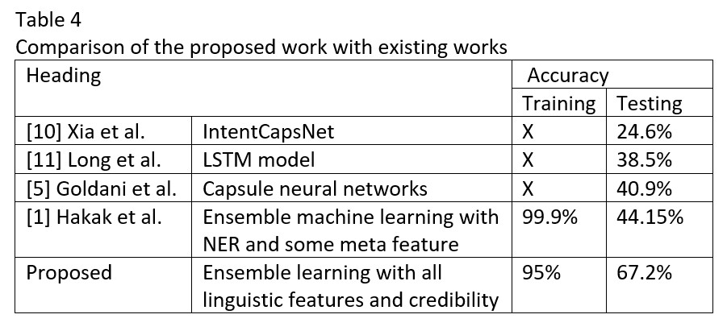

# 6.Conclusion

In this paper, we proposed a fake news detection method. We have used the ensemble machine learning technique by using random forest, decision tree with bagging and extra tree classifier. We have extracted the NER, POS Tagging, Dependencies, Sentiment and speaker credibility features from the dataset to train and test it. Our model achieved better results on the LIAR dataset as compared to others. The model gives an accuracy of 67.2% and 95% on testing and training respectively. In the future work, we will try to reduce the number of features as well as including more datasets.

# 

# 7.References

1. Saqib Hakak, Mamoun Alazab, Suleman Khan, Thippa Reddy Gadekallu, Praveen Kumar Reddy Maddikunta and Wazir Zada Khan, 2021, "An ensemble machine learning approach through effective feature extraction to classify fake news", Future Generation Computer Systems 117.

2. Arush Agarwal and Akhil Dixit, 2020, "Fake News Detection: An Ensemble Learning Approach", COE Engg. Dept. NSUT.

3. Figueira Alvaro and Oliveira Luciana, 2017, “The current state of fake news:chal-´ lenges and opportunities”, Procedia Computer Science, pg 817-825.

4. P.H.A. Faustini and T.F. Covões, 2020, “Fake news detection in multiple platforms and languages”, Expert Syst. Appl. 113503.

5. M.H. Goldani, S. Momtazi and R. Safabakhsh, 2020, “Detecting fake news with capsule neural networks”, arXiv preprint arXiv:2002.01030.

6. Roy Arjun, Basak Kingshuk, Ekbal Asif and Bhattacharyya P ushpak, 2018, “A Deep Ensemble Framework for Fake News Detection and Classification” ArXiv, abs/1811.04670.

7. Thanh Thi Nguyen, Quoc Viet Hung Nguyen, Cuong M. Nguyen, Dung Nguyen, Duc Thanh Nguyen and Saeid Nahavandi, 2021, “Deep Learning for Deepfakes Creation and Detection: A Survey”, arXiv:1909.11573v3.

8. Pooja Khurana, Deepak Kumar and Sanjeev Kumar, 2019, “Research of Fake News Spreading Through Whatsapp”, International Journal of Innovative Technology and Exploring Engineering (IJITEE) ISSN: 2278-3075, Volume-8, Issue- 6S4.

9. Hunt Allcott and Matthew Gentzkow, 2017, “Social Media and Fake News in the 2016 Election”, Journal of Economic Perspectives—Volume 31, Number 2, Pages 211–236.

10. C. Xia, C. Zhang, X. Yan, Y. Chang and P. Yu, 2018, “Zero-shot user intent detection via capsule neural networks”, in: Proceedings of the Conference on Empirical Methods in Natural Language Processing, Association for Computational Linguistics, Brussels, Belgium, pp. 3090–3099.

11. Y. Long, Q. Lu, R. Xiang, M. Li and C.-R. Huang, 2017, “Fake news detection through multi-perspective speaker profiles”, in: Proceedings of the Eighth International Joint Conference on Natural Language Processing, Asian Federation of Natural Language Processing, Taipei, Taiwan pp. 252–256.

12. C.J. Hutto and Eric Gilbert, 2014, “VADER: A Parsimonious Rule-based Model for Sentiment Analysis of Social Media Text”, Association for the Advancement of Artificial Intelli-gence.

13. Mark Neumann, Daniel King, Iz Beltagy and Waleed Ammar, 2019, “ScispaCy: Fast and Robust Models for Biomedical Natural Language Processing”, Allen Institute for Artificial Intelligence, Seattle, WA, USA.

14. Petro Liashchynskyi and Pavlo Liashchynskyi, 2019, “Grid Search, Random Search, Genetic Algorithm: A Big Comparison for NAS”, arXiv:1912.06059v1.

15. Giorgio Valentini and Francesco Masulli, 2002, “Ensembles of Learning Machines”, Conference: 13th Italian Workshop on Neural Nets, WIRN VIETRI 2002, Vietri sul Mare, Italy.

16. Kristína Machová, Miroslav Puszta, František Barčák and Peter Bednár, 2006, “A Comparison of the Bagging and the Boosting Methods Using the Decision Trees Classifiers”, article in Computer Science and Information Systems.

17. G. Biau and E. Scornet, 2016, A random forest guided tour, Test 25 (2) 197–227.

18. T.G. Dietterich, 2002, “Ensemble learning, in: The Handbook of Brain Theory and Neural Networks”, Vol. 2, MIT Press Cambridge, Massachusetts, pp. 110–125.

19. X. Dong, Z. Yu, W. Cao, Y. Shi and Q. Ma, 2020, “A survey on ensemble learning”, Front. Comput. Sci. 1–18.

20. William Yang Wang, 2017, ““Liar, Liar Pants on Fire”: A New Benchmark Dataset for Fake News Detection”, arXiv:1705.00648v1.