QUERY OPTIMIZATION IN
MULTIDATABASE
SYSTEMS

DBMS Seminar Report



Session: 2008-2009

Submitted To: Submitted By:

Dr. S. C. Gupta Harsh Chitlangia
Professor & Head 07/CTA/08
NIC Delhi ME CTA 1st YEAR

DEPARTMENT OF COMPUTER ENGINEERING
DELHI COLLEGE OF ENGINEERING
DELHI UNIVERSITY, DELHI

QUERY OPTIMIZATION IN MULTIDATABASE SYSTEMS

ABSTRACT

A multidatabase system (MDBS) integrates information from autonomous local databases managed by heterogeneous database management systems (DBMS) in a distributed environment. For a query involving more than one database, global query optimization should be performed to achieve good overall system performance. The significant differences between an MDBS and a traditional distributed database system (DDBS) make query optimization in the former more challenging than in the latter. Challenges for query optimization in an MDBS are discussed in this paper. A two-phase optimization approach for processing a query in an MDBS is proposed. Several global query optimization techniques suitable for an MDBS, such as semantic query optimization, query optimization via probing queries, parametric query optimization and adaptive query optimization, are suggested. The architecture of a global query optimizer incorporating these techniques is designed.

1. INTRODUCTION

The main goal of the CORDS (Centre of Research for Reliable Distributed Systems) project is to provide users with an environment for developing distributed applications. The database subproject within CORDS investigates database access for distributed applications. To meet users growing needs for accessing various existing databases managed by heterogeneous DBMSs, global multidatabase services are required in the environment as shown in Figure 1.

Bright, Hurson and Pakzad define a multi -database system (MDBS) as a distributed system that acts as a front end to multiple local (component) DBMSs. The global system provides full database functionality and interacts with local DBMSs at their external user interfaces. A key feature is the autonomy that individual databases retain to serve existing applications.

There are two major approaches to designing an MDBS: global schema and multidatabase language. The global schema approach provides users with one or more global schemas that integrate a number of independently developed local schemas that may be specified in various data models. The multidatabase language approach shifts the burden of integration from global database administrators (DBA) to users and local DBAs. Users are provided with a multidatabase language that has many extended support functions and more control over the information than a standard database language has a well-known MDBS using this approach is MRDSM which provides the multidatabase language MSQL, a multidatabase version of SQL.

The global schema approach is employed to design our MDBS. Our global schema is a set of multidatabase (MDB) views. Each local DBA can export the whole or part of a local schema to the multidatabase as an export schema that is specified in terms of the local data model as shown in Figure 2.

A component schema is a conversion of the corresponding export schema in terms of the global data model that is assumed to be the relational data model in our MDBS. A set of MDB views can be created for a group of users on a cluster of component schemas.

A global user issues a query against his/her MDB views that may refer to data in several component databases. Global query optimization is needed to achieve good overall system performance. An optimal strategy for executing a global query is pursued by a global query optimizer in an MDBS. A global query is decomposed into several component queries that can be executed at

relevant component database systems (DBS). An MDBS agent and component DBMS in a component DBS then perform local query optimization to further improve the performance. Although local query optimization techniques in a component DBMS are provided, many other local query optimization techniques can be devised for an MDBS agent. In particular, when a local data model is different from the global one, the relevant MDBS agent must provide efficient transformations between these two models. Local query optimization in our MDBS will be discussed in a separate paper. This paper focuses on the discussion of global query optimization in our MDBS.

2. CHALLENGES FOR QUERY OPTIMIZATION IN A MDBS

Optimal or heuristic searches join or semi joins, static or dynamic optimization, sequential or parallel execution. Many system environment factors have been considered, such as, network topology (bus, ring, star or tree topology, and broadcast or point-to-point transmission), transmission protocols, communication medium (reflected in the media data rate parameter), host system, data models (relational, network, hierarchical, functional, or object oriented), and data allocation.

Can these query optimization techniques be directly applied to an MDBS? The answer is not obvious, because there are some fundamental differences between a traditional DDBS and an MDBS. These differences raise new challenges for query optimization in an MDBS. The global data model is assumed to be relational. Many results are valid, however, for a no relational data model as well.

A key feature of an MDBS is its local autonomy. Most differences between a DDBS and an MDBS are caused by local autonomy. Veijalainen and Popescu-Zeletin classify local autonomy into three types:
(1) design
(2) communication and
(3) execution.

Design autonomy, which is the major one of the three types, refers to the ability of a component DBS to choose its own design.

Communication autonomy is the ability of a component DBS to decide whether to communicate with other component DBSs. A component DBS with this autonomy can decide when and how it responds to a request from outside. This autonomy complicates the global query optimization in an MDBS, because the response time of a request is not predictable. A component DBS may decide to delay the response to an outside request for an arbitrary amount of time. Therefore, a global query optimizer cannot always rely on the performance parameters of a component DBS to decide query optimization strategies.

Execution autonomy is the ability of a component DBMS to execute local operations without interference from external operations and to set the order in which to execute those operations. A global query optimizer cannot rely on the order of operations in which it submits the operations to a component DBMS. If an operation must precede another operation, the MDBS has to wait for the completion of the first one before it submits the second one. Also, the optimizer cannot predict the response time for an operation, because the order in which operations are executed is not known.
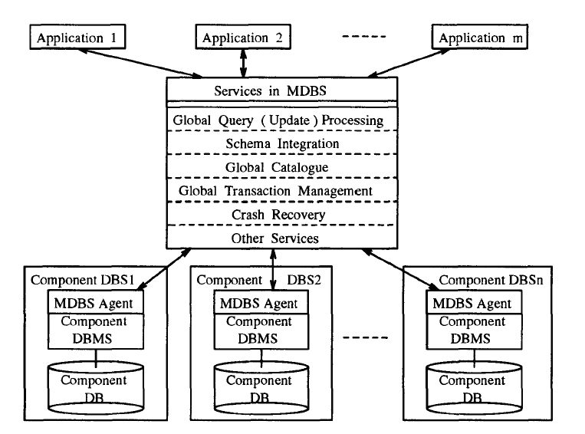
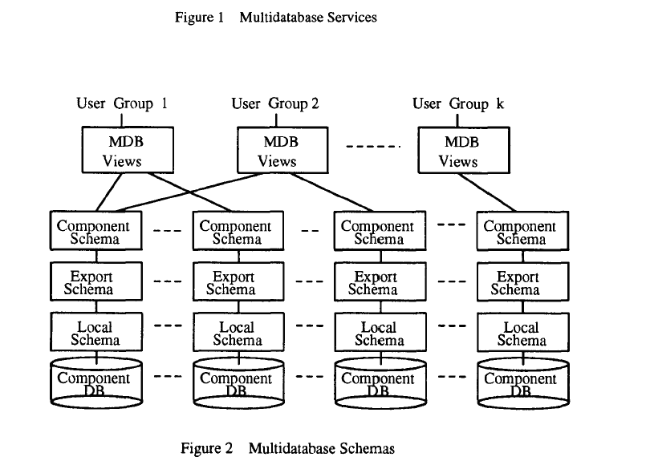

3. QUERY PROCESSING APPROACHES & THE OPTIMIZATION OBJECTIVE

3 .1 Two-Phase Optimization Approach:-

Stored queries and queries that are embedded in application programs are usually executed many times. For such queries, it is worthwhile performing comprehensive query optimization at compile time and simply executes the access plans repeatedly at run time. This approach for processing query is so-called the compilation approach. Another option is the interpretation approach: query optimization is performed on the fly while a query is being executed. Because an access plan is not stored, the same plan may be composed every time the query is executed. This is obviously unnecessary and wastes time. The time for query optimization affects the response time for the query. Simple query optimization is usually performed in this approach. An interactive query is usually executed once. For such a query, the interpretation approach is better than the compilation approach because the latter takes more time creating an optimal access plan that is used only once. In our environment, because we assume that most queries are stored or embedded queries, the compilation approach seems better than the interpretation approach.

The benefits of the compilation approach are moderated, however, in an MDBS environment. Local autonomy allows the functionality and resources of a component DBS to be changed at any time causing invalid access plans to occur more often than in a traditional DDBS at run time. Time spent on recreating access plans increases the response time for queries. Lack of information at the global level at compile time also makes the optimality of a created access plan doubtful. Based on these observations, we propose a two-phase optimization approach for processing a global query in an MDBS:
1. Phase I (compile time): Perform as much query optimization as possible to create a complete global access plan or an incomplete (some execution strategies have not been decided yet) global access plan, if a complete one is not possible, for a query.

2. Phase II (run time): Perform dynamic query optimization to improve a complete global access plan and complete an incomplete global access plan. Perform recompilation for an invalid global access plan to create a new global access plan.

Because incomplete global access plans are introduced when there is not enough optimization information at compile time, the possibility of expensive recompilation for invalid global access plans is reduced greatly. Interpreting an incomplete part of an access plan at run time inherits

the ideas of the interpretation approach. Therefore, the two-phase optimization approach can also be considered as a mixed compilation and interpretation approach. In our MDBS, request and data transformations are done by a data integration subsystem and component MDBS agents.

3 .2 Optimization Objective:-

Before developing optimization procedures, one has to decide on the appropriate objective function. Two common objectives are minimum total cost and minimum response time. The objective of minimum total cost is more appropriate than minimum response time in a multi-user distributed system because of the uncontrolled nature of minimum-response-time access plans; that is, the overall load on the system is likely to grow exponentially as access plans try to minimize response time without regard to resource consumption. This leads the system to an overall degradation in performance. Therefore, the objective of minimum total cost is adopted in our query optimization.

The sampling method may be used to obtain information about the system, such as, startup time, transmission rate, and concurrency control overhead. Such information is stored in a global catalogue. The global query optimizer retrieves such information from it when a cost is evaluated for a global access plan.

4. COMPILE-TIME OPTIMIZATION

4.1 Semantic Query Optimization:-

Local integrity constraints can only be used to maintain the data consistency in an individual component DB. Because different components may represent semantically equivalent or related data, there are some global integrity constraints on interdatabase dependencies and relationships. Although such global (interdatabase) integrity constraints are originally specified for global update operations, the global query optimizer can make use of them to optimize a global query (that is, to perform semantic query optimization). In SQO, the integrity constraints are used to transform a query into another query which is semantically equivalent to the original query and which can be executed more efficiently.

For example, in a multidatabase, there are the following two relations:

EMPLOYEE (Emp#, Name, Position, BasicSalary),
ENGINEER (ID#, Name, Sex, BirthDate, ActualSalary,Address, Speciality,Experience)

that are stored in two component databases DB1 and DB2 respectively. The DB1 and DB2 are located in two different sites A and B. Site A runs a powerful high-speed mainframe, while site B runs a microcomputer. Communication between A and B is expensive. Assume the following inter - database integrity constraints are specified: each engineer is an employee with

(a) Id# = Emp#,
(b) Position = "Engineer", and
(c) ActualSalary = BasicSalary * 1 .15.

When a global user at site A issues the following query,

SELECT Id#, Name, ActualSalary FROM ENGINEER, (2)

the global query optimizer consults the global catalogue to obtain above information about site processing capabilities, communication cost, integrity constraints, and the sizes of the relations. If the size of EMPLOYEE is not much greater than that of ENGINEER, the global query optimizer may transform the Query (2) into the following semantically equivalent query,

SELECT Emp#, Name, BasicSalary * 1 .1 5
FROM EMPLOYEE
WHERE Position = "Engineer”. (3)
Because the query (3) is executed on a faster computer and at the same site as the global user (with no communication), it usually can be processed much more efficiently than the query (2).

4 .2 Query Optimization via Probing Queries:-

The global query optimizer in our MDBS performs global SQO to transform a global user's query into a more efficient and semantically equivalent query. It then produces a global access plan for the transformed query. This global access plan tells the MDBS which part of the query is executed on which component DBS and how to integrate the intermediate results to produce the final results at run time. How to create a good global access plan for a query is the main task of the global query optimizer.

As mentioned in Section 2, the benefits of the semijoin strategy are reduced greatly in an MDBS environment. Even in a DDBS environment, the semijoin strategy is not always beneficial. The join strategy, therefore, is adopted in our MDBS.

If a global query retrieves data only from one component database, the global access plan is very simple: send the query to the corresponding component DBS for execution. If a global query retrieves data from several component databases, there usually are many ways to execute the query. For example, assume the query R1 R2 R3 is issued at site 0 ( denotes the natural join), where Ri is a relation in the component DBi at site i (i = 1, 2, 3). The following are three feasible global access plans to execute it:

Access Plan 1: Transfer R1 to site 2 and perform R1 R2 at site 2. Send the result to site 3 and perform (R1 R2) R3 at site 3. Send the result to site 0.
Access Plan 2: Transfer R3 to site 2 and perform R2 R3 at site 2. Send the result to site 1 and perform R1 (R2 R3) at site 1. Send the result to site 0.
Access Plan 3: Transfer R1, R2 and R3 to site 0 and perform R1 R2 R3 there.

These three global access plans can be represented by the trees (a), (b) and (c) as shown in Figure 3 respectively. There still are many other possible global access plans. The global query optimizer tries to select an optimal one from many possibilities. Whether one is good or not depends on many factors, such as, amount of data transferred the transmission rate of the network, and local processing capabilities and speeds. These factors have been modeled into the cost function (1).

Using cost function (1), the total cost of Access Plan 1 in the above example is
Where |R| is the size of the relation R. The global query optimizer selects a global access plan with minimal total cost if the solution space is not too large. Otherwise, the query optimizer may use heuristic rules to reduce the solution space, and select the minimal-cost global access plan in the remaining solution space.
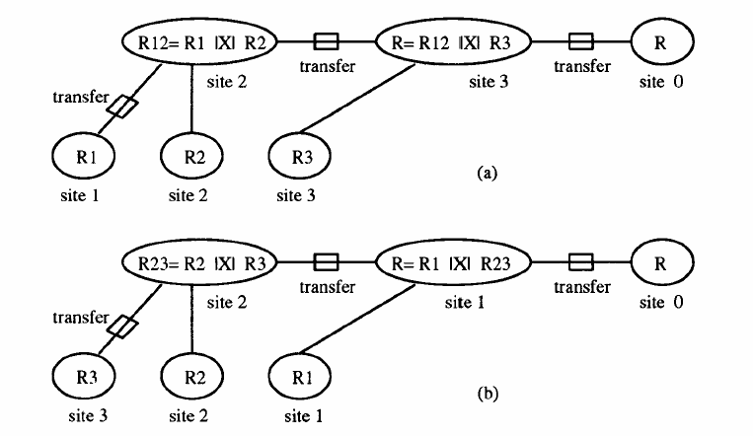
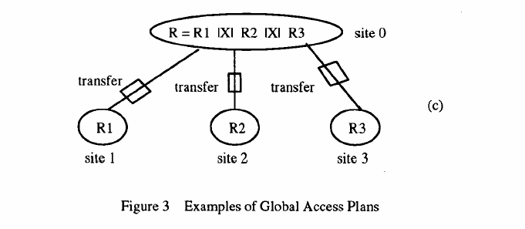
5. RUNTIME OPTIMIZATION

5.1 Parametric Query Optimization:-

At compile time, the global query optimizer may produce an incomplete global access plan or a poor complete one. This is because some information was not available at compile time. There are two types of such information: the runtime values for the parameters of a query; and the intermediate results and dynamic system characteristics. Making use of these two types of information to improve query processing gives us two types of runtime query optimization.

Q(x) = SELECT * FROM R
WHERE R.a >: x,

Where R is a relation and x is a host variable. The values of these variables (parameters) are not known until run time. Using the values of the parameters of a query at run time to improve the query processing is called Parametric query optimization (PQO).

5 .2 Adaptive Query Optimization:-

Although runtime parameter values for a query are only known at run time, they are known before the query is executed. Another type of runtime information, for example, intermediate results and dynamic system characteristics, is known during the execution of the query.

If a complete global access is detected to be invalid at run time, the global query optimizer recompiles the query to create a new valid access plan. If a complete access plan is detected to be far from optimal during its execution at run time, some adjustments of the unexecuted part of the access plan should be made to improve the performance. This situation may happen because:

(1) Inaccurate cost estimates may be used in creating the global access plan,
(2) Dynamic characteristics of the system, such as, system and communication loads,

were not available at compile time. For an incomplete access plan, the global query optimizer must complete the access plan at run time by using updated runtime information. Using such runtime information to improve or complete an access plan is Adaptive query optimization (AQO).

As an example, consider the global access plan (a) in Figure 3. If R12 = R1 R2 is executed in site 2 and if the |R12| is much larger than the prior estimate, the global query optimizer needs to check the goodness of the global access plan and probably replace it with the global access plan in Figure 4 if 1R31 is small and if local processing costs are almost the same at site 2 and site 3. Figure 5 shows an example of incomplete global access plans. In this global access plan, whether sending R12 to site 3 to perform the final join there or sending R3 to site 2 to perform the final join there is undetermined.

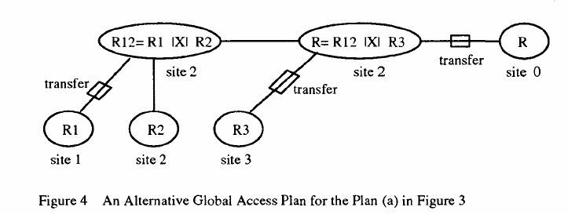

One reason for this may be that it is impossible or too expansive to estimate |R12| at compile time. Once R12 is computed at run time, the global query optimizer can complete the rest of the global access plan by using runtime information.

6. ARCHITECTURE OF THE GLOBAL QUERY OPTIMIZER

At compile time, when the MDBS receives an SQL query from a global user, the Parser (P) checks the syntax and semantics of the query using the schema information provide d by the Global Catalogue (GC) subsystem. The Semantic Query Optimization (SQO) module then optimizes the query using interdatabase integrity constraints stored in the global catalogue. The original query may be transformed into a more efficient and semantically equivalent query. For the transformed query, the Processing Strategy Analyzer (PSA) obtains necessary optimization information from the global catalogue and may perform some probing (test) queries. Using the information, the Processing Strategy Analyzer analyzes several alternative strategies for processing the query to select a good one from them based on a cost model and on heuristic rules. This processing strategy includes the major decisions about how to transform data among component DBSs, where to execute join operations and so on. According to the processing strategy, the Access Plan Generator (APG) produces and sends the component queries for the given query to relevant component DBSs for local query optimization (such as, local semantic query optimization done by MDBS agents in component DBSs and local query optimization done by component DBMSs) . A detailed global access plan for the query is then created by the Access Plan Generator. All global access plans for queries are managed by the Global Access Plan Manager (GAPM) for later use.

At run time, when the MDBS receives an execution request for a query, the Execution Coordinator (EC) asks for the global access plan from the Global Access Plan Manager. The latter first checks the validity mark for the global access plan (some invalid global access plans may, however, only be known during its execution). If the global access plan is invalid, the global query optimizer produces a new valid global access plan. Based on the global access plan, the Execution Coordinator coordinates and monitors the data transmissions among component DBSs and local executions at component DBSs. The Execution Coordinator returns some runtime information to the Run-Time Optimizer (RTO) which performs parametric and adaptive query optimization using the information. An improved or completed global access plan is then passed to the Execution Coordinator for further execution. The results of the query are passed to the user's application by the MDBS agent of the component DBS at the result site under the guidance of the Execution Coordinator.

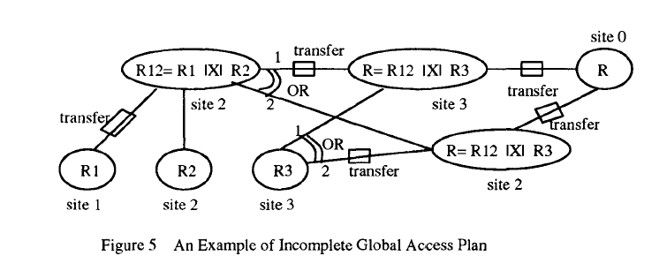

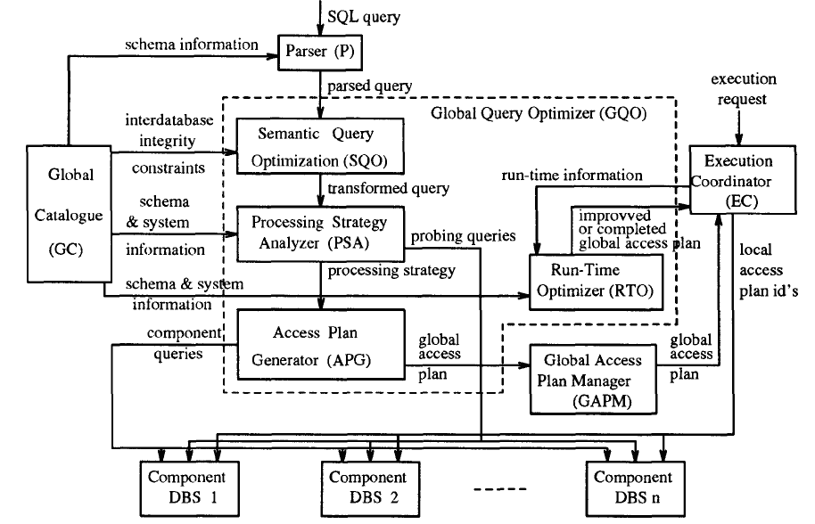

7. CONCLUSION:

Multidatabase systems (MDBS) have attracted more and more researchers recently. A key feature of an MDBS is its local autonomy. Autonomy makes query optimization in an MDBS different from that in a traditional distributed database system (DDBS).

This report discussed the challenges for query optimization in an MDBS that are caused by different types of autonomy, such as, design autonomy, communication autonomy, and execution autonomy.

Stored queries and queries that are embedded in application programs are usually executed many times. For such queries, it is worthwhile performing comprehensive query optimization at compile time and simply executes the access plans repeatedly at run time. This approach for processing query is so-called the compilation approach. Another option is the interpretation approach: query optimization is performed o n the fly while a query is being executed. Because an access plan is not stored, the same plan may be composed every time the query is executed. This is obviously unnecessary and wastes time. The time for query optimization affects the response time for the query. Simple query optimization is usually performed in this approach. An interactive query is usually executed once. For such a query, the interpretation approach is better than the compilation approach because the latter takes more time creating an optimal access plan that is used only once. In our environment, because we assume that most queries are stored or embedded queries, the compilation approach seems better than the interpretation approach.

The benefits of the compilation approach are moderated, however, in an MDBS environment. Local autonomy allows the functionality and resources of a component DBS t o be changed at any time causing invalid access plans to occur more often than in a traditional DDBS at run time. Time spent on recreating access plans increases the response time for queries. Lack of information at the global level at compile time also makes the optimality of a created access plan doubtful. Based on these observations, we propose a two-phase optimization approach for processing a global query in an MDBS:
1. Phase I (compile time): Perform as much query optimization as possible to create a complete global access plan or an incomplete (some execution strategies have not been decided yet) global access plan, if a complete one is not possible, for a query.

2. Phase II (run time): Perform dynamic query optimization to improve a complete global access plan and complete an incomplete global access plan. Perform recompilation for an invalid global access plan to create a new global access plan.

