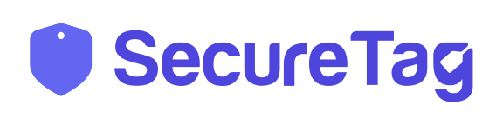
SecureTag
Complete User Guide
How to use your SecureTag sticker — for owners and for anyone who scans it

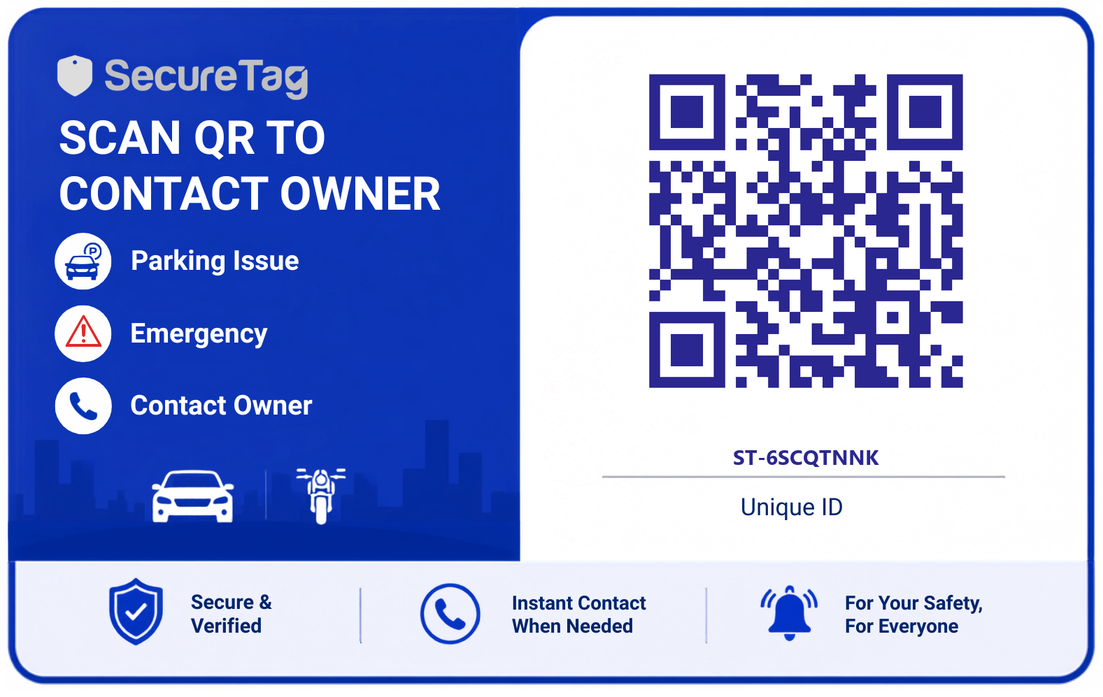
Your SecureTag sticker — the QR code links straight to your car's contact page

A simple, step-by-step guide in plain language.
No technical knowledge needed.

What's in this guide
1. What is SecureTag?
2. What's in the box
3. Sticking your SecureTag on your vehicle
4. Setting up your tag the first time it's scanned (First Scan)
5. What happens when someone else scans your tag later (Regular Scan)
6. Emergency and accident scans (faster, automatic sharing)
7. Turning on Lost Mode
8. If you decide not to share your contact
9. Editing your details later
10. Frequently asked questions
11. Safety and privacy — good to know

1. What is SecureTag?
SecureTag is a small sticker you put on your car or bike. It has a QR code on it. If someone needs to reach you — because your car is blocking them, there's an emergency, or they simply found your vehicle — they just scan the code with their phone camera. No app to download. Your phone number is never shown publicly — it is only shared after you say yes.
In short:
Scan the code → Owner is instantly notified → Owner allows contact → Caller can call you.
Your number stays private the whole time, unless you choose to share it.

Why this is useful
- Someone can reach you immediately if your vehicle is blocking a road or driveway.
- In an accident or emergency, help can reach you (or your emergency contact) within seconds.
- You never have to print or share your personal phone number in public.
- You stay in control — you choose whether to accept each request.

2. What's in the box
Each SecureTag comes as a printed card / sticker like the one below. Every tag has its own unique QR code and ID number — no two tags are the same.

Example SecureTag. The QR code and the ID (e.g. ST-6SCQTNNK) are unique to your tag.
Points to check
- Make sure the QR code isn't scratched, torn, or covered — it needs to scan cleanly.
- Note down your tag's unique ID (printed under the QR code) somewhere safe, in case you need support.

3. Sticking your SecureTag on your vehicle
Before you register the tag online, place it somewhere it can be easily seen and scanned.
- Clean the surface where you'll stick it (windshield corner, rear windscreen, or body panel) with a dry cloth.
- Peel the backing off the sticker.
- Press it firmly onto the clean, dry surface. Avoid curved or textured areas — the QR code needs to stay flat so phone cameras can read it.
- Wait a few minutes before touching it again, so it sticks properly.
Tip:
Popular spots are the rear windshield (inside, facing out), the bumper, or the fuel-tank area for two-wheelers. Pick a spot that stays visible and dry.

4. Setting up your tag (First Scan)
The very first time your SecureTag is scanned, it won't have any information on it yet. This first scan should ideally be done by YOU, the owner, right after sticking the tag on — this is how you register your details against that tag.
Step 1 — Scan the QR code
Open your phone's camera app and point it at the QR code on the sticker. Tap the link/notification that pops up. This takes you to your tag's page in your phone's browser — no app needed.
Step 2 — You'll see "Activate this tag"
Since this tag hasn't been registered by anyone yet, you'll see a screen asking you to activate it.
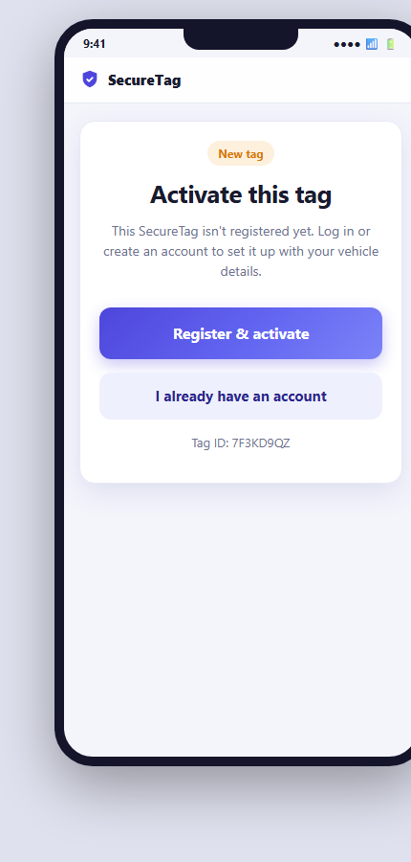
First scan on a new tag: you're asked to register or log in.
- Tap "Register & activate" if this is your first time using SecureTag.
- Tap "I already have an account" if you've registered a tag with SecureTag before.
Step 3 — Create your account
Enter your email address and choose a password (at least 6 characters). This account lets you manage all your SecureTags and see requests from people who scan them.
Step 4 — Fill in your details
After logging in, you'll see the registration form. Fill in your information so that people who scan your tag can reach you.
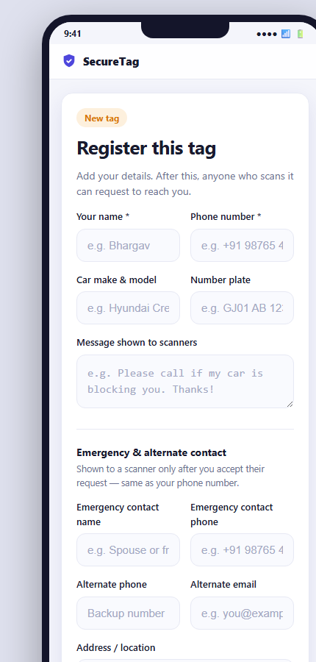
The registration form — fields marked * are required.
Fields explained
- Your name * — shown to the person calling you, so they know who they're speaking to.
- Phone number * — the number that will ring when someone's request is accepted.
- Car make & model — e.g. "Hyundai Creta" (optional, but helpful).
- Number plate — helps confirm it's the right vehicle (optional).
- Message shown to scanners — a short note people see before contacting you, e.g. "Please call if my car is blocking you. Thanks!"
- Emergency contact name & phone — a trusted person (spouse, family, friend) who can be reached if you can't be, especially during accidents or emergencies.
- Alternate phone / email — backup ways to reach you.
- Address / location — your home or usual parking address (optional).
Good to know:
Your emergency and alternate contact details are private too. They are only shown to a scanner after you accept their request — treated exactly the same as your main phone number.

Once you're happy with the details, tap "Activate this tag". That's it — your tag is now live!

5. What happens when someone scans your tag later
Once your tag is registered, anyone who scans it afterwards (a stranger, security guard, another driver, etc.) sees a different screen — they are guided through a short request process, and your phone number is only revealed once you approve it.
Step 1 — They scan the code
Same as before: point the phone camera at the sticker and tap the link that appears.
Step 2 — They pick a reason
The scanner is shown a simple screen asking why they need to reach you. They tap one reason, can add a short note, and then send the request.
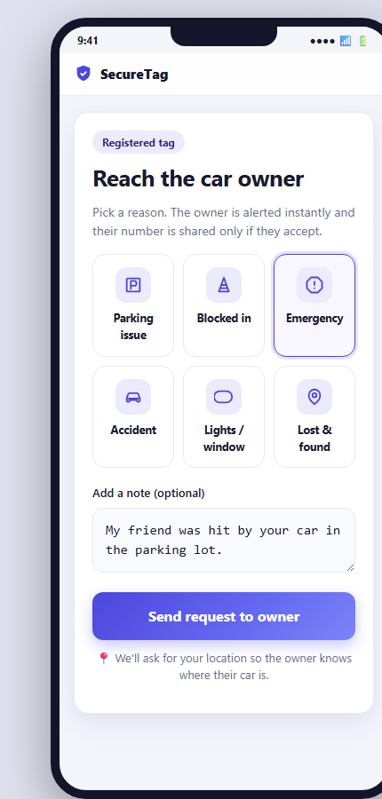
The scanner picks a reason (Parking issue, Blocked in, Emergency, Accident, Lights/window, Lost & found) and can add a note.
The reasons available are:
- Parking issue — they need you to move your car.
- Blocked in — your vehicle is blocking theirs.
- Emergency — urgent situation needing immediate contact.
- Accident — your vehicle may be involved in an accident.
- Lights / window — e.g. you left your lights on or a window open.
- Lost & found — they found your vehicle (e.g. reported missing/lost).
The scanner is also asked to allow their phone's location, so you know where your car is when you get the alert. They can skip this if they prefer — the request still goes through.
Step 3 — You get notified, and they wait
As soon as the request is sent, you (the owner) are alerted. The scanner sees a waiting screen and your phone number is NOT shown to them yet.
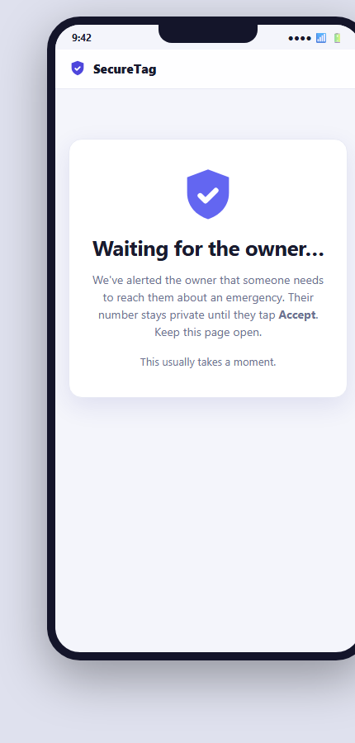
The scanner waits here. Your number stays private until you respond.
Step 4 — You accept or decline
You will get an alert about the request (through your SecureTag account/notification). You can choose to Accept (share your contact) or Decline (keep it private).
Step 5a — If you Accept: contact is shared, and a call starts automatically
The moment you accept, the scanner's screen instantly shows your contact card with your name, phone number, and vehicle details (whichever you filled in). Their phone's dialer opens automatically to call you — they don't even need to tap the call button, though it's there if needed.
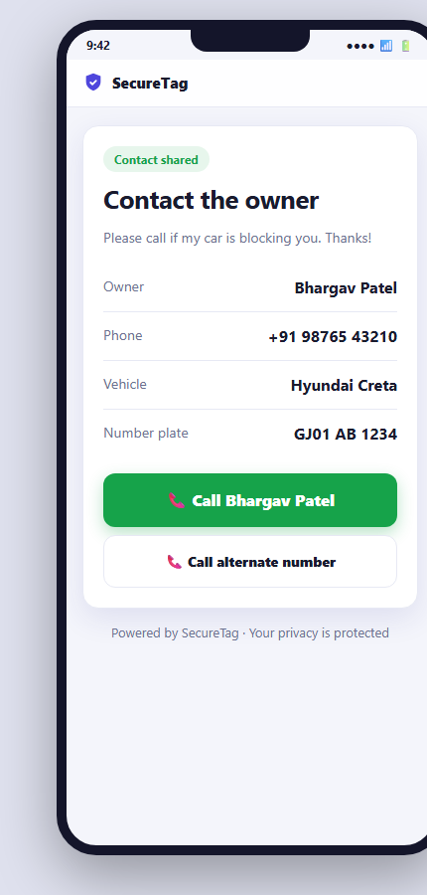
What the scanner sees once you accept: your contact details and a big green Call button.
Step 5b — If you Decline: they're told to contact local authorities
If you decide not to share your details for this request, the scanner sees a polite message instead — your information stays completely private.
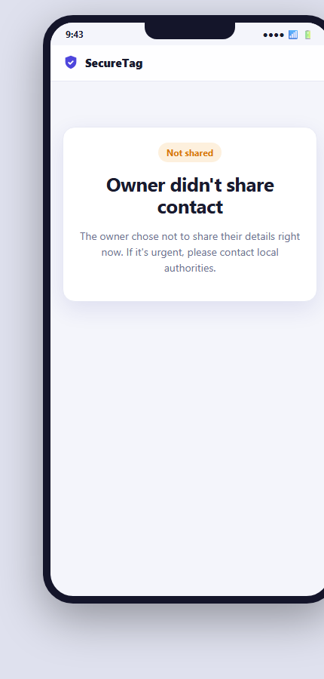
What the scanner sees if you decline the request.

6. Emergency and accident scans
For the two most urgent reasons — Emergency and Accident — SecureTag skips the waiting step. There is no need for you to tap Accept. The moment the scanner picks one of these reasons and sends the request, their screen immediately shows the contact card.
Why this is different:
In a genuine emergency, waiting for the owner to respond could cost precious time — and the owner involved in the accident may not even be able to respond. So SecureTag shares contact details right away for these two reasons.

Who gets called first, and why
Because the vehicle's owner might be the person who is hurt or unavailable, SecureTag doesn't dial the owner's own number first for Emergency/Accident. Instead, it tries in this order:
- Alternate phone number (a backup number you provided)
- Emergency contact (the trusted person you named — e.g. spouse, family member, friend)
- Your own phone number (used only if no alternate/emergency contact was provided)
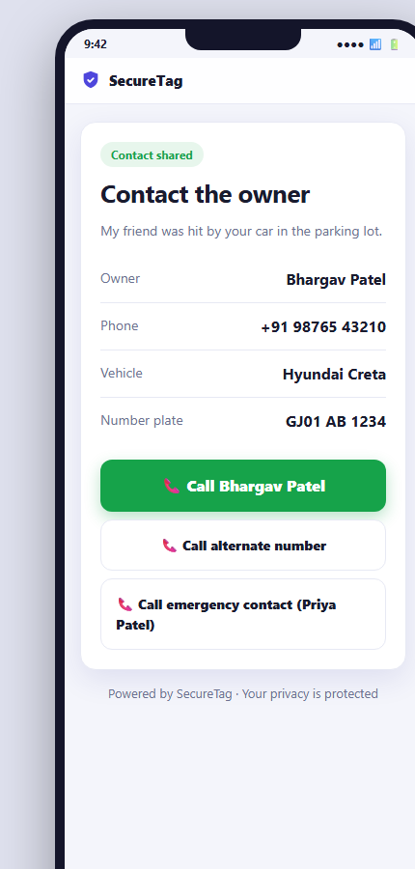
Emergency/Accident contact card — shown instantly, with the alternate and emergency-contact call buttons.
This is exactly why filling in an emergency contact matters:
Add a trusted person's name and number when you register your tag — it could make all the difference if you're ever in an accident and can't answer your own phone.

7. Turning on Lost Mode
If your vehicle ever goes missing, you can turn on "Lost Mode" from your own tag page (open your tag's link while logged in, and tap "Turn ON Lost Mode").
What changes when Lost Mode is on
- Anyone who scans your tag instantly sees your contact details — no waiting for you to accept.
- The scanner is also shown a "Share my location" button, so if a good samaritan finds your vehicle, they can send you their GPS location with one tap.
Remember to turn it off:
Once your vehicle is found, go back to your tag page and tap "Turn OFF Lost Mode" so future scans go back to the normal request-and-accept process.

8. If you decide not to share your contact
You are always in control for non-emergency requests (Parking issue, Blocked in, Lights/window, Lost & found). If a request doesn't feel genuine, or you simply can't respond right now, you can decline it and your details stay private. The scanner is told to contact local authorities if the matter is urgent.

9. Editing your details later
Your details are not permanent — you can update them any time. Log into your SecureTag account, open your tag, and tap "Edit details" to change your name, phone number, vehicle info, message, or emergency contacts. Changes apply immediately to future scans.

10. Frequently asked questions
Q: Does the person scanning need to install an app?
A: No. Scanning works with any phone's regular camera app. It opens a normal web page — nothing to download or install.
Q: Will my phone number be visible to everyone who scans my tag?
A: No. Your number is private by default. It's only shown to a specific scanner after you accept their request (or automatically for Emergency/Accident reasons, or while Lost Mode is on).
Q: What if I don't respond to a request?
A: The scanner will simply keep waiting on their screen. If it's genuinely urgent, they're advised to contact local authorities instead.
Q: Can I have more than one SecureTag (for multiple vehicles)?
A: Yes. Each tag has its own unique QR code and ID, and you can register each one separately under the same account.
Q: What happens if I lose access to my account?
A: Contact SecureTag support with your tag's unique ID (printed under the QR code) for help recovering access.
Q: Does this drain my phone's battery or need internet at all times?
A: No constant connection is needed. The tag itself needs no power — it's just a printed QR code. Your phone only needs internet briefly when someone scans it and you respond.

11. Safety and privacy — good to know
- Your phone number and personal details are never printed on the sticker itself — only the QR code and a random ID.
- Every request needs your approval before your contact is shared, except Emergency, Accident, and while Lost Mode is on (by your own choice).
- You can decline any non-emergency request with no consequence.
- You can edit or remove your details at any time from your account.
- Adding a trusted emergency contact is strongly recommended — it ensures someone can always be reached on your behalf during accidents.

Powered by SecureTag · Your privacy is protected

