The following are plots to various k values in multiples of 5 ranging from 5-45

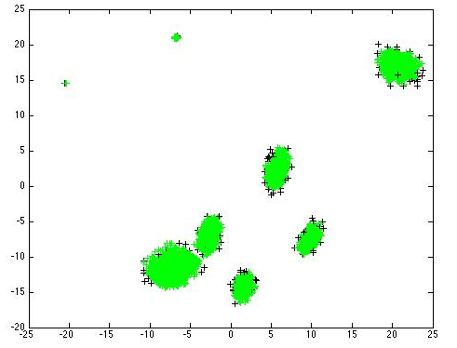

here k=5



k=15



k=25



k=35

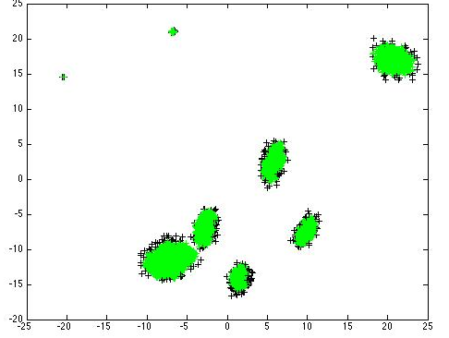

k=45