Algorithms and approaches for Emotion Perception: A comprehensive study of challenges and solutions

Chandra Sekhar S  
B.E, Computer Science and Engineering  
BMS Institute of TechnologyBangalore, India  
chandrasshekar03@gmail.com

Bhargav Sagiraju   
B.E, Computer Science and Engineering  
BMS Institute of TechnologyBangalore, India  
bhargavsagiraju@gmail.com

Dr. Thippeswamy G

Professor, Dean (Academics)

BMS Institute of Technology

Yelahanka, Bangalore-64 swamy.gangappa@gmail.com

Adarsh Kumar Sah   
B.E, Computer Science and Engineering  
BMS Institute of TechnologyBangalore, India  
adarshkumar.sah6@gmail.com

***Abstract*– The system which perceives emotion is the one with the capacity to learn from experience, connectivity, security, the ability to adapt according to current data and the capacity for remote monitoring and management. Such systems incorporate functions of sensing, actuation, and control to describe and analyses a situation. One can make use of this knowledge-based system to achieve their goals. The expressive ability emotions using human face is one of the most natural ways of communicating our emotions next to speech and text. Hence, the motivation to develop an intelligent system by adding the elements of human emotion using advanced learning algorithms become today’s necessity.**

**Observation of emotions through sensors acts upon an environment using actuators and directs its activity towards achieving goals is based on human Computer Interaction. The natural variation in human’s emotion requires the classification algorithm to distinguish the smaller features from the large pool of input features. Analyzing and computing such behavior is achieved through Reinforced Learning, which allows the system to make calculated decisions. Acquiring, interpreting and organizing information of human emotion requires the concept of Perceptron. The Neural Network approach for this purpose consists of many interconnected processing elements to solve specific problems. It refers to a specific type of paradigm that emulates the way synapses work in human brain. This information-processing paradigm that is inspired by the way biological nervous systems, such as the brain, process information. The key element of this paradigm is the novel structure of the information processing system.**

**Keywords– Reinforcement Learning, Artificial Neural Networks, Emotions, Intelligence, Human Computer Interaction.**

# I. INTRODUCTION

Emotion perception from text, speech or visuals using reinforced learning allows decision making. To train a model to make a sequence of decisions from the provided environment, the system uses reinforcement learning to employ all the trials and errors to come up with the emotion-based solution. Hence the motivation to develop an intelligent system using advanced learning algorithms becomes today’s necessity. The intelligent system is a computerized AI that tries and succeeds in representing, reasoning about the various events, and interpreting the data. In doing so it learns about the structure of the data, analyses the data to extract patterns, meaning and identify strategies to act on the results of its analysis. Intelligent system with the use of natural language processing, text analysis detects the various emotions in text and possibly speech to process huge data sets. In return the system respond appropriately, continuously learns from the users and give suggestions based on learned patterns from the user environment. The main idea of this Intelligent System is to detect every possible emotion from the data collected from user sentences and facial gestures, reply to the user with smart solutions, effectively and exclusively in offline mode. The offline mode is essential because existing Intelligent Systems today are all online and implementing such system offline requires the mixture of various analytical models. The proposed system works by extracting the feature from the data generated by human emotions and uses the rule-based AI to map the memories, learn from trial and error method. It makes use of the Neural Networks to create stronger links on success, just like how neurons inside the brain work. This system uses Computer Vision to detect the visual emotions in the future by making use of external hardware for higher parallel computations.

Other criteria for intelligent systems include the capacity to

learn from experience, security, connectivity, the ability to adapt according to current data and the capacity for remote monitoring and management. When any system claims to be powered by Artificial Intelligence or NLP or Neural Network human like behaviour is achieved through Reinforced Learning which allows the system to make calculated decisions. In artificial intelligence, an intelligent agent (IA) is an autonomous entity which observes through sensors and acts upon an environment using actuators and directs its activity towards achieving goals. Intelligent agents may also learn or use knowledge to achieve their goals. They may be very simple or very complex. An Artificial Neural Network is an information processing paradigm that is inspired by the way biological nervous systems, such as the brain, process information.

The key element of this paradigm is the novel structure of the information processing system. It is composed of a large number of highly interconnected processing elements working in unison to solve specific problems. ANNs, like people, learn by example. An ANN is configured for a specific application, such as pattern recognition or data classification, through a learning process.

# II LITERATURE SURVEY

|  |  |  |
| --- | --- | --- |
| Title | Merits | Limitations |
| Attention-Based Bidirectional Long Short-Term Memory Networks for  Relation Classification [1] | Accurately describes a new algorithm for Classification keeping in mind the different tags to be classified using gates. | Unable to define related dependencies in features. |
| GloVe: Global Vectors for Word Representation [2] | Defines a new standard in terms of the word quantization required in classifying a sentence | No relative testing done on algorithms. No specified dataset ready for immediate use. |
| Rule-based Emotion Detection on Social Media:  Putting Tweets on Plutchik’s Wheel  [3] | Describes a procedural approach to detecting emotions in tweets by tags using a defined dataset. | No definite tagging introduced to classify emotions and dependencies. |
| Various approaches for human emotion recognition: A Study [4] | Discusses the many possible approaches of classifying emotions with several methods to identify dependencies. | No information about processing. |
| Reporting Accuracy, Inference Time and Power Consumption for Face Emotion Recognition on Embedded Systems [5] | Describes an approach to process information using specified hardware. | Does not mention any direct correlation with emotions. |

# III METHODOLOGY

The “Emotion Perception using Reinforcement Learning” is a real-time Intelligent learning systematic model that classifies, learns and gives output in terms of emotion analysis on text, speech and facial gestures. The supervised learning algorithm used is highly useful in the processing of data and pattern inside the data into clusters. Understanding the domain of emotion detection using reinforced learning which allows decision making, we train a model to make a sequence of decisions from the provided environment, the system uses reinforcement learning to employ all the trials and errors to come up with the emotion-based solution. Computation for the pool of emotional data in the Neural Network is achieved through the Reinforced learning. This unique information-processing system inspired by the biological nervous system is what constitutes the method of detecting emotions. The checkpoint (acting as the database in the format of brainstorm file) stores the timely data in efficient, parsed and organized way so that the previously trained data can be used instead of training the whole dataset again. This also eliminates the need of data formatting and unparsed data contained the argument-based outputs.

The system, succeeds in giving intrinsic rewards for every suggestion of the system to corresponding user queries with emotions derived. It reasons the various events to respond accordingly, efficiently in offline mode. For every user thought, the system learns the structure of the data, analyses the query and distinguishes the emotion and chooses the best answering method by detecting the various emotions from the text. The system makes suggestions, learns from every iteration, and tries to make the overall experience interactive by derived query results.

Flow Diagram

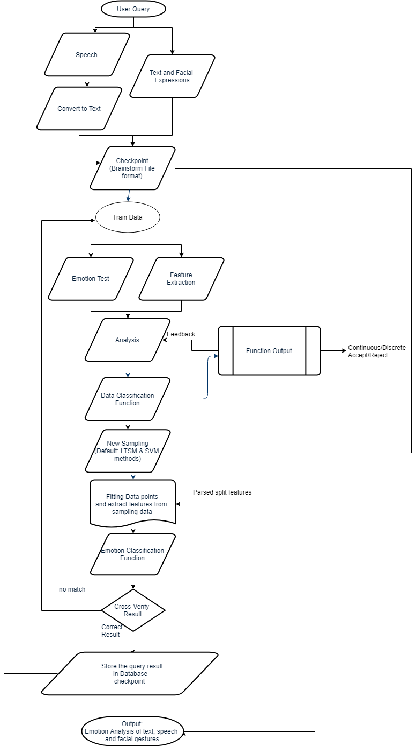

Sampling the data using the methods used in this system fits the data accordingly and decides the input from both continuous and discrete data. The unique feedback system decides the best method to be used according to the situation,

This is achieved by the integration of the following methods:

*A) Support Vector Machines*

This machine learning algorithm uses supervised learning algorithm that can both classify and be used for regression purpose. This is particularly useful when the data is unbiased and the overfitting of data is not possible. For example, daily normal fluctuations constitute biased data and this can be used to predict, filter probable mood-draining emotional situation. This is done by the intelligence used by the neural networks. Fitting the data during the training phase using plane-regression method, a model is taken as hierarchical data format and provides a hypothesis function that predicts result for the more input data. The high-performance classification for the detected pattern requires the increased use of SVM models. The Support Vector Machine technique was also shown to have equivalent performance to Neural Networks. Training a model to by making a sequence of decisions from the provided environment, the system uses reinforcement learning to employ all the trials and errors to come up with the Intelligent emotion-based solutions for real-world Scenario emotional problems.

*B) Long short-term memory*

Long short-term memory (LSTM) is an artificial recurrent neural network (RNN) architecture used in the field of deep learning. They use networks that are well-suited for classification, processing and making predictions based on real-time series data, since there can be lags of unknown duration between important events in a time series. Higher fluctuations in the person’s mood constitute the biased data and LTSM can be used to map and fit the datapoints over the network effectively. The input data (text, speech and facial expression) is observed, monitored and managed using the previously mapped data to the networks. This network integrates the human emotions with their knowledge of past and the present experience, maps the emotion-based line data and keeps track on the person’s whereabouts. This leads to the prediction of current situation and the intelligence of the system is mapped with emotions to output the user-friendly suggestions for the real-time emotional problems.

VI. FUTURE SCOPE

The future application of this model into the smartphones, laptops and wearables like smart watches enabled with camera and mic helps in proper understanding of human emotions, provide appropriate suggestions for making the human lives better. The Intelligent System then provides smart solutions to the user to work on their emotion. This is essential because of the evolution of generation Z, where the generated data and updates are faster than the generation itself, and every digital user spends less time updating themselves.

##### V. CONCLUSION

The system makes a clear-cut prediction and makes sure that every bit of user query is processed and based on the training, the emotion is derived and respond to the user in minimal time, with smart suggestions/ requirements. The system can also learn from user habits and produce suggestions to the user, this allows for more personalized usage. The system can have several integrations with Raspberry Pi and Intel Movidius to have lifelong learning to continue making decisions.

ACKNOWLEDGEMENT

This work is done, supervised and supported by the students and faculty members of the Department of Computer Science and Engineering, BMS Institute of Technology, Bangalore.

REFERENCES

* [1] Peng Zhou, Wei Shi, Jun Tian, Zhenyu Qi, Bingchen Li, Hongwei Hao, Bo Xu, 2013, Attention-Based Bidirectional Long Short-Term Memory Networks for Relation Classification.\
* [2] Jeffrey Pennington, Richard Socher, Christopher D. Manning 2014, GloVe: Global Vectors for Word Representation.
* [3] Erik Tromp, Mykola Pechenizkiy 2014, Rule-based Emotion Detection on Social Media: Putting Tweets on Plutchik’s Wheel.
* [4] R.Anish Menon, Anurag De, B.Priyanka Reddy, B.Sukanya 2016, Various approaches for human emotion recognition: a study.
* [5] Jelena Milosevic, Dexmont Pe˜na, Andrew Forembsky, David Moloney 2018, Reporting Accuracy, Inference Time and Power Consumption for Face Emotion Recognition on Embedded Systems.
* [6] Benaissa Azzeddine Rachid, Harbaoui Azza and Ben Ghezala Henda 2018, Sentiment Analysis Approaches based on Granularity Levels.