**CHAPTER 1**

**ABSTRACT**

Emotion perception from text, speech or visuals using reinforced learning allows decision making. To train a model to make a sequence of decisions from the provided environment, the system uses reinforcement learning to employ all the trials and errors to come up with the emotion-based solution. Hence the motivation to develop an intelligent system using advanced learning algorithms becomes today’s necessity. An intelligent system is a machine with an embedded, Internet-connected computer that has the capacity to gather and analyse data and communicate with other systems. Other criteria for intelligent systems include the capacity to learn from experience, security, connectivity, the ability to adapt according to current data and the capacity for remote monitoring and management.When any system claims to be powered by Artificial Intelligence or NLP or Neural Network human like behaviour is achieved through Reinforced Learning which allows the system to make calculated decisions. In artificial intelligence, an intelligent agent (IA) is an autonomous entity which observes through sensors and acts upon an environment using actuators and directs its activity towards achieving goals. Intelligent agents may also learn or use knowledge to achieve their goals. They may be very simple or very complex. An Artificial Neural Network is an information processing paradigm that is inspired by the way biological nervous systems, such as the brain, process information. The key element of this paradigm is the novel structure of the information processing system. It is composed of a large number of highly interconnected processing elements working in unison to solve specific problems. ANNs, like people, learn by example. An ANN is configured for a specific application, such as pattern recognition or data classification, through a learning process.

**CHAPTER 2**

**SYSTEM ANALYSIS**

The goal of the proposed system is to recognise the user query with maximum accuracy and respond accordingly, with related emotions and the adaption to the previous corrected user queries. The number of steps varies as the simulations are preformed to derive the results and store them to the checkpoints database as a reward.

**Overall process**

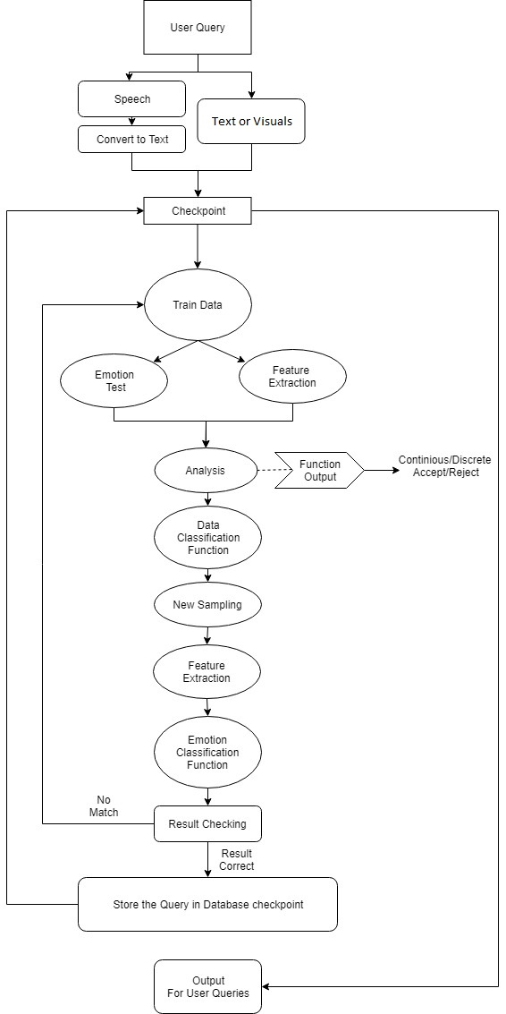

### Mapping of Requirements

**Functional Requirements**

|  |  |  |  |
| --- | --- | --- | --- |
|  | **PURPOSE** | **REQUIREMENT** | **MODULE MAPPING** |
| 1. | Learning Pattern | * Uses supervised & unsupervised learning pattern simultaneously. | * Maps & adapts user environment * Helps in continuous learning. |
| 2. | Platform Dependency | * UI based. * Dynamic database (django framework & SQLite database) * Additional assistant feature. | * User is given option to select mode i.e. text, speech or visual as input. * After certain training of the model, a hardware module of raspberry pi will take inputs in all 3 modes. |
| 3. | Communication | Software modules   * TensorFlow, NLTK * React XPI * Python, JavaScript as backend. | * Ensures least delay * More compatibility |

**Non-Functional Requirements**

|  |  |  |  |
| --- | --- | --- | --- |
|  | **PURPOSE** | **REQUIREMENT** | **MODULE MAPPING** |
| 1. | Execution Cycle | * System processes require more cycles for speech & visual emotion. | * Executes several instances in parallel architecture. |
| 2. | Efficiency | * Expecting an efficiency of 80% and above in all modes (currently at 53% in text, 60% in speech, 82% in visuals) | * System must provide useful intuition, makes meaningful analysis & respond accordingly. |
| 3. | Usage | * Repeatedly giving inputs of similar type will fetch better results. * User emotions are analysed and appropriate response is put through. | * User’s emotional perception is detected. * Helps in making series of decisions from user point of view. |

**Functionalities of the Subsystems**

The system is mainly divided into 3 subsystems. The subsystems are Application module/Interface, Inventory and Database.

**Application Module:**

* It keeps track of the conversations.
* Separate module stores the processed & analysed information in json format.
* It can open three different windows based on the mode selected by the user (text, speech, visual).
* Further, a raspberry pi module will be used to take inputs in the form of text, speech and visuals.

**Database:**

* Uses SQLite 3 for faster retrieval of structured data.
* Django framework is used to maintain the database.
* It doesn’t hold the training data but maps the processed results every time.
* It makes use of hierarchical file format.
* After a level of training is completed, a MOVIDS stick is used to enhance the processing which is inserted to the Raspberry pi module.

**Inventory:**

* Offers a user-friendly interaction between the user and the system.
* It gives multiple options for the user to give same query from different platforms.
* System can be used as a web localhost or as a compiled script on a pc or a hardware module (Raspberry pi).
* Raspberry pi comes with a digital display which helps track the inputs and the computations happening as well as the output can be checked.

**CHAPTER 3**

**SYSTEM DESIGN**

**Architectural Design**

As previously mentioned, system comprises of 3 main sub divisions. The subsystems are Application module/Interface, Inventory and Database.

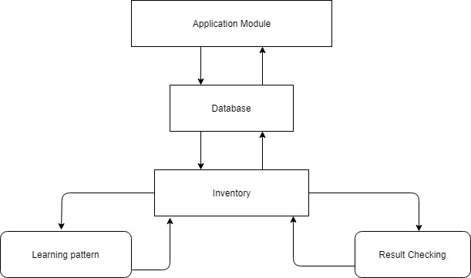

**Component Design**

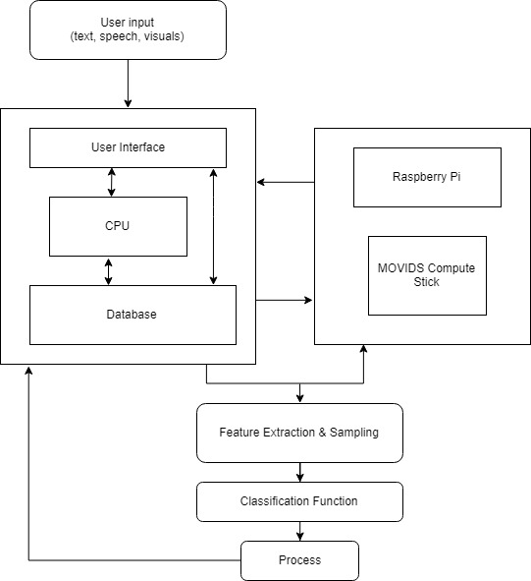

The system come in single forms, aims to be working using integrated modules in the Offline Mode and have many applications, from controlling the situation-based answering considering facts, detecting the various emotions in text and possibly speech to processing huge data sets. In order to develop deep learning inference application at the edge, we use Intel’s both energy efficient and low cost Movidius USB stick. Movidius Neural Compute Stick can run without any need of Internet. The system enables rapid prototyping, validation, and deployment of deep neural networks.

**Behavioural Design**

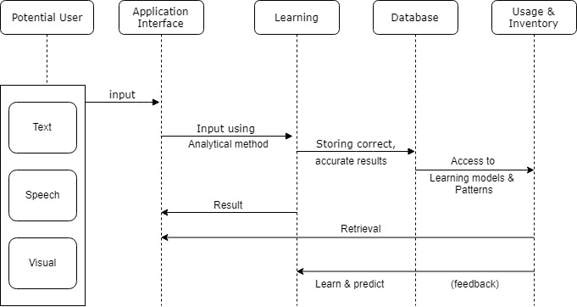

The user query can be in form of text, speech or visuals on which under the application interface module the analytical methods like supervised, semi-supervised or unsupervised learning is applied which derives the results and store them to the checkpoints database as a reward. To compare the performance of the system, multiple initial simulation of problems will be executed. The goal is to recognise the user query with maximum accuracy and respond accordingly, with related emotions and the adaption to the previous corrected user queries. Also, the previously learned patterns and models helps in the inventory activities. Furthermore, it helps the system to predict the next activity of the user.

**REFERENCES**

* [1] Peng Zhou, Wei Shi, Jun Tian, Zhenyu Qi, Bingchen Li, Hongwei Hao, Bo Xu 2013, Attention-Based Bidirectional Long Short-Term Memory Networks for Relation Classification.
* [2] Jeffrey Pennington, Richard Socher, Christopher D. Manning 2014, GloVe: Global Vectors for Word Representation.
* [3] Erik Tromp, Mykola Pechenizkiy 2014, Rule-based Emotion Detection on Social Media: Putting Tweets on Plutchik’s Wheel.
* [4] Benaissa Azzeddine Rachid, Harbaoui Azza and Ben Ghezala Henda 2018, Sentiment Analysis Approaches based on Granularity Levels.
* [5] R.Anish Menon, Anurag De, B.Priyanka Reddy, B.Sukanya 2016, Various approaches for human emotion recognition: a study.
* [6] Jelena Milosevic, Dexmont Pe˜na, Andrew Forembsky, David Moloney 2018, Reporting Accuracy, Inference Time and Power Consumption for Face Emotion Recognition on Embedded Systems.
* [7] Guillaume Daval-Frerot, Abdessalam Bouchekif, Anatole Moreau 2018, Epita at SemEval-2018 Task 1: Sentiment Analysis Using Transfer Learning Approach.
* [8] A. Kalyani, B. Premalatha, K.Ravi kiran 2018, Real Time Emotion Recognition from Facial Images using Raspberry Pi.
* [9] David Zimbra, Ahmed Abbasi, Daniel Zeng, Hsinchun Chen 2018, The State-of-the-Art in Twitter Sentiment Analysis: A Review and Benchmark Evaluation.
* [10] R. Cowie, E. Douglas-Cowie, N. Tsapatsoulis, G. Votsis, S. Kollias, W. Fellenz, J.G.Taylor 2001, Emotion Recognition in Human-Computer Interaction.
* [11] Abdalsamad Keramatfar, Hossein Amirkhani 2018, Bibliometrics of sentiment analysis literature.