Contents
JMeter Distributed Execution in AWS Sandbox with Influx DB and Grafana Monitoring 1
Launching the instances 1
Launching AWS Sandbox EC2 Instances 1
Selecting the appropriate instance size 2
Configuring the instance details 3
Adding storage 4
Adding tags 5
Creating or selecting a security group 6
Reviewing instance launch 7
Creating or selecting a public/private key pair 8
Confirmation screen 8
Viewing instance(s) 9
Connecting from Windows with PuTTY and WinSCP 10
Finding the Public DNS 10
Setting up a PuTTY Configuration 11
Creating WinSCP connections for transferring files: 13
Configuring the instances 14
Updating packages 14
Installing Java and JMeter 14
Updating JMeter execute permissions 15
Installing Influx DB 15
Installing Grafana 16
Allocating more memory for the JMeter hub 16
Configuring Grafana 16
Connecting to Grafana 16
Adding Data Sources 17
Importing the JMeter dashboard 19
Executing a test 20
Starting jmeter-server on the nodes 20
Executing the test 21
Monitoring the test 23
Grafana Monitoring 23
Terminal monitoring 24

JMeter Distributed Execution in AWS Sandbox with Influx DB and Grafana Monitoring

Launching the instances

Launching AWS Sandbox EC2 Instances
- Chose the following AMI: Red Hat Enterprise Linux 7.3 (HVM), SSD Volume Type
  - 1 instance to serve as the JMeter hub
  - 1 instance for every set of 250 desired users to serve as the JMeter node(s)
  - 1 instance to serve as the Influx DB listener and Grafana server
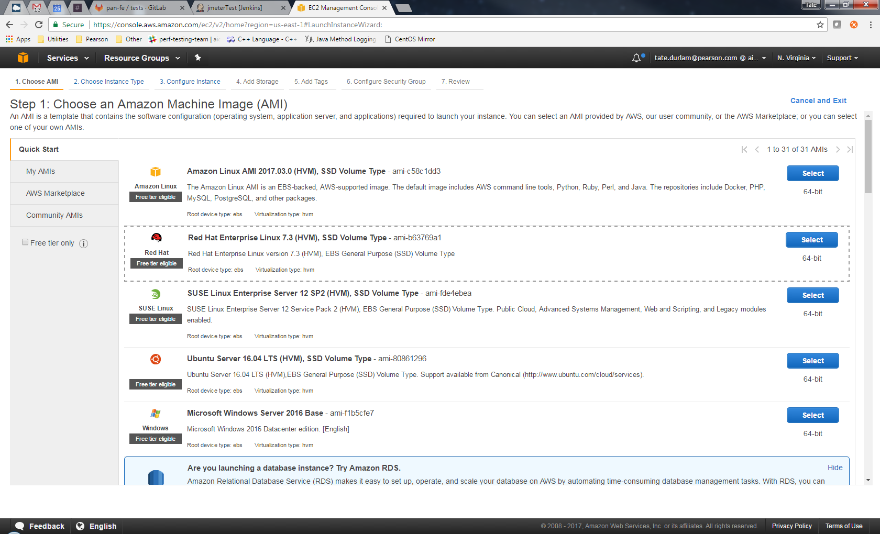

Selecting the appropriate instance size
- t2 medium* seems to be sufficient for the JMeter nodes
- t2 large seems to be sufficient for the JMeter hub and the Influx DB listener
Note: These can be resized later if necessary. (Go with t2 mediums or larges, not micros as shown.)
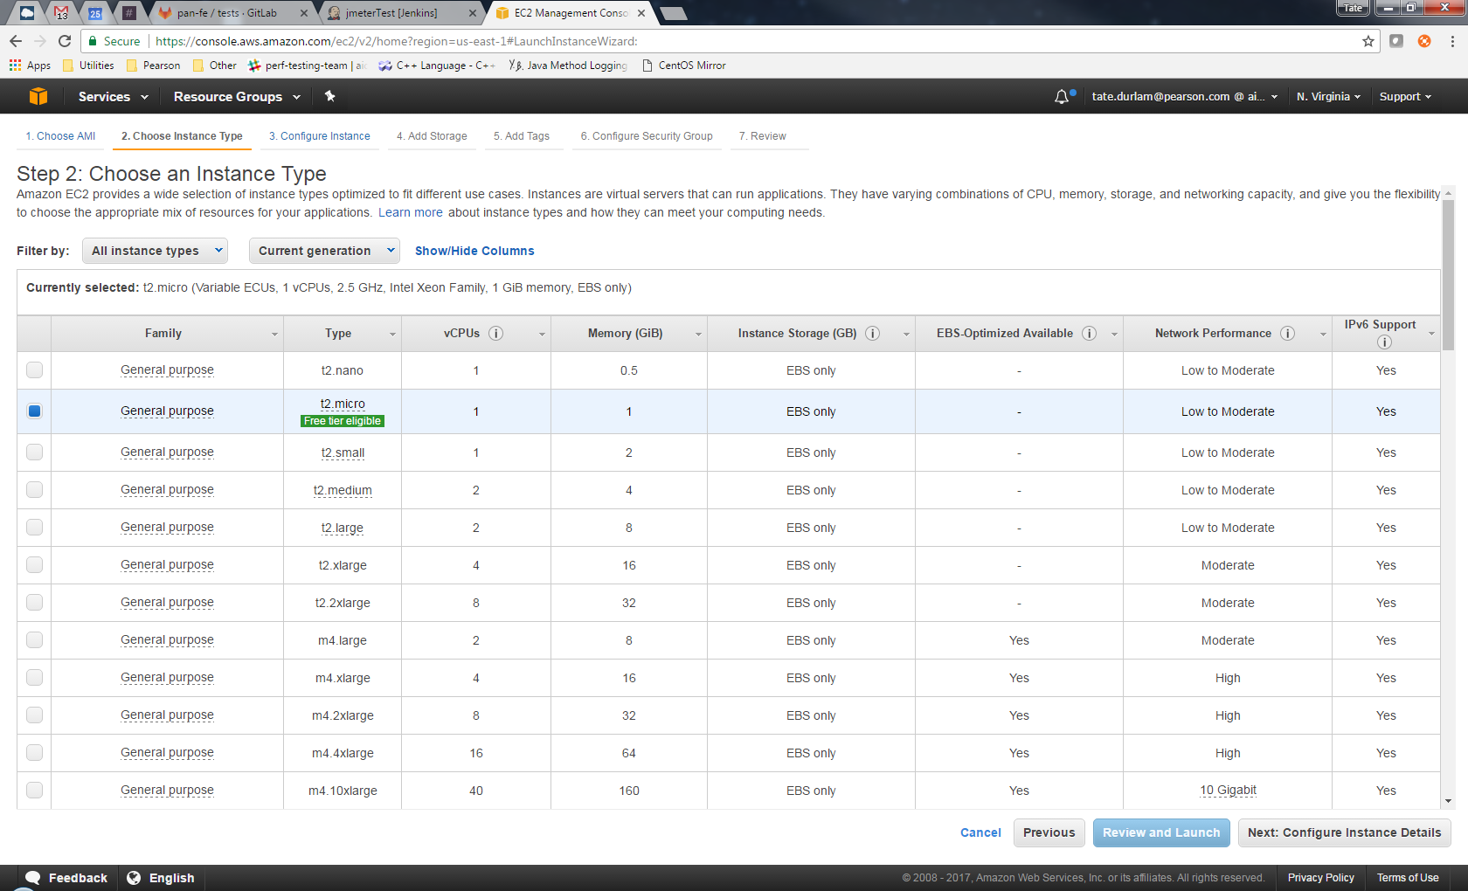

Configuring the instance details
- Network – select ‘vpc-b625c0d3’
- Subnet – select ‘subnet-dcecb49a | us-east-1c’
- Auto-assign Public IP – select ‘Enable’
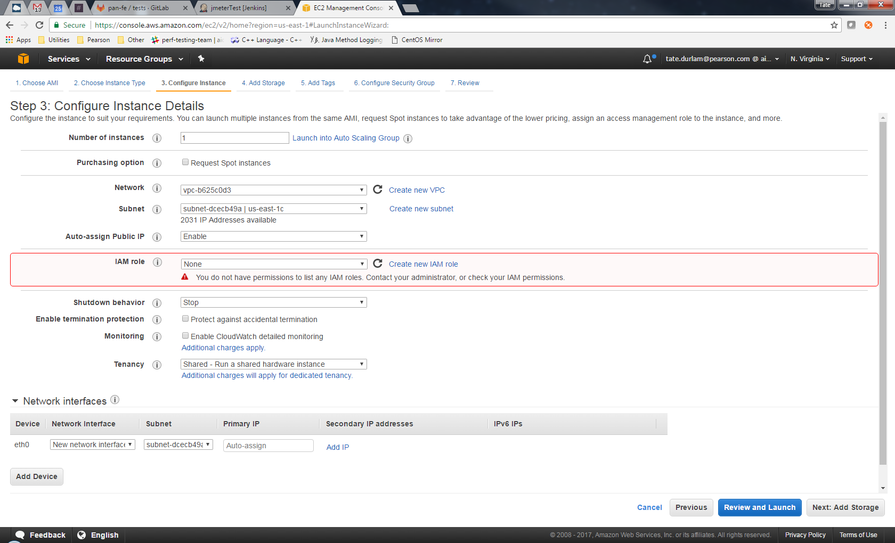

Adding storage
- The default 10 GiB General Purpose SSD seems to be sufficient
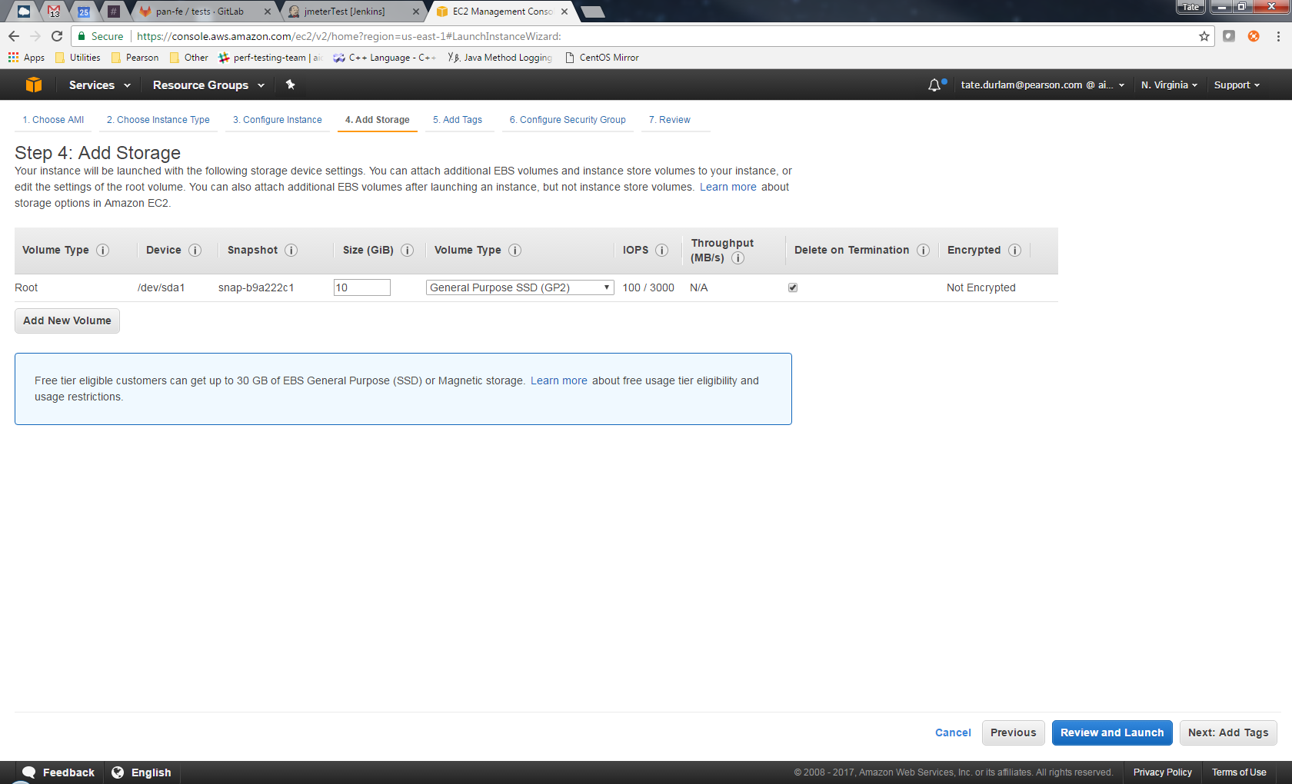

Adding tags
- At a minimum, add a ‘Name’ tag with an appropriate value so you can easily find your instance(s) later
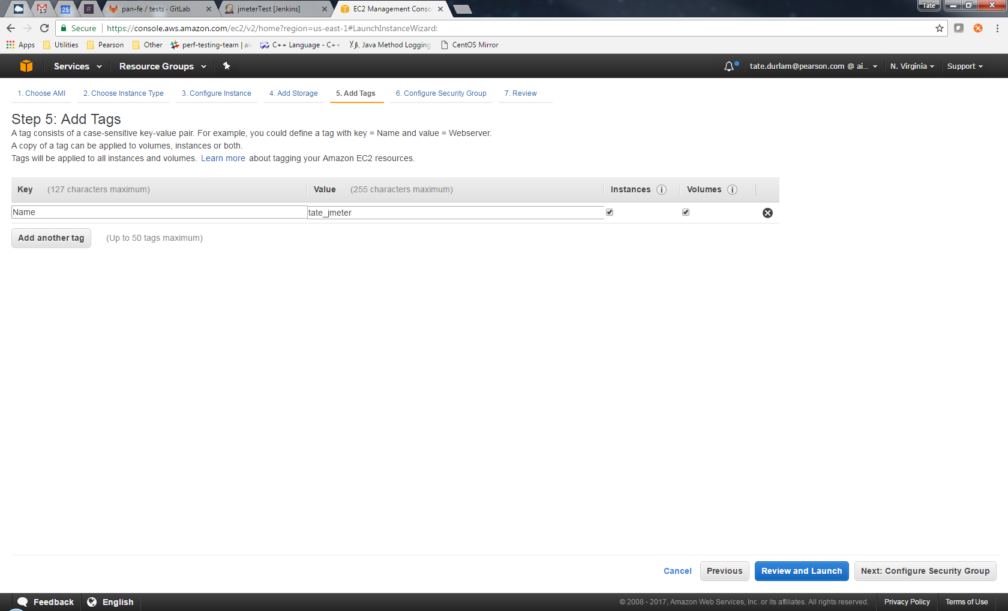

Creating or selecting a security group
- You will need inbound rules to let you connect to these instances from your IP
- You will need an inbound rule to let these instances connect to each other
Note: After creating the security group for your first instance, you can just select it when creating any additional instances
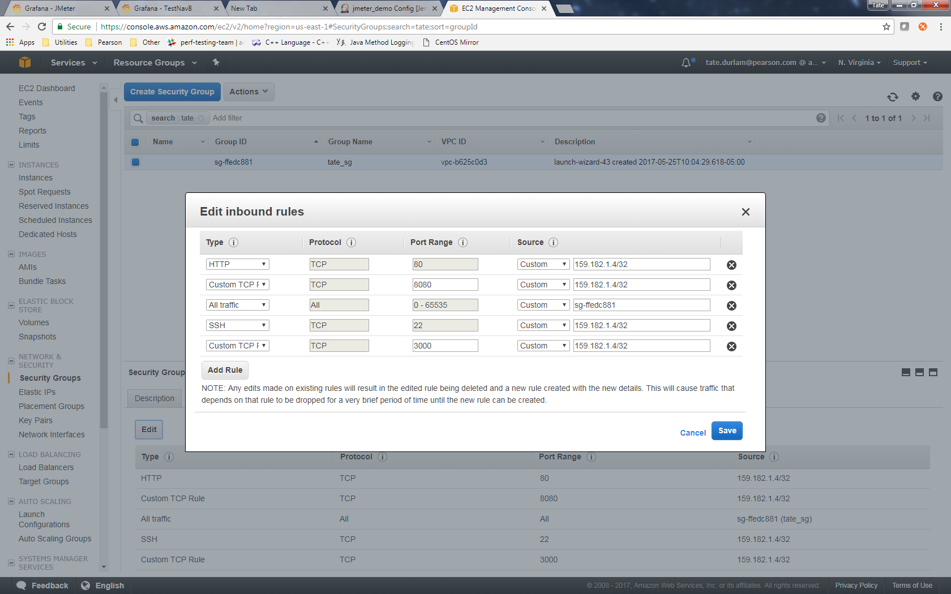

Reviewing instance launch
- Review the details and make any edits if necessary
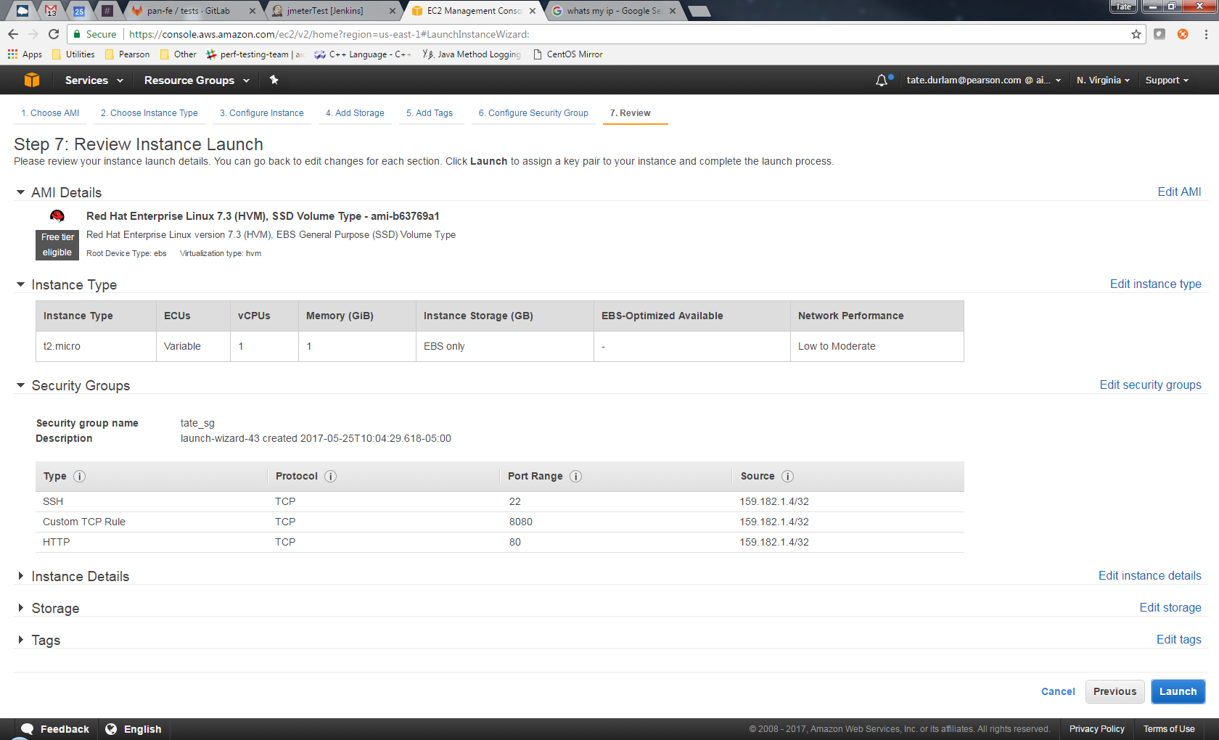

Creating or selecting a public/private key pair
- If you haven’t already, create a public/private key pair for connecting to your instances, and select it:
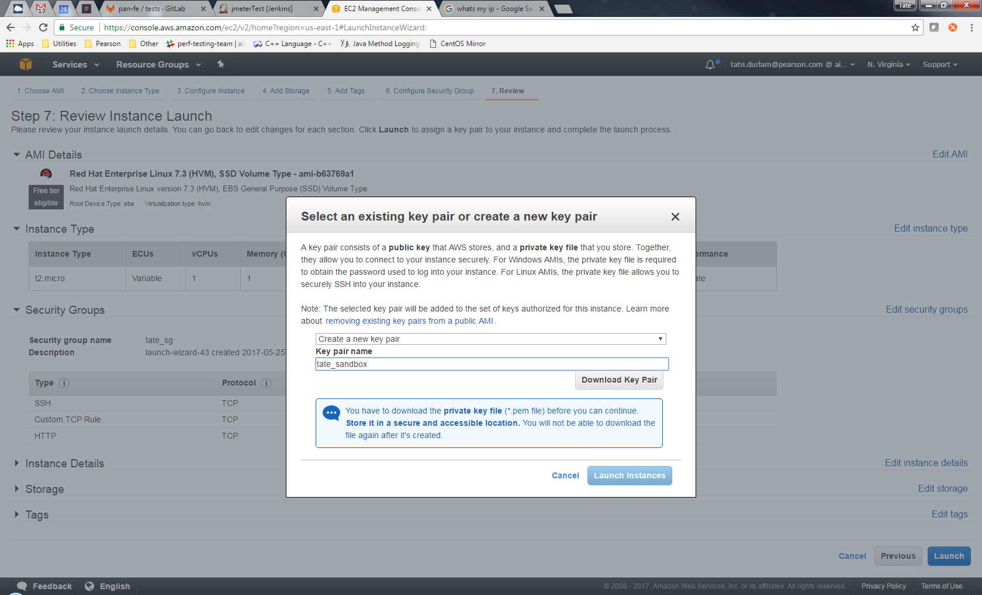

Confirmation screen
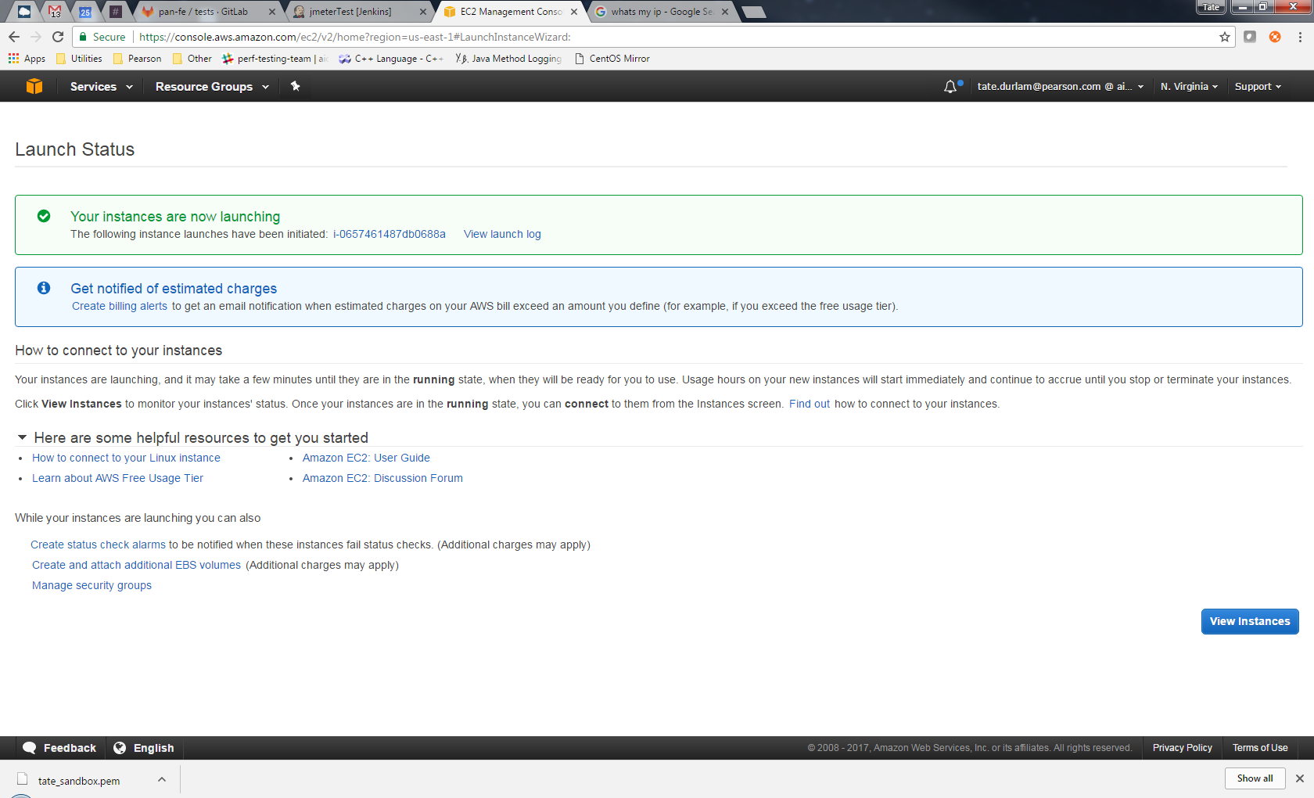

Viewing instance(s)
- You can search for your instance(s) using all or part of any tag values you added
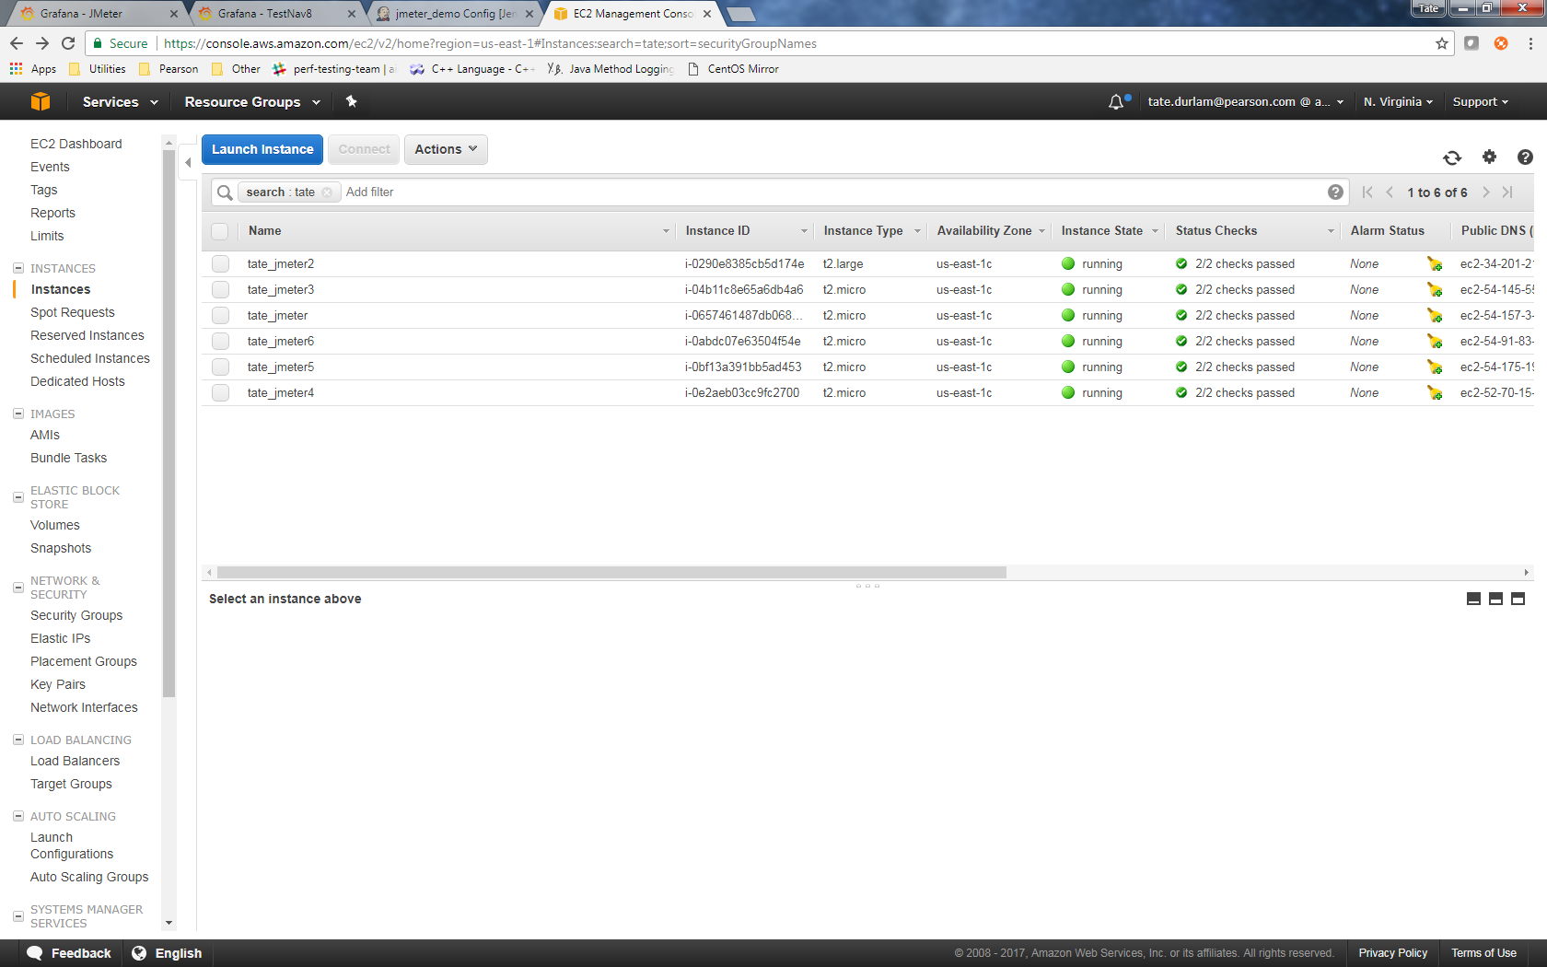

Connecting from Windows with PuTTY and WinSCP

Finding the Public DNS
- Find the instance to which you would like to connect in the AWS console
- Hit the ‘Connect’ button or select the Description tab to get the Public DNS for the instance
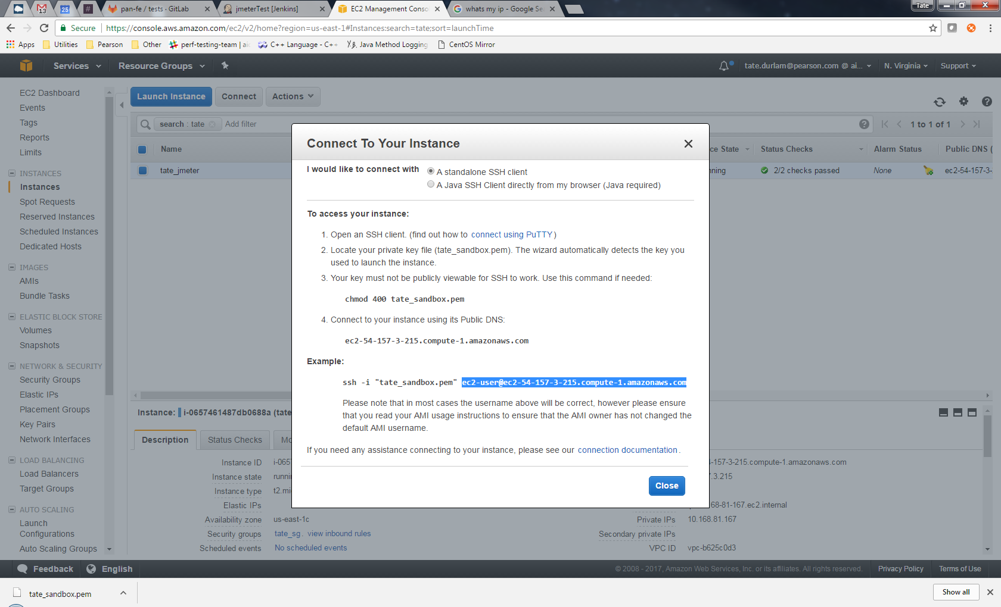

Setting up a PuTTY Configuration
- Host Name – enter the Public DNS from previous step
- Port – enter 22
- Connection type – Select ‘SSH’
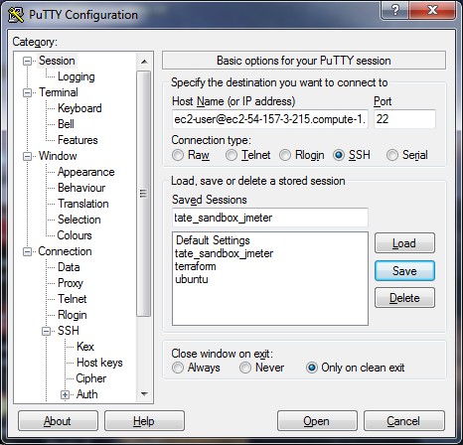

- Add your private key file for authentication
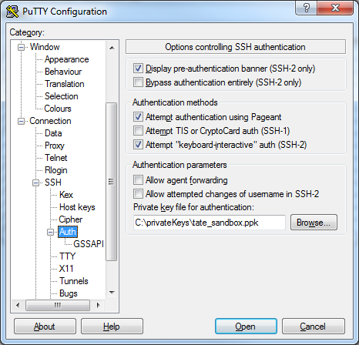

Creating WinSCP connections for transferring files:
- File protocol – select SCP
- Host name – enter the Public DNS from previous step
- Port number – enter 22
- User name – enter ec2-user
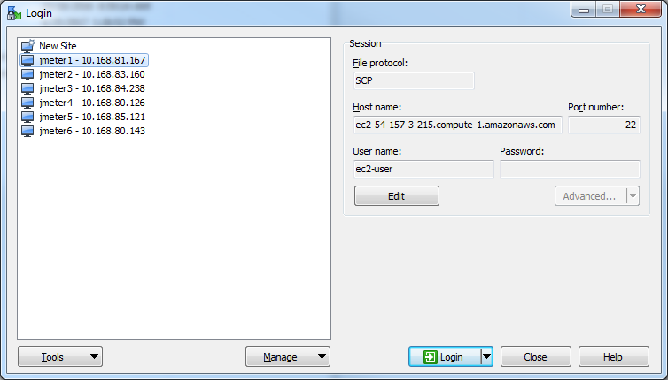

- Hit the Advanced button, or Edit then Advanced to access the advanced settings shown below, select your private key file for connecting to the instance and save the configuration:
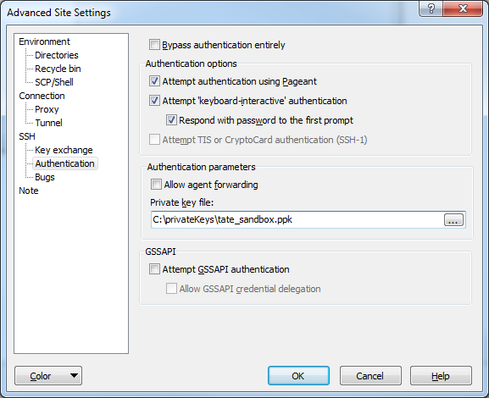

Configuring the instances

Updating packages
- Connect to the instance using PuTTY and execute the following:
sudo yum update –y

Installing Java and JMeter
- Download jdk-8u121-linux-x64.rpm to your local machine
- Download apache-jmeter-3.2 to your local machine and unzip
- Connect to the instance using WinSCP
- Copy the jdk-8u121-linux-x64.rpm and the apache-jmeter-3.2 folder to the /usr/tmp directory on the instance
- Connect to the instance using PuTTY and execute the following commands:
cd /usr/tmp
sudo mv apache-jmeter-3.2 /opt
sudo rpm –ivh jdk-8u121-linux-x64.rpm

Updating JMeter execute permissions
- Connect to the instance using PuTTY and execute the following commands:
cd /opt/apache-jmeter-3.2/bin
chmod +x jmeter-server
chmod +x jmeter.sh
chmod +x jmeter

Installing Influx DB
- Chose an instance to serve as the Influx DB listener and Grafana server
- Connect to the instance using PuTTY and execute the following commands:
cat <<EOF | sudo tee /etc/yum.repos.d/influxdb.repo
[influxdb]
name = InfluxDB Repository – RHEL \$releasever
baseurl = https://repos.influxdata.com/rhel/\$releasever/\$basearch/stable
enabled = 1
gpgcheck = 1
gpgkey = https://repos.influxdata.com/influxdb.key
EOF

sudo yum install influxdb

cd /etc/influxdb/

- Use vi to update the influxdb.conf file and change the lines in the http and graphite sections as shown below:
sudo vi influxdb.conf

[http]
enabled = true
bind-address = “:8086”
auth-enabled = false
log-enabled = true
write-tracing = false
pprof-enabled = false
https-enabled = false

[[graphite]]
# Determines whether the graphite endpoint is enabled.
enabled = true
database = “jmeter”
# retention-policy = “”
Bind-address = “:2003”
- Start the influxdb service:
sudo service influxdb start
- Create the jmeter and grafana databases by executing the following commands:
influx
create database jmeter
create database grafana
exit

Installing Grafana
- Connect to the Influx DB listener and Grafana server instance using PuTTY
- Execute the following commands:
sudo yum install https://s3-us-west-2.amazonaws.com/grafana-releases/release/grafana-4.3.1-1.x86_64.rpm
- Start the grafana-server service:
sudo service grafana-server start

Allocating more memory for the JMeter hub
- Connect to the JMeter hub instance using WinSCP (or PuTTY)
- Navigate or cd to /opt/apache-jmeter-3.2/bin
- Uncomment and change the JVM_ARGS line in the jmeter.sh file so it reads as follows:
JVM_ARGS="-Xms1024m –Xmx2048m"

Configuring Grafana

Connecting to Grafana
- In a browser, go to http://<Public DNS of InfluxDB/Grafana instance>:3000 (Example: http://ec2-54-157-3-215.compute-1.amazonaws.com:3000)

Adding Data Sources
- Add an InfluxDB data source and set it as the default
  - Name – influxdb
  - Type – InfluxDB
  - Access – proxy
  - Url – http://<Public DNS of InfluxDB/Grafana instance>:8086 (Example: http://ec2-54-157-3-215.compute-1.amazonaws.com:8086)
  - Database – jmeter
  - User – root
  - Password – root
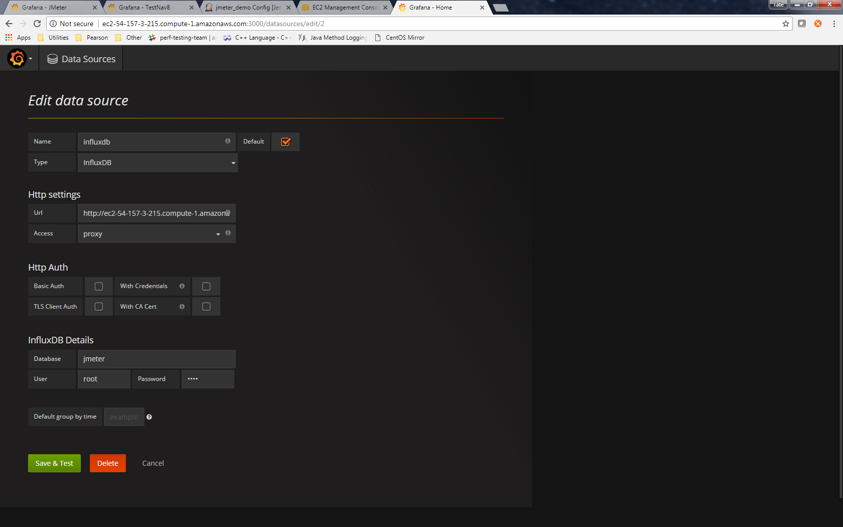

- Add a Grafana data source
  - Name – grafana
  - Type – InfluxDB
  - Url – http://<Public DNS of InfluxDB/Grafana instance>:8086 (Example: http://ec2-54-157-3-215.compute-1.amazonaws.com:8086)
  - Database – grafana
  - User – root
  - Password – root
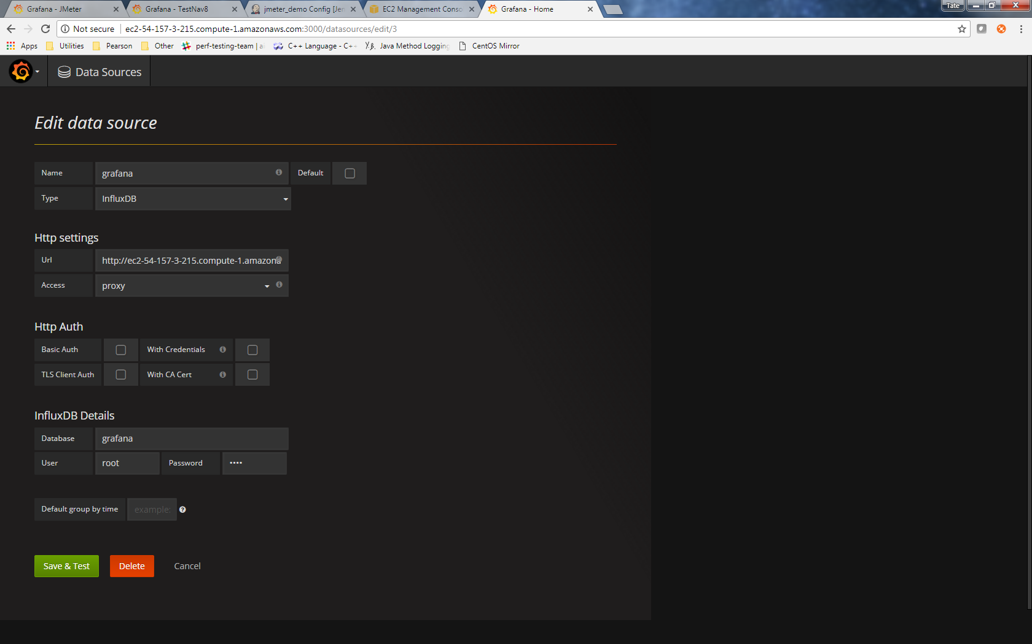

Importing the JMeter dashboard
- The dashboard json file which can be imported into Grafana as shown below can be found here: https://bitbucket.pearson.com/projects/AIATOOLS/repos/jmeter-repo/browse
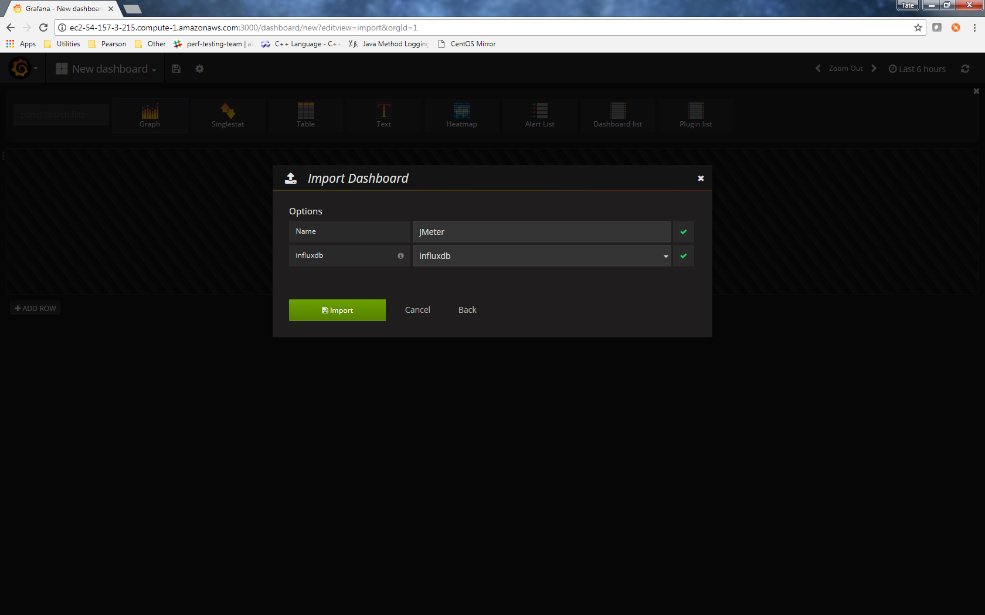

- After importing, you should see the following, which will start populating with data when a test is being executed:
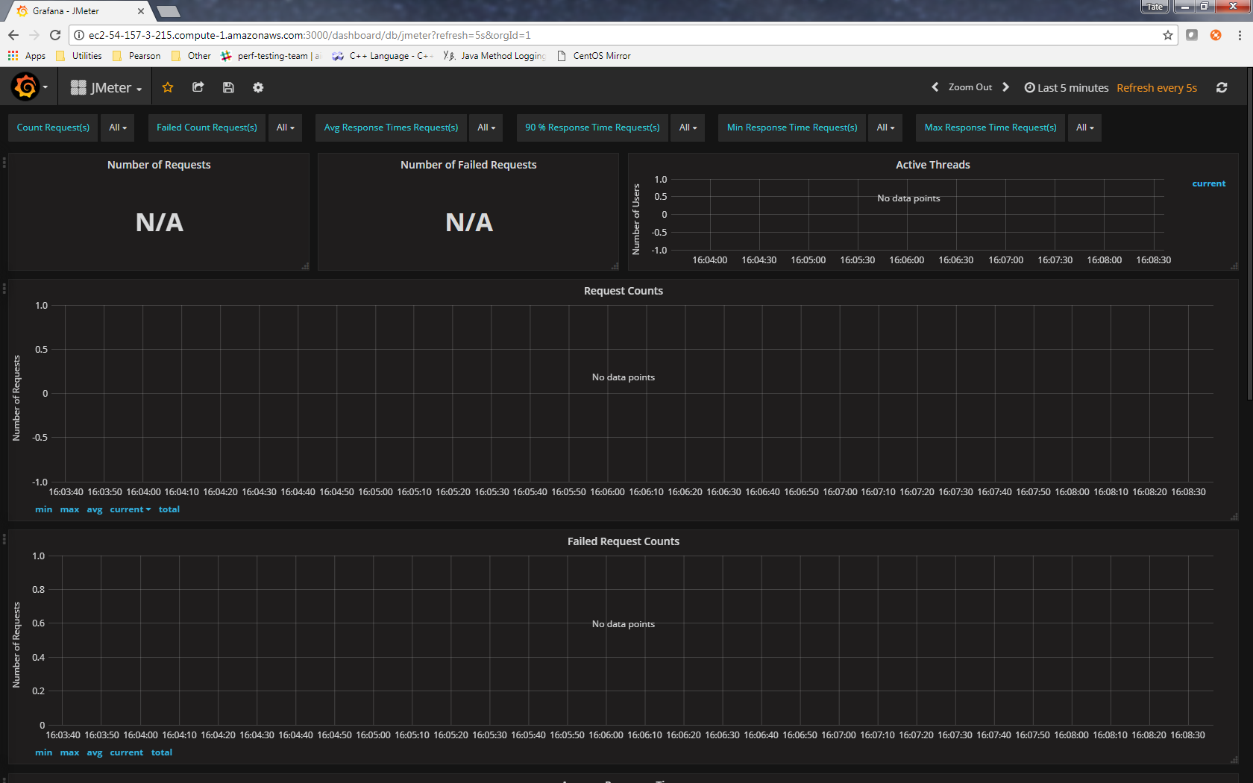

Executing a test

Starting jmeter-server on the nodes
- The jmeter-server must be running on each node before starting the test
- To start the jmeter-server connect to each JMeter node using PuTTY and execute the following:
cd /opt/apache-jmeter-3.2/bin/ && bash jmeter-server
- The node terminals should look like this after the jmeter-server has been started:
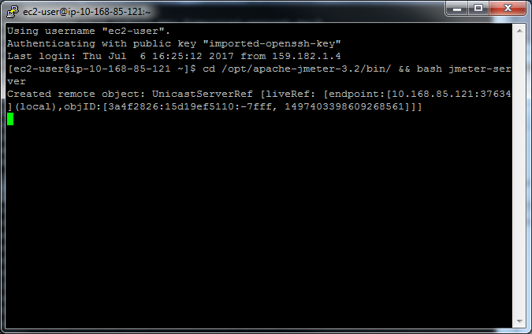

Executing the test
- Connect to the JMeter hub using PuTTY and execute the following after making the appropriate substitutions:
rm -r <path_to_dashboard_results_folder>; rm -r <path_to_raw_results_file>; bash /opt/apache-jmeter-3.2/bin/jmeter.sh -n -G<path_to_additional_properties_file>; -t <path_to_jmx_test_file>; -R <comma-separated_list_of_node_private_ips> -l <path_to_raw_results_file>; -e -o <path_to_dashboard_results_folder> -X

- Example of command after substitutions:
rm -r /opt/apache-jmeter-3.2/bin/examples/dashboardResults; rm -r /opt/apache-jmeter-3.2/bin/examples/result.jtl; bash /opt/apache-jmeter-3.2/bin/jmeter.sh -n -G/opt/apache-jmeter-3.2/bin/test.properties -t /opt/apache-jmeter-3.2/bin/examples/pa-next-jmeter-scripts/PANext_TestPlan.jmx -R 10.168.84.238,10.168.80.126,10.168.85.121,10.168.80.143 -l /opt/apache-jmeter-3.2/bin/examples/results/result.jtl -e -o /opt/apache-jmeter-3.2/bin/examples/results/dashboardResults -X
- This will delete the previous dashboard results folder and raw results file if they exist, start the PANext_TestPlan.jmx test on each of the nodes listed after the –R argument, pass any properties found in the test.properties file to each node, create a new dashboard results folder and raw result file, and stop the jmeter-server on the nodes when the test completes
- The terminal for the hub should look like this after the test has run for a bit:
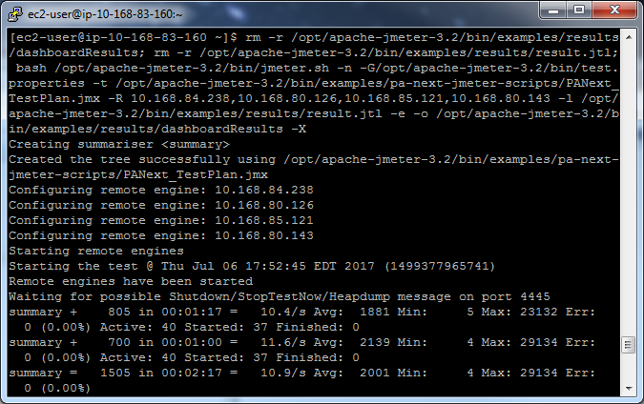

Monitoring the test

Grafana Monitoring
- Once the test has been started, go to http://<Public DNS of InfluxDB/Grafana instance>:3000 (Example: http://ec2-54-157-3-215.compute-1.amazonaws.com:3000)
- Select the JMeter dashboard, which should begin populating with data like the example below

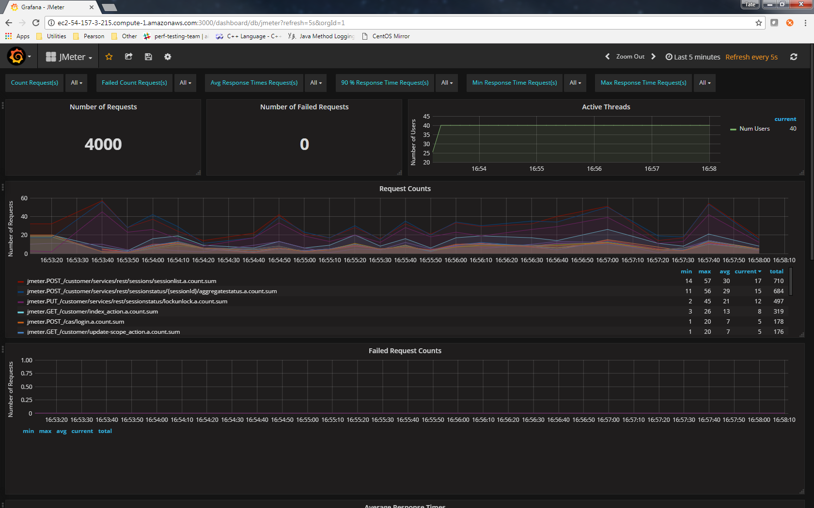

Terminal monitoring
- The hub terminal running the test will also print summary messages roughly every 30 seconds which provide a very high-level status of the test:
