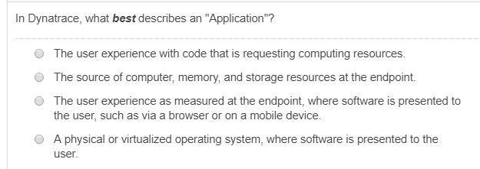
The user experience as measured at the endpoint, where software is presented to the user, such as via a browser or on a mobile device

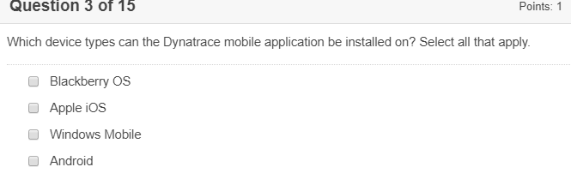
Apple iOS, Android
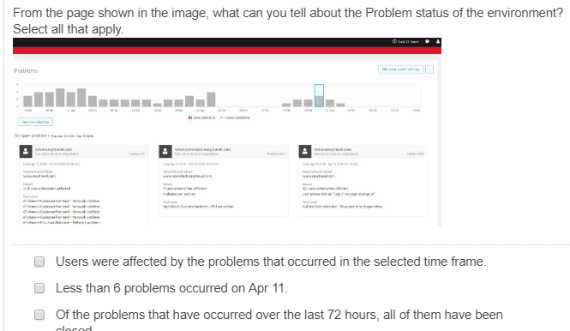
Picture is not clear
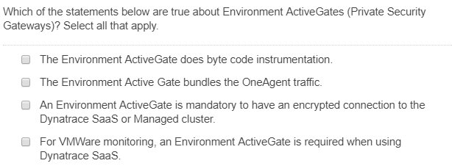

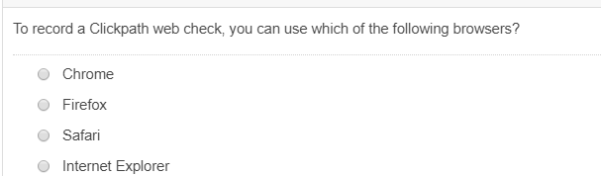
Chrome
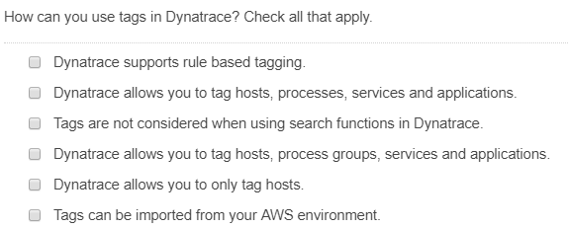
Dynatrace allows you to tag hosts, processes, services and applications
Dynatrace allows you to tag hosts, process groups, services and applications
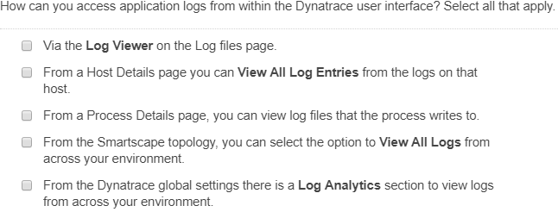
Via the Log Viewer on the Log files page
From the Dynatrace global settings there is a Log Analytics section to view logs from across your environment
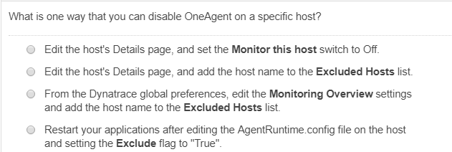
Edit the host’s Details page, and set the Monitor this host switch to Off
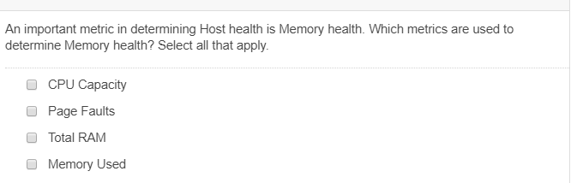
Page Faults and Memory Used
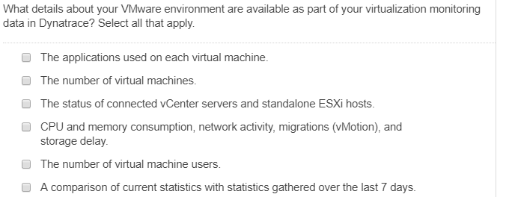
The number of virtual machines
The status of connected vCenter servers and standalone ESXi hosts
CPU and memory consumption, network activity, migrations (vMotion), and storage delay
A comparison of current statistics with statistics gathered over the last 7 days
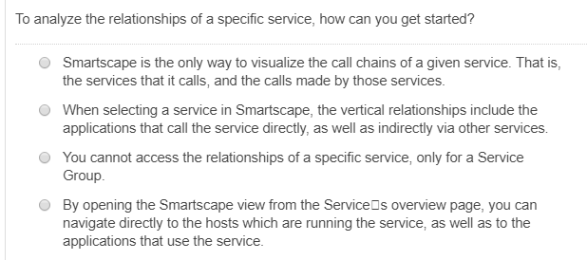

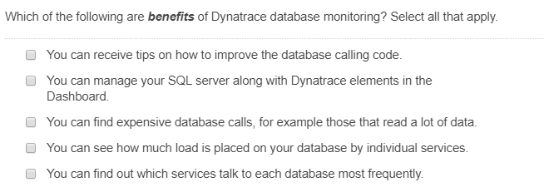
You can receive tips on how to improve the database calling code
You can find expensive database calls, for example those that read a lot of data
You can see how much load is placed on your database by individual services

