Jmeter Microservices Performance Testing
Prerequisites:
- To download the libraries from the GitHub repository https://github.com/rtaum/Library from the Master branch. Either you can clone or download the libraries and place them in C Drive folder
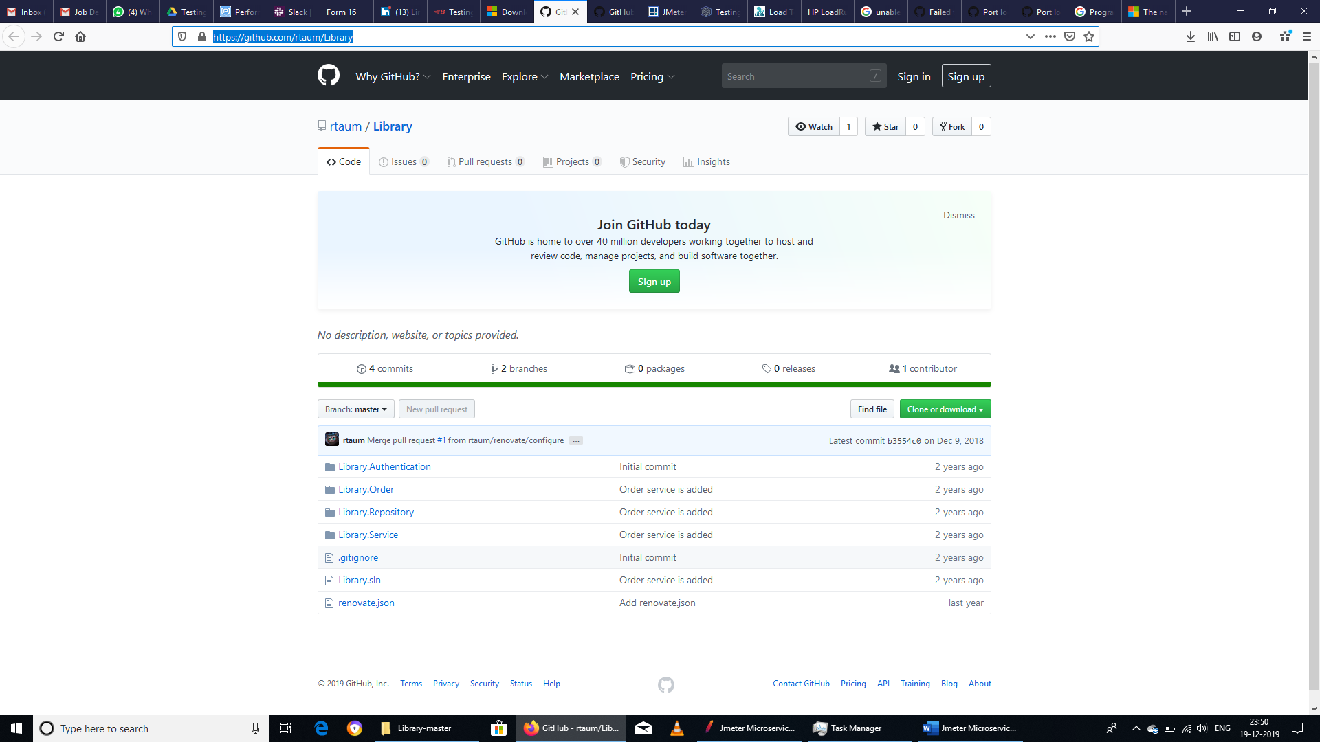
- To run these libraries, you need to download the .Net Core SDK 2.1 or above. You can download from this link https://dotnet.microsoft.com/download and install it to your pc based on the Operating System
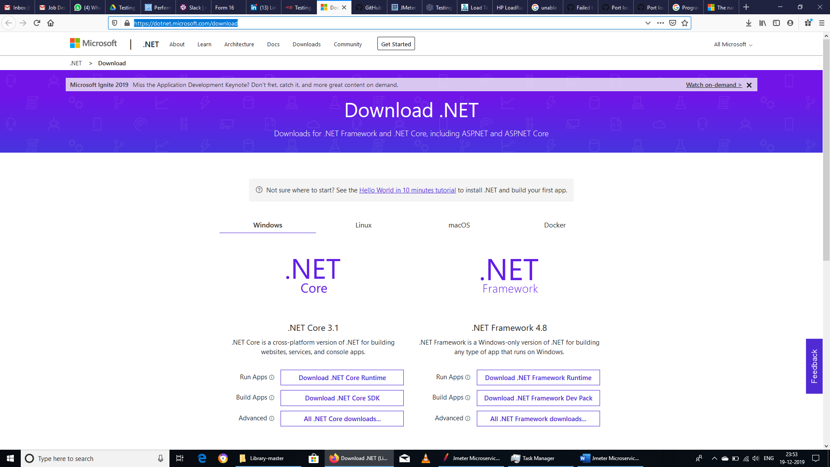
- There are few changes to be done to the library files. You can find them below for your reference.
- After navigating to the Library Authentication service path “C:\Microservice Performance Testing using Jmeter\Library-master\Library-master\Library.Authentication”. Program File is to be updated with the below code.
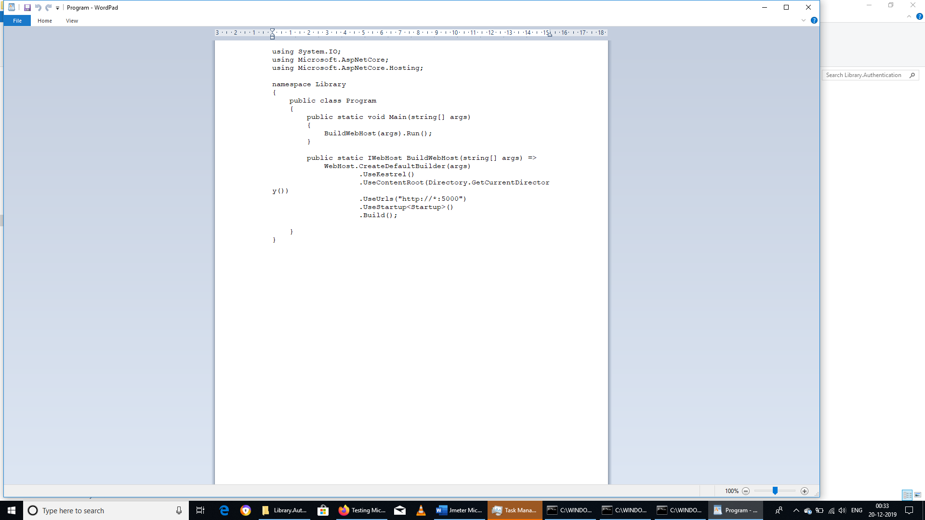
- After navigating to the Library Service path “C:\Microservice Performance Testing using Jmeter\Library-master\Library-master\Library.Service”. Program File is to be updated with the below code.
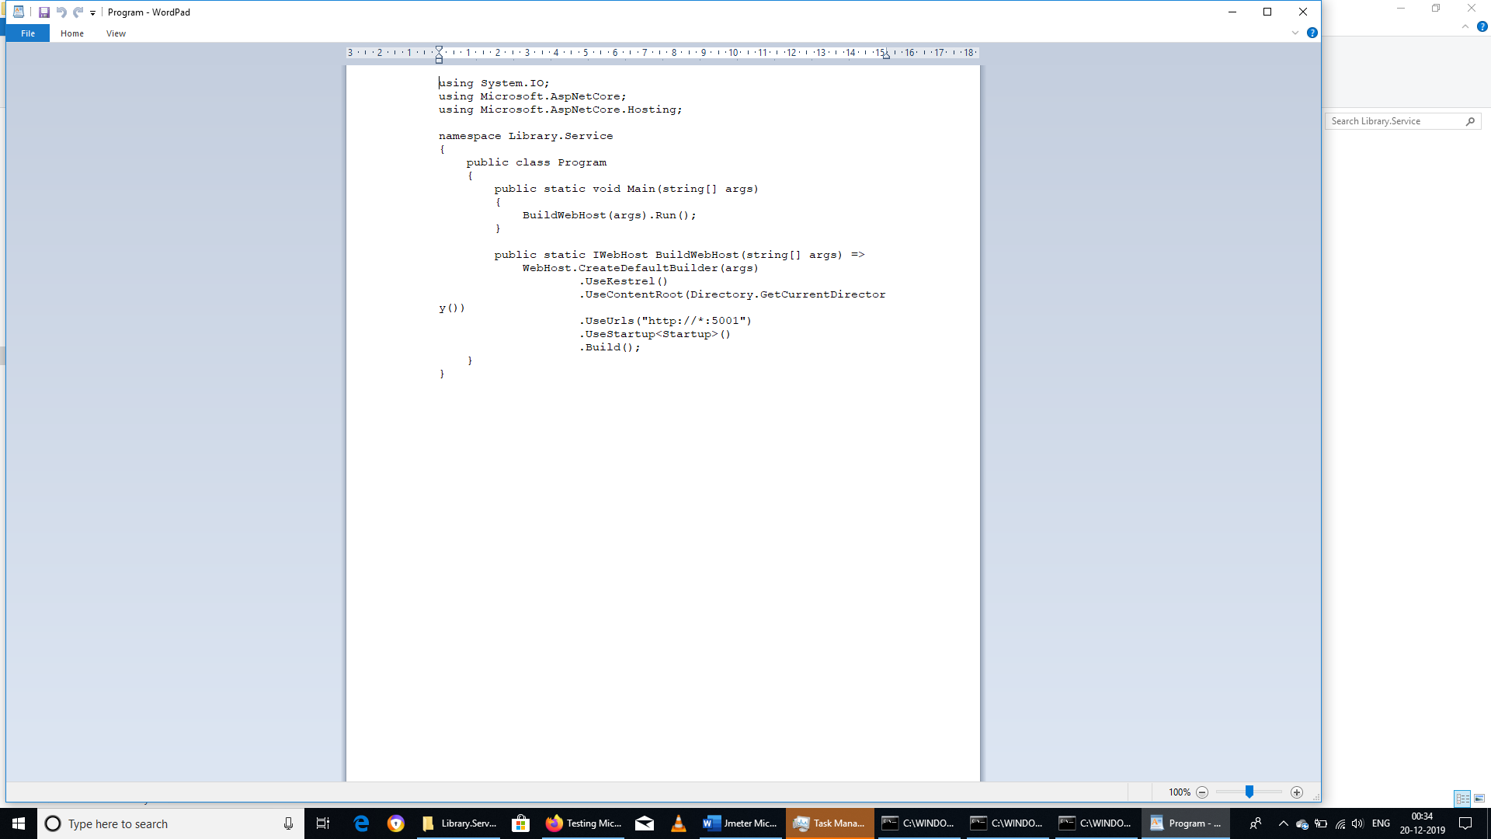
- After navigating to the Library Order path “C:\Microservice Performance Testing using Jmeter\Library-master\Library-master\Library.Order”. Program File is to be updated with the below code.
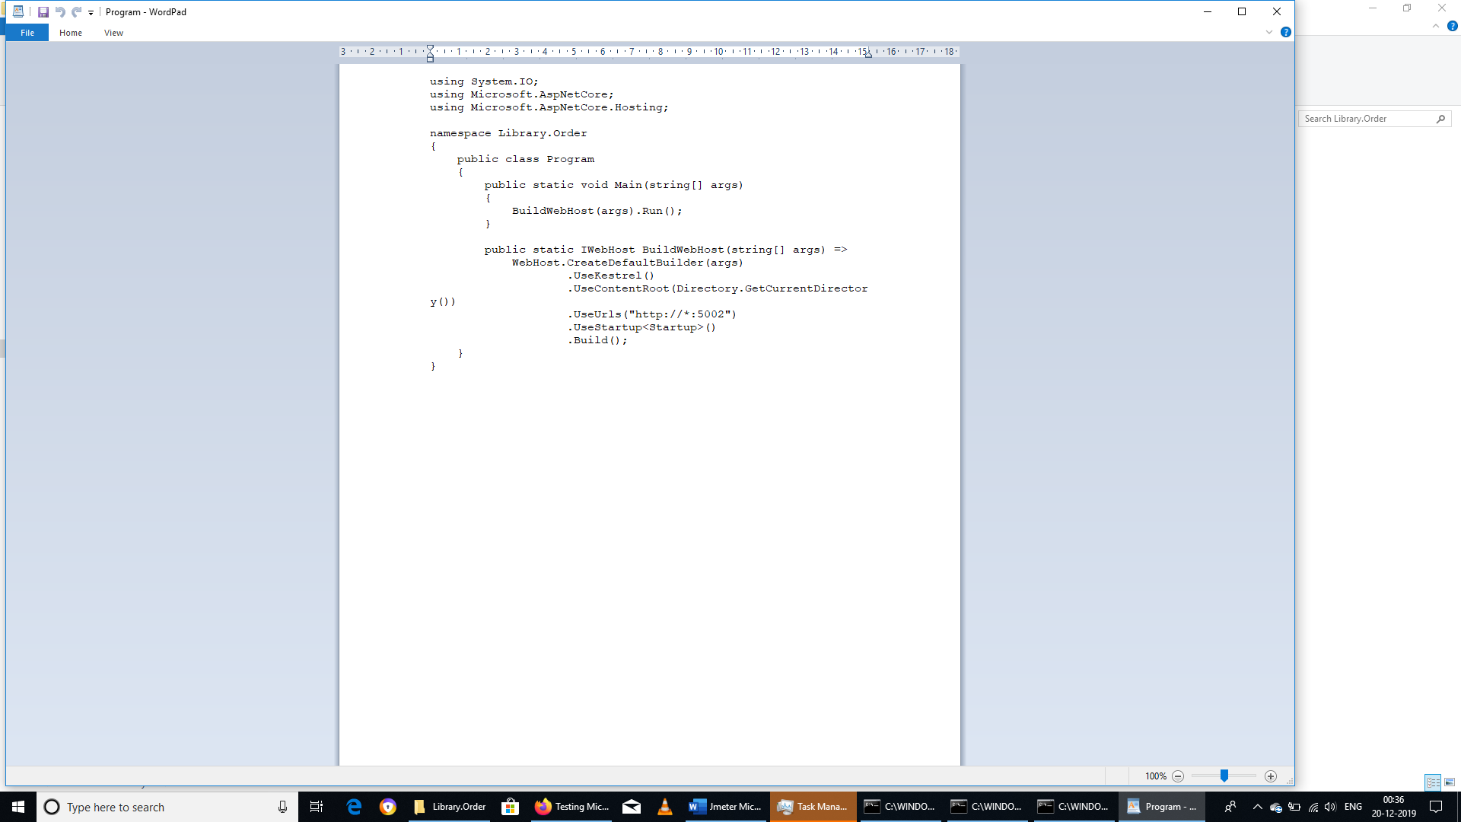
- Launch 3 command prompt windows and navigate to the respective folder path ex:
- 1st command prompt with “C:\Microservice Performance Testing using Jmeter\Library-master\Library-master\Library.Authentication” and then run the service using “dotnet run” command
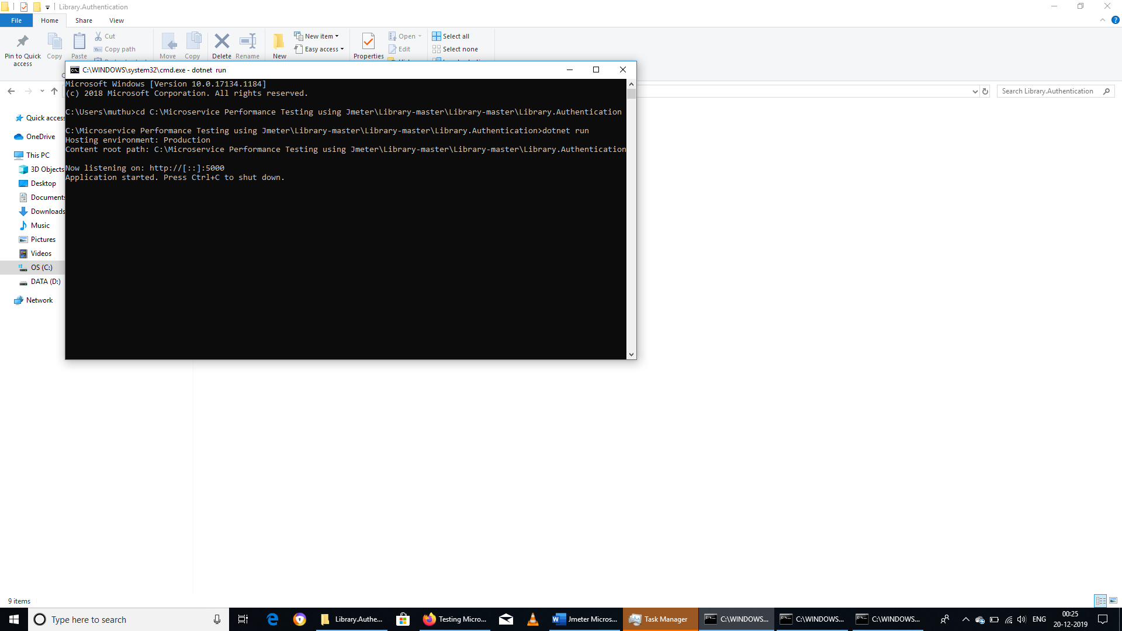
- 2nd command prompt with “C:\Microservice Performance Testing using Jmeter\Library-master\Library-master\Library.Service” and then run the service using “dotnet run” command
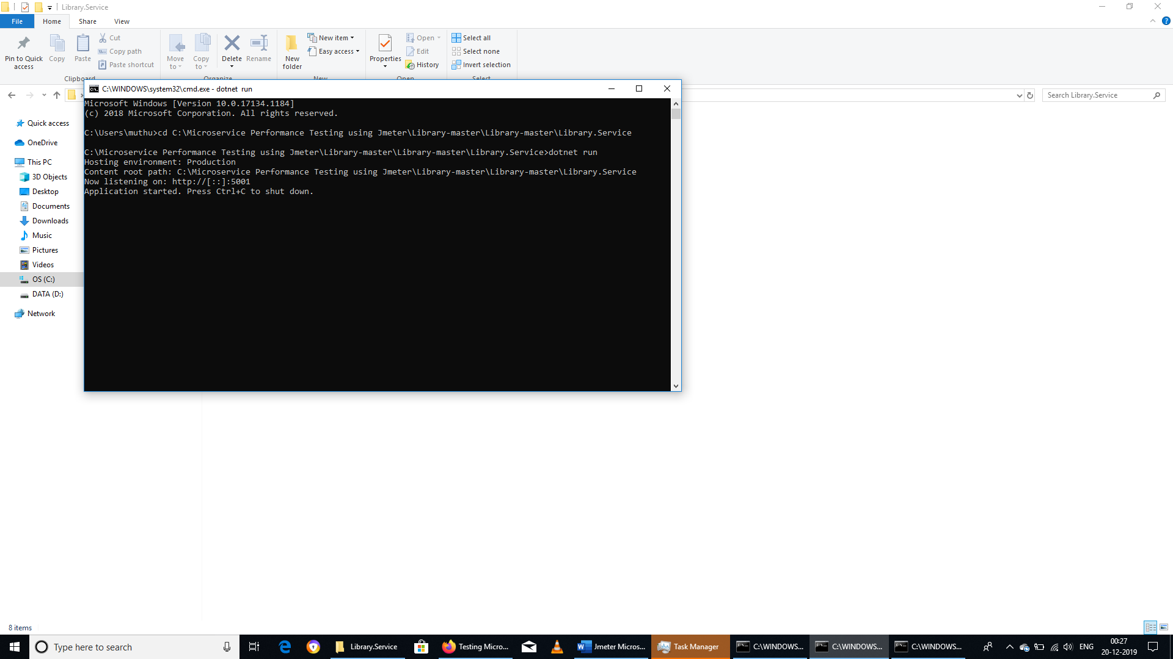
- 3rd command prompt with “C:\Microservice Performance Testing using Jmeter\Library-master\Library-master\Library.Order” and then run the service using “dotnet run” command
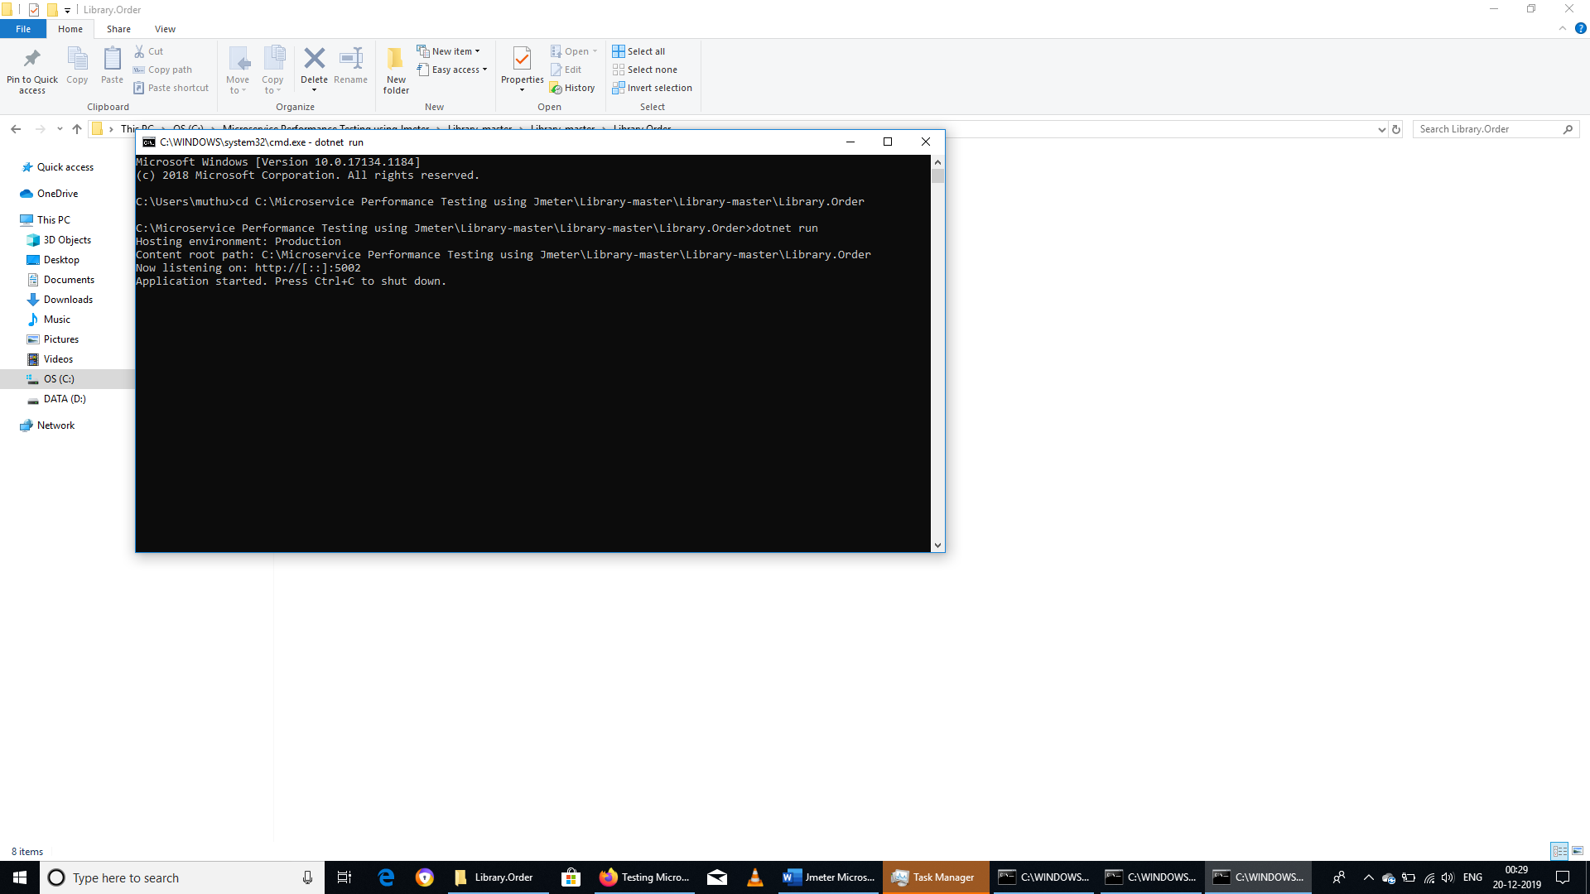
- Jmeter web services script is to be prepared. You can find the screenshot of the same below for your reference.
- Jmeter Test Plan Screenshot
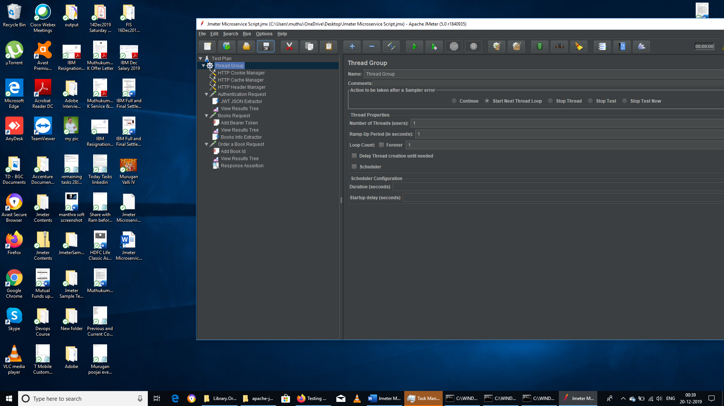
- Authentication Request
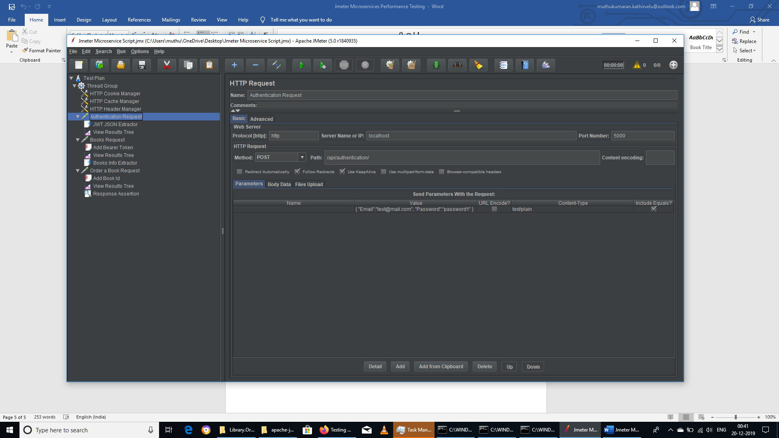
Response
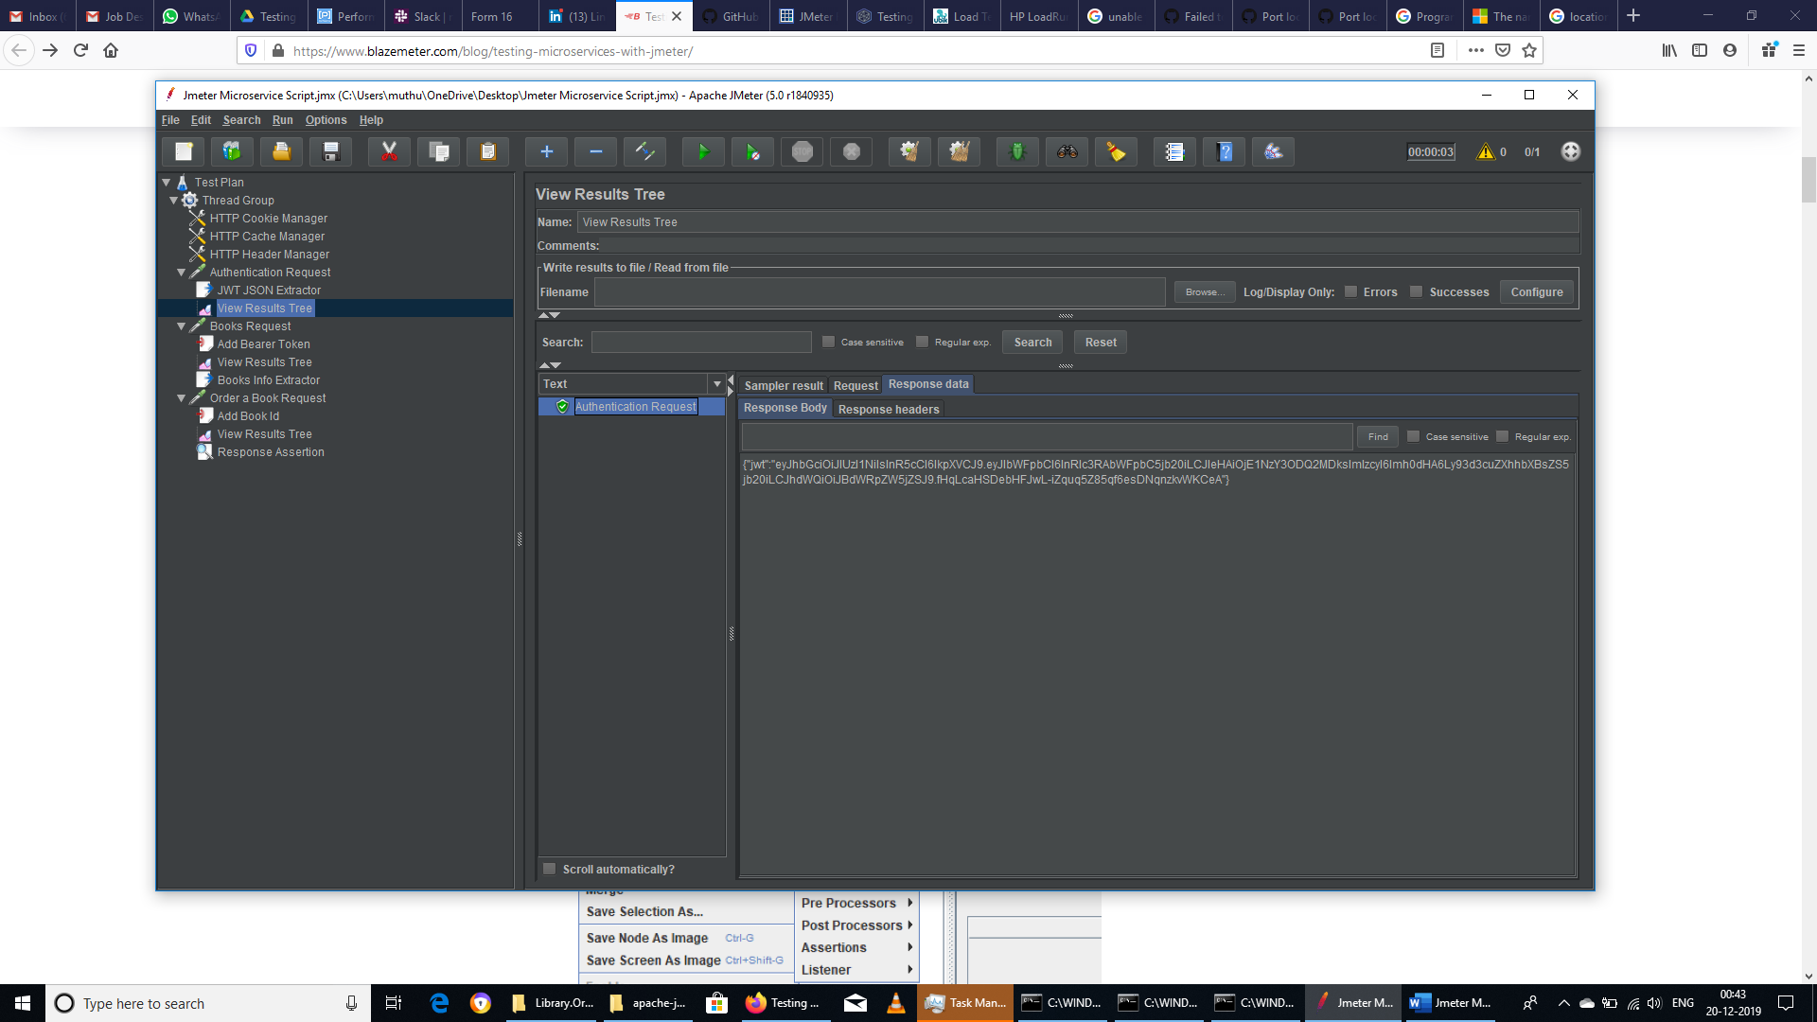
- Book Request
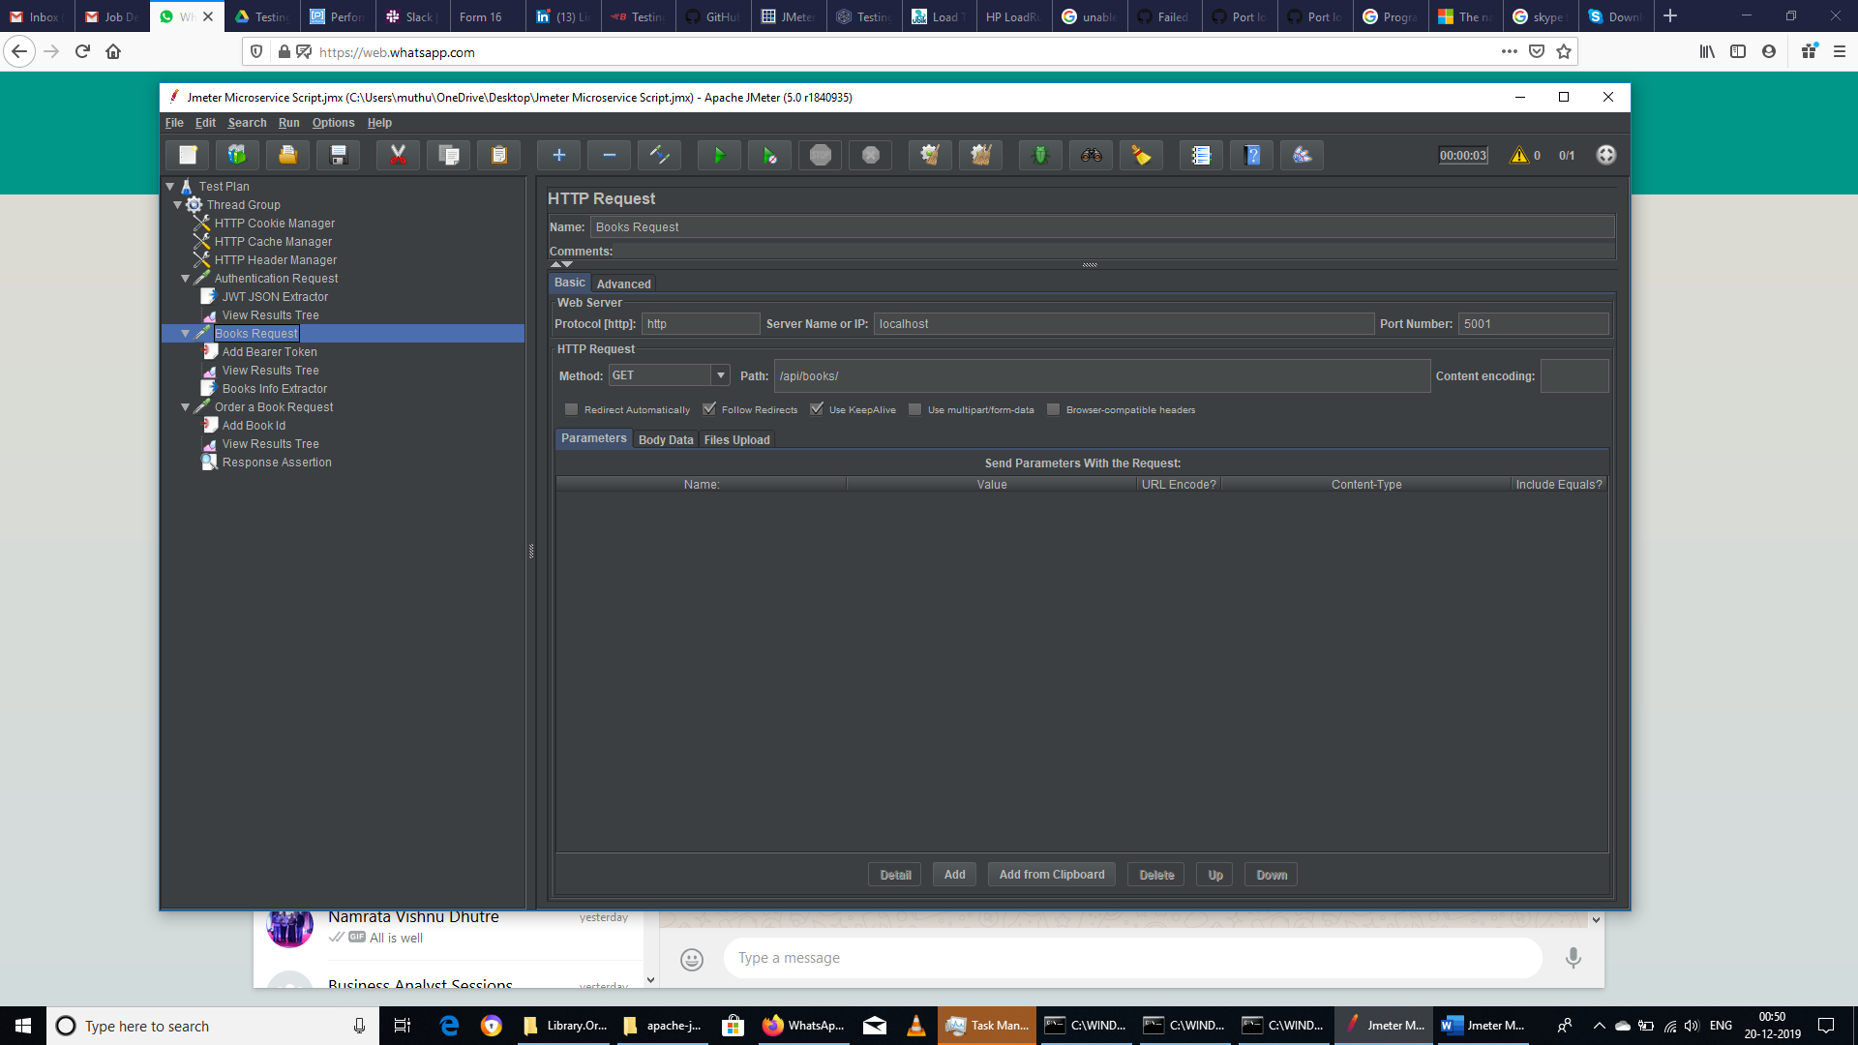
Response
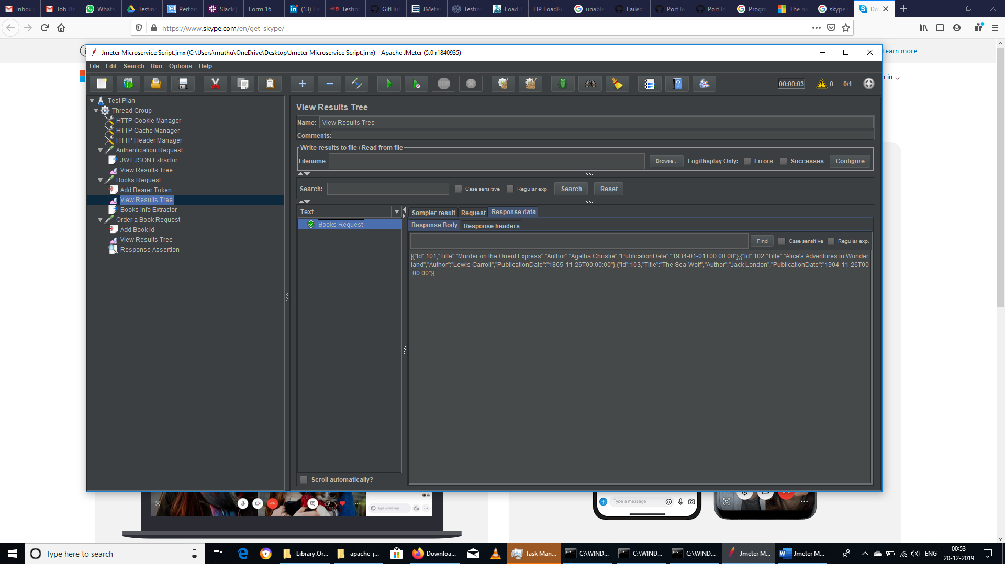
- Order a Book Request
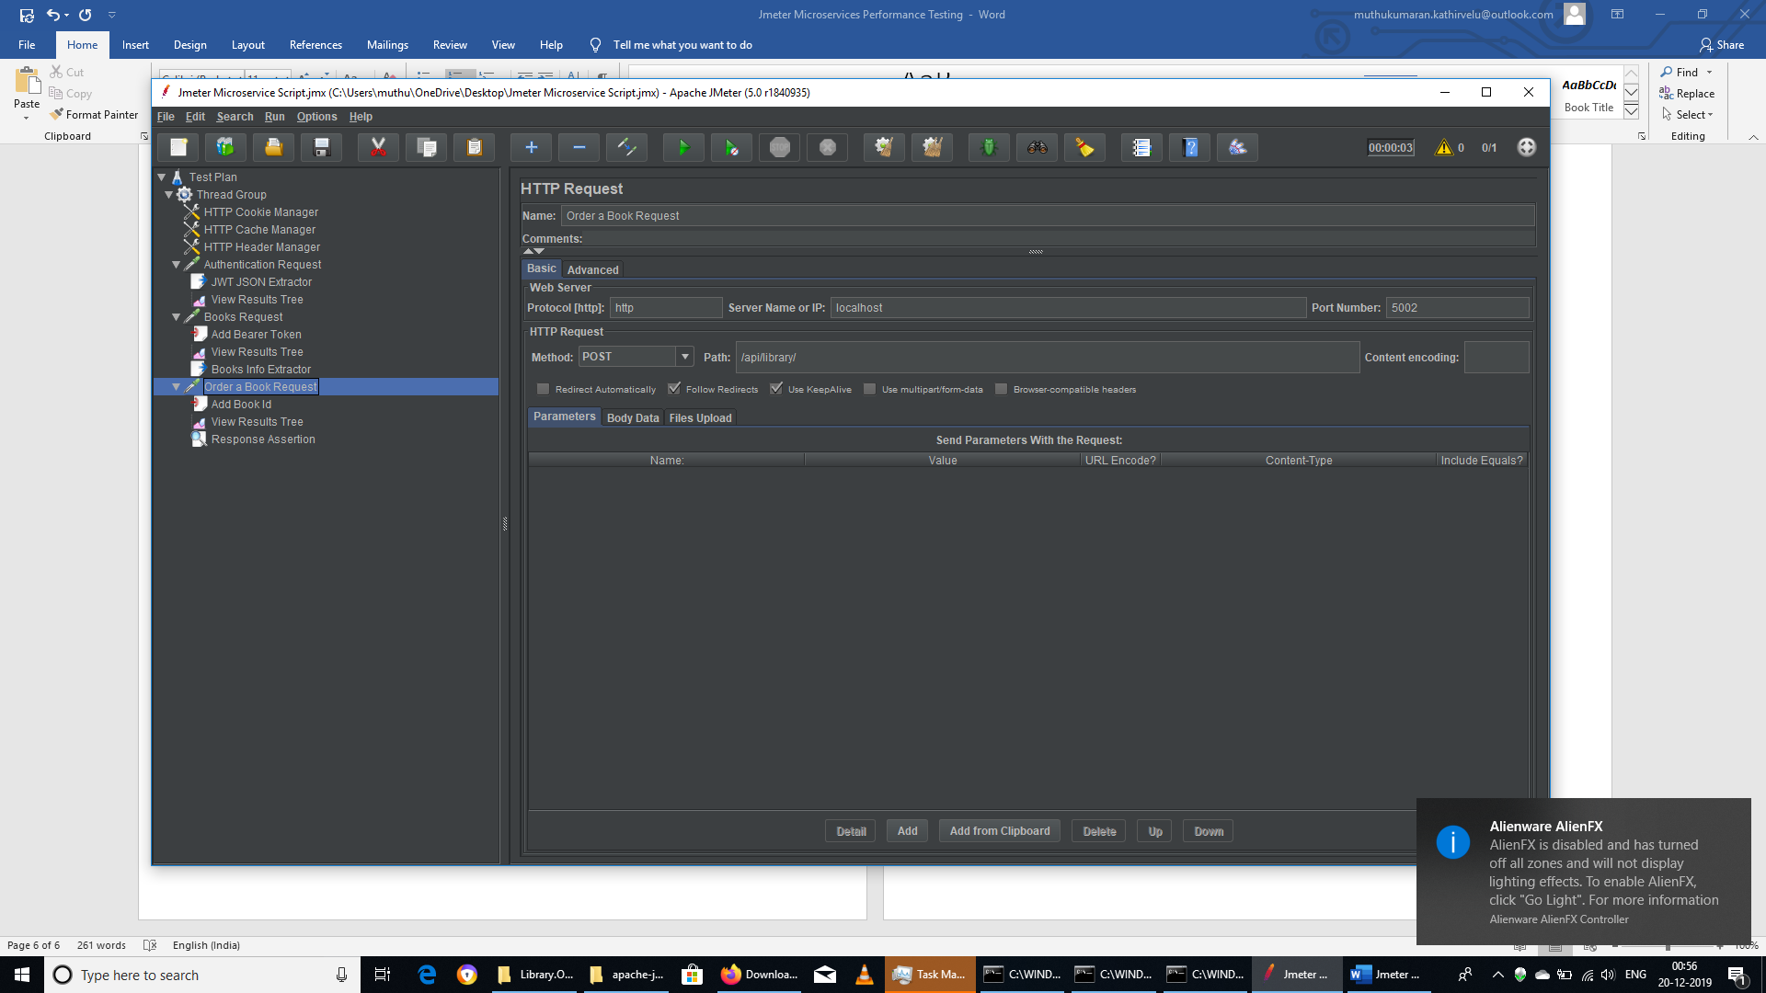
Response
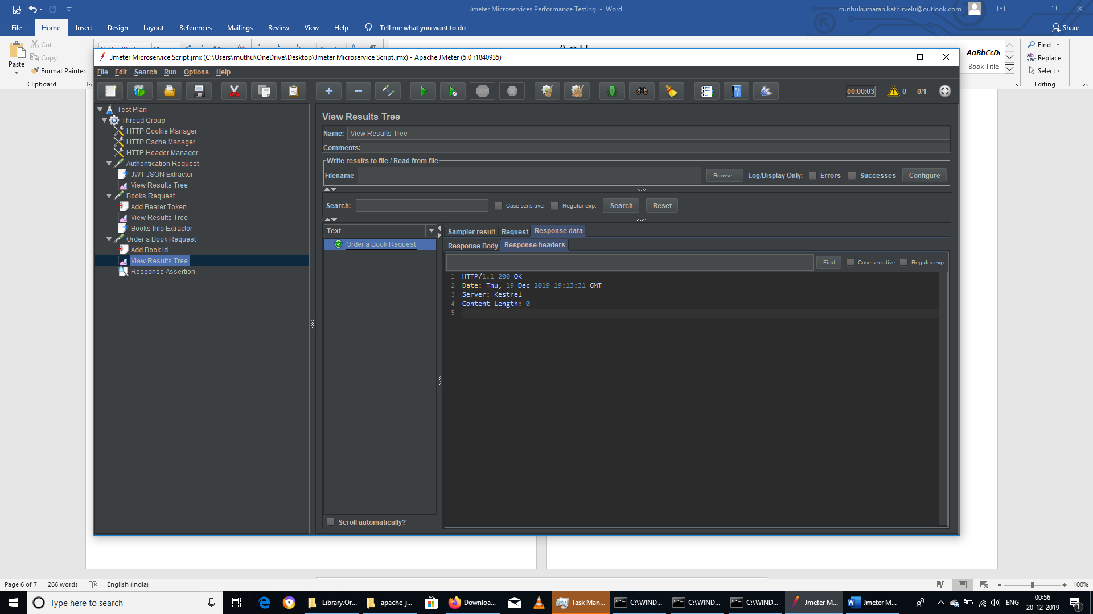
- Reference Links:
- https://www.blazemeter.com/blog/testing-microservices-with-jmeter/
- https://github.com/rtaum/Library/tree/master
- https://dotnet.microsoft.com/download
- https://github.com/dotnet/core/issues/2001
- https://github.com/dotnet/core/issues/948
- https://forums.asp.net/t/2103237.aspx?The+name+Directory+does+not+exist+in+the+current+context

