1. Are the HTML tags and elements the same thing ?

Ans: No HTML tags and elements are not the same thing, elements containing start or ending, attributes and everything within starting and closing HTML tags

1. What are tags and Attributes in HTML ?

Ans: To describe the characteristics of elements HTML tags are used, and attributes specified into opening tags attributes are “Name and value etc…”

1. What are void elements in HTML? With Example.

Ans: In HTML void elements have not any closing tags, they have only opening tags example : <link>, <a>, <br> etc..

1. What are HTML entities? With Example

Ans: HTML entities means that “reserved characters which are not present in the keyboard”a piece of line that begins with ampersand and end with the semicolon. Example: &amp; &lt; &copy;

1. What are different types of lists in HTML ? With example

Ans : There are three type of list : (1) ordered list (2) un-ordered list 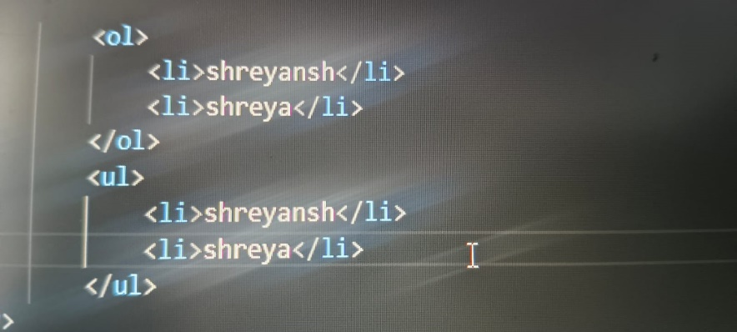

1. What is class attribute in HTML? With Example

Ans: class attribute is used for provide same classname to one or more-elements 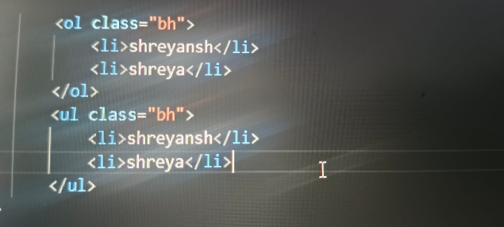

1. Whate is the difference between the id attribute and the class attribute of html elements ? with example

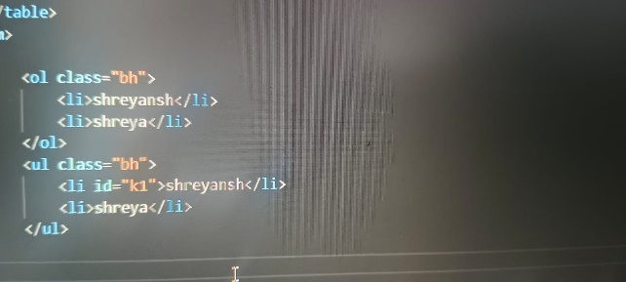Ans: class used for provide a class - name to one or more elements and id provides unique name to only one elements

1. What are various formatting tags in the html?

Ans : <b> , <strong> , <i>, <em> , <mark> , <small> , <del> , <ins>, <sub> , <sup>

1. How cell padding is different from cell spacing? with example

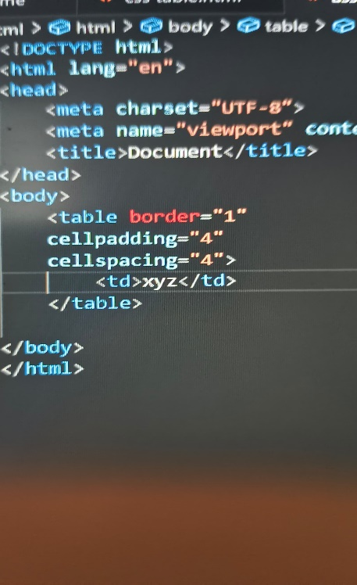Ans: cell padding is used to create a space between the border of table and content, cell spacing is used to create space between cells

1. How can we club two or more rows or columns into a single row or column in an HTML table? With Example

Ans. We can club two or more rows or column into single row or column in an html table.

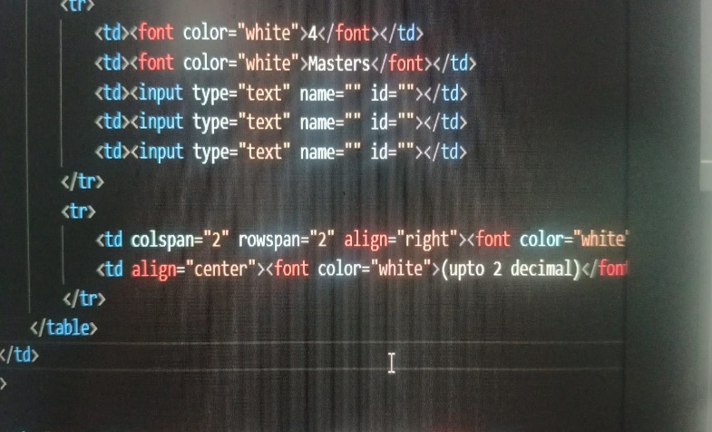

1. What is the difference between a block-level element and an inline element?

Ans. Block level element will cover 100% width and inline level element will cover only required width

1. 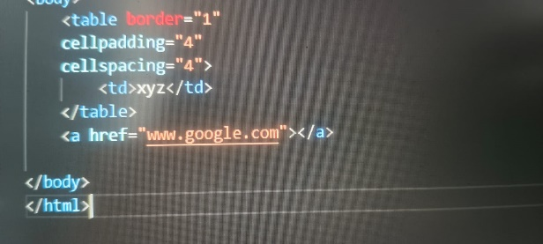How to create a Hyperlink in HTML? With Example.

Ans. We can create hyperlink using <a> tag, we can add URL using href = “” attribute

1. What is the use of an iframe tag? With Example.

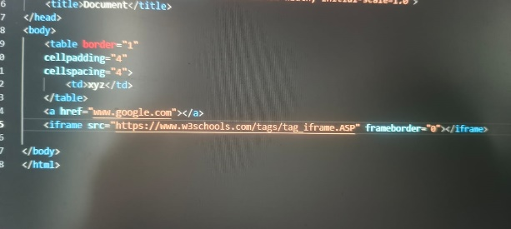Ans. Iframe tag is used for embed documents, videos, post from other platform

1. What is the use of a span tag? Explain with example?

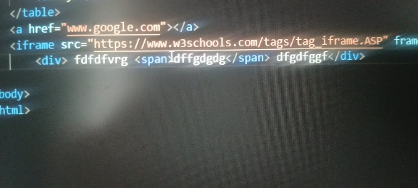Ans. Span tag is inline level tag, which is used for styling a text

1. How to insert a picture into a background image of a web page? With Example.

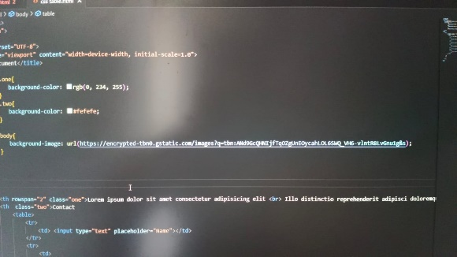Ans. We can insert image by using background-image:url( )

1. How are active links different from normal links?

Ans; normal links cannot be open, but we can open active links

1. What are the different tags to separate sections of text?

Ans. <br>,<div>,<p>,<span>,<blockquote>

1. What is SVG?

Ans. SVG stands for scalable vector graphics, used for displaying two dimensional graphics, charts, and issustrations on website

1. What is difference between HTML and XHTML?

Ans. HTML is used to display content, text based document, in graphical form form in the browser. XHTML is more strict and has strict syntax, and follows XML rules

1. What are logical and physical tags in HTML?

Ans ; physical tags provides physical appearance to the text, logical tags provides logical or semantic value to text

Physical tags :- <b>, <i>, <u>,<big>,<small>

Logical tags:- <var>,<strong>,<samp>,<ins>,<del>