1. **Task Description**

* Select the currency you want to convert from and the currency you want to convert to using the dropdown menus. The default amount is 1, but you can change it to any amount you want to convert.

1. 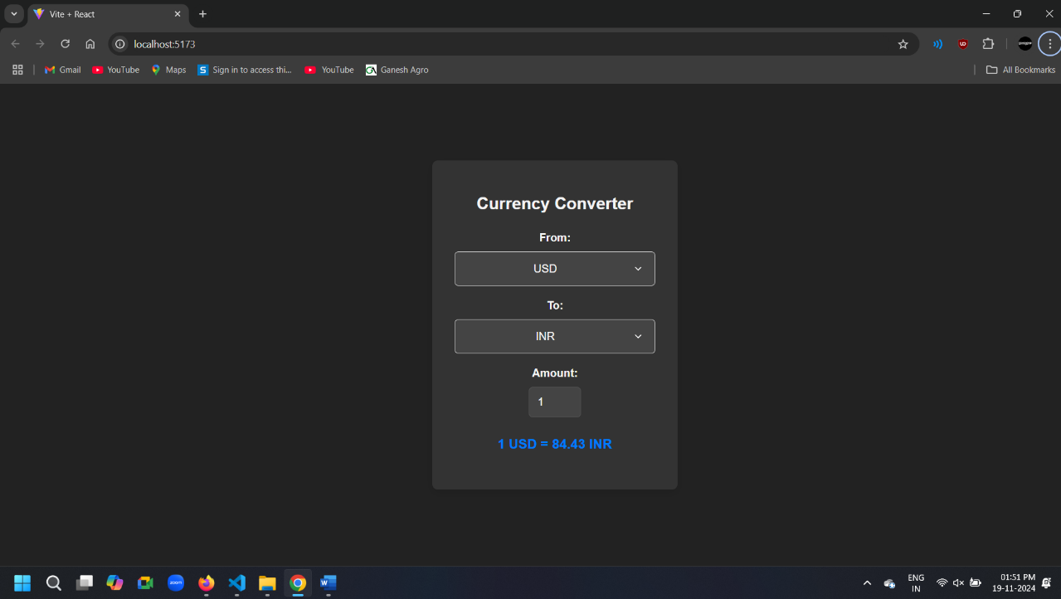**Task Output Screenshot**
2. **Widget Used in Task**

* Dropdowns: Used to select the "From" and "To" currencies. These are clickable lists where users can search and choose a currency.
* Input Field: Allows users to enter the amount they want to convert. It’s a number input field.
* Text Display: Used to show labels like "From" and "To" for currency selection, and the result of the conversion.
* Data: The ExchangeRate API provides real-time currency conversion rates, allowing the app to convert amounts accurately using the latest exchange rates.

1. **Link**

**Github:** [**https://github.com/bhargav4889/Task_No_1_MERN_Bhargav_Kachhela**](https://github.com/bhargav4889/Task_No_1_MERN_Bhargav_Kachhela)