1. **Task Description**

* The app displays the current theme, like "Current Mode: Light" or "Current Mode: Dark," at the top. A button below lets users switch between Light and Dark modes, with the text updating dynamically to show the next available option. Switching themes is quick and easy with just one click.

1. **Task Output Screenshot**

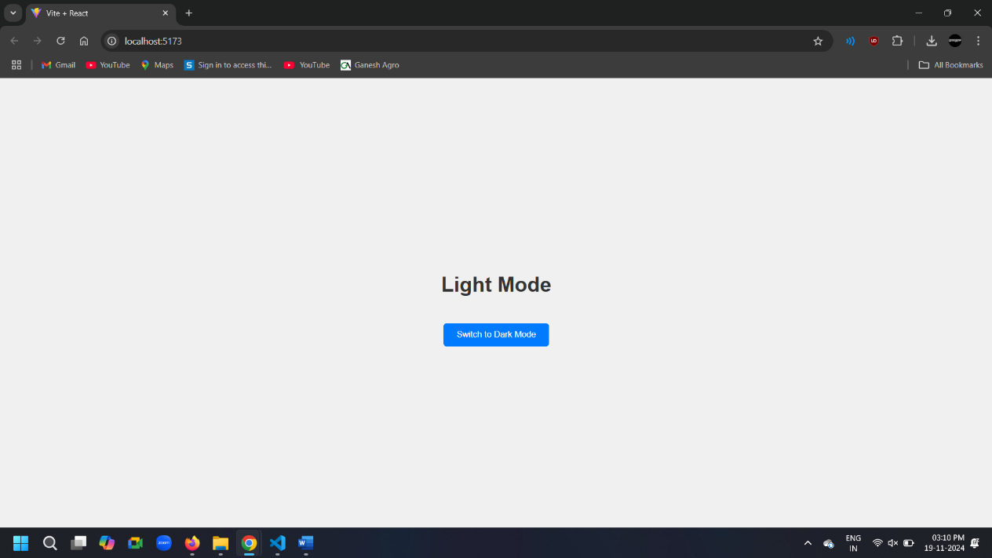**2.1 Light Mode**

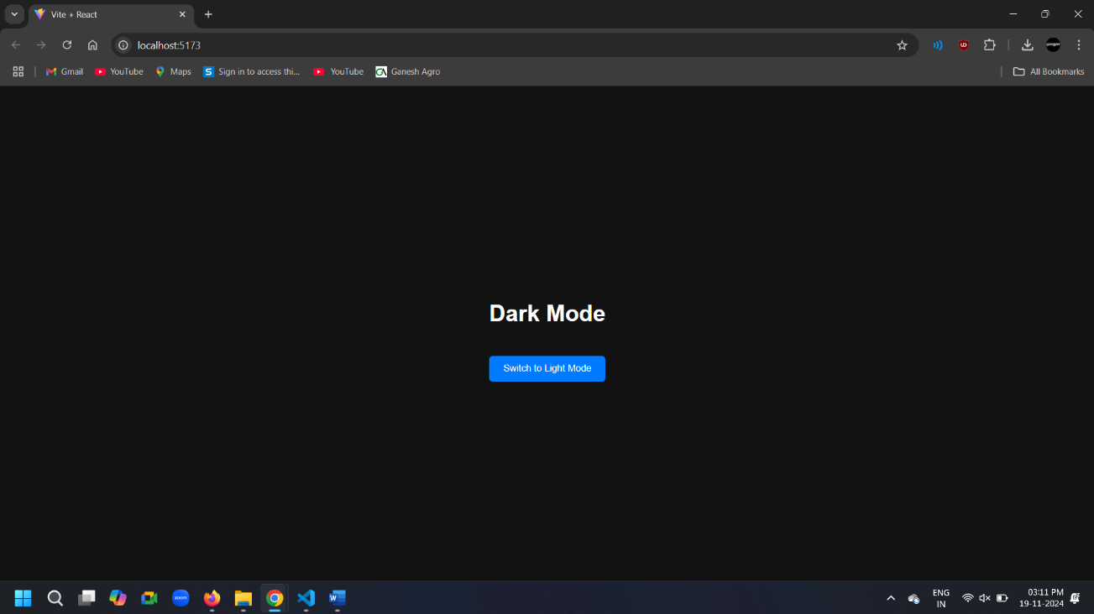**2.2 Dark Mode**

1. **Widget Used in Task**

* Button: Used to toggle between Light Mode and Dark Mode. The button dynamically updates its label based on the current theme (e.g., "Switch to Dark Mode" when in Light Mode).
* Text Display: Shows the current theme mode with a heading like “Light Mode” or “Dark Mode”. This text updates automatically when the theme changes.
* Local Storage: Saves the user’s selected theme so it stays the same even after refreshing or reopening the app for e.g. If the user switches to Dark Mode, the app will remember this choice.
* useState Hook: Manages the current theme (light or dark) in memory while the app is running.
* useEffect Hook: Automatically fetches the saved theme from Local Storage when the app starts.

1. **Link**

**GitHub:** [**https://github.com/bhargav4889/Task_No_2_MERN_Bhargav_Kachhela**](https://github.com/bhargav4889/Task_No_2_MERN_Bhargav_Kachhela)