1. **Task Description**

* In this task we use Free API is NewsAPI it provide top news fetch and show news details with images.

1. **Task Output Screenshot**

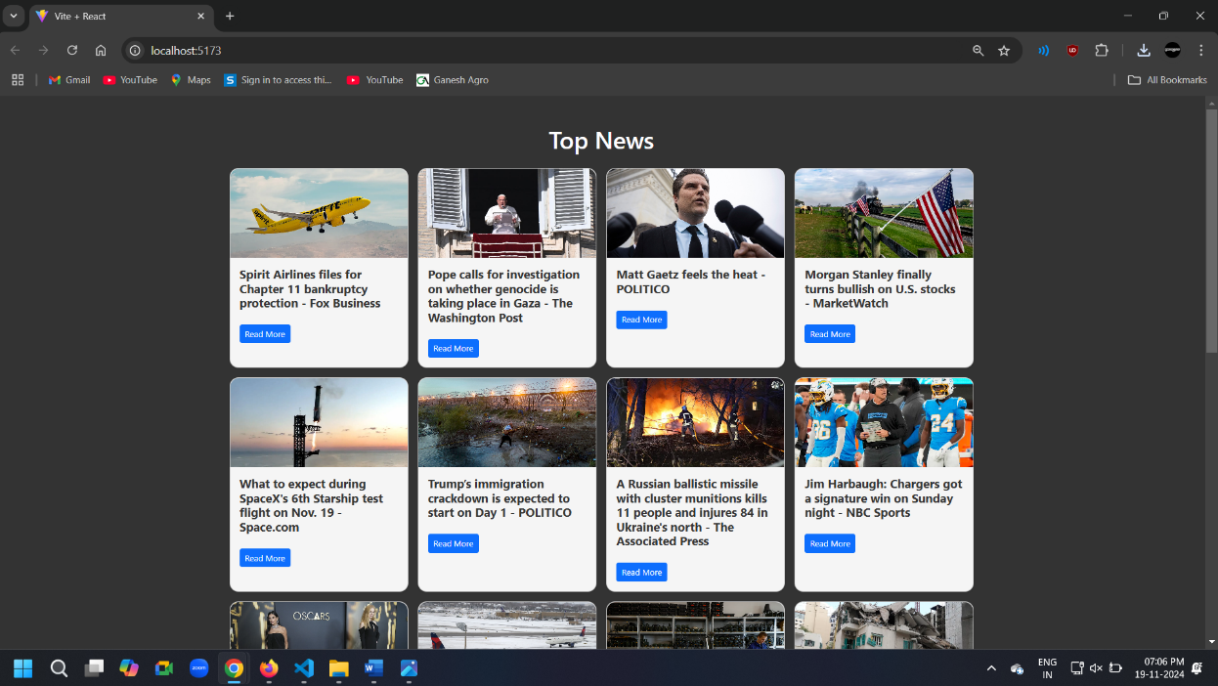**2.1 Screenshot**

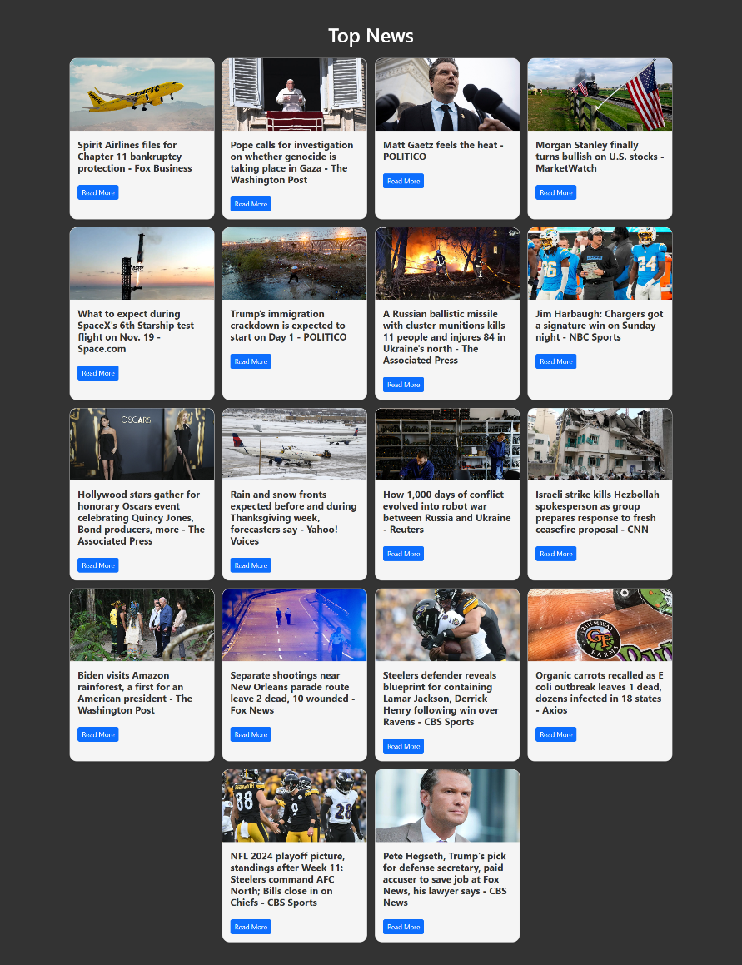**2.2 Full Screen Screenshot**

1. **Widget Used in Task**

* Button: Used as a "Read More" link in each news card. The button allows users to navigate to the full news article in a new tab. It is styled using Bootstrap classes for a professional look.
* Text Display: Displays the heading "Top News" at the top of the app, providing context for the news feed. The article titles are also displayed in bold text on each card.
* API (NewsAPI): Provides real-time top headlines, allowing the app to fetch and display the latest news articles dynamically. For example, articles include titles, images, and links to full stories.
* useState Hook: Manages the state for: articles (the fetched news articles),loading (loading status while fetching data), error (error messages in case of API failures).
* useEffect Hook: Fetches news articles from the API when the app loads. It also changes the page's background and text colors to provide a dark theme for better readability.

1. **Link**

**GitHub:** [**https://github.com/bhargav4889/Task_No_3_MERN_Bhargav_Kachhela**](https://github.com/bhargav4889/Task_No_3_MERN_Bhargav_Kachhela)