1. **Task Description**

* In this task we create three roles guest (by default), admin , user By Default page show is guest and one button login named click button show login page then enter username and password then check username and password role identify then redirect if admin then admin side or user then user side redirect

1. 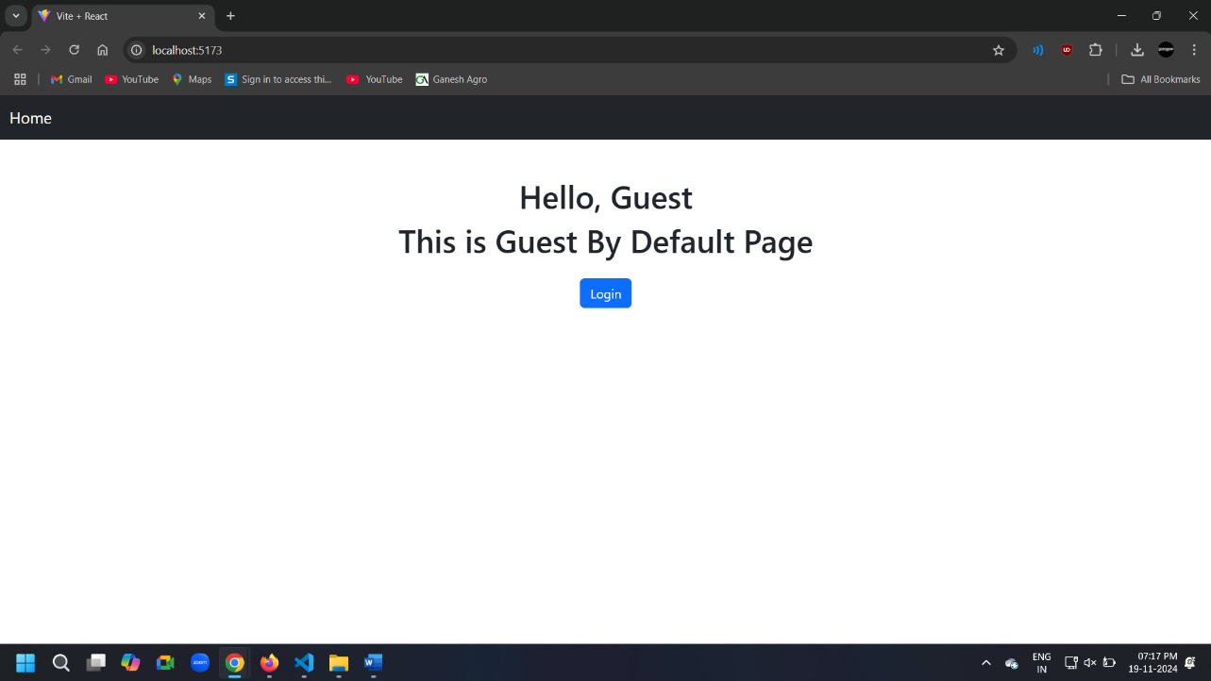**Task Output Screenshot**

**2.1 Default Page – Guest**

**2.2 Login Page**

**2.3 After Redirect Admin Side Dashboard**

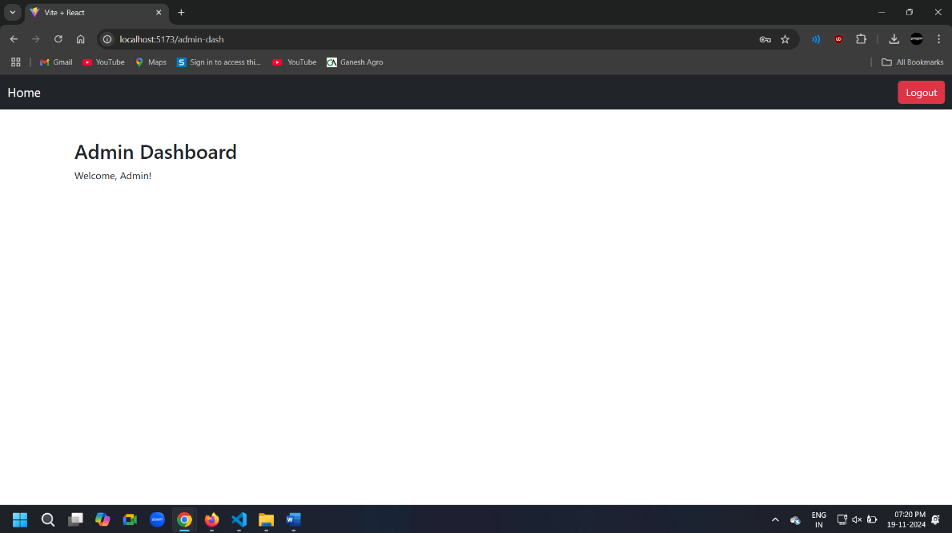

**2.4 After Login Then Home Page (Login As Admin)**

**2.5 After Redirect User Side Dashboard**

**2.6 After Login Then Home Page ( Login as User)**

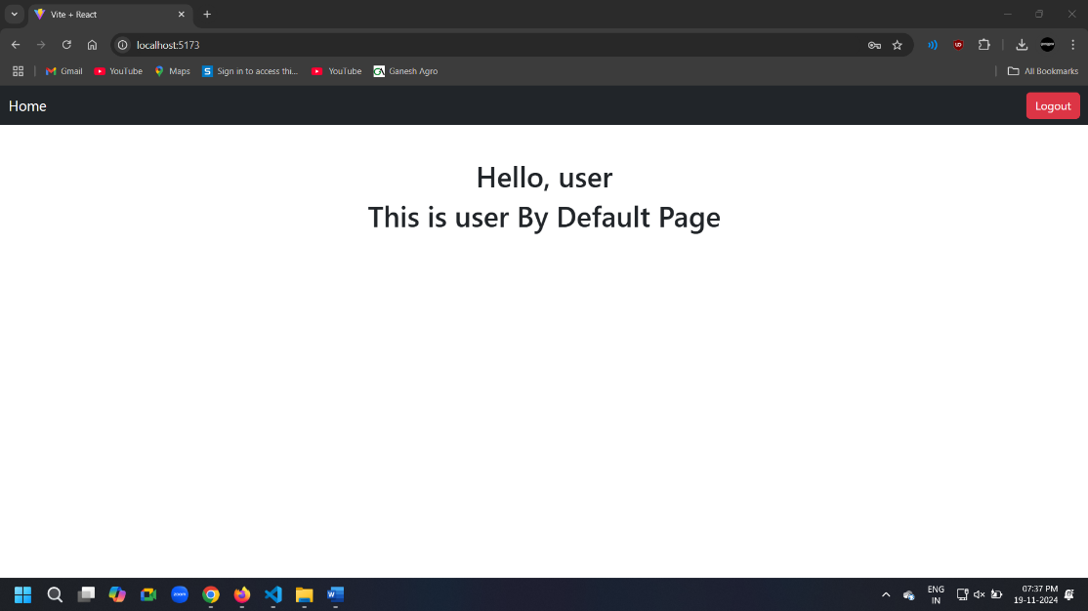

1. **Widget Used in Task**

* Input Fields: Two input fields are provided for the user to enter their username and password. These fields use the value and onChange attributes to update the respective state variables (username and password).
* Button: A single Login button submits the form.
* Text Display: The heading "Login" is shown prominently at the top of the form. Any error message, such as "Invalid username or password" or "Please fill in all fields," is displayed dynamically in red below the input fields.
* Static Data: A hardcoded authData array is used to validate usernames and passwords. Each user entry includes a username, password, and role.
* useState Hook: Manages the state for: username and password (user inputs),error (error messages).
* useNavigate Hook: Handles navigation after successful login: Redirects to /admin-dash for admin users. Redirects to /user-dash for user roles**.**

1. **Link**

**GitHub:** [**https://github.com/bhargav4889/Task_No_4_MERN_Bhargav_Kachhela**](https://github.com/bhargav4889/Task_No_4_MERN_Bhargav_Kachhela)