1. **Task Description**

* The app displays the current theme, like "Current Mode: Light" or "Current Mode: Dark," at the top. A button below lets users switch between Light and Dark modes, with the text updating dynamically to show the next available option. Switching themes is quick and easy with just one click.

1. **Task Output Screenshot**

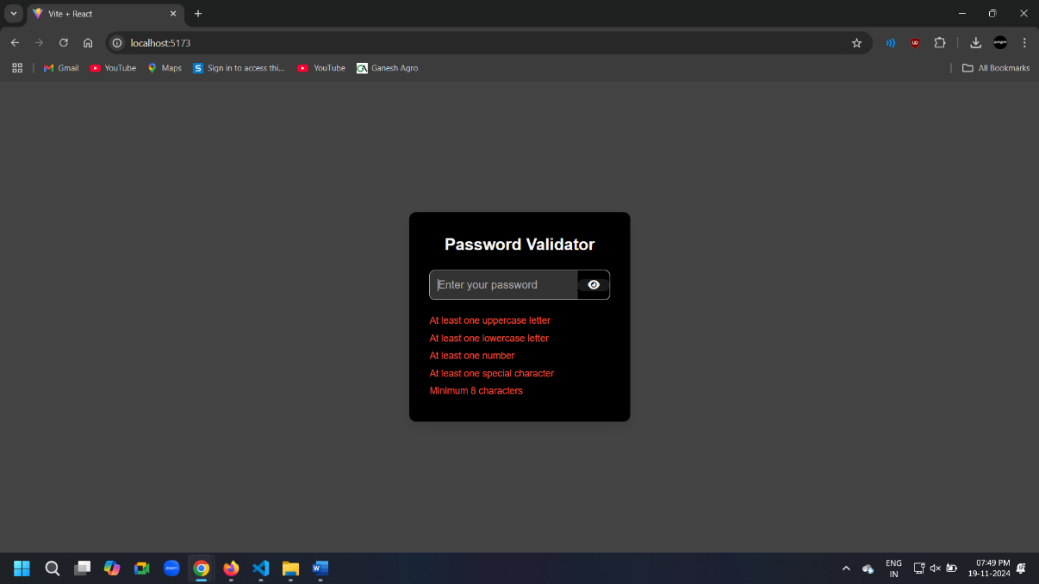 **2.1 Default Page**

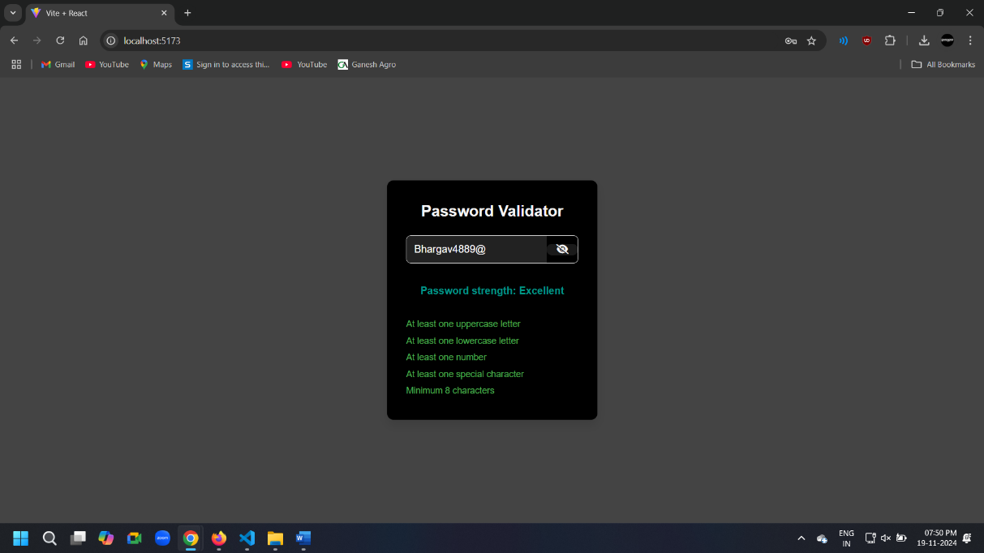**2.2 After Password Entered**

1. **Widget Used in Task**

* Input Field: A single input field allows the user to type their password. The type attribute dynamically changes between "text" and "password" based on the visibility toggle.
* Button: A toggle button (Eye/Eye Slash icon) allows users to show or hide the password text, enhancing usability.
* Password Strength Display: The password's strength is evaluated and displayed dynamically as: Not Valid, Good, Very Good, Strong, or Excellent. The strength text is styled with different colors (via CSS) to indicate progress visually.
* Validation List: A list displays password requirements dynamically. Each criterion (uppercase, lowercase, number, special character, and minimum length) changes between valid (green) and invalid (red) based on the entered password.
* getPasswordStrength Function: Evaluates the password's strength based on: Length, Presence of uppercase/lowercase letters, Numbers,Special characters. Returns a label for strength (e.g., "Good" or "Excellent").
* useState Hook: Manages the state for: password (user input), showPassword (password visibility toggle).

1. **Link**

**GitHub:** [**https://github.com/bhargav4889/Task_No_5_MERN_Bhargav_Kachhela**](https://github.com/bhargav4889/Task_No_5_MERN_Bhargav_Kachhela)