WEEK 4 REPORT
Supervised Learning Model Implementation
Adult Income Classification using Python and Scikit-learn
Classification target: income >50K vs <=50K

1. Introduction
Week 4 focused on building and evaluating supervised learning models using the cleaned Adult Income dataset. The objective was to predict whether an individual earns more than $50K per year based on demographic, education, employment and financial characteristics. The workflow covered data preparation, feature engineering, preprocessing, model training, validation, performance comparison, error analysis and model improvement.
Three classification algorithms were evaluated: Logistic Regression, Decision Tree and Random Forest. Multiple evaluation metrics were used because the income classes are imbalanced and accuracy alone does not fully describe how well the minority >50K class is identified.

2. Dataset and Target Definition
The project uses the cleaned Adult Income dataset prepared during the earlier weeks of the internship. The target variable is income, with two categories: <=50K and >50K. The income label was used only as the prediction target and was not included as an input feature.
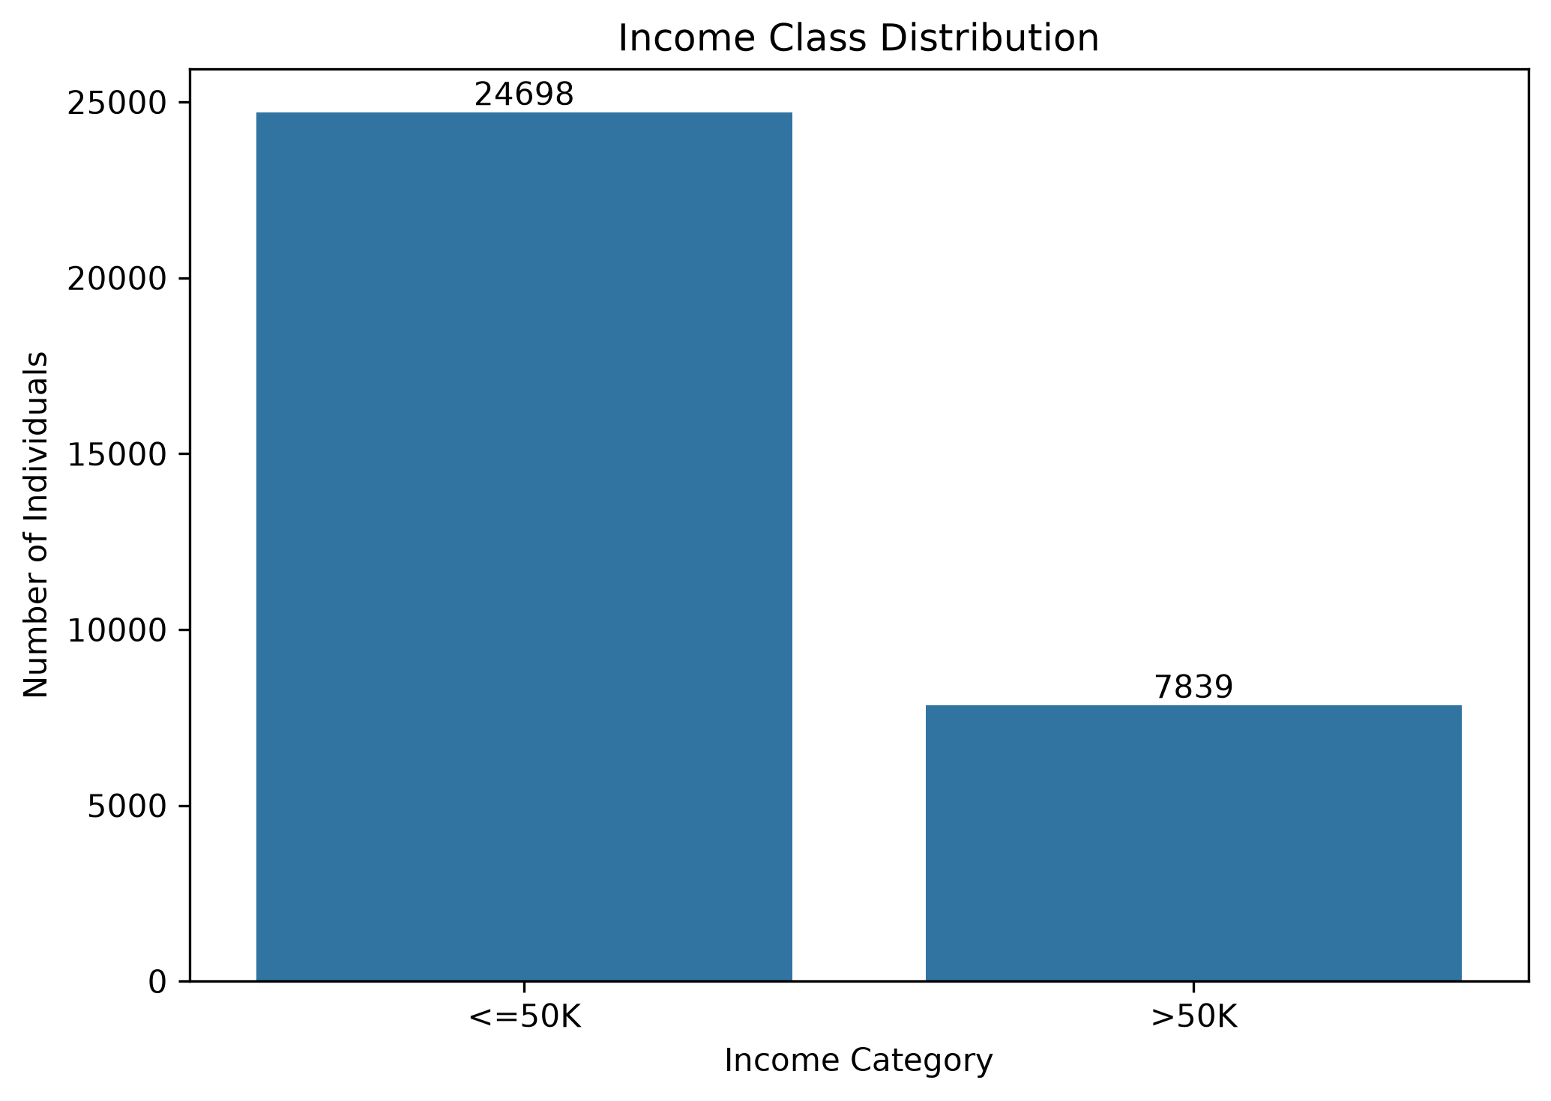
Figure 1. Target class distribution

3. Data Preparation and Feature Engineering
The dataset was separated into input variables and the income target. Numerical and categorical variables were handled through a preprocessing pipeline. Numerical variables were scaled where required, while categorical variables were converted using one-hot encoding so that they could be used by the machine-learning algorithms.
Feature engineering was also used to create additional information from existing variables. One of the engineered features was capital_total, representing combined capital-gain and capital-loss information. Another derived feature was work_hours_age_ratio. These features were retained for model training and were later evaluated through Random Forest feature importance.

4. Train-Test Split and Preprocessing
The data was divided into training and test sets so that the final model could be evaluated on observations that were not used during training. A Scikit-learn Pipeline was used to keep preprocessing and model training together, reducing the risk of applying transformations inconsistently between training and testing data.

5. Initial Model Comparison
Three supervised classification algorithms were trained using the same prepared data. The results below are based on the held-out test set.
Model | Accuracy | Precision | Recall | F1 Score | ROC-AUC
Logistic Regression | 85.79% | 74.19% | 62.88% | 68.07% | 91.47%
Decision Tree | 86.60% | 78.81% | 60.71% | 68.59% | 90.60%
Random Forest | 87.11% | 82.17% | 59.38% | 68.94% | 92.30%

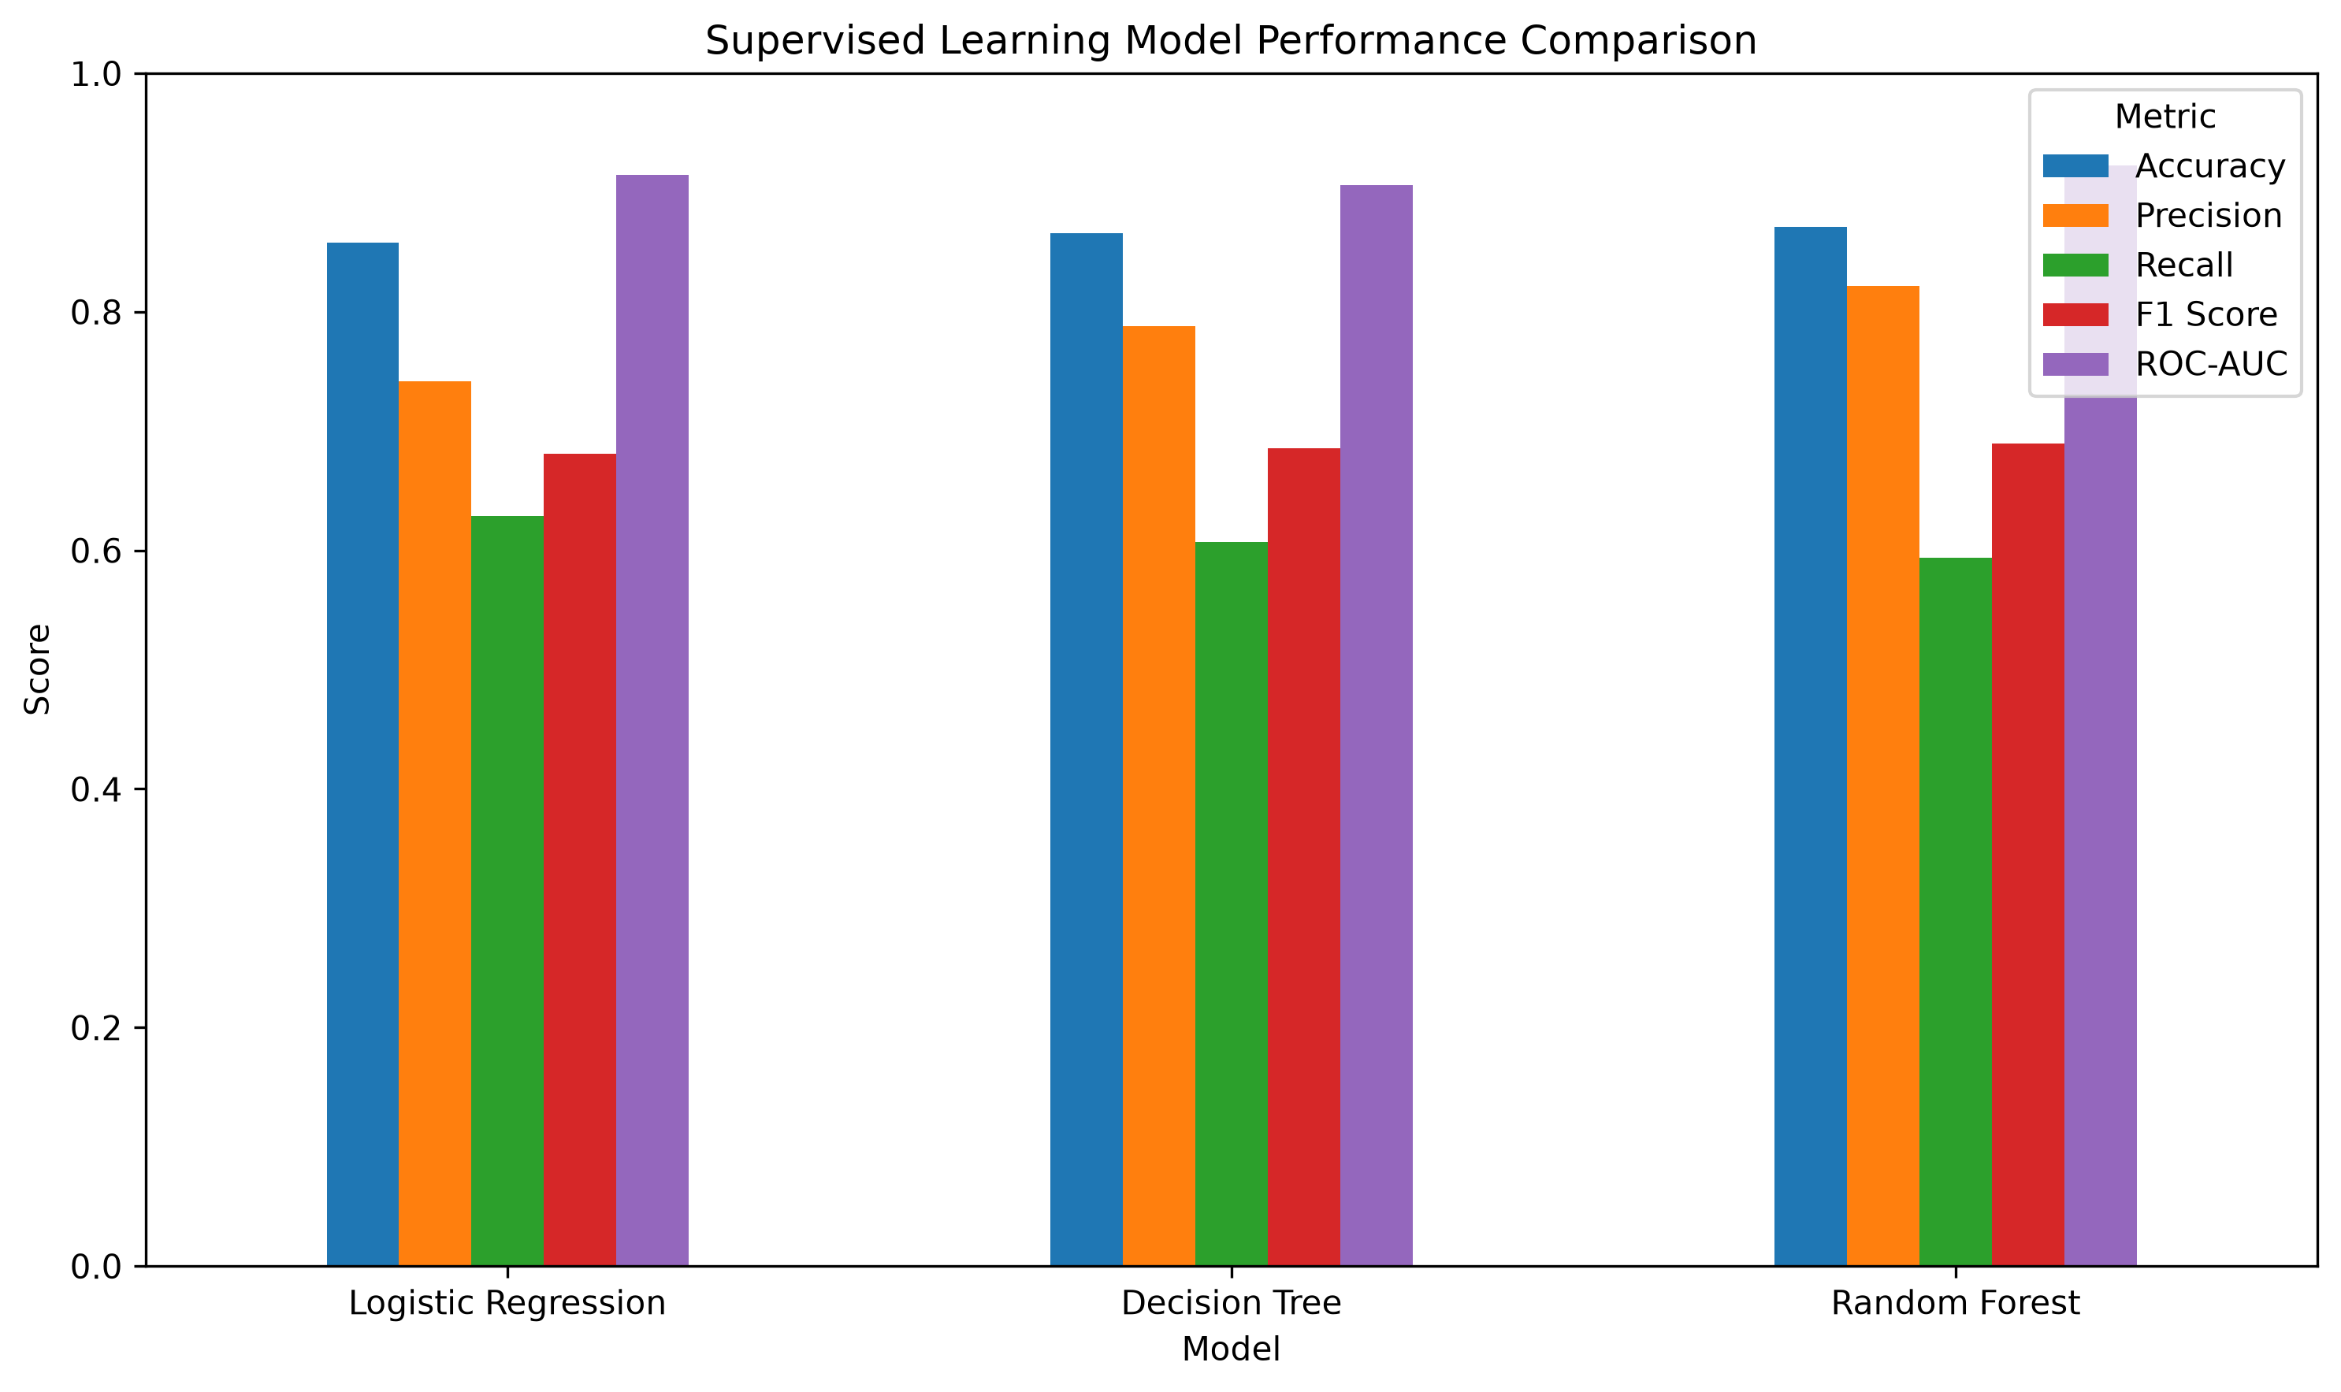
Figure 2. Performance comparison of the three initial models
Random Forest produced the highest test accuracy at 87.11%, the highest precision at 82.17%, the highest F1-score among the three initial models at 68.94%, and the highest ROC-AUC at 92.30%. Logistic Regression had the highest recall at 62.88%, while Decision Tree achieved 86.60% accuracy.

6. Cross-Validation
Five-fold cross-validation was applied to the training data for the Random Forest model. This was used to check whether performance remained reasonably stable across different subsets of the training data.
Metric | Mean | Std Dev
Accuracy | 86.07% | 0.28%
Precision | 79.92% | 1.16%
Recall | 56.37% | 0.60%
F1 Score | 66.11% | 0.59%
ROC-AUC | 91.64% | 0.47%

The mean cross-validation accuracy was 86.07% and mean ROC-AUC was 91.64%. The standard deviation for ROC-AUC was only 0.47 percentage points, while the accuracy standard deviation was 0.28 percentage points. These relatively small variations indicate that the model behaved consistently across the five folds.

7. Confusion Matrix and Classification Errors
The final Random Forest confusion matrix provides a class-level view of the predictions. It contains 4,738 correctly classified <=50K observations, 202 <=50K observations predicted as >50K, 637 >50K observations predicted as <=50K, and 931 correctly classified >50K observations.
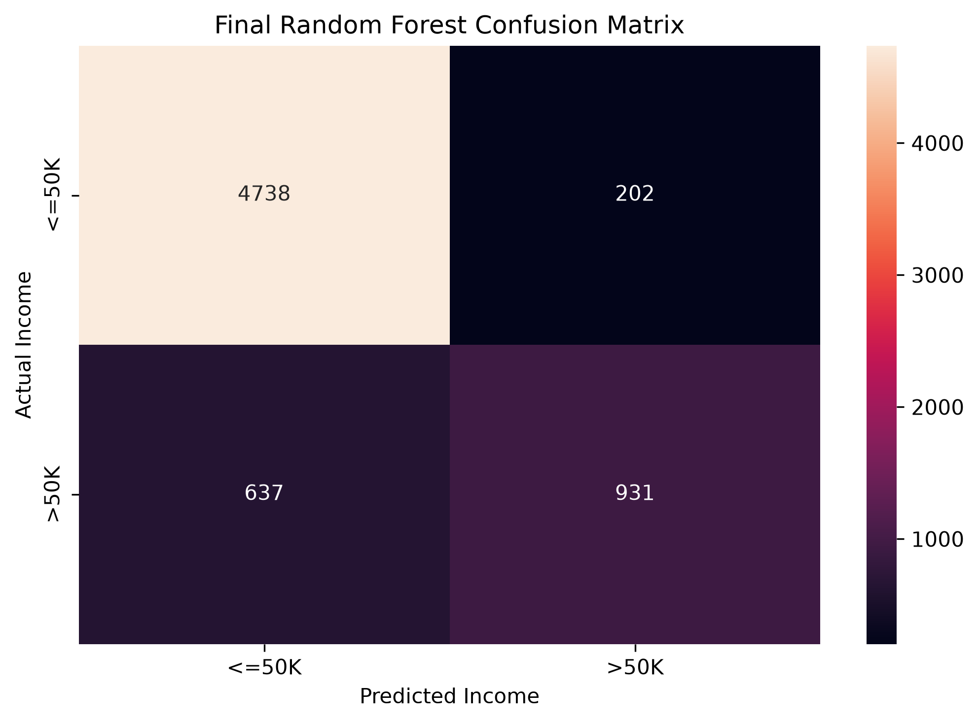
Figure 3. Final Random Forest confusion matrix
The 637 false negatives are important because they represent individuals who actually earn >50K but were classified as <=50K. This helps explain the relatively modest 59.38% recall for the >50K class.

8. ROC Curve Analysis
ROC curves were used to compare the models' ability to distinguish between the two income categories across different classification thresholds.
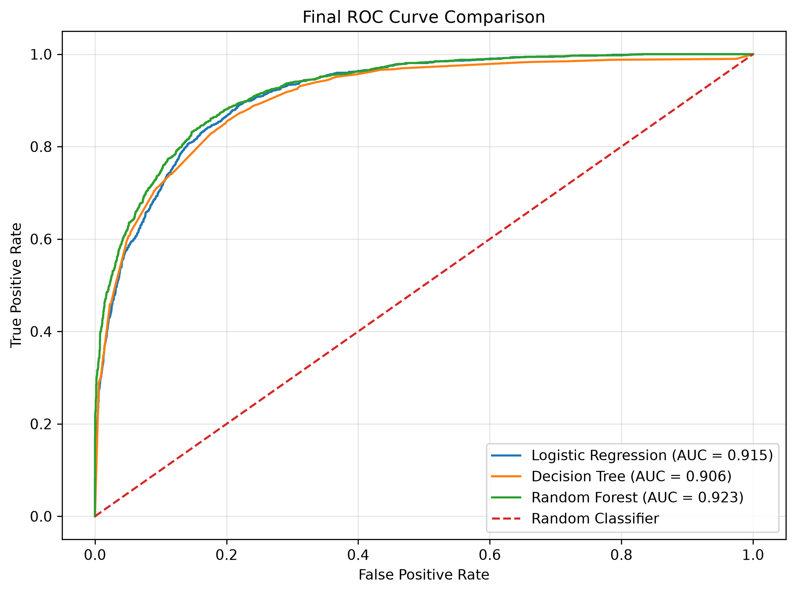
Figure 4. Final ROC curve comparison
Random Forest achieved a test ROC-AUC of 0.9230, compared with 0.9147 for Logistic Regression and 0.9060 for Decision Tree. This indicates that Random Forest provided the strongest overall class-discrimination ability on the test set.

9. Random Forest Feature Importance
Feature importance was extracted from the fitted Random Forest after preprocessing. Because categorical variables were one-hot encoded, the ranking contains both numerical variables and transformed categorical indicators.
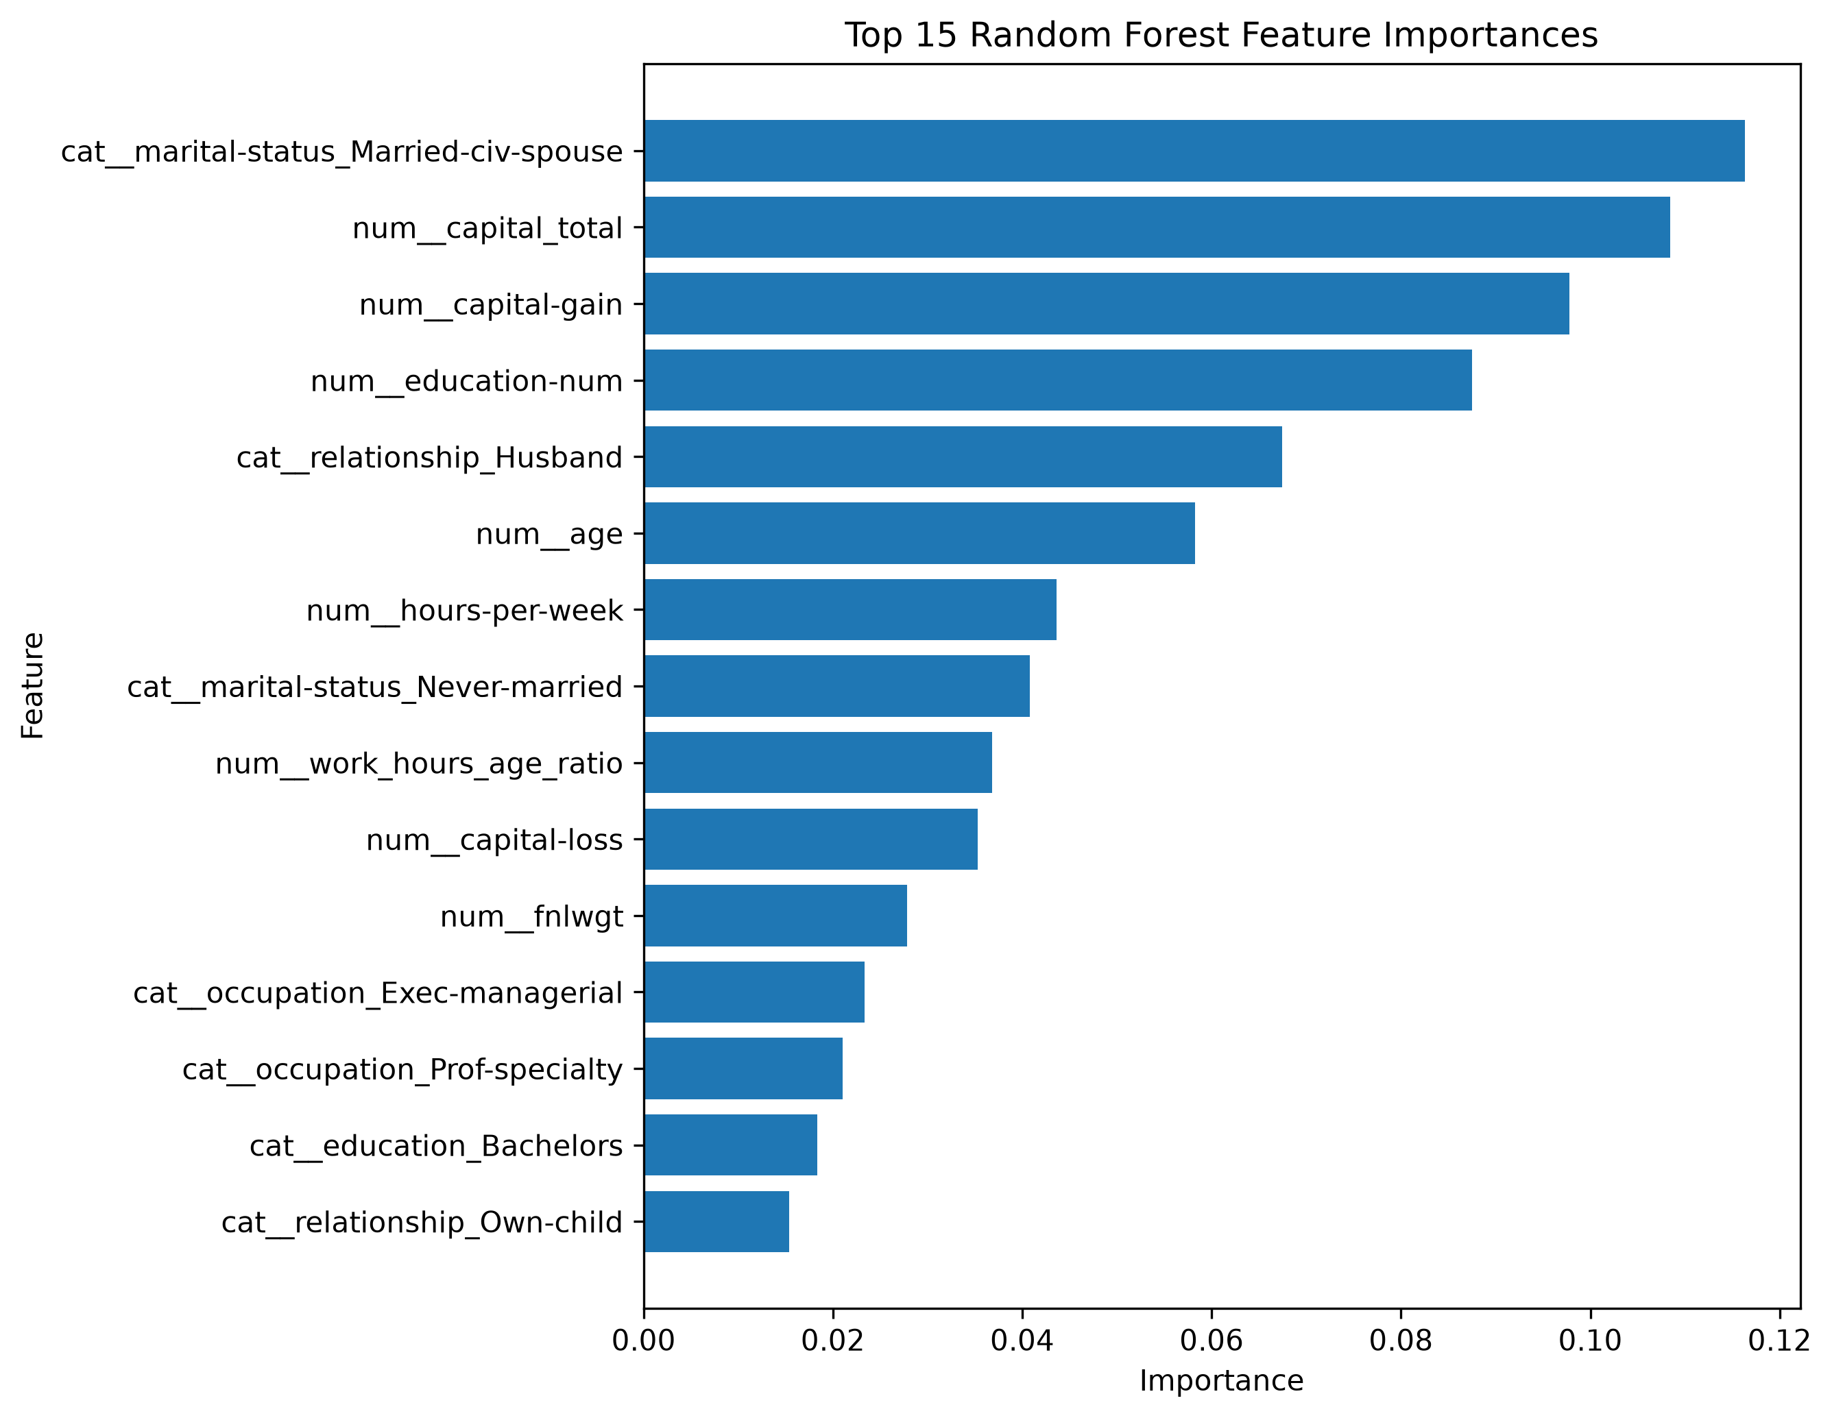
Figure 5. Top Random Forest feature importances
Rank | Feature | Importance
1 | Married-civ-spouse | 0.1163
2 | capital_total | 0.1085
3 | capital-gain | 0.0978
4 | education-num | 0.0875
5 | relationship_Husband | 0.0675
6 | age | 0.0582
7 | hours-per-week | 0.0436
8 | Never-married | 0.0408
9 | work_hours_age_ratio | 0.0368
10 | capital-loss | 0.0353

The strongest feature was Married-civ-spouse with an importance of 0.1163. It was followed by capital_total at 0.1085, capital-gain at 0.0978 and education-num at 0.0875. The engineered work_hours_age_ratio feature also appeared in the top ten with an importance of 0.0368. These values indicate predictive usefulness within this dataset and should not be interpreted as evidence of causation.

10. Error Analysis
Error analysis compared the average numerical characteristics of correctly and incorrectly classified observations. Incorrect predictions had a higher average age (43.42 versus 38.04), higher education-num (10.81 versus 9.96), and higher hours-per-week (44.95 versus 39.84). In contrast, correct predictions had much higher average capital-gain (1,277.30 versus 164.16) and capital_total (1,370.82 versus 225.26).
Feature | Correct Predictions | Incorrect Predictions
age | 38.04 | 43.42
fnlwgt | 191,544.17 | 183,792.09
education-num | 9.96 | 10.81
capital-gain | 1,277.30 | 164.16
capital-loss | 93.51 | 61.10
hours-per-week | 39.84 | 44.95
capital_total | 1,370.82 | 225.26
work_hours_age_ratio | 1.17 | 1.11

These differences suggest that some observations have combinations of characteristics that are harder for the model to classify correctly. The analysis also shows why error-level investigation adds useful information beyond aggregate metrics.

11. Model Improvement Using Class Weighting
Because the >50K class is less frequent, a class-weighted Random Forest was tested using class_weight='balanced'. The aim was to improve recall for the minority class.
Metric | Original RF | Balanced RF | Change
Accuracy | 87.11% | 81.78% | -5.33 pp
Precision | 82.17% | 58.08% | -24.09 pp
Recall | 59.38% | 87.56% | +28.18 pp
F1 Score | 68.94% | 69.84% | +0.90 pp
ROC-AUC | 92.30% | 92.33% | +0.03 pp

The balanced model increased recall from 59.38% to 87.56%, a gain of 28.18 percentage points. However, precision fell from 82.17% to 58.08% and accuracy fell from 87.11% to 81.78%. F1-score increased only slightly from 68.94% to 69.84%, while ROC-AUC remained almost unchanged at 92.33%.
This experiment demonstrates a clear precision-recall trade-off. The balanced model is useful when missing >50K cases is considered more costly, but the original Random Forest provides the better general-purpose balance of accuracy and precision.

12. Final Model Selection
The original Random Forest was selected as the final general-purpose model. On the test set it achieved 87.11% accuracy, 82.17% precision, 59.38% recall, 68.94% F1-score and 92.30% ROC-AUC.
The five-fold cross-validation results also supported the stability of the model, with mean accuracy of 86.07% and mean ROC-AUC of 91.64%. The balanced Random Forest is retained as an alternative when high recall for the >50K class is the primary objective.

13. Model Strengths
- Strong overall test accuracy of 87.11%.
- High precision of 82.17% for the >50K class.
- Highest ROC-AUC among the three initial models at 92.30%.
- Reasonably stable five-fold cross-validation performance.
- Ability to model non-linear relationships and interactions between variables.
- Feature-importance output provides an interpretable ranking of predictive signals.

14. Model Limitations
- Recall for the >50K class was 59.38%, so a substantial number of higher-income observations were missed.
- The dataset contains imbalanced income classes, which affects interpretation of accuracy.
- Feature importance indicates predictive usefulness, not causation.
- The model is dependent on the variables and population represented by the Adult dataset.
- The balanced model showed that improving minority-class recall can substantially reduce precision and accuracy.

15. Possible Future Improvements
- Perform systematic hyperparameter tuning using Grid Search or Randomized Search.
- Explore threshold tuning to obtain a more suitable precision-recall trade-off.
- Investigate additional feature engineering and interaction features.
- Evaluate other ensemble methods such as Gradient Boosting or XGBoost.
- Use model explainability techniques for more detailed individual-prediction analysis.
- Validate the final approach on newer or independent datasets before practical deployment.

16. Conclusion
This project implemented a complete supervised learning workflow for predicting whether an individual earns more than $50K using the Adult Income dataset. The work covered preprocessing, feature engineering, train-test evaluation, multiple classification algorithms, cross-validation, confusion-matrix analysis, ROC analysis, feature importance, error analysis and model improvement.
Random Forest provided the strongest overall initial performance, reaching 87.11% accuracy and 92.30% ROC-AUC on the test set. The analysis also showed that marital status, capital-related variables, education, relationship, age and working hours were important predictive signals. The balanced Random Forest experiment demonstrated that recall could be increased substantially, but only with a considerable reduction in precision and accuracy.
Overall, the project demonstrates that model selection should be based on the practical objective and multiple evaluation metrics rather than accuracy alone. The final model is suitable as an analytical baseline, while further tuning and external validation would be required before using it in a real-world decision system.

