Adult Income Prediction and Data Science Analysis
Week 6 — Integrative Capstone Project and Evaluation

End-to-End Python Data Science, Machine Learning and Deep Learning Pipeline

Internship Capstone Report

1. Executive Summary
This final capstone integrates the complete data science workflow developed throughout the six-week internship using the Adult Income dataset. The project combines data preparation, exploratory data analysis, unsupervised learning, supervised machine learning, and deep learning into a single analytical pipeline.
The primary objective is to understand factors associated with income classification and predict whether an individual belongs to the `<=50K` or `>50K` annual income category.
The project evaluates multiple traditional machine-learning models along with a neural network. The final neural network achieved 83.06% accuracy, 60.49% precision, 85.54% recall, 70.87% F1-score, and 91.90% ROC-AUC.
The analysis demonstrates that model selection depends on the application objective. Random Forest provided stronger overall accuracy and precision, while the neural network provided strong recall for the minority `>50K` class.

2. Problem Statement
Income classification is a useful example of a binary classification problem involving demographic, educational, employment, and financial information. The goal of this project is to develop a complete data science workflow capable of analyzing the factors associated with income and predicting whether an individual's annual income is greater than $50K.
The problem is challenging because the target classes are imbalanced. There are substantially more observations in the `<=50K` category than in the `>50K` category. Therefore, model performance must be evaluated using multiple metrics rather than accuracy alone.

3. Dataset and Data Preparation
The project uses the cleaned Adult Income dataset developed during the earlier stages of the internship. The final dataset contains 32,537 observations and 15 original variables, with `income` serving as the target variable.
The dataset contains demographic variables such as age, sex, race, and relationship; educational variables such as education and education number; employment variables such as workclass, occupation, and hours per week; and financial variables including capital gain and capital loss.

Target Distribution
The target distribution contains 24,698 individuals in the `<=50K` category and 7,839 individuals in the `>50K` category. This corresponds to approximately 75.91% and 24.09%, respectively.
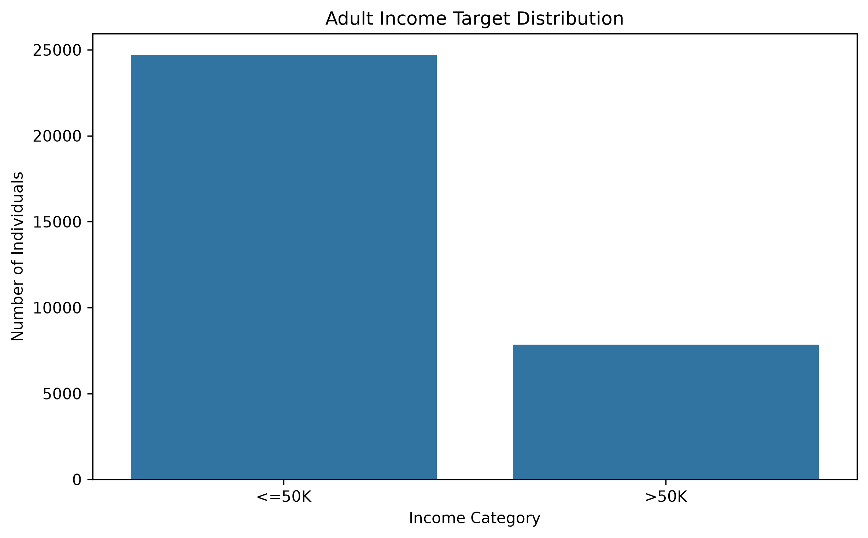
Figure 1. Distribution of the Adult Income target classes.

4. Exploratory Data Analysis
Exploratory data analysis was performed to identify patterns and relationships that could help explain income classification before building predictive models.

4.1 Education and Income
Educational attainment showed a meaningful association with income. Education levels associated with higher qualifications generally contained a larger proportion of individuals earning more than $50K.
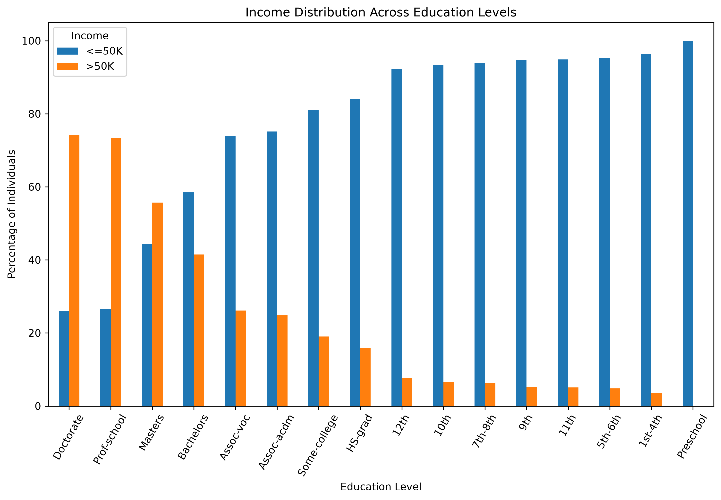
Figure 2. Income distribution across education levels.

4.2 Age and Income
The higher-income group generally showed an older age distribution. This pattern may reflect differences in work experience, career progression, and earning potential.
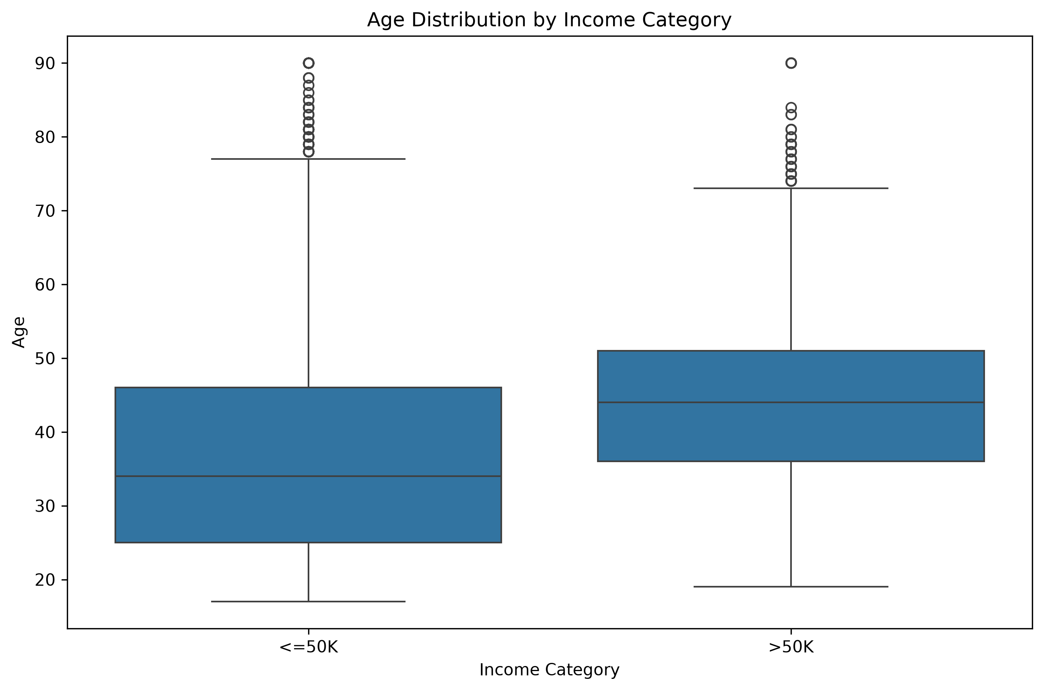
Figure 3. Age distribution by income category.

4.3 Working Hours and Income
Individuals in the higher-income category generally showed higher weekly working hours. Working hours therefore provide useful information for income classification, although they cannot independently determine income.
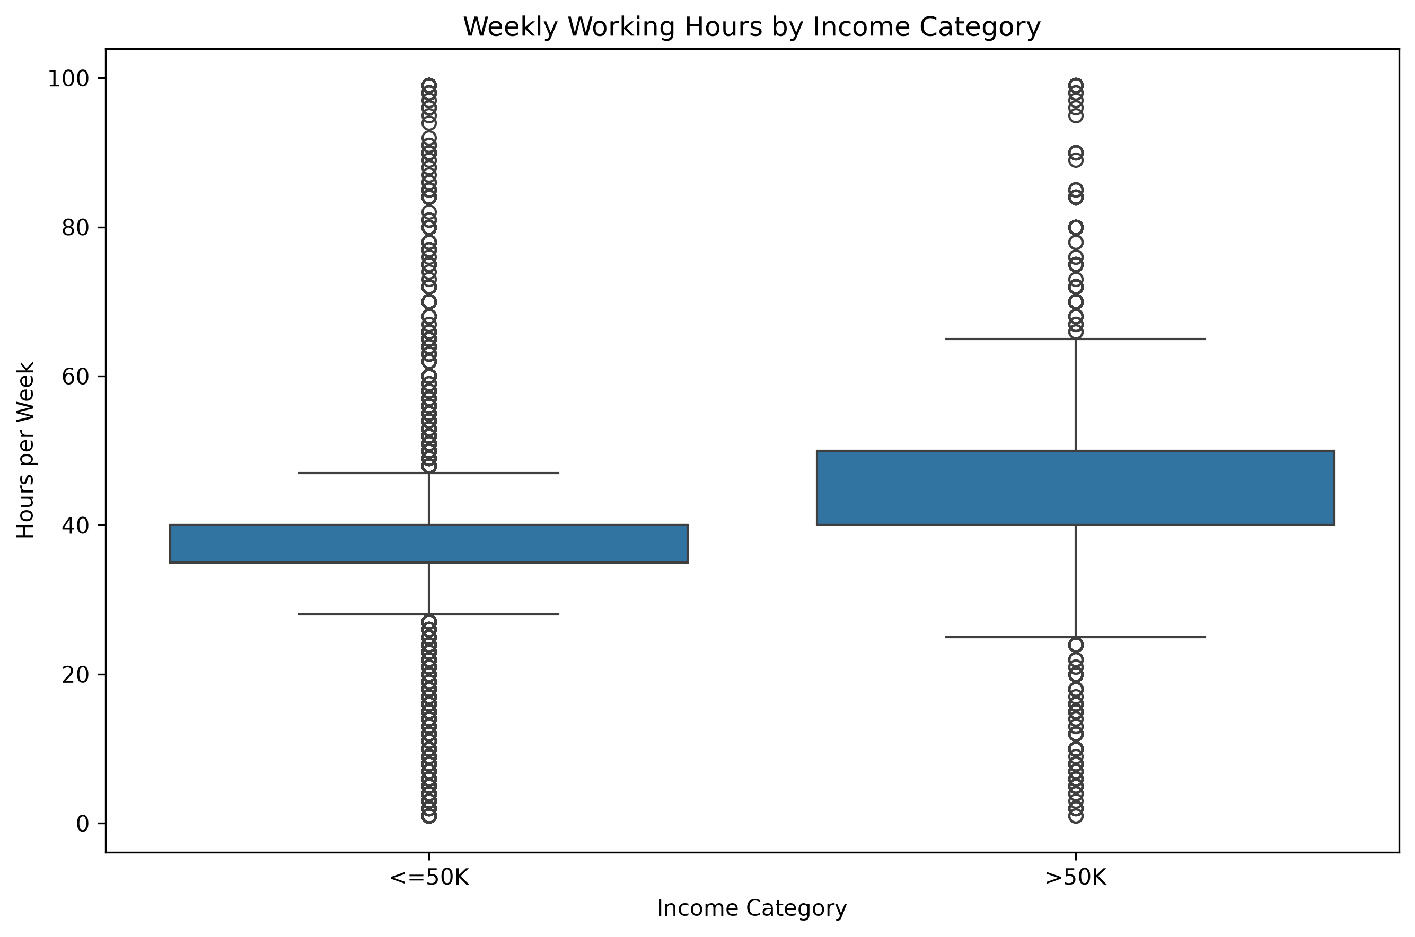
Figure 4. Weekly working hours by income category.

5. Unsupervised Learning — K-Means and PCA
K-Means clustering was used to identify naturally occurring groups within the dataset. The clustering stage used age, education number, hours per week, capital gain, and capital loss.
The features were standardized before clustering because they operate on different numerical scales. Silhouette-score analysis supported the selection of K=2.
The resulting clusters showed meaningful differences. One smaller cluster contained approximately 1,484 observations, while the larger cluster contained approximately 31,053 observations.
The smaller cluster had an average age of approximately 41.63 years, education number of 10.99, and 43.36 working hours per week. Approximately 51.95% of this group belonged to the `>50K` category.
The larger cluster had an average age of approximately 38.44 years, education number of 10.04, and 40.30 working hours per week. Approximately 22.76% belonged to the `>50K` category.
This represents a difference of approximately 29.19 percentage points in the proportion of higher-income individuals between the two clusters.
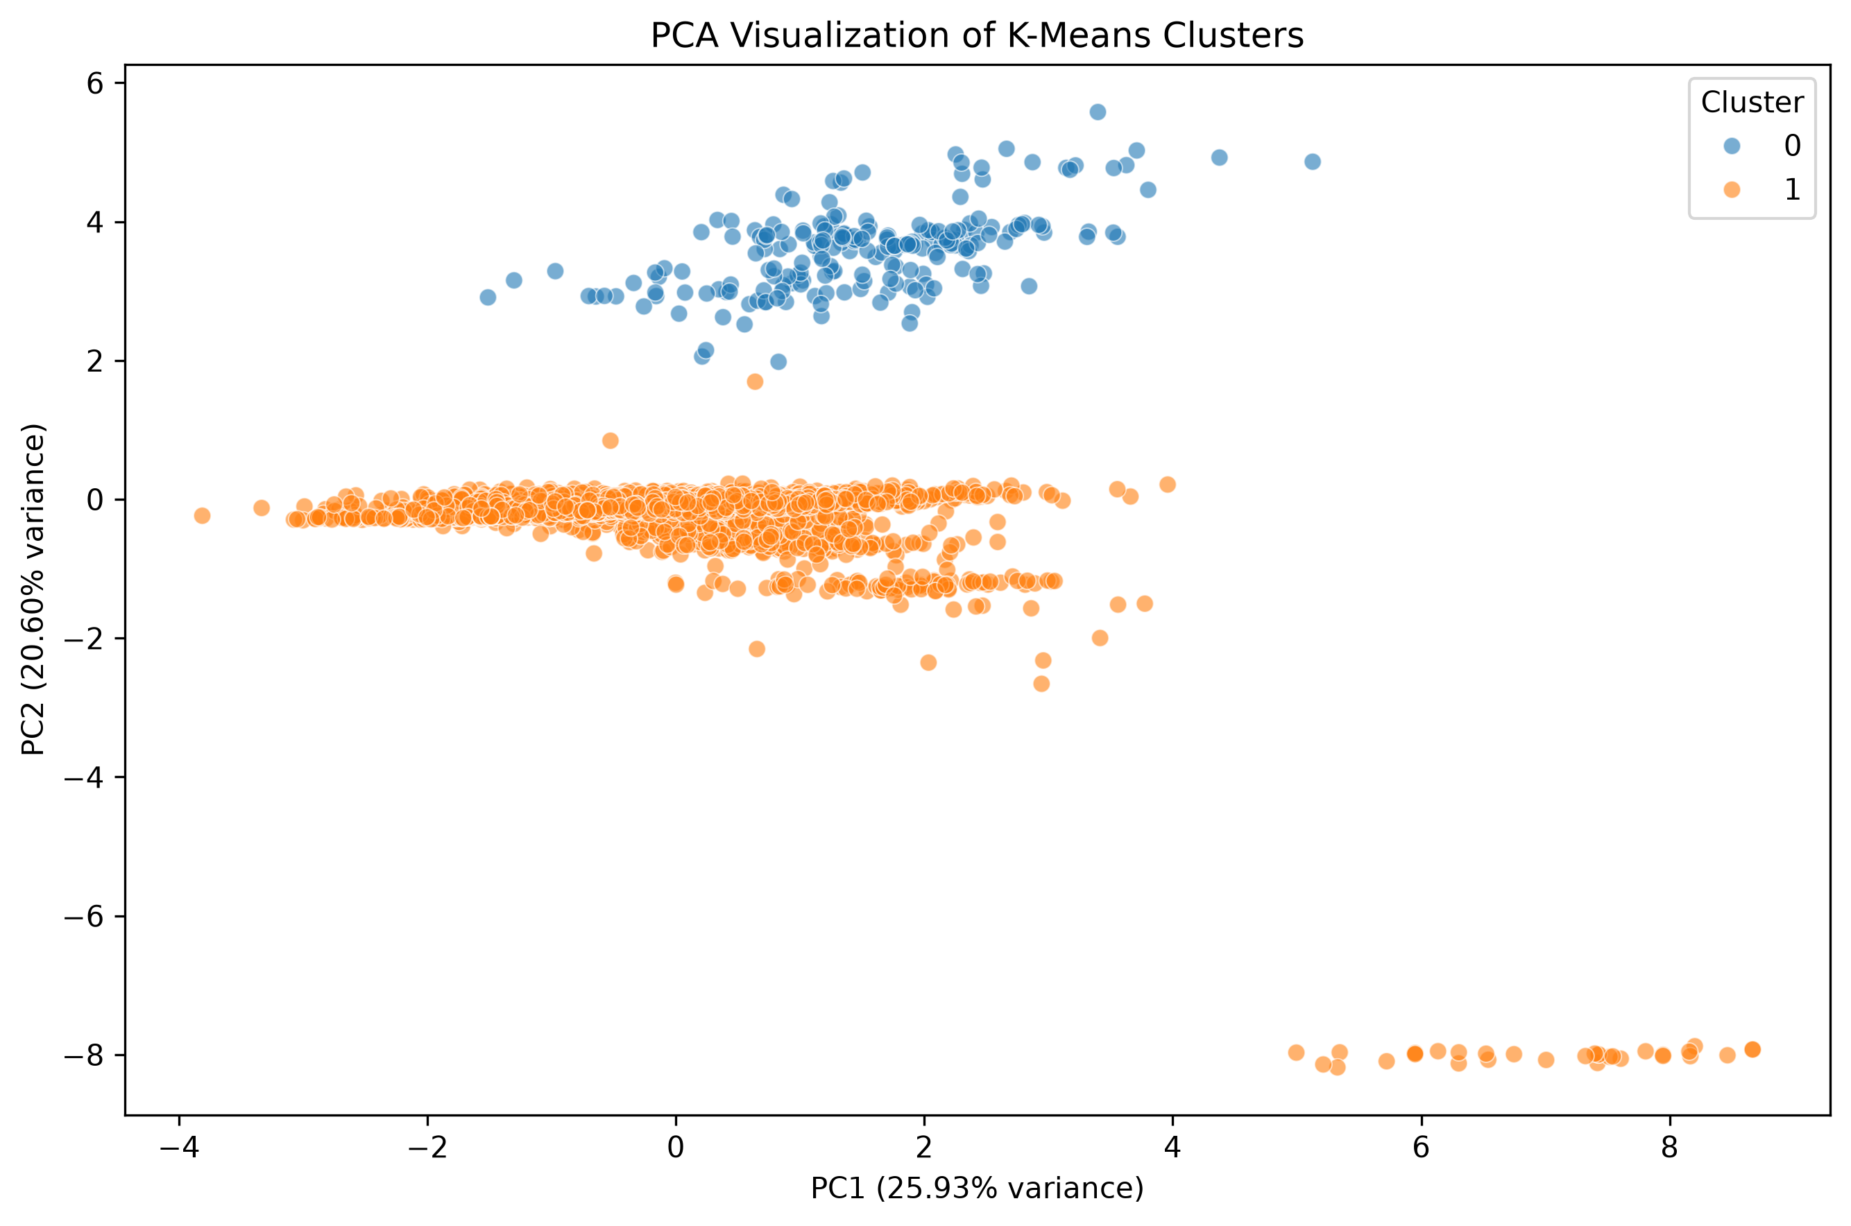
Figure 5. PCA visualization of the K-Means clusters.

6. Supervised Learning Model Comparison
Multiple supervised-learning algorithms were evaluated during the project. Logistic Regression, Decision Tree, Random Forest, and Balanced Random Forest were compared with the final neural network.
Model | Accuracy | Precision | Recall | F1 | ROC-AUC
Logistic Regression | 85.79% | 74.19% | 62.88% | 68.07% | 91.47%
Decision Tree | 86.60% | 78.81% | 60.71% | 68.59% | 90.60%
Random Forest | 87.11% | 82.17% | 59.38% | 68.94% | 92.30%
Balanced Random Forest | 81.78% | 58.08% | 87.56% | 69.84% | 92.33%
Neural Network | 83.06% | 60.49% | 85.54% | 70.87% | 91.90%

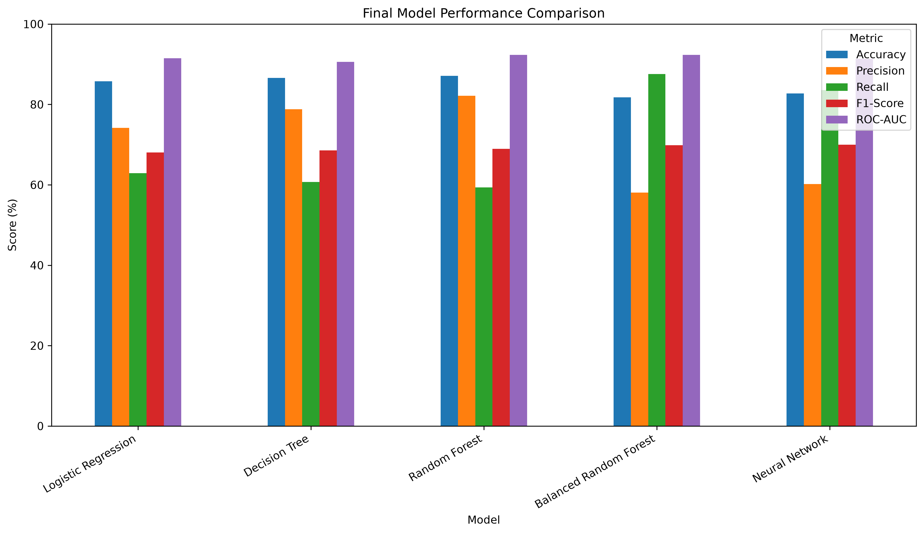
Figure 6. Comparison of predictive-model performance.
Random Forest achieved the highest accuracy at 87.11% and the highest precision at 82.17%. Balanced Random Forest achieved the highest recall among the traditional and neural models at 87.56% and the highest ROC-AUC at 92.33%.
The neural network achieved the highest F1-score in the comparison at 70.87%, while maintaining a strong recall of 85.54%.

7. Deep Learning Model
The final deep-learning model is a feed-forward neural network implemented using TensorFlow and Keras.

Architecture
The network contains an input layer followed by two fully connected hidden layers. The first hidden layer contains 64 neurons with ReLU activation, followed by 30% dropout. The second hidden layer contains 32 neurons with ReLU activation, followed by 20% dropout. A single sigmoid output neuron performs the binary classification.
Dropout was included to reduce overfitting. The Adam optimizer was used with a learning rate of 0.001, while binary cross-entropy was used as the loss function.
Class weights were applied because the `>50K` class is the minority class. Early stopping was also used to prevent unnecessary training after validation performance stopped improving.

8. Final Neural Network Evaluation
The final Week 6 neural network was evaluated on 4,881 previously unseen test observations.
Metric | Result
Accuracy | 83.06%
Precision | 60.49%
Recall | 85.54%
F1-score | 70.87%
ROC-AUC | 91.90%

8.1 Confusion Matrix
The confusion matrix provides a detailed breakdown of the model's predictions.
 | Predicted <=50K | Predicted >50K
Actual <=50K | 3,048 | 657
Actual >50K | 170 | 1,006

The model correctly classified 3,048 observations in the <=50K category and 1,006 observations in the >50K category. It produced 657 false positives and 170 false negatives.
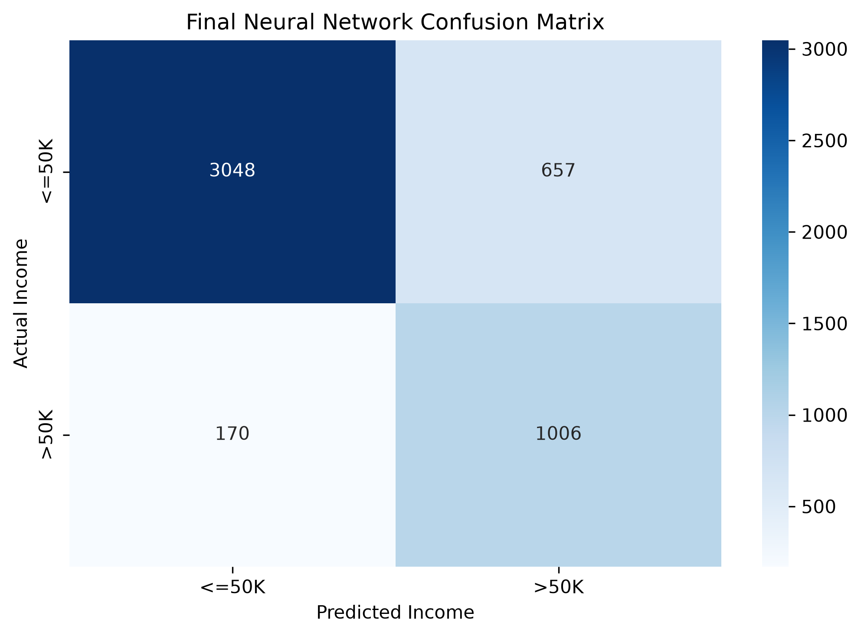
Figure 7. Confusion matrix for the final neural network.

8.2 ROC Curve
The final neural network achieved a ROC-AUC of 91.90%, indicating strong discrimination between the two income categories across different classification thresholds.
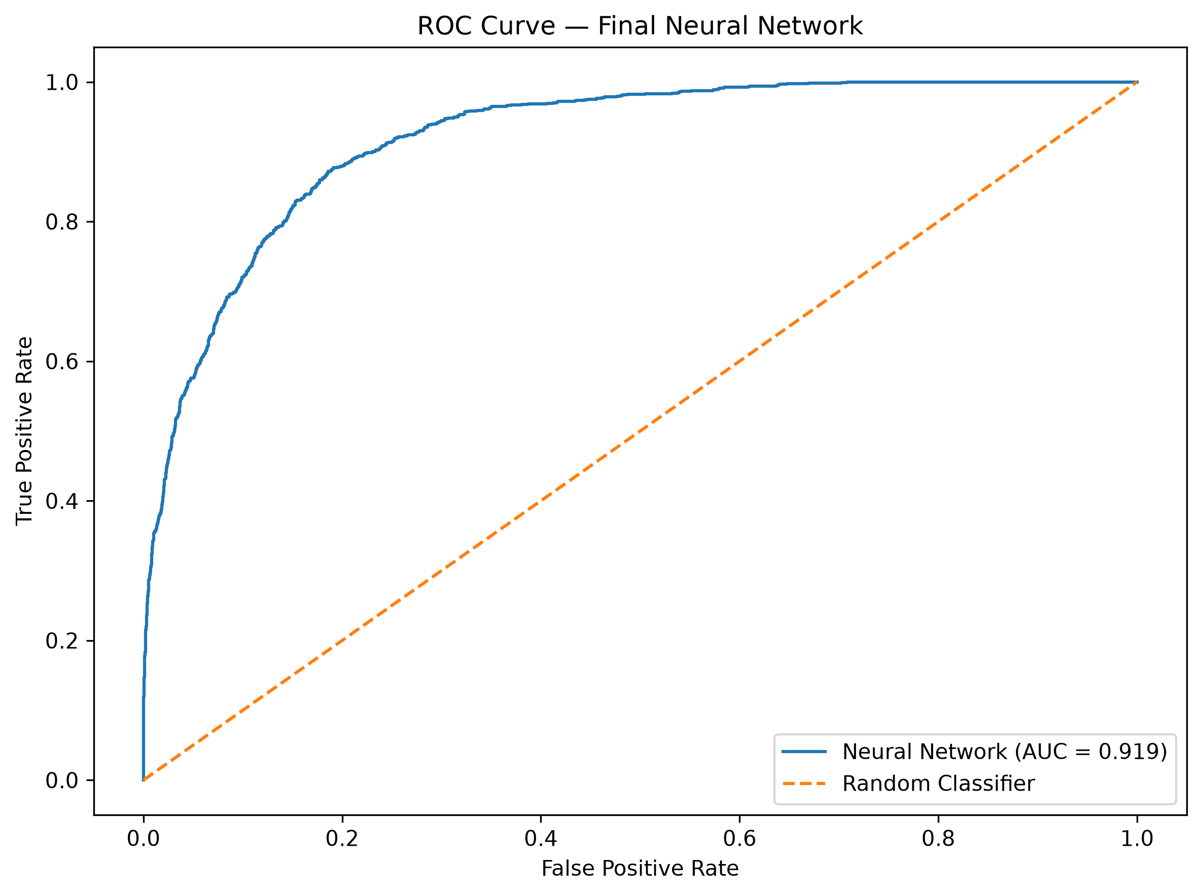
Figure 8. ROC curve for the final neural network.

9. Error Analysis
Error analysis was performed to understand the characteristics of correctly and incorrectly classified observations.
The analysis compares numerical characteristics including age, education number, working hours, capital gain, capital loss, total capital, and the work-hours-to-age ratio.
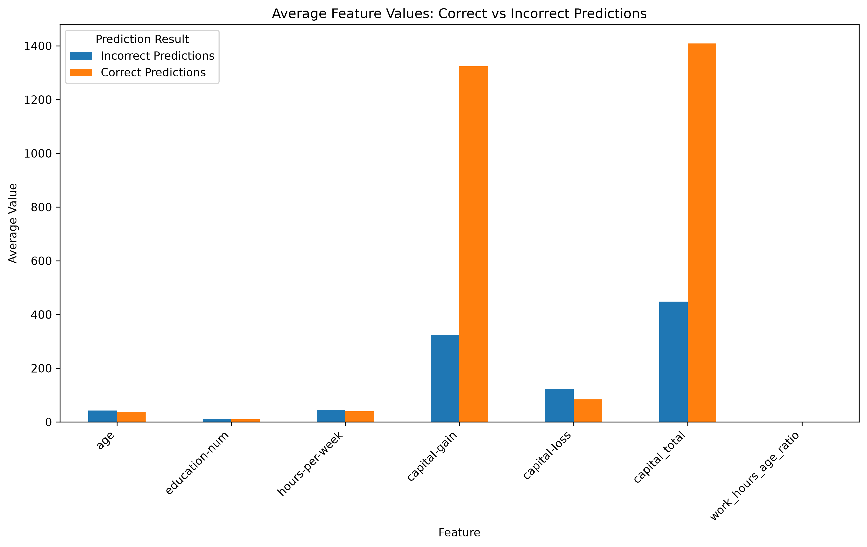
Figure 9. Comparison of feature characteristics for correct and incorrect predictions.
The results indicate that classification errors can occur when individuals have characteristics that overlap between the two income categories. This demonstrates why income classification cannot be reliably determined using a single variable.

10. Key Findings
- The dataset contains 32,537 observations with a substantial imbalance between the two income classes.
- Education, age, working hours, and financial variables provide useful information for distinguishing income categories.
- K-Means clustering identified two groups with substantially different characteristics and higher-income proportions.
- Random Forest achieved the highest overall accuracy at 87.11%.
- Balanced Random Forest achieved the highest recall among the traditional models at 87.56%.
- The final neural network achieved 83.06% accuracy, 60.49% precision, 85.54% recall, 70.87% F1-score, and 91.90% ROC-AUC.
- The neural network achieved strong minority-class detection but did not outperform Random Forest in overall accuracy.
- Model selection should depend on whether the application prioritizes accuracy, precision, recall, or balanced performance.

11. Recommendations
- Use Random Forest when overall prediction accuracy and precision are the primary objectives.
- Consider Balanced Random Forest or the neural network when identifying as many >50K individuals as possible is more important.
- Evaluate models using precision, recall, F1-score, ROC-AUC, and confusion matrices rather than accuracy alone.
- Retain education, age, employment, and financial variables because income classification depends on multiple characteristics.
- Tune the neural-network classification threshold in future work if a different precision-recall trade-off is required.
- Use model-explainability methods such as SHAP in future versions to improve interpretation of individual predictions.

12. Limitations
- The Adult Income dataset is a historical benchmark dataset and may not represent current economic conditions.
- The target classes are imbalanced, which makes minority-class prediction more challenging.
- The neural network does not automatically outperform traditional ensemble methods on this tabular dataset.
- Deep-learning experiments were performed in a local development environment with a relatively compact architecture.
- Neural-network predictions are less directly interpretable than simpler statistical models.
- The evaluation is based on a single held-out test set and would benefit from external validation in a real-world application.

13. Future Improvements
- Perform systematic hyperparameter optimization for the neural network.
- Experiment with additional architectures and regularization methods.
- Investigate threshold optimization to improve the precision-recall trade-off.
- Apply SHAP or other explainability methods to understand individual predictions.
- Evaluate the models using external or more recent income datasets.
- Develop a deployment interface where users can enter feature values and receive an income-category prediction.

14. Final Conclusion
This six-week internship project successfully developed an end-to-end data science pipeline for analyzing and predicting Adult Income categories.
The project progressed from data cleaning and exploratory analysis to unsupervised learning, supervised machine learning, and deep learning. This progression provided practical experience across the major stages of a modern data science workflow.
The exploratory analysis identified meaningful relationships between income and variables such as education, age, working hours, and financial characteristics. K-Means clustering provided an additional perspective by identifying population groups with different income distributions.
The supervised-learning comparison demonstrated that Random Forest provided the strongest overall accuracy and precision, while Balanced Random Forest and the neural network provided stronger recall for the minority income class.
The final neural network achieved 83.06% accuracy, 60.49% precision, 85.54% recall, 70.87% F1-score, and 91.90% ROC-AUC. Its performance demonstrates that deep learning can effectively learn useful patterns from tabular data, although a traditional ensemble model remained stronger for overall accuracy.
Overall, the capstone demonstrates the ability to independently design and execute a complete Python-based data science project, evaluate alternative analytical approaches, interpret model behavior, and translate quantitative results into practical recommendations.

15. Project Deliverables
- Week 1 — Data exploration and cleaning
- Week 2 — Exploratory data analysis and visualization
- Week 3 — K-Means clustering and PCA
- Week 4 — Supervised machine learning
- Week 5 — Deep learning application
- Week 6 — Integrative capstone and evaluation
GitHub Repository: https://github.com/bhargav55678/adult-income-data-cleaning

