WEEK 3 REPORT
Unsupervised Learning and Clustering
Adult Income Dataset

Technical Internship Project

1. Introduction
This week focused on applying unsupervised learning techniques to the cleaned Adult Income dataset. The main objective was to identify groups of individuals with similar characteristics without using income as an input variable.
K-Means clustering was selected because it is a commonly used unsupervised learning algorithm for grouping observations based on similarity.
The clustering analysis used five numerical features: age, education-number, hours-per-week, capital-gain, and capital-loss. Income was intentionally excluded from the clustering inputs and was analyzed after clustering to understand whether the resulting groups showed different income patterns.

2. Dataset Used
The analysis was performed using the cleaned Adult Income dataset prepared during the previous weeks.
- Total observations: 32,537
- Total columns: 15
- Clustering features: 5
The selected clustering features have different numerical ranges, particularly capital gain and capital loss. Therefore, standardization was performed before applying K-Means.

3. Data Preparation
The five selected numerical variables were standardized using StandardScaler. Standardization was necessary because K-Means uses distance calculations to group observations. Without scaling, variables with larger numerical ranges could have a disproportionate influence on the clustering results.
After standardization, the transformed variables had approximately zero mean and unit standard deviation.

4. Selection of the Number of Clusters

4.1 Elbow Method
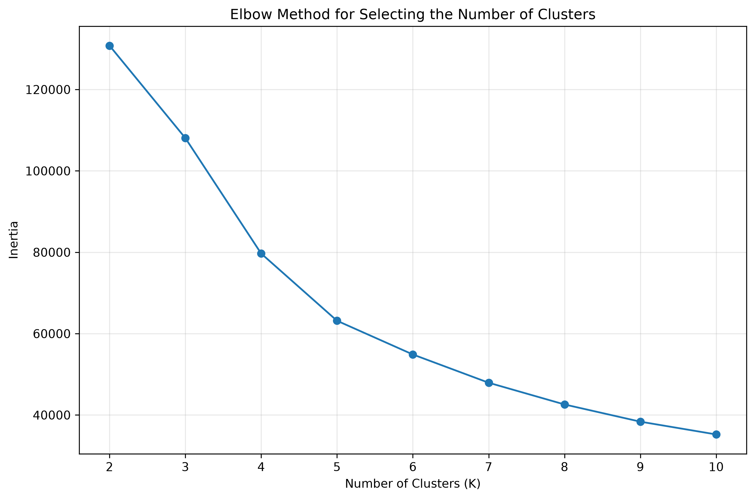
Figure 1. Elbow Method for selecting the number of clusters.
The Elbow Method was used to examine how the within-cluster sum of squares changed as the number of clusters increased. The reduction in inertia becomes smaller as more clusters are introduced. This method was considered together with the Silhouette Score and the interpretability of the resulting groups.

4.2 Silhouette Score
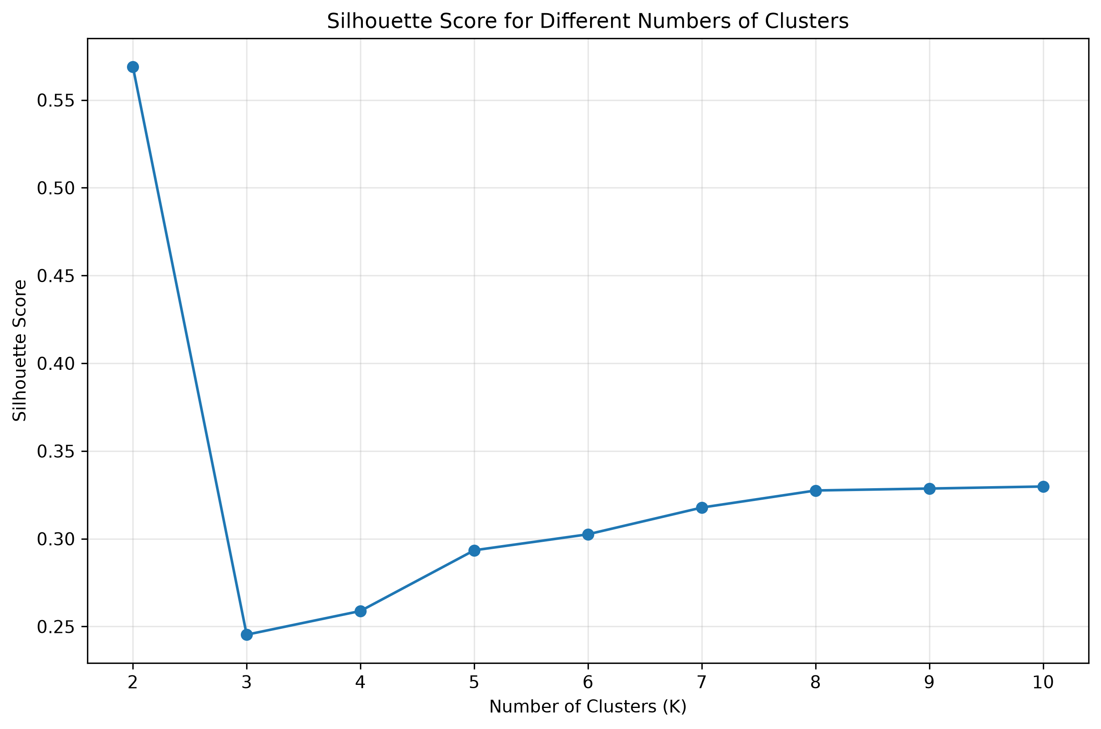
Figure 2. Silhouette scores for K values from 2 to 10.
Silhouette scores were calculated for K values from 2 to 10 using a fixed random sample of 5,000 observations to keep the evaluation computationally efficient.
K | Silhouette Score
2 | 0.5690
3 | 0.2453
4 | 0.2589
5 | 0.2934
6 | 0.3026
7 | 0.3178
8 | 0.3275
9 | 0.3286
10 | 0.3298
K = 2 produced the highest silhouette score of 0.5690 among the tested values. Based on the Elbow Method, Silhouette Score, and the interpretability of the resulting groups, K = 2 was selected for the final K-Means model.

5. Final K-Means Clustering
A K-Means model with two clusters was fitted using the standardized five numerical features. The final model used two clusters, random state 42, and 10 initializations.

5.1 Cluster Size Distribution
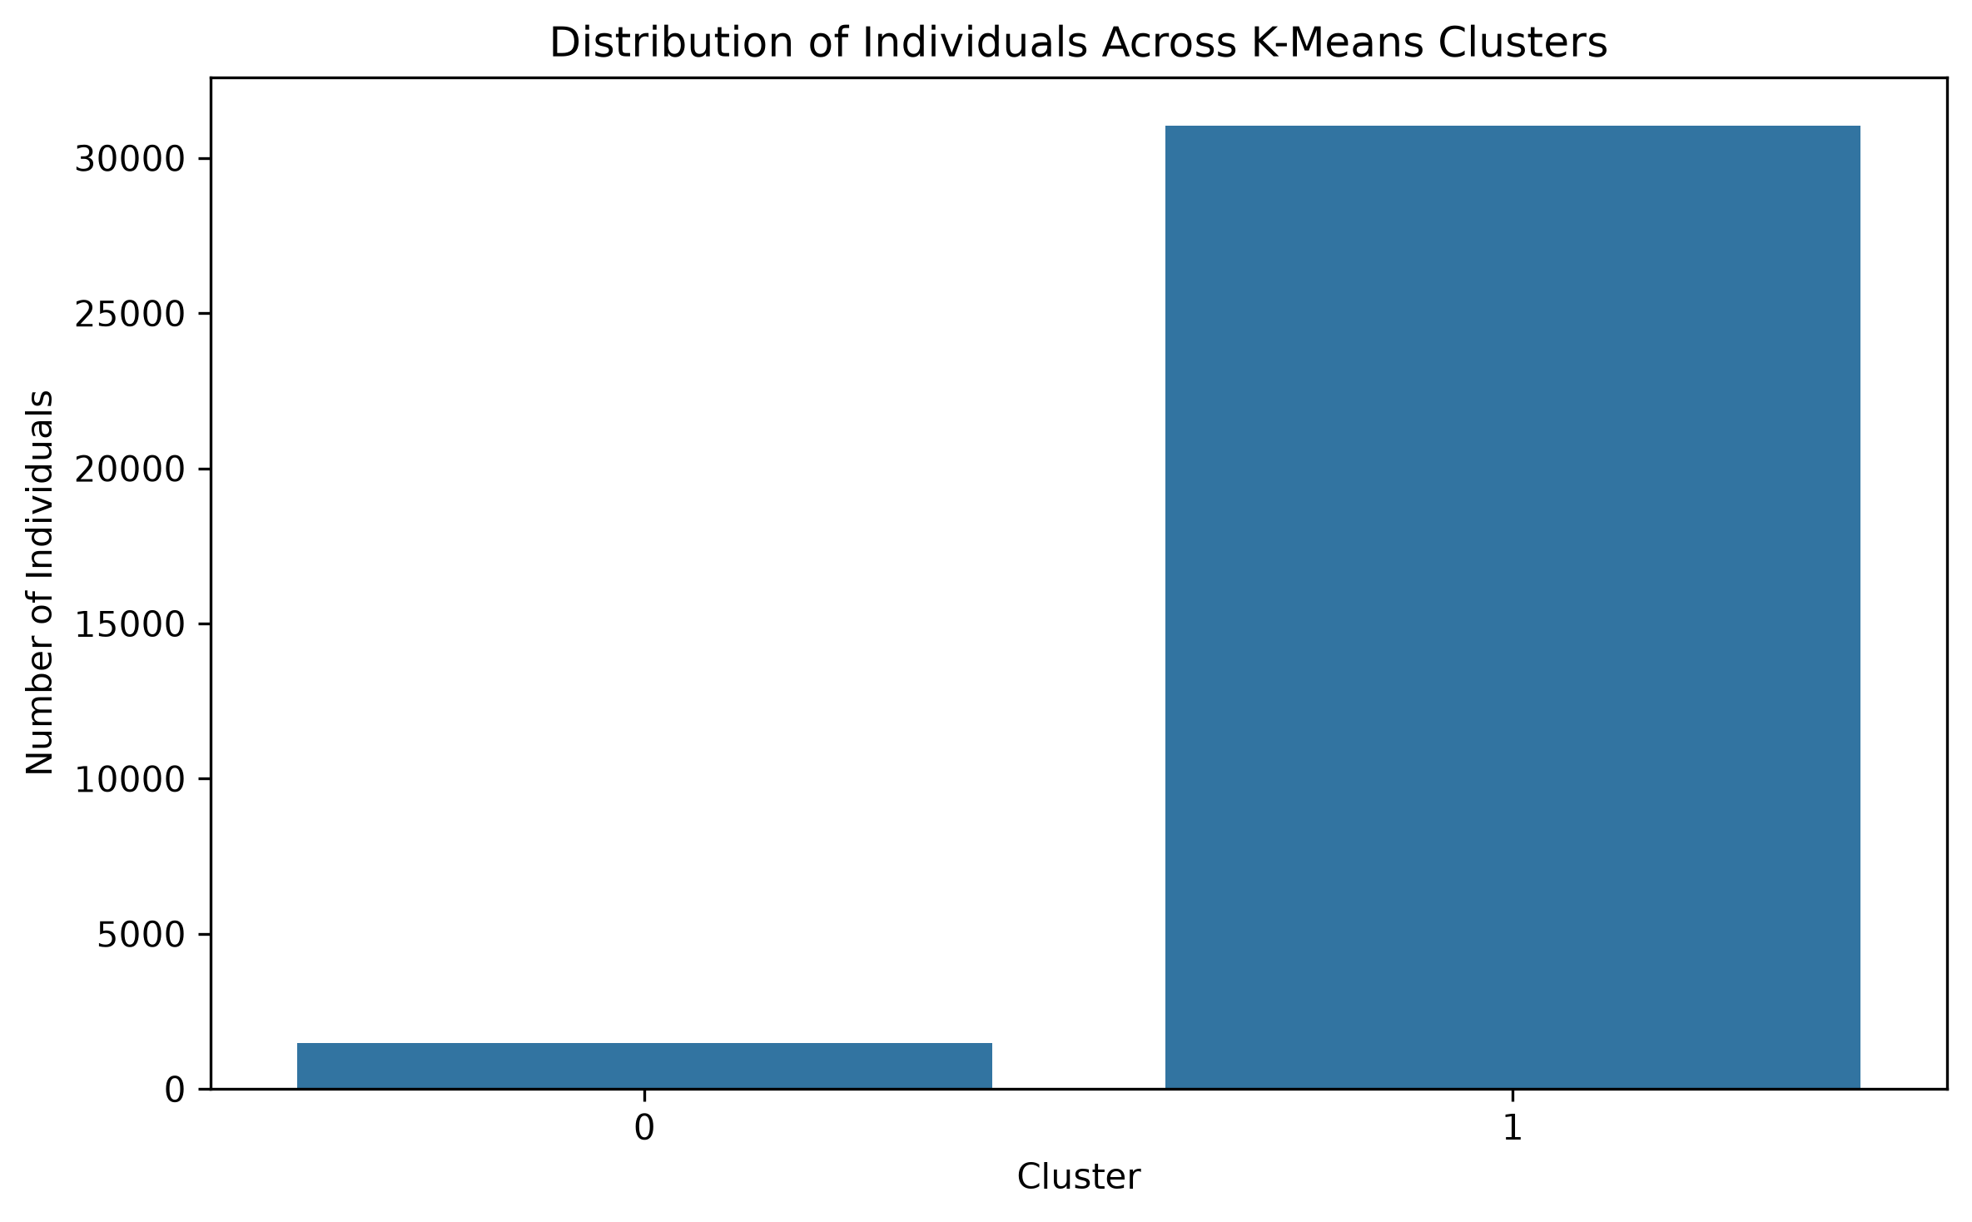
Figure 3. Distribution of observations between Cluster 0 and Cluster 1.
The final clustering produced two groups. Cluster 0 contains 1,484 individuals (4.56% of the dataset), while Cluster 1 contains 31,053 individuals (95.44%). Cluster 1 therefore represents the large majority of observations, while Cluster 0 is a much smaller group. The imbalance should be considered when interpreting the results.

6. Cluster Profile
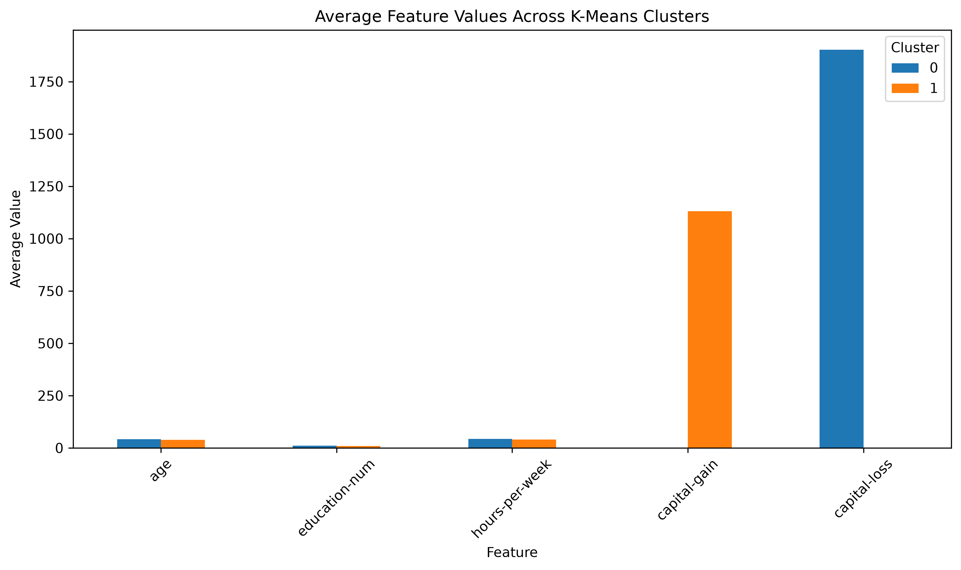
Figure 4. Average numerical profile of the two clusters.
The average values of the five clustering features were compared between Cluster 0 and Cluster 1.
Cluster 0 has a higher average age of 41.63 years compared with 38.44 years in Cluster 1. Its average education-number is also slightly higher at 10.99 compared with 10.04. Cluster 0 works an average of 43.36 hours per week, compared with 40.30 hours per week for Cluster 1.
The largest differences appear in the financial variables. Cluster 0 has an average capital loss of 1,901.71, while Cluster 1 has an average capital loss of only 0.66. In contrast, Cluster 1 has an average capital gain of 1,129.98, while Cluster 0 has an average capital gain of 0.00. These differences indicate that the financial variables contribute strongly to the separation between the two clusters.

7. Income Distribution Across Clusters
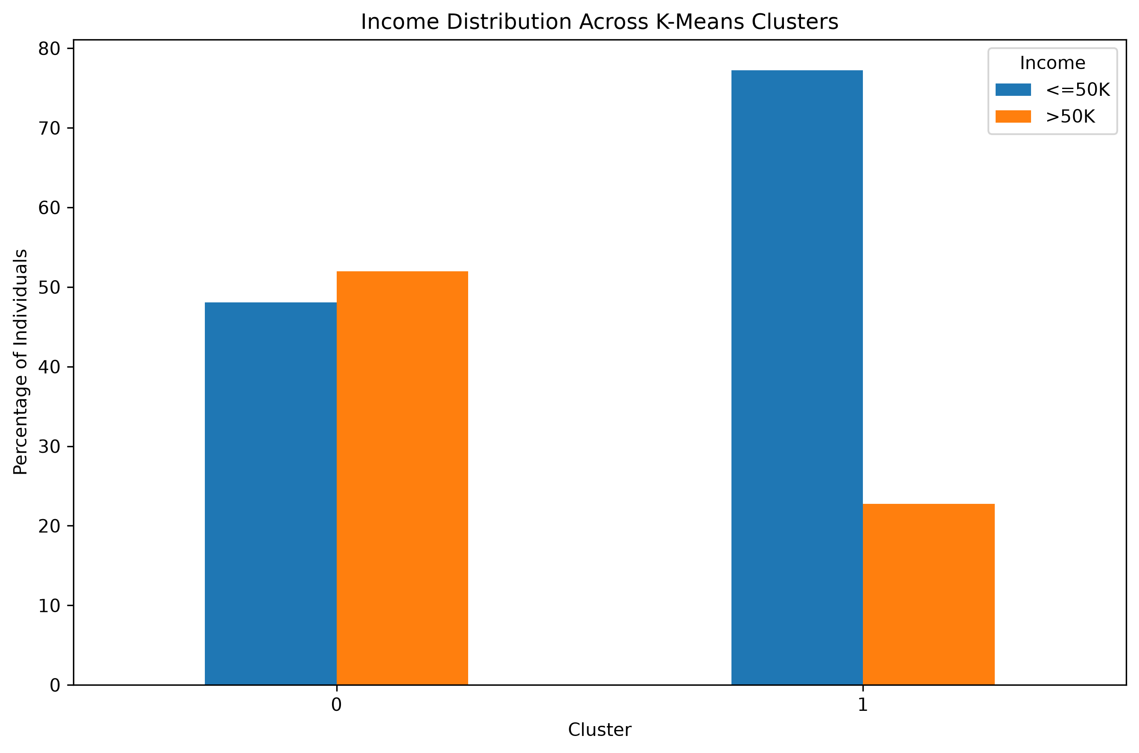
Figure 5. Income distribution within each cluster.
Income was not used as an input feature during K-Means clustering. Instead, it was examined after clustering to determine whether the groups identified using numerical characteristics show different income patterns.
In Cluster 0, 51.95% of individuals have an income above 50K. In Cluster 1, the corresponding proportion is 22.76%. This represents a difference of approximately 29.19 percentage points between the two clusters.
The observed income difference is an association within the dataset and should not be interpreted as evidence that cluster membership causes a particular income level.

8. Workclass Distribution
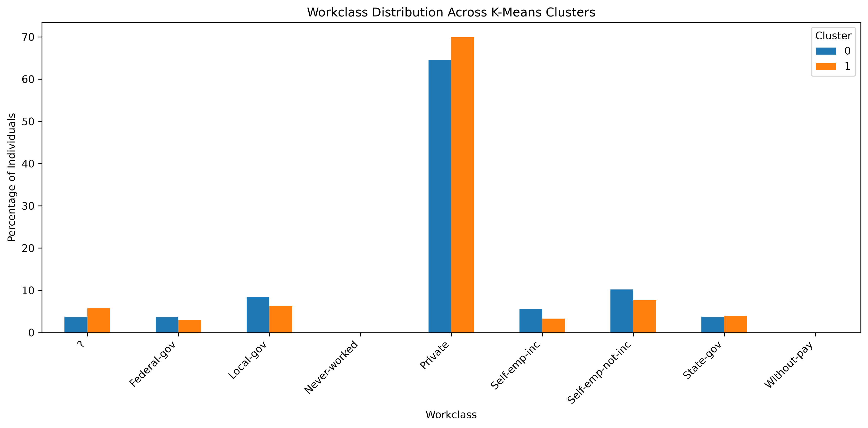
Figure 6. Workclass composition across the two clusters.
The workclass distribution was examined to understand whether the two clusters differ in their employment categories. The percentages show the composition of each cluster rather than overall frequency, allowing the employment structure of the groups to be compared despite their different sizes. Workclass was used for post-clustering interpretation and was not a direct K-Means input.

9. Occupation Distribution
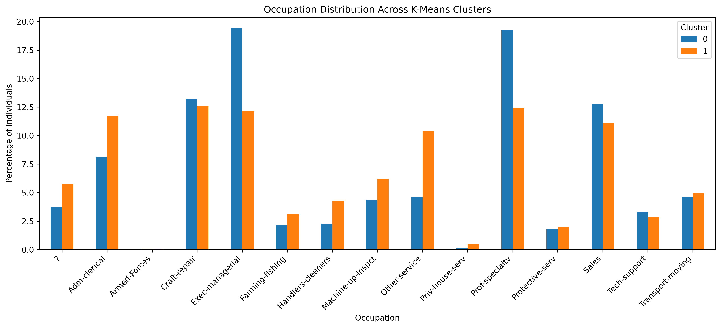
Figure 7. Occupation composition across the two clusters.
Occupation provides another useful way to interpret the clusters. The distribution shows how different occupational categories are represented within Cluster 0 and Cluster 1. Occupation should be interpreted together with education, age, working hours, and financial variables because no single characteristic completely explains the differences between the clusters.

10. Marital Status Distribution
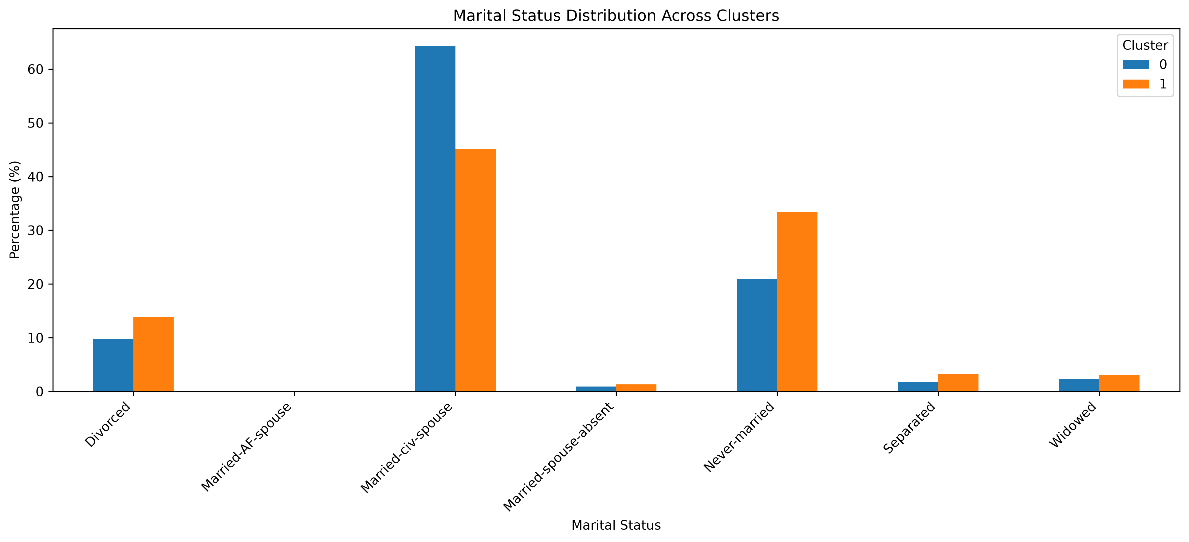
Figure 8. Marital status composition across the two clusters.
Marital status was analyzed to further understand the demographic characteristics of the clusters. Comparing the percentages helps identify whether the groups have noticeably different demographic compositions. Marital status was not used as an input feature for K-Means and was included only for post-clustering interpretation.

11. Sex Distribution
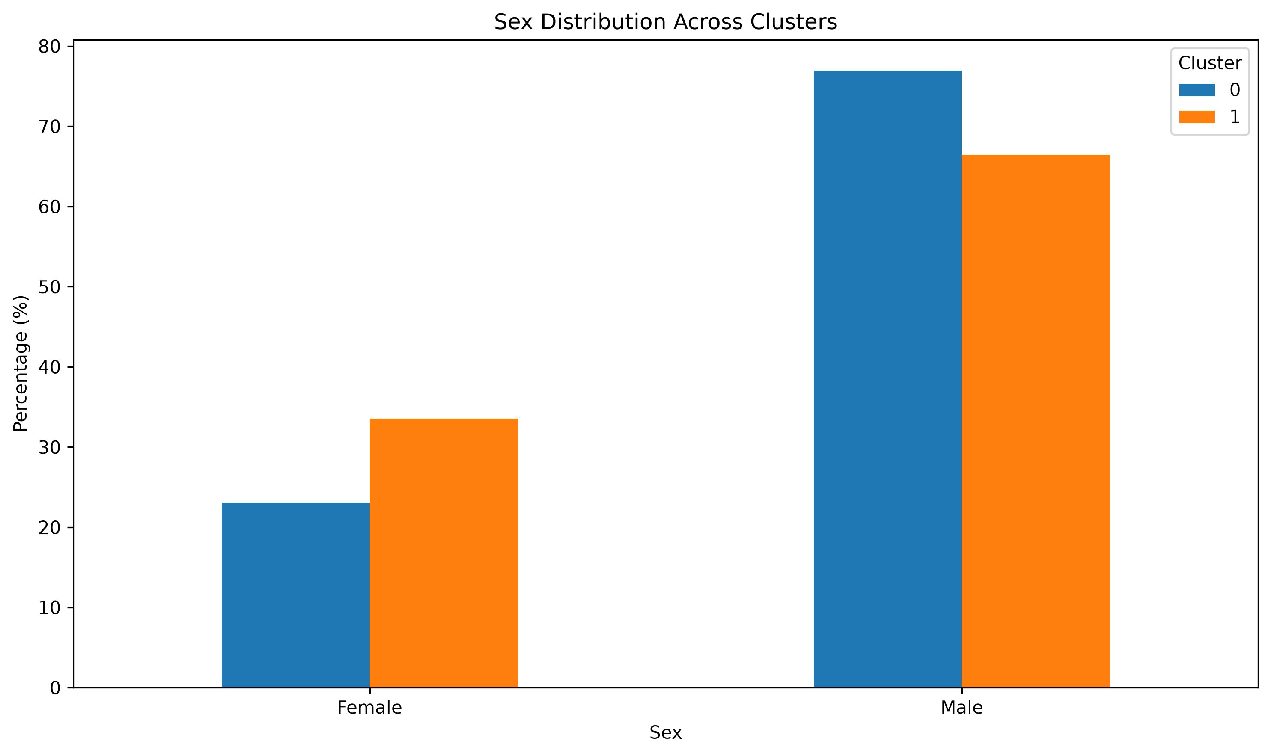
Figure 9. Sex distribution across the two clusters.
The sex distribution was examined to identify demographic differences between the two clusters. The percentages show the representation of male and female individuals within each cluster. Sex was not included as an input feature for K-Means and was used only for post-clustering interpretation.

12. PCA-Based Cluster Visualization
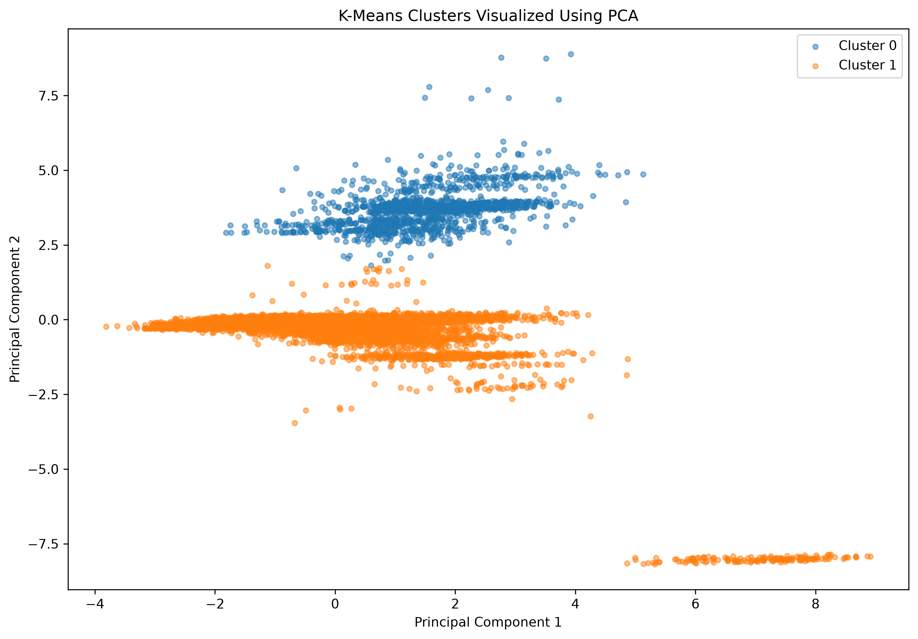
Figure 10. K-Means cluster assignments visualized using the first two PCA components.
Principal Component Analysis (PCA) was used to reduce the five-dimensional clustering data into two principal components for visualization. The first principal component explained 25.93% of the variance, while the second principal component explained 20.60%. Together, PC1 and PC2 explained 46.54% of the total variance in the standardized clustering data.
The scatter plot provides a two-dimensional representation of the K-Means cluster assignments. Some overlap between the clusters is expected because the original clustering was performed using five numerical dimensions, while PCA represents the data using only two dimensions.

13. Final Cluster Characteristics

Cluster 0
Cluster 0 contains 1,484 individuals, representing 4.56% of the dataset. The group has an average age of 41.63 years, an average education-number of 10.99, and an average working time of 43.36 hours per week. A major characteristic of this cluster is its high average capital loss of 1,901.71, while its average capital gain is 0.00. The proportion of individuals earning above 50K is 51.95%.

Cluster 1
Cluster 1 contains 31,053 individuals, representing 95.44% of the dataset. The average age is 38.44 years, the average education-number is 10.04, and the average working time is 40.30 hours per week. This group has an average capital gain of 1,129.98 and a very low average capital loss of 0.66. The proportion earning above 50K is 22.76%.
Overall, the two clusters differ most noticeably in their financial variables. Cluster 0 also shows somewhat higher average age, education level, working hours, and high-income representation.

14. Business and Research Implications
The clustering results can be useful for exploratory analysis of demographic and employment patterns.
From a business perspective, the identified groups could help organizations understand different segments of the workforce based on characteristics such as education, age, working hours, and financial indicators. Such segmentation could support workforce planning, targeted analysis, and further employee or customer research.
From a research perspective, clustering provides a way to discover groups without requiring a predefined target variable. The resulting clusters can be studied further to investigate relationships between demographic characteristics, employment categories, and income levels.
The strong difference in cluster sizes is also important. Cluster 1 represents 95.44% of the dataset, while Cluster 0 represents only 4.56%. Therefore, Cluster 0 can be viewed as a smaller and more distinct group within this dataset rather than an equally sized segment.
The difference in income distribution is also notable. The proportion of individuals earning above 50K is 51.95% in Cluster 0 compared with 22.76% in Cluster 1. This can provide a starting point for further research into the characteristics associated with higher income.
However, the clusters should not be interpreted as definitive social or economic categories. They are mathematical groupings produced from the selected features and depend on the dataset, preprocessing decisions, scaling method, and selected value of K.

15. Limitations
- The final clusters are highly imbalanced, with 95.44% of observations assigned to Cluster 1 and only 4.56% assigned to Cluster 0.
- The clustering was performed using only five numerical variables. Other demographic and categorical variables were not used as direct inputs to K-Means.
- Capital gain and capital loss contain highly skewed values. Although standardization was applied, these financial variables still have a strong influence on the resulting clusters.
- The PCA visualization explains 46.54% of the total variance using two components, meaning that some information from the original five-dimensional data is not visible in the two-dimensional plot.

16. Conclusion
K-Means clustering was successfully applied to the cleaned Adult Income dataset using five standardized numerical features: age, education-number, hours-per-week, capital-gain, and capital-loss.
The Elbow Method and Silhouette Score were used to evaluate different values of K. The highest silhouette score among the tested values was obtained at K = 2, with a score of 0.5690. Therefore, two clusters were selected for the final analysis.
The resulting clusters were examined using numerical profiles, workclass, occupation, marital status, sex, and income distributions. Cluster 0 contained 1,484 individuals, while Cluster 1 contained 31,053 individuals.
Income was analyzed only after clustering. The percentage of individuals earning above 50K was 51.95% in Cluster 0 and 22.76% in Cluster 1, showing a clear difference in income composition between the groups.
PCA was also used to visualize the clusters. The first two principal components together explained 46.54% of the total variance.
Overall, this analysis demonstrates how unsupervised learning can be used to discover patterns and groups in a dataset without directly using the target variable during clustering. The results provide a foundation for further experimentation with alternative clustering algorithms, feature selections, and preprocessing techniques.

